1)Install Webots
https://cyberbotics.com/

2)Install ROS(Melodic)
https://cybebotics.com/doc/guide/tutorial-8-using-ros

3)Clone the code from Github
https://github.com/hughhhhhhhh/webots_slam.git

4)Open the webots and load the world
File - Open world – webotsslam_github/worlds/SLAM.wbt

5)Open Matlab and load the script
webotsslam_github/controllers/matlab_supervisor/webotsscript.m

6)Run the first section and second section of webotsscript
7)Open terminal and run ROS
write down the following commands
roscore
// open a new tab
cd catkin_ws/
source devel/setup.bash
cd src
rosrun webots_ros pioneer3at
8)Run gmapping
// open a new tab and go to the locatin of catkin_ws/
source devel/setup.bash
cd src
rosrun gmapping slam_gmapping scan:=/pioneer3at/Sick_LMS_291/laser_scan/layer0 _xmax:=30 _xmin:=-30 _ymax:=30 _ymin:=-30 _delta:=0.2
9) Visualize the sensors output in rqt
// open new tab and write down the following command
rqt
10)Show the SLAM resluts
Add-By topic - Map
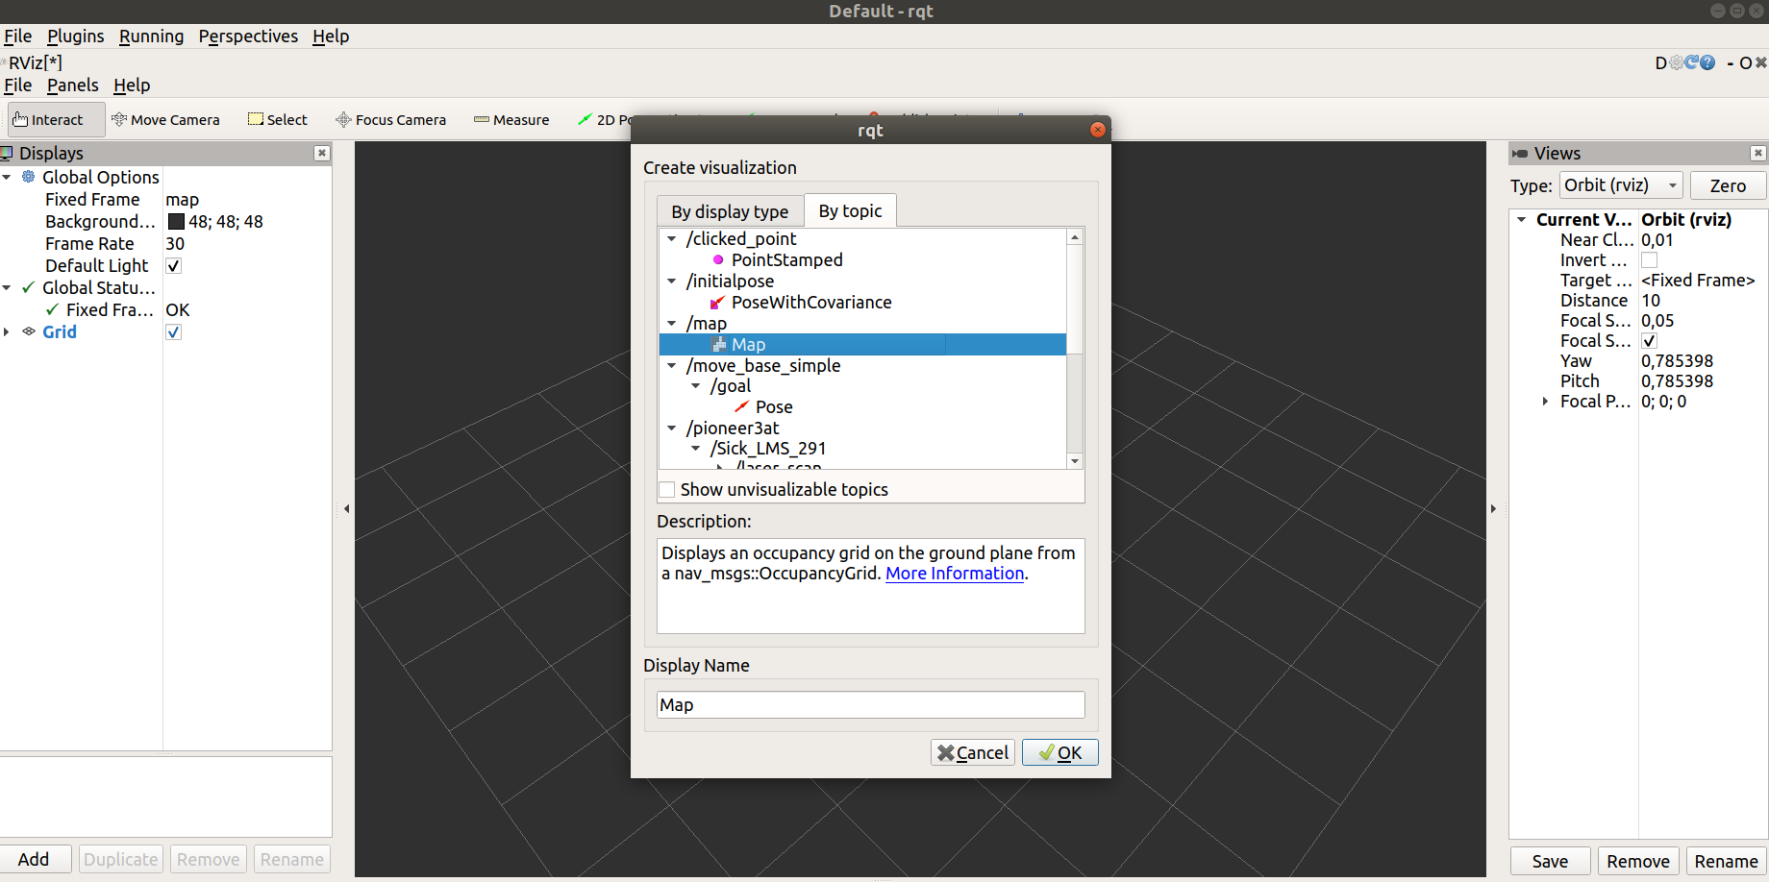
11)Save the result of the SLAM
// open terminal and go to the locatin of catkin_ws/
source devel/setup.bash
cd src
rosrun map_server map_saver -f my_map

12) Calculation the exploration
run the corresponding section in matlab script

