# 文献翻译

## 英文原文

**SMARTPHONE ACTIVATED DOOR LOCK USING WIFI**

N. Hashim, N. F. A. M. Azmi, F. Idris and N. Rahim

**Abstract**

A smartphone has variety of uses and becomes one of the most important devices nowadays. This paper describes the design and operation of a door locking using smartphone through Wireless Fidelity (WiFi) technology. Programmed using Android, the smartphone can lock and unlock the door within WiFi range. Android application is designed using Eclipse and a Peripheral Interface Controller (PIC) is used as the main controller of the design. This design is able to work within maximum range of 40 meters and 150 meters. Smartphone activated door lock using WiFi has been designed, implemented and tested successfully.

**[Key Words]** smartphone, door lock, WiFi, android, and PIC.

**INTRODUCTION**

Nowadays, the capability of smartphones is astonishing. A Smartphone is capable to handle applications that can perform a wide variety of functions. The purpose of this project is to simplify the tasks of locking and unlocking the door and to increase the security of the door locking system. The design used solenoid lock and Peripheral Interface Controller (PIC) as the main parts. The WiFi module and PIC are placed inside the home, apartment or building which is next to the door. The design will be managed through the Android application in the smartphone to unlock and lock the door automatically. The proposed design is also user friendly, where there is a reset button inside house to allow user to exit the door during emergency situation.

Recently, a lot of researchers have developed a technology based home security and automation. The authors in [1] have developed application for controlling access cabinet using Microsoft SQL Server Management Studio for managing the database of the users. This design requires a server which is costly but useful in office area where a controlling system is needed to control people accessing the cabinet.

In [2-3], the authors discussed the ongoing project using Bluetooth technology to control the access of the door locking using Android and Arduino. By using Bluetooth, the door locking system only can be accessed within shorter range compared to WiFi technology.

**OVERVIEW OF THE DESIGN**

1.1 Motivation

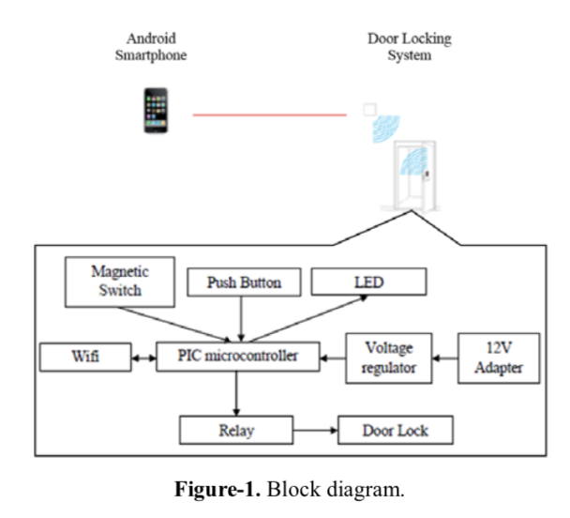Figure-1 shows the block diagram of the proposed door locking design. The block diagram consists of one transmitter and one receiver. Both of them are communicating using WiFi standard, which is IEEE 802.11. In this design, an Android smartphone with WiFi access is functioning as the transmitter. The receiver parts consist of a PIC, WiFi module, relay, and solenoid door lock. When the correct IP address and port number are received, the solenoid lock will be activated and it will unlock the door for 5 seconds. Besides, there is a resetbutton to unlock the door from inside the house. This is useful for emergency exit especially for home owner.

The development of this project consists of software and hardware implementation. Two main soft wares used in this design are Eclipse for building the Android application and C language for PIC to control the door locking. As for the hardware part, the design of the door lock was chosen carefully in order to increase the security of the door locking besides saving energy. In this project solenoid lock was chosen where the lock design is focused to an electrically operated door system that has high reliability. The locking mechanisms are holding a latch keeper in locking position to prevent opening of the door. This condition of system revealed that the solenoid is in unlocked position when it is energized and does not require electricity when solenoid is in locked position [4]. Thus this situation leads to electric saving characteristic design.

This project concentrates on Android application. The Android Development Kit (SDK) [5-7] is used where it provide libraries needed to interface with hardware.Android system architecture is the Android that created on top of the open-source Linux 2.6 Kernel. The Android team chooses to use this Kernel. It provides a proven core features to develop the Android operating system.

**HARDWARE CONFIGURATION**

Figure-2 shows the schematic diagram for the receiver part. PIC16F877A consists of 40 pins but only 33 I/O pins can be set as digital input or digital output which can be used to control the whole design. The PIC able operate from 4.5 VDC to 6 VDC. By using voltage regulator LM7805, the voltage is stepped down to 5 VDC. The WiFi module used in this project is XBee WiFi module [8] where it provides low power and low cost solution by offering simple serial to IEEE 802.11 connectivity.

The frequency band for the chosen WiFi module is 2.4 GHz. This band can transmit power of more than 15dBm and cover ranges of up to 120 meters. The relay output is a single pole double throw (SPDT) which its coil can be energized using 5 V and de-energized using 0 V. Initially, the relay output is normally closed. When the input coil of relay is energized, the output will switch to normally open. The switching is used to control device which is less than 250 VAC and 10 A. The LED is used as an indication for door opening or closing. When the output is low, the door is lock and both LED are OFF and vice versa.

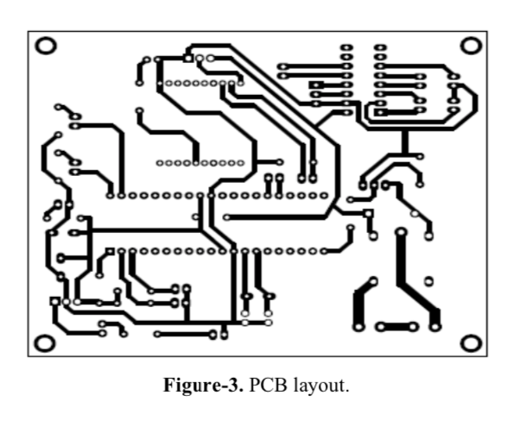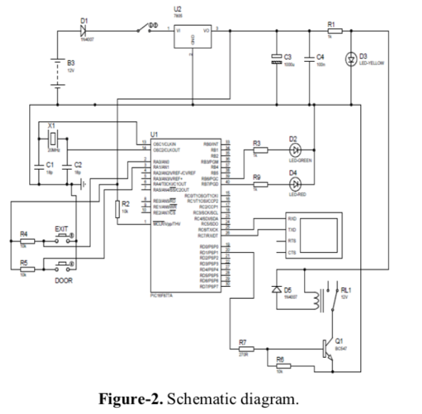Proteus 8 is used to design the schematic diagram and the corresponding PCB layout. The PCB layout of the door locking is shown in Figure-3.

**SOFTWARE CONFIGURATION**

The flowchart of the project is shown in Figure-4. The door will unlock if it receives the correct password or the exit button is pressed. When the microcontroller detects the data ‘A’, the output pin D1 become high and the door is unlocked and the magnetic switch will be opened. After 5 seconds, the door will lock automatically and the magnetic switch will be touching each other.

The source code when the WiFi data is detected is shown in Figure-5. In Figure-6, if the exit button is pressed, the output pin D1 will also become high and that indicates the door is unlocked. Pin A1 becomes high when the door is open. At this time, pin B6 becomes high and pin B7 is low. Lastly, when the door is closed, pin D1 and B6 becomes low. The purpose of the push button is to make sure people from inside 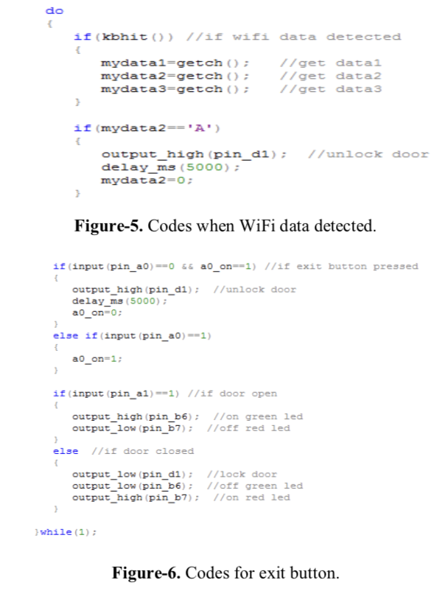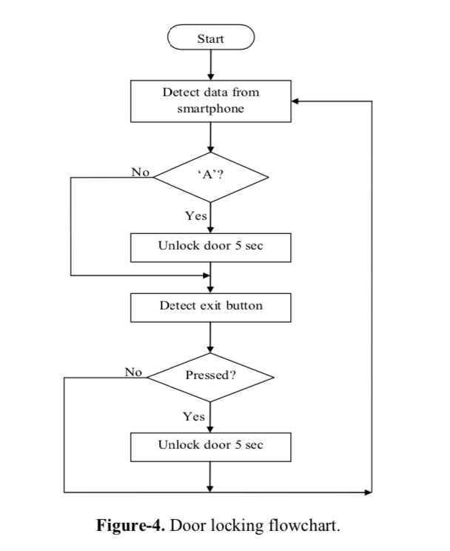the house can unlock the door without using smartphone especially during emergency situation.

**RESULT AND DISCUSSIONS**

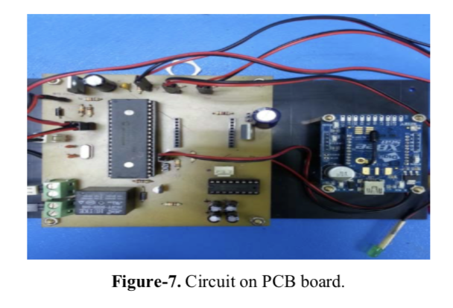Figure-7 shows the circuit on Printed Circuit Board (PCB) together with the WiFi module used in this project. The PCB is attached next to the door to control the operation of the door lock. The Android application is shown in Figure-8. The Android application interface is designed to allow user to key in the IP address and port number according the IP address of the WiFi. The user can unlock the door after connected with the design within maximum range of 40 meters and 150 meters.

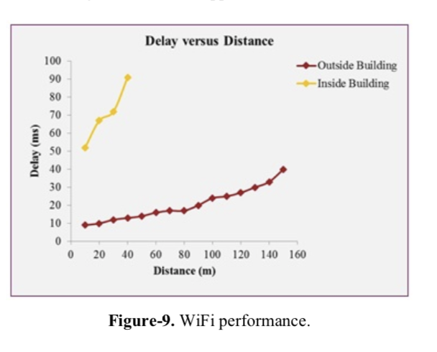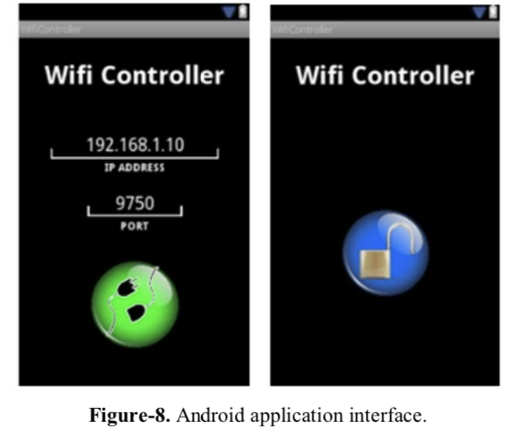Analysis was conducted to test the performance of the design at indoor and outdoor as shown in Figure-9. Based on the graph for both measurements, as the distance is increasing, the delays are increased as well. For outdoor analysis, the connection between smartphone and WiFi is lost after 150 meters due to the WiFi limitation range while for indoor analysis, the connection between smartphone and WiFi is lost after 40 meters. Fewer obstacles observed for outdoor analysis which effects in better results compared to indoor analysis. Obstacles reduce the effectiveness of the WiFi transmission due to path loss [8]. This design works better in less obstacles work environment.

**CONCLUSIONS**

Smartphone activated door locking using WiFi has been designed, implemented and tested successfully. This design used a smart phone to lock and unlock door wirelessly using WiFi technology. In future, the existing relay can be replaced with solid state relay (SSR) to reduce the power consumption and increase the stability of the design. Furthermore, security features can be added to increase the efficiency of the design. This could be done by introducing application protocol encryption in future. Last but not least, the Android application interface can be further enhanced to ease the user in case they could not remember the IP address and port number.

**REFERENCES：**

[1] Fedelin D. P. Jr., Malabed J.N.G., Manalo N.S.A, and Roxas K.M.P. 2013. Controlled Access Cabinet Door via Android Phone. International Journal of Management, IT and Engineering (IJMIE). 3(7): 379- 389.

[2] Ismail N.H., Tukiran Z., Shamsuddin N.N. and Saadon E.I.S. 2014. Android-based Home Door Locks Application via Bluetooth for Disabled People. IEEE International Conference on Control System and Engineering, Penang, Malaysia.

[3] Potts J. and Sukittanon S. 2012. Exploiting Bluetooth on Android Mobile Devices for Home Security Application. In: Proceedings of IEEE Southeastcon. 1-4.

[4] Sivarao, Alif A., Taufik., Yuhazri., Haery I., Robert K.M., and Tin S.L. 2012. Critical Review of Electro- Mechanical Door Locking System and Proposal towards Development of Innovative Super Energy Saving Door Locking System. International of Engineering and Innovative Technology (IJEIT). 2(5):

[5] Gargenta M. and Nakamura M. 2014. Learning Android: Develop Mobile Apps Using Java and Eclipse. 2nd Ed. O’Reilly. USA.

[6] Zigurd M., Laird Dornin., G. Blake M., and Masumi N. 2012. Programming Android. 2nd Ed. O’Reilly. USA.

[7] Felker D. and Dobbs J. 2001. Android Application Development for Dummies. Wiley Publishing Inc.

[8] Norlezah H. Mohd A. H. A. R., and Fakrulradzi I. 2015. Home Security System Using ZigBee. Jurnal Teknologi. 74(10).

# 翻译原文：

**基于wifi的智能手机激活门锁系统设计**

作者 N. Hashim, N. F. A. M. Azmi, F. Idris and N. Rahim

**摘要：**

智能手机具有多种用途，并成为当今最重要的设备之一。本文介绍了使用智能手机通过无线保真（WiFi）技术进行门锁的系统设计。使用Android进行编程，智能手机可以在WiFi范围内锁定和解锁门。Android应用程序使用Eclipse编程，外围接口控制器（PIC）用作设计的主控制器。 该设计能够在40米和150米的最大范围内工作。系统已经设计完成，并测试成功。

**关键字：**智能手机，门锁，wifi，安卓，和PIC

**介绍：**

如今，智能手机的功能令人惊讶。智能手机能够处理可执行各种功能的应用程序。本论文项目的是简化开锁和关锁流程，并提高门锁系统的安全性。该设计使用电磁锁和外围接口控制器（PIC）作为主要部件。WiFi模块和PIC放置在住房，公寓或其他建筑物靠近门的位置。该设计将通过智能手机中的Android应用程序进行管理，来自动关锁解锁。改系统提出的设计是用户友好的，其中住宅内有一个复位按钮，允许用户在紧急情况下离开住宅。

最近，许多研究人员开发了一些基于家庭安全和自动化的技术。 [1]中的作者开发了使用Microsoft SQL Server Management Studio控制访问机柜的应用程序，用于管理用户的数据库。该设计需要服务器，该服务器在办公区域中是昂贵但有用的，它需要控制系统来控制访问机柜的人。

在[2-3]中，作者讨论了正在进行的项目，该项目使用蓝牙技术来控制使用Android和Arduino进行门锁的访问。与WiFi技术相比，蓝牙只允许门锁系统在更短的范围内访问。

**概要设计：**

图1显示了所提出的门锁设计的概要图。该图由一个发射器和一个接收器组成。它们都使用WiFi标准进行通信，这是IEEE 802.11协议。在此设计中，具有WiFi接入功能的Android智能手机可用作发射器。接收器部件包括PIC，WiFi模块，继电器和电磁门锁。收到正确的IP地址和端口号后，电磁锁将被激活，它将解锁门5秒钟。此外，还有一个重置按钮，可以从房屋内部解锁门。这是紧急出口，对于处于特殊情况的房主来说非常有用。

该项目的开发实现包括软件和硬件两部分。本设计中使用的两个主要软件是用于构建Android应用程序的Eclipse和用于编写PIC的C语言，其目的是来控制门锁。至于硬件部分，需要小心选择门锁设计，以增加门锁的安全性，同时节省能源。在本项目中，具有高可靠性的电磁锁最终被选中。锁定机构将闩锁保持器保持在锁定位置以防止门打开。这样，电磁阀在通电时处于解锁位置，当电磁阀处于锁定位置时则不耗费电[4]。这种特性将使系统较为省电。

该项目专注于Android应用程序。 Android开发工具包（SDK）[5-7]用于提供与硬件接口所需的库.Android系统架构是在开源Linux 2.6内核之上创建的Android。 Android团队选择使用此内核。它为开发Android操作系统提供了经过验证的核心功能。

**硬件设计：**

图2显示了接收器部分的示意图。 PIC16F877A由40个引脚组成，但只有33个I / O引脚可以设置为数字输入或数字输出，可用于控制整个设计。 PIC能够在4.5 至6 V直流电压范围内工作。通过使用稳压器LM7805，电压降至5 V。该项目中使用的WiFi模块是XBee WiFi模块[8]，它通过提供简单的串行到IEEE 802.11连接提供低功耗和低成本解决方案。

所选WiFi模块的频段为2.4 GHz。该频段可传输超过15dBm的功率，覆盖范围可达120米。继电器输出为单刀双掷（SPDT），其线圈可以使用5 V通电，并使用0 V断电。最初，继电器输出常闭。当继电器的输入线圈通电时，输出将切换到常开。该开关用于控制小于250 V和10A的设备.LED用作门打开或关闭的指示。当输出低时，门被锁定并且两个LED都关闭，反之亦然。

Proteus 8用于设计原理图和相应的PCB布局。门锁的PCB布局如图3所示。



**软件设计：**

该项目的流程图如图4所示。 如果收到正确的密码或按下退出按钮，门将解锁。 当微控制器检测到数据“A”时，输出引脚D1变为高电平，门被解锁，磁性开关将被打开。 5秒后，门将自动锁定，磁性开关将相互接触。

检测WiFi数据时的源代码如图5所示。 在图6中，如果按下退出按钮，输出引脚D1也将变为高电平，表示门已解锁。 门打开时，引脚A1变高。 此时，引脚B6变为高电平，引脚B7变为低电平。 最后，当门关闭时，引脚D1和B6变低。 按钮的目的是确保房屋内的人可以在不使用智能手机的情况下解锁门，特别是在紧急情况下。

**结果和讨论：**

图7显示了印刷电路板（PCB）上的电路以及本项目中使用的WiFi模块。 PCB安装在门旁边，以控制门锁的操作。 Android应用程序如图8所示。 Android应用程序界面旨在允许用户根据WiFi的IP地址键入IP地址和端口号。用户可以在与设计连接后在40米和150米的最大范围内解锁门。

进行分析以测试室内和室外设计的性能，如图9所示。基于两个测量的图表，随着距离的增加，延迟也增加。对于室外分析，由于WiFi限制范围，智能手机和WiFi之间的连接在150米后丢失，而对于室内分析，智能手机和WiFi之间的连接在40米后丢失。与室内分析相比，室外分析观察到的障碍更少，效果更好。由于路径损耗，障碍降低了WiFi传输的有效性[8]。这种设计在较少障碍的工作环境中工作得更好。

**结论：**

智能手机激活门锁使用WiFi已成功设计，实施和测试。 这种设计使用智能手机使用WiFi技术无线锁定和解锁门。 现有的继电器可以用固态继电器（SSR）代替，以降低功耗并提高设计的稳定性。 此外，可以添加安全功能以提高设计效率。 这可以通过引入应用程序协议加密来完成。最后需要说明的是，Android应用程序需要进一步增强，用户在忘记IP地址和端口号的情况下也要能够轻松使用。

**参考文献：**

[1] Fedelin D. P. Jr., Malabed J.N.G., Manalo N.S.A, and Roxas K.M.P. 2013. Controlled Access Cabinet Door via Android Phone. International Journal of Management, IT and Engineering (IJMIE). 3(7): 379- 389.

[2] Ismail N.H., Tukiran Z., Shamsuddin N.N. and Saadon E.I.S. 2014. Android-based Home Door Locks Application via Bluetooth for Disabled People. IEEE International Conference on Control System and Engineering, Penang, Malaysia.

[3] Potts J. and Sukittanon S. 2012. Exploiting Bluetooth on Android Mobile Devices for Home Security Application. In: Proceedings of IEEE Southeastcon. 1-4.

[4] Sivarao, Alif A., Taufik., Yuhazri., Haery I., Robert K.M., and Tin S.L. 2012. Critical Review of Electro- Mechanical Door Locking System and Proposal towards Development of Innovative Super Energy Saving Door Locking System. International of Engineering and Innovative Technology (IJEIT). 2(5):

[5] Gargenta M. and Nakamura M. 2014. Learning Android: Develop Mobile Apps Using Java and Eclipse. 2nd Ed. O’Reilly. USA.

[6] Zigurd M., Laird Dornin., G. Blake M., and Masumi N. 2012. Programming Android. 2nd Ed. O’Reilly. USA.

[7] Felker D. and Dobbs J. 2001. Android Application Development for Dummies. Wiley Publishing Inc.

[8] Norlezah H. Mohd A. H. A. R., and Fakrulradzi I. 2015. Home Security System Using ZigBee. Jurnal Teknologi. 74(10).