JMP is a suite of statistical analysis tools, with data visualisation and exploration features, developed by SAS Institute.

* It has a graphical user interface and the user can build graphs and tables using drag and drop functionality, making it accessible to a wider range of users.
* Very interactive design. The data is linked between windows (selected datapoints are highlighted in other graphs/tables), which encourages the user to explore data further
* Helpful video quick start tutorials
* Includes specific tools for exploring and manage outliers and missing values

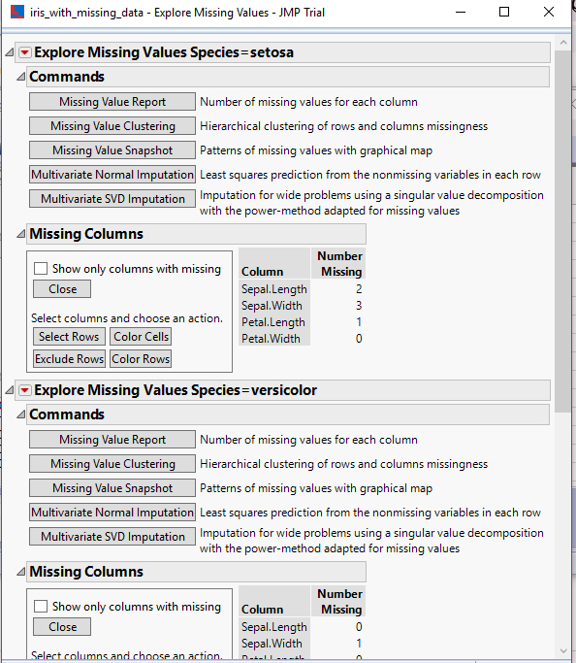

Preliminary visual analysis of the data can be performed in JMP using scatterplot (2D or 3D) and boxplot graphs, and colour coded parallel plots similar to below.

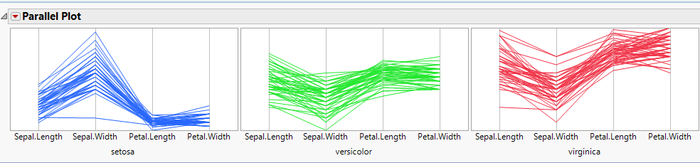

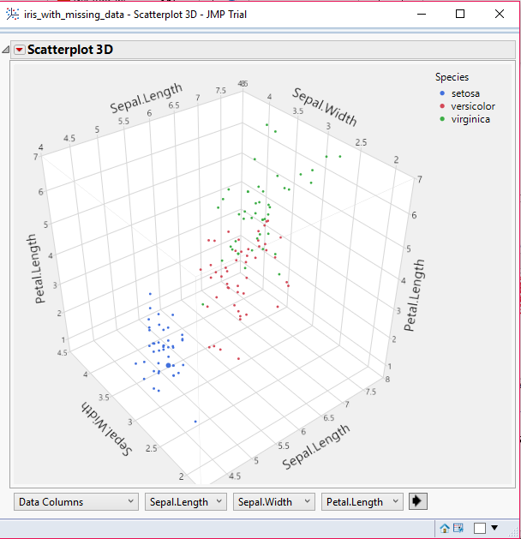

With regards to the iris dataset, SAS JMP is commonly used to perform discriminant analysis and cluster analysis.

Canonical Discriminant Analysis (CDA) is a technique very similar to multivariate ANOVA (analysis of variance). The goal of this technique is to find what combination of variables would best differentiate between species of iris. The technique can be considered similar to multivariate ANOVA (analysis of variance), in that the means of multiple variables are compared (e.g. petal length, petal width) to determine which variables make a group statistically different.

The CANDISC Procedure in JMP performs CDA and outputs canonical variables to identify group membership (see iris results below). If the dataset contains missing values as with iris.csv, these values are omitted from analysis.

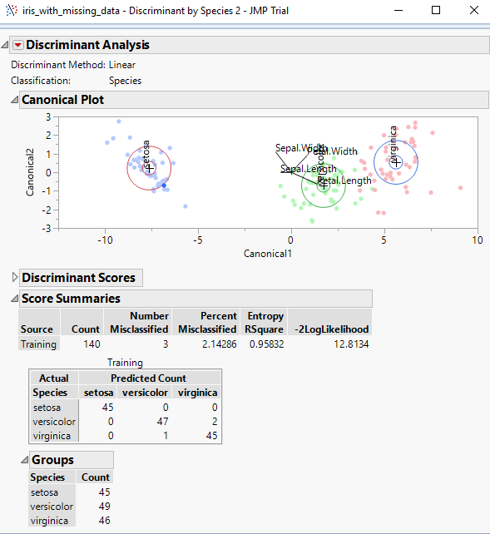

<https://studylib.net/doc/7062331/discriminant-analysis-in-jmp>

<http://www.statsoft.com/textbook/discriminant-function-analysis>

<http://support.sas.com/documentation/cdl/en/statug/66859/HTML/default/viewer.htm#statug_candisc_example01.htm>

<https://books.google.ie/books?id=q3g4DwAAQBAJ&pg=SA9-PA74&lpg=SA9-PA74&dq=jmp+iris+analysis&source=bl&ots=z1-DlqhxKl&sig=ACfU3U2roBp7toPXy9ogpiwNrNAUPFxG_w&hl=en&sa=X&ved=2ahUKEwiqmsX8gpjgAhU2SBUIHR7fDoQQ6AEwCXoECAoQAQ#v=onepage&q=jmp%20iris%20analysis&f=false>