IMDb Web Test

Hugh Pedley

CS 1632 – DELIVERABLE 3: Web Testing with BDD

For this deliverable, I decided to web test IMDb. I figured I would test a web site that I use extremely frequently, and while Reddit seemed like an obvious choice, I did not want to test a site that Prof. Laboon had already written some tests for. IMDb is almost ubiquitous in its use in the USA now (as evidenced by the fact that it’s a default app that you can’t uninstall in Samsung Android phones now). Because of that, I assumed that it was well tested and would be fairly simple to write passing tests for.

In addition to that, and perhaps most importantly for me, IMDb appears to use little to no Javascript and uses mostly static page layouts. This goes well with the warning in the deliverable 3 description to avoid such dynamic sites as Facebook or Amazon.

Finally, IMDb goes well with the other two suggestions from Prof. Laboon. By that, I mean that I understand IMDb well from my time using it, and it does not cost any additional money for me to use (at least, for most of the functionality).

I had relatively few challenges during this deliverable. Deciding to take this on by myself was a bit of a struggle, but mostly because I underestimated how long it would take for me to actually come up with four user stories and at least five scenarios for each to do the appropriate amount of testing.

Writing the tests themselves were relatively painless, as it follows fairly well from our writing of Junit tests. The only difficult part was actually in running and passing the tests. Every once in a while, when running a new test, an old one that had previously passed would fail. Occasionally this was because my internet at home disconnected briefly (massively confusing the first time that happened), but typically this was not the case. Instead, I merely ran the tests again and they would all pass (or the new one would fail, and I would make a simple fix). I’m still not entirely sure how I would prevent this in the future, but I still got all green on my tests so I’m also not sure how much of a problem it actually is.

My code can be found at: <https://github.com/hughpedley/cs1632_deliverable3>

User Story 1:

As a user,

I want to be able to navigate using any links on IMDb,

So that I can learn more about movies in an efficient manner.

Tested scenarios:

testShowsCorrectTitle()

Given that I am on the main page, when I view the title, then I should see that it contains ‘IMDb’.

testHasCorrectHeaderLinks()

Given that I am on the main page, when I view the top bar, I should see that it contains ‘movies’, ‘tv’, ‘showtimes’, ‘celebs’, ‘events’, ‘photos’, ‘news’, ‘community’, and ‘watchlist’.

testHasSearchBar()

Given that I am on the main page, when I view the top of the page, I should see a search bar and search button.

testSeeMovies()

Given that I am on the main page, when I click on the ‘movies’ link, then I should be redirected to the movies page.

testSeeTV()

Given that I am on the main page, when I click on the ‘TV’ link, then I should be redirected to the TV page.

testSeeShowtimes()

Given that I am on the main page, when I click on the ‘showtimes’ link, then I should be redirected to the showtimes page.

testSeeCelebs()

Given that I am on the main page, when I click on the ‘celebs’ link, then I should be redirected to the celebs page.

testSeePhotos()

Given that I am on the main page, when I click on the ‘photos’ link, then I should be redirected to the photos page.

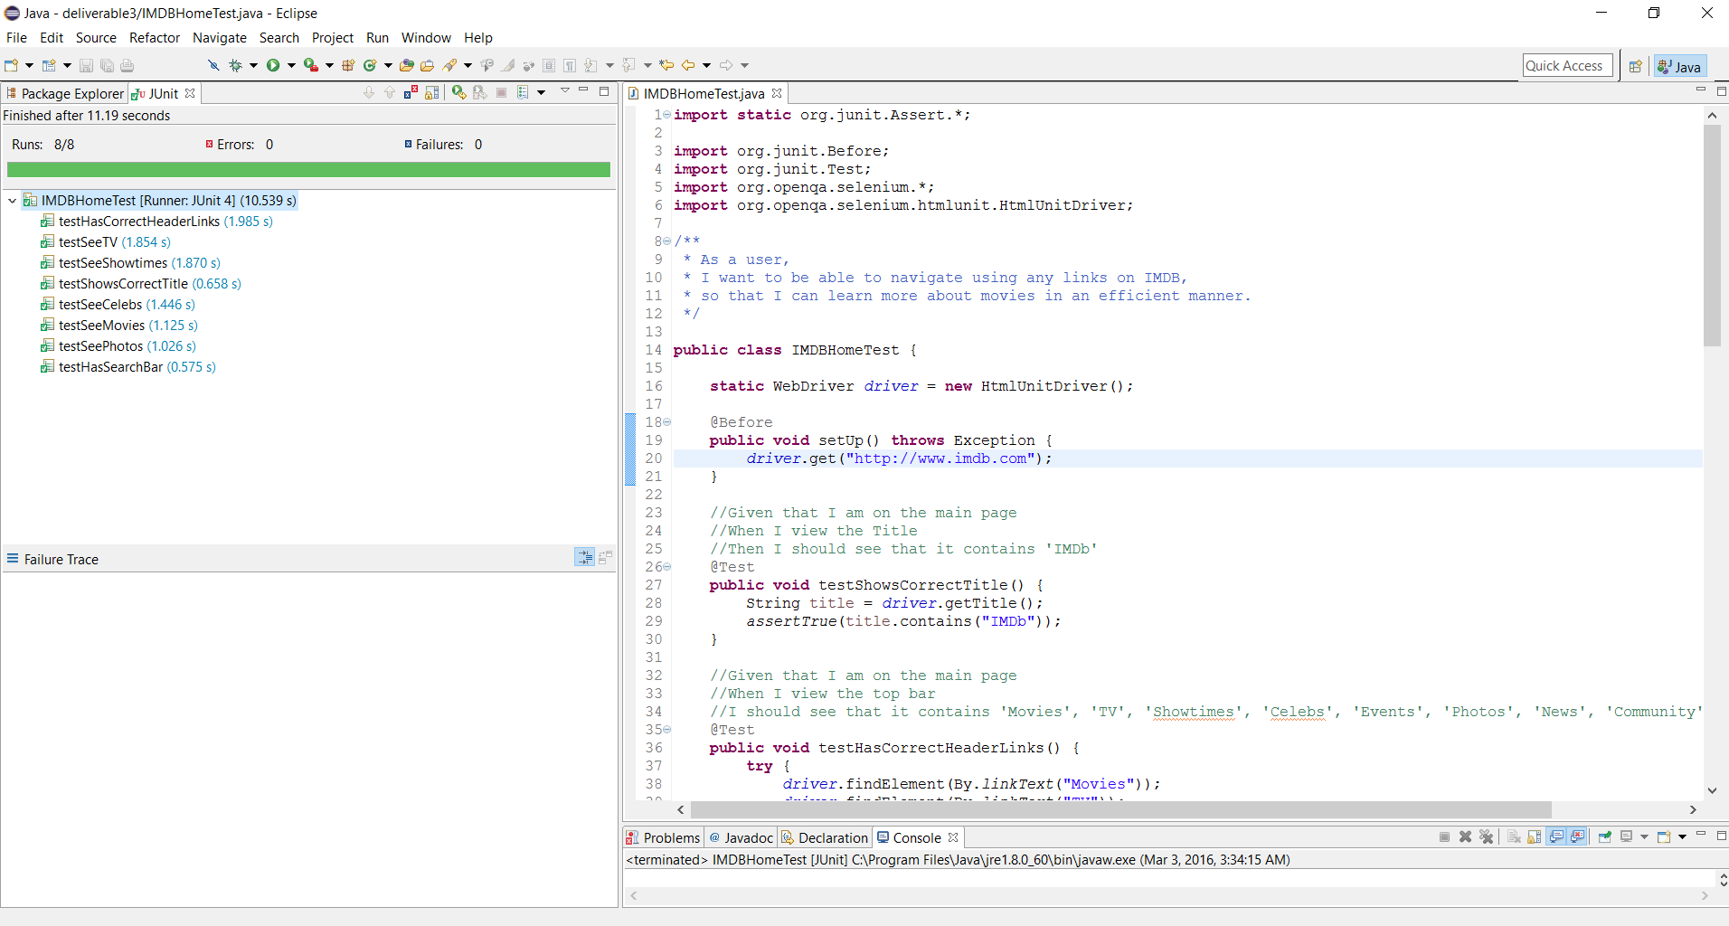

User Story 2:

As a user,

I want to be able to view full information about any specific movie,

So that I can read as much as possible about that specific movie.

Tested scenarios:

testShowsMovieTitle()

Given that I am on a specific movie’s page, when I look at the title, then I should see the name of the movie.

testGetShowtimes()

Given that I am on a movie’s page that I want to see, when I click get showtimes and tickets, I should see a list of theaters showing the movie.

testGetPlotSummary()

Given that I am on a movie’s page, when I click on plot summary, I should be brought to the plot summary page.

testGetCast()

Given that I am on a movie’s page, when I click to see the full cast of a movie, I should be brought to the full cast page.

testAdditionalMedia()

Given that I am on a movie’s page, when I look at the list of additional photos and videos, then I should have the ability to navigate to these separate pages specific to the movie.

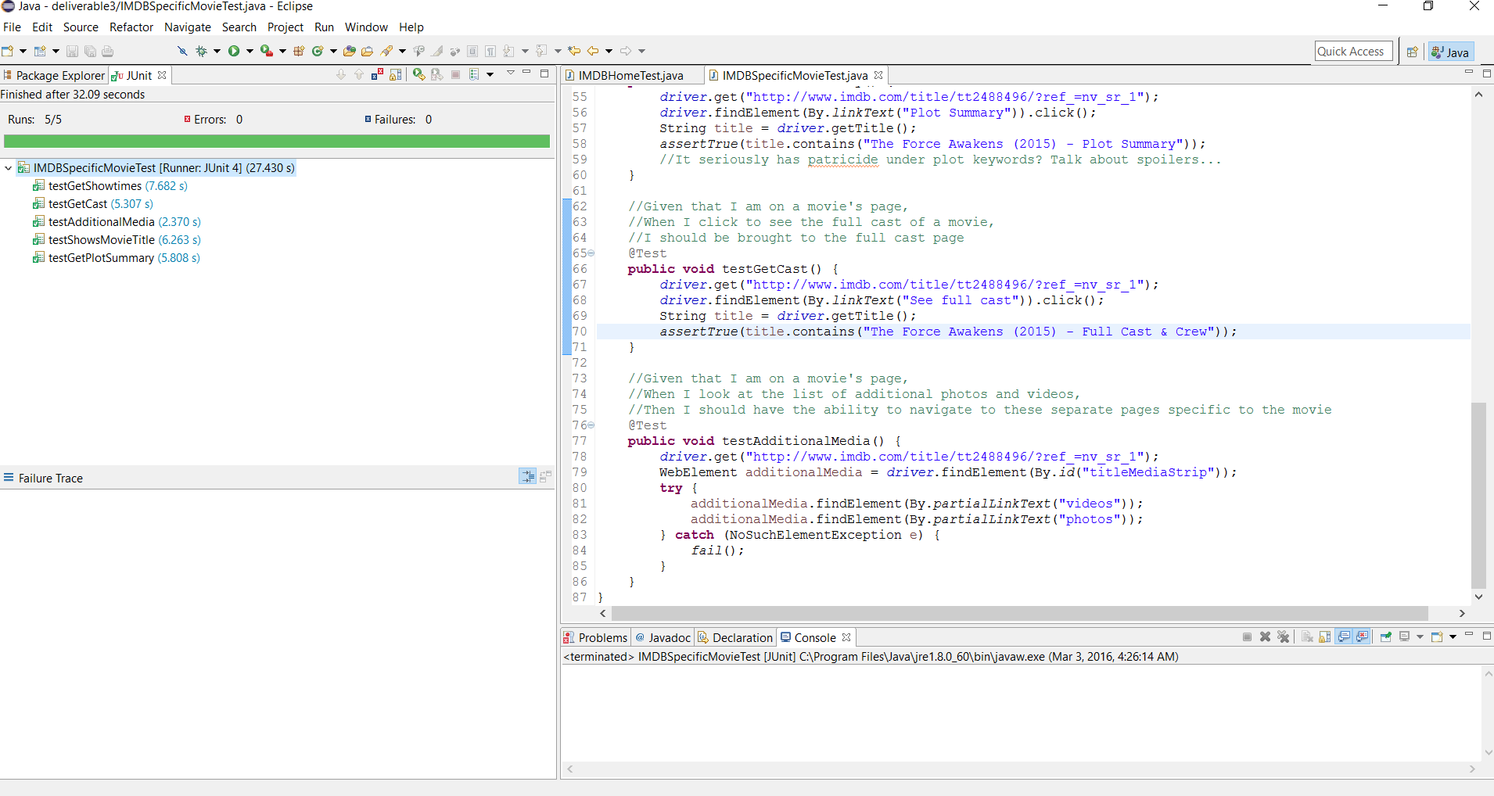

User Story 3:

As a user,

I want to be able to search effectively for a movie or TV show,

So that I can efficiently find what I am looking for.

Tested Scenarios:

testEmpty()

Given that I enter nothing in the search bar, when I attempt to search, then the page will inform me to enter a word or phrase to search on.

testNoResults()

Given that I am on the main page, when I attempt to search for a nonsense string of characters, then I will be told “No results found for “ the input I entered.

testAdvancedSearch()

Given that I am on the main page, when I click advanced search from the dropdown menu next to the search bar, then I will be redirected to a new page for the advanced search and subsequent options.

testDisplayingResults()

Given that I am on the main page, when I attempt to search for something, then the site will bring me to search results informing me of how many results were found for my search.

testExactTitle()

Given that I want to search for a specific movie or TV show, when I attempt to search for my input, then I should be given the option to filter results to exactly match my query.

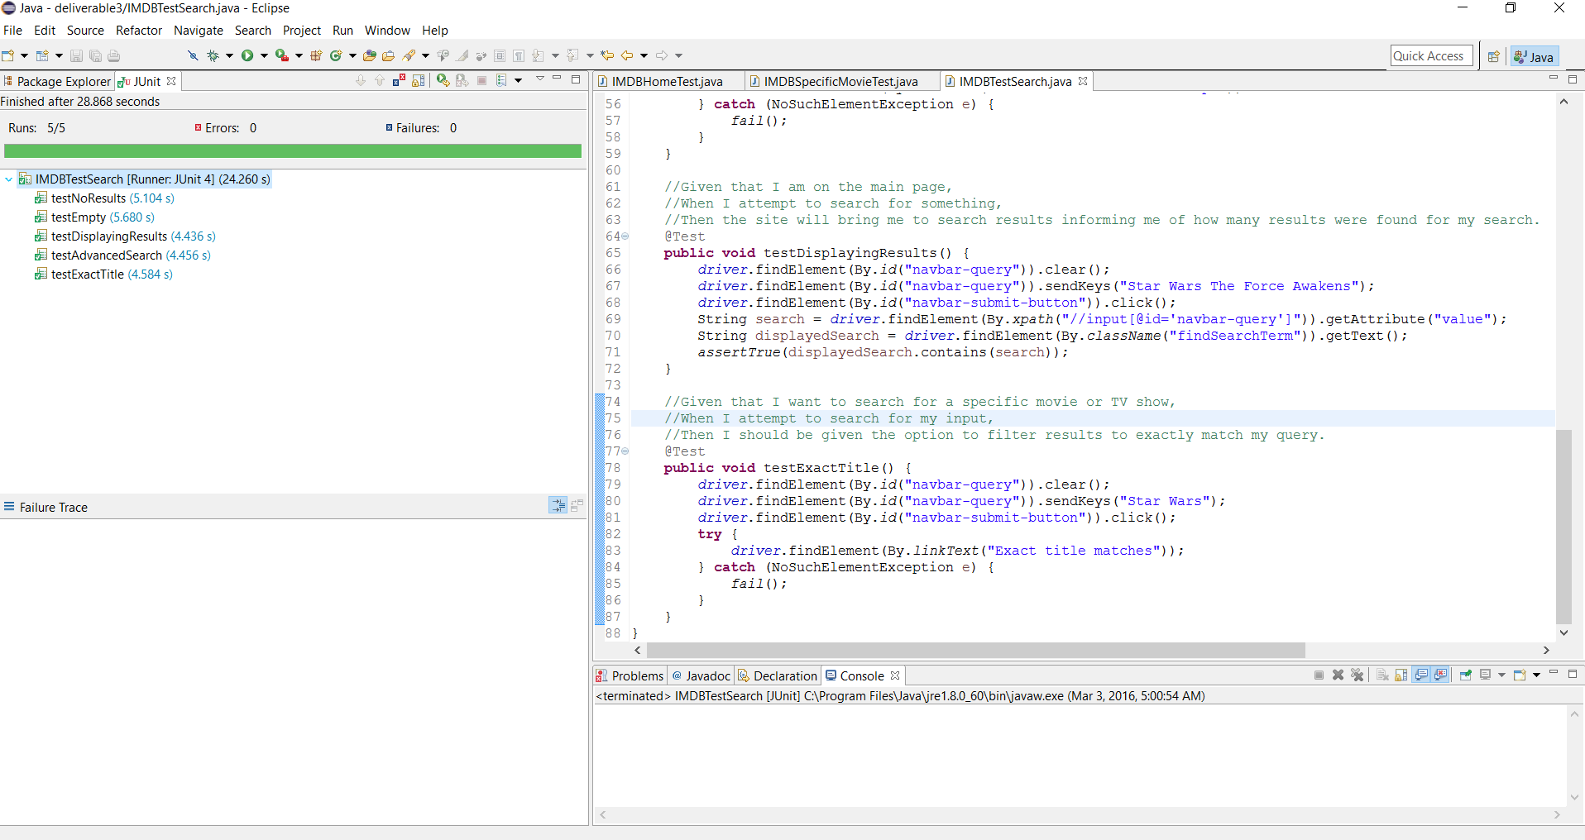

User Story 4:

As a user,

I want to be able to find and use a help page,

So that I can answer any questions that I may have about using the web site.

Tested Scenarios:

testFindHelp()

Given that I am on the main page, when I want to find help, then I should be able to click help.

testHelpLinksToHelp()

Given that I want to find help, when I click on the help link, then I should be redirected to the help page.

testHelpSectionsDisplayed()

Given that I clicked on help, when I see the help page, then I should see sections called “Top Frequently Asked Questions”, “Help Sections & FAQS”, and “Adding Data to IMDb”.

testHelpSearchBar()

Given that I am on the help page, when I want to look for specific help for my problem, then I should be able to search for it using a search bar.

testHelpScores()

Given that I am on the help page, when I search for my query and want to know how helpful something will be, then I should see a score informing me of how relevant the result is.

