Triad Polysemy Induction Tasks

Hugh Rabagliati

5 July 2016

#### Introduction

1. A key debate in developmental psych concerns the role of labels in how children learn and use categories.
2. Give v brief rundown of broader evidence eg waxman
3. But Perhaps the most well articulated debate is gelman sloutsky. Two line summary
4. The assumption behind these debates is that children use labels as these are robust category markers, eg for statistical or conceptual reasons.
5. But that's not quite right: Labels are not robust category markers, in that almost all labels are used to refer to multiple different categories. We call this phenomenon lexical flexibility
6. Here we investigate what the presence of lex flex means for the role of labels in how children reason about concepts and categories.

#### Gelman Sloutsky debate

1. Broader overview and history of gelman sloutsky debate. Perhaps end with final experiment in Sloutsky Fisher JECP, where they show that even phonological similarity between words can affect children's induction, and that the size of this effect is not mediated by similarity of the two concepts under comparison.
2. What do these theories say about lex flex? Gelman - labels are category markers. To the degree that a labels meaning can be discerned, there shouldn't be a problem, as reasoning is done based on kinds, not labels. Sloutsky - labels contribute to similarity. Overlapping labels should contribute to similarity judgments and thereby cause children to "hallucinate" that distinct kinds are the same.

#### Experiment 1

This vs chicken experiment. We compare label (this chicken, this chicken) with no label (this one, this one).

##### Adults

## Warning: Removed 1 rows containing missing values (geom_errorbar).

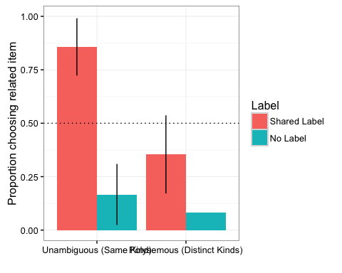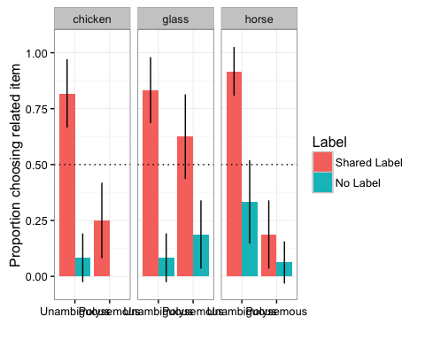

Label * Meaning mixed effects model, followed by t-tests against chance for each condition.

## Warning in checkConv(attr(opt, "derivs"), opt$par, ctrl = control  
## $checkConv, : Model failed to converge with max|grad| = 0.027305 (tol =  
## 0.001, component 1)

## Generalized linear mixed model fit by maximum likelihood (Laplace  
## Approximation) [glmerMod]  
## Family: binomial ( logit )  
## Formula: Choice ~ Label * Meaning + (1 + Label | ID) + (1 + Meaning |   
## question.number)  
## Data: Adult  
##   
## AIC BIC logLik deviance df.resid   
## 154.5 185.7 -67.3 134.5 157   
##   
## Scaled residuals:   
## Min 1Q Median 3Q Max   
## -2.3044 -0.3024 -0.1391 0.1809 2.3637   
##   
## Random effects:  
## Groups Name Variance Std.Dev. Corr   
## ID (Intercept) 0.7957 0.892   
## Label.L 3.2488 1.802 -0.30  
## question.number (Intercept) 1.2834 1.133   
## Meaning.L 5.4857 2.342 -0.72  
## Number of obs: 167, groups: ID, 14; question.number, 12  
##   
## Fixed effects:  
## Estimate Std. Error z value Pr(>|z|)   
## (Intercept) -0.983598 0.002712 -362.7 <2e-16 ***  
## Label.L -3.408398 0.002712 -1256.8 <2e-16 ***  
## Meaning.L -1.740383 0.002801 -621.4 <2e-16 ***  
## Label.L:Meaning.L 2.356227 0.002801 841.3 <2e-16 ***  
## ---  
## Signif. codes: 0 '***' 0.001 '**' 0.01 '*' 0.05 '.' 0.1 ' ' 1  
##   
## Correlation of Fixed Effects:  
## (Intr) Labl.L Mnng.L  
## Label.L 0.000   
## Meaning.L 0.000 0.000   
## Lbl.L:Mnn.L 0.000 0.000 0.000   
## convergence code: 0  
## Model failed to converge with max|grad| = 0.027305 (tol = 0.001, component 1)

##   
## One Sample t-test  
##   
## data: subset(Adult.Sum, Meaning == "Unambiguous (Same Kind)" & Label == "Shared Label")$Choice  
## t = 4.4907, df = 4, p-value = 0.0109  
## alternative hypothesis: true mean is not equal to 0.5  
## 95 percent confidence interval:  
## 0.6399709 1.0933625  
## sample estimates:  
## mean of x   
## 0.8666667

##   
## One Sample t-test  
##   
## data: subset(Adult.Sum, Meaning == "Unambiguous (Same Kind)" & Label == "No Label")$Choice  
## t = -4.4721, df = 5, p-value = 0.006566  
## alternative hypothesis: true mean is not equal to 0.5  
## 95 percent confidence interval:  
## -0.02493319 0.35826652  
## sample estimates:  
## mean of x   
## 0.1666667

##   
## One Sample t-test  
##   
## data: subset(Adult.Sum, Meaning == "Polysemous (Distinct Kinds)" & Label == "Shared Label")$Choice  
## t = -1.3129, df = 7, p-value = 0.2306  
## alternative hypothesis: true mean is not equal to 0.5  
## 95 percent confidence interval:  
## 0.09150396 0.61682938  
## sample estimates:  
## mean of x   
## 0.3541667

##   
## One Sample t-test  
##   
## data: subset(Adult.Sum, Meaning == "Polysemous (Distinct Kinds)" & Label == "No Label")$Choice  
## t = -9.3541, df = 7, p-value = 3.317e-05  
## alternative hypothesis: true mean is not equal to 0.5  
## 95 percent confidence interval:  
## -0.0219954 0.1886621  
## sample estimates:  
## mean of x   
## 0.08333333

##### Children

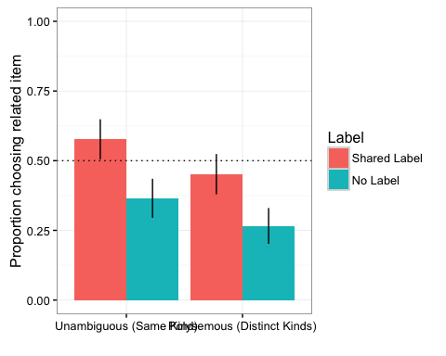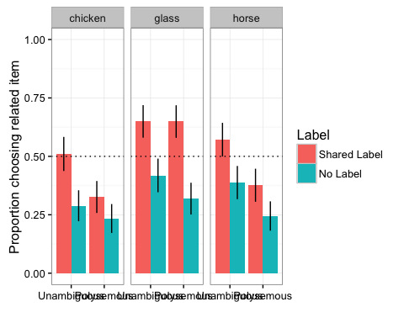

Label * Meaning mixed effects model, followed by t-tests against chance for each condition.

## Generalized linear mixed model fit by maximum likelihood (Laplace  
## Approximation) [glmerMod]  
## Family: binomial ( logit )  
## Formula:   
## Choice ~ Label * Meaning + (1 + Label | ID) + (1 | question.number)  
## Data: Child  
##   
## AIC BIC logLik deviance df.resid   
## 1464.8 1505.2 -724.4 1448.8 1139   
##   
## Scaled residuals:   
## Min 1Q Median 3Q Max   
## -1.8713 -0.7172 -0.4626 0.8564 2.2659   
##   
## Random effects:  
## Groups Name Variance Std.Dev. Corr  
## ID (Intercept) 0.2197 0.4688   
## Label.L 0.9090 0.9534 0.02  
## question.number (Intercept) 0.1173 0.3425   
## Number of obs: 1147, groups: ID, 95; question.number, 12  
##   
## Fixed effects:  
## Estimate Std. Error z value Pr(>|z|)   
## (Intercept) -0.42689 0.12985 -3.288 0.001011 **   
## Label.L -0.68400 0.13836 -4.944 7.67e-07 ***  
## Meaning.L -0.40265 0.11726 -3.434 0.000595 ***  
## Label.L:Meaning.L 0.05675 0.19333 0.294 0.769104   
## ---  
## Signif. codes: 0 '***' 0.001 '**' 0.01 '*' 0.05 '.' 0.1 ' ' 1  
##   
## Correlation of Fixed Effects:  
## (Intr) Labl.L Mnng.L  
## Label.L 0.051   
## Meaning.L 0.037 0.035   
## Lbl.L:Mnn.L 0.021 0.048 0.043

##   
## One Sample t-test  
##   
## data: subset(Child.Sum, Meaning == "Unambiguous (Same Kind)" & Label == "Shared Label")$Choice  
## t = 1.995, df = 48, p-value = 0.05174  
## alternative hypothesis: true mean is not equal to 0.5  
## 95 percent confidence interval:  
## 0.4993860 0.6570766  
## sample estimates:  
## mean of x   
## 0.5782313

##   
## One Sample t-test  
##   
## data: subset(Child.Sum, Meaning == "Unambiguous (Same Kind)" & Label == "No Label")$Choice  
## t = -3.6101, df = 48, p-value = 0.0007292  
## alternative hypothesis: true mean is not equal to 0.5  
## 95 percent confidence interval:  
## 0.2913484 0.4406244  
## sample estimates:  
## mean of x   
## 0.3659864

##   
## One Sample t-test  
##   
## data: subset(Child.Sum, Meaning == "Polysemous (Distinct Kinds)" & Label == "Shared Label")$Choice  
## t = -1.5838, df = 45, p-value = 0.1202  
## alternative hypothesis: true mean is not equal to 0.5  
## 95 percent confidence interval:  
## 0.3707760 0.5154559  
## sample estimates:  
## mean of x   
## 0.4431159

##   
## One Sample t-test  
##   
## data: subset(Child.Sum, Meaning == "Polysemous (Distinct Kinds)" & Label == "No Label")$Choice  
## t = -7.0353, df = 45, p-value = 9.034e-09  
## alternative hypothesis: true mean is not equal to 0.5  
## 95 percent confidence interval:  
## 0.2017307 0.3345011  
## sample estimates:  
## mean of x   
## 0.2681159

#### Discussion

Potentially evidence for Sloutsky account

But one surprising result: Adults go with label on lex flex condition. Why?

Pragmatic account? Why would they use distinct labels if they did not want us to use them?

### Experiment 2:

Always use labels, but vary if they are shared or synonyms. By sloutsky fisher JECP, should still get effect.

Here, we compare inferences from e.g., Chicken Animal to Duck, and either another Chicken Animal or Chicken Meat. We also vary whether the same label is used twice (both pictures called chicken) or whether a synonym is used (one called chicken, one called drumsticks).

### Adults

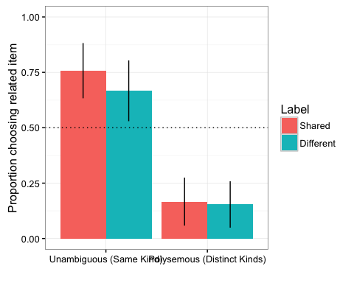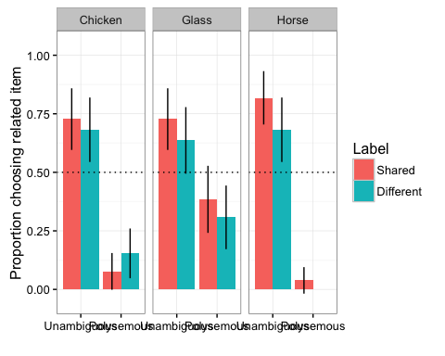

Label * Meaning mixed effects model, followed by t-tests against chance for each condition.

## Generalized linear mixed model fit by maximum likelihood (Laplace  
## Approximation) [glmerMod]  
## Family: binomial ( logit )  
## Formula:   
## UnrelatedChoice ~ WordType * LabelType + (1 + LabelType | SubjNo) +   
## (1 | ItemNo)  
## Data: Adult  
##   
## AIC BIC logLik deviance df.resid   
## 289.9 319.2 -137.0 273.9 280   
##   
## Scaled residuals:   
## Min 1Q Median 3Q Max   
## -3.8831 -0.4629 0.2711 0.4453 3.1935   
##   
## Random effects:  
## Groups Name Variance Std.Dev. Corr   
## SubjNo (Intercept) 1.4689 1.2120   
## LabelTypeDifferent 0.1927 0.4389 -1.00  
## ItemNo (Intercept) 0.4879 0.6985   
## Number of obs: 288, groups: SubjNo, 24; ItemNo, 12  
##   
## Fixed effects:  
## Estimate Std. Error z value Pr(>|z|)  
## (Intercept) -1.6063 0.5978 -2.687 0.00721  
## WordTypePolysemous 3.6682 0.8034 4.566 4.98e-06  
## LabelTypeDifferent 0.6668 0.5470 1.219 0.22278  
## WordTypePolysemous:LabelTypeDifferent -0.7464 0.8153 -0.915 0.35995  
##   
## (Intercept) **   
## WordTypePolysemous ***  
## LabelTypeDifferent   
## WordTypePolysemous:LabelTypeDifferent   
## ---  
## Signif. codes: 0 '***' 0.001 '**' 0.01 '*' 0.05 '.' 0.1 ' ' 1  
##   
## Correlation of Fixed Effects:  
## (Intr) WrdTyP LblTyD  
## WrdTypPlysm -0.729   
## LblTypDffrn -0.708 0.596   
## WrdTypP:LTD 0.544 -0.728 -0.770

##   
## One Sample t-test  
##   
## data: subset(Adult.Sum, WordType == "Non-Polysemous" & LabelType == "Same")$Choice  
## t = 2.8333, df = 10, p-value = 0.01775  
## alternative hypothesis: true mean is not equal to 0.5  
## 95 percent confidence interval:  
## 0.5550177 0.9601338  
## sample estimates:  
## mean of x   
## 0.7575758

##   
## One Sample t-test  
##   
## data: subset(Adult.Sum, WordType == "Non-Polysemous" & LabelType == "Different")$Choice  
## t = 2.2361, df = 10, p-value = 0.04933  
## alternative hypothesis: true mean is not equal to 0.5  
## 95 percent confidence interval:  
## 0.5005910 0.8327423  
## sample estimates:  
## mean of x   
## 0.6666667

##   
## One Sample t-test  
##   
## data: subset(Adult.Sum, WordType == "Polysemous" & LabelType == "Different")$Choice  
## t = -8.6841, df = 12, p-value = 1.608e-06  
## alternative hypothesis: true mean is not equal to 0.5  
## 95 percent confidence interval:  
## 0.06699738 0.24069493  
## sample estimates:  
## mean of x   
## 0.1538462

##   
## One Sample t-test  
##   
## data: subset(Adult.Sum, WordType == "Polysemous" & LabelType == "Same")$Choice  
## t = -7.2111, df = 12, p-value = 1.07e-05  
## alternative hypothesis: true mean is not equal to 0.5  
## 95 percent confidence interval:  
## 0.06595101 0.26738233  
## sample estimates:  
## mean of x   
## 0.1666667

### Children

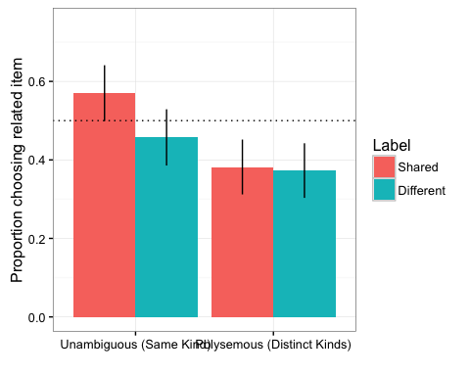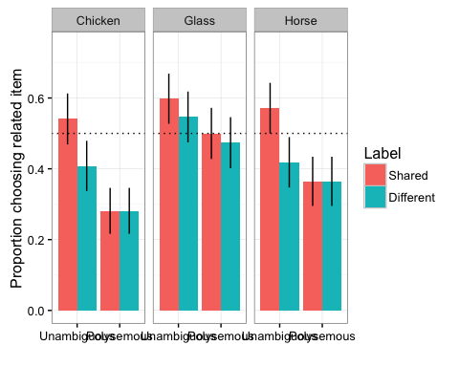

Label * Meaning mixed effects model, followed by t-tests against chance for each condition.

## Generalized linear mixed model fit by maximum likelihood (Laplace  
## Approximation) [glmerMod]  
## Family: binomial ( logit )  
## Formula: Choice ~ Meaning * LabelType + (1 + LabelType | SubjNo) + (1 +   
## Meaning | question.number)  
## Data: Child  
##   
## AIC BIC logLik deviance df.resid   
## 1520.1 1570.6 -750.0 1500.1 1151   
##   
## Scaled residuals:   
## Min 1Q Median 3Q Max   
## -1.8804 -0.7276 -0.4563 0.8167 2.1833   
##   
## Random effects:  
## Groups Name Variance Std.Dev. Corr   
## SubjNo (Intercept) 0.4282 0.6544   
## LabelTypeDifferent 0.4205 0.6485 -0.17  
## question.number (Intercept) 0.1638 0.4048   
## Meaning.L 0.1039 0.3224 0.67   
## Number of obs: 1161, groups: SubjNo, 97; question.number, 12  
##   
## Fixed effects:  
## Estimate Std. Error z value Pr(>|z|)   
## (Intercept) -0.2732 0.1501 -1.820 0.06875 .   
## Meaning.L -0.4905 0.1628 -3.013 0.00258 **  
## LabelTypeDifferent -0.1417 0.0939 -1.509 0.13138   
## Meaning.L:LabelTypeDifferent 0.1932 0.1330 1.453 0.14622   
## ---  
## Signif. codes: 0 '***' 0.001 '**' 0.01 '*' 0.05 '.' 0.1 ' ' 1  
##   
## Correlation of Fixed Effects:  
## (Intr) Mnng.L LblTyD  
## Meaning.L 0.316   
## LblTypDffrn -0.057 0.004   
## Mnng.L:LbTD 0.002 -0.085 0.031

##   
## One Sample t-test  
##   
## data: subset(Child.Sum, WordType == "Non-Polysemous" & LabelType == "Same")$Choice  
## t = 1.7633, df = 48, p-value = 0.08422  
## alternative hypothesis: true mean is not equal to 0.5  
## 95 percent confidence interval:  
## 0.4901714 0.6499646  
## sample estimates:  
## mean of x   
## 0.570068

##   
## One Sample t-test  
##   
## data: subset(Child.Sum, WordType == "Non-Polysemous" & LabelType == "Different")$Choice  
## t = -1.1923, df = 48, p-value = 0.239  
## alternative hypothesis: true mean is not equal to 0.5  
## 95 percent confidence interval:  
## 0.3830445 0.5298807  
## sample estimates:  
## mean of x   
## 0.4564626

##   
## One Sample t-test  
##   
## data: subset(Child.Sum, WordType == "Polysemous" & LabelType == "Different")$Choice  
## t = -3.3806, df = 47, p-value = 0.001464  
## alternative hypothesis: true mean is not equal to 0.5  
## 95 percent confidence interval:  
## 0.2961843 0.4482601  
## sample estimates:  
## mean of x   
## 0.3722222

##   
## One Sample t-test  
##   
## data: subset(Child.Sum, WordType == "Polysemous" & LabelType == "Same")$Choice  
## t = -3.0723, df = 47, p-value = 0.003528  
## alternative hypothesis: true mean is not equal to 0.5  
## 95 percent confidence interval:  
## 0.3046424 0.4592465  
## sample estimates:  
## mean of x   
## 0.3819444

## Comparison of Experiments 1 and 2

### Adults

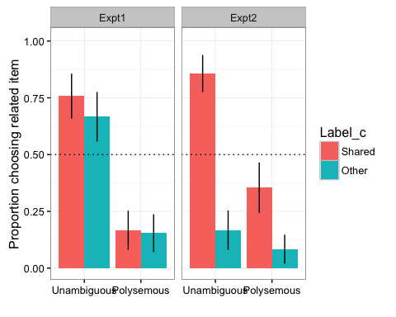 And data analysis

## Generalized linear mixed model fit by maximum likelihood (Laplace  
## Approximation) [glmerMod]  
## Family: binomial ( logit )  
## Formula: Choice ~ Meaning * Label_c * Expt + (1 | ID)  
## Data: Adult  
##   
## AIC BIC logLik deviance df.resid   
## 451.5 488.6 -216.8 433.5 446   
##   
## Scaled residuals:   
## Min 1Q Median 3Q Max   
## -2.9732 -0.4793 -0.3441 0.4488 4.5824   
##   
## Random effects:  
## Groups Name Variance Std.Dev.  
## ID (Intercept) 0.5409 0.7354   
## Number of obs: 455, groups: ID, 38  
##   
## Fixed effects:  
## Estimate  
## (Intercept) -0.5725  
## MeaningPolysemous (Distinct Kinds) -1.1484  
## Label_cOther -0.7776  
## ExptExpt2 -0.2051  
## MeaningPolysemous (Distinct Kinds):Label_cOther 0.2641  
## MeaningPolysemous (Distinct Kinds):ExptExpt2 0.2812  
## Label_cOther:ExptExpt2 -0.6234  
## MeaningPolysemous (Distinct Kinds):Label_cOther:ExptExpt2 0.1600  
## Std. Error  
## (Intercept) 0.1870  
## MeaningPolysemous (Distinct Kinds) 0.1904  
## Label_cOther 0.1402  
## ExptExpt2 0.1872  
## MeaningPolysemous (Distinct Kinds):Label_cOther 0.1387  
## MeaningPolysemous (Distinct Kinds):ExptExpt2 0.1870  
## Label_cOther:ExptExpt2 0.1393  
## MeaningPolysemous (Distinct Kinds):Label_cOther:ExptExpt2 0.1386  
## z value Pr(>|z|)  
## (Intercept) -3.061 0.00221  
## MeaningPolysemous (Distinct Kinds) -6.033 1.61e-09  
## Label_cOther -5.546 2.92e-08  
## ExptExpt2 -1.096 0.27309  
## MeaningPolysemous (Distinct Kinds):Label_cOther 1.905 0.05684  
## MeaningPolysemous (Distinct Kinds):ExptExpt2 1.504 0.13265  
## Label_cOther:ExptExpt2 -4.474 7.66e-06  
## MeaningPolysemous (Distinct Kinds):Label_cOther:ExptExpt2 1.155 0.24822  
##   
## (Intercept) **   
## MeaningPolysemous (Distinct Kinds) ***  
## Label_cOther ***  
## ExptExpt2   
## MeaningPolysemous (Distinct Kinds):Label_cOther .   
## MeaningPolysemous (Distinct Kinds):ExptExpt2   
## Label_cOther:ExptExpt2 ***  
## MeaningPolysemous (Distinct Kinds):Label_cOther:ExptExpt2   
## ---  
## Signif. codes: 0 '***' 0.001 '**' 0.01 '*' 0.05 '.' 0.1 ' ' 1  
##   
## Correlation of Fixed Effects:  
## (Intr) MnP(DK) Lbl_cO ExptE2 MnP(DK):L_O MP(DK):E L_O:EE  
## MnngP(DKnd) -0.054   
## Label_cOthr 0.095 0.173   
## ExptExpt2 0.332 -0.048 0.109   
## MnP(DK):L_O 0.145 0.076 -0.056 0.118   
## MnP(DK):EE2 -0.068 0.309 0.110 -0.073 0.101   
## Lbl_cOt:EE2 0.105 0.139 0.411 0.094 -0.091 0.140   
## MP(DK):L_O: 0.121 0.097 -0.086 0.148 0.401 0.086 -0.050

### Children

Graph the two experiments side-by-side. Other = Synonym in Expt 1, No Label in Expt 2 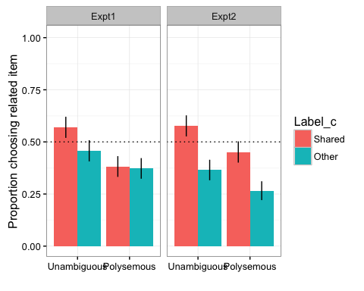

And data analysis

## Warning in checkConv(attr(opt, "derivs"), opt$par, ctrl = control  
## $checkConv, : Model failed to converge with max|grad| = 0.00576668 (tol =  
## 0.001, component 1)

## Generalized linear mixed model fit by maximum likelihood (Laplace  
## Approximation) [glmerMod]  
## Family: binomial ( logit )  
## Formula: Choice ~ Meaning * Label_c * Expt + (1 + Label_c | ID) + (1 +   
## Meaning | QuNum)  
## Data: Child  
##   
## AIC BIC logLik deviance df.resid   
## 2961.3 3041.7 -1466.6 2933.3 2294   
##   
## Scaled residuals:   
## Min 1Q Median 3Q Max   
## -2.0105 -0.7298 -0.4559 0.8280 2.4445   
##   
## Random effects:  
## Groups Name Variance Std.Dev. Corr   
## ID (Intercept) 0.32674 0.5716   
## Label_cOther 0.44133 0.6643 -0.09  
## QuNum (Intercept) 0.15473 0.3934   
## MeaningPolysemous (Distinct Kinds) 0.04376 0.2092 0.51   
## Number of obs: 2308, groups: ID, 192; QuNum, 12  
##   
## Fixed effects:  
## Estimate  
## (Intercept) -0.35411  
## MeaningPolysemous (Distinct Kinds) -0.31911  
## Label_cOther -0.32058  
## ExptExpt2 -0.08422  
## MeaningPolysemous (Distinct Kinds):Label_cOther 0.07873  
## MeaningPolysemous (Distinct Kinds):ExptExpt2 0.01976  
## Label_cOther:ExptExpt2 -0.17209  
## MeaningPolysemous (Distinct Kinds):Label_cOther:ExptExpt2 -0.05489  
## Std. Error  
## (Intercept) 0.13005  
## MeaningPolysemous (Distinct Kinds) 0.08736  
## Label_cOther 0.06793  
## ExptExpt2 0.06283  
## MeaningPolysemous (Distinct Kinds):Label_cOther 0.06767  
## MeaningPolysemous (Distinct Kinds):ExptExpt2 0.06275  
## Label_cOther:ExptExpt2 0.06751  
## MeaningPolysemous (Distinct Kinds):Label_cOther:ExptExpt2 0.06742  
## z value Pr(>|z|)  
## (Intercept) -2.723 0.00647  
## MeaningPolysemous (Distinct Kinds) -3.653 0.00026  
## Label_cOther -4.719 2.37e-06  
## ExptExpt2 -1.340 0.18010  
## MeaningPolysemous (Distinct Kinds):Label_cOther 1.163 0.24463  
## MeaningPolysemous (Distinct Kinds):ExptExpt2 0.315 0.75289  
## Label_cOther:ExptExpt2 -2.549 0.01080  
## MeaningPolysemous (Distinct Kinds):Label_cOther:ExptExpt2 -0.814 0.41554  
##   
## (Intercept) **   
## MeaningPolysemous (Distinct Kinds) ***  
## Label_cOther ***  
## ExptExpt2   
## MeaningPolysemous (Distinct Kinds):Label_cOther   
## MeaningPolysemous (Distinct Kinds):ExptExpt2   
## Label_cOther:ExptExpt2 *   
## MeaningPolysemous (Distinct Kinds):Label_cOther:ExptExpt2   
## ---  
## Signif. codes: 0 '***' 0.001 '**' 0.01 '*' 0.05 '.' 0.1 ' ' 1  
##   
## Correlation of Fixed Effects:  
## (Intr) MnP(DK) Lbl_cO ExptE2 MnP(DK):L_O MP(DK):E L_O:EE  
## MnngP(DKnd) 0.323   
## Label_cOthr -0.006 0.014   
## ExptExpt2 0.014 0.010 0.024   
## MnP(DK):L_O 0.009 -0.024 0.040 0.012   
## MnP(DK):EE2 0.006 0.016 0.009 0.040 0.019   
## Lbl_cOt:EE2 0.012 0.010 0.026 -0.028 0.015 0.013   
## MP(DK):L_O: 0.005 0.014 0.014 0.013 0.019 -0.030 0.037  
## convergence code: 0  
## Model failed to converge with max|grad| = 0.00576668 (tol = 0.001, component 1)

We can also look at how this varies by age 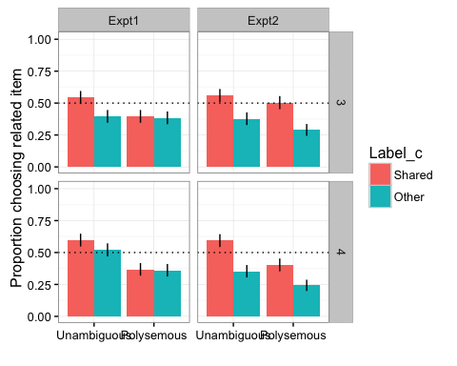 And analysis (note that model doesn't converge with random intercepts for subjects, just items).

## Generalized linear mixed model fit by maximum likelihood (Laplace  
## Approximation) [glmerMod]  
## Family: binomial ( logit )  
## Formula: Choice ~ Meaning * Label_c * Age * Expt + (1 | QuNum)  
## Data: Child  
##   
## AIC BIC logLik deviance df.resid   
## 3048.8 3146.5 -1507.4 3014.8 2291   
##   
## Scaled residuals:   
## Min 1Q Median 3Q Max   
## -1.55 -0.83 -0.60 1.01 2.36   
##   
## Random effects:  
## Groups Name Variance Std.Dev.  
## QuNum (Intercept) 0.11 0.33   
## Number of obs: 2308, groups: QuNum, 12  
##   
## Fixed effects:  
## Estimate  
## (Intercept) -0.2996  
## MeaningPolysemous (Distinct Kinds) -0.2674  
## Label_cOther -0.2803  
## Age4 -0.0069  
## ExptExpt2 -0.0730  
## MeaningPolysemous (Distinct Kinds):Label_cOther 0.0608  
## MeaningPolysemous (Distinct Kinds):Age4 -0.1035  
## Label_cOther:Age4 0.0135  
## MeaningPolysemous (Distinct Kinds):ExptExpt2 0.0198  
## Label_cOther:ExptExpt2 -0.1509  
## Age4:ExptExpt2 -0.0709  
## MeaningPolysemous (Distinct Kinds):Label_cOther:Age4 0.0116  
## MeaningPolysemous (Distinct Kinds):Label_cOther:ExptExpt2 -0.0501  
## MeaningPolysemous (Distinct Kinds):Age4:ExptExpt2 0.0171  
## Label_cOther:Age4:ExptExpt2 -0.0233  
## MeaningPolysemous (Distinct Kinds):Label_cOther:Age4:ExptExpt2 0.0390  
## Std. Error  
## (Intercept) 0.1054  
## MeaningPolysemous (Distinct Kinds) 0.0437  
## Label_cOther 0.0438  
## Age4 0.0437  
## ExptExpt2 0.0437  
## MeaningPolysemous (Distinct Kinds):Label_cOther 0.0437  
## MeaningPolysemous (Distinct Kinds):Age4 0.0437  
## Label_cOther:Age4 0.0437  
## MeaningPolysemous (Distinct Kinds):ExptExpt2 0.0437  
## Label_cOther:ExptExpt2 0.0437  
## Age4:ExptExpt2 0.0437  
## MeaningPolysemous (Distinct Kinds):Label_cOther:Age4 0.0438  
## MeaningPolysemous (Distinct Kinds):Label_cOther:ExptExpt2 0.0437  
## MeaningPolysemous (Distinct Kinds):Age4:ExptExpt2 0.0437  
## Label_cOther:Age4:ExptExpt2 0.0437  
## MeaningPolysemous (Distinct Kinds):Label_cOther:Age4:ExptExpt2 0.0438  
## z value  
## (Intercept) -2.8  
## MeaningPolysemous (Distinct Kinds) -6.1  
## Label_cOther -6.4  
## Age4 -0.2  
## ExptExpt2 -1.7  
## MeaningPolysemous (Distinct Kinds):Label_cOther 1.4  
## MeaningPolysemous (Distinct Kinds):Age4 -2.4  
## Label_cOther:Age4 0.3  
## MeaningPolysemous (Distinct Kinds):ExptExpt2 0.5  
## Label_cOther:ExptExpt2 -3.4  
## Age4:ExptExpt2 -1.6  
## MeaningPolysemous (Distinct Kinds):Label_cOther:Age4 0.3  
## MeaningPolysemous (Distinct Kinds):Label_cOther:ExptExpt2 -1.1  
## MeaningPolysemous (Distinct Kinds):Age4:ExptExpt2 0.4  
## Label_cOther:Age4:ExptExpt2 -0.5  
## MeaningPolysemous (Distinct Kinds):Label_cOther:Age4:ExptExpt2 0.9  
## Pr(>|z|)  
## (Intercept) 0.004  
## MeaningPolysemous (Distinct Kinds) 1e-09  
## Label_cOther 2e-10  
## Age4 0.874  
## ExptExpt2 0.095  
## MeaningPolysemous (Distinct Kinds):Label_cOther 0.164  
## MeaningPolysemous (Distinct Kinds):Age4 0.018  
## Label_cOther:Age4 0.757  
## MeaningPolysemous (Distinct Kinds):ExptExpt2 0.651  
## Label_cOther:ExptExpt2 6e-04  
## Age4:ExptExpt2 0.105  
## MeaningPolysemous (Distinct Kinds):Label_cOther:Age4 0.791  
## MeaningPolysemous (Distinct Kinds):Label_cOther:ExptExpt2 0.251  
## MeaningPolysemous (Distinct Kinds):Age4:ExptExpt2 0.695  
## Label_cOther:Age4:ExptExpt2 0.593  
## MeaningPolysemous (Distinct Kinds):Label_cOther:Age4:ExptExpt2 0.374  
##   
## (Intercept) **   
## MeaningPolysemous (Distinct Kinds) ***  
## Label_cOther ***  
## Age4   
## ExptExpt2 .   
## MeaningPolysemous (Distinct Kinds):Label_cOther   
## MeaningPolysemous (Distinct Kinds):Age4 *   
## Label_cOther:Age4   
## MeaningPolysemous (Distinct Kinds):ExptExpt2   
## Label_cOther:ExptExpt2 ***  
## Age4:ExptExpt2   
## MeaningPolysemous (Distinct Kinds):Label_cOther:Age4   
## MeaningPolysemous (Distinct Kinds):Label_cOther:ExptExpt2   
## MeaningPolysemous (Distinct Kinds):Age4:ExptExpt2   
## Label_cOther:Age4:ExptExpt2   
## MeaningPolysemous (Distinct Kinds):Label_cOther:Age4:ExptExpt2   
## ---  
## Signif. codes: 0 '***' 0.001 '**' 0.01 '*' 0.05 '.' 0.1 ' ' 1

##   
## Correlation matrix not shown by default, as p = 16 > 12.  
## Use print(...., correlation=TRUE) or  
## vcov(....) if you need it

#### Discussion

No robust effect of synonyms, and effect was signif different between two experiments.

### Gen discussion

What can lex flex tell us about role of labels in induction?

What can induction tell us about children's early word meanings?