Lab Topic 2 Block 1 Machine Learning

Hugo Knape & Zahra Jalil Pour & Niklas Larsson

11/12/2020

# State of contribution

### Assignment1: Zahra Jalilpour

### Assignment2: Niklas Larsson

### Assignment3: Hugo Knap

## # Assignment 1.

title: “Untitled” author: “z” date: ‘2020-11-20’ output: html_document: default pdf_document: default latex_engine: xelatex —

# Assignment 1: LDA and logistic regression

In LDA , features in each class has multivariate normal distribution and common variance $ $. The covariance matrix is the same in all class $Cov(X)=Σ$. Random variable $X$ is a vector $X=(X_{1},X_{2},...,X_{p})$ Mean of each class is :



Perior probabity or $  pi_k$ is equal to:

$${\hat{π}}_{k}=\frac{\{i ; y_{i}=k\}}{n}$$

$X$ follows multivariate Gaussian distribution.

## Task 1

### Make a scatterplot

ggplot(iris, aes(x=Sepal.Width , y= Sepal.Length, shape= Species, color=Species)) + geom_point() +stat_ellipse()

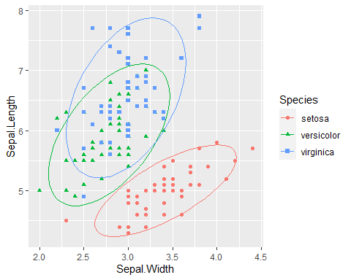 Here we can see that we have more than two classes. Then LDA is the preferred linear classification technique, and LDA is a simple model for preparation and application. Here we can not use logistic regression, because we have more than two classes. Although we can use multi logistic regression but is rarely used for this purpose. LDA is a stable model when the classes are separated well. Also LDA generally is used for small data sets.

## Task 2

### 2-a

Compute mean, covariance matrix and prior probabilities for each class:

## [1] "Covariance matrix in Setosa class"

## Sepal.Length Sepal.Width  
## Sepal.Length 0.12424898 0.09921633  
## Sepal.Width 0.09921633 0.14368980

## [1] "Covariance matrix in Versicolor class"

## Sepal.Length Sepal.Width  
## Sepal.Length 0.26643265 0.08518367  
## Sepal.Width 0.08518367 0.09846939

## [1] "Covariance matrix in Virginica class"

## Sepal.Length Sepal.Width  
## Sepal.Length 0.40434286 0.09376327  
## Sepal.Width 0.09376327 0.10400408

## [1] "mean for each class"

## setosa versicolor virginica  
## Sepal.Length 5.006 5.936 6.588  
## Sepal.Width 3.428 2.770 2.974

## [1] "prior probability for each class: "

## [1] 0.3333333

## [1] 0.3333333

## [1] 0.3333333

### 2-b

pooled covariance matrix:

## [1] "degree of freedom: "

##   
## setosa versicolor virginica   
## 49 49 49

## [1] "pooled covariance matrix: "

## Sepal.Length Sepal.Width  
## Sepal.Length 0.26500816 0.09272109  
## Sepal.Width 0.09272109 0.11538776

### 2-c

probabilistic model: The probability of $p(X=x|Y=k)$ is given by:

$$f_{k}(x)=\frac{1}{(2π)^{p/2}|Σ|^{1/2}} exp\left(−\frac{1}{2}(x−μ_{k})^{T}Σ^{−1}(x−μ_{k})\right)$$

By considering prior probability is $P(Y=k)=π_{k}$, and taking logarithm , we will find Linear discriminant function or Linear score function:

$$δ_{k}(x)=x^{T}Σ^{−1}μ_{k}−\frac{1}{2}μ_{k}^{T}Σ^{−1}μ_{k}+log(π_{k})$$

$$\hat{G}(x)=\text{ arg }\max_{k}δ_{k}(x)$$

The decision boundary is the set of points in which two classes are equally probable:

$$δ_{k}(x)=δ_{l}(x)$$

We consider $ _k,  _k,  $ by MLE as below:

$$\hat{Σ}=\frac{1}{m}\sum_{i=1}^{m}{(}x^{(i)}−μ_{y^{(i)}})(x^{(i)}−μ_{y^{(i)}})^{T}$$

$${\hat{π}}_{k}=\frac{\{i ; y_{i}=k\}}{n}$$

### 2_d

Compute discriminant functions for each class:

## [1] "Discriminant matrix for three different species"

## setosa versicolor virginica  
## [1,] 65.69175 58.09672 54.93699  
## [2,] 53.22218 50.02352 46.49679  
## [3,] 54.90090 47.79962 43.70231  
## [4,] 51.69789 45.01644 40.69200  
## [5,] 66.53111 56.98477 53.53975  
## [6,] 77.32196 67.28187 64.77443  
## [7,] 57.76144 47.52328 43.11160  
## [8,] 62.48874 55.31354 51.92669  
## [9,] 45.29187 39.45008 34.67140  
## [10,] 55.24337 50.85914 47.30332  
## [11,] 73.27960 65.61065 63.16137  
## [12,] 60.12509 51.41841 47.51914  
## [13,] 52.04036 48.07596 44.29302  
## [14,] 46.13122 38.33812 33.27416  
## [15,] 84.07045 75.90775 74.39605  
## [16,] 90.97336 77.30264 75.41841  
## [17,] 77.32196 67.28187 64.77443  
## [18,] 65.69175 58.09672 54.93699  
## [19,] 78.84626 72.28896 70.57921  
## [20,] 71.75530 60.60356 57.35658  
## [21,] 67.21605 63.10381 60.74177  
## [22,] 69.73412 59.76795 56.55005  
## [23,] 61.80380 49.19450 44.72466  
## [24,] 61.64939 56.42550 53.32393  
## [25,] 60.12509 51.41841 47.51914  
## [26,] 54.40401 51.97109 48.70056  
## [27,] 62.48874 55.31354 51.92669  
## [28,] 66.87358 60.04429 57.14076  
## [29,] 64.85240 59.20868 56.33423  
## [30,] 54.90090 47.79962 43.70231  
## [31,] 54.06154 48.91157 45.09955  
## [32,] 67.21605 63.10381 60.74177  
## [33,] 79.00068 65.05797 61.97995  
## [34,] 84.56734 71.73628 69.39780  
## [35,] 55.24337 50.85914 47.30332  
## [36,] 58.44638 53.64232 50.31362  
## [37,] 70.41906 65.88699 63.75208  
## [38,] 65.34928 55.03720 51.33598  
## [39,] 47.31305 40.28569 35.47793  
## [40,] 63.67057 57.26111 54.13046  
## [41,] 64.50993 56.14916 52.73322  
## [42,] 34.34660 36.38397 32.03598  
## [43,] 51.35542 41.95692 37.09099  
## [44,] 64.50993 56.14916 52.73322  
## [45,] 71.75530 60.60356 57.35658  
## [46,] 52.04036 48.07596 44.29302  
## [47,] 71.75530 60.60356 57.35658  
## [48,] 53.71907 45.85205 41.49854  
## [49,] 72.09777 63.66308 60.95760  
## [50,] 60.46756 54.47793 51.12015  
## [51,] 82.08291 92.59365 94.38906  
## [52,] 74.99195 80.90825 81.16643  
## [53,] 78.87990 89.81047 91.37875  
## [54,] 46.16487 55.85963 54.07370  
## [55,] 68.08905 79.51336 80.14407  
## [56,] 58.63443 63.93283 62.51390  
## [57,] 75.83131 79.79630 79.76919  
## [58,] 41.09509 45.00985 41.65760  
## [59,] 71.29206 82.29654 83.15437  
## [60,] 50.70412 53.35939 50.68851  
## [61,] 34.19218 43.61496 40.63524  
## [62,] 65.04045 69.49919 68.53450  
## [63,] 50.05282 64.76185 64.28602  
## [64,] 65.38292 72.55871 72.13552  
## [65,] 59.47379 62.82088 61.11666  
## [66,] 76.51625 85.91534 86.97121  
## [67,] 61.49497 63.65649 61.92319  
## [68,] 57.79508 65.04479 63.91114  
## [69,] 52.41647 68.65699 68.69357  
## [70,] 51.38906 59.47843 57.89053  
## [71,] 69.08282 71.17042 70.14757  
## [72,] 63.36174 71.72310 71.32898  
## [73,] 59.66185 73.11139 73.31693  
## [74,] 63.36174 71.72310 71.32898  
## [75,] 68.92840 78.40141 78.74683  
## [76,] 73.31324 83.13216 83.96091  
## [77,] 71.63453 85.35606 86.75539  
## [78,] 74.49507 85.07972 86.16468  
## [79,] 64.20110 70.61114 69.93174  
## [80,] 54.59207 62.26161 60.90083  
## [81,] 48.18605 56.69525 54.88023  
## [82,] 48.18605 56.69525 54.88023  
## [83,] 57.79508 65.04479 63.91114  
## [84,] 60.15873 68.93992 68.31868  
## [85,] 59.13132 59.76136 57.51565  
## [86,] 74.30701 74.78921 73.96440  
## [87,] 76.51625 85.91534 86.97121  
## [88,] 55.61948 71.44017 71.70387  
## [89,] 61.49497 63.65649 61.92319  
## [90,] 50.20723 57.53086 55.68676  
## [91,] 52.22841 58.36647 56.49329  
## [92,] 67.40411 73.39432 72.94205  
## [93,] 55.77389 64.20917 63.10461  
## [94,] 40.25573 46.12180 43.05484  
## [95,] 55.43142 61.14965 59.50359  
## [96,] 62.67680 65.60406 64.12696  
## [97,] 60.65562 64.76844 63.32043  
## [98,] 66.56475 74.50628 74.33929  
## [99,] 45.47992 49.74059 46.87167  
## [100,] 58.63443 63.93283 62.51390  
## [101,] 75.83131 79.79630 79.76919  
## [102,] 57.79508 65.04479 63.91114  
## [103,] 79.22237 92.86999 94.97977  
## [104,] 67.74658 76.45384 76.54306  
## [105,] 72.13141 81.18459 81.75713  
## [106,] 85.13151 102.60782 105.99862  
## [107,] 43.11627 45.84546 42.46413  
## [108,] 79.56484 95.92951 98.58078  
## [109,] 64.38915 80.90166 82.13202  
## [110,] 92.53130 99.83123 102.02273  
## [111,] 76.17378 82.85582 83.37020  
## [112,] 64.88604 76.73019 77.13377  
## [113,] 75.67689 87.02729 88.36845  
## [114,] 52.57089 61.42599 60.09430  
## [115,] 59.81626 65.88040 64.71767  
## [116,] 74.99195 80.90825 81.16643  
## [117,] 72.13141 81.18459 81.75713  
## [118,] 102.48280 111.24029 114.65465  
## [119,] 78.22860 101.21294 104.97627  
## [120,] 50.05282 64.76185 64.28602  
## [121,] 80.90109 90.64608 92.18529  
## [122,] 57.45261 61.98526 60.31013  
## [123,] 82.27097 102.88416 106.58933  
## [124,] 63.70421 74.78262 74.93000  
## [125,] 80.55861 87.58656 88.58427  
## [126,] 84.44657 96.48878 98.79660  
## [127,] 64.54357 73.67066 73.53276  
## [128,] 67.40411 73.39432 72.94205  
## [129,] 66.90722 77.56580 77.94030  
## [130,] 80.40420 94.81756 97.18354  
## [131,] 78.72549 97.04146 99.97802  
## [132,] 104.84645 115.13543 119.06219  
## [133,] 66.90722 77.56580 77.94030  
## [134,] 65.72539 75.61823 75.73653  
## [135,] 59.31938 70.05187 69.71592  
## [136,] 86.31333 104.55539 108.20240  
## [137,] 77.85249 80.63191 80.57572  
## [138,] 72.97077 80.07264 80.35989  
## [139,] 66.22228 71.44676 70.73828  
## [140,] 78.87990 89.81047 91.37875  
## [141,] 76.51625 85.91534 86.97121  
## [142,] 78.87990 89.81047 91.37875  
## [143,] 57.79508 65.04479 63.91114  
## [144,] 79.71926 88.69852 89.98151  
## [145,] 80.55861 87.58656 88.58427  
## [146,] 74.49507 85.07972 86.16468  
## [147,] 59.66185 73.11139 73.31693  
## [148,] 72.13141 81.18459 81.75713  
## [149,] 76.67066 78.68434 78.37195  
## [150,] 65.04045 69.49919 68.53450

### 2-e

Compute equation of decision boundaries between classes:

## [1] decision boundary for Setosa ~ Versicolor  
## [2]   
## [3] W1 :

## [,1]  
## Sepal.Length -7.657399  
## Sepal.Width 11.855698

## [1] "W0 : 5.15282159558004"

## [1] decision boundary for Versicolor ~ Verginica  
## [2]   
## [3] W1 :

## [,1]  
## Sepal.Length -2.5620509  
## Sepal.Width 0.2908121

## [1] "W0 : 15.2083506778689"

## [1] decision boundary for Verginica ~ Setosa  
## [2]   
## [3] W1 :

## [,1]  
## Sepal.Length 10.21945  
## Sepal.Width -12.14651

## [1] "W0 : -20.3611722734489"

### 3-a

predict function:

library(ggplot2)  
D <- cbind(d1,d2,d3)  
  
for(i in row(D)){  
 predict <-apply(X = D[,], MARGIN = 1, FUN = which.max)  
}  
new_df <- iris  
new_df <- cbind(new_df, predict)  
new_df$predict[new_df$predict == "1"] <- "setosa"  
new_df$predict[new_df$predict == "2"] <- "versicolor"  
new_df$predict[new_df$predict == "3"] <- "virginica"  
ggplot(new_df, aes(x=Sepal.Length , y= Sepal.Width, shape= predict, color=predict)) + geom_point()+stat_ellipse()

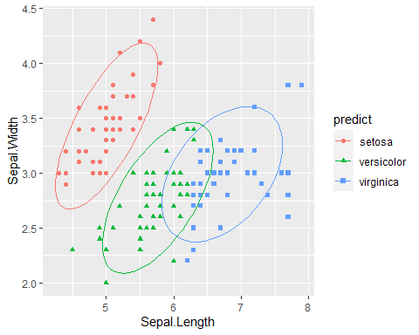

Actual<- iris$Species  
t_3 <-table(Actual, new_df$predict)  
knitr::kable(t_3, caption = "MissClassification matrix for manual prediction")

MissClassification matrix for manual prediction

|  |  |  |  |
| --- | --- | --- | --- |
|  | setosa | versicolor | virginica |
| setosa | 49 | 1 | 0 |
| versicolor | 0 | 36 | 14 |
| virginica | 0 | 15 | 35 |

lda_error_3 = 1- sum(diag(t_3))/sum(t_3)  
paste("MSE for manual LDA: " ,lda_error_3)

## [1] "MSE for manual LDA: 0.2"

### 3_b

lda function

library(MASS)  
new_data3c <- iris  
fitted_lda <- lda(Species~Sepal.Length + Sepal.Width, data = new_data3c)  
fitted_lda

## Call:  
## lda(Species ~ Sepal.Length + Sepal.Width, data = new_data3c)  
##   
## Prior probabilities of groups:  
## setosa versicolor virginica   
## 0.3333333 0.3333333 0.3333333   
##   
## Group means:  
## Sepal.Length Sepal.Width  
## setosa 5.006 3.428  
## versicolor 5.936 2.770  
## virginica 6.588 2.974  
##   
## Coefficients of linear discriminants:  
## LD1 LD2  
## Sepal.Length -2.141178 -0.8152721  
## Sepal.Width 2.768109 -2.0960764  
##   
## Proportion of trace:  
## LD1 LD2   
## 0.9628 0.0372

#### Confusion Matrix###  
Classification <- predict(fitted_lda, data = new_data3c)$class  
Actual<- iris$Species  
t <-table(Actual, Classification)  
knitr::kable(t,caption = "MissClassification matrix for LDA")

MissClassification matrix for LDA

|  |  |  |  |
| --- | --- | --- | --- |
|  | setosa | versicolor | virginica |
| setosa | 49 | 1 | 0 |
| versicolor | 0 | 36 | 14 |
| virginica | 0 | 15 | 35 |

lda_error = 1- sum(diag(t))/sum(t)  
paste("MSE of LDA model: ", lda_error)

## [1] "MSE of LDA model: 0.2"

Miss classification matrix and Accuracy in both model are same.

library("mvtnorm")  
bvn1 <- as.data.frame(mvrnorm(50, mu =m1, S ))  
bvn2 <- as.data.frame(mvrnorm(50, mu=m2, S))  
bvn3 <- as.data.frame(mvrnorm(50, mu=m3, S))  
bv <- rbind(bvn1,bvn2,bvn3)  
  
ggplot() +  
 geom_point(data=bv, aes(bv$Sepal.Length, bv$Sepal.Width, color=iris$Species))

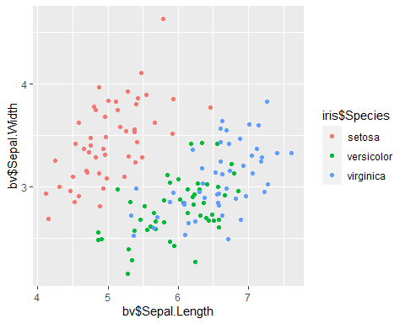 By using new generate data, we can see the Setosa species is classified better than two classes, like other models. ### 5 Logistic Regression

library(nnet)  
multi_model <- multinom(Species~Sepal.Length + Sepal.Width, data =iris)

## # weights: 12 (6 variable)  
## initial value 164.791843   
## iter 10 value 62.715967  
## iter 20 value 59.808291  
## iter 30 value 55.445984  
## iter 40 value 55.375704  
## iter 50 value 55.346472  
## iter 60 value 55.301707  
## iter 70 value 55.253532  
## iter 80 value 55.243230  
## iter 90 value 55.230241  
## iter 100 value 55.212479  
## final value 55.212479   
## stopped after 100 iterations

multi_model

## Call:  
## multinom(formula = Species ~ Sepal.Length + Sepal.Width, data = iris)  
##   
## Coefficients:  
## (Intercept) Sepal.Length Sepal.Width  
## versicolor -92.09924 40.40326 -40.58755  
## virginica -105.10096 42.30094 -40.18799  
##   
## Residual Deviance: 110.425   
## AIC: 122.425

new_data <- iris  
new_data$predicted<- predict(multi_model, new_data, type="class")  
summary(new_data)

## Sepal.Length Sepal.Width Petal.Length Petal.Width   
## Min. :4.300 Min. :2.000 Min. :1.000 Min. :0.100   
## 1st Qu.:5.100 1st Qu.:2.800 1st Qu.:1.600 1st Qu.:0.300   
## Median :5.800 Median :3.000 Median :4.350 Median :1.300   
## Mean :5.843 Mean :3.057 Mean :3.758 Mean :1.199   
## 3rd Qu.:6.400 3rd Qu.:3.300 3rd Qu.:5.100 3rd Qu.:1.800   
## Max. :7.900 Max. :4.400 Max. :6.900 Max. :2.500   
## Species predicted   
## setosa :50 setosa :50   
## versicolor:50 versicolor:51   
## virginica :50 virginica :49   
##   
##   
##

t_multi <- table(new_data$Species, new_data$predicted)  
t_multi

##   
## setosa versicolor virginica  
## setosa 50 0 0  
## versicolor 0 38 12  
## virginica 0 13 37

ME_error <- 1-sum(diag(t_multi))/sum(t_multi)  
paste( "ME_error= ", ME_error)

## [1] "ME_error= 0.166666666666667"

ggplot(new_data, aes(x=Sepal.Width , y= Sepal.Length, shape= predicted, color=predicted)) + geom_point() +stat_ellipse()

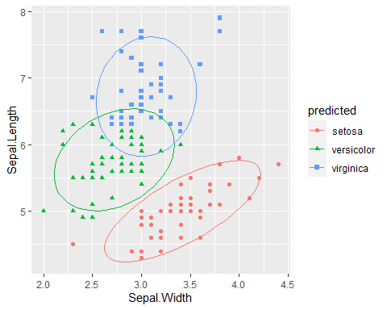 We can see here that ME in logistic regression model is lower than two other models.

# Assignment 2. Decision trees and Naïve Bayes for bank marketing

## Task 1

Pre-process data by removing “Duration” feature, converting all character columns to categorical classes (factors) and split into train-, validation- and testset.

data = read.csv2("bank-full.csv")  
data$duration = NULL  
  
character_vars = lapply(data, class) == "character"  
data[, character_vars] = lapply(data[, character_vars], as.factor)  
#str(data)  
  
  
n=dim(data)[1]  
set.seed(12345)  
id=sample(1:n, floor(n*0.4))  
train=data[id,]  
  
id1=setdiff(1:n, id)  
set.seed(12345)  
id2=sample(id1, floor(n*0.3))  
valid=data[id2,]  
  
id3=setdiff(id1,id2)  
test=data[id3,]  
  
#sum(c(dim(train)[1],dim(valid)[1], dim(test)[1])) == dim(data)[1]

## Task 2

Fit three different models from the given settings.

n = dim(train)[1]  
fit_def = tree(formula = y ~., data=train, control = tree.control(nobs = n))  
fit_node = tree(formula = y ~., data=train, control = tree.control(nobs = n, minsize = 7000))  
fit_dev = tree(formula = y ~., data=train, control = tree.control(nobs = n, mindev = 0.0005))  
  
misclass = matrix(0,3,2)  
dimnames(misclass) = list( c("Default","Node","Deviance"), c("Test","Validation") )  
  
  
pred_def_train = predict(fit_def, newdata = train, type = "class")  
pred_def_val = predict(fit_def, newdata = valid, type = "class")  
misclass[1,1] = sum(train$y != pred_def_train)/length(train$y)  
misclass[1,2] = sum(valid$y != pred_def_val)/length(valid$y)  
  
  
pred_node_train = predict(fit_node, newdata = train, type = "class")  
pred_node_val = predict(fit_node, newdata = valid, type = "class")  
misclass[2,1] = sum(train$y != pred_node_train)/length(train$y)  
misclass[2,2] = sum(valid$y != pred_node_val)/length(valid$y)  
  
  
pred_dev_train = predict(fit_dev, newdata = train, type = "class")  
pred_dev_val = predict(fit_dev, newdata = valid, type = "class")  
misclass[3,1] = sum(train$y != pred_dev_train)/length(train$y)  
misclass[3,2] = sum(valid$y != pred_dev_val)/length(valid$y)  
  
misclass

## Test Validation  
## Default 0.10484406 0.1092679  
## Node 0.10484406 0.1092679  
## Deviance 0.09400575 0.1119221

From this result the default/nodesize trees performs best on validation data while deviance model does the opposite. Judging by these result the Deviance-model would be overfitting compared to the other two which also could be seen in the graphical illustrations below. The deviance model do have more potential to be optimized as this tree is much larger. The default and nodesize does only differ by one node which can explain why they perform identically!

Increasing the minimum node size results in a smaller tree as the data is divided in to larger areas (each area represent a terminal node) and there are less “classification squares” to decide a label between.

Decreasing the deviance forces the model to split nodes more often which will result in a larger tree as seen below. This does introduce more risk for overfitting. The deviance is calculated by

$$Deviance=−\sum_{i=1}^{n}{p}(c_{i})log(p(c_{i}))$$

where $p(c_{i})$ is the probability of class $c_{i}$ in the node. Using a lower value for deviance forces the probability for classification to be higher which results in more splits.

plot(fit_def, type = "uniform")

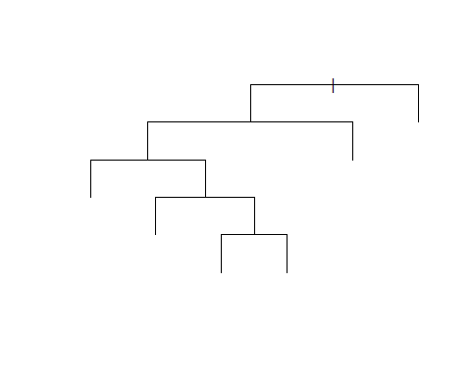

plot(fit_node, type = "uniform")

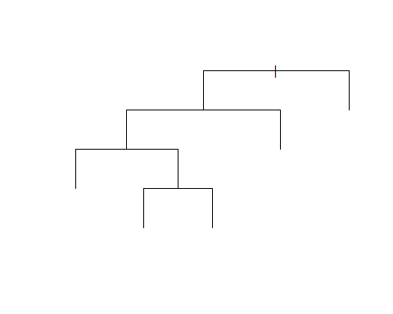

plot(fit_dev, type = "uniform")

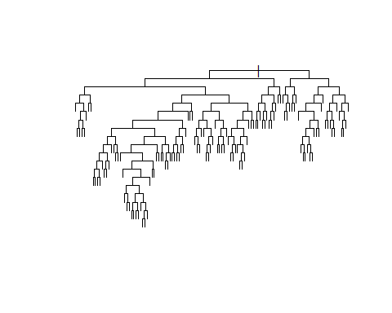 ## Task 3

trainScore = rep(0,50)  
testScore = rep(0,50)  
  
for(i in 2:50){  
 prunedTree = prune.tree(fit_dev, best = i)  
 pred = predict(prunedTree, newdata = valid, type = "tree" )  
 trainScore[i] = deviance(prunedTree)  
 testScore[i] = deviance(pred)  
}

As seen in the figure below the trees total deviance decreases rapidly during the first part as the model is able to distinguish between more features. As the number of leaves increases the training data’s deviance keeps decreasing while the validation data starts to increase after around 20 leafs. This is where the optimal tree size is found. The reason why the training-deviance is larger than the validations is due to the training set being larger therefore more values to sum up.

plot(2:50, trainScore[2:50], type = "b", col = "red", ylim = c(8000,12000), main = "Task 3", xlab = "Sequence", ylab = "Deviance")  
points(2:50, testScore[2:50], type = "b", col = "blue")  
legend("topright", c("Train","Validation"), pch = c("o","o"), col= c("red","blue"))

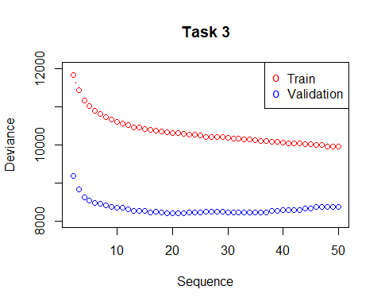 The optimal size (number of leaves/terminal nodes) is found where at the minimum deviance. The optimal number of leaves and the most significant features is shown in the summary of the optimal model:

opt_leaf = which.min(testScore[2:50])  
opt_mdl = prune.tree(fit_dev, best = opt_leaf)  
summary(opt_mdl)

##   
## Classification tree:  
## snip.tree(tree = fit_dev, nodes = c(581L, 17L, 577L, 79L, 37L,   
## 77L, 576L, 153L, 580L, 6L, 1157L, 16L, 5L, 1156L, 156L, 152L,   
## 579L, 7L))  
## Variables actually used in tree construction:  
## [1] "poutcome" "month" "contact" "pdays" "age" "day" "balance"   
## [8] "housing"   
## Number of terminal nodes: 21   
## Residual mean deviance: 0.5706 = 10310 / 18060   
## Misclassification error rate: 0.1041 = 1882 / 18084

The tree structure seems to use more terminal nodes than necessary as there are a lot of nodes which leads to the same label/ typ of terminal node, could be due to the deviance setting. The number of terminal nodes are indeed the same as the optimal which where found above. The outcome feature seems to be the most significant as it is set as the root node. This feature indicate wherever the customer was persuaded to subscribe a term deposit, which seems like a good starting point.

plot(opt_mdl, type = "uniform")  
text(opt_mdl)

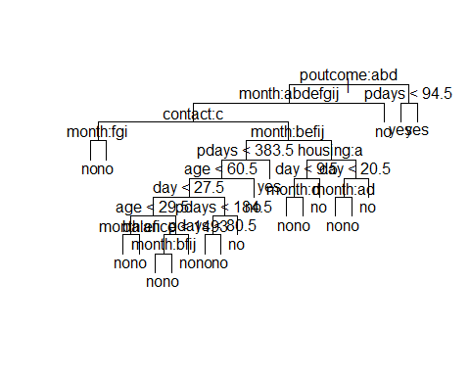 The prediction power of this model is ok, it does get the right answer in about 9/10 cases but its’ main failure is by classifying False Negatives.

pred_valid = predict(opt_mdl, newdata = valid, type = "class")  
val_error = sum(pred_valid != valid$y)/length(valid$y)  
val_conf_matrix = table(valid$y, pred_valid)  
val_conf_matrix

## pred_valid  
## no yes  
## no 11758 167  
## yes 1319 319

sprintf("Misclassification rate: %.4f", val_error)

## [1] "Misclassification rate: 0.1096"

## Task 4

By introducing a loss matrix to penalize the False Negative predictions the misclassification rate did increase but the number of False Negative classifications decreased! Using a loss matrix will direct the focus of learning towards the weighting of the matrix, in this case classifying False Negatives gives a five time larger penalty than False Positive and this will affect the overall classification which is why error rate increased.

Using the loss matrix does give a good result as the previous model have been trained on both the training and validation set while this model only have been exposed to the training set, suggesting that it learn faster (but more knowledge about the data is required to set up the loss matrix).

lossMatrix = matrix(c(0,5,1,0),2,2)  
  
fit_matrix = rpart(formula = y~., data = train, parms = list(loss = lossMatrix))  
pred_matrix = predict(fit_matrix, newdata = test, type = "class")  
error = sum(pred_matrix != test$y)/length(test$y)  
cm_matrix = table(test$y, pred_matrix)  
cm_matrix

## pred_matrix  
## no yes  
## no 10880 1099  
## yes 807 778

sprintf("Misclassification rate: %.4f", error)

## [1] "Misclassification rate: 0.1405"

## Task 5

As can be seen in the graph below the optimal tree model seems to be the best model as the “area under curve” (AUC) is greater than the naive’s model. Comparing two models AUC could occasionally lead the wrong assumption within certain regions but in practice the AUC-measure performs well as a general comparison. The AUC is calculated using the trapezoidal rule. In this case the tree models ROC curve is always above the naive’s which also indicates that the tree model would perform best. Both models are well above the dashed line which could be interpret as a minimum boarder for a models predictive power, if a models is below this line the predictive power is worse than random guessing.

fit_naive = naiveBayes(formula = y~., data = train)  
  
opt_pred = predict(opt_mdl, newdata = test, type = "vector")  
naive_pred = predict(fit_naive, newdata = test, type = "raw")  
  
thres = seq(0, 0.95, 0.05)  
TPR_tree = rep(0,length(thres))  
FPR_tree = rep(0,length(thres))  
TPR_naive = rep(0,length(thres))  
FPR_naive = rep(0,length(thres))  
y = test$y  
  
  
for(i in 1:length(thres)){  
 TP_tree = 0  
 FP_tree = 0  
 TP_naive = 0  
 FP_naive = 0  
   
 for(j in 1:length(test$y)){  
   
 if(opt_pred[j,2] >= thres[i]){   
 if(y[j] == "yes"){   
 TP_tree = TP_tree + 1  
 }  
 else{  
 FP_tree = FP_tree + 1  
 }  
 }  
   
 if(naive_pred[j,2] >= thres[i]){   
 if(y[j] == "yes"){   
 TP_naive = TP_naive + 1   
 }  
 else{   
 FP_naive = FP_naive + 1   
 }  
 }  
   
 }  
 TPR_tree[i] = TP_tree/sum(test$y == "yes")  
 FPR_tree[i] = FP_tree/sum(test$y == "no")  
   
 TPR_naive[i] = TP_naive/sum(test$y == "yes")  
 FPR_naive[i] = FP_naive/sum(test$y == "no")  
}

sub_model = seq(0,1,0.01)  
AUC_tree = sum(abs(diff(FPR_tree)) * (head(TPR_tree,-1)+tail(TPR_tree,-1)))/2  
AUC_naive = sum(abs(diff(FPR_naive)) * (head(TPR_naive,-1)+tail(TPR_naive,-1)))/2  
AUC_sub = sum(abs(diff(sub_model)) * (head(sub_model,-1)+tail(sub_model,-1)))/2  
  
plot(sub_model, sub_model, col = "black", type = "l", lty = 2, main = "ROC", xlab = "False Positive Rate", ylab = "True Positive Rate")  
lines(FPR_tree, TPR_tree, col = "red", type = "o")  
lines(FPR_naive, TPR_naive, col = "blue", type = "o")  
  
leg_text = c(sprintf("Random guess AUC: %.2f", AUC_sub),sprintf("Tree model AUC: %.2f", AUC_tree),sprintf("Naive model AUC: %.2f", AUC_naive))  
  
legend("bottomright", legend = leg_text, pch = c("-","o","o"), col = c("black", "red", "blue"))

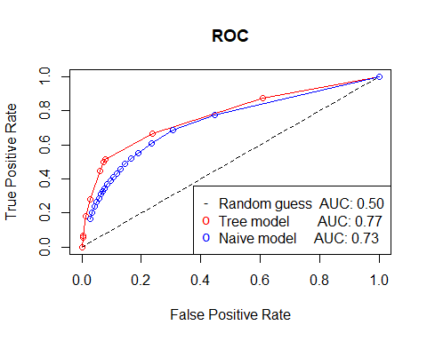

# Assignment 3: Principal components for crime level analysis.

## Task 1

communties <- read.csv("communities.csv")  
communties <- communties[, -communties$ViolentCrimesPerPop]  
#1  
df <- (scale(communties))  
s <- cov(df)  
s.eigen <- eigen(s)  
save <- c()  
for (v in s.eigen$values) {  
 h<- (v / sum(s.eigen$values))  
 save <- c(save, h)  
 }  
save[1]+save[2]

## [1] 0.4230255

nintyfive <- 0  
i <- 1  
while (nintyfive < 0.95) {  
 nintyfive <- save[i] + nintyfive  
 i <- i + 1  
}  
i-1

## [1] 35

The first to components explains around 42 percent of the variation. It needs 35 features to obtain at least 95% of variance in the data.

## Task 2

#PRINCOMP  
res <- princomp(df)  
lambda <- res$sdev^2  
#Plot  
U <- res$loadings  
x <- res$scores  
  
plot(U[,1], main="Scoreplot, PC1")

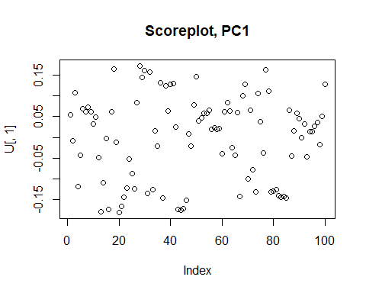

The Scoreplot over PC1 shows that it seems around 15 features has a higher absolute value then 0.15 which means that they have a notable contribution to the first component.

The 5 features that has the biggest contribution to the first component are shown in the table down. We can see that many of they features has to do with Income and family which is a very logical relationship to crime level

#Absolute values  
features <- as.data.frame(U[,1])  
features$variable <- rownames(features)   
features$`U[, 1]` <- abs(features$`U[, 1]`)  
newdata <- features[order(features[,1],decreasing = TRUE ),]  
newdata[1:5, ]

## U[, 1] variable  
## medFamInc 0.1802364 medFamInc  
## medIncome 0.1788053 medIncome  
## PctKids2Par 0.1754391 PctKids2Par  
## pctWInvInc 0.1736648 pctWInvInc  
## PctFam2Par 0.1723885 PctFam2Par

The 5 features that has the biggest contribution to the first component are shown in the table above. We can see that many of they features has to do with Income and family which is a very logical relationship to crime level

#pc1 AGAINST PC2  
  
pc12 <- as.data.frame(x[,1:2])  
pc12$crimes <- communties$ViolentCrimesPerPop  
library(ggplot2)  
p1 <- ggplot(data = pc12, aes(x=Comp.1, y=Comp.2, color=crimes))+  
 geom_point() +  
 theme_bw() +  
 labs(title = "PC1 vs PC2" , x = "PC1" , y = "PC2", colour = "ViolentCrimesPerPop") +  
 theme(axis.title.y = element_text(vjust = 0.5, size = 13 , face = "bold")) +  
 theme(axis.title.x = element_text(vjust = 0.5 ,size = 13 , face = "bold")) +  
 theme(plot.title = element_text(size = 14, face = "bold" , hjust = 0.4 )) +  
 theme(axis.text.y = element_text(size = 11)) +   
 theme(axis.text.x = element_text(size = 11))   
p1

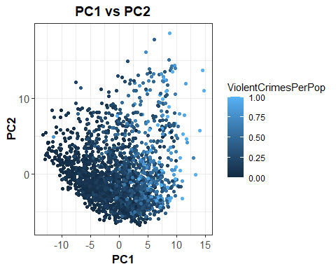

The plot above shows the PC1 versus PC2 with color of Violentcrimesperpop. The picture shows that the PC1 is pretty good to separate low and high values on violentcrimesperpop. It’s hard to see any pattern between PC1 and PC2.

## Task 3

model <- lm(crimes ~ poly(Comp.1,2), data = pc12)  
pc12$pred <- (model$fitted.values)  
  
ggplot(pc12, aes(x=Comp.1, y = crimes)) +  
 geom_point(color= "orange") + theme_bw() +  
 geom_line(aes(y=pred, lwd=1)) +  
 labs(title = "PC1 vs Crimes" , x = "PC1" , y = "Crimes") +  
 theme(axis.title.y = element_text(vjust = 0.5, size = 13 , face = "bold")) +  
 theme(axis.title.x = element_text(vjust = 0.5 ,size = 13 , face = "bold")) +  
 theme(plot.title = element_text(size = 14, face = "bold" , hjust = 0.4 )) +  
 theme(axis.text.y = element_text(size = 11)) +   
 theme(axis.text.x = element_text(size = 11))

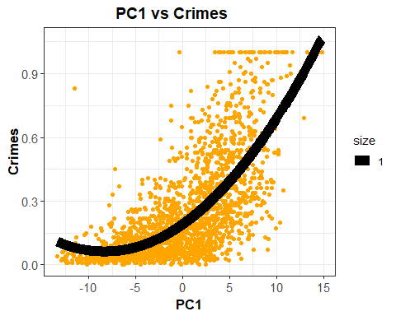

The plot above shows the violentcrimesperpop versus PC1 with the fitted values from the model above as the black line. The graph shows that the model seems to capture the connection between the target and the feature pretty good.

## Task 4

### a)

library(boot)  
data <- pc12  
data2 <- data[order(data$Comp.1),]  
mle <- lm(crimes ~ poly(Comp.1,2), data = data2)  
rng <- function(data,mle2){  
 n <- nrow(data)  
 data1<- data.frame(crimes=data$crimes,Comp.1=data$Comp.1)  
 data1$crimes <- rnorm(n,predict(mle2, newdata=data1),sd(mle2$residuals))  
 return(data1)}  
  
  
f1=function(data1){  
 res=lm(crimes~poly(Comp.1,degree=2),data1)  
 ViolentCrimesPerPopP=predict(res,newdata=data2)  
 return(ViolentCrimesPerPopP)}  
  
fit <- lm(crimes ~ poly(Comp.1,2), data = data2)  
crimesP=predict(fit)  
  
res2 <- boot(data2, statistic=f1, R=3000, mle = fit, ran.gen=rng , sim="parametric")  
e2 <- envelope(res2)  
  
  
plot(data$Comp.1,data$crimes , pch=21, bg="orange", ylim=c(-0.3,1.1), main = "Confidence interval")  
points(data2$Comp.1,crimesP,type="l") #plot fitted line  
#plot confidence bands  
points(data2$Comp.1,e2$point[2,], type="l", col="blue")  
points(data2$Comp.1,e2$point[1,], type="l", col="blue")

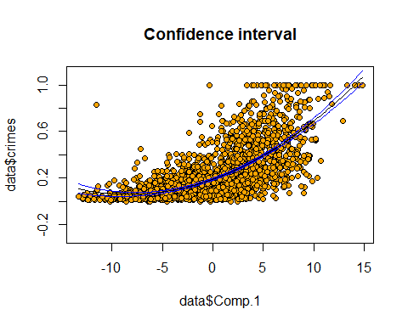

The plot above shows the plot from task 3 but now with confidence intervals. You can see that the confidence intervals are wider in the beginning and the end. That is because is fewer points there compared to in the middle of the plot which gives them more uncertainty.

### b)

f1 <- function(data1){  
 res <- lm(crimes ~ poly(Comp.1,2), data = data1)  
 crimesP <- predict(res, newdata = data2 )  
 n <- length(data2$crimes)  
 predictedP <- rnorm(n, crimesP, sd(mle$residuals))  
 return(predictedP)  
}  
  
  
rng <- function(data, mle ){  
 data1 <- data.frame(crimes=data$crimes, Comp.1=data$Comp.1)  
 n <- length(data$crimes)  
 data1$Crimes <- rnorm(n, predict(mle, newdata = data1), sd(mle$residuals))  
 return(data1)  
}  
  
  
  
res <- boot(data2, statistic=f1, R=3000,  
 mle=mle,ran.gen=rng, sim="parametric")  
  
e <- envelope(res) #compute prediction bands

## Warning in envelope(res): unable to achieve requested overall error rate

fit <- lm(crimes ~ poly(Comp.1,2), data = data2)  
crimesP=predict(fit)  
plot(data$Comp.1,data$crimes , pch=21, bg="orange", ylim=c(-0.3,1.1))  
points(data2$Comp.1,crimesP,type="l") #plot fitted line  
#plot prediction bands  
points(data2$Comp.1,e$point[2,], type="l", col="blue")  
points(data2$Comp.1,e$point[1,], type="l", col="blue")

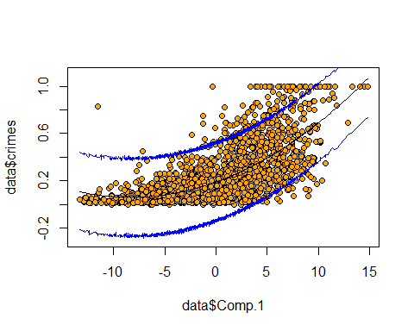

The plot above shows the plot from task 3 but now with prediction intervals. You can see that the predictions bands have almost the same width all over the plot and that the intervals alot of the points in the plot. This is because prediction is made out of every fitted point instead of confidence interval which is made out of the fitted line.

# Appendix:

knitr::opts_chunk$set(echo = TRUE)  
library(kknn)  
library(ggplot2)  
library(e1071)  
library(tree)  
library(rpart)  
library(ggplot2)  
library(datasets)  
  
ggplot(iris, aes(x=Sepal.Width , y= Sepal.Length, shape= Species, color=Species)) + geom_point() +stat_ellipse()  
  
data(iris)  
### covariance matrix per each class  
paste("Covariance matrix in Setosa class")  
(var(subset(iris,subset=Species=='setosa',select=c(1:2))) -> S1)  
paste("Covariance matrix in Versicolor class")  
(var(subset(iris,subset=Species=='versicolor',select=c(1:2))) -> S2)  
paste("Covariance matrix in Virginica class")  
(var(subset(iris,subset=Species=='virginica',select=c(1:2))) -> S3)  
  
  
### mean per each class  
  
m1 <- colMeans(subset(iris,subset=Species=='setosa',select=c(1:2)))   
  
m2 <- colMeans(subset(iris,subset=Species=='versicolor',select=c(1:2)))   
  
m3 <- colMeans(subset(iris,subset=Species=='virginica',select=c(1:2)))  
  
paste("mean for each class")  
results <- cbind(m1,m2,m3)  
colnames(results) <- c("setosa","versicolor","virginica")  
rownames(results) <- c("Sepal.Length", "Sepal.Width")  
results  
  
  
### prior probability per each class  
paste("prior probability for each class: ")  
(nrow(subset(iris,subset=Species=='setosa')) / nrow(iris) -> prio_prob1)  
(nrow(subset(iris,subset=Species=='versicolor')) / nrow(iris) -> prio_prob2)  
(nrow(subset(iris,subset=Species=='virginica')) / nrow(iris) -> prio_prob3)  
  
paste("degree of freedom: ")  
(table(iris$Species)-1 -> dof)  
  
  
paste("pooled covariance matrix: ")  
((dof[1]*S1+dof[2]*S2+dof[3]*S3)/sum(dof) -> S)  
multi_gusi_model <- function(x,mean,sigma){  
 p <- ncol(x)  
 sig_inv <- solve(sigma)  
 state1 <- (sqrt((2*pi)^p) *(det(sigma)))  
 state2 <- -(1/2)*(as.matrix(x-mean) %*% solve(sigma) %*% t(x-mean) )  
 model <- (1/state1) * exp(state2)  
 return(model)  
}  
  
discriminant <- function(x,mean_i, pooled_cov, prior_i){  
 #mu <- as.matrix(mean_i)  
 #browser()  
 state1 <- as.matrix(x) %*% solve(pooled_cov) %*% mean_i  
 state2 <- 0.5 * t(mean_i) %*% solve(pooled_cov) %*% mean_i  
 d <- state1 - as.numeric(state2) + as.numeric(log(prior_i))  
 return(d)  
}  
#example for one class  
#pooled <- ((dof[1]*S1+dof[2]*S2+dof[3]*S3)/sum(dof) -> S)  
prior <- (nrow(subset(iris,subset=Species=='setosa')) / nrow(iris) -> prio_prob1)  
d1 <-discriminant(iris[c(1,2)] ,matrix(m1,ncol = 1),S,prio_prob1)  
  
d2 <-discriminant(iris[c(1,2)] ,matrix(m2,ncol = 1),S,prio_prob2)  
  
d3 <-discriminant(iris[c(1,2)] ,matrix(m3,ncol = 1),S,prio_prob3)  
  
D_mat <- cbind(d1,d2,d3)  
colnames(D_mat) <- c("setosa","versicolor","virginica")  
paste("Discriminant matrix for three different species" )  
D_mat  
w0 <- function(pi_k, pi_l, mu_k, mu_l, pooled_cov){  
 m1 <- as.matrix(m1)  
 m2 <- as.matrix(m2)  
 w0 <- -(1/2)*t(mu_k + mu_l) %*% solve(pooled_cov) %*% (mu_k - mu_l)  
 return(w0)  
}  
w1 <-function(pi_k, pi_l, mu_k, mu_l, pooled_cov){  
 m1 <- as.matrix(m1)  
 m2 <- as.matrix(m2)  
 w1 <- solve(pooled_cov) %*% (mu_k - mu_l)  
 return(as.matrix(w1))  
}   
msg1 <- paste("decision boundary for Setosa ~ Versicolor\n\n")  
msg2 <- paste(msg1, "W1 : ")  
noquote(strsplit(msg2, "\n")[[1]])  
w1(0.33,0.33,m1,m2,S)  
paste("W0 : ", w0(0.33,0.33,m1,m2,S))  
  
msg1 <- paste("decision boundary for Versicolor ~ Verginica\n\n")  
msg2 <- paste(msg1, "W1 : ")  
noquote(strsplit(msg2, "\n")[[1]])  
w1(0.33,0.33,m2,m3,S)  
paste("W0 : ",w0(0.33,0.33,m2,m3,S))  
  
msg1 <- paste("decision boundary for Verginica ~ Setosa\n\n")  
msg2 <- paste(msg1, "W1 : ")  
noquote(strsplit(msg2, "\n")[[1]])  
w1(0.33,0.33,m3,m1,S)  
paste("W0 : ", w0(0.33,0.33,m3,m1,S))  
library(ggplot2)  
D <- cbind(d1,d2,d3)  
  
for(i in row(D)){  
 predict <-apply(X = D[,], MARGIN = 1, FUN = which.max)  
}  
new_df <- iris  
new_df <- cbind(new_df, predict)  
new_df$predict[new_df$predict == "1"] <- "setosa"  
new_df$predict[new_df$predict == "2"] <- "versicolor"  
new_df$predict[new_df$predict == "3"] <- "virginica"  
ggplot(new_df, aes(x=Sepal.Length , y= Sepal.Width, shape= predict, color=predict)) + geom_point()+stat_ellipse()  
  
Actual<- iris$Species  
t_3 <-table(Actual, new_df$predict)  
knitr::kable(t_3, caption = "MissClassification matrix for manual prediction")  
lda_error_3 = 1- sum(diag(t_3))/sum(t_3)  
paste("MSE for manual LDA: " ,lda_error_3)  
library(MASS)  
new_data3c <- iris  
fitted_lda <- lda(Species~Sepal.Length + Sepal.Width, data = new_data3c)  
fitted_lda  
#### Confusion Matrix###  
Classification <- predict(fitted_lda, data = new_data3c)$class  
Actual<- iris$Species  
t <-table(Actual, Classification)  
knitr::kable(t,caption = "MissClassification matrix for LDA")  
lda_error = 1- sum(diag(t))/sum(t)  
paste("MSE of LDA model: ", lda_error)  
  
library("mvtnorm")  
bvn1 <- as.data.frame(mvrnorm(50, mu =m1, S ))  
bvn2 <- as.data.frame(mvrnorm(50, mu=m2, S))  
bvn3 <- as.data.frame(mvrnorm(50, mu=m3, S))  
bv <- rbind(bvn1,bvn2,bvn3)  
  
ggplot() +  
 geom_point(data=bv, aes(bv$Sepal.Length, bv$Sepal.Width, color=iris$Species))  
library(nnet)  
multi_model <- multinom(Species~Sepal.Length + Sepal.Width, data =iris)  
multi_model  
new_data <- iris  
new_data$predicted<- predict(multi_model, new_data, type="class")  
summary(new_data)  
t_multi <- table(new_data$Species, new_data$predicted)  
t_multi  
ME_error <- 1-sum(diag(t_multi))/sum(t_multi)  
paste( "ME_error= ", ME_error)  
  
  
ggplot(new_data, aes(x=Sepal.Width , y= Sepal.Length, shape= predicted, color=predicted)) + geom_point() +stat_ellipse()  
  
  
data = read.csv2("bank-full.csv")  
data$duration = NULL  
  
character_vars = lapply(data, class) == "character"  
data[, character_vars] = lapply(data[, character_vars], as.factor)  
#str(data)  
  
  
n=dim(data)[1]  
set.seed(12345)  
id=sample(1:n, floor(n*0.4))  
train=data[id,]  
  
id1=setdiff(1:n, id)  
set.seed(12345)  
id2=sample(id1, floor(n*0.3))  
valid=data[id2,]  
  
id3=setdiff(id1,id2)  
test=data[id3,]  
  
#sum(c(dim(train)[1],dim(valid)[1], dim(test)[1])) == dim(data)[1]  
  
n = dim(train)[1]  
fit_def = tree(formula = y ~., data=train, control = tree.control(nobs = n))  
fit_node = tree(formula = y ~., data=train, control = tree.control(nobs = n, minsize = 7000))  
fit_dev = tree(formula = y ~., data=train, control = tree.control(nobs = n, mindev = 0.0005))  
  
misclass = matrix(0,3,2)  
dimnames(misclass) = list( c("Default","Node","Deviance"), c("Test","Validation") )  
  
  
pred_def_train = predict(fit_def, newdata = train, type = "class")  
pred_def_val = predict(fit_def, newdata = valid, type = "class")  
misclass[1,1] = sum(train$y != pred_def_train)/length(train$y)  
misclass[1,2] = sum(valid$y != pred_def_val)/length(valid$y)  
  
  
pred_node_train = predict(fit_node, newdata = train, type = "class")  
pred_node_val = predict(fit_node, newdata = valid, type = "class")  
misclass[2,1] = sum(train$y != pred_node_train)/length(train$y)  
misclass[2,2] = sum(valid$y != pred_node_val)/length(valid$y)  
  
  
pred_dev_train = predict(fit_dev, newdata = train, type = "class")  
pred_dev_val = predict(fit_dev, newdata = valid, type = "class")  
misclass[3,1] = sum(train$y != pred_dev_train)/length(train$y)  
misclass[3,2] = sum(valid$y != pred_dev_val)/length(valid$y)  
  
misclass  
  
plot(fit_def, type = "uniform")  
plot(fit_node, type = "uniform")  
plot(fit_dev, type = "uniform")  
  
trainScore = rep(0,50)  
testScore = rep(0,50)  
  
for(i in 2:50){  
 prunedTree = prune.tree(fit_dev, best = i)  
 pred = predict(prunedTree, newdata = valid, type = "tree" )  
 trainScore[i] = deviance(prunedTree)  
 testScore[i] = deviance(pred)  
}  
  
plot(2:50, trainScore[2:50], type = "b", col = "red", ylim = c(8000,12000), main = "Task 3", xlab = "Sequence", ylab = "Deviance")  
points(2:50, testScore[2:50], type = "b", col = "blue")  
legend("topright", c("Train","Validation"), pch = c("o","o"), col= c("red","blue"))  
  
opt_leaf = which.min(testScore[2:50])  
opt_mdl = prune.tree(fit_dev, best = opt_leaf)  
summary(opt_mdl)  
plot(opt_mdl, type = "uniform")  
text(opt_mdl)  
pred_valid = predict(opt_mdl, newdata = valid, type = "class")  
val_error = sum(pred_valid != valid$y)/length(valid$y)  
val_conf_matrix = table(valid$y, pred_valid)  
val_conf_matrix  
sprintf("Misclassification rate: %.4f", val_error)  
  
  
lossMatrix = matrix(c(0,5,1,0),2,2)  
  
fit_matrix = rpart(formula = y~., data = train, parms = list(loss = lossMatrix))  
pred_matrix = predict(fit_matrix, newdata = test, type = "class")  
error = sum(pred_matrix != test$y)/length(test$y)  
cm_matrix = table(test$y, pred_matrix)  
cm_matrix  
sprintf("Misclassification rate: %.4f", error)  
  
  
fit_naive = naiveBayes(formula = y~., data = train)  
  
opt_pred = predict(opt_mdl, newdata = test, type = "vector")  
naive_pred = predict(fit_naive, newdata = test, type = "raw")  
  
thres = seq(0, 0.95, 0.05)  
TPR_tree = rep(0,length(thres))  
FPR_tree = rep(0,length(thres))  
TPR_naive = rep(0,length(thres))  
FPR_naive = rep(0,length(thres))  
y = test$y  
  
  
for(i in 1:length(thres)){  
 TP_tree = 0  
 FP_tree = 0  
 TP_naive = 0  
 FP_naive = 0  
   
 for(j in 1:length(test$y)){  
   
 if(opt_pred[j,2] >= thres[i]){   
 if(y[j] == "yes"){   
 TP_tree = TP_tree + 1  
 }  
 else{  
 FP_tree = FP_tree + 1  
 }  
 }  
   
 if(naive_pred[j,2] >= thres[i]){   
 if(y[j] == "yes"){   
 TP_naive = TP_naive + 1   
 }  
 else{   
 FP_naive = FP_naive + 1   
 }  
 }  
   
 }  
 TPR_tree[i] = TP_tree/sum(test$y == "yes")  
 FPR_tree[i] = FP_tree/sum(test$y == "no")  
   
 TPR_naive[i] = TP_naive/sum(test$y == "yes")  
 FPR_naive[i] = FP_naive/sum(test$y == "no")  
}  
  
  
sub_model = seq(0,1,0.01)  
AUC_tree = sum(abs(diff(FPR_tree)) * (head(TPR_tree,-1)+tail(TPR_tree,-1)))/2  
AUC_naive = sum(abs(diff(FPR_naive)) * (head(TPR_naive,-1)+tail(TPR_naive,-1)))/2  
AUC_sub = sum(abs(diff(sub_model)) * (head(sub_model,-1)+tail(sub_model,-1)))/2  
  
plot(sub_model, sub_model, col = "black", type = "l", lty = 2, main = "ROC", xlab = "False Positive Rate", ylab = "True Positive Rate")  
lines(FPR_tree, TPR_tree, col = "red", type = "o")  
lines(FPR_naive, TPR_naive, col = "blue", type = "o")  
  
leg_text = c(sprintf("Random guess AUC: %.2f", AUC_sub),sprintf("Tree model AUC: %.2f", AUC_tree),sprintf("Naive model AUC: %.2f", AUC_naive))  
  
legend("bottomright", legend = leg_text, pch = c("-","o","o"), col = c("black", "red", "blue"))  
  
communties <- read.csv("communities.csv")  
communties <- communties[, -communties$ViolentCrimesPerPop]  
#1  
df <- (scale(communties))  
s <- cov(df)  
s.eigen <- eigen(s)  
save <- c()  
for (v in s.eigen$values) {  
 h<- (v / sum(s.eigen$values))  
 save <- c(save, h)  
 }  
save[1]+save[2]  
  
nintyfive <- 0  
i <- 1  
while (nintyfive < 0.95) {  
 nintyfive <- save[i] + nintyfive  
 i <- i + 1  
}  
i-1  
#PRINCOMP  
res <- princomp(df)  
lambda <- res$sdev^2  
#Plot  
U <- res$loadings  
x <- res$scores  
  
plot(U[,1], main="Scoreplot, PC1")  
#Absolute values  
features <- as.data.frame(U[,1])  
features$variable <- rownames(features)   
features$`U[, 1]` <- abs(features$`U[, 1]`)  
newdata <- features[order(features[,1],decreasing = TRUE ),]  
newdata[1:5, ]  
#pc1 AGAINST PC2  
  
pc12 <- as.data.frame(x[,1:2])  
pc12$crimes <- communties$ViolentCrimesPerPop  
library(ggplot2)  
p1 <- ggplot(data = pc12, aes(x=Comp.1, y=Comp.2, color=crimes))+  
 geom_point() +  
 theme_bw() +  
 labs(title = "PC1 vs PC2" , x = "PC1" , y = "PC2", colour = "ViolentCrimesPerPop") +  
 theme(axis.title.y = element_text(vjust = 0.5, size = 13 , face = "bold")) +  
 theme(axis.title.x = element_text(vjust = 0.5 ,size = 13 , face = "bold")) +  
 theme(plot.title = element_text(size = 14, face = "bold" , hjust = 0.4 )) +  
 theme(axis.text.y = element_text(size = 11)) +   
 theme(axis.text.x = element_text(size = 11))   
p1  
model <- lm(crimes ~ poly(Comp.1,2), data = pc12)  
pc12$pred <- (model$fitted.values)  
  
ggplot(pc12, aes(x=Comp.1, y = crimes)) +  
 geom_point(color= "orange") + theme_bw() +  
 geom_line(aes(y=pred, lwd=1)) +  
 labs(title = "PC1 vs Crimes" , x = "PC1" , y = "Crimes") +  
 theme(axis.title.y = element_text(vjust = 0.5, size = 13 , face = "bold")) +  
 theme(axis.title.x = element_text(vjust = 0.5 ,size = 13 , face = "bold")) +  
 theme(plot.title = element_text(size = 14, face = "bold" , hjust = 0.4 )) +  
 theme(axis.text.y = element_text(size = 11)) +   
 theme(axis.text.x = element_text(size = 11))   
  
library(boot)  
data <- pc12  
data2 <- data[order(data$Comp.1),]  
mle <- lm(crimes ~ poly(Comp.1,2), data = data2)  
rng <- function(data,mle2){  
 n <- nrow(data)  
 data1<- data.frame(crimes=data$crimes,Comp.1=data$Comp.1)  
 data1$crimes <- rnorm(n,predict(mle2, newdata=data1),sd(mle2$residuals))  
 return(data1)}  
  
  
f1=function(data1){  
 res=lm(crimes~poly(Comp.1,degree=2),data1)  
 ViolentCrimesPerPopP=predict(res,newdata=data2)  
 return(ViolentCrimesPerPopP)}  
  
fit <- lm(crimes ~ poly(Comp.1,2), data = data2)  
crimesP=predict(fit)  
  
res2 <- boot(data2, statistic=f1, R=3000, mle = fit, ran.gen=rng , sim="parametric")  
e2 <- envelope(res2)  
  
  
plot(data$Comp.1,data$crimes , pch=21, bg="orange", ylim=c(-0.3,1.1), main = "Confidence interval")  
points(data2$Comp.1,crimesP,type="l") #plot fitted line  
#plot confidence bands  
points(data2$Comp.1,e2$point[2,], type="l", col="blue")  
points(data2$Comp.1,e2$point[1,], type="l", col="blue")  
  
f1 <- function(data1){  
 res <- lm(crimes ~ poly(Comp.1,2), data = data1)  
 crimesP <- predict(res, newdata = data2 )  
 n <- length(data2$crimes)  
 predictedP <- rnorm(n, crimesP, sd(mle$residuals))  
 return(predictedP)  
}  
  
  
rng <- function(data, mle ){  
 data1 <- data.frame(crimes=data$crimes, Comp.1=data$Comp.1)  
 n <- length(data$crimes)  
 data1$Crimes <- rnorm(n, predict(mle, newdata = data1), sd(mle$residuals))  
 return(data1)  
}  
  
  
  
res <- boot(data2, statistic=f1, R=3000,  
 mle=mle,ran.gen=rng, sim="parametric")  
  
e <- envelope(res) #compute prediction bands  
fit <- lm(crimes ~ poly(Comp.1,2), data = data2)  
crimesP=predict(fit)  
plot(data$Comp.1,data$crimes , pch=21, bg="orange", ylim=c(-0.3,1.1))  
points(data2$Comp.1,crimesP,type="l") #plot fitted line  
#plot prediction bands  
points(data2$Comp.1,e$point[2,], type="l", col="blue")  
points(data2$Comp.1,e$point[1,], type="l", col="blue")