Does External Data Improve Auckland House Price Prediction? An Explainable Machine Learning Study
Dominik Wecke, Huy Nguyen, Jiayi Du, Thao Nguyen, Xiang Yang
University of Auckland, Auckland, New Zealand
Abstract
House prices shape lending, rates and most families’ biggest financial decision, yet free online valuation tools give a price without a reason. We build an explainable machine-learning pipeline for Auckland house prices and ask whether data about a home’s surroundings improves prediction. From 92,010 Auckland Council sales (2024–2026), we use Splink-based record linkage to give properties a LINZ coordinate, keep 59,708 market sales, and link 16 external features: location, 2023 Census and deprivation statistics, flood and noise exposure, and building activity. Under time-ordered five-fold cross-validation, adding these features to the same XGBoost model cuts RMSE from $343,718 to $212,678 and MAPE from 19.3% to 11.0%. A paired bootstrap shows the gain is significant, and a two-stage test shows the external features explain 29.3% of the variance in a property-only model’s errors. Three importance methods agree that location drives most of the gain. XGBoost beats four other models, including a hedonic regression (MAPE 11.0% vs 15.7%), and SHAP explains each prediction in dollars. On 45 recent sales, two free online estimates (homes.co.nz and OneRoof) recorded before each sale were more accurate (MAPE 5.8% vs 9.6%), pointing to the value of richer property data.
Index Terms—house price prediction, explainable AI, SHAP, record linkage, Splink, gradient boosting, hedonic regression, Auckland

I. Introduction
For most New Zealand households, a home is the largest thing they will ever buy. Its value matters to many people: buyers and sellers use it to set a price, banks use it to decide how much to lend, and Auckland Council uses it to set rates. In Auckland, these values are hard to predict. Homes differ a lot in size, age and condition, and so do the places they sit in. Some areas are close to the city centre or the coast, some neighbourhoods are much richer than others, and some homes sit in a flood plain or under a flight path. A model that only looks at the house itself is therefore likely to miss a large part of its price.
Free online valuation tools give buyers a number but not a reason. A buyer cannot see whether an estimate is high because of the house, its location or something else. This matters when the estimate informs a decision worth around a million dollars.
Past research has studied this problem from two sides. Hedonic studies of Auckland have measured the effect of one external factor at a time, such as flood risk [1], school zones [2], leaky-building stigma [3] and social housing [4]. These models are easy to interpret, but they are built to explain one effect, not to predict new sales [5]. Machine learning models predict prices more accurately [6], [7], and SHAP [8] can show which features drive each prediction. However, we found no study that applies explainable machine learning to Auckland, and few that measure how much a combined set of external data improves prediction on sales the model has not seen.
This paper answers two research questions:
- RQ1: Does adding Auckland-specific external features (location, neighbourhood, hazards and building activity) improve house price prediction compared with using only a property’s own features?
- RQ2: How accurate and interpretable is our explainable model compared with a traditional hedonic model and free online valuation estimates for the same Auckland properties?
We test three hypotheses:
- H1: The same XGBoost model predicts sale prices with lower error when the external features are added, and the drop in error is statistically significant.
- H2: The external features contain information that the property features do not, so a model that sees only external features can predict part of the error left by a property-only model.
- H3: Machine learning models (XGBoost, CatBoost, random forest and a neural network) predict sale prices more accurately than a hedonic regression that uses the same features and the same test sales.
To test them, we built a data pipeline (Fig. 1). We start from the Auckland Council sales file, which has street addresses but no map coordinates. We link the properties to the official LINZ address list with uk_address_matcher [9], a probabilistic record linkage tool built on Splink [10], and keep 59,708 normal market sales of single homes. The coordinate then lets us attach 16 external features from public data. We train every model with time-ordered cross-validation, so it always learns from earlier sales and is tested on later ones. A paired bootstrap tests H1, a two-stage residual model tests H2, and a comparison on the same folds tests H3. This comparison also picks the main model for the rest of the paper and checks that the SHAP findings hold across different models. Finally, three importance methods show which external data matters, and SHAP explains why the model gives a certain price for a single home.
Our main contributions are:
- We build a reproducible linked dataset and describe each step from the raw sales file to the model-ready data: record linkage, cleaning, and linking 16 external features from nine public sources.
- We test the value of external data fairly, by keeping the model and its settings fixed and changing only the features. External data cuts RMSE by 38.1% and MAPE from 19.3% to 11.0%, and explains 29.3% of the variance in the errors a property-only model leaves.
- We show that location drives most of this gain. Neighbourhood statistics carry real signal but largely repeat location, and hazard and building-activity features add almost nothing at city scale.
- We compare five models trained on the same inputs and explain their predictions sale by sale. XGBoost is the most accurate (MAPE 11.0% vs 15.7% for a hedonic regression), all five agree on the most important features, and SHAP gives each prediction a short explanation a buyer can read.
- We benchmark our model honestly against two online tools. On 45 recent sales, homes.co.nz and OneRoof estimates recorded before each sale beat our model (MAPE 5.8% for both vs 9.6%), even when our model is retrained up to the same date, which shows the limits of public data.
The rest of the paper is organised as follows. Section II reviews related work. Section III describes the pipeline, the models and how we test each hypothesis. Section IV presents and discusses the results. Section V sets out the limitations, and Section VI concludes and suggests future work.

II. Related Work

A. Hedonic models and outside factors in Auckland
Rosen [11] described a house as a bundle of features, each with its own price, found by regressing sale price on those features. As Shmueli [5] notes, such models are mainly used to explain the effect of each feature, not to predict new sales as well as possible. Auckland studies show that factors outside the property matter. Bourassa et al. [12] found that adding valuer-defined submarkets improved a hedonic model more than switching to more complex spatial models. Samarasinghe and Sharp [1] found that flood-prone homes on the North Shore sold at a discount, which became smaller once flood-risk information was made public. Rehm and Filippova [2] showed that being zoned for popular state schools raised prices, though not evenly; Rehm [3] found that leaky-building stigma lowered them by about 5%; and Sequeira and Filippova [4] found that nearby social housing lowered them by 1.7–23%. Overseas, Bui et al. [13] combined a hedonic model with spatial econometrics and found that flood-affected homes in Ho Chi Minh City sold for 9% less after a major flood. Each of these studies looks at one factor in a linear model, so none shows how much a combined set of outside data improves prediction. We add 16 external features to one model at once and measure the change in error on unseen sales.

B. Machine learning versus hedonic models
Tree-based models learn curved effects and interactions from the data without the analyst choosing their shape. They usually predict prices better than hedonic regression. On Ljubljana apartments, Čeh et al. [6] found that a random forest reached a MAPE of about 7% against 17% for regression, and in Busan, An et al. [7] found that a random forest explained with SHAP appraised condominium prices more accurately than hedonic models. In Russia, Antipov and Pokryshevskaya [14] also found that a random forest won (MAPE 14.9% vs 18.3%), but a closer check found groups of apartments whose prices it consistently over- or underestimated, so one overall number can hide weak spots. Gradient-boosted trees such as XGBoost, by Chen and Guestrin [15], do similarly well. Soltani et al. [16] stressed that features and training data must only use sales that happened before the sale being predicted. Most comparisons change the model and the features at the same time, so it is unclear how much of the gain comes from better data. We change only one at a time: the features with the model fixed (H1), then the model with the features fixed (H3), always training on past sales only.

C. External data and explainable models
SHAP, by Lundberg and Lee [8], splits each prediction into one contribution per feature, which makes machine learning models easier to read. In Lisbon, Trindade Neves et al. [17] found that open data on the surroundings cut MAE by 8.24%, and SHAP ranked longitude and latitude among the top features. In Sydney, Lee et al. [18] used SHAP to show that the effect of amenities on price changes with distance and differs by amenity type, and in Beijing, Chen et al. [19] used GeoShapley to show that price effects are non-linear and vary across the city. These studies rank features with SHAP alone. When features overlap, as coordinates and area statistics do, one ranking can mislead. We therefore test first whether external data helps, and then compare three importance methods that react differently to overlap.

III. Methodology
All code is available online. Fig. 1 gives an overview. Steps 1–4 build the dataset (Sections III-A–III-D); steps 5–8 train, test and explain the models (Sections III-E–III-I).
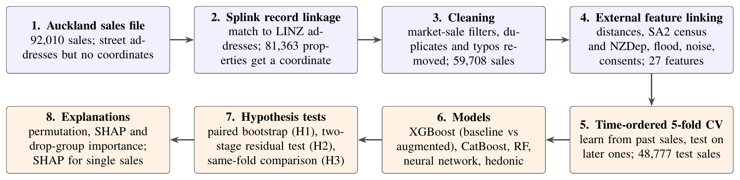
Fig. 1. The full pipeline. Blue steps build the dataset; orange steps train, test and explain the models.

A. Auckland sales data
Our main data is the Auckland Council sales file [20]. It lists 92,010 property sales from January 2024 to August 2026, with 41 columns that describe the sale (price, date, sale type) and the property (land area, floor area, building age, condition, garages, and so on). Each property has a council valuation reference and a street address: a house number, an optional unit or letter, and a street name with a short road type (for example “St Michaels AV”). The file has no coordinates and no suburb, so on its own it cannot tell us where a home is.

B. Linking sales to coordinates with Splink
To place each property on the map, we linked it to the LINZ NZ Addresses list [21], which gives a coordinate for every official address in New Zealand. The two sources share no key, and the same address is often written differently (short forms, unit formats, missing letters or typing errors). An exact join on the address text would miss many homes and could not tell a near miss from a wrong address.
We therefore used probabilistic record linkage with uk_address_matcher [9], an address-matching package built on Splink [10], [22], which implements the Fellegi–Sunter model [23]. For a candidate pair of records (one sale address, one LINZ address), the model compares several fields. Each comparison has a few ordered levels, such as exact agreement, close agreement by a string-similarity score, disagreement, and missing. For level $ℓ$ of comparison $k$, the model learns two probabilities: $m_{kℓ}$, the chance of seeing that level when the two records are the same address, and $u_{kℓ}$, the chance of seeing it when they are not. It adds up the evidence from all comparisons into a match weight
w=log2λ1−λ+k​log2mkγkukγk, p=2w1+2w, (1)
where $γ_{k}$ is the level seen for comparison $k$, $λ$ is the prior chance that a random pair is a match, and $p$ is the match probability. Agreement adds weight and disagreement removes it; the rarer an agreement is among non-matching pairs, the more weight it adds.
Before matching, we turned the separate address parts in both sources into one standardised address string. We made the letter case consistent, put the parts in the same order and made common abbreviations the same in both sources. From this string, the package derives the features it compares, such as the numbers in the address, the road name and, where available, the postcode. Working from the whole string, rather than only from fixed fields such as house number and street name, copes better with addresses that are incomplete, abbreviated or written in a different order.
Matching ran in two stages with the package’s default settings. First, records whose standardised strings were identical were matched directly. Second, the remaining records were matched probabilistically: a blocking step kept only plausible candidate pairs that share address features, and a pretrained address-matching model scored each pair. Because the $m$ and $u$ values come with this pretrained model, we needed no hand-labelled pairs. The model also adjusts for term frequency, so that agreeing on a common word counts less than agreeing on a rare, distinctive one.
To choose a match-weight threshold, we reviewed matched pairs by hand. We split the matches into match-weight bands five units wide and drew a random sample of up to 50 pairs from each band. Starting with the lowest band, we checked each sampled pair by comparing the two address strings and, where needed, the location on an online map. A band was accepted when fewer than 2% of its sampled pairs were false matches. The first band to pass was $[0,5)$, and since higher weights mean stronger evidence of a match, we kept every match with a weight of at least 0, taking the best-scoring LINZ address for each valuation reference. This links 81,363 of the 85,180 distinct properties in the sales file (95.5%) to one LINZ address and coordinate; a few LINZ addresses (72) are shared by two valuation references. We join the coordinates back to the sales by valuation reference, built from the roll number, the assessment number and the lower-cased suffix that separates units under one assessment.

C. Cleaning
We kept only sales that show a normal market price for one home. Table I lists the filters in the order we applied them.
TABLE I. Filters applied to the sales data, in order
Filter | Sales left
All sales in the file | 92,010
Residential, rural or lifestyle zoning | 80,070
One unit of use | 77,370
Freehold | 76,395
One property per sale | 74,112
Arm’s-length market sale | 61,244
Coordinate found by Splink | 59,798
Exact duplicate records removed | 59,711
Floor-area typos removed | 59,708
The zoning and unit filters remove commercial properties and buildings with several homes. The tenure filter removes leasehold sales, which sell for less because the buyer does not own the land. The one-property filter is important here because when several properties are sold together, the record shows one combined price but the features of only one property, so the model cannot learn from it. The arm’s-length filter removes sales between related parties, which may not reflect market value. Linkage found a coordinate for 97.6% of the remaining sales. We then removed records that repeat the same property, date and price, which are duplicates, and three records whose building floor area is more than ten times the council’s mass-appraisal floor area (for example 360,000 m² for an ordinary house).
We also removed five columns that would leak the answer (data leakage). The net, chattels and other price columns add up to the sale price. The council’s capital value and land value are themselves price estimates, so a model that used them would copy the council’s valuation instead of learning from property and location data.

D. External features and feature sets
With a coordinate for every sale, we attached 16 external features from nine public sources (Table II). All distances are measured in metres in the New Zealand Transverse Mercator projection (NZTM2000). We used three kinds of join.
The first measures distances. We computed the straight-line distance to a fixed CBD point (Queen Street, 174.7645° E, 36.8485° S), to the nearest of 2,564 open schools, and to the nearest point on the coastline. To make the coastline search fast, we placed a point every 20 m along the coast and found the nearest one with a k-d tree; this is within about 10 m of the exact distance. Walking distances to the nearest supermarket and bus stop follow the road network.
The second checks which area a home lies in (a point-in-polygon test). We found the 2025 Statistical Area 2 (SA2) that contains each home, and whether the home lies in a council flood plain or an aircraft noise area.
The third looks up values for that area. Through its SA2, each home gets the area’s NZDep2023 deprivation decile (1 = least deprived, 10 = most), 2023 Census statistics and the number of new dwellings consented in the past 12 months. Employment rate is employed people divided by people aged 15 and over; unemployment rate is unemployed people divided by the labour force; population density is the SA2 population divided by its land area. Every sale found an SA2 and an NZDep2023 value. SA2 statistics are area-level values shared by every home in the same SA2.
TABLE II. External features, their sources and how each was linked
Feature | Source | Link
Latitude, longitude | LINZ [21] | Splink match
Distance to CBD | LINZ coordinate | straight line to CBD point
Distance to nearest school | MoE [24] | nearest point
Distance to coastline | LINZ [25] | nearest point
Walk to supermarket, bus stop | OSM [26], AT [27] | road network
NZDep2023 decile | Otago [28] | SA2 [29]
Median income, employment, unemployment, population, density | Census [30] | SA2
In flood plain, aircraft noise category | Auckland Council [31] | point in polygon
New dwellings consented (12 months) | Stats NZ [32] | SA2
With these external features in place, we built two feature sets (Table III). The baseline set has 11 features that describe only the property and the sale date; it says nothing about location. The augmented set adds the 16 external features, for 27 in total. We group the external features into three groups, which we use later to measure importance.
TABLE III. Feature sets
Group | Features
Baseline (11)
Size | land area, building floor area
Building | age, condition, construction type, property type, off-street parking, garages under main roof, freestanding garages
Time | sale year, sale month
External (16)
Location (7) | latitude, longitude, distance to CBD, distance to coastline, distance to nearest school, walking distance to supermarket, walking distance to bus stop
Neighbourhood (6) | NZDep2023 decile, median personal income, employment rate, unemployment rate, population, population density (all per SA2)
Hazards and building activity (3) | in flood plain, aircraft noise category, new dwellings consented in the SA2 (past 12 months)
Land area, floor area and the two walking distances are right-skewed (a few very large values), so we applied $log(1+x)$ to them.
We also dropped two features that repeat others: sale quarter, which is calculated from sale month, and the council’s mass-appraisal floor area, which repeats the building floor area (Spearman $ρ=0.96$; variance inflation factor 17–18). This cost XGBoost only $212 of RMSE and stops two copies of a feature from splitting its SHAP credit.

E. Training and testing on time-based cross-validation folds
House prices change over time, so a model should only learn from sales that happened before the ones it predicts. Shuffling the data at random would let the model learn from the future, which makes results look better than they would be in practice [16].
We therefore sort the 59,708 sales by date and use five-fold expanding-window cross-validation (Fig. 2). The data is cut into six back-to-back time blocks of about 9,950 sales. In fold $k$, the model trains on blocks $1$ to $k$ and is tested on block $k+1$, so each fold learns from more history than the one before. Every sale after the first block is tested exactly once, by a model that has never seen it.
Inside each fold, all preprocessing is learned from the training blocks only and then applied to the test block: category codes (a category not seen in training gets its own code), the median used to fill missing walking distances (1.4–2.7% of sales), and the price limits below. Before training, we remove sales priced below the 1st or above the 99th percentile of the training prices ($430,000–$450,000 and $4.2M–$4.5M, depending on the fold), and apply the same limits to the test block. This stops a few extreme sales from dominating the error, but it means our results describe the middle 98% of the market. After this step, 48,777 test predictions remain across the five folds.
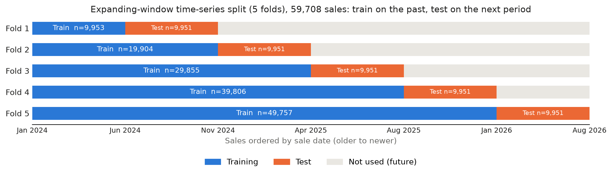
Fig. 2. Five-fold expanding-window cross-validation. Each fold trains on all earlier sales and tests on the next period.
For $n$ test sales with actual price $y_{i}$ and predicted price ${\hat{y}}_{i}$, we report three error measures:
$$\begin{aligned}MAE&=\frac{1}{n}\sum_{i=1}^{n}{|}y_{i}−{\hat{y}}_{i}|, (2) \\ RMSE&=\sqrt{\frac{1}{n}\sum_{i=1}^{n}{(}y_{i}−{\hat{y}}_{i})^{2}}, (3) \\ MAPE&=\frac{100}{n}\sum_{i=1}^{n}{\frac{|y_{i}−{\hat{y}}_{i}|}{y_{i}}}. (4)\end{aligned}$$
MAE is the typical error in dollars. RMSE gives more weight to large errors, which matter most for expensive homes. MAPE is the error as a percentage of price, so a $100K miss on a $600K home counts more than the same miss on a $3M home. We pool the test predictions from all five folds and compute each measure once.

F. Models
Our main model is XGBoost [15], a gradient-boosted tree model that predicts the sale price in dollars. We chose it because it handles curved effects and mixed feature types well, and tree models beat linear regression in earlier house price studies [6], [7]. It uses 500 trees, maximum depth 6, learning rate 0.05, 80% of rows and of features sampled per tree, and random seed 42.
We do not tune any of our models. If each model were tuned separately, part of any difference could come from tuning rather than from the features or the algorithm. Fixed settings keep the comparisons fair, at the cost of slightly understating what each model could reach.
To check that our results do not depend on one algorithm, we train three more machine learning models and a hedonic regression on exactly the same inputs. The three machine learning models are:
- Random forest [33]: 150 trees, maximum depth 18, at least 2 sales per leaf.
- CatBoost [34]: 500 trees, depth 6, learning rate 0.05, set to match XGBoost. It gets the same integer category codes as the other models.
- Neural network: a multilayer perceptron with a learned embedding (up to 16 dimensions) for each categorical feature and three hidden layers (256, 128 and 64 units, ReLU, dropout 0.1), trained with Adam [35] (learning rate ${10}^{−3}$, batch 512, mean squared error) on the standardised log price. Training runs for up to 100 epochs, but stops early once the error on the latest 10% of the training period has not improved for 10 epochs; in practice this happened after 28–47 epochs. Numeric inputs are clipped to the training 0.5th–99.5th percentiles and standardised.
The hedonic regression is the traditional approach: a linear regression on the log of price,
$$lny_{i}=β_{0}+x_{i}^{⊤}β+ε_{i}, (5)$$
fitted by ordinary least squares on the same 27 features. Each category is one-hot encoded, with its most common level as the reference, and any column that never changes in a fold’s training data is dropped for that fold. As for the neural network, numeric inputs are clipped to the training 0.5th–99.5th percentiles, so one unusual value cannot produce an extreme price. Turning a log prediction back into dollars with $exp(⋅)$ underestimates the average price, so we multiply by Duan’s smearing factor [36]:
$${\hat{y}}_{i}=exp​\left({\hat{β}}_{0}+x_{i}^{⊤}\hat{β}\right)⋅\frac{1}{m}\sum_{j=1}^{m}{e^{{\hat{ε}}_{j}}}, (6)$$
where ${\hat{ε}}_{j}$ are the $m$ training residuals. The neural network uses the same correction. For both models, final predictions are capped to the range of training prices.

G. Testing the hypotheses
We test H1 with a paired bootstrap. We train XGBoost on the baseline and the augmented feature set over the same folds. To check that the augmented model is better and not just lucky, we draw $n$ test sales at random with replacement and compute
$$Δ^{(b)}=M_{\text{base}}^{(b)}−M_{\text{aug}}^{(b)} (7)$$
for each metric $M$ [37]. Both models are scored on the same resampled sales, so the test is paired. We repeat this $B=2,000$ times; the 2.5th and 97.5th percentiles of $Δ^{(b)}$ give a 95% confidence interval. If it does not include zero, the improvement is statistically significant.
We test H2 with a two-stage residual test. H1 shows that external features help, but the model might only use them to relearn something the property features already contain. In stage 1, we take the baseline model’s out-of-fold errors $r_{i}=y_{i}−{\hat{y}}_{i}^{\text{base}}$. In stage 2, a new XGBoost model sees only the 16 external features and predicts $r_{i}$, with its own five-fold expanding-window split over these sales in date order. The first block (8,132 sales) is training only, leaving 40,645 sales with a stage-2 prediction. Stage 2 never sees a property feature, so an out-of-fold $R^{2}$ above zero means the external features explain something the property features missed.
We test H3 by comparing the five models on the same folds. All five models of Section III-F use the same features, folds, price limits and metrics, so any difference comes from the model alone. We compare their pooled errors and their errors in each fold. H3 is supported if every machine learning model has a lower error than the hedonic regression, both pooled and in each of the five folds.

H. Measuring feature importance
To see which external data drives the gain, we use fold 5: the model trains on all sales up to January 2026 and is tested on the 9,769 sales from January to August 2026. We study the three external groups of Table III with three methods. Grouped permutation importance shuffles all features of a group together in the test set and measures the RMSE increase (average of 20 repeats). SHAP gives the share of a group in the total mean absolute SHAP value, on 500 test sales. Drop-group retraining trains the model again without the group (or without one feature) and measures the change in RMSE.
The three react differently when two groups carry similar information. Permutation breaks a group while the model still relies on it, so it shows how much the model uses the group, which can overstate how much it is needed. Drop-group retraining lets the model fall back on a similar group, so it shows what is unique to the group but can understate its value. SHAP splits the credit between similar features. Reading them together shows both use and uniqueness.

I. Explaining single predictions
SHAP values add up: for each sale, the model’s average prediction plus the SHAP value of every feature equals the prediction. We use this to explain one held-out sale at a time. Starting from the average predicted price, each feature adds or removes a dollar amount. For a short summary, we add up the contributions within five themes: location, neighbourhood and hazards (as in Table III), house and land (the size and building features), and market timing (sale year, sale month and new dwellings consented). Adding them up is valid because SHAP values are additive. A waterfall chart shows the largest single contributions with feature values in real units (square metres, kilometres, deciles). For the tree models we use exact TreeSHAP [8]; for the neural network and hedonic model we use SHAP’s permutation explainer with 100 training sales as background.

J. Online valuation benchmark
To test the second half of RQ2, we compared our model with two free automated estimates: HomesEstimate on homes.co.nz [38] and the OneRoof estimate [39]. Online estimates are updated after a sale, so an estimate looked up later may already reflect the sale price and make the online tool look better than it was. We avoid this by using estimates recorded in early July 2026 (homes.co.nz on 9 July, OneRoof in the first days of July), before every sale in the sample.
We took the 50 most recent sales in our dataset (28 July to 18 August 2026), so each sold at least 19 days after its estimates were recorded. Two were outside the model’s price limits (Section III-E) and three were missing at least one online estimate, leaving 45 homes with all estimates. We compare two versions of our XGBoost model on these homes. The first, “Ours (to 24 Jan)”, is the fold-5 prediction used in the rest of the paper, from a model trained on sales up to 24 January 2026. The second, “Ours (to 9 Jul)”, is the same model retrained on the sales before 9 July 2026 (58,223 after the same price limits), so that it knows the market up to about the same time as the online estimates. Besides MAE, RMSE and MAPE, we report the share of homes predicted within 5% and 10% of the sale price, a common way to judge automated valuations.

IV. Experiments and Results

A. Results of the baseline and augmented models
Table IV and Fig. 3 give the pooled error over all five folds. Adding the 16 external features cuts RMSE by $131,040, from $343,718 to $212,678 (38.1%), MAE by $95,242, and MAPE by 8.4 percentage points, from 19.3% to 11.0%. The paired bootstrap gives 95% confidence intervals of $126,988–$135,157 for the RMSE gain, $93,358–$97,194 for MAE and 8.2–8.5 points for MAPE. None includes zero, so H1 is supported. The gain is also steady over time: the augmented model wins in every fold, with RMSE between $191,483 and $238,373 against $320,862 to $370,069 for the baseline. Both models also improve in later folds, which have more training history.
This result shows that two homes with the same size, age and condition can sell for very different prices depending on where they are, and the baseline model, which only knows the house itself, cannot see this difference.
TABLE IV. Baseline (property only) vs. augmented (with external features), XGBoost, pooled over 5 folds, $n=48,777$
Model | Features | RMSE | MAE | MAPE
Baseline | 11 | $343,718 | $223,224 | 19.3%
Augmented | 27 | $212,678 | $127,983 | 11.0%
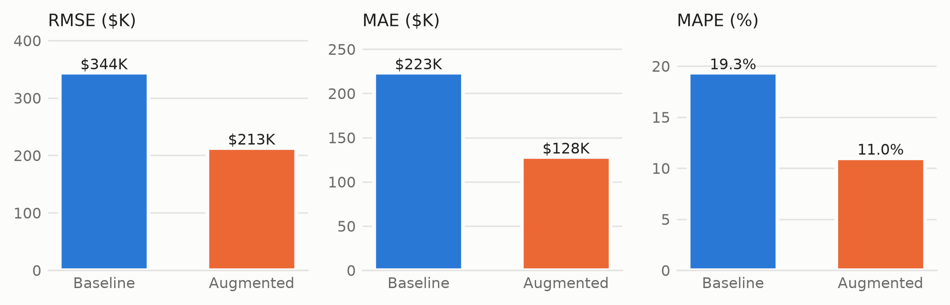
Fig. 3. Pooled error of the baseline and augmented XGBoost models.

B. Impact of external features
A model could look like it needs external data only because the property features are not strong enough. Because of that, we ran the two-stage test, and it rules this out. A model that sees only the 16 external features explains 29.3% of the variance in what the property-only model gets wrong (on 40,645 held-out errors), and cuts the RMSE of those errors from $339,582 to $285,308. Since this model never sees a property feature, the 29.3% must be information the property features do not contain, so H2 is supported. The other 70.7% is not explained by our external data. It likely comes from things neither data source records.

C. Analysis of external features
Table V compares the three methods on fold 5 (9,769 test sales, augmented RMSE $191,483). Together, the external features hold 52.3% of the model’s total SHAP value, and dropping all of them raises RMSE by $129,379, in line with the five-fold result above.
TABLE V. Importance of the external feature groups on fold 5, by the three methods of Section III-H (a negative drop-group value means the model was slightly better without the group)
Group | Permutation | SHAP | Drop-group
All external (16) | +171.2% | 52.3% | +$129,379
Location (7) | +131.1% | 35.1% | +$20,146
Neighbourhood (6) | +32.1% | 16.1% | +$1,665
Hazards and building activity (3) | +0.9%$​^{*}$ | 1.0% | $−$$1,119$​^{*}$
Location matters most on all three measures. Distance to the CBD alone holds 15.5% of total SHAP, more than latitude (8.1%) or longitude (8.6%), and is second only to building floor area (21.0%) across all 27 features (Fig. 4). The SHAP plot shows the shape of this effect: being close to the CBD raises the price a lot, while beyond a certain distance further kilometres change little. A straight-line model cannot capture this shape.
Neighbourhood statistics, on the other hand, mostly repeat location. The model clearly uses them: shuffling the group raises RMSE by 32.1%, and it holds 16.1% of SHAP, led by the deprivation decile (6.9%). Yet retraining without the group costs only $1,665, because the model recovers almost the same information from location. The reverse is not true: without the location group the model still loses $20,146, even though the neighbourhood statistics remain. Without all external features it loses $129,379, more than six times the sum of the three group losses in Table V. In plain terms, location and neighbourhood statistics describe much the same thing (how desirable an area is), and location describes it more fully. The same holds for single features: no external feature costs more than $3,752 when dropped alone (latitude), and for eight of them the model is slightly better without them, within noise. This is why one ranking method on its own would mislead.
Hazards and building activity add almost nothing at city scale. Only 6.4% of sales lie in a flood plain and 5.3% in an aircraft noise area. These features may matter for those homes, but they cannot explain much of the price variation across all of Auckland. Our hazard data is also simple: it only records whether a home is in a flood plain and which noise category applies. With better hazard data, such as flood depth or records of past flooding, hazards may contribute more. The 12-month count of consents in an SA2 changes slowly and overlaps with location.
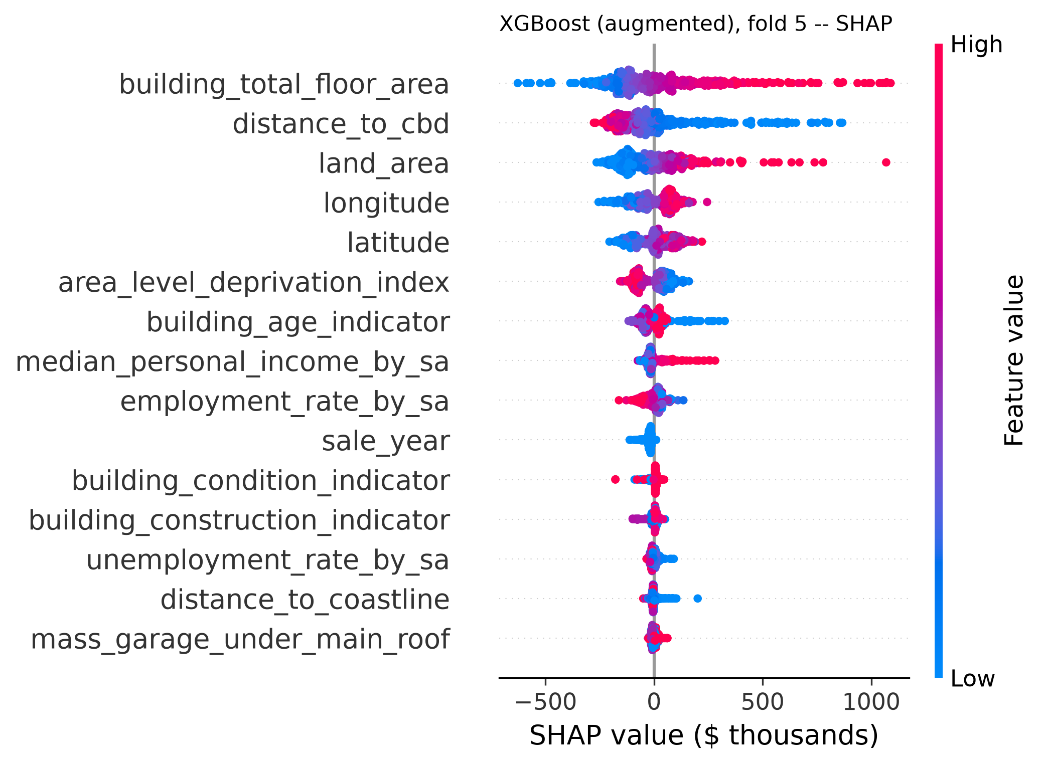
Fig. 4. SHAP summary for the augmented XGBoost model on 500 fold-5 test sales (15 most important features). Each dot is one sale; colour shows the feature’s value.

D. Comparison of five models
Table VI compares the five models on the same 48,777 test sales and the same 27 features. XGBoost is the most accurate on every metric (MAPE 11.0%), followed closely by CatBoost and random forest (11.6%), then the neural network (12.3%). The hedonic regression is clearly the least accurate (15.7%): its RMSE is 44% higher than XGBoost’s. Every one of the four machine learning models beats it, both pooled and in each of the five folds; even the weakest, the neural network, has a lower RMSE than the hedonic model in every fold ($224,206–$275,297 vs $288,480–$323,713). H3 is supported. All four machine learning models train all five folds in under a minute on a CPU, so the accuracy gain costs little.
TABLE VI. All models on the same features and folds, pooled, $n=48,777$. Time is for training all five folds.
Model | RMSE | MAE | MAPE | Time
XGBoost | $212,678 | $127,983 | 10.98% | 4 s
CatBoost | $220,406 | $135,087 | 11.61% | 10 s
Random forest | $228,130 | $134,876 | 11.55% | 14 s
Neural network | $247,526 | $148,230 | 12.29% | 49 s
Hedonic (OLS, log) | $306,564 | $186,708 | 15.72% | 4 s
The tree models most likely win because of how they treat each feature. The hedonic model explains 72.9% of the variance in log price on fold 5’s training data, so it is a reasonable model, but it gives each feature one straight-line effect for the whole city. Tree models can learn that the CBD distance matters a lot near the city and little far away, or that a large section is worth more in some areas than others. The neural network can learn such shapes too, but on tabular data of this size it trails the tree models, as is often seen on such data [40].
The models also agree on what matters. Table VII shows the SHAP share of the leading features in each model, on the same 500 fold-5 test sales. Building floor area is first and distance to the CBD second in all five models. The main difference is that the hedonic model leans more on SA2 income and employment and on building age (8.5–8.9% each): a linear model cannot learn sharp local patterns from latitude and longitude, so it relies on smoother area summaries instead. That five very different models agree on the top features makes these conclusions more trustworthy than any single model’s ranking.
TABLE VII. Share of total mean $|$SHAP$|$ (%) for leading features, same 500 fold-5 test sales. RF = random forest, NN = neural network.
Feature | XGB | CatB | RF | NN | Hedonic
Building floor area | 21.0 | 21.8 | 31.6 | 16.8 | 21.0
Distance to CBD | 15.5 | 14.6 | 18.9 | 16.6 | 11.0
Land area | 12.7 | 14.0 | 13.6 | 11.5 | 3.8
Latitude + longitude | 16.7 | 17.2 | 19.1 | 13.6 | 11.2
Deprivation decile | 6.9 | 8.1 | 3.7 | 7.0 | 3.4
Median income (SA2) | 3.4 | 3.9 | 3.3 | 4.5 | 8.6
Building age | 4.7 | 4.5 | 2.1 | 4.7 | 8.5

E. Accuracy versus interpretability
The hedonic model’s strength is that each coefficient has a one-sentence meaning that holds for every house. On fold 5, for example, each extra $10,000 of median personal income in the SA2 goes with 12.3% higher prices, each kilometre further from the CBD with 1.2% lower prices, each step up the deprivation decile with 1.3% lower prices, and a flood plain location with 1.8% lower prices, all else equal. XGBoost cannot give one number per feature, because a feature’s effect changes from sale to sale. Instead, SHAP gives a dollar breakdown for each prediction. This is the trade-off RQ2 asks about: the machine learning model gives up one global number per feature, but keeps a clear per-sale explanation while cutting the hedonic model’s MAPE by about 30%.
Fig. 5 shows what such a per-sale explanation looks like for one held-out sale from fold 5’s test period: a home sold in June 2026 for $1,285,000. The XGBoost model, trained only on sales up to January 2026, predicted $1,266,131 (1.5% below). Starting from the average prediction of $1,151,033:
- the neighbourhood adds $65,399, mostly from a low deprivation decile (2 of 10, +$71,055);
- location adds $41,119: the home’s latitude (+$85,033) outweighs its 16.9 km distance from the CBD ($−$$63,763);
- the house and land add $26,184: a large floor area (172 m², +$84,080) and a new building (built in the 2020s, about +$34,000) more than offset a small section (186 m², $−$$94,139);
- market timing (a 2026 sale) removes $19,070, and hazards change the price by only $1,469.
With this breakdown, a buyer can see that the price is pushed up mainly by the area and by the large, new house, while the small section pulls it down.
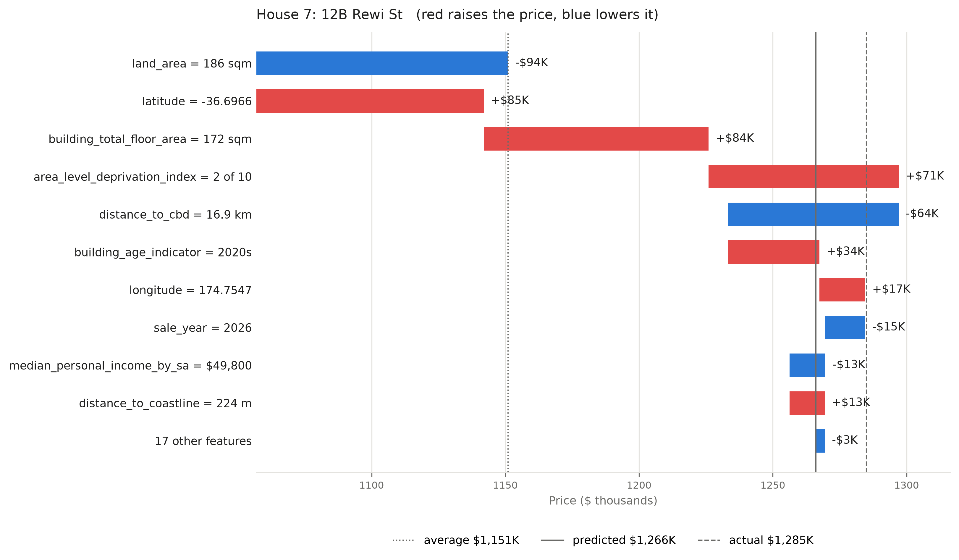
Fig. 5. SHAP explanation of one held-out sale (XGBoost, fold 5). Bars run from the average prediction to the model’s prediction; red raises the price and blue lowers it. Lines mark the average, predicted and actual price.

F. Comparison with online valuation estimates
On the same 45 homes, both online tools are clearly more accurate than our model (Table VIII). homes.co.nz and OneRoof both reach a MAPE of 5.8%, against 9.6% for our model, and they place 51% and 58% of their estimates within 5% of the sale price, compared with 31% of ours. Our model is closer than homes.co.nz on 16 homes and closer than OneRoof on 18, but it beats both tools on only 12 of the 45 homes (27%). Fig. 6 also shows that when it is further away, the difference is often large.
TABLE VIII. Our model vs. two online tools on the same 45 homes (sold 28 July – 18 August 2026; online estimates recorded in early July 2026)
Predictor | MAPE | MAE | $≤$5% | $≤$10%
homes.co.nz | 5.8% | $70,253 | 51% | 78%
OneRoof | 5.8% | $72,917 | 58% | 80%
Ours (to 24 Jan) | 9.6% | $125,720 | 31% | 56%
Ours (to 9 Jul) | 9.9% | $132,675 | 31% | 60%
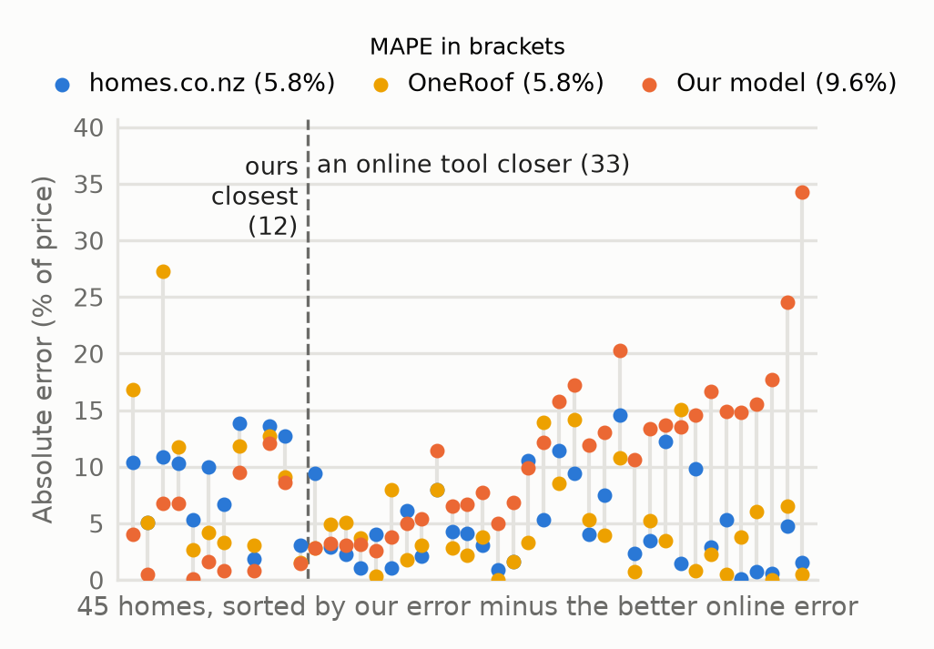
Fig. 6. Absolute error for each of the 45 homes: our model (to 24 Jan), homes.co.nz and OneRoof (both early July). Homes are sorted from where our model does best relative to the better online tool (left) to where it does worst (right); the dashed line separates the 12 homes where ours is closest from the 33 where an online tool is closer.
The per-home results show where our model falls short. Its largest errors are a home it overestimates by 34% and a $4.1M home it underestimates by 25%, near the top of our price range where training sales are few (right end of Fig. 6). Where our model is closer (left end), its margin is usually smaller. These large misses point to details that the council file does not hold, such as interior quality or recent renovations.
This answers the second half of RQ2. Our model is far more accurate than the traditional hedonic approach and explains every prediction in dollars, but it is less accurate than commercial online estimates, which give no reason for their numbers. Closing this gap is the clearest next step: adding property details beyond the council records should improve accuracy while keeping the explanations.

V. Limitations
First, our results cover only part of the market. Because the price filter keeps the middle 98% of each fold’s training prices, the results describe the typical Auckland home and may not hold for the cheapest or most expensive 1% of sales. In addition, record linkage placed 97.6% of the arm’s-length single-home sales. If the missing 2.4% are different from the rest, for example new subdivisions not yet in LINZ, our results could be slightly off for that part of the market. The data also covers only one city over 2024–2026, when the market was flat: the median sale price stayed between $950,000 and $1,020,000 in every quarter. Since tree models cannot extend a price trend into months they have not seen, their predictions would lag in a fast-rising market, and the size of the gain may differ in other cities or periods.
Second, the area data is coarse. The neighbourhood features are 2023 Census and NZDep2023 values for the whole SA2, so every home in an SA2 shares them. They also do not change over 2024–2026, and they describe the area rather than the buyer. Moreover, one SA2 (51 sales) has a recorded median income of $0, probably a census coding issue that we did not correct.
Third, our explanations show what the model relies on, not what causes prices to change. Because location and neighbourhood features overlap, no single importance number should be read as the true value of one feature.
Fourth, we fixed every model’s settings to keep the comparisons fair. This means that a project that only cared about accuracy could tune each model and would likely do somewhat better than every number here.
Lastly, the online benchmark is small. It uses 45 homes from three weeks of sales, mostly in the middle of the market, and two online tools. Therefore, while the direction of the result is clear, the exact size of the gap is uncertain, and other tools (such as propertyvalue.co.nz) may score differently.

VI. Conclusion and Future Work
This paper asked whether Auckland-specific external data improves house price prediction (RQ1), and how an explainable model built on it compares with a traditional hedonic model and free online valuations (RQ2). We built a pipeline from the Auckland Council sales file to a linked dataset: Splink record linkage gave 95.5% of properties a LINZ coordinate, and the coordinate let us attach 16 external features from nine public sources. We then tested the models with time-ordered cross-validation, so every prediction was made from past sales only.
For RQ1, the answer is yes, by a wide and significant margin. Adding the external features cuts XGBoost’s RMSE by 38.1% and MAPE from 19.3% to 11.0% (H1), and a model that sees only external data explains 29.3% of the variance in the errors a property-only model leaves (H2). The reason is simple: two similar houses in different places can sell for very different prices, and only the external features tell the model where a house is and what its area is like.
For the first part of RQ2, all four machine learning models beat a hedonic regression on the same features (H3), most likely because they can learn curved and local effects. XGBoost is the most accurate (MAPE 11.0% vs 15.7%), and it still explains each prediction in dollars through SHAP. For the second part of RQ2, two free online estimates (homes.co.nz and OneRoof) recorded before each sale were more accurate on 45 recent sales (MAPE 5.8% for both vs 9.6%), even after we retrained our model up to the same date. Public council and area data bring our model within about 4 MAPE points of commercial estimates; closing the rest seems to need richer data about the house itself. Even so, our model offers something the online tools do not: for each price, a SHAP waterfall chart (Fig. 5) shows which features raised or lowered it and by how much, so a buyer can see why a home is valued as it is. A buyer could use the two together, taking the online estimate as the number and our explanation as the reason behind it.
The clearest practical finding is that most of the value of external data is the value of location. Distance to the CBD and the coordinates carry the largest share; area census and deprivation statistics are useful but mostly repeat what location already says; and flood, noise and building-activity features add almost nothing to a city-wide model. For a team building a similar model with limited time, an accurate coordinate (here, good record linkage) and a few location measures are worth more than many extra area features.
The main drawbacks are that the model is less accurate than commercial online estimates and misses most on unusual homes, that area data is coarse and fixed in time, and that SHAP shows association, not cause. If this work continued as a master’s project, we would: (1) repeat the online benchmark on a larger sample and several tools, recording estimates for homes as they are listed, and test whether listing data (photos, descriptions) closes the gap; (2) tune each model and add a prediction interval (for example with quantile regression or conformal prediction), so the buyer sees a price range instead of one fixed price; (3) test whether hazards matter more in the parts of Auckland where they are common, using location–feature interaction methods such as GeoShapley [41]; and (4) add school enrolment zones and recent nearby sales, built only from earlier sales [16].

Contributions
Larger tasks, such as preparing the external features and gathering the online estimates, were split into smaller parts shared between members.
Dominik Wecke: Designed the methodology and project plan; prepared, filtered and cleaned the Auckland Council data; performed the Splink record linkage; gathered the online valuation estimates; contributed to the results analysis; wrote the Methodology section.
Huy Nguyen: Led the literature review; produced data visualisations; coded and trained the random forest model; wrote the Introduction and Related Work sections.
Jiayi Du: Prepared external data; analysed the data; coded and trained the CatBoost model; performed the error analysis; co-wrote the Experiments and Results section.
Thao Nguyen: Built the data processing pipeline; prepared external features; trained the XGBoost model; gathered the online valuation estimates and compared them with our model; wrote the Limitations and the Conclusion and Future Work sections.
Xiang Yang: Prepared external features; experimented with the neural network; studied the hedonic model; analysed the results and produced the SHAP explanations; co-wrote the Experiments and Results section.

References
[1] O. Samarasinghe and B. Sharp, “Flood prone risk and amenity values: A spatial hedonic analysis,” Aust. J. Agricultural Resource Econ., vol. 54, no. 4, pp. 457–475, 2010.
[2] M. Rehm and O. Filippova, “The impact of geographically defined school zones on house prices in New Zealand,” Int. J. Housing Markets Anal., vol. 1, no. 4, pp. 313–336, 2008.
[3] M. Rehm, “Judging a house by its cover: Leaky building stigma and house prices in New Zealand,” Int. J. Housing Markets Anal., vol. 2, no. 1, pp. 57–77, 2009.
[4] V. Sequeira and O. Filippova, “Does concentration of social housing influence house prices? Evidence from New Zealand,” Int. J. Housing Markets Anal., vol. 14, no. 4, pp. 720–744, 2021, doi: 10.1108/IJHMA-04-2020-0032.
[5] G. Shmueli, “To explain or to predict?” Stat. Sci., vol. 25, no. 3, pp. 289–310, 2010, doi: 10.1214/10-STS330.
[6] M. Čeh, M. Kilibarda, A. Lisec, and B. Bajat, “Estimating the performance of random forest versus multiple regression for predicting prices of the apartments,” ISPRS Int. J. Geo-Inf., vol. 7, no. 5, p. 168, 2018.
[7] S. An, Y. Song, H. Jang, and K. Ahn, “Toward transparent and accurate housing price appraisal: Hedonic price models versus machine learning algorithms,” Financial Innov., vol. 11, no. 1, p. 141, 2025.
[8] S. M. Lundberg and S.-I. Lee, “A unified approach to interpreting model predictions,” in Proc. Adv. Neural inf. Process. Syst. (NeurIPS), 2017, pp. 4765–4774.
[9] Ministry of Justice Analytical Services, “Uk_address_matcher: Address matching with Splink.” 2026. Available: https://moj-analytical-services.github.io/uk_address_matcher/
[10] R. Linacre, S. Lindsay, T. Manassis, Z. Slade, and T. Hepworth, “Splink: Free software for probabilistic record linkage at scale,” Int. J. Popul. Data Sci., vol. 7, no. 3, 2022, doi: 10.23889/ijpds.v7i3.1794.
[11] S. Rosen, “Hedonic prices and implicit markets: Product differentiation in pure competition,” J. Political Econ., vol. 82, no. 1, pp. 34–55, 1974.
[12] S. C. Bourassa, E. Cantoni, and M. Hoesli, “Spatial dependence, housing submarkets, and house price prediction,” J. Real Estate Finance Econ., vol. 35, no. 2, pp. 143–160, 2007.
[13] N. Bui, L. Wen, and B. Sharp, “House prices and flood risk exposure: An integration of hedonic property model and spatial econometric analysis,” J. Real Estate Finance Econ., vol. 69, no. 1, pp. 100–131, 2024.
[14] E. A. Antipov and E. B. Pokryshevskaya, “Mass appraisal of residential apartments: An application of random forest for valuation and a CART-based approach for model diagnostics,” Expert Syst. Appl., vol. 39, no. 2, pp. 1772–1778, 2012.
[15] T. Chen and C. Guestrin, “XGBoost: A scalable tree boosting system,” in Proc. 22nd ACM SIGKDD int. Conf. Knowl. Discovery data mining, 2016, pp. 785–794.
[16] A. Soltani, M. Heydari, F. Aghaei, and C. J. Pettit, “Housing price prediction incorporating spatio-temporal dependency into machine learning algorithms,” Cities, vol. 131, p. 103941, 2022.
[17] F. Trindade Neves, M. Aparicio, and M. de Castro Neto, “The impacts of open data and eXplainable AI on real estate price predictions in smart cities,” Appl. Sci., vol. 14, no. 5, p. 2209, 2024.
[18] H. Lee, H. Han, and C. Pettit, “Capturing the distance decay effect of amenities on housing price using explainable artificial intelligence,” Appl. Geogr., vol. 174, p. 103486, 2025.
[19] Y. Chen, Y. Ye, X. Liu, C. Yin, and C. A. Jones, “Examining the nonlinear and spatial heterogeneity of housing prices in urban Beijing: An application of GeoShapley,” Habitat Int., vol. 162, p. 103439, 2025.
[20] Auckland Council, “District valuation roll and property sales data (DVR and DVRS files).” Auckland Council, Auckland, New Zealand, 2026.
[21] Land Information New Zealand, “NZ addresses.” LINZ Data Service, 2026. Available: https://data.linz.govt.nz
[22] Ministry of Justice Analytical Services, “Splink: Probabilistic record linkage documentation.” Available: https://moj-analytical-services.github.io/splink/
[23] I. P. Fellegi and A. B. Sunter, “A theory for record linkage,” J. Amer. Stat. Assoc., vol. 64, no. 328, pp. 1183–1210, 1969.
[24] Ministry of Education, “New Zealand schools directory.” Education Counts, 2026. Available: https://www.educationcounts.govt.nz
[25] Land Information New Zealand, “NZ coastline.” LINZ Data Service, 2026. Available: https://data.linz.govt.nz
[26] OpenStreetMap contributors, “OpenStreetMap New Zealand extract.” Geofabrik, 2026. Available: https://download.geofabrik.de
[27] Auckland Transport, “GTFS static timetable data.” Auckland Transport, 2026. Available: https://at.govt.nz
[28] J. Atkinson, C. Salmond, and P. Crampton, “NZDep2023 index of deprivation,” Department of Public Health, University of Otago, Wellington, New Zealand, 2024.
[29] Stats NZ, “Statistical area 2 2025 (generalised).” Stats NZ Geographic Data Service, 2025. Available: https://datafinder.stats.govt.nz
[30] Stats NZ, “2023 Census totals by topic for individuals by Statistical Area 2.” Stats NZ, 2024. Available: https://datafinder.stats.govt.nz
[31] Auckland Council, “Flood plains and Unitary Plan aircraft noise overlay.” Auckland Council Open Data, 2026. Available: https://data-aucklandcouncil.opendata.arcgis.com
[32] Stats NZ, “Building consents issued.” Stats NZ, 2026. Available: https://www.stats.govt.nz
[33] L. Breiman, “Random forests,” Mach. Learn., vol. 45, no. 1, pp. 5–32, 2001.
[34] L. Prokhorenkova, G. Gusev, A. Vorobev, A. V. Dorogush, and A. Gulin, “CatBoost: Unbiased boosting with categorical features,” in Proc. Adv. Neural inf. Process. Syst. (NeurIPS), 2018.
[35] D. P. Kingma and J. Ba, “Adam: A method for stochastic optimization,” in Proc. Int. Conf. Learn. Represent. (ICLR), 2015.
[36] N. Duan, “Smearing estimate: A nonparametric retransformation method,” J. Amer. Stat. Assoc., vol. 78, no. 383, pp. 605–610, 1983.
[37] B. Efron and R. J. Tibshirani, An introduction to the bootstrap. New York, NY, USA: Chapman & Hall, 1993.
[38] homes.co.nz, “HomesEstimate property value estimates.” 2026. Available: https://homes.co.nz
[39] OneRoof, “OneRoof property value estimates.” 2026. Available: https://www.oneroof.co.nz
[40] L. Grinsztajn, E. Oyallon, and G. Varoquaux, “Why do tree-based models still outperform deep learning on typical tabular data?” in Proc. Adv. Neural inf. Process. Syst. (NeurIPS), datasets and benchmarks track, 2022.
[41] Z. Li, “GeoShapley: A game theory approach to measuring spatial effects in machine learning models,” Ann. Amer. Assoc. Geographers, vol. 114, no. 7, pp. 1365–1385, 2024, doi: 10.1080/24694452.2024.2350982.

https://github.com/hugn456/COMPSCI_760_Group_3_Intelligent_Real_Estate_Price_Prediction_Model

