Hugo Vega Hernandez

CSD310-H306 Database Development and Use

5.2 Assignment, 06/21/2024

LEFT() function - extracts a number of characters from a string (starting from left).

This removes however many characters you want from the string. You would use this to select only a certain number of letters or display a specific name or letters.

RIGHT () function - extracts a number of characters from a string (starting from right).

This removes however many characters you want from the string. You would use this to select only a certain number of letters or display a specific name or letters.

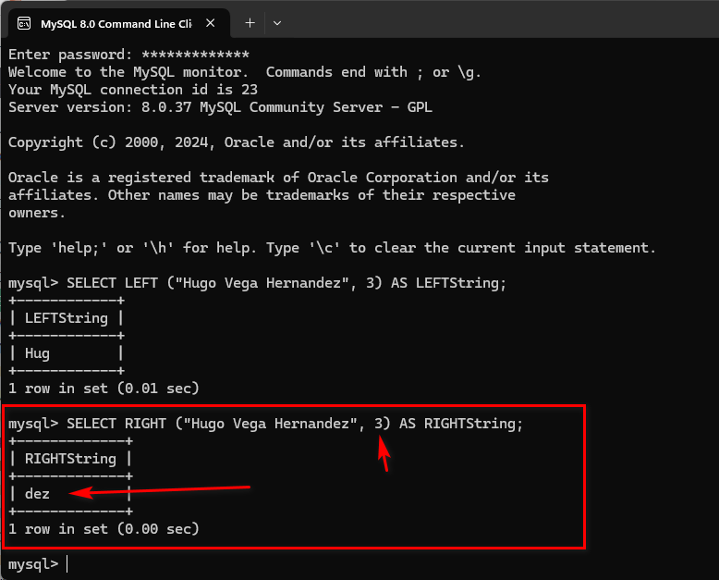

TRIM function - Removes leading or trailing spaces in a string.

Trim() is basically a function to remove spaces. You would use this when you have too many spaces within your code. It helps clean up your strings.

