Prob3_MA568

Hengchang Hu

11/3/18

#### 1.Plot the animal’s movement trajectory with its position at the spike times for each neuron overlaid.

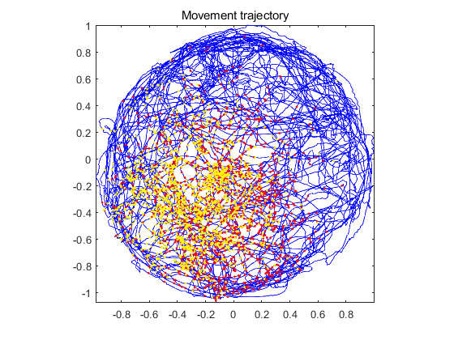

#### From the plot, we can see that the two neurons are basically tuned at the same position at the center of this plot. When x is between -0.4 and 0, y is between -0.8 and 0, these two neurons are most likely to spike.

#### 2.Use the above GLM command to fit the exponential linear model in equation (1) to the spikes data. Are all of the resulting parameter estimates significant? Plot the maximum likelihood model intensity as a function of (x, y) position. How well does this capture the spatial firing properties of the neuron?

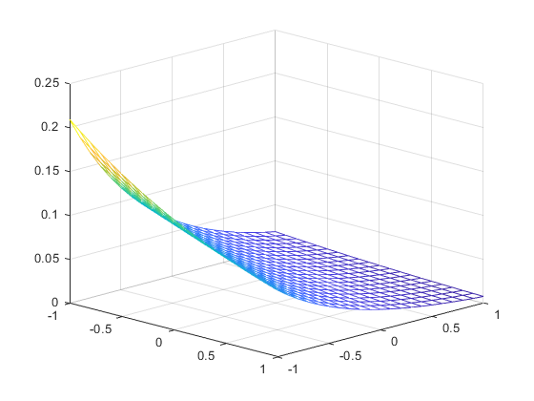

#### By using command [b, dev1, stats] = glmfit ([xN yN], spikes, ‘poisson’), we can get from matlab that p-value is [0; 8.481741076741080e-27; 3.852396449328239e-153]. So all of the resulting parameter estimates are significant. This model follows the trend that firing rate goes up when x value and y value decrease. However, when x value and y value are smaller and smaller, the firing rate should go down instead of increasing continuously. So we may need to add quadratic functions of xN and yN.

#### 3.One way to improve on this exponential linear model is to add quadratic functions of xN and yN. Write down and fit a GLM model containing all terms of quadratic and smaller order. Are all of the maximum likelihood estimates for this model significant? Plot the maximum likelihood model intensity as a function of (x, y) position. Does this improve the description of the spatial firing properties of the neuron? Compute the AIC (dev + 2 * (number of parameters)) values for the exponentiated linear and quadratic models. Which model describes the data better?

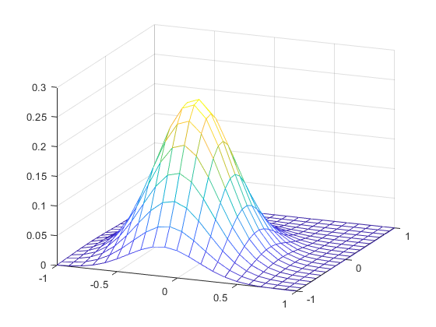

#### By using command [b, dev2, stats] = glmfit ([xN yN xN.*xN yN.*yN xN.*yN], spikes, ‘poisson’), we can get from matlab that p-value is [0; 2.65e-35; 3.86e-126; 1.15e-188; 1.68e-162; 0.6196]. Therefore, xN.*yN term is not significant and the rest are all significant. So we can remove xN.*yN term. This quadratic model does improve the description of the spatial firing properties because the firing rate reach the maximum value when x value and y value are slightly negative and when they become more negative the firing rate goes down. And we can get the AIC value from AIC1 = dev1 + 2 * 3 = 11394, and AIC2 = dev2 + 2 * 6 = 9153. Therefore, the quadratic model describes the data better than the exponentiated linear.

#### 4.The spikes_hist matrix contains the spiking history at each point in time in 1 ms bins going back 20 ms. spikes_hists (:, 1:p) would contain the history going back p ms. For p = 0 to 20, fit GLM model and plot the AIC as a function of p. What is the optimal model order?

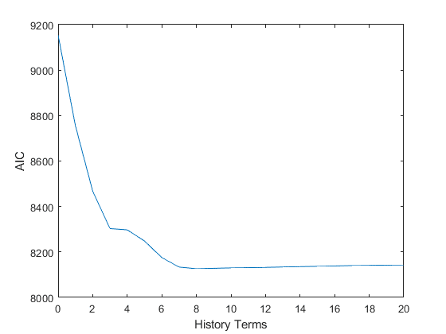

#### From the plot we can see that AIC value is smallest when history goes back 8 ms. So the optimal model will have constant term, 2 linear terms, 2 quadratic terms and 8 history terms.

**5.Augment GLM model from question 4 to include the past spiking history of the other recorded neuron. Are any of the parameters associated with these spiking interactions significant? Which of your models is most parsimonious?**

#### By using command [b, dev, stats] = glmfit ([X spikes_hist (: , 1:8) spikes2_hist], spikes, ‘poisson’) and check the p values, we can know that all parameter estimates about history of the other recorded neuron are non-significant. So the 2 neuron should not have interaction term. The optimal model will still be same as question 4.

#### 6.Assume we didn’t know that these neurons were tuned to position. Fit the GLM model with only history and network interaction components. Are the parameters related to the network interactions now significant? Explain why the interaction terms might be significant only when we fail to model the spatial component of the firing activity.

#### By using command [b, dev, stats] = glmfit ([spikes_hist (: , 1:8) spikes2_hist], spikes, ‘poisson’), we can see that all p values are smaller than 0.05, i.e. all interaction parameters become significant when we remove position information. Early in question 1 we already found that the place where these two neurons are most likely to fire are highly overlapping, so we can actually use the spiking activity of one neuron to predict the other neuron.

#### 7.For the most parsimonious model you have constructed, construct a KS plot based on time rescaling of the interspike intervals. How well does this model capture the observed spiking activity?

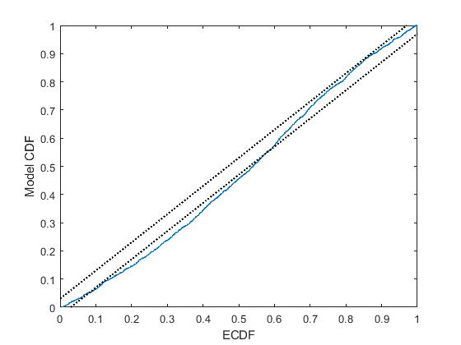

#### From the plot we can see that the most parsimonious model does not completely pass the KS test, so there may be some other structures that we do not capture. However, the KS statistics is very small so that we can claim that this model is a fairly good model.