**Chun Ho Cheng – 101177455**

**Git Repo:** [**https://github.com/hugo990126/comp3005_project**](https://github.com/hugo990126/comp3005_project)

**Demo videos(playlist):** [comp3005_project - YouTube](https://www.youtube.com/playlist?list=PLhCOTlHzQYQV-N0CXnyyuezSNr9wrDS6u)

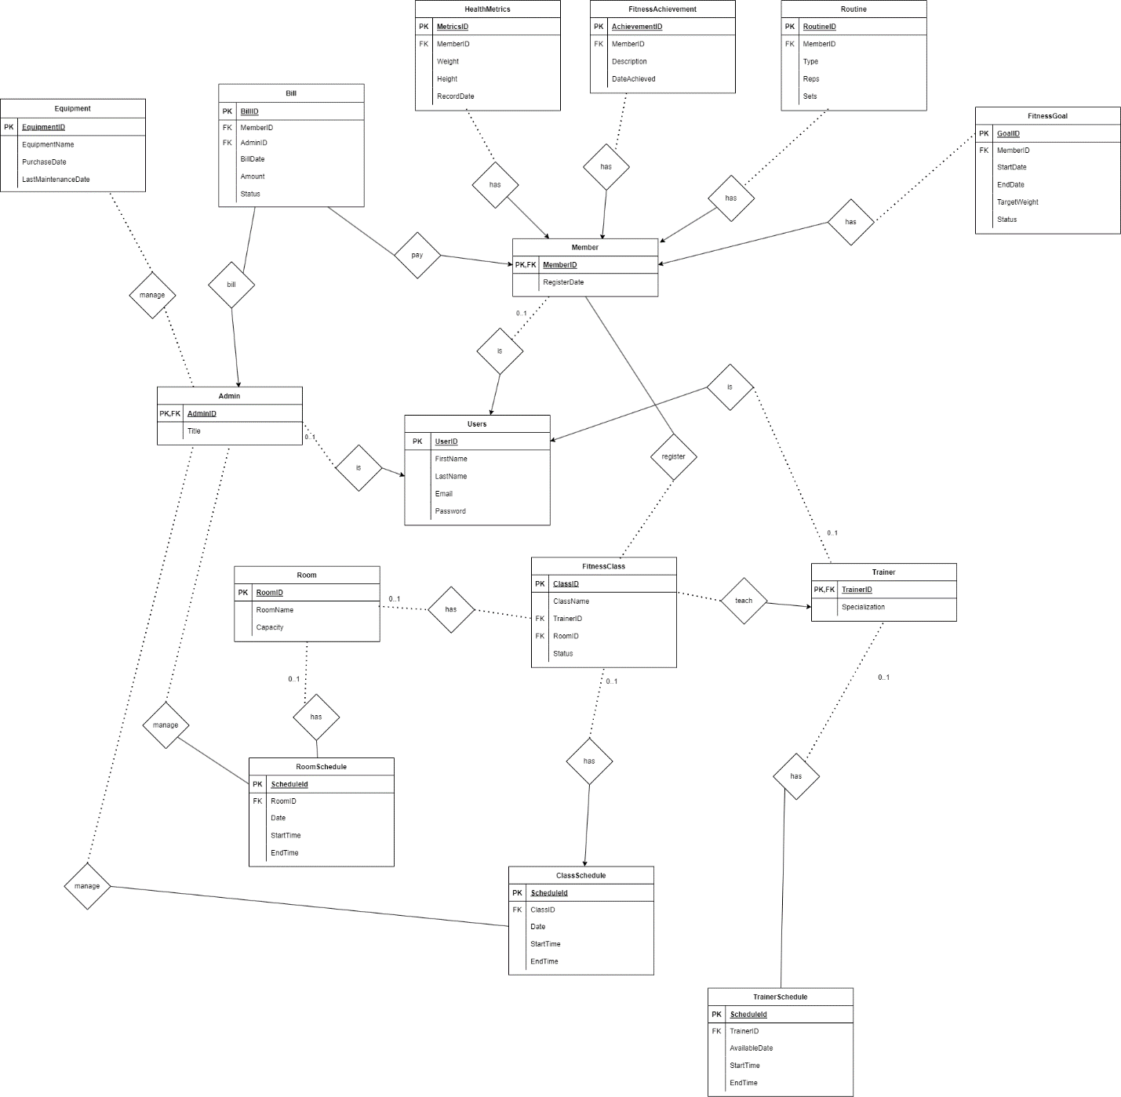

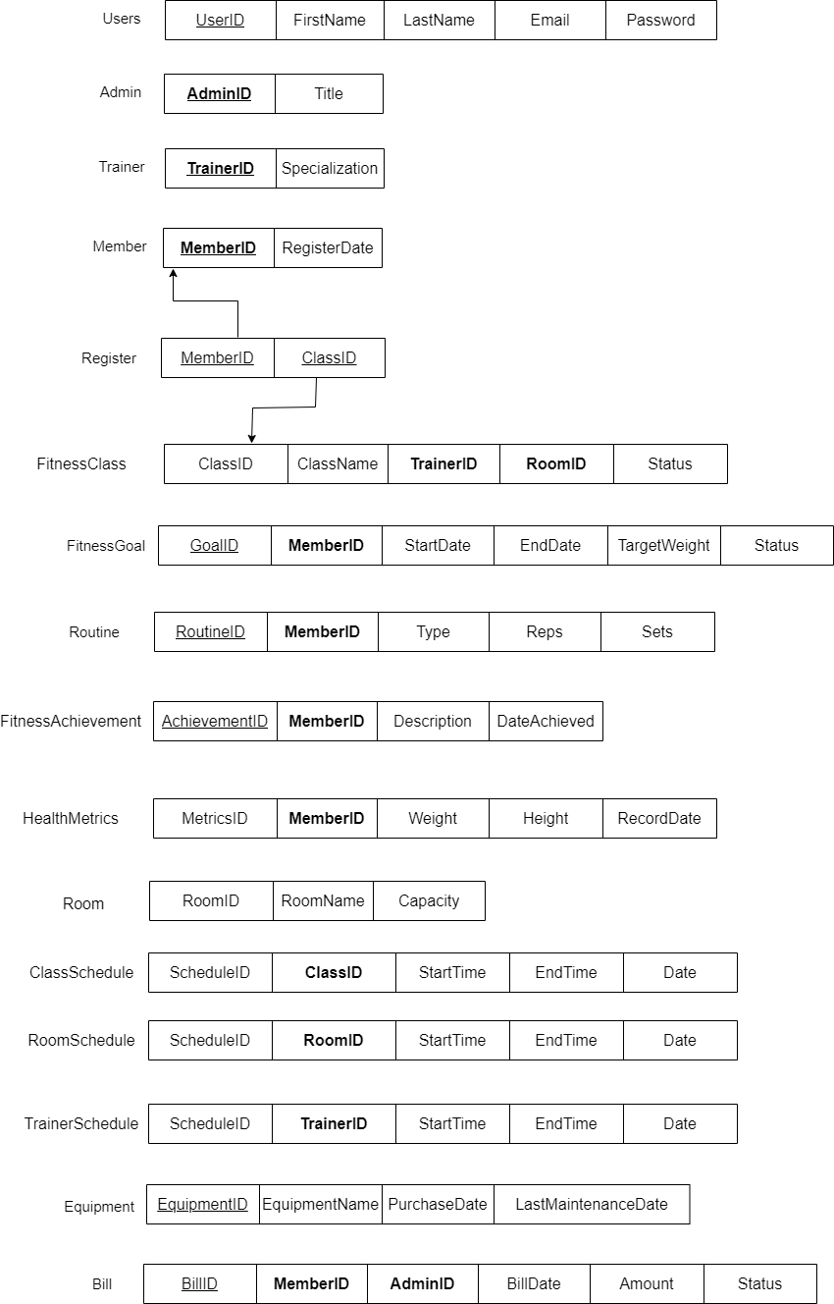

Assumptions:

* Dotted lines or ER-diagram are partial participation (cardinality is 0 to many if not specify).
* Everyone is a user, either a member, admin, or trainer.
* A user can be both a trainer and an admin at the same time.
* 1 bill is handled by exactly 1 admin.
* TrainerSchedule stores time slots representing the trainer is available instead of busy.
* Members reschedule a personal training session by canceling the session and booking a new one.
* Payment is made in person, recorded by admin, then updated in the database.