Lab 03. Concurrency and synchronization

Hugo Hernandez

CSCI 4334: Operating Systems

Wendy Aracely Sanchez Gomez

05/03/2026

Background and objective
  - Slides shared by the instructor.
  - https://www.youtube.com/playlist?list=PLfqABt5AS4FmuQf70psXrsMLEDQXNkLq2
Objective: To understand the lifecycle of POSIX threads and implement synchronization mechanisms, such as Mutexes and Semaphores, to manage shared memory and resolve concurrency conflicts (Race Conditions) in a Linux environment.

Lab procedure

Part I: Thread Fundamentals and Lifecycle
Step 1. Open a terminal on Linux ("Ctrl + Alt + T").
Step 2. Creating your first threadnao
In this step, we introduce the POSIX Threads library. Creating a thread is different from a regular function call. When you call a function normally, the program waits for it to finish. When you create a thread, the program starts the function in the background and immediately moves to the next line of code.
- Open your terminal and create a new file named pthread01.c using the nano editor by typing:
nano pthread01.c

- Type or paste the following code into the editor:
#include <stdio.h>
#include <pthread.h> // Header for POSIX threads

// This is the function the thread will execute.
// It must return void* and take void* as an argument. void *work() {
printf("Hello world!\n"); return NULL;
}
int main(int argc, char **argv) {
// Declare a variable to hold the Thread ID pthread_t thread1;
/* Create the thread using pthread_create: Arguments:
- &thread1: Pointer to the thread identifier.
- NULL: Thread attributes (NULL means default attributes).
- work: The name of the function to be executed by the thread.
- NULL: Arguments passed to the 'work' function (none in this case).
*/
pthread_create(&thread1, NULL, work, NULL);
// The program reaches this point immediately after starting the thread.
// If it exits here, the new thread is destroyed instantly. return 0;

}
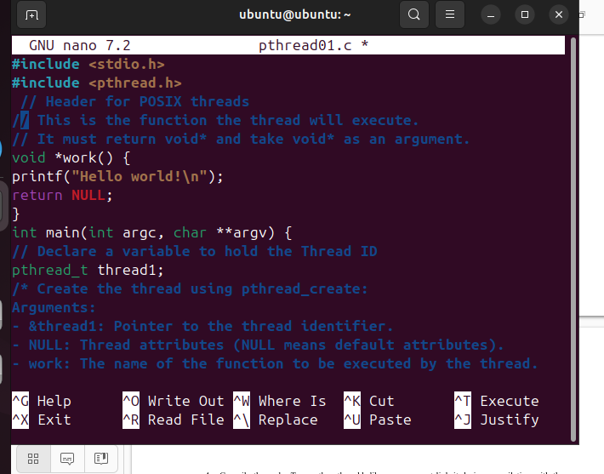

- Save and Exit nano:
  - Press Ctrl + O then Enter to save (Write Out).
  - Press Ctrl + X to exit the editor.

- Compile the code: To use the pthread.h library, you must link it during compilation with the - pthread (or -lpthread) flag:
gcc -pthread pthread01.c -o pthread01

- Run the program:
./pthread01

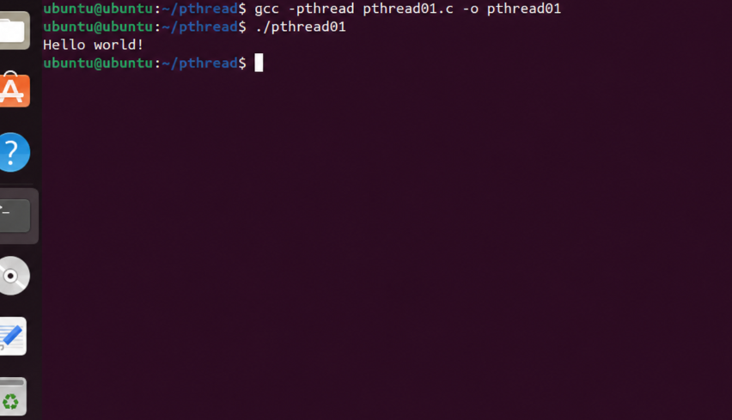

Step 3. Preventing premature exit with sleep
In the previous step, the program likely finished before the thread had a chance to execute. This is because the main thread does not wait for other threads unless explicitly told to do so.
To fix this temporarily, we will use the sleep() function (from the <unistd.h> library) to force the main thread to wait, giving our new thread enough time to print its message.
- Modify the file using the following code:
#include <stdio.h> #include <pthread.h>
#include <unistd.h> // Essential library for the sleep() function
// void* is the mandatory return type for thread functions in C. void *work() {
printf("Hello world! (from the created thread)\n"); return NULL;
}
int main(int argc, char **argv) { pthread_t thread1;
// Creating the thread
// The main process will NOT wait for 'work' unless we force it. pthread_create(&thread1, NULL, work, NULL);
/* THE FIX: We force the main thread to pause for 5 seconds.
This keeps the process alive long enough for the thread to reach the CPU and execute its printf statement.
*/ sleep(5);
printf("Main thread is now exiting after waiting 5s.\n"); return 0;
}

What happened during those 5 seconds? The main thread is blocked (sleeping), but the process remains alive, allowing the work thread to finish its task.

Question: Is sleeping for a fixed amount of time an efficient way to synchronize threads? What if the task takes 6 seconds? We will solve this in the next step.

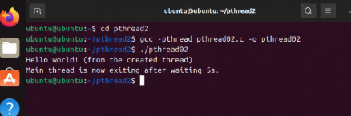
Step 4. Proper Synchronization using pthread_join
Using sleep() in the main thread (as we did in Step 3) is a poor solution because we don't always know how long a thread will take to finish.
The professional way to synchronize is using pthread_join. This function acts as a "waiting station": it blocks the main thread and prevents it from exiting until the specific thread (in this case, thread1) has finished its execution.
#include <stdio.h> #include <pthread.h> #include <unistd.h>

void *work() {
// Now the thread is the one that takes time to finish sleep(5);
printf("Hello world!\n"); return NULL;
}
int main(int argc, char **argv) { pthread_t thread1;

pthread_create(&thread1, NULL, work, NULL);
/* THE SOLUTION: pthread_join
The main thread will stop here and wait for 'thread1' to terminate. Arguments:
- thread1: The ID of the thread we are waiting for.
- NULL: A pointer to receive the return value (not used here).
*/
pthread_join(thread1, NULL);

printf("Main thread exiting cleanly after thread1 finished.\n"); return 0;
}
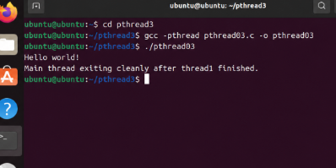
What changed? In Step 3: The main thread was "blindly" sleeping, hoping the other thread would finish. In Step 4: The main thread is now waiting specifically for thread1.
Even though work sleeps for 5 seconds, the program will exit immediately after the "Hello world!" is printed. This is efficient synchronization.
Note that pthread_join is the thread equivalent of the wait() system call used for processes (fork).

Step 5. Monitoring Threads in the OS
Now that we know how to synchronize threads, let's see how the Operating System views them. Although threads share the same Process ID (PID), each thread has its own Thread ID (TID). In this step, we will use the getpid() function to find the process ID and a Linux command to list the active threads.
- Update the code to include PID reporting and a longer sleep:

#include <stdio.h> #include <pthread.h> #include <unistd.h>

void *work() {
// We use 10 seconds to give you time to run the 'ps' command sleep(10);
printf("Hello world!\n"); return NULL;
}

int main(int argc, char **argv) { pthread_t thread1;
int ret;

// getpid() returns the ID assigned by the OS to this process printf("Process ID: %d\n", getpid());
printf("Before creation of thread\n");
ret = pthread_create(&thread1, NULL, work, NULL); if (ret == 0)
printf("Thread created successfully\n");
else
printf("Problem in creating thread\n");

pthread_join(thread1, NULL); printf("Thread terminated\n");
return 0;
}

- While the program is running and "sleeping", quickly open a second terminal (Ctrl + Alt + T). Look at the Process ID printed in your first terminal (e.g., Process ID: 3228). In the new terminal, run the following command (replace 3228 with your actual PID):
ps –T –p 3228

What to look for in the output?
In the second terminal, you should see two entries under the same PID: the main thread (usually identified by the same number as the PID) and the work thread (with a different TID).
This proves that even though it looks like one program, the OS is managing two separate execution entities (LWP - Light Weight Processes) simultaneously.

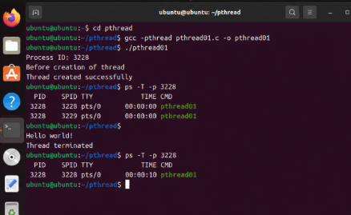
Step 6. Managing Multiple Threads
One of the main advantages of threads is the ability to launch multiple tasks simultaneously. In this step, we will create two separate threads that execute the same work function.
Note that we now need two pthread_t variables and, most importantly, two pthread_join calls. The main thread will wait for thread1 to finish and then for thread2. If thread1 is already done when the first join finishes, the second join will return immediately.
- Update the code to handle two threads:
#include <stdio.h>

#include <pthread.h> #include <unistd.h>
void *work() {
// Both threads will sleep for 10 seconds sleep(10);
printf("Hello world!\n"); return NULL;
}

int main(int argc, char **argv) {
// We declare two thread identifiers pthread_t thread1, thread2;

printf("Process ID: %d\n", getpid());

// Launching both threads almost simultaneously pthread_create(&thread1, NULL, work, NULL); pthread_create(&thread2, NULL, work, NULL);

// The main thread waits for BOTH to finish pthread_join(thread1, NULL); pthread_join(thread2, NULL);
printf("All threads have terminated. Exiting.\n"); return 0;
}

- While the program is running, go to your second terminal. Run the command again with the new PID:
ps -T -p [YOUR_NEW_PID]

What to look for in the output?
You should now see three rows in the ps command output:
  - The main thread.
  - Thread 1 (Executing work).
  - Thread 2 (Executing work).
Both threads sleep for 10 seconds. Does the total execution time of the program become 20 seconds (10 + 10) or stay around 10 seconds?
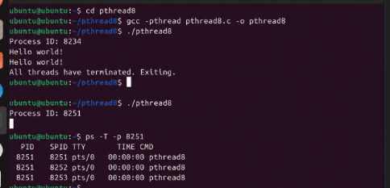

Step 7. Executing Different Tasks Simultaneously
In a real-world application (like a web browser), one thread might be downloading a file while another is rendering the user interface. To simulate this, we will now assign a different function to each thread.
Although both functions currently just sleep and print, they represent independent tasks that the Operating System will manage in parallel.
- Update the code with two distinct functions:
// Function for Thread 1 void *work() {
sleep(10);
printf("Hello world 1! (Task A finished)\n"); return NULL;
}
// Function for Thread 2 void *work2() {
sleep(10);
printf("Hello world 2! (Task B finished)\n"); return NULL;
}
int main(int argc, char **argv) { pthread_t thread1, thread2;
printf("Process ID: %d\n", getpid());
// Launching thread1 to execute 'work' pthread_create(&thread1, NULL, work, NULL);

// Launching thread2 to execute 'work2' pthread_create(&thread2, NULL, work2, NULL);

// Wait for both to complete pthread_join(thread1, NULL); pthread_join(thread2, NULL);

printf("Both different tasks are done. Exiting.\n"); return 0;
}
#include <stdio.h> #include <pthread.h> #include <unistd.h>

Does 'Hello world 1' always appear before 'Hello world 2'?
Not necessarily. Since they run concurrently and have the same sleep time, the order depends on the OS Scheduler.

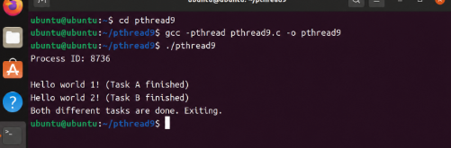

Part II: Threads vs. Processes – Memory Architecture
Step 8. Processes vs. Threads: Implementation
Now that you know how to create threads, we will compare them with processes.
  - Processes: When you use fork(), the OS creates a near-exact copy of the parent process. They have separate memory spaces.
  - Threads: When you create threads, they live inside the same process and share the same memory.
In this step, we will write two separate small programs to observe these two different ways of achieving concurrency.
- Create the Process program:
nano processes.c
#include<stdlib.h> #include<stdio.h> #include<unistd.h>

#include<sys/wait.h> #include<sys/types.h>
int main(int argc, char* argv[])
{
// fork() creates a new child process int pid = fork();
if (pid == -1) return 1;
// Both parent and child will execute this line printf("Hello from processes\n");

// Parent waits for the child to finish if(pid != 0) wait(NULL);
return 0;
}

- Create the Thread program:
nano threads.c
#include<stdlib.h> #include<stdio.h> #include<unistd.h> #include<pthread.h>
// Function for the threads to execute void* routine() {
printf("Hello from threads\n"); return NULL;
}

int main(int argc, char* argv[])
{
pthread_t t1, t2;
// Creating two threads within the same process pthread_create(&t1, NULL, &routine, NULL); pthread_create(&t2, NULL, &routine, NULL);
// Waiting for both threads pthread_join(t1, NULL); pthread_join(t2, NULL);
return 0;
}

- Compile and run both:
gcc processes.c -o processes
./processes
gcc -pthread threads.c -o threads
./threads

What to observe?
  - The Processes program results in 2 messages total (Parent and Child).
  - The Threads program results in 2 messages total (Thread 1 and Thread 2).

  - Visually, they look similar, but in the next steps, we will prove that Threads share variables while Processes do not.
fork() returns twice (once in the parent, once in the child), whereas pthread_create only starts a specific function in a new thread.

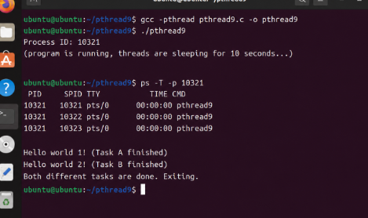

Step 9. Verifying Process IDs (PIDs)
The function getpid() returns the unique identifier that the Operating System assigns to a process.
  - In the Process program, fork() creates a new process, so we expect to see two different PIDs.
  - In the Thread program, hilos are just execution units within the same process, so we expect to see the same PID for both.

- Modify the Process program:
#include<stdlib.h> #include<stdio.h> #include<unistd.h> #include<sys/wait.h> #include<sys/types.h>

int main(int argc, char* argv[])
{
int pid = fork();
if (pid == -1) return 1;

// Printing the PID of the current execution flow printf("Process PID: %d\n", getpid());
if (pid != 0) wait(NULL); return 0;
}

- Modify the Thread program:
#include<stdlib.h> #include<stdio.h> #include<unistd.h> #include<pthread.h>
void* routine() {
// Printing the PID of the process that owns this thread printf("Thread belonging to PID: %d\n", getpid()); return NULL;
}

int main(int argc, char* argv[])
{
pthread_t t1, t2;
// Both threads will execute the same 'routine' pthread_create(&t1, NULL, &routine, NULL); pthread_create(&t2, NULL, &routine, NULL);
pthread_join(t1, NULL); pthread_join(t2, NULL);

return 0;
}

Even though threads share the same PID, the OS still distinguishes them internally with a TID (Thread ID), as they saw in Step 5 with the ps command.

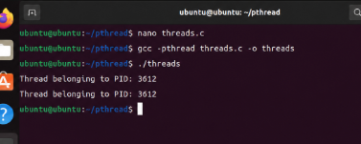
Step 10. Memory Isolation in Processes
When a process is forked, the Operating System creates a copy of the parent's memory for the child. This means that variables like x are no longer shared; each process has its own private version of x.
In this step, we will increment x only in the child process (pid == 0). If memory were shared, both would see the change. If it is isolated, only the child will show the incremented value.
- Modify the Process program:
#include<stdlib.h> #include<stdio.h> #include<unistd.h> #include<sys/wait.h> #include<sys/types.h>

int main(int argc, char* argv[])
{
int x = 2; // Local variable int pid = fork();

if (pid == -1) return 1;

// Only the child process increments x if (pid == 0) {
x++;
printf("Child is incrementing x...\n");
}

// We sleep for 2 seconds to ensure both processes exist at the same time sleep(2);

printf("Process id: %d | Value of x: %d\n", getpid(), x);

// Parent waits for child if (pid != 0) wait(NULL);
return 0;
}

What happened?
Even though x was 2 for both at the start, once the fork() happened, they became two separate "worlds". The child (PID 5002) sees x = 3. The parent (PID 5001) still sees x = 2.
Processes do not share memory. Changing a variable in one does not affect the other.

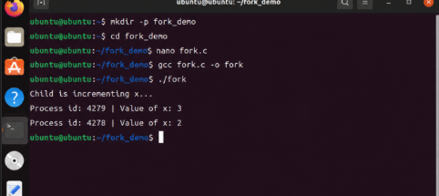

Step 11. Global Variables in Processes

Does moving the variable outside of main make it shared between processes? No. When fork() is called, the entire address space is duplicated. This includes: the Stack (local variables), the Heap (dynamic memory), and the Static/Data segment (global variables).
Each process still gets its own independent copy of the global variable x.
- Modify the code:
#include<stdlib.h> #include<stdio.h> #include<unistd.h> #include<sys/wait.h> #include<sys/types.h>

// x is now a GLOBAL variable int x = 2;

int main(int argc, char* argv[])
{
int pid = fork();
if (pid == -1) return 1;

// Increment only in the child process if (pid == 0) {
x++;
}

sleep(2);

// Each process will print its own version of the global 'x' printf("Process id: %d | Global x: %d\n", getpid(), x);
if (pid != 0) wait(NULL); return 0;
}

Even though x is global, the output is identical to Step 10.
The Reason, a fork() creates a complete clone. The child process has its own global x at the same memory address as the parent, but in a different physical RAM location. Global variables do not facilitate communication between processes.
Processes are like two different computers. Now let's see how threads behave; they are like two people sharing the same desk.
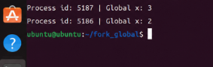

Step 12. Shared Memory in Threads
Unlike processes, threads live within the same address space. This means they share the same global variables. In this code, Thread 1 executes routine() and increments the global variable x. Thread 2 executes routine2(), which only prints the value of x. Because they share memory, Thread 2 will see the modification made by Thread 1.
- Modify your thread program:
#include<stdlib.h> #include<stdio.h> #include<unistd.h> #include<pthread.h>

// Global variable shared by all threads in this process int x = 2;

void* routine() {
x++; // Incrementing the shared variable sleep(2);
printf("Thread 1 (routine) sees x as: %d\n", x); return NULL;
}
void* routine2() {
// This thread does not increment x, but it will see the change sleep(2);
printf("Thread 2 (routine2) sees x as: %d\n", x); return NULL;
}
int main(int argc, char* argv[])
{
pthread_t t1, t2;
// Creating two threads that share the same memory space pthread_create(&t1, NULL, &routine, NULL); pthread_create(&t2, NULL, &routine2, NULL);
pthread_join(t1, NULL); pthread_join(t2, NULL);

return 0;
}

There is only one x in the entire process. It is in the shared space. When routine executes x++, it is modifying the exact same memory location that routine2 reads.
Threads are much more efficient for sharing data than processes, but this also makes them dangerous. If two threads try to change x at the same time, you get a Race Condition.
  - In processes: if child changed x , parent didn't see it.
  - In threads: if thread1 changed x, thread2 did see it.
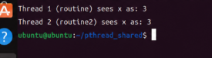

Part III: Critical section and race condition
Step 13. Basic shared counter
Following the logic from Step 12, we are now using a specific variable name mails and both threads will execute the same routine. In this step, each thread increments the counter only once.

Modify your code:
#include <stdlib.h> #include <stdio.h> #include <pthread.h>
// Global variable shared by both threads int mails = 0;

void* routine() {
// Each thread tries to increment the counter 1,000,000 times for (int i = 0; i < 1000000; i++) {
mails++;
}

return NULL;
}

int main(int argc, char* argv[]) { pthread_t t1, t2;

// Launching both counter threads
if (pthread_create(&t1, NULL, &routine, NULL) != 0) return 1; if (pthread_create(&t2, NULL, &routine, NULL) != 0) return 2;

// Waiting for them to finish
if (pthread_join(t1, NULL) != 0) return 3; if (pthread_join(t2, NULL) != 0) return 4;

// The result will likely be LESS than 2,000,000 printf("Number of emails: %d\n", mails);
return 0;
}

Everything works as expected.
Step 14. Incrementing with a small loop.
Now, we add a small loop of 100 iterations to each thread. We want to see if the counter can handle a bit more work.

Modify your code:
#include <stdlib.h> #include <stdio.h> #include <pthread.h>

int mails = 0;

void* routine() {
for(int i = 0; i < 100; i++) { mails++;
}
return NULL;
}

int main(int argc, char* argv[]) { pthread_t t1, t2;
pthread_create(&t1, NULL, &routine, NULL); pthread_create(&t2, NULL, &routine, NULL); pthread_join(t1, NULL);
pthread_join(t2, NULL);

printf("Number of emails: %d\n", mails); return 0;
}

With only 100 iterations, the CPU usually finishes one thread before the other even starts, so the result often remains correct.
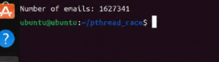
Step 15. The Race Condition (1,000,000 iterations)
What happens if we increase the workload to 1,000,000 iterations? Now, both threads will be running for a longer time, and the Operating System will be forced to switch between them constantly.

Modify your code:
#include <stdlib.h> #include <stdio.h> #include <pthread.h>

int mails = 0;

void* routine() {
for(int i = 0; i < 1000000; i++) { mails++;
}
return NULL;
}
int main(int argc, char* argv[]) { pthread_t t1, t2;
pthread_create(&t1, NULL, &routine, NULL); pthread_create(&t2, NULL, &routine, NULL); pthread_join(t1, NULL);
pthread_join(t2, NULL);
printf("Number of emails: %d\n", mails); return 0;
}

The result changes in every execution because of a race condition. The mails++ operation is not atomic; it requires three CPU steps.
- Read: Load the value of mails from RAM to a register.
- Increment: Add 1 to the register value.
- Write: Save the new value back to RAM.
When thread A is at the "Increment" step, the OS might pause it and let thread B "Read" the old value. When both threads "Write" back to memory, they store the same value, and one increment is lost. The final number is random because it depends on exactly when the OS decides to switch between threads.

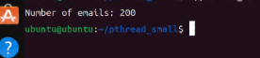

Part IV: Thread synchronization and mutex
Step 16. Solving the race condition with mutex
To fix the inconsistent results from Step 15, we must ensure that only one thread can access the "Critical Section" (the mails++ line) at a time. We do this using a Mutex (short for Mutual Exclusion).
A Mutex acts like a lock. When a thread calls pthread_mutex_lock, it "takes the key." If another thread tries to lock the same mutex, it must wait until the first thread calls pthread_mutex_unlock to release the key. This ensures the mails++ operation is performed safely.
Update your code in threads.c:
#include <stdlib.h> #include <stdio.h> #include <unistd.h> #include <pthread.h>

int mails = 0;
// 1. Declare the mutex

pthread_mutex_t mutex;

void* routine() {
for (int i = 0; i < 1000000; i++) {
// 3. Lock before entering the critical section pthread_mutex_lock(&mutex);
mails++;
// 4. Unlock after leaving the critical section pthread_mutex_unlock(&mutex);
}
return NULL;
}
int main(int argc, char* argv[]) { pthread_t t1, t2;

// 2. Initialize the mutex pthread_mutex_init(&mutex, NULL);
if (pthread_create(&t1, NULL, &routine, NULL) != 0) return 1; if (pthread_create(&t2, NULL, &routine, NULL) != 0) return 2;

if (pthread_join(t1, NULL) != 0) return 3; if (pthread_join(t2, NULL) != 0) return 4;

// 5. Clean up the mutex pthread_mutex_destroy(&mutex);
// The result will now ALWAYS be 2,000,000 printf("Number of mails: %d\n", mails);

return 0;
}

No matter how many times you run it, the result will always be exactly 2,000,000.
By locking the mutex, we make the three steps of mails++ (Read, Increment, Write) appear as one single, unbreakable (atomic) operation to other threads.
You might notice that the program takes slightly longer to finish than in Step 15. This is because the threads are now waiting for each other instead of running blindly.

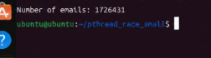
Step 17. Scaling to Multiple Threads
The power of synchronization with Mutex is that it scales. In this step, we increase the number of threads from 2 to 4. Without a mutex, having 4 threads would make the "Race Condition" even more aggressive and the error in the final count would be much larger.
However, with our pthread_mutex_lock and pthread_mutex_unlock in place, each thread will patiently wait for its turn to increment the counter, ensuring that the final result is exactly 4,000,000.
Update your code in threads.c:
#include <stdlib.h> #include <stdio.h> #include <unistd.h> #include <pthread.h>

int mails = 0; pthread_mutex_t mutex;

void* routine() {

for (int i = 0; i < 1000000; i++) { pthread_mutex_lock(&mutex); mails++; pthread_mutex_unlock(&mutex);
}
return NULL;
}

int main(int argc, char* argv[]) {
// We now declare four thread identifiers pthread_t t1, t2, t3, t4;

pthread_mutex_init(&mutex, NULL);
// Creating 4 threads executing the same routine pthread_create(&t1, NULL, &routine, NULL); pthread_create(&t2, NULL, &routine, NULL); pthread_create(&t3, NULL, &routine, NULL); pthread_create(&t4, NULL, &routine, NULL);

// We must join every single thread to wait for the complete result pthread_join(t1, NULL);
pthread_join(t2, NULL); pthread_join(t3, NULL); pthread_join(t4, NULL);

pthread_mutex_destroy(&mutex);
// The result should be exactly 4,000,000 printf("Number of mails: %d\n", mails);

return 0;
}

Observations:
Scalability: The logic of the program remains the same regardless of the number of threads. The mutex successfully serializes the access to the mails variable.
Performance: observe if the program takes longer to run now. With 4 threads all fighting for the same lock, there is more "contention," which can slow down the execution compared to a single-threaded version, even though we are using more "cores." More threads don't always mean more speed if the synchronization overhead is high.

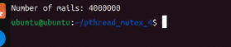
Step 18. Verification: Removing the Lock
To prove that the mutex was indeed the hero in the previous step, we will now perform a "stress test." By commenting out the lock and unlock commands, we allow all 4 threads to access and modify the mails variable simultaneously without any restrictions.
With 4 threads running 1,000,000 iterations each, the "Race Condition" will be much more severe than it was with only 2 threads.
#include<stdlib.h> #include<stdio.h> #include<unistd.h> #include<pthread.h>

int mails = 0; pthread_mutex_t mutex;

void* routine()
{
for (int i=0; i<1000000; i++)
{
// We comment the protection to observe the failure
// pthread_mutex_lock(&mutex); mails++;
// pthread_mutex_unlock(&mutex);
}
return NULL;
}
int main(int argc, char* argv[])
{
pthread_t t1, t2, t3, t4; pthread_mutex_init(&mutex, NULL);
pthread_create(&t1, NULL, &routine, NULL); pthread_create(&t2, NULL, &routine, NULL); pthread_create(&t3, NULL, &routine, NULL); pthread_create(&t4, NULL, &routine, NULL);

pthread_join(t1, NULL); pthread_join(t2, NULL); pthread_join(t3, NULL); pthread_join(t4, NULL);

pthread_mutex_destroy(&mutex);

// Watch the chaos!
printf("Number of mails: %d\n", mails);

return 0;
}

The number will be significantly lower than 4,000,000 and will change drastically every time you run it.
With 4 threads and no mutex, the corruption of the data is much more evident. The probability of two or more threads reading the same value at the same time increases with every added thread.
Performance vs. Correctness: You might notice the program runs much faster now. However, the result is wrong. This is the fundamental trade-off in concurrent programming: speed is useless without data integrity.
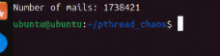

Part V: Semaphores and Resource Management
Step 19. Introduction to POSIX Semaphores
A semaphore (sem_t) is a synchronization object that maintains a counter.
- sem_init: Initializes the semaphore. The third argument (1 in this case) is the initial value.
- sem_wait: Decrements the counter. If the counter is 0, the thread waits.
- sem_post: Increments the counter, allowing another thread to enter.
In this initial code, we create 4 threads using a loop. We also pass a unique ID to each thread by allocating memory with malloc. Note that in this specific step, we are initializing the semaphore but not yet using it to block anything; we are just setting up the structure.
Create the file semaphores.c:
nano semaphores.c

#include <stdlib.h> #include <stdio.h> #include <unistd.h> #include <pthread.h> #include <string.h> #include <semaphore.h>

#define THREAD_NUM 4

// Declare the semaphore sem_t semaphore;

void* routine(void* args) {
// We cast the argument back to int and print it printf("Hello from thread %d\n", *(int*)args); free(args); // Clean up the memory allocated in main return NULL;
}

int main(int argc, char* argv[]) { pthread_t th[THREAD_NUM];
// Initialize semaphore: (address, pshared, initial_value)
// pshared = 0 means it's shared between threads, not processes. sem_init(&semaphore, 0, 1);
int i;
for (i = 0; i < THREAD_NUM; i++) {
int* a = malloc(sizeof(int));
*a = i;
if (pthread_create(&th[i], NULL, &routine, a) != 0) { perror("Failed to create thread");
}
}
for (i = 0; i < THREAD_NUM; i++) {
if (pthread_join(th[i], NULL) != 0) { perror("Failed to join thread");
}
}
// Clean up sem_destroy(&semaphore);

return 0;
}

- malloc in threads: Since the loop moves very fast, if we passed the address of i directly (&i), all threads might end up seeing the same final value of i. We use malloc to give each thread its own "copy" of its ID.
- Semaphore Value: Right now, the semaphore has a value of 1, acting like a Mutex, but we haven't called sem_wait yet, so the threads are printing freely.

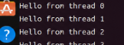
Step 20. Add the sem_wait and sem_post commands to see the difference. Note that the semaphore has a value of 1 set up in sem_init command. Compile and run it.
#include<stdlib.h> #include<stdio.h> #include<unistd.h> #include<pthread.h> #include<string.h>

#include<semaphore.h> #define THREAD_NUM 4 sem_t semaphore;
void* routine(void* args)
{
sem_wait(&semaphore); sleep(1);
printf("Hello from thread %d\n", *(int*)args); sem_post(&semaphore);
free(args);
}

int main(int argc, char* argv[])
{
pthread_t th[THREAD_NUM]; sem_init(&semaphore, 0, 1);
for (int i=0; i < THREAD_NUM; i++)
{
int* a = malloc(sizeof(int));
*a = i;
if(pthread_create(&th[i], NULL, &routine, a) !=0) perror("Fail to create thread");
}

for (i=0; i < THREAD_NUM; i++)
{
if(pthread_join(th[i], NULL) !=0) perror("Fail to join thread");
}
sem_destroy(&semaphore); return 0;
}

In computer science theory, semaphore operations are traditionally known by the letters P and V, terms originally introduced by Edsger Dijkstra. In modern C programming using the semaphore.h library, these operations map directly to sem_wait and sem_post:

C Function | Classical Name | Dutch Word | Meaning in Code
sem_wait() | P | Proberen (To test) | Try to enter. Decrements the counter. If the value is 0, the thread blocks and waits.
sem_post() | V | Verhogen (To increment) | Signal / Release. Increments the counter and wakes up a waiting thread.

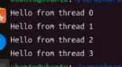

Step 21. Implementing sem_wait and sem_post.
Now we are going to restrict access to the printf statement using the semaphore.

- sem_wait(&semaphore): This checks the semaphore's value. Since it is 1, the first thread to arrive decrements it to 0 and proceeds.
- The "Wait": When the other 3 threads arrive, they find the value at 0 and must wait (block) until it becomes greater than 0 again.
- sem_post(&semaphore): When a thread finishes, it increments the value back to 1, "waking up" the next thread in line.
Because of the sleep(1), this program will take exactly 4 seconds to finish, as threads are forced to go one by one.
Modify semaphores.c:
#include <stdlib.h> #include <stdio.h> #include <unistd.h> #include <pthread.h> #include <string.h> #include <semaphore.h>
#define THREAD_NUM 4 sem_t semaphore;
void* routine(void* args) {
// 1. Wait/Lock: Decrease the semaphore value sem_wait(&semaphore);

sleep(1); // Force a delay to see the serialization printf("Hello from thread %d\n", *(int*)args);
// 2. Post/Unlock: Increase the semaphore value sem_post(&semaphore);

free(args); return NULL;
}
int main(int argc, char* argv[]) { pthread_t th[THREAD_NUM];
// Initial value is 1 sem_init(&semaphore, 0, 1);

int i;
for (i = 0; i < THREAD_NUM; i++) {
int* a = malloc(sizeof(int));
*a = i;
if (pthread_create(&th[i], NULL, &routine, a) != 0) { perror("Failed to create thread");
}
}

for (i = 0; i < THREAD_NUM; i++) {
if (pthread_join(th[i], NULL) != 0) { perror("Failed to join thread");
}
}

sem_destroy(&semaphore); return 0;
}

Even though 4 threads were created almost at the same time, the semaphore with value 1 acted as a "bottleneck."

Comparison with Mutex: In this specific configuration (value = 1), the semaphore is functionally identical to a Mutex. It provides Mutual Exclusion.
What would happen if we changed the initial value of the semaphore to 2 or 3?

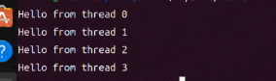
Step 22. Multiple Access with Counting Semaphores
The real difference between a Mutex and a Semaphore is that a Semaphore can allow multiple threads to access a resource at the same time.
By changing the initial value to 3 in sem_init(&semaphore, 0, 3), you are saying: "There are 3 available slots/permits."
- The first 3 threads to call sem_wait will pass immediately.
- The 4th thread will be blocked and must wait until one of the first three calls sem_post. Modify semaphores.c and change the initial value:
#include <stdlib.h> #include <stdio.h> #include <unistd.h> #include <pthread.h> #include <string.h> #include <semaphore.h>
#define THREAD_NUM 4 sem_t semaphore;
void* routine(void* args) { sem_wait(&semaphore);
// Now multiple threads can be here at the same time! sleep(1);
printf("Hello from thread %d\n", *(int*)args); sem_post(&semaphore);
free(args); return NULL;
}

int main(int argc, char* argv[]) { pthread_t th[THREAD_NUM];
// CHANGE: Initial value set to 3 sem_init(&semaphore, 0, 3);

int i;
for (i = 0; i < THREAD_NUM; i++) {
int* a = malloc(sizeof(int));
*a = i;
if (pthread_create(&th[i], NULL, &routine, a) != 0) { perror("Failed to create thread");
}
}
for (i = 0; i < THREAD_NUM; i++) {
if (pthread_join(th[i], NULL) != 0) { perror("Failed to join thread");
}
}

sem_destroy(&semaphore); return 0;
}

Why this happens:
- Group of 3: The first three messages appear at the same time because the semaphore had 3 permits.
- The last one: The 4th thread had to wait for one of the others to finish (sem_post) before it could print its message.
While a Mutex is like a bathroom key (only one person at a time), a Semaphore is like a restaurant with 3 tables.

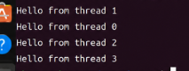

Questions
Part I: The Basics (Steps 1 - 12)
- Memory Management: Explain the fundamental difference between how processes and threads manage memory. Why is it "easier" but "riskier" for threads to communicate?
- Thread Lifecycle: What are the specific roles of pthread_create and pthread_join? What happens to the main program if pthread_join is omitted?

Part II: The Conflict (Steps 13 - 15)
- The Race Condition: Define Race Condition based on your observations in Step 15. Why did the counter fail to reach 2,000,000?
- Atomic Operations: Is the C operation mails++ atomic? Explain the three steps the CPU performs "under the hood" (Read-Modify-Write) and why this matters in multi-threading.
- Critical Section: Write a formal definition of a Critical Section. Identify exactly which line of code was the Critical Section in Step 15.

Part III: Mutex Synchronization (Steps 16 - 18)
- Mutual Exclusion: What does "Mutex" stand for? Explain how pthread_mutex_lock and unlock prevent data corruption.
- Performance Trade-off: In Step 18, you removed the mutex and the code ran faster but gave the wrong result. Explain the trade-off between execution speed and data integrity.

Part IV: Memory & Arguments (Step 19)
- Pointer Casting: In the command *(int*)args, explain what each part does: What is args, why do we cast it to (int*), and what does the first * do?
- Dynamic Allocation: Why did we use malloc to pass the ID to each thread instead of just passing the address of the loop variable &i?

Part V: Semaphores (Steps 20 - 22)
- Mutex vs. Semaphores: What is the main functional difference between a Mutex and a Semaphore? (Hint: Think about the "initial value").
- P and V Operations: Define sem_wait and sem_post in terms of the classical P and V operations. What happens to the semaphore's internal counter in each?
- Counting Semaphores: Compare your observations from Steps 20, 21, and 22. How did changing the initial value (1, 2, and 3) affect the timing and concurrency of the output?

Submission

Lab report structure
  - Title page. Must include UTRGV logo, student name, course number, date, instructor name, and the lab name.
  - Introduction. Brief overview of the lab. Include the objective given in this pdf.
  - Lab procedure. Explain each step describing what you did and what you observed (do not copy and paste the instruction from this pdf). Explain the results. You must list the code snippets of each step followed by an explanation. Every image must be explained.
  - Questions. Answer the questions and cite the references. Use reliable sources (books, scientific papers, official documentation sites, etc.).
  - Conclusions. Restate the objective and summarize the procedure. Describe your final impression of what you practiced and learned.
  - References. List of references provided by the instructor and the ones used on the question section.

Labs’ rubric

 | Excellent | Good | Acceptable | Poor
1 Title page | Title page contains all required fields:  - UTRGV logo,  - student name, (3) course number,  (4) date, (5) instructor name, and (6) lab name. | Title page contains 3-4 required fields. | Title page contains 1-2 required fields. | The lab does not have a title page.
5 | 5 | 4 | 2 | 0
2 Introduction | Introduction is complete and well- written. It includes a brief overview of the lab and a general objective. | Introduction is nearly complete,  missing some minor points. | Introduction is not complete,  missing major points. | The lab does not have an introduction.
10 | 10 | 8 | 4 | 0
3 Lab procedure | Lab procedure is complete. All questions are answered, and it has the  corresponding outputs. | Lab procedure is completed in  80%. | Lab procedure is completed in an  60%. | Lab procedure is completed in less of a  60%.
30 | 30 | 20 | 10 | 0
4 Questions | Questions are correct and complete. | Questions are correct and  completed in 80%. | Questions are correct and  completed in 60%. | Questions are correct and completed in less of 60%.

30 | 30 | 20 | 10 | 0
5 Conclusions | Conclusions are complete. It includes a summary of the experimental procedure and a final impression of the learned knowledge. | Conclusions are nearly complete, missing some minor points. | Conclusions are not complete, missing major points. | The lab does not have a conclusion.
20 | 20 | 16 | 10 | 0
6 References | References are complete (author, year, article or book title, journal or publisher). | References are nearly complete, missing some minor  information. | References are nearly complete, missing some major  information. | The lab does not have references.
5 | 5 | 4 | 2 | 0

