REPORT

1 FSM for the Sender & Receiver
- Sender

WAITE
UDP_send(seg[sendbase]);
reset_timer();
timeout
rUDP_send(message)
sendbase = rcvseg.acknum;
if (sendbase <= nextseqnum)
reset_timer();
rUDP_rcv(rcvseg) && notcorrupt(rcvseg)
sendbase=1
nextseqnum=1
rUDP_rcv(rcvseg) && corrupt(rcvseg)
^
4
if(nextseqnum < sendbase + N)
{
seg[nextseqnum] = make_seg(nextseqnum, data, checksum);
UDP_send(seg[nextseqnum]);
if(sendbase == nextseqnum)
reset_timer();
nextseqnum += seg[nextseqnum].length;
} else
refuse_data(message);

- Receiver
rUDP_rcv(rcvseg) && corrupt(rcvseg)

WAITE
seg[nextacknum] = make_seg(nextacknum, ,checksum);
UDP_send(seg[nextacknum]);
nextacknum = 1

rUDP_rcv(rcvseg) && notcorrupt(rcvseg)

buffer_seg(rcvseg);
deliver_data();
nextacknum = update_acknum();
seg[nextacknum] = make_seg(nextacknum, ,checksum);
UDP_send(seg[nextacknum]);

2 Implementation
- Finite State Machine design for implementation of interactions between the sender and receiver.
- Buffer Design:
- rUDP_sender:
typedef struct
{
char buf[MAXNUM];
int front, rear;
}QueueBuf;

// Buffer Information Management
// linked queue
typedef struct // element type
{
int seqnum = 0;
int length = 0;
}Info;

typedef struct node
{
Info info;
node* next = NULL;
}InfoNodeType;

typedef struct
{
InfoNodeType* front;
InfoNodeType* rear;
}BufInfoManagLq;

- rUDP_receiver:
typedef struct{
int seqnum;
int payload_len;
char seg[sizeof(Segment)];
}RecvNode;

typedef struct{
int index = 0;
RecvNode recv_array[10];
}RecvBuf;

- multiple threads for FSM and main function

3 Notice
- When receive buffer is full, it automatically adopts memory substitution(replace the last element with the new one).

- Also:
- no trunc
- no fast retransmit
- retransmit one each time
- initial seqnum predefined
- the sender leaves the acknum empty in its sent segment
- the receiver leaves seqnum empty in its feedback segment
- no size-limitation and reuse for the sequence number

4 Output
- N=50 & not create transmission error and loss
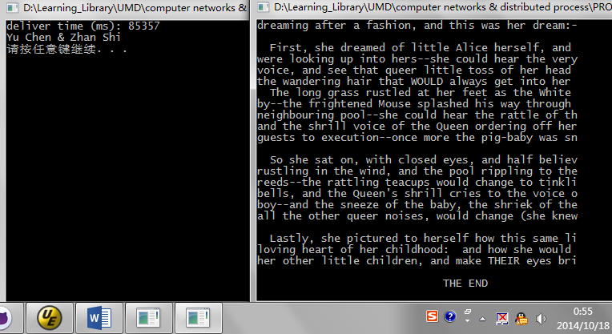

- N=50 & create transmission error and loss
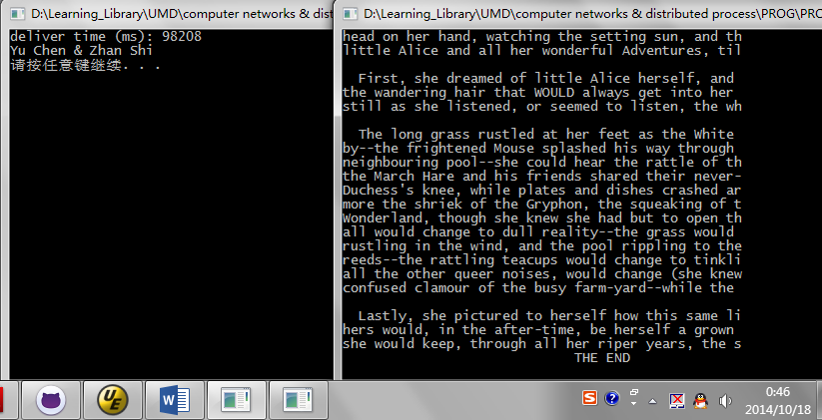

- N=100 & not create transmission error and loss

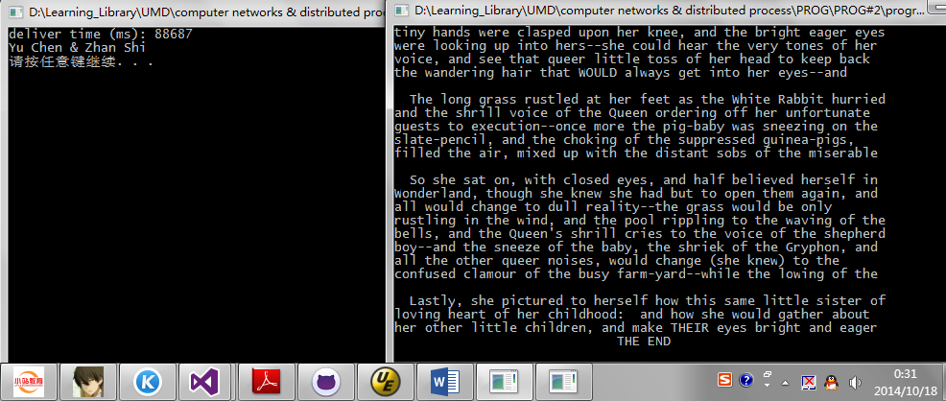

- N=100 & create transmission error and loss
