Hong Kong Institute of Information Technology
Higher Diploma in Software Engineering (IT114105)
Contemporary Topics in Software Engineering (ITP4507)

Smart Delivery Fleet Management System (SDFMS)
Assignment Report
Student name: Chu Shun Hin
Student number: 250017281
Submission date: Friday 13 November 2026

Table of Contents
A. Analysis and Design of the Application 2
A.1 Assumptions made during analysis and design 2
A.2 How I designed the application 3
B. System Design with Class Diagram 4
B.1 Design overview 4
B.2 Class diagrams 5
B.3 Main classes and relationships 10
C. Discussion of the Design Patterns Applied 10
C.1 Command pattern 10
C.2 Factory pattern 12
C.3 Memento pattern 13
User Guide 13
Compiling and running the program 14
The menu 14
Commands 14
Leaving the system 17
D. Test Plan and Test Cases 17
D.1 Environment and method 17
D.2 Test cases 17

A. Analysis and Design of the Application
This section records the assumptions I made while analysing the problem and designing the application, and then explains how I structured the design in the source code. The assumptions and the design description are limited to what the assignment brief requires and to what the program actually does.

A.1 Assumptions made during analysis and design
I made the following assumptions during the analysis and design of SDFMS. Each assumption is supported by the assignment brief or by the behaviour implemented in the source code.
1. SDFMS is a console application. The menu and prompts follow the sample run in the brief, and the input command codes are not changed, as the brief requires.
2. This version supports only two fleet types: delivery van (type code v) and refrigerated truck (type code r). The brief states that the company may later add further fleet varieties, such as motorcycle-delivery fleets and electric-cargo-bike fleets. In the program, a new type can be introduced by registering a new VehicleFleetFactory.FleetType rather than by rewriting the existing command classes.
3. All data are held in memory for a single run. The source does not read or write a file or a database.
4. A fleet ID must be unique and non-empty. CreateFleetCommand.execute() rejects an empty identifier with the message “Fleet ID cannot be empty!” and a duplicate identifier with “Fleet ID already exists!”.
5. A fleet name must be non-empty when a fleet is created and when the current fleet is renamed. In both cases the program prints “Fleet name cannot be empty!”.
6. Creating a fleet also makes that fleet the current fleet. CreateFleetCommand calls FleetSystem.addFleet and FleetSystem.setCurrentFleet, and then prints “Current fleet is changed to ”, followed by the fleet ID and a full stop.
7. The commands add driver, modify driver role, delete driver, show fleet, and change fleet name require a current fleet. If none is set, the program prints “No current fleet!” and does not record the command on the undo stack.
8. A driver ID must be unique within the current fleet, not necessarily across all fleets. AddDriverCommand checks uniqueness with FleetDrivers.find(fleet, driverID) on the current fleet only, and prints “Driver ”, the driver ID, and “ already exists in the current fleet!” when the identifier is already present.
9. Driver information is entered on one line in the form id, name. After trimming, both parts must be non-empty; otherwise the program prints “Invalid driver information!”.
10. A role is an integer. For a delivery van fleet, 1 is van driver and 2 is courier driver. For a refrigerated truck fleet, 1 is refrigerated-truck driver and 2 is cold-chain delivery driver. A non-integer or a value that is not valid for the current fleet type produces “Invalid role!”.
11. The list of drivers in a fleet is stored as a Vector<Driver> held in an AbstractList<Driver> field, which the brief permits (Vector or LinkedList as the concrete implementation of AbstractList).
12. Only five functions are undoable, as required by the brief: create fleet, add driver, modify driver role, delete driver, and change fleet name. Set current fleet, show fleet, display all fleets, undo, redo, and list undo/redo are not pushed onto the undo stack. UndoCommand.execute() and RedoCommand.execute() return false so that Main does not call Caretaker.record for them.
13. A successful undoable command is recorded only when execute() returns true. Caretaker.record() pushes the command onto the undo stack and clears the redo stack.
14. Command codes are compared with String.equals after trim(), so they are case-sensitive. An unknown code produces “Invalid command!”. The exit code x is handled in Main.main and is not created by CommandFactory.
15. The Memento pattern is applied only to modify driver role and change fleet name, as the brief requires. The attributes and operations of VehicleFleet and Driver that the brief specifies are retained.

A.2 How I designed the application
I structured the program around a console command loop in Main. Main creates a Scanner, a FleetSystem, a Caretaker, a VehicleFleetFactory, and a CommandFactory. In each iteration it prints the menu, reads a command code, asks CommandFactory.createCommand to obtain a Command, and calls execute(). If execute() returns true and the object is an UndoableCommand, Main passes it to Caretaker.record. The exit command is handled directly in Main.main rather than as a Command object.
I kept the domain classes required by the brief and did not remove or change their specified attributes and operations. VehicleFleet remains an abstract class with updateDriverRole() and showFleet() as abstract operations; DeliveryVanFleet and RefrigeratedTruckFleet extend it. I added FleetSystem to hold every fleet, in creation order, and the current fleet, and FleetDrivers as a helper that finds a driver, copies and restores the driver list, and prints drivers by role. User requests are Command objects: Command defines boolean execute(), and UndoableCommand adds undo(), redo(), and toString(). Five commands implement UndoableCommand; the remaining menu actions implement Command only. Object creation is concentrated in three factories: CommandFactory, DriverFactory, and VehicleFleetFactory, which registers FleetType implementations so that a later fleet type can be added without rewriting CreateFleetCommand or CommandFactory. For change fleet name and modify driver role, the commands hold before and after mementos (FleetNameMemento and DriverRoleMemento). I did not add createMemento or setMemento operations to VehicleFleet or Driver. Caretaker stores UndoableCommand objects, not mementos directly.

B. System Design with Class Diagram

B.1 Design overview
The application is organised into four groups of classes, shown in the four figures in Section B.2. The domain model (Figure 1) comprises FleetSystem, the abstract VehicleFleet and its two subclasses, Driver, and the FleetDrivers helper. The command layer (Figure 2) comprises Command, UndoableCommand, the eleven command classes, CommandFactory, Main, and Caretaker. The factories (Figure 3) are CommandFactory, DriverFactory, and VehicleFleetFactory with its nested FleetType interface. The memento types (Figure 4) are FleetNameMemento and DriverRoleMemento. Main is the entry point and the invoker of commands. The attributes and operations required by the brief for VehicleFleet, DeliveryVanFleet, RefrigeratedTruckFleet, and Driver are kept as specified and are shown in Figure 1.

B.2 Class diagrams
The four figures below present the classes in the program. They extend the simplified class diagram in the brief by adding the classes and interfaces that I introduced. They do not remove the attributes or operations that the brief requires.
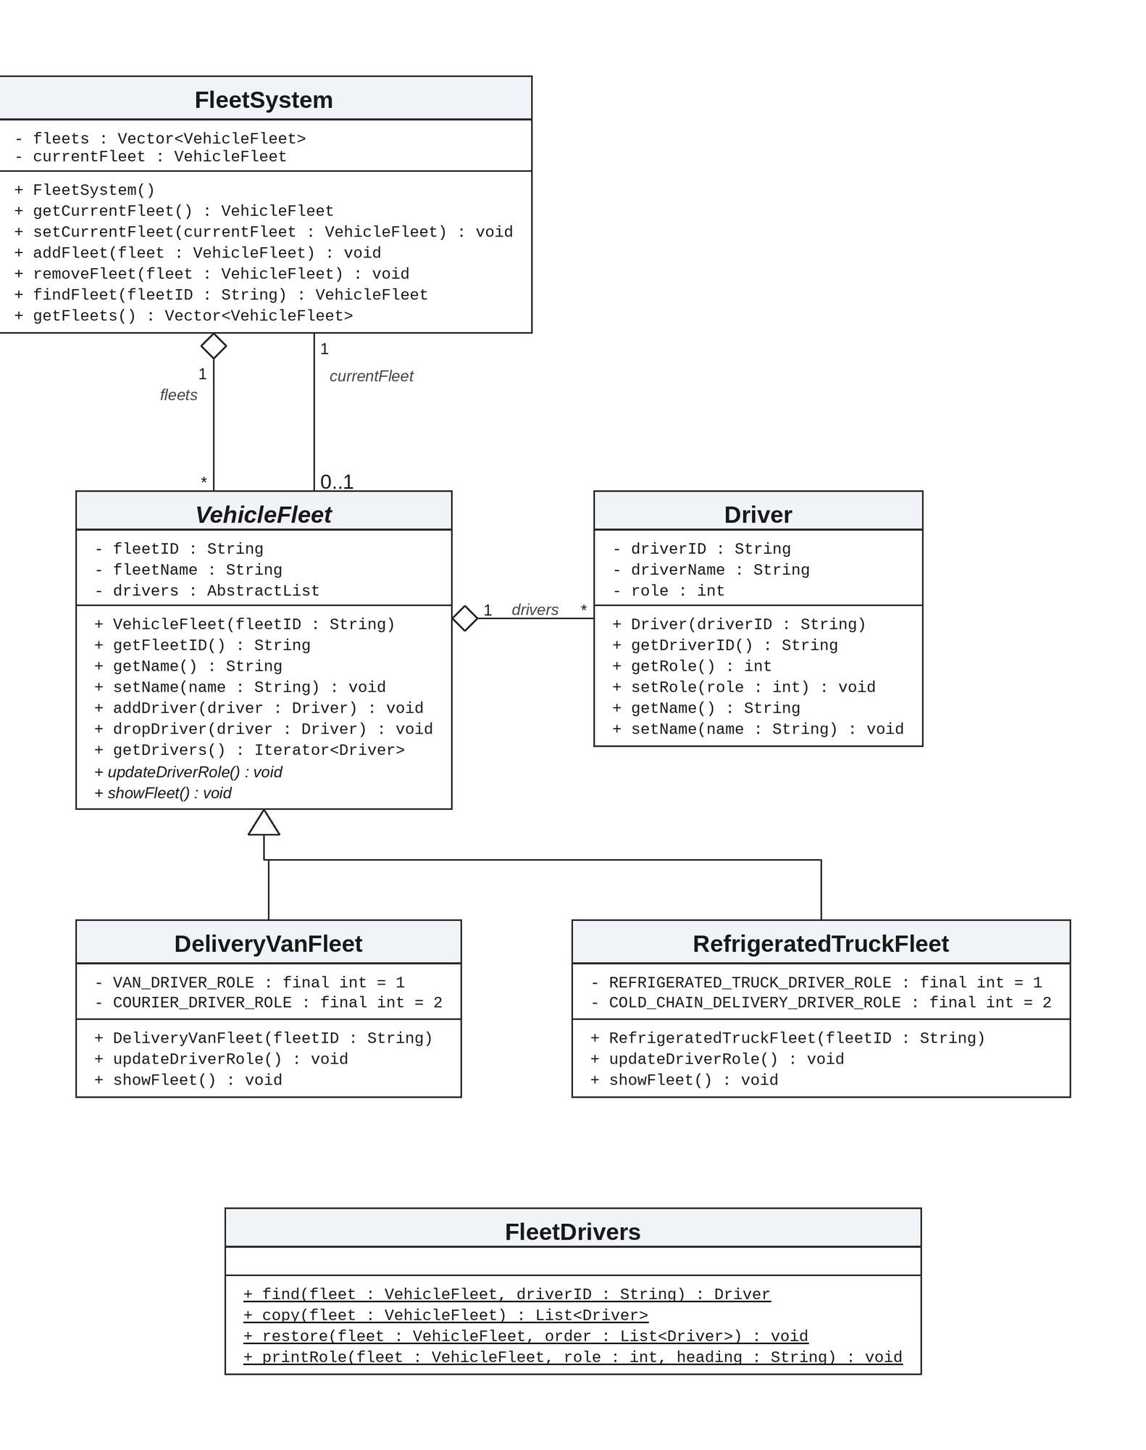
Figure 1. Domain model of SDFMS, including the classes required by the brief and the added types FleetSystem and FleetDrivers.
Figure 1 shows the domain model. FleetSystem has an aggregation of many VehicleFleet objects and also holds the current fleet. VehicleFleet is abstract, with abstract operations updateDriverRole() and showFleet(), and has an aggregation of many Driver objects, matching the relationship in the brief. DeliveryVanFleet and RefrigeratedTruckFleet specialise VehicleFleet. FleetDrivers is an added utility that locates, copies, restores, and prints drivers by calling only getDrivers(), addDriver(), and dropDriver() on a VehicleFleet.
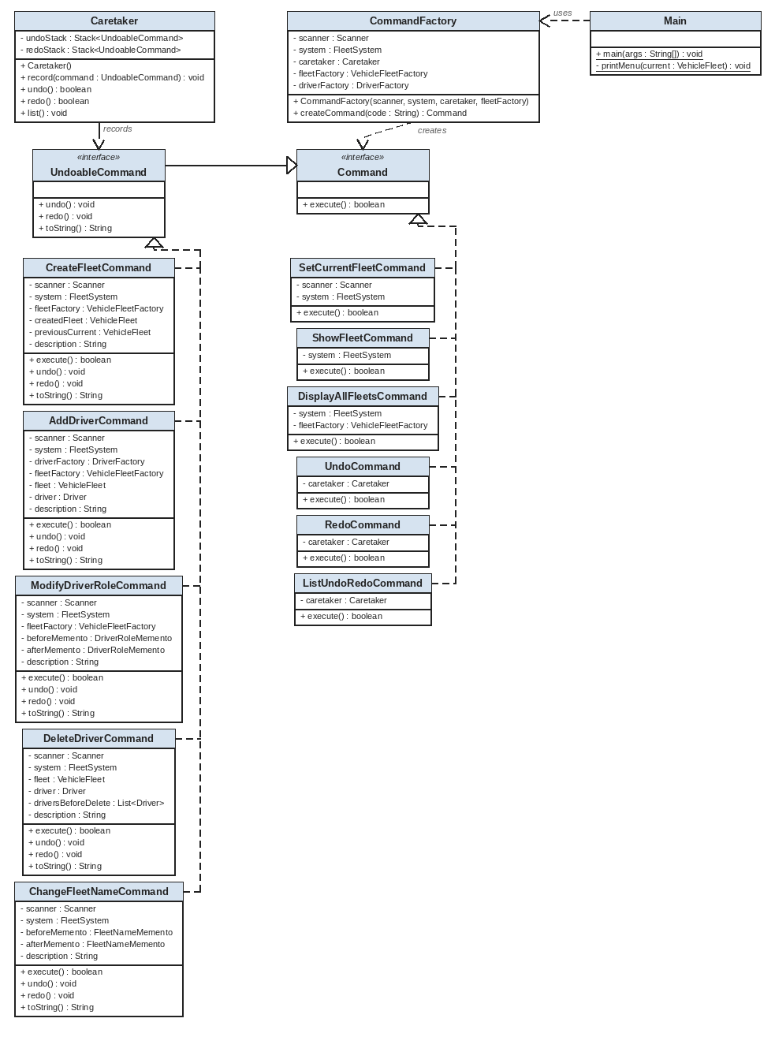
Figure 2. Command structure of SDFMS, showing Command, UndoableCommand, the eleven command classes, CommandFactory, Main, and Caretaker.
Figure 2 shows the command layer. Five classes implement UndoableCommand: CreateFleetCommand, AddDriverCommand, ModifyDriverRoleCommand, DeleteDriverCommand, and ChangeFleetNameCommand. Six classes implement Command only: SetCurrentFleetCommand, ShowFleetCommand, DisplayAllFleetsCommand, UndoCommand, RedoCommand, and ListUndoRedoCommand. Main uses CommandFactory to obtain a command and uses Caretaker to record a successful UndoableCommand. Main depends on CommandFactory, shown by the uses arrow. printMenu is underlined because it is static. Each command has its own dashed realization to UndoableCommand or to Command.
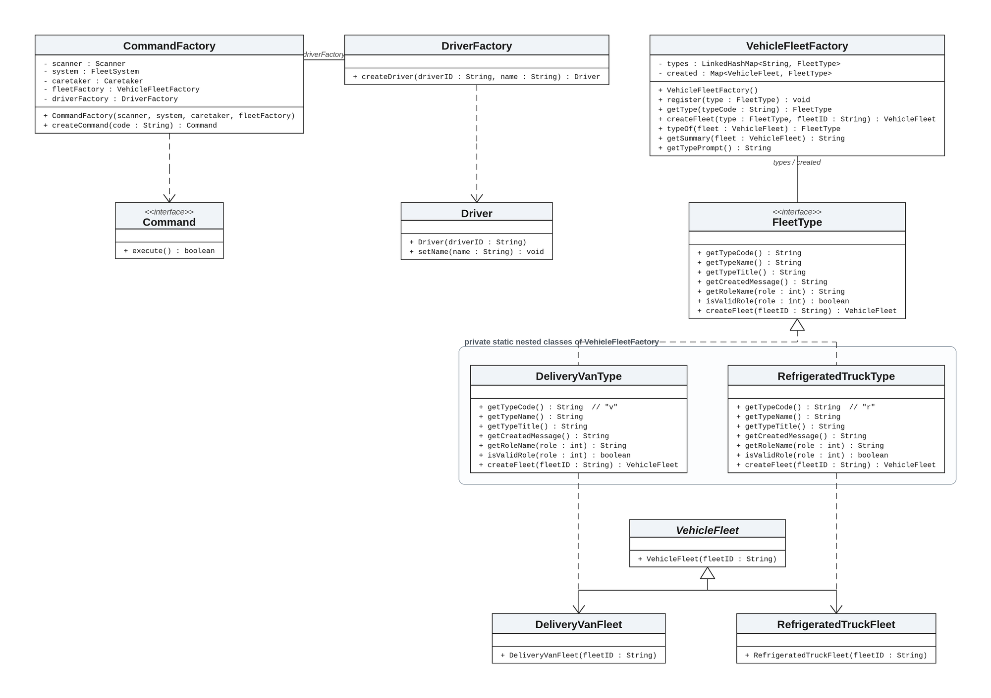
Figure 3. Factory structure of SDFMS, showing CommandFactory, DriverFactory, VehicleFleetFactory, the nested FleetType interface and type classes, and the products they create.
Figure 3 shows the three factories. CommandFactory.createCommand creates a Command for a menu code. DriverFactory.createDriver constructs a Driver and calls setName. VehicleFleetFactory keeps a registry of FleetType objects; DeliveryVanType and RefrigeratedTruckType create DeliveryVanFleet and RefrigeratedTruckFleet. This is the Factory pattern, not Abstract Factory: each factory creates one kind of product, rather than a family of products together.
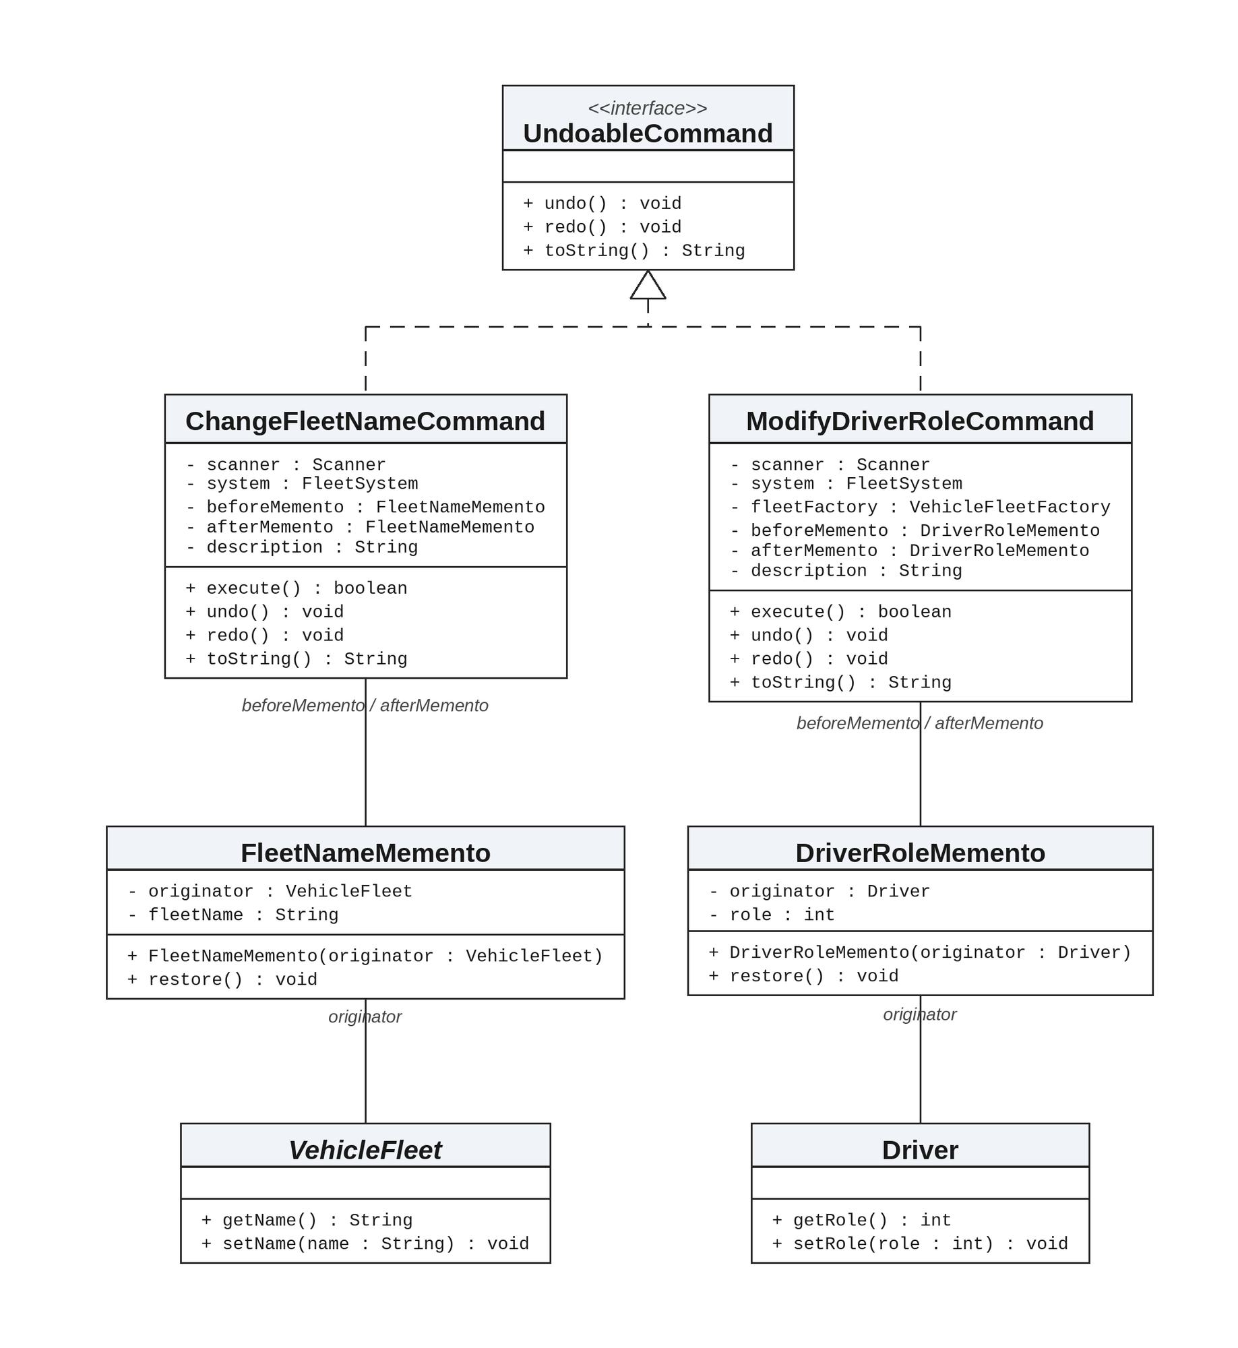
Figure 4. Memento structure of SDFMS. VehicleFleet and Driver show only the operations used by the mementos; their full definitions appear in Figure 1.
Figure 4 shows the mementos used for change fleet name and modify driver role. ChangeFleetNameCommand holds a beforeMemento and an afterMemento of type FleetNameMemento; ModifyDriverRoleCommand holds the same pair of type DriverRoleMemento. FleetNameMemento.restore() calls setName; DriverRoleMemento.restore() calls setRole. Caretaker is not shown again here; it stores the command objects, and those commands store the mementos.

B.3 Main classes and relationships
VehicleFleet has the private attributes fleetID, fleetName, and drivers (an AbstractList). It provides the constructor VehicleFleet(String fleetID), the operations getFleetID(), getName(), setName(String name), addDriver(Driver driver), dropDriver(Driver driver), and getDrivers() (which returns Iterator<Driver>), and the abstract operations updateDriverRole() and showFleet(). DeliveryVanFleet extends VehicleFleet and keeps VAN_DRIVER_ROLE = 1, COURIER_DRIVER_ROLE = 2, the constructor DeliveryVanFleet(String fleetID), and implementations of updateDriverRole() and showFleet(). RefrigeratedTruckFleet keeps REFRIGERATED_TRUCK_DRIVER_ROLE = 1, COLD_CHAIN_DELIVERY_DRIVER_ROLE = 2, the constructor RefrigeratedTruckFleet(String fleetID), and the same two operations. Driver has driverID, driverName, and role, the constructor Driver(String driverID), and the operations getDriverID(), getRole(), setRole(int), getName(), and setName(String name).
FleetSystem is associated with every VehicleFleet it stores and with the single current fleet. Each VehicleFleet is associated with the drivers in its list. CommandFactory is associated with FleetSystem, Caretaker, VehicleFleetFactory, DriverFactory, and the Scanner. Main creates those objects and, in the command loop, depends on Command through execute(). Caretaker is associated with the UndoableCommand objects on its two stacks. The two memento classes are associated with their originators, VehicleFleet and Driver.

C. Discussion of the Design Patterns Applied
The brief requires three design patterns: Command; Factory or Abstract Factory; and Memento. This section explains how I used each pattern in the SDFMS source, with reference to the concrete classes and methods. I used the Factory pattern, not Abstract Factory.

C.1 Command pattern
I used the Command pattern so that each menu function is an object with its own execute() method, and so that the five functions that must support undo and redo can be stored and replayed. The Command interface declares boolean execute(), which returns true only when the action succeeds. UndoableCommand extends Command and adds undo(), redo(), and toString(). The toString() value is the line that appears in the undo and redo lists.
CommandFactory.createCommand(String code) creates the command object for a menu code: CreateFleetCommand for c, SetCurrentFleetCommand for s, AddDriverCommand for a, ModifyDriverRoleCommand for m, DeleteDriverCommand for d, ShowFleetCommand for sf, DisplayAllFleetsCommand for sa, ChangeFleetNameCommand for cn, UndoCommand for u, RedoCommand for r, and ListUndoRedoCommand for l. It returns null for any other code, and Main then prints “Invalid command!”. Main.main is the invoker: after printMenu and reading a line, it calls createCommand, then command.execute(). If the result is true and the object is an UndoableCommand, it calls caretaker.record((UndoableCommand) command).
The five undoable classes build a description string during execute() and return it from toString(), in the forms used in the sample undo list in the brief: “Create ”, the type name from FleetType.getTypeName(), “ fleet, ”, the fleet ID, and the fleet name; “Add driver, ”, the driver ID, the name, and the role name from FleetType.getRoleName(role); “Modify driver role, ”, the driver ID and the new role name; “Delete driver, ” and the driver ID; and “Change fleet name, ”, the fleet ID and the new name. The other six command classes are not undoable. UndoCommand.execute() calls caretaker.undo() and returns false; RedoCommand.execute() calls caretaker.redo() and also returns false, so Main does not record undo or redo as new history entries.
Caretaker holds undoStack and redoStack, both of type Stack<UndoableCommand>. record() pushes onto the undo stack and clears the redo stack. undo() pops the undo stack, calls command.undo(), pushes onto the redo stack, and prints “Command (”, the command’s toString() text, and “) is undone.”, or “Nothing to undo!” if the stack is empty. redo() is the opposite and prints “) is redone.” or “Nothing to redo!”. list() prints “Undo List”, each toString() value in stack order, “-- End of undo list --”, then the same structure for the redo list. CreateFleetCommand.undo() calls system.removeFleet(createdFleet) and, if that fleet is still current, restores previousCurrent with setCurrentFleet; redo() adds the fleet again if needed and makes it current. AddDriverCommand.undo() calls fleet.dropDriver(driver); redo() calls fleet.addDriver(driver). DeleteDriverCommand stores the driver order with FleetDrivers.copy; undo() calls FleetDrivers.restore so that the previous order is put back; redo() calls fleet.dropDriver(driver) again. ChangeFleetNameCommand and ModifyDriverRoleCommand delegate undo and redo to mementos, which are described in Section C.3.

C.2 Factory pattern
The brief allows the Factory pattern or the Abstract Factory pattern for creating Command, VehicleFleet, and Driver objects. I used the Factory pattern in three factory classes, not Abstract Factory: the factories do not create a family of related products in one step.
CommandFactory takes a Scanner, a FleetSystem, a Caretaker, and a VehicleFleetFactory, and it constructs its own DriverFactory. createCommand(String code) is the only place that selects which command class to instantiate. DriverFactory.createDriver(String driverID, String name) constructs new Driver(driverID), calls setName(name), and returns the object; AddDriverCommand.execute() uses this method after validating the input line and the role. VehicleFleetFactory defines a public nested interface FleetType with getTypeCode(), getTypeName(), getTypeTitle(), getCreatedMessage(), getRoleName(int role), isValidRole(int role), and createFleet(String fleetID). The constructor registers DeliveryVanType (code v) and RefrigeratedTruckType (code r). register(FleetType type) stores a type in a LinkedHashMap. createFleet(FleetType type, String fleetID) calls type.createFleet(fleetID) and records the mapping; typeOf(VehicleFleet fleet) returns that mapping. getSummary(VehicleFleet fleet) builds the display-all line, and getTypePrompt() builds the prompt “Enter fleet type (v = delivery van | r = refrigerated truck) :- ”. CreateFleetCommand.execute() uses getTypePrompt, getType, createFleet, and type.getCreatedMessage() (for example, “Delivery van fleet is created.” or “Refrigerated truck fleet is created.”). AddDriverCommand and ModifyDriverRoleCommand call typeOf, isValidRole, and getRoleName. DisplayAllFleetsCommand prints getSummary for each fleet in system.getFleets().
This design supports the Open-Closed Principle stated in the brief. A new fleet type can be added as a new VehicleFleet subclass and a new FleetType registered with VehicleFleetFactory.register, without rewriting CreateFleetCommand, AddDriverCommand, ModifyDriverRoleCommand, or DisplayAllFleetsCommand.

C.3 Memento pattern
The brief requires the Memento pattern for the undo and redo of “modify driver role” and “change fleet name”. I applied it only to those two functions. The other undoable commands restore state by holding the created fleet, the added or deleted driver, or a copy of the driver list, rather than by using a memento.
FleetNameMemento stores a VehicleFleet as originator and a String fleetName. The constructor saves originator.getName(); restore() calls originator.setName(fleetName). DriverRoleMemento stores a Driver as originator and an int role. The constructor saves originator.getRole(); restore() calls originator.setRole(role). ChangeFleetNameCommand.execute() constructs beforeMemento = new FleetNameMemento(fleet), calls fleet.setName(newName), and constructs afterMemento = new FleetNameMemento(fleet). ModifyDriverRoleCommand.execute() constructs the same pair with DriverRoleMemento around driver.setRole(role). In both commands, undo() calls beforeMemento.restore() and redo() calls afterMemento.restore().
I did not add createMemento or setMemento methods to VehicleFleet or Driver, because the brief states that the attributes and operations of those existing classes must not be removed or modified. The commands capture state through the public getters and restore it through the public setters. Caretaker stores UndoableCommand objects rather than memento objects; the two commands themselves hold the before and after mementos.

User Guide
This user guide describes how to compile and run SDFMS, how the menu is presented, and how each command behaves in the program. The prompts, messages, and command codes are those implemented in the source. The brief states that the input command codes cannot be changed.

Compiling and running the program
The program is a Java console application. A Java compiler and a Java runtime are required. The submission includes a Windows batch file, run.bat, in the same folder as the source files. The file contains the following commands:
javac *.java
java Main
Running run.bat from that folder compiles every .java file and starts the Main class. The same two commands can be entered at a command prompt.

The menu
Each time the program is ready for a command, Main.printMenu writes the following lines. If a current fleet has been set, a line such as “The current fleet is F001 CENTRAL EXPRESS.” is included, using the actual fleet ID and name; otherwise that line is omitted.
Smart Delivery Fleet Management System (SDFMS)
c = create fleet, s = set current fleet, a = add driver, m = modify driver role,
d = delete driver, sf = show fleet, sa = display all fleets, cn = change fleet name,
u = undo, r = redo, l = list undo/redo, x = exit system
The current fleet is F001 CENTRAL EXPRESS.
Please enter command [ c | s | a | m | d | sf | sa | cn | u | r | l | x ] :-
The program reads a whole line and trims leading and trailing spaces. The code must match one of the values above exactly; the comparison is case-sensitive. An unknown code produces “Invalid command!” and the menu is shown again.

Commands

c — Create a vehicle fleet (undoable)
The program prompts “Enter fleet type (v = delivery van | r = refrigerated truck) :- ”. Any type other than v or r produces “Invalid fleet type!”. It then prompts “Fleet ID:- ” and “Fleet Name:- ”. An empty identifier produces “Fleet ID cannot be empty!”; a duplicate produces “Fleet ID already exists!”; an empty name produces “Fleet name cannot be empty!”. On success it prints “Delivery van fleet is created.” or “Refrigerated truck fleet is created.”, then “Current fleet is changed to ”, followed by the fleet ID and a full stop. The new fleet becomes the current fleet. This command is undoable.

s — Set the current fleet
The program prompts “Please input fleet ID:- ”. If no fleet with that identifier exists, it prints “Fleet ”, the identifier, and “ is not found!” and the current fleet is unchanged. On success it prints “Changed current fleet to ”, followed by the fleet ID and a full stop. This command is not undoable.

a — Add a driver to the current fleet (undoable)
If there is no current fleet, the program prints “No current fleet!”. Otherwise it prompts “Please input driver information (id, name):- ”. A line without a comma, or with an empty identifier or name, produces “Invalid driver information!”. A duplicate identifier in the current fleet produces “Driver ”, the driver ID, and “ already exists in the current fleet!”. It then prints the role prompt for the current fleet type: “Role (1 = van driver | 2 = courier driver) :- ” or “Role (1 = refrigerated-truck driver | 2 = cold-chain delivery driver) :- ”. A value that is not an integer, or that is not valid for that type, produces “Invalid role!”. On success it prints “Driver is added.” This command is undoable.

m — Modify the role of a driver in the current fleet (undoable)
If there is no current fleet, the program prints “No current fleet!”. Otherwise it prompts “Please input driver ID:- ”. If that driver is not in the current fleet, it prints “Driver ”, the driver ID, and “ is not found in the current fleet!”. It then uses the same role prompt and validation as the add-driver command. On success it prints “Driver role is updated.” This command is undoable.

d — Delete a driver from the current fleet (undoable)
If there is no current fleet, the program prints “No current fleet!”. Otherwise it prompts “Please input driver ID:- ”. If that driver is not in the current fleet, it prints “Driver ”, the driver ID, and “ is not found in the current fleet!”. On success it prints “Driver is deleted.” This command is undoable. Undo restores the driver list, including the previous order.

sf — Show the current fleet
If there is no current fleet, the program prints “No current fleet!”. Otherwise it calls showFleet() on the current fleet. A delivery van fleet is shown as “Delivery Van Fleet ”, the name, and the ID in parentheses, then the headings “Van Driver” and “Courier Driver”. A refrigerated truck fleet is shown as “Refrigerated Truck Fleet ”, then “Refrigerated-Truck Driver” and “Cold-Chain Delivery Driver”. Under each heading it lists matching drivers as the driver ID, a comma, and the name, or prints “: NIL” after the heading if that role has no drivers. This command is not undoable.

sa — Display all fleets
If the system has no fleets, the program prints “No fleet record!”. Otherwise it prints one line for each fleet, in creation order, without listing drivers. The line has the form of the type title, the name, and the ID in parentheses, for example “Delivery Van Fleet CENTRAL EXPRESS (F001)” or “Refrigerated Truck Fleet FROST LINE (F102)”. This command is not undoable.

cn — Change the name of the current fleet (undoable)
If there is no current fleet, the program prints “No current fleet!”. Otherwise it prompts “Please input new name of the current fleet:- ”. An empty name produces “Fleet name cannot be empty!”. On success it prints “Fleet name is updated.” This command is undoable.

u — Undo the last command
If the undo list is empty, the program prints “Nothing to undo!”. Otherwise it undoes the most recent undoable command and prints “Command (”, the command’s toString() text, and “) is undone.” The command is moved to the redo list. Undo itself is not recorded as a new undoable command.

r — Redo the last undone command
If the redo list is empty, the program prints “Nothing to redo!”. Otherwise it redoes the command most recently undone and prints “Command (”, the command’s toString() text, and “) is redone.” The command is moved back to the undo list. A new successful undoable command clears the redo list. Redo itself is not recorded as a new undoable command.

l — Show the undo and redo lists
The program prints the two lists in the following form. Each item is the toString() value of an undoable command, in the order of the stack (the earliest recorded command is listed first; the most recent is listed last). This command is not undoable.
Undo List
-- End of undo list --
Redo List
-- End of redo list --
If a list has no commands, the corresponding heading and the end marker are still printed, with no command lines between them.

Leaving the system
The code x leaves the system. It is handled in the main method of class Main and is not created by CommandFactory. The program prints “Thank you for using SDFMS. System terminated.” and ends. Data held in memory are not saved to a file.

D. Test Plan and Test Cases
This section sets out the test plan and test cases for the Smart Delivery Fleet Management System (SDFMS). The cases use only the twelve command codes required by the brief: c, s, a, m, d, sf, sa, cn, u, r, l, and x.

D.1 Environment and method
The submitted source consists of 26 Java files and the Windows batch file run.bat, which contains the commands javac *.java and java Main. Each test starts a new program instance. Input is entered in order, one item per line. The code x ends the run. The program writes to standard output. PASS means the listed expected messages were present in the recorded output and the process exited normally.
The plan covers all twelve menu functions, undo and redo of the five operations that the brief requires to be undoable (create fleet, add driver, modify driver role, delete driver, and change fleet name), and selected invalid-input and history cases.

D.2 Test cases
The following test cases record observed console results for the stated scenarios. The Actual column quotes the relevant recorded standard output for that run. Each case below includes the messages from that run and a screen capture of the console session. For undo and redo of create fleet, add driver, delete driver and change fleet name, the session shows the fleet after undo and again after redo.
TC | Test case, steps and observed result | Result
TC01 | Create a fleet  Setup: Fresh session  Steps: c | v | F001 | CENTRAL EXPRESS | x  Expected: “Delivery van fleet is created.” and “Current fleet is changed to F001.”  Actual:  Enter fleet type (v = delivery van | r = refrigerated truck) :- v  Fleet ID:- F001  Fleet Name:- CENTRAL EXPRESS  Delivery van fleet is created.  Current fleet is changed to F001.  Thank you for using SDFMS. System terminated.  Screen capture of this run:  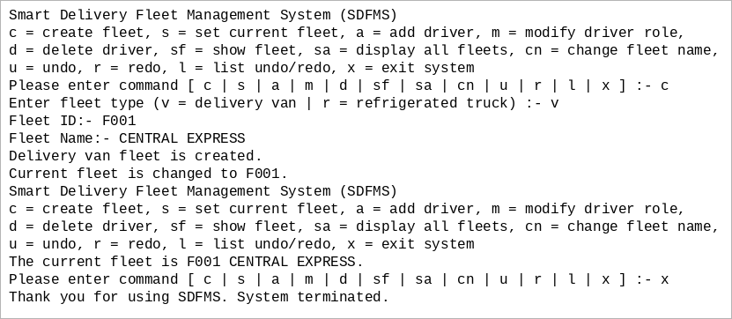 | PASS
TC02 | Set current fleet  Setup: Fresh session  Steps: c | v | F001 | CENTRAL EXPRESS | a | d001, Alex Chan | 1 | c | r | F102 | FROST LINE | s | F001 | x  Expected: “Changed current fleet to F001.”  Actual:  Enter fleet type (v = delivery van | r = refrigerated truck) :- v  Fleet ID:- F001  Fleet Name:- CENTRAL EXPRESS  Delivery van fleet is created.  Current fleet is changed to F001.  Please input driver information (id, name):- d001, Alex Chan  Role (1 = van driver | 2 = courier driver) :- 1  Driver is added.  Enter fleet type (v = delivery van | r = refrigerated truck) :- r  Fleet ID:- F102  Fleet Name:- FROST LINE  Refrigerated truck fleet is created.  Current fleet is changed to F102.  Please input fleet ID:- F001  Changed current fleet to F001.  Thank you for using SDFMS. System terminated.  Screen capture of this run:  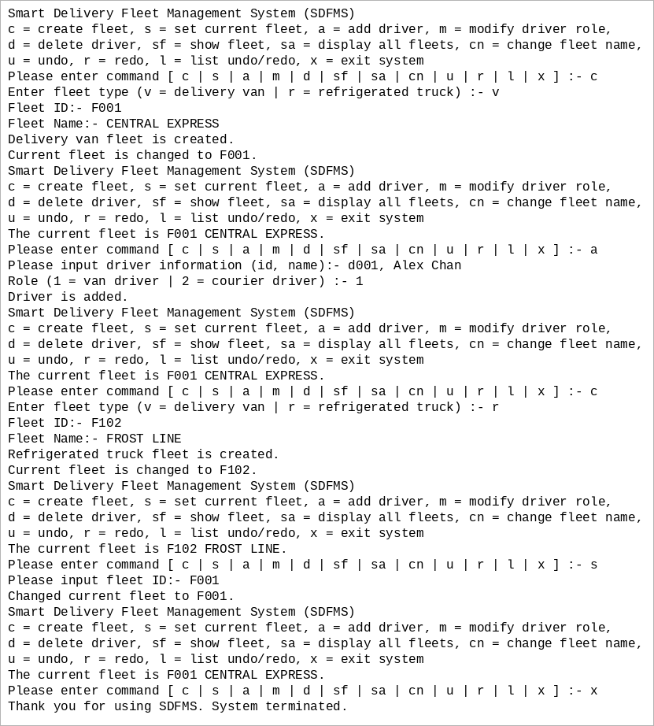 | PASS
TC03 | Add a driver  Setup: Fresh session  Steps: c | v | F001 | CENTRAL EXPRESS | a | d001, Alex Chan | 1 | x  Expected: “Driver is added.”  Actual:  Enter fleet type (v = delivery van | r = refrigerated truck) :- v  Fleet ID:- F001  Fleet Name:- CENTRAL EXPRESS  Delivery van fleet is created.  Current fleet is changed to F001.  Please input driver information (id, name):- d001, Alex Chan  Role (1 = van driver | 2 = courier driver) :- 1  Driver is added.  Thank you for using SDFMS. System terminated.  Screen capture of this run:  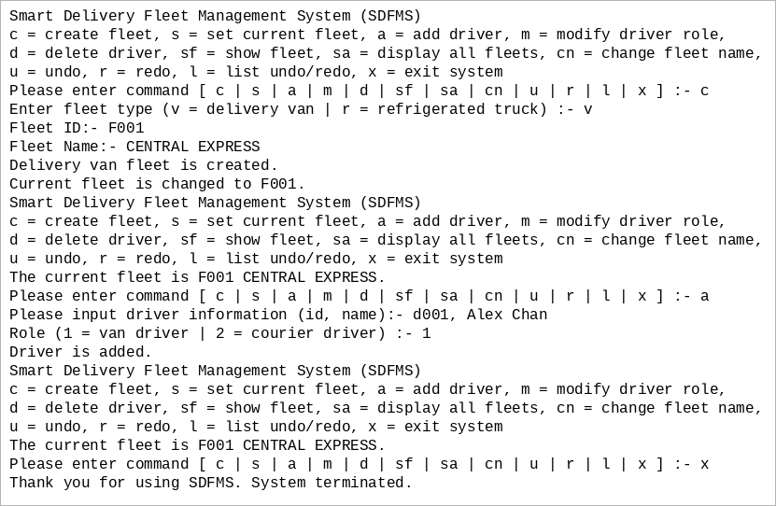 | PASS
TC04 | Modify driver role  Setup: Fresh session  Steps: c | v | F001 | CENTRAL EXPRESS | a | d001, Alex Chan | 1 | m | d001 | 2 | sf | x  Expected: “Driver role is updated.” The show-fleet listing then has no van driver and lists d001, Alex Chan under Courier Driver.  Actual:  Enter fleet type (v = delivery van | r = refrigerated truck) :- v  Fleet ID:- F001  Fleet Name:- CENTRAL EXPRESS  Delivery van fleet is created.  Current fleet is changed to F001.  Please input driver information (id, name):- d001, Alex Chan  Role (1 = van driver | 2 = courier driver) :- 1  Driver is added.  Please input driver ID:- d001  Role (1 = van driver | 2 = courier driver) :- 2  Driver role is updated.  Delivery Van Fleet CENTRAL EXPRESS (F001)  Van Driver: NIL  Courier Driver:  d001, Alex Chan  Thank you for using SDFMS. System terminated.  Screen capture of this run:  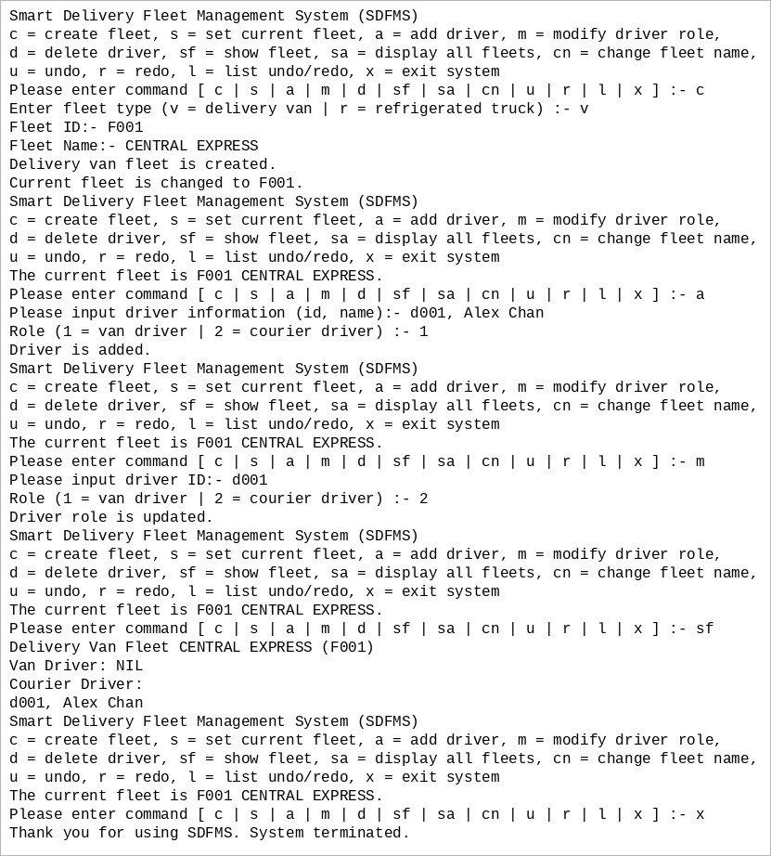 | PASS
TC05 | Delete a driver  Setup: Fresh session  Steps: c | v | F001 | CENTRAL EXPRESS | a | d001, Alex Chan | 1 | d | d001 | sf | x  Expected: “Driver is deleted.” The show-fleet listing then has “Van Driver: NIL” and “Courier Driver: NIL”.  Actual:  Enter fleet type (v = delivery van | r = refrigerated truck) :- v  Fleet ID:- F001  Fleet Name:- CENTRAL EXPRESS  Delivery van fleet is created.  Current fleet is changed to F001.  Please input driver information (id, name):- d001, Alex Chan  Role (1 = van driver | 2 = courier driver) :- 1  Driver is added.  Please input driver ID:- d001  Driver is deleted.  Delivery Van Fleet CENTRAL EXPRESS (F001)  Van Driver: NIL  Courier Driver: NIL  Thank you for using SDFMS. System terminated.  Screen capture of this run:  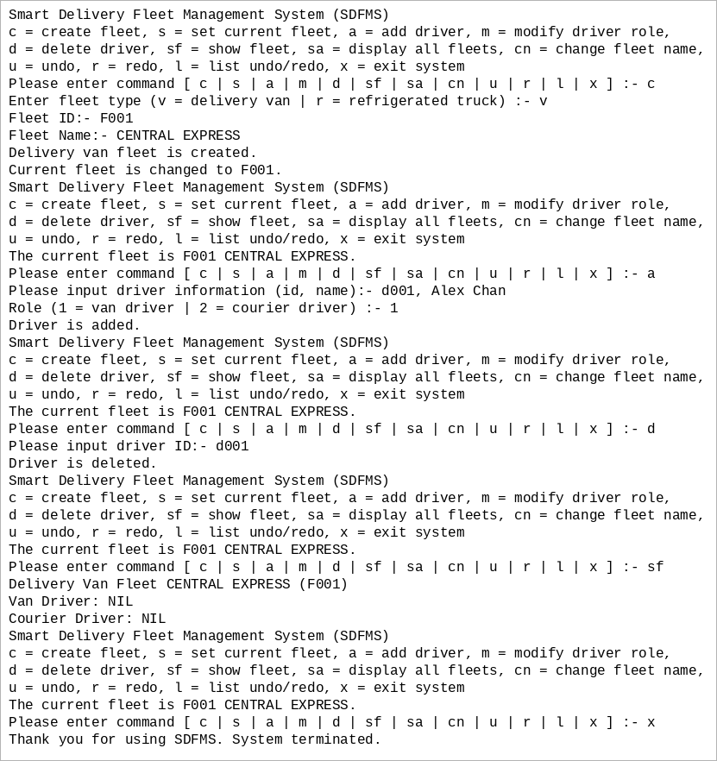 | PASS
TC06 | Show current fleet  Setup: Fresh session  Steps: c | v | F001 | CENTRAL EXPRESS | a | d001, Alex Chan | 1 | sf | x  Expected: d001, Alex Chan listed under Van Driver, and “Courier Driver: NIL”  Actual:  Enter fleet type (v = delivery van | r = refrigerated truck) :- v  Fleet ID:- F001  Fleet Name:- CENTRAL EXPRESS  Delivery van fleet is created.  Current fleet is changed to F001.  Please input driver information (id, name):- d001, Alex Chan  Role (1 = van driver | 2 = courier driver) :- 1  Driver is added.  Delivery Van Fleet CENTRAL EXPRESS (F001)  Van Driver:  d001, Alex Chan  Courier Driver: NIL  Thank you for using SDFMS. System terminated.  Screen capture of this run:  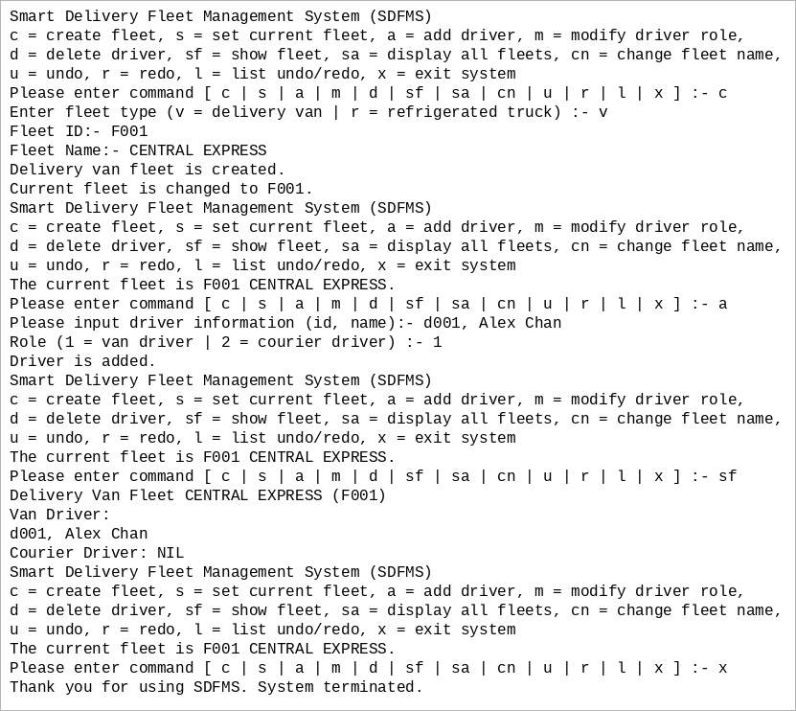 | PASS
TC07 | Display all fleets  Setup: Fresh session  Steps: c | v | F001 | CENTRAL EXPRESS | a | d001, Alex Chan | 1 | c | r | F102 | FROST LINE | sa | x  Expected: “Delivery Van Fleet CENTRAL EXPRESS (F001)” and “Refrigerated Truck Fleet FROST LINE (F102)”  Actual:  Enter fleet type (v = delivery van | r = refrigerated truck) :- v  Fleet ID:- F001  Fleet Name:- CENTRAL EXPRESS  Delivery van fleet is created.  Current fleet is changed to F001.  Please input driver information (id, name):- d001, Alex Chan  Role (1 = van driver | 2 = courier driver) :- 1  Driver is added.  Enter fleet type (v = delivery van | r = refrigerated truck) :- r  Fleet ID:- F102  Fleet Name:- FROST LINE  Refrigerated truck fleet is created.  Current fleet is changed to F102.  Delivery Van Fleet CENTRAL EXPRESS (F001)  Refrigerated Truck Fleet FROST LINE (F102)  Thank you for using SDFMS. System terminated.  Screen capture of this run:  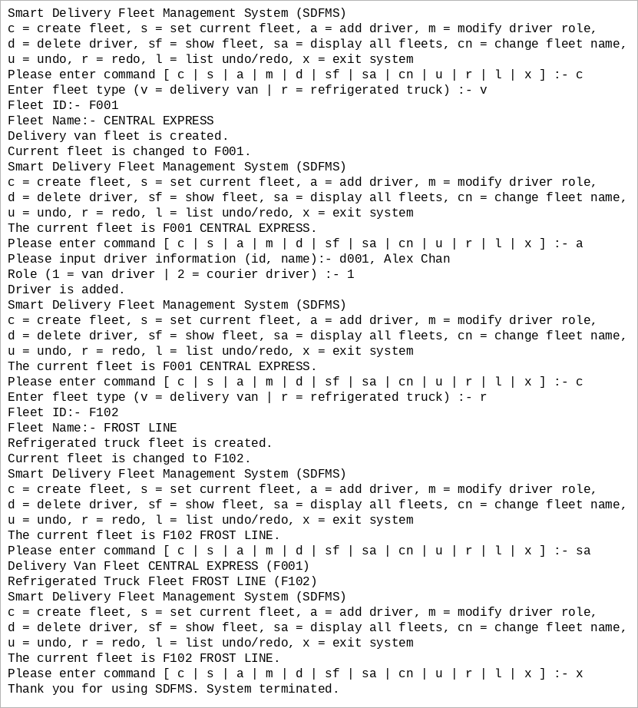 | PASS
TC08 | Change fleet name  Setup: Fresh session  Steps: c | v | F001 | CENTRAL EXPRESS | cn | METRO EXPRESS | sf | x  Expected: “Fleet name is updated.” The show-fleet heading is then “Delivery Van Fleet METRO EXPRESS (F001)”.  Actual:  Enter fleet type (v = delivery van | r = refrigerated truck) :- v  Fleet ID:- F001  Fleet Name:- CENTRAL EXPRESS  Delivery van fleet is created.  Current fleet is changed to F001.  Please input new name of the current fleet:- METRO EXPRESS  Fleet name is updated.  Delivery Van Fleet METRO EXPRESS (F001)  Van Driver: NIL  Courier Driver: NIL  Thank you for using SDFMS. System terminated.  Screen capture of this run:  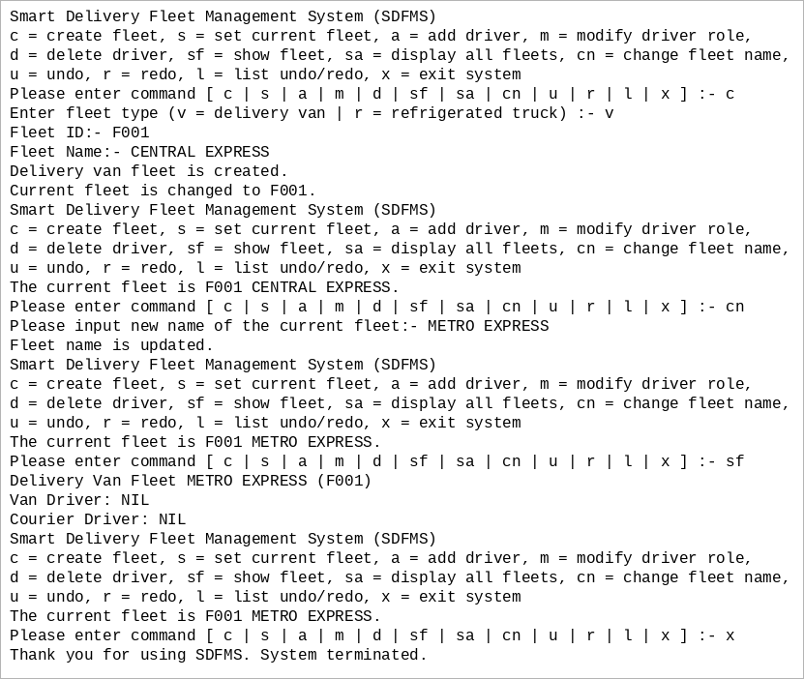 | PASS
TC09 | Undo role change  Setup: Fresh session  Steps: c | v | F001 | CENTRAL EXPRESS | a | d001, Alex Chan | 1 | m | d001 | 2 | u | sf | x  Expected: “Command (Modify driver role, d001, courier driver) is undone.”; d001, Alex Chan listed under Van Driver.  Actual:  Enter fleet type (v = delivery van | r = refrigerated truck) :- v  Fleet ID:- F001  Fleet Name:- CENTRAL EXPRESS  Delivery van fleet is created.  Current fleet is changed to F001.  Please input driver information (id, name):- d001, Alex Chan  Role (1 = van driver | 2 = courier driver) :- 1  Driver is added.  Please input driver ID:- d001  Role (1 = van driver | 2 = courier driver) :- 2  Driver role is updated.  Command (Modify driver role, d001, courier driver) is undone.  Delivery Van Fleet CENTRAL EXPRESS (F001)  Van Driver:  d001, Alex Chan  Courier Driver: NIL  Thank you for using SDFMS. System terminated.  Screen capture of this run:  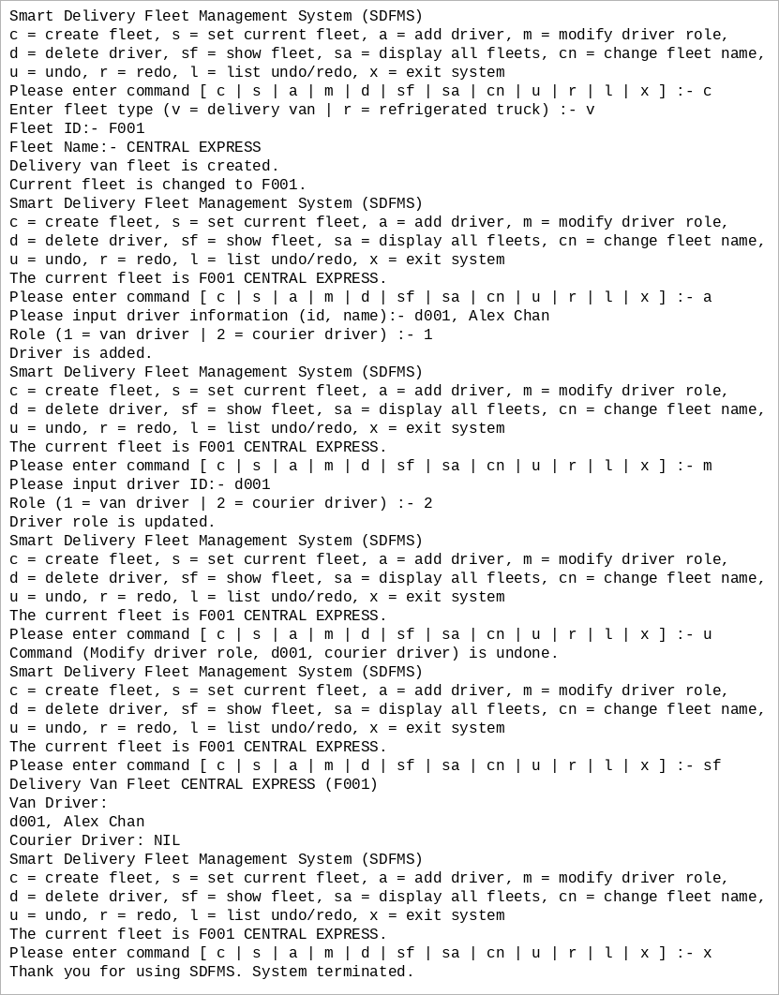 | PASS
TC10 | Redo role change  Setup: Fresh session  Steps: c | v | F001 | CENTRAL EXPRESS | a | d001, Alex Chan | 1 | m | d001 | 2 | u | r | sf | x  Expected: “Command (Modify driver role, d001, courier driver) is redone.”; d001, Alex Chan listed under Courier Driver.  Actual:  Enter fleet type (v = delivery van | r = refrigerated truck) :- v  Fleet ID:- F001  Fleet Name:- CENTRAL EXPRESS  Delivery van fleet is created.  Current fleet is changed to F001.  Please input driver information (id, name):- d001, Alex Chan  Role (1 = van driver | 2 = courier driver) :- 1  Driver is added.  Please input driver ID:- d001  Role (1 = van driver | 2 = courier driver) :- 2  Driver role is updated.  Command (Modify driver role, d001, courier driver) is undone.  Command (Modify driver role, d001, courier driver) is redone.  Delivery Van Fleet CENTRAL EXPRESS (F001)  Van Driver: NIL  Courier Driver:  d001, Alex Chan  Thank you for using SDFMS. System terminated.  Screen capture of this run:  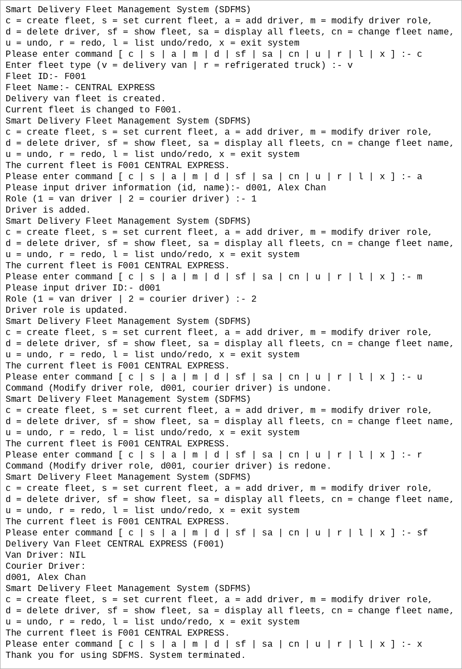 | PASS
TC11 | Show undo/redo lists  Setup: Fresh session  Steps: c | v | F001 | CENTRAL EXPRESS | a | d001, Alex Chan | 1 | u | l | x  Expected: an Undo List containing “Create delivery van fleet, F001, CENTRAL EXPRESS” and a Redo List containing “Add driver, d001, Alex Chan, van driver”  Actual:  Enter fleet type (v = delivery van | r = refrigerated truck) :- v  Fleet ID:- F001  Fleet Name:- CENTRAL EXPRESS  Delivery van fleet is created.  Current fleet is changed to F001.  Please input driver information (id, name):- d001, Alex Chan  Role (1 = van driver | 2 = courier driver) :- 1  Driver is added.  Command (Add driver, d001, Alex Chan, van driver) is undone.  Undo List  Create delivery van fleet, F001, CENTRAL EXPRESS  -- End of undo list --  Redo List  Add driver, d001, Alex Chan, van driver  -- End of redo list --  Thank you for using SDFMS. System terminated.  Screen capture of this run:  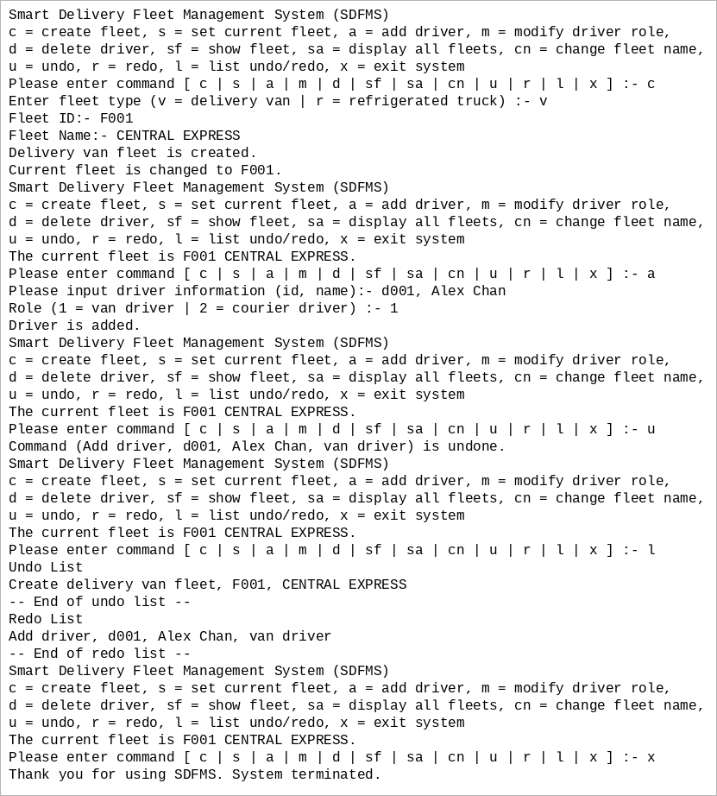 | PASS
TC12 | Exit system  Setup: Fresh session  Steps: x  Expected: “Thank you for using SDFMS. System terminated.”  Actual:  Thank you for using SDFMS. System terminated.  Screen capture of this run:  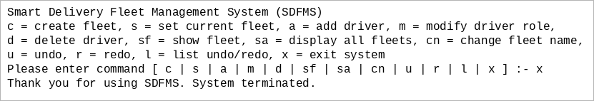 | PASS
TC13 | Undo and redo create fleet  Setup: Fresh session  Steps: c | v | F001 | CENTRAL EXPRESS | u | sa | r | sa | x  Expected: “Command (Create delivery van fleet, F001, CENTRAL EXPRESS) is undone.”; “No fleet record!”; the same command “is redone.”; “Delivery Van Fleet CENTRAL EXPRESS (F001)”.  Actual:  Enter fleet type (v = delivery van | r = refrigerated truck) :- v  Fleet ID:- F001  Fleet Name:- CENTRAL EXPRESS  Delivery van fleet is created.  Current fleet is changed to F001.  Command (Create delivery van fleet, F001, CENTRAL EXPRESS) is undone.  No fleet record!  Command (Create delivery van fleet, F001, CENTRAL EXPRESS) is redone.  Delivery Van Fleet CENTRAL EXPRESS (F001)  Thank you for using SDFMS. System terminated.  Screen capture of this run:  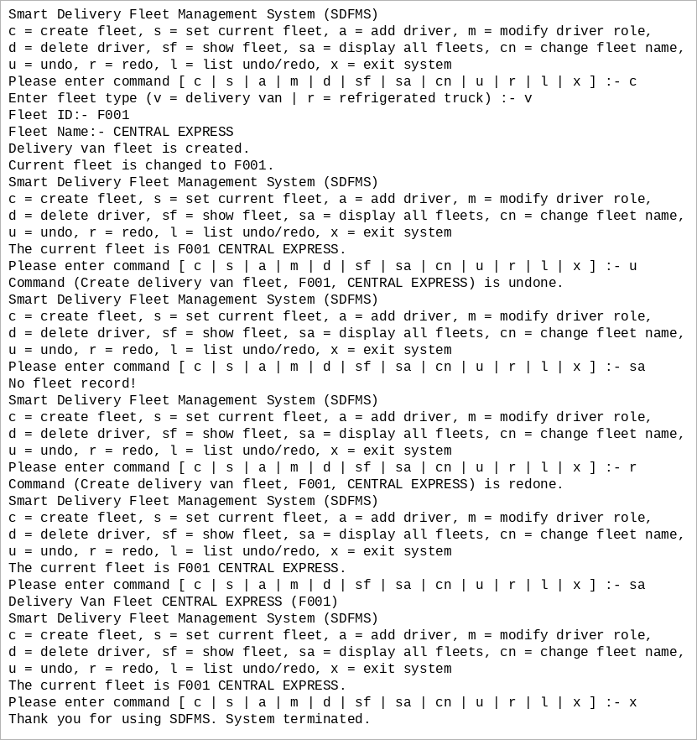 | PASS
TC14 | Undo and redo add driver  Setup: Fresh session  Steps: c | v | F001 | CENTRAL EXPRESS | a | d001, Alex Chan | 1 | u | sf | r | sf | x  Expected: “Command (Add driver, d001, Alex Chan, van driver) is undone.” and both role headings NIL; the same command “is redone.” and d001, Alex Chan listed under Van Driver.  Actual:  Enter fleet type (v = delivery van | r = refrigerated truck) :- v  Fleet ID:- F001  Fleet Name:- CENTRAL EXPRESS  Delivery van fleet is created.  Current fleet is changed to F001.  Please input driver information (id, name):- d001, Alex Chan  Role (1 = van driver | 2 = courier driver) :- 1  Driver is added.  Command (Add driver, d001, Alex Chan, van driver) is undone.  Delivery Van Fleet CENTRAL EXPRESS (F001)  Van Driver: NIL  Courier Driver: NIL  Command (Add driver, d001, Alex Chan, van driver) is redone.  Delivery Van Fleet CENTRAL EXPRESS (F001)  Van Driver:  d001, Alex Chan  Courier Driver: NIL  Thank you for using SDFMS. System terminated.  Screen capture of this run:  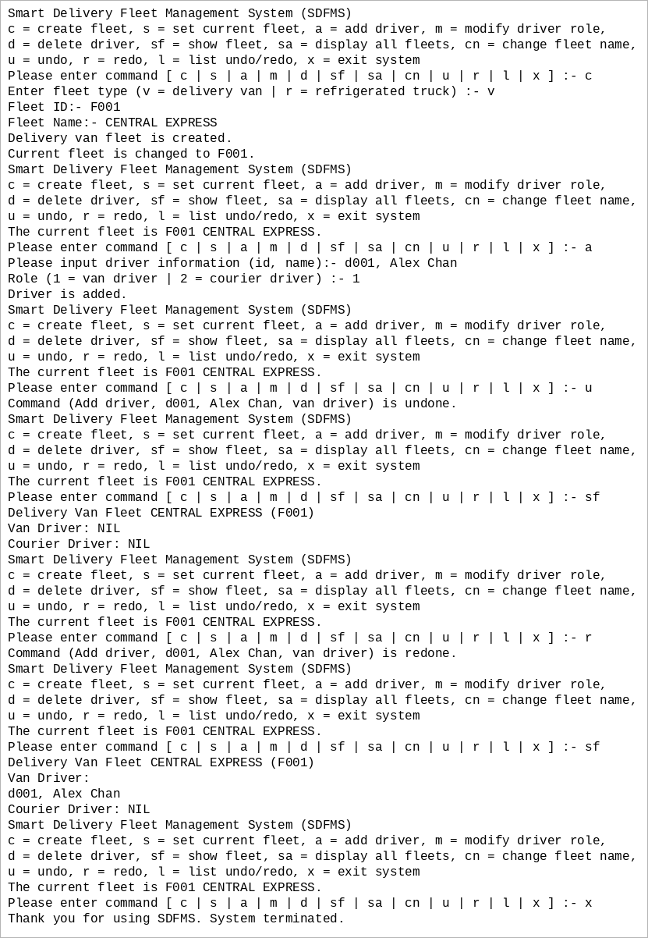 | PASS
TC15 | Undo and redo delete driver  Setup: Fresh session  Steps: c | v | F001 | CENTRAL EXPRESS | a | d001, Alex Chan | 1 | d | d001 | u | sf | r | sf | x  Expected: “Command (Delete driver, d001) is undone.” and d001, Alex Chan listed under Van Driver; the same command “is redone.” and “Van Driver: NIL”.  Actual:  Enter fleet type (v = delivery van | r = refrigerated truck) :- v  Fleet ID:- F001  Fleet Name:- CENTRAL EXPRESS  Delivery van fleet is created.  Current fleet is changed to F001.  Please input driver information (id, name):- d001, Alex Chan  Role (1 = van driver | 2 = courier driver) :- 1  Driver is added.  Please input driver ID:- d001  Driver is deleted.  Command (Delete driver, d001) is undone.  Delivery Van Fleet CENTRAL EXPRESS (F001)  Van Driver:  d001, Alex Chan  Courier Driver: NIL  Command (Delete driver, d001) is redone.  Delivery Van Fleet CENTRAL EXPRESS (F001)  Van Driver: NIL  Courier Driver: NIL  Thank you for using SDFMS. System terminated.  Screen capture of this run:  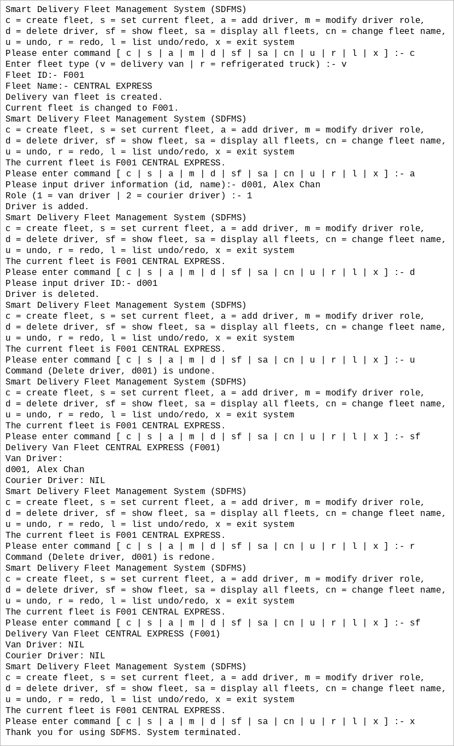 | PASS
TC16 | Undo and redo fleet name  Setup: Fresh session  Steps: c | v | F001 | CENTRAL EXPRESS | cn | METRO EXPRESS | u | sf | r | sf | x  Expected: “Command (Change fleet name, F001, METRO EXPRESS) is undone.” and the heading “Delivery Van Fleet CENTRAL EXPRESS (F001)”; the same command “is redone.” and the heading “Delivery Van Fleet METRO EXPRESS (F001)”.  Actual:  Enter fleet type (v = delivery van | r = refrigerated truck) :- v  Fleet ID:- F001  Fleet Name:- CENTRAL EXPRESS  Delivery van fleet is created.  Current fleet is changed to F001.  Please input new name of the current fleet:- METRO EXPRESS  Fleet name is updated.  Command (Change fleet name, F001, METRO EXPRESS) is undone.  Delivery Van Fleet CENTRAL EXPRESS (F001)  Van Driver: NIL  Courier Driver: NIL  Command (Change fleet name, F001, METRO EXPRESS) is redone.  Delivery Van Fleet METRO EXPRESS (F001)  Van Driver: NIL  Courier Driver: NIL  Thank you for using SDFMS. System terminated.  Screen capture of this run:  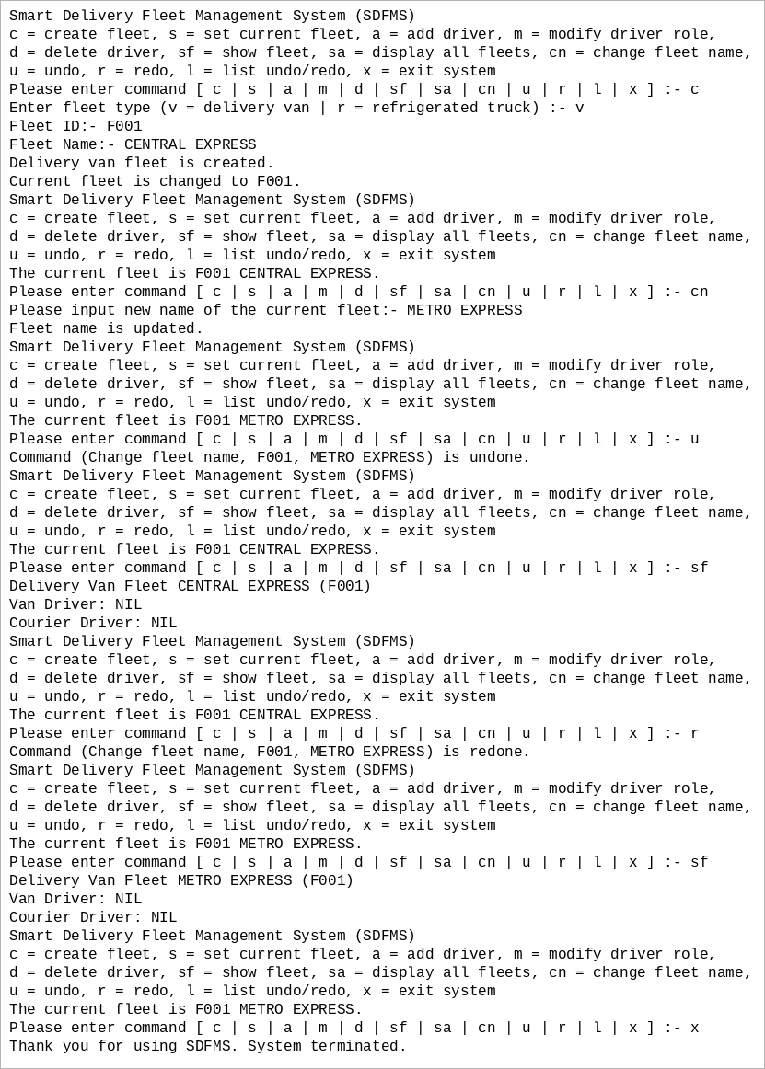 | PASS
TC17 | Invalid input and empty history  Setup: Fresh session  Steps: u | r | a | c | z | x  Expected: “Nothing to undo!”; “Nothing to redo!”; “No current fleet!”; “Invalid fleet type!”  Actual:  Nothing to undo!  Nothing to redo!  No current fleet!  Enter fleet type (v = delivery van | r = refrigerated truck) :- z  Invalid fleet type!  Thank you for using SDFMS. System terminated.  Screen capture of this run:  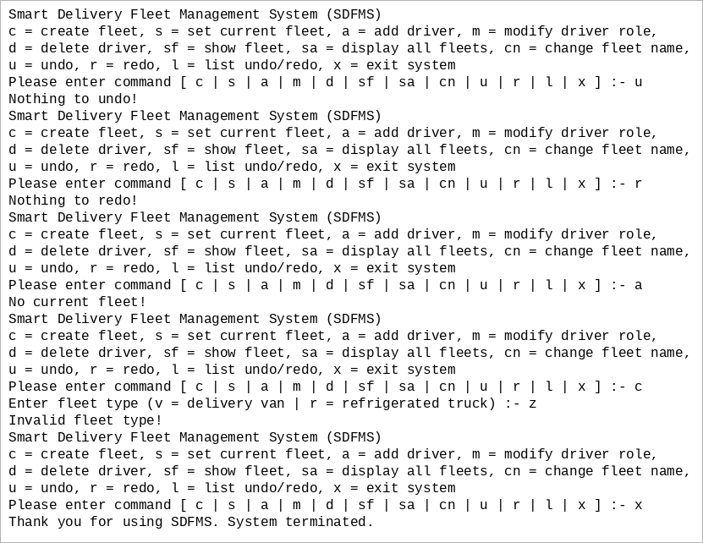 | PASS
TC18 | Duplicate ID, invalid role, redo reset  Setup: Fresh session  Steps: c | v | F001 | CENTRAL EXPRESS | a | d001, Alex Chan | 1 | u | cn | NEW NAME | r | a | d002, Lee | 9 | a | d002, Lee | 1 | a | d002, New | x  Expected: “Nothing to redo!”; “Invalid role!”; “Driver d002 already exists in the current fleet!”. The duplicate is rejected before a role is requested.  Actual:  Enter fleet type (v = delivery van | r = refrigerated truck) :- v  Fleet ID:- F001  Fleet Name:- CENTRAL EXPRESS  Delivery van fleet is created.  Current fleet is changed to F001.  Please input driver information (id, name):- d001, Alex Chan  Role (1 = van driver | 2 = courier driver) :- 1  Driver is added.  Command (Add driver, d001, Alex Chan, van driver) is undone.  Please input new name of the current fleet:- NEW NAME  Fleet name is updated.  Nothing to redo!  Please input driver information (id, name):- d002, Lee  Role (1 = van driver | 2 = courier driver) :- 9  Invalid role!  Please input driver information (id, name):- d002, Lee  Role (1 = van driver | 2 = courier driver) :- 1  Driver is added.  Please input driver information (id, name):- d002, New  Driver d002 already exists in the current fleet!  Thank you for using SDFMS. System terminated.  Screen capture of this run:  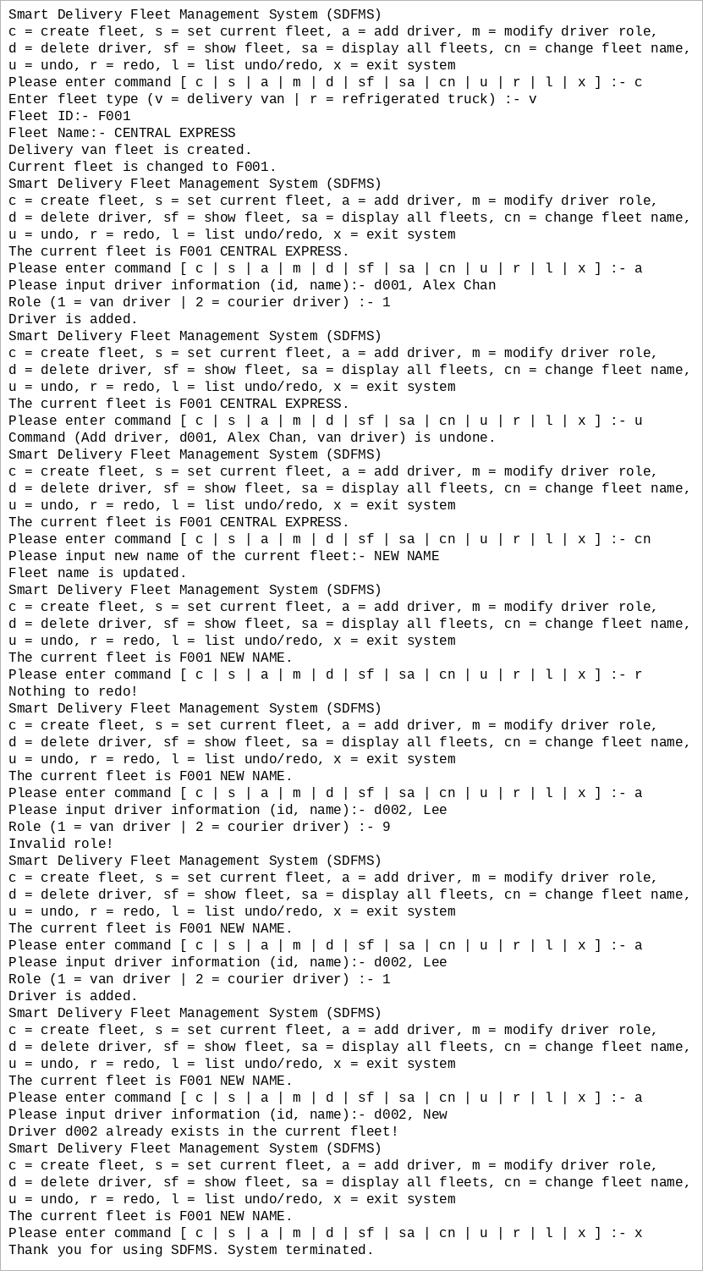 | PASS

