Escape Room Explanation:

This Escape Room consists of three challenges to be completed within a time limit set by a timer. Participants who complete them in time must press SW9 and will see a light lit up, indicating their victory, and, of course, will be able to exit through the door. Participants who don't complete the challenges in time will be able to exit through the door, but will not see the victory light.

On our board, the victory LED will be the leftmost LED, LEDR3, and the door LED will be the one to its right, LEDR4.

Challenge 1:

In this challenge you must solve the following mathematical problem::

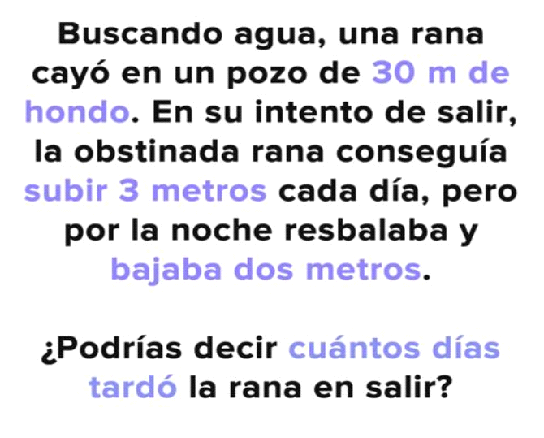

TRADUCTION: A FROG WAS LOOKING FOR WATER WHEN IT FELL INTO A 30 METER WELL. IN ITS ATTEMPT TO LEAVE, THE FROG ACHIEVED TO CLIMB 3 METER PER DAY, BUT AT NIGHT IT WAS SLIPING AND FELL 2 METER.

¿COULD YOU TELL HOW MANY DAYS DOES THE FROG LAST TO LEAVE TE WELL?

The solution to this challenge will be entered in the 2-bit binary code of the tens place (for example: if the answer is 13, you enter a binary 1: 01).

This is entered into the switches at the bottom right (SW1 and SW0), with the one on the far right being the most significant (0 in the previous example).

Finally, if the challenge is passed, LEDR0 will light up.

Challenge 2:

This challenge consists of solving the following riddle:

**Soy el número que representa los días de la semana, ¿quién soy?**

I AM THE NUMBER THAT REPRESENT THE DAYS OF THE WEEK. ¿WHO AM I?

Como te habrás dado cuenta, la respuesta es un número que se puede expresar en 3 bits. Para superar este reto deberás introducir esta solución tanto en Gray como en BCD, para esto usaras un total de 6 switches. El GRAY lo introducirás en SW2, SW3 y SW4 siendo SW4 el más significativo y el BCD en SW5, SW6 y SW7 siendo SW7 el más significativo. El número gray quedará mostrado en HEX0 y el BCD en HEX1 .Si el resultado en GRAY y en BCD son correctos habrás superado el reto y se encenderá el LEDR1.

Here we leave you the GRAY and BCD conversion table for 3 bits:

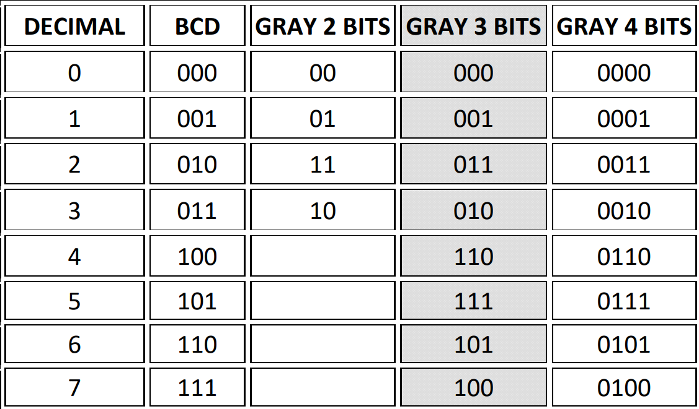

Challenge 3:

In this final challenge, participants will press a KEY0 button to observe a sequence of numbers, the result of which will be represented in HEX2. Participants will also have a second KEY1 button to reset the sequence at any time.

The challenge is to continue this logical sequence. To do so, they will have a third KEY2 button to enter the number, which will be observed in HEX3. Participants will have a second KEY3 button to reset their solution.

When participants think they have guessed correctly, they must turn on SW8.

Finally, if the challenge is passed, LEDR2 will light up.