Reproducible Research: Peer Assessment 1

## Loading and preprocessing the data

The code below set some variables concerned about the script enviroment in order to standardize and facilitate its use.  
It also loads some general libraries that will be used on the following steps.

library(dplyr)

##   
## Attaching package: 'dplyr'

## The following objects are masked from 'package:stats':  
##   
## filter, lag

## The following objects are masked from 'package:base':  
##   
## intersect, setdiff, setequal, union

library(plyr)

## -------------------------------------------------------------------------

## You have loaded plyr after dplyr - this is likely to cause problems.  
## If you need functions from both plyr and dplyr, please load plyr first, then dplyr:  
## library(plyr); library(dplyr)

## -------------------------------------------------------------------------

##   
## Attaching package: 'plyr'

## The following objects are masked from 'package:dplyr':  
##   
## arrange, count, desc, failwith, id, mutate, rename, summarise,  
## summarize

workingdirectory <- "~/R/RepData_PeerAssessment1"  
zipfile.name <- "activity.zip"  
csvfile.name <- "activity.csv"  
files.path <- workingdirectory  
zipfile.path <- paste(files.path, zipfile.name, sep = "/")  
csvfile.path <- paste(files.path, csvfile.name, sep = "/")  
  
setwd(workingdirectory)

As a next step it unzip and load the dataset. For this, it verifies if the file is where expected (the zip file dataset must be provided and placed into the specific folder as defined into the **zipfile.path** variable). The script also checks if load/unzip step is really required once it may had been executed beforehand.

# Check if zipfile is where expected  
if (!file.exists(zipfile.path)) {  
 stop(  
 paste(  
 "Message: The script couldn't continous because the data file was not found at '",  
 zipfile.path, "'", ". Solution: place the ", zipfile.name,  
 " (the one that contains the data source for this script) at ",  
 files.path, " directory and try again", sep = ""  
 )  
 )  
}  
  
# Unzip if csv file doesn't exists  
if (!file.exists(csvfile.path)) {  
 unzip(zipfile.path)  
}  
  
# Read the data  
activity.rawdata <-  
 read.csv(  
 file = csvfile.path, header = TRUE, sep = ",", stringsAsFactors = FALSE  
 )  
# Create a different dataframe so the raw data is preserved at its original   
# format in order to future need  
activity.data <- activity.rawdata

From now on, it format the columns to the correct type of value

# Converts steps columns into number values  
if (class(activity.data$steps) != "integer") {  
 activity.data$steps <- as.numeric(activity.data$steps)  
}  
  
# Converts the date column into date values  
if (class(activity.data$date) != "Date") {  
 activity.data$date <-  
 as.Date(x = as.character(activity.data$date), format = "%Y-%m-%d")  
}  
  
# Converts the interval column into number values  
if (class(activity.data$steps) != "integer") {  
 activity.data$steps <- as.numeric(activity.data$steps)  
}

The code below just bring up some additional information about the dataframe in order to you to be familiar with its content.

# Data structure info  
str(activity.data)

## 'data.frame': 17568 obs. of 3 variables:  
## $ steps : int NA NA NA NA NA NA NA NA NA NA ...  
## $ date : Date, format: "2012-10-01" "2012-10-01" ...  
## $ interval: int 0 5 10 15 20 25 30 35 40 45 ...

# Percental of NA at each column  
sapply(  
 activity.data, FUN = function(x) {  
 mean(is.na(x))  
 }  
)

## steps date interval   
## 0.1311475 0.0000000 0.0000000

## What is the mean total number of steps taken per day?

To answer this question, the script executes some preparation steps in order to preserve the clean and tidy data.set that was build by the previous code. Thus some new variables were created and some additional cleanning data steps executed, since all NA values will be ignored to answer the currently.

# Create a new dataset with no NA value  
activity.naignored <- activity.data[!is.na(activity.data$steps),]

The following code summarises the total number of steps for each day and plot the result into a histogram. Furthermore, it scratches a vertical blue line into the graph indicating the average number of total taken steps per day.

# Summarises the total daily number os steps  
totalbyday.naignored <- ddply(  
 activity.naignored,   
 .(date),  
 summarise,  
 total = sum(steps)  
)  
  
# Plots the histogram  
hist(totalbyday.naignored$total,  
 main = "Frequency of days by its number of steps",   
 xlab = "Number of the steps in one day",  
 ylab = "Frequency of days"  
)  
  
# Adds a vertical blue line indicating the daily average number of steps  
abline(v = mean(totalbyday.naignored$total), lwd = 3, col = "blue")

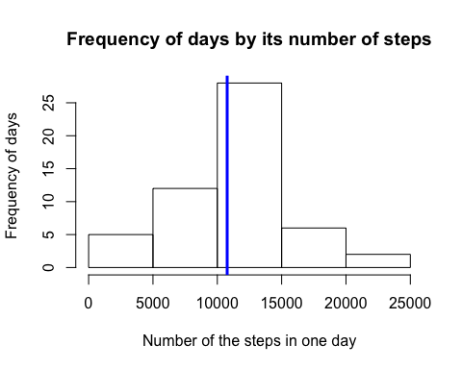

Besides the graph information below, the following code reports some numerical info concerned about what has been asked.

# mean daily number of steps  
mean(totalbyday.naignored$total)

## [1] 10766.19

# median daily number of steps  
median(totalbyday.naignored$total)

## [1] 10765

As you can see the average number of total daily steps is 1.076618910^{4}.

## What is the average daily activity pattern?

To answer this question the code below used the same data frame as before, which means that all records containing NA values were ignored. The first step was calculates the mean number of steps of each 5-minute interval across all days.

# Calculate the mean number of steps of each 5-minute interval across all days  
meanbyinterval.naignored <- ddply(  
 activity.naignored,   
 .(interval),   
 summarise,   
 mean = mean(steps)  
)

Then, it plots one graph ilustrating the mean number of steps for each 5-minutes interval across all days.

#Plot the graph with the average number of steps for each 5-minutes interval  
plot(  
 x = meanbyinterval.naignored$interval,   
 y = meanbyinterval.naignored$mean,   
 type = "l",   
 xlab = "Interval",   
 ylab = "Number of steps",   
 main = "Average number of steps Vs day interval"  
)

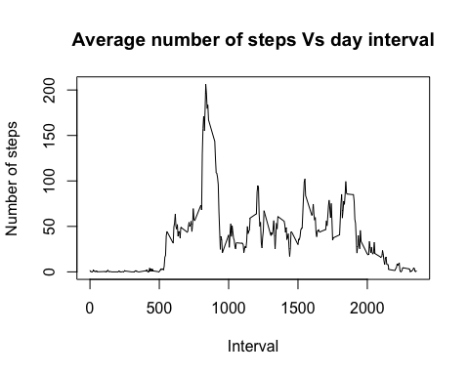

As a complementary info, the script identifies in which 5-minutes interval the average number of steps use to have the biggest number of steps.

# Gets the 5-minutes interval which has the maximum average number of steps  
# across all days  
meanbyinterval.naignored[  
 meanbyinterval.naignored$mean == max(meanbyinterval.naignored$mean),]

## interval mean  
## 104 835 206.1698

## Imputing missing values

As you could see at the beginning of this analises, the original dataset contains NA values. For the previous analyses, theses observations were ignored, but it would be interesting to check if by ignoring all these values ( 2304 to be more precise, or 13.1147541% of observations)  
we are not changing the result significantly. For this purpose the code created a new data frame where no observation containing NA values were ignored and its values replaced by its correspondent average number of total steps interval across all days.  
First, the code bellow reports the number and percental of observations containing NA values.

# Calculate the number and percental of rows with missing values  
sum(!complete.cases(activity.data))

## [1] 2304

mean(!complete.cases(activity.data))

## [1] 0.1311475

Now it iterates over the data frame and replaces all NA values by it's correspondent mean 5-minutes interval.

# Replace NA values by interval mean  
activity.nafilled <- activity.data  
for (i in 1:nrow(activity.nafilled)) {  
 #Get the step value  
 step.value <- activity.nafilled[i,"steps"]  
 if (is.na(step.value)) {  
 #Get the step interval  
 step.interval <- activity.nafilled[i, "interval"]  
   
 #Repacle step value from na by the mean step value at the correspond  
 #interval  
 activity.nafilled[i,"steps"] <-   
 meanbyinterval.naignored[  
 meanbyinterval.naignored$interval == step.interval, "mean"]  
 }  
}  
# remove the variables that won't be used on the following code.  
rm(step.value, step.interval)

Now it's time to report the results. First, the total daily number of steps result ilustrated into a histogram which contains the same vertical blue line indicating the average number of daily total steps.

# Calculate the total daily number of steps from activity.nafilled variable  
totalbyday.nafilled <- ddply(  
 activity.nafilled,   
 .(date),  
 summarise,  
 total = sum(steps)  
)  
  
# Plots the histogram  
hist(totalbyday.nafilled$total,  
 main = "Frequency of days by its number of steps",   
 xlab = "Number of the steps in one day",  
 ylab = "Frequency of days"  
)  
  
# Adds a vertical blue line that marks the daily average number of steps  
abline(v = mean(totalbyday.nafilled$total), lwd = 3, col = "blue")

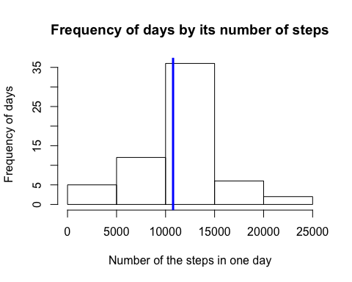

Now the numeric mean and median values of total number of steps taken per day.

# mean daily number of steps  
mean(totalbyday.nafilled$total)

## [1] 10766.19

# median daily number of steps  
median(totalbyday.nafilled$total)

## [1] 10766.19

Lastly the boxplot and the summary comparison below, allows you to identify that by ignoring or replacing NA values by its correspondent 5-minutes interval mean, doesn't make any big difference, once that the mean value remains almost the same. Some difference can be seen only ate the quartiles.

# Plots a boxplot graph so it enables a visually comparison between ignored and   
# filled NAs values  
totalbyday.nafilled <- cbind(totalbyday.nafilled, datasource = "na.filled")  
totalbyday.naignored <- cbind(totalbyday.naignored, datasource = "na.ignored")  
totalbyday.union <- rbind(totalbyday.nafilled, totalbyday.naignored) %>%   
 data.frame()  
boxplot(  
 total ~ datasource,   
 totalbyday.union,   
 main = "Total daily steps from Filled Vs Ignored NAs")

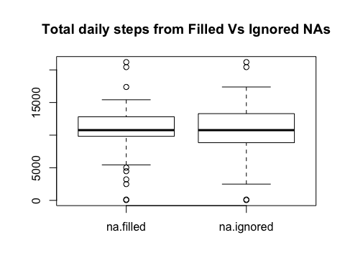

cbind(  
 na.filled = summary(totalbyday.nafilled$total),   
 na.ignored = summary(totalbyday.naignored$total)  
)

## na.filled na.ignored  
## Min. 41 41  
## 1st Qu. 9819 8841  
## Median 10770 10760  
## Mean 10770 10770  
## 3rd Qu. 12810 13290  
## Max. 21190 21190

## Are there differences in activity patterns between weekdays and weekends?

To try to answer this question the code below identified which is the weekday of each sample. Then, it classified the weekdays into **weekend** or **weekday**.  
Next, it finds the mean number of steps by each 5-minutes interval across all days to finally plot all these data into one line graph.

# Add the weekday (sun-sat) and weekdaytype (weekday or weekend) columns  
activity.weekday <- cbind(  
 activity.nafilled,   
 weekday = sapply(activity.nafilled$date, weekdays)  
 )  
activity.weekday <- cbind(  
 activity.weekday,   
 weekdaytype = sapply(activity.weekday$weekday, function(x){  
 if(as.numeric(x) %in% c(2,3,5,6,7) ){  
 "weekday"  
 }else{  
 "weekend"  
 }  
 })  
 ) %>%   
 data.frame()  
  
# Calculate the mean number os steps by each 5-minutes interval  
total.byintervalandweekday <- ddply(  
 activity.weekday,   
 .(interval, weekdaytype),  
 summarise,  
 mean = mean(steps)  
)  
  
# Plot hte values by  
library(ggplot2)

## Warning: package 'ggplot2' was built under R version 3.2.4

ggplot(  
 data = total.byintervalandweekday,   
 aes(x = interval, y = mean, color = factor(weekdaytype)),  
 xlab = "Interval",  
 ylab = "Mean number of steps"  
) + geom_line() + scale_color_hue(name = "Legenda") + ggtitle(label = "Mean number of steps by interval - Weekend Vs Weekday")

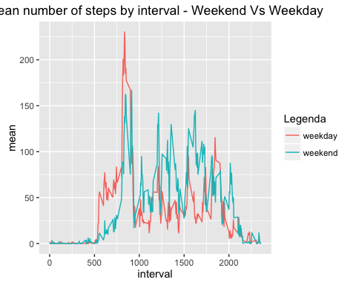

By checking out the last graph it's possible to conclude: - People usually starts to walk after the 500 5-minutes interval - On the weekdays the number of steps at the initial intervals is higher thant those at the weekend. - Between the 800 (aprox.) and 1.000 interval, the number of steps seams to be the highest of the day, indicating a possible running activity during this period of time;  
- Along all the rest of the day people walks more during the weekend than during the weekdays, problably because at weekdays people use to be at the office, where it's not usual to walk.