# Track1

## S2 – results eq1

without stimuli (default)

With stimuli (default)

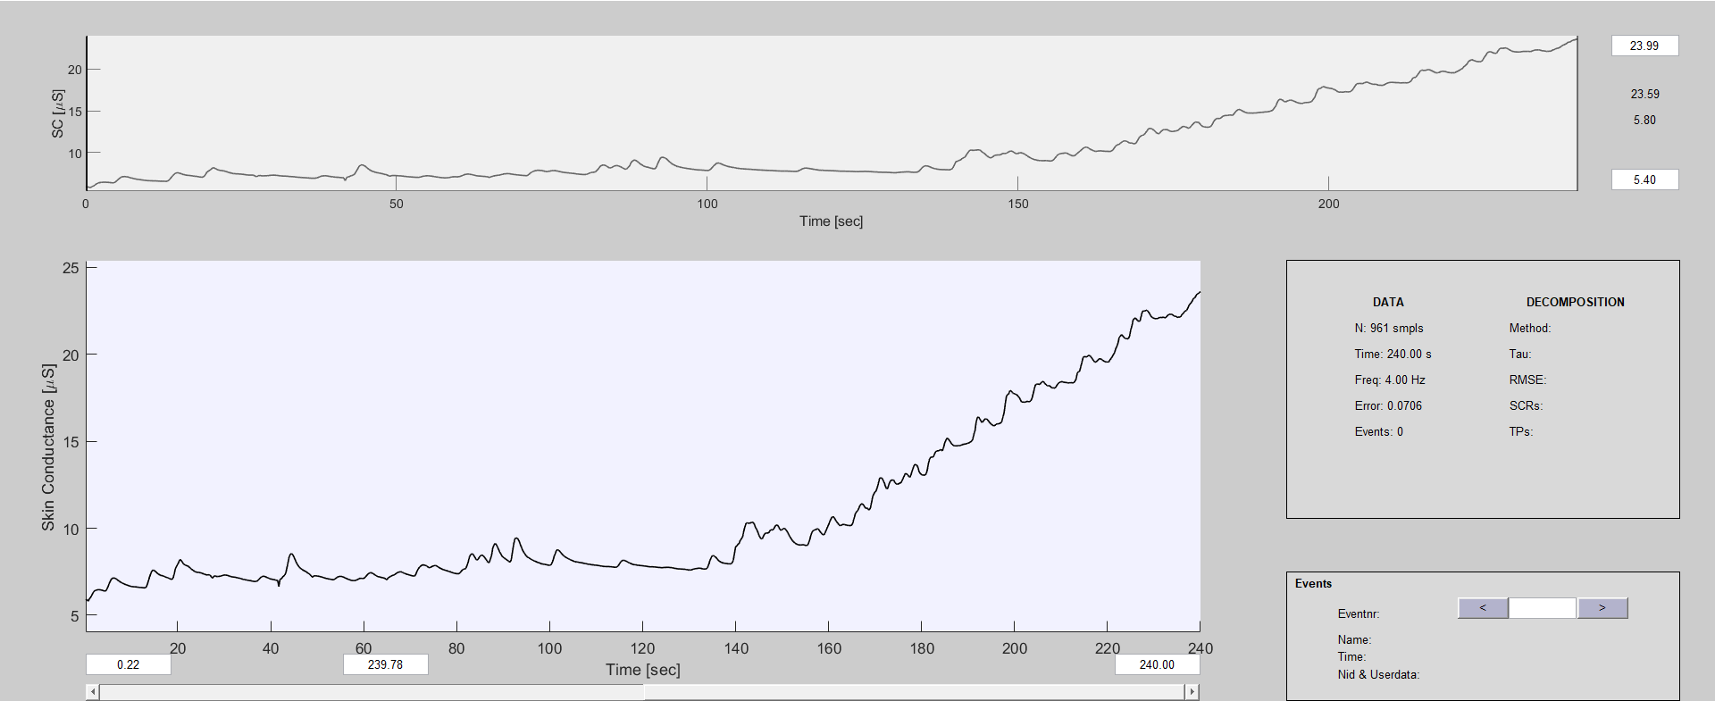

Note:

In the comparison between the two data, it is possible to clearly differentiate changes in skin conductance, and in status (default) with the person still the data remain relatively stable with little variation between values. When the person is finally in contact with the sound stimulus, we can see that the skin conductance values ​​shoot up to maximum values ​​around 20-30.

Note: The difference is very noticeable

## S3 – results eq1

without stimuli (default)

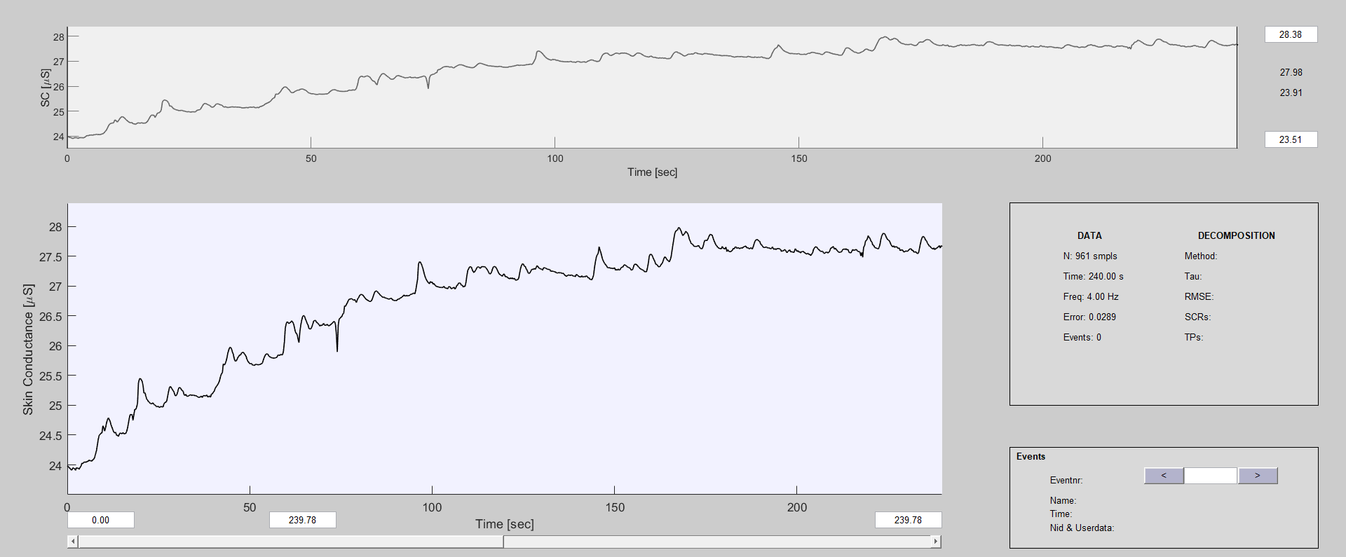

With stimuli (default)

Note:

In the comparison between the two data, it is possible to clearly differentiate changes in skin conductance, and in status (default) with the person still, the behavior of the data is identical to the previous analysis with some slight differences in the data trend and with higher values ​​than the previous analysis, however the data are also relatively stable. When the person is finally in contact with the sound stimulus, we can see that the skin conductance values ​​shoot up to maximum values ​​around 25-35.

Note: The difference is very noticeable, however, a smaller difference.

## S2 – results eq2

without stimuli (default)

With stimuli (default)

## S2 – results eq3

without stimuli (default)

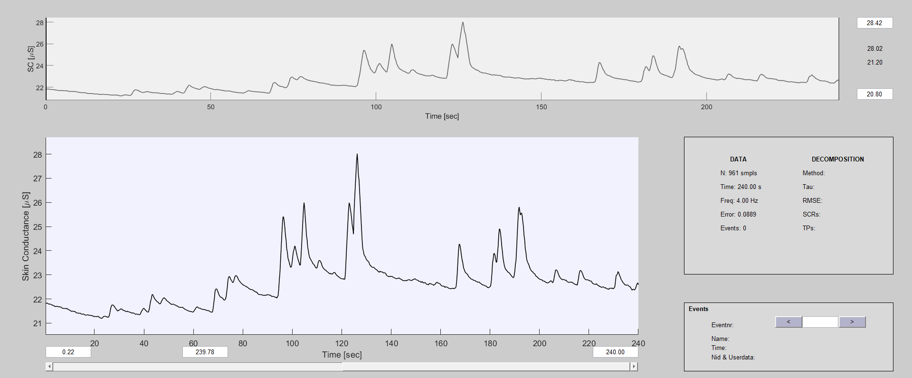

With stimuli (default)

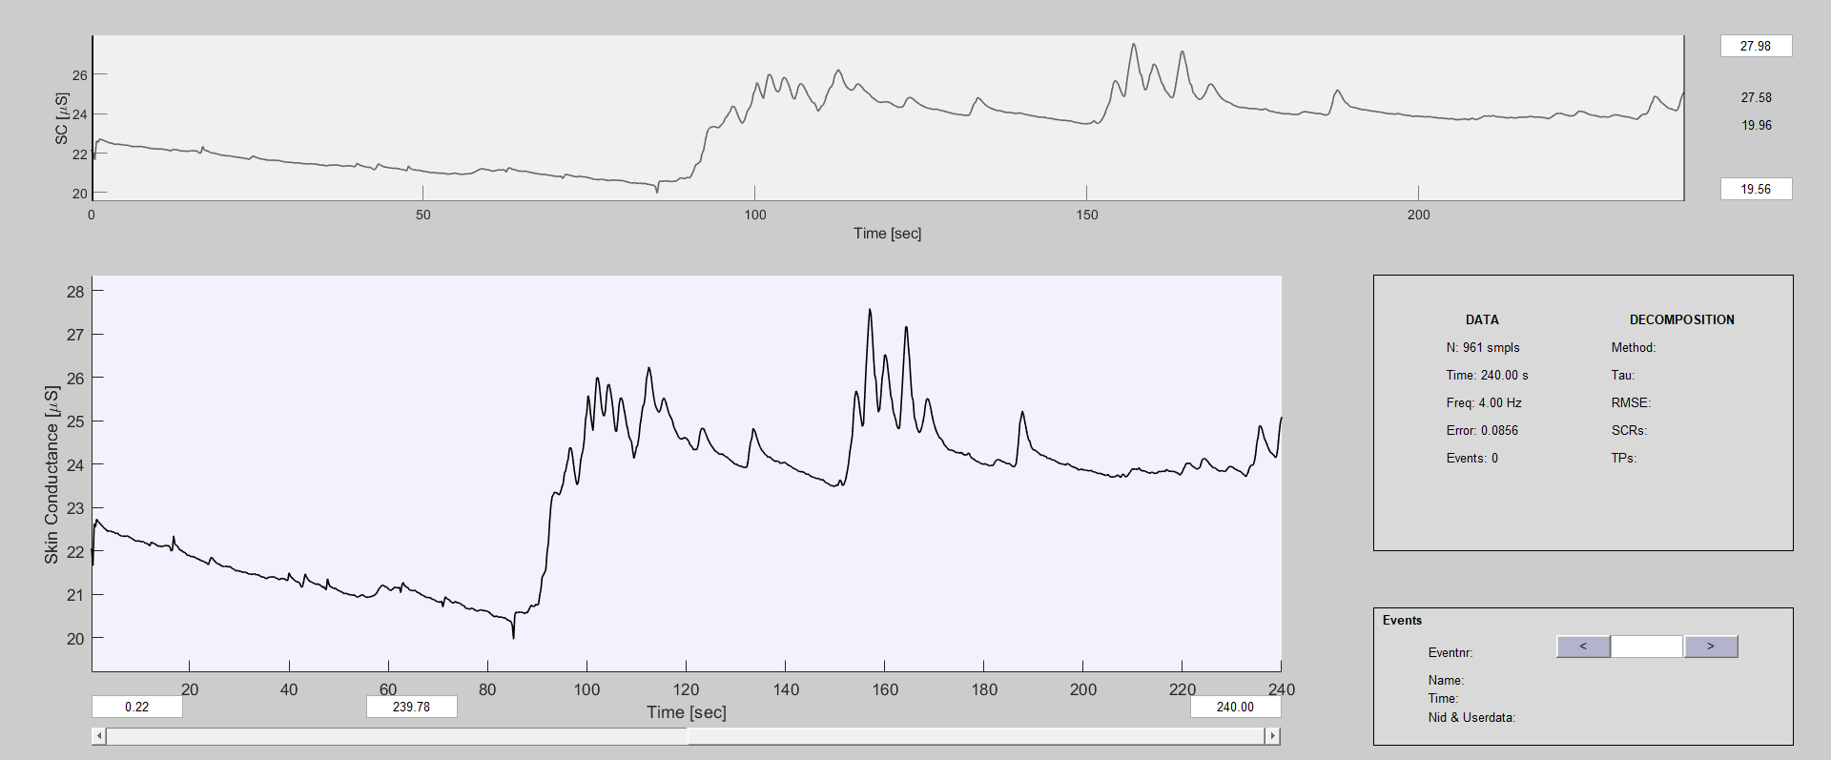

## S2 – results eq4

without stimuli (default)

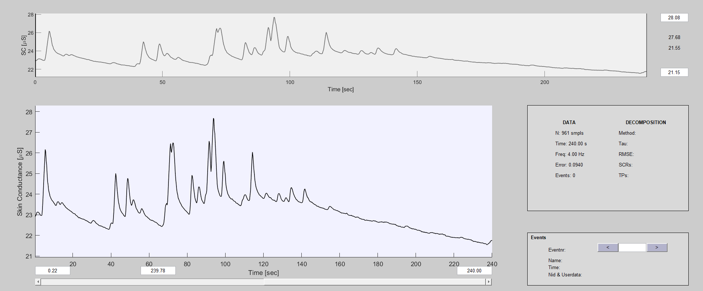

With stimuli (default)

