**I. Pen-and-paper**

**1)**

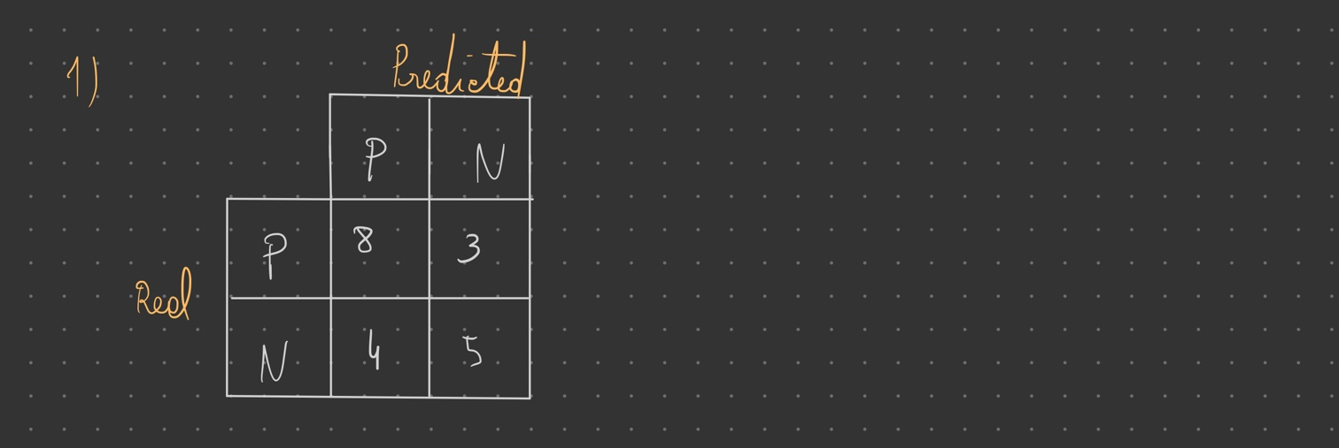

**2)**

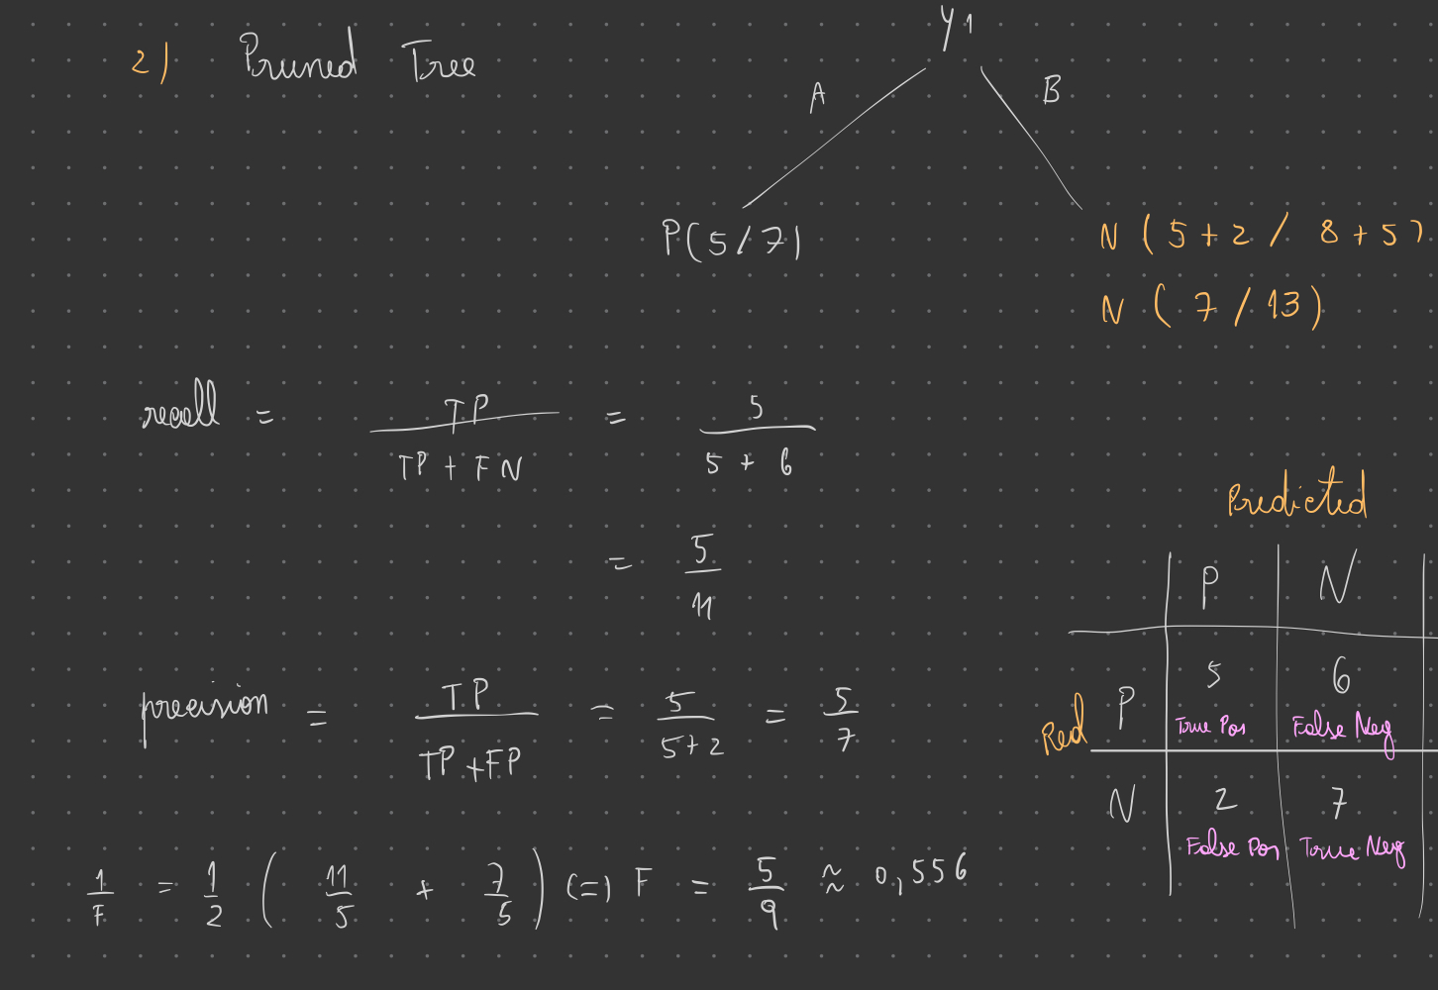

**3)**

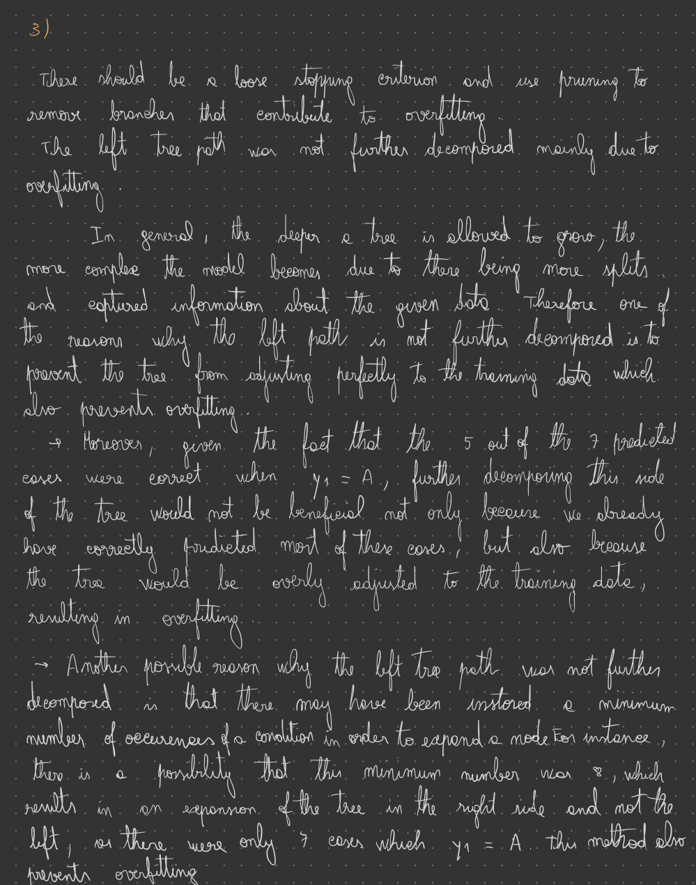

**4)**

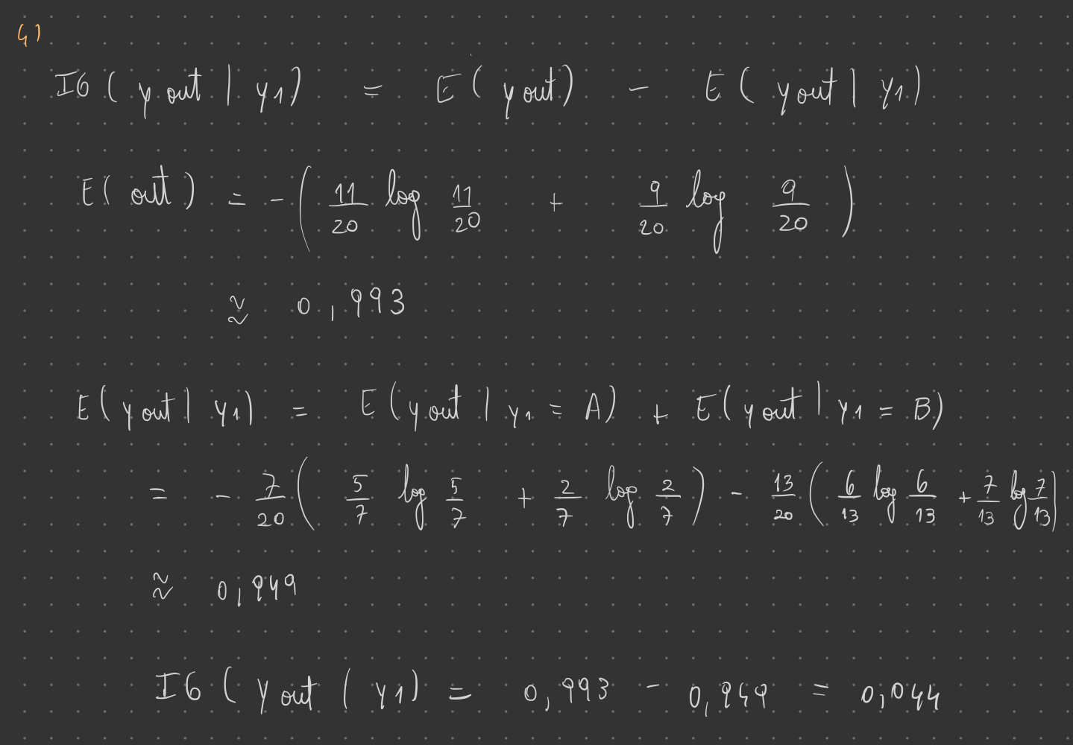

**II. Programming and critical analysis**

**1)**

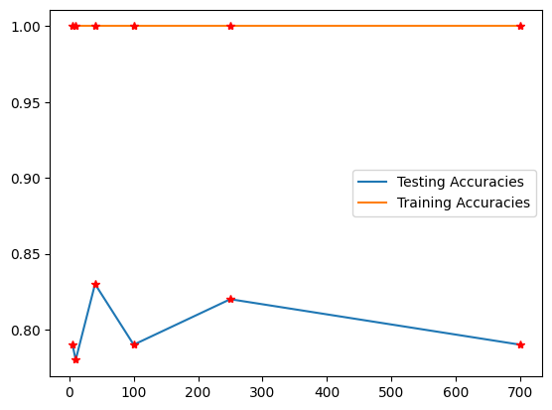

**2)**

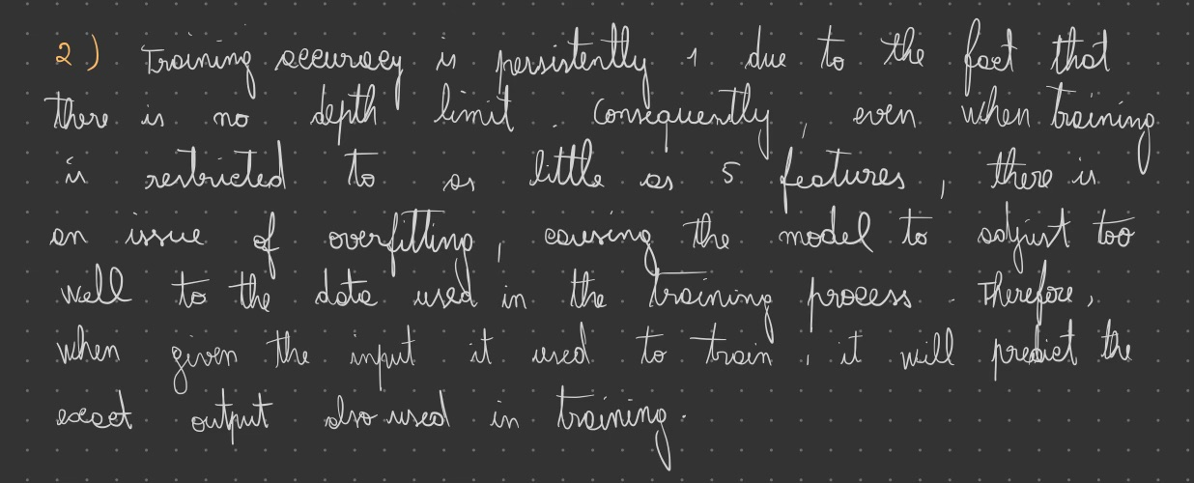

**III. APPENDIX**

**import** pandas **as** pd

**from** scipy.io.arff **import** loadarff

**from** sklearn.model_selection **import** train_test_split

**from** sklearn.feature_selection **import** mutual_info_classif, SelectKBest

**import** matplotlib.pyplot **as** plt

**import** seaborn **as** sns

**from** sklearn **import** metrics, datasets, tree

data **=** loadarff('pd_speech.arff')

df **=** pd.DataFrame(data[**0**])

df['class'] **=** df['class'].str.decode('utf-8')

testingAccuracies **=** []

trainingAccuracies **=** []

featureNums **=** (**5**, **10**, **40**, **100**, **250**, **700**)

target **=** df["class"]

variables **=** []

**for** i **in** df.columns:

variables.append(i)

X **=** df.copy()

X **=** X.drop('class', **axis** **=** **1**)

X_train, X_test, y_train, y_test **=** train_test_split(X, target, **test_size** **=** **0.30**, **stratify** **=** target, **random_state** **=** **1**)

**for** i **in** featureNums:

selector_method **=** SelectKBest(mutual_info_classif, **k** **=** i)

selector_method.fit(X_train, y_train)

X_train_i **=** selector_method.transform(X_train)

X_test_i **=** selector_method.transform(X_test)

predictor **=** tree.DecisionTreeClassifier()

predictor.fit(X_train_i, y_train)

y_predTesting **=** predictor.predict(X_test_i)

y_predTraining **=** predictor.predict(X_train_i)

testingAccuracies.append(**round**(metrics.accuracy_score(y_test, y_predTesting), **2**))

trainingAccuracies.append(**round**(metrics.accuracy_score(y_train, y_predTraining), **2**))

**print**("accuracy on testing set:", **round**(metrics.accuracy_score(y_test, y_predTesting), **2**))

plt.plot(featureNums, testingAccuracies, **label** **=** "Testing Accuracies")

plt.plot(featureNums, trainingAccuracies, **label** **=** "Training Accuracies")

**for** i **in** **range**(**0**, **len**(featureNums)):

plt.plot(featureNums[i],testingAccuracies[i], 'r*')

plt.plot(featureNums[i],trainingAccuracies[i], 'r*')

plt.legend()

plt.show()

**END**