**I. Pen-and-paper**



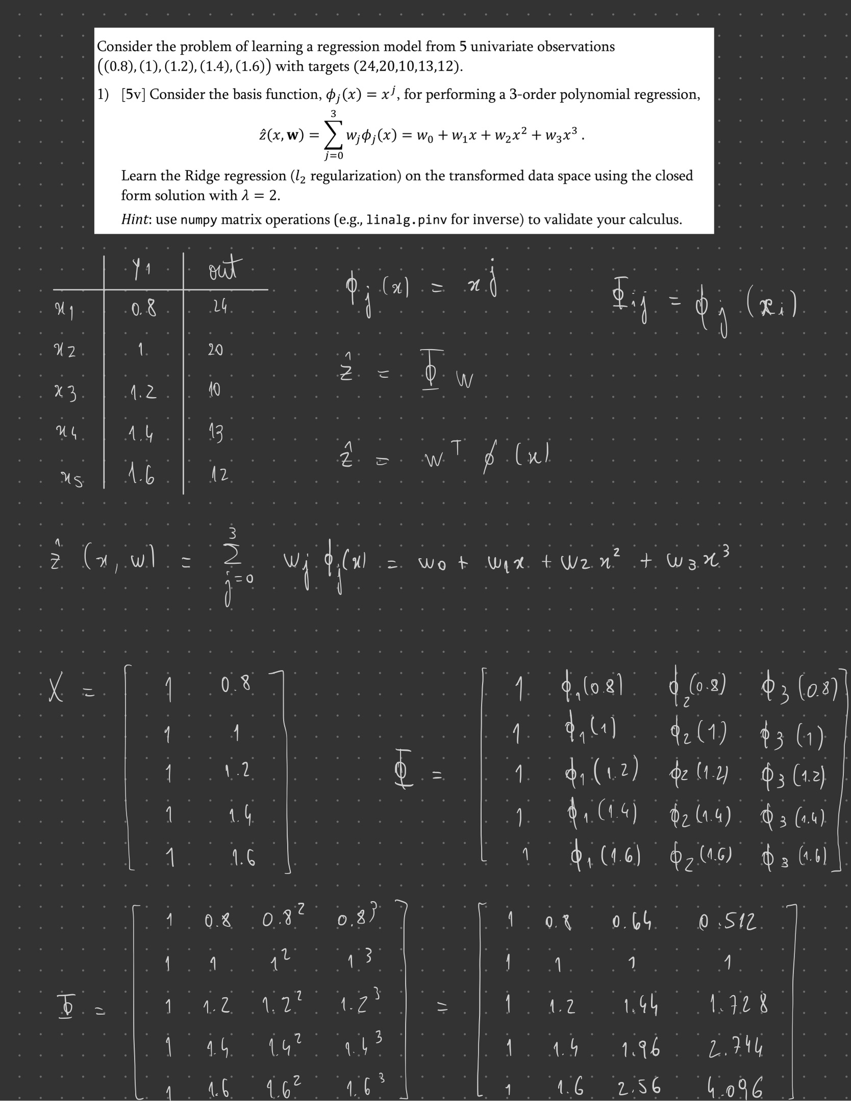

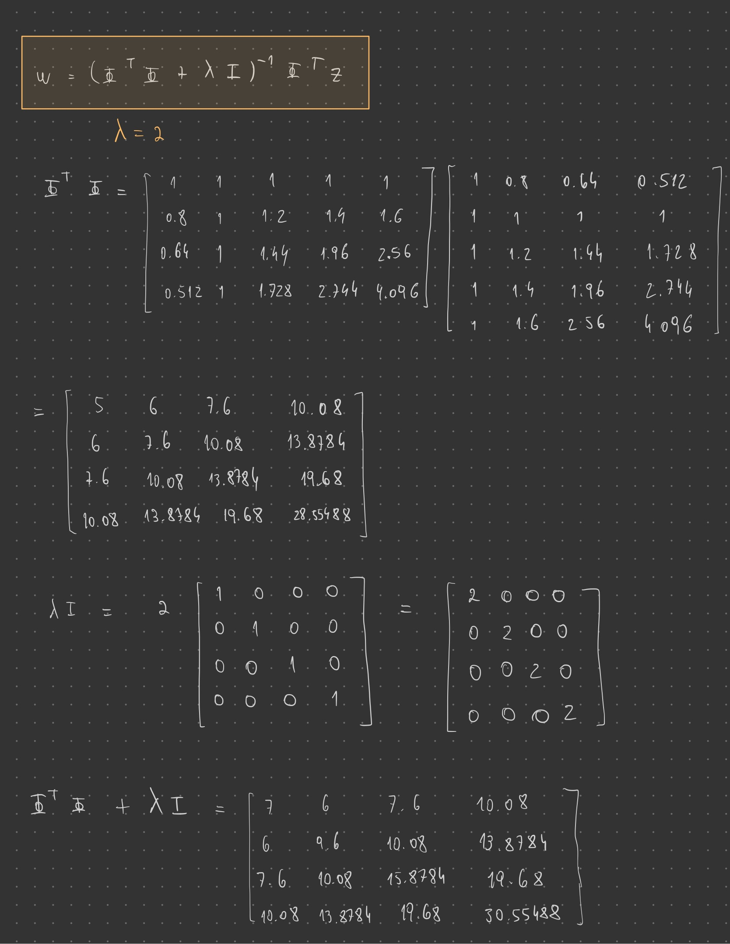

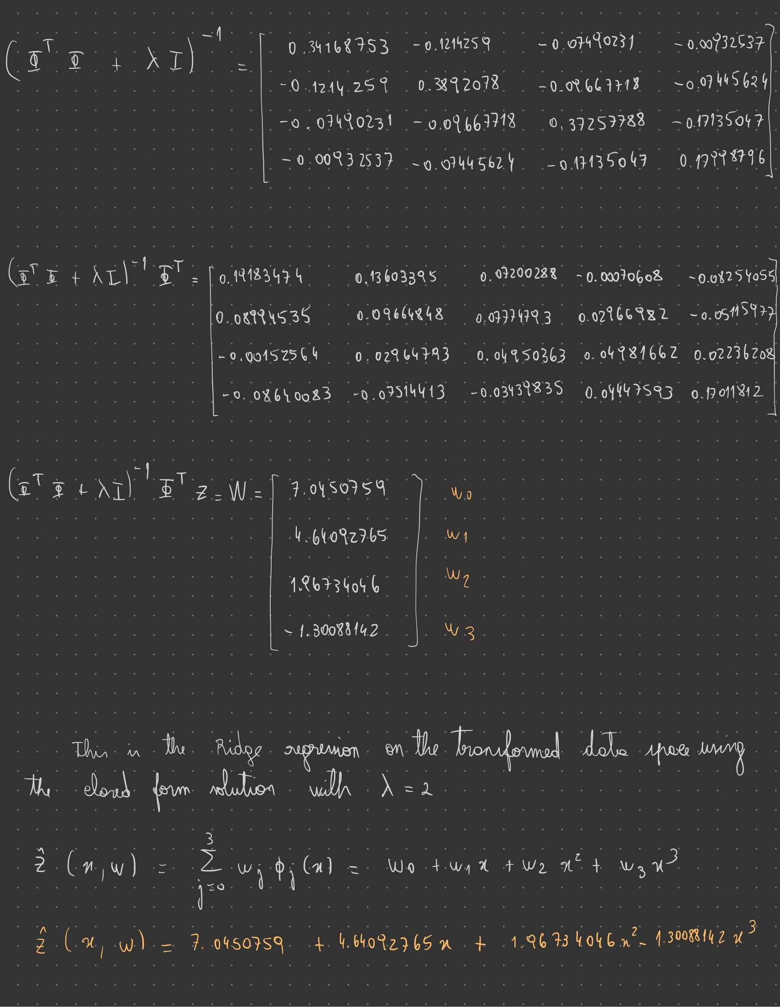

**2)** Answer 2

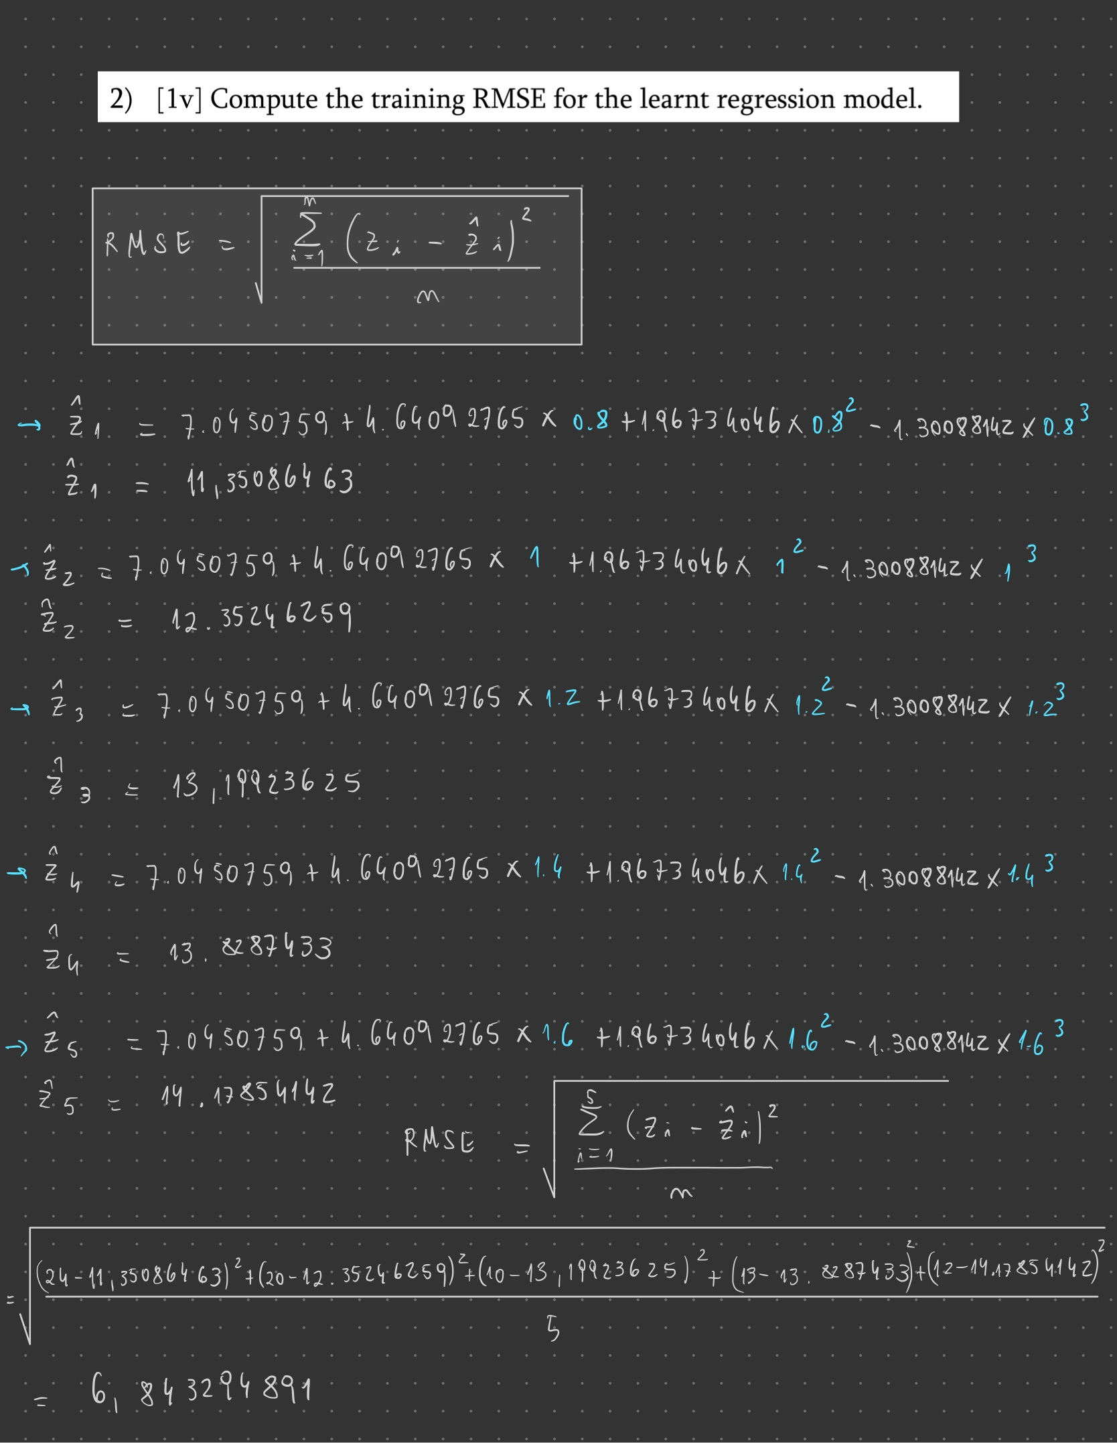

**3)** Answer 3

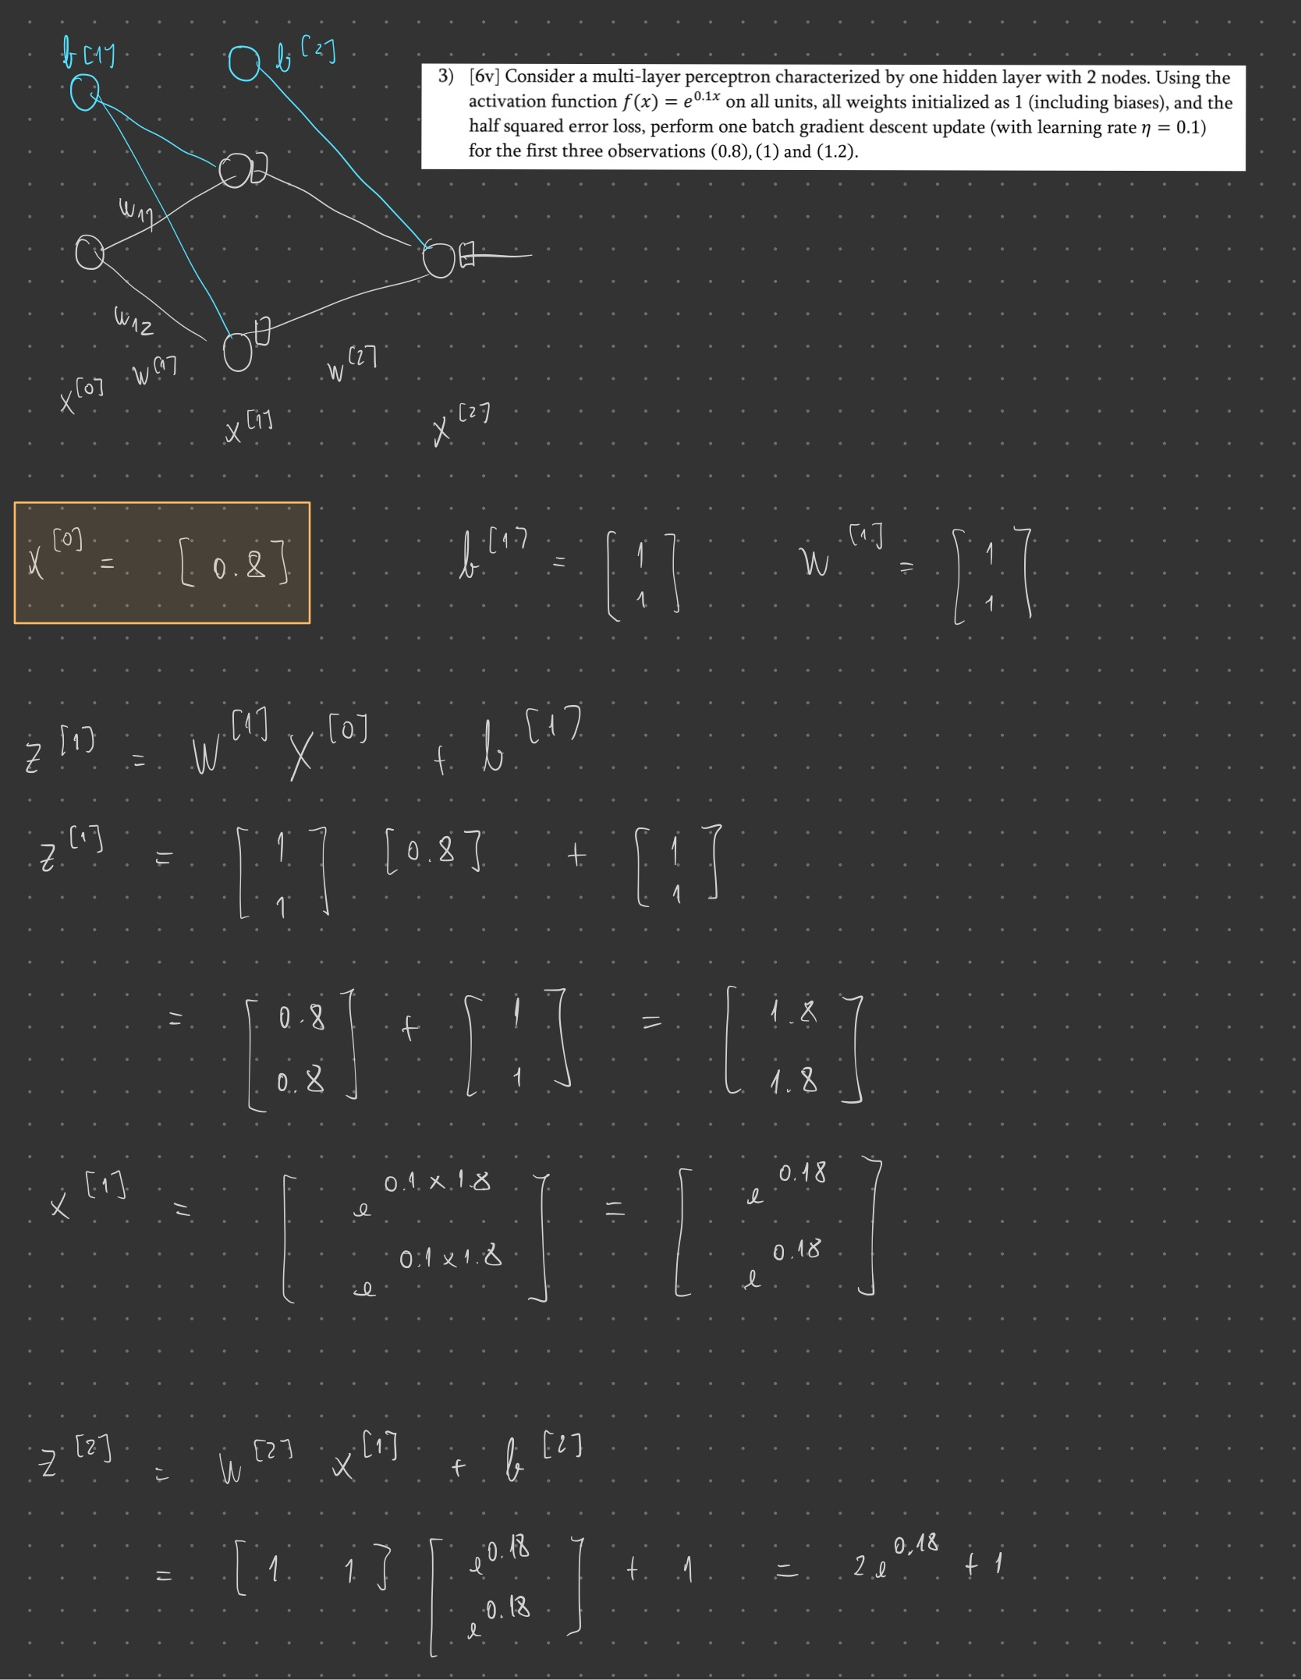

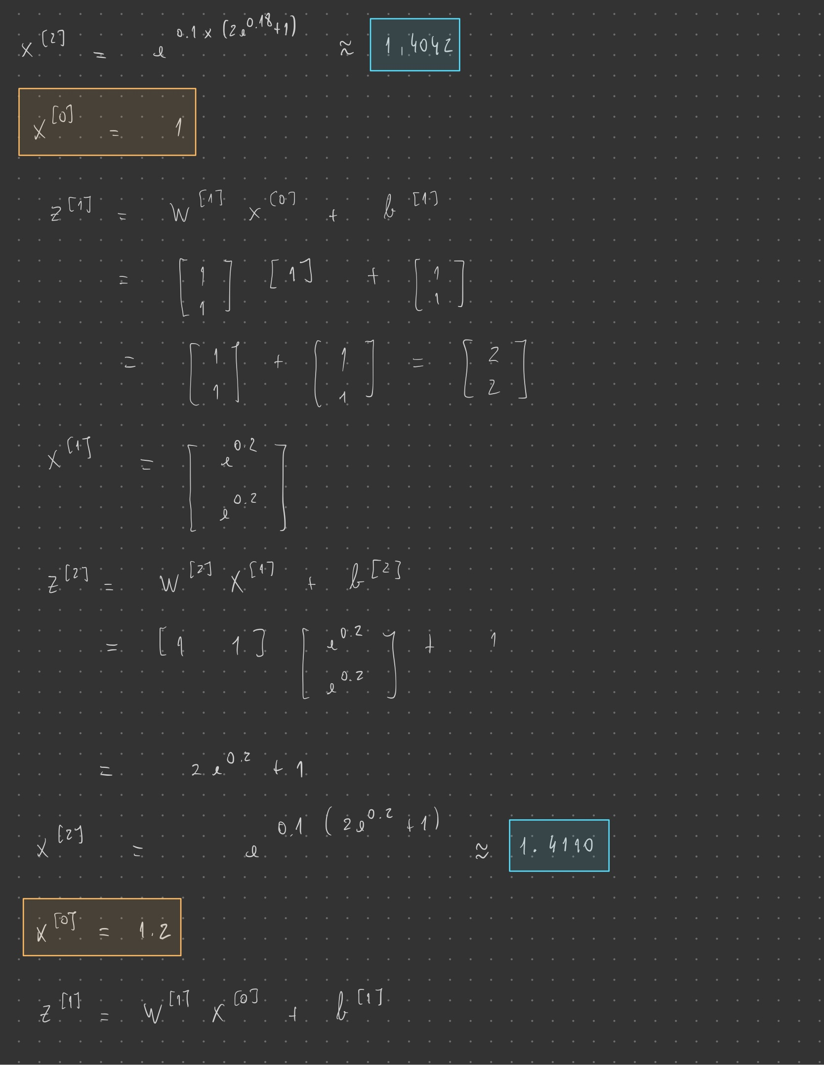

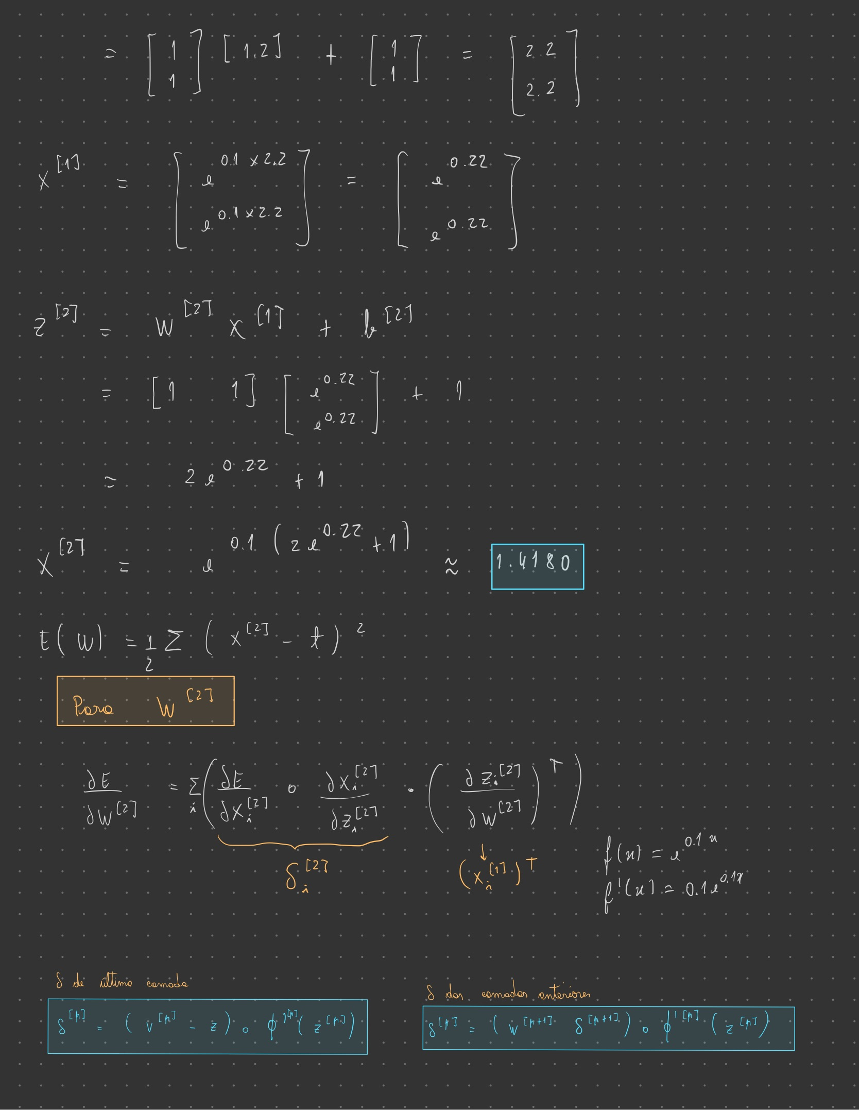

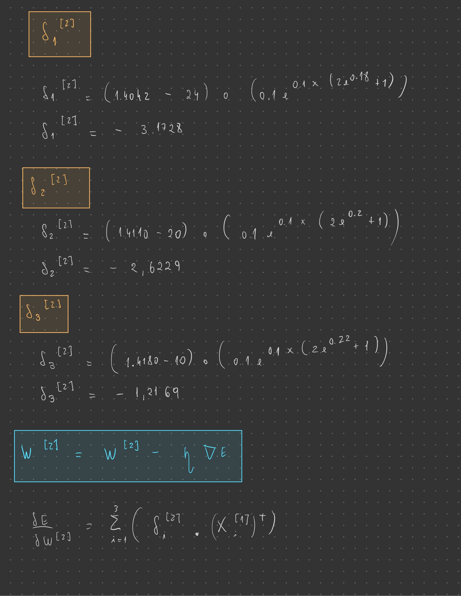

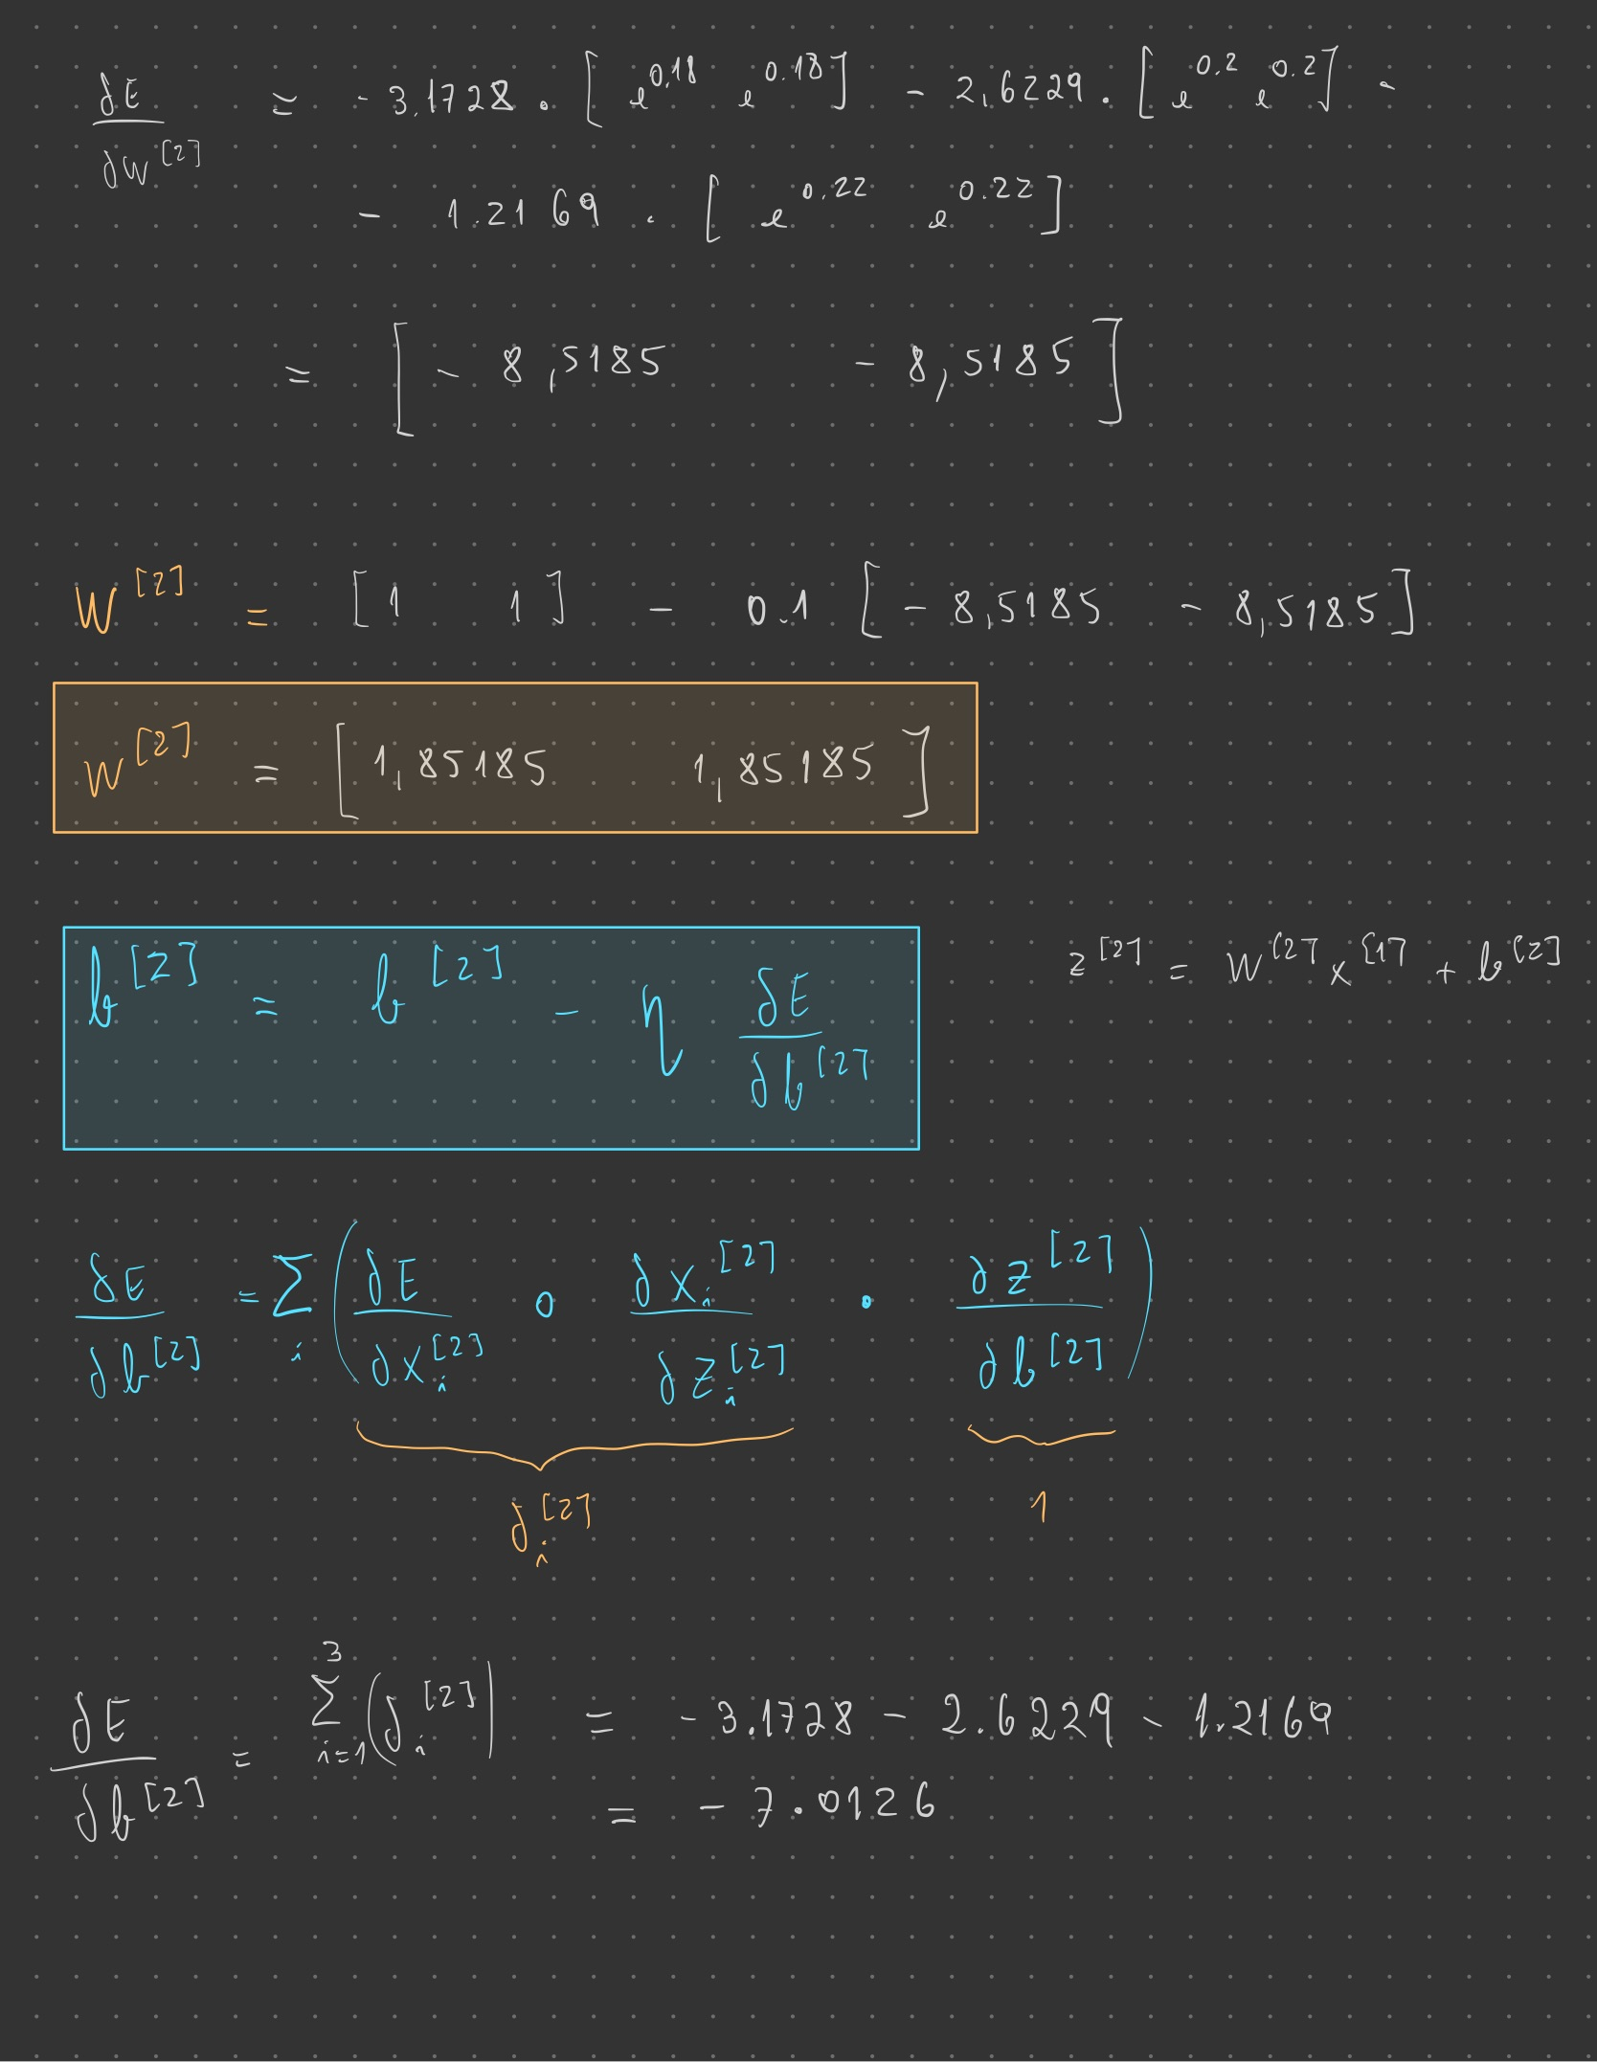

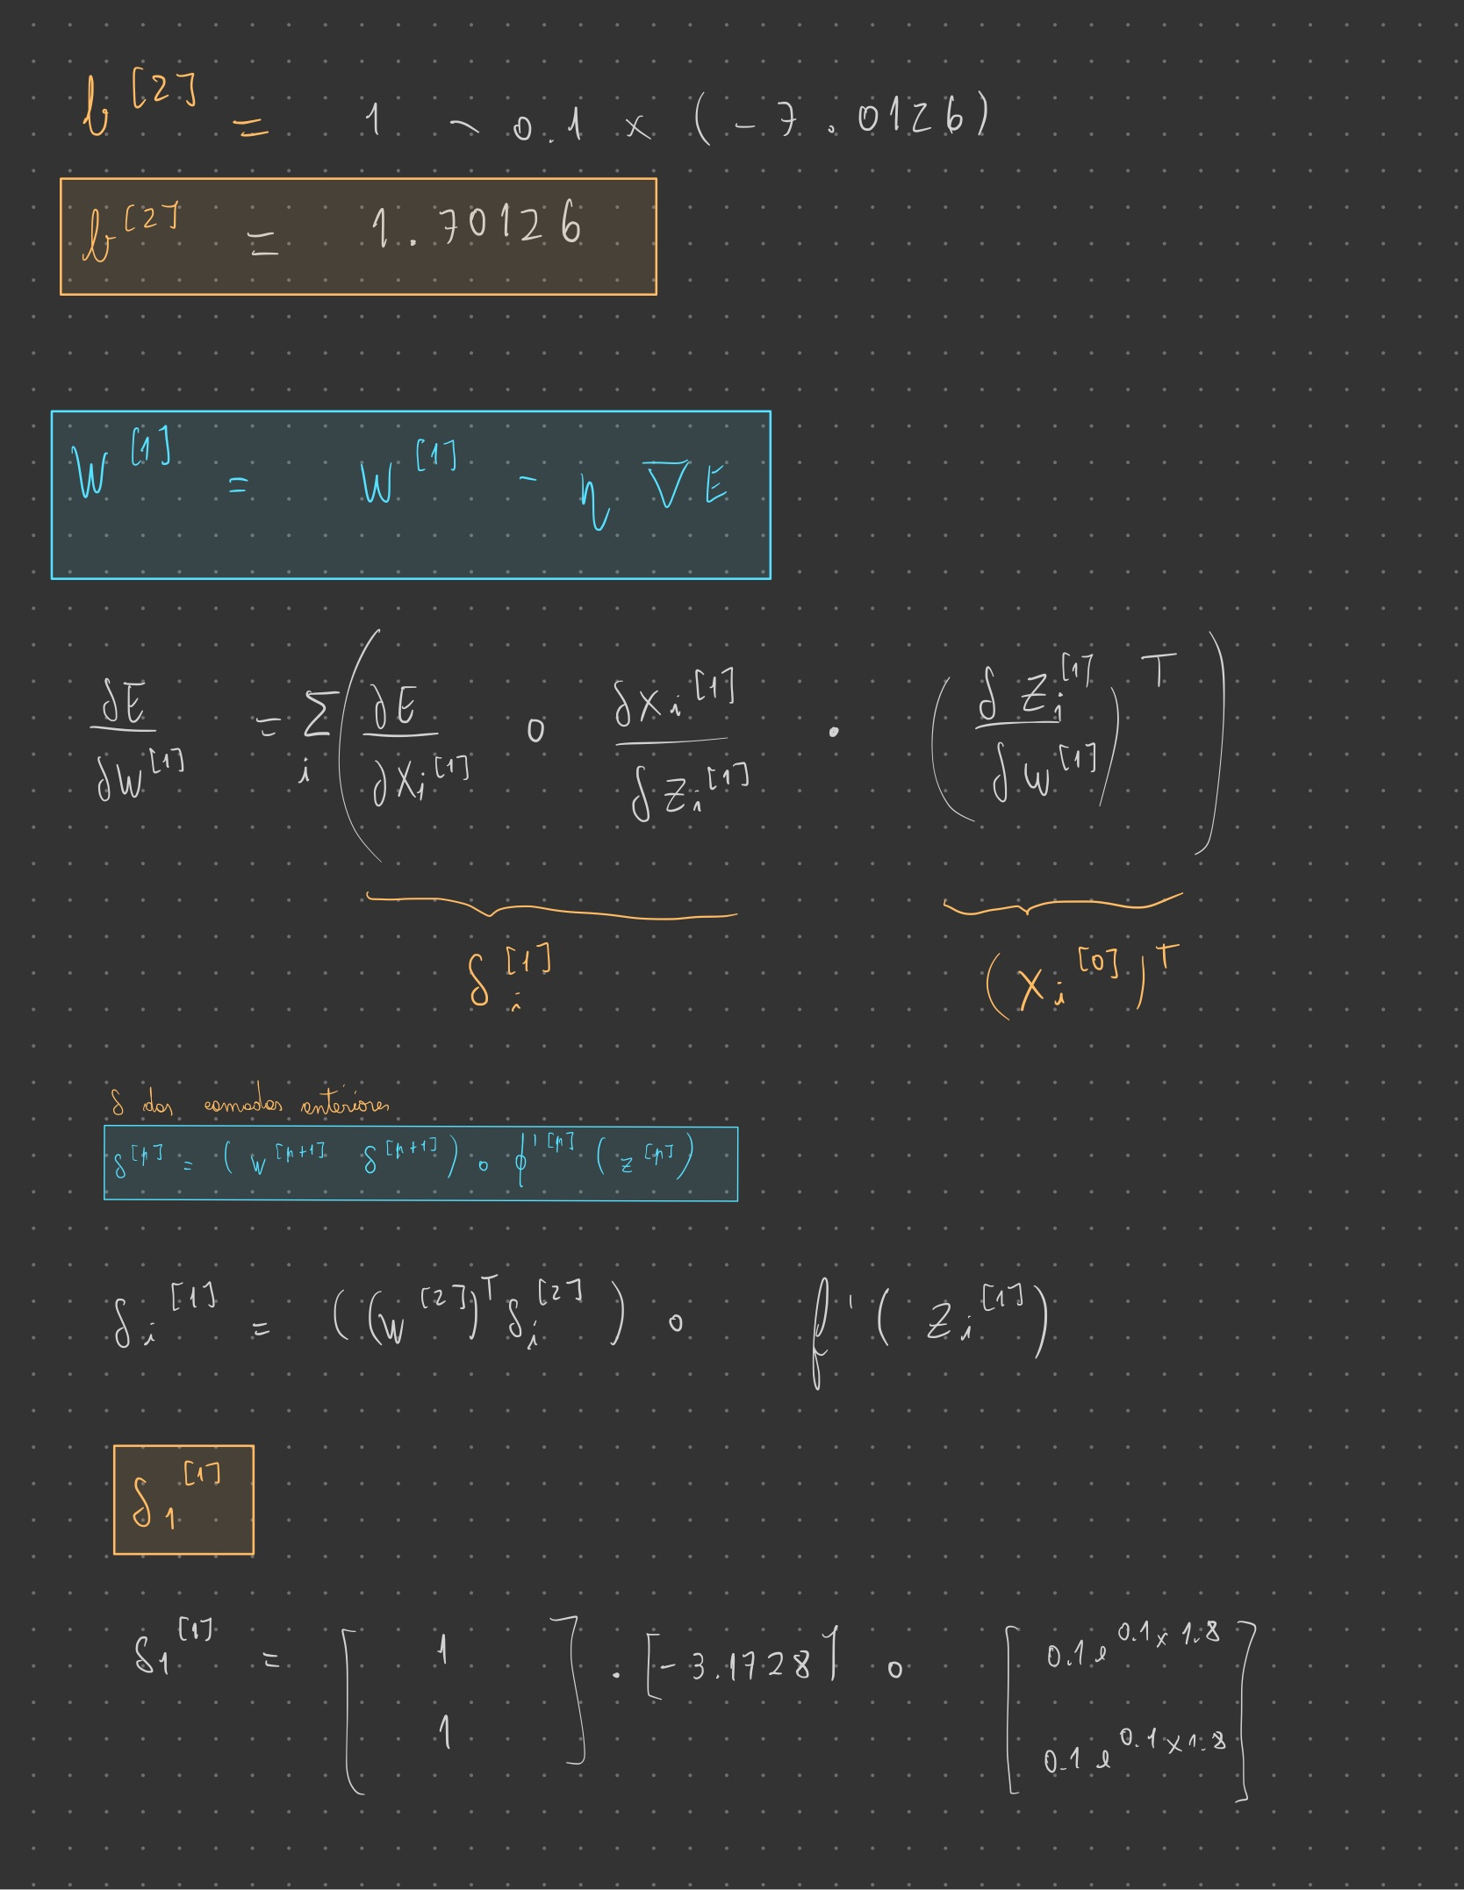

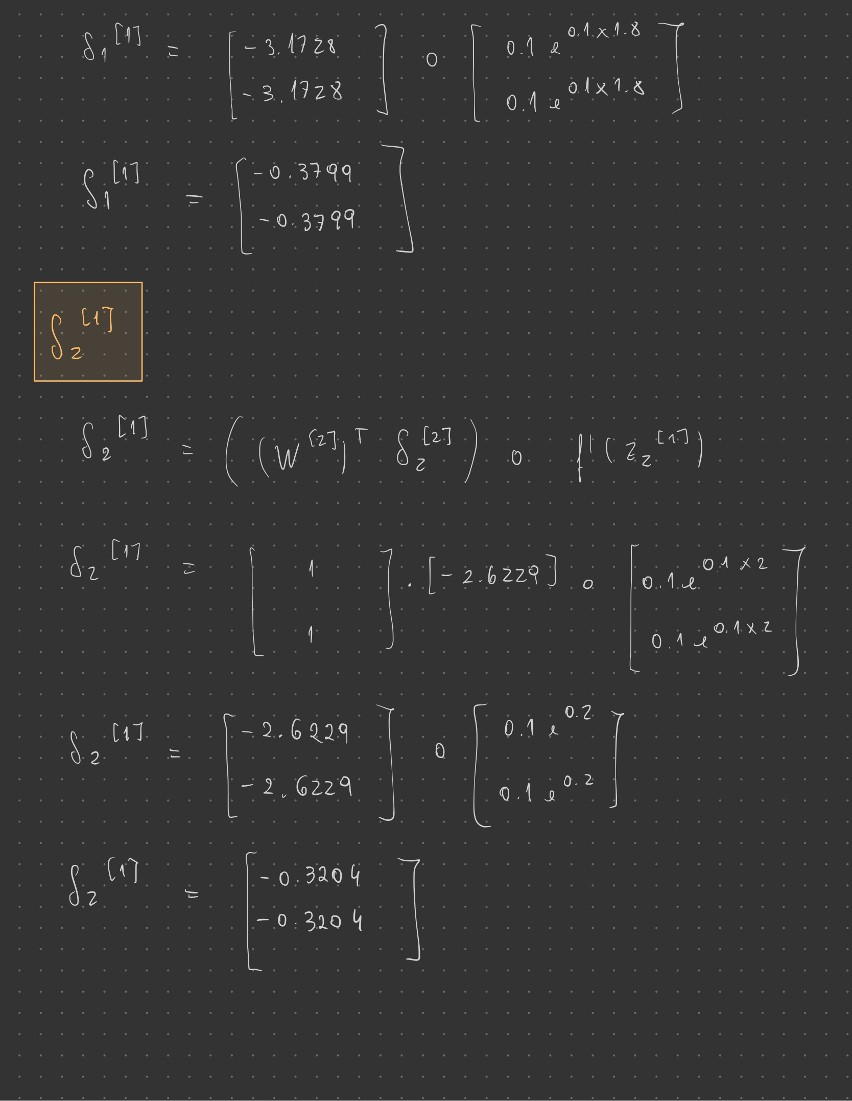

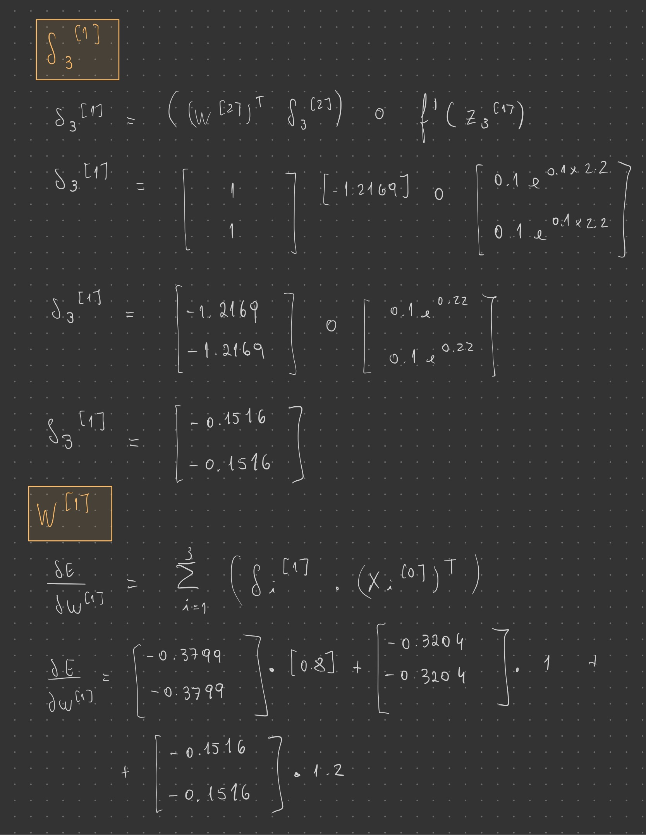

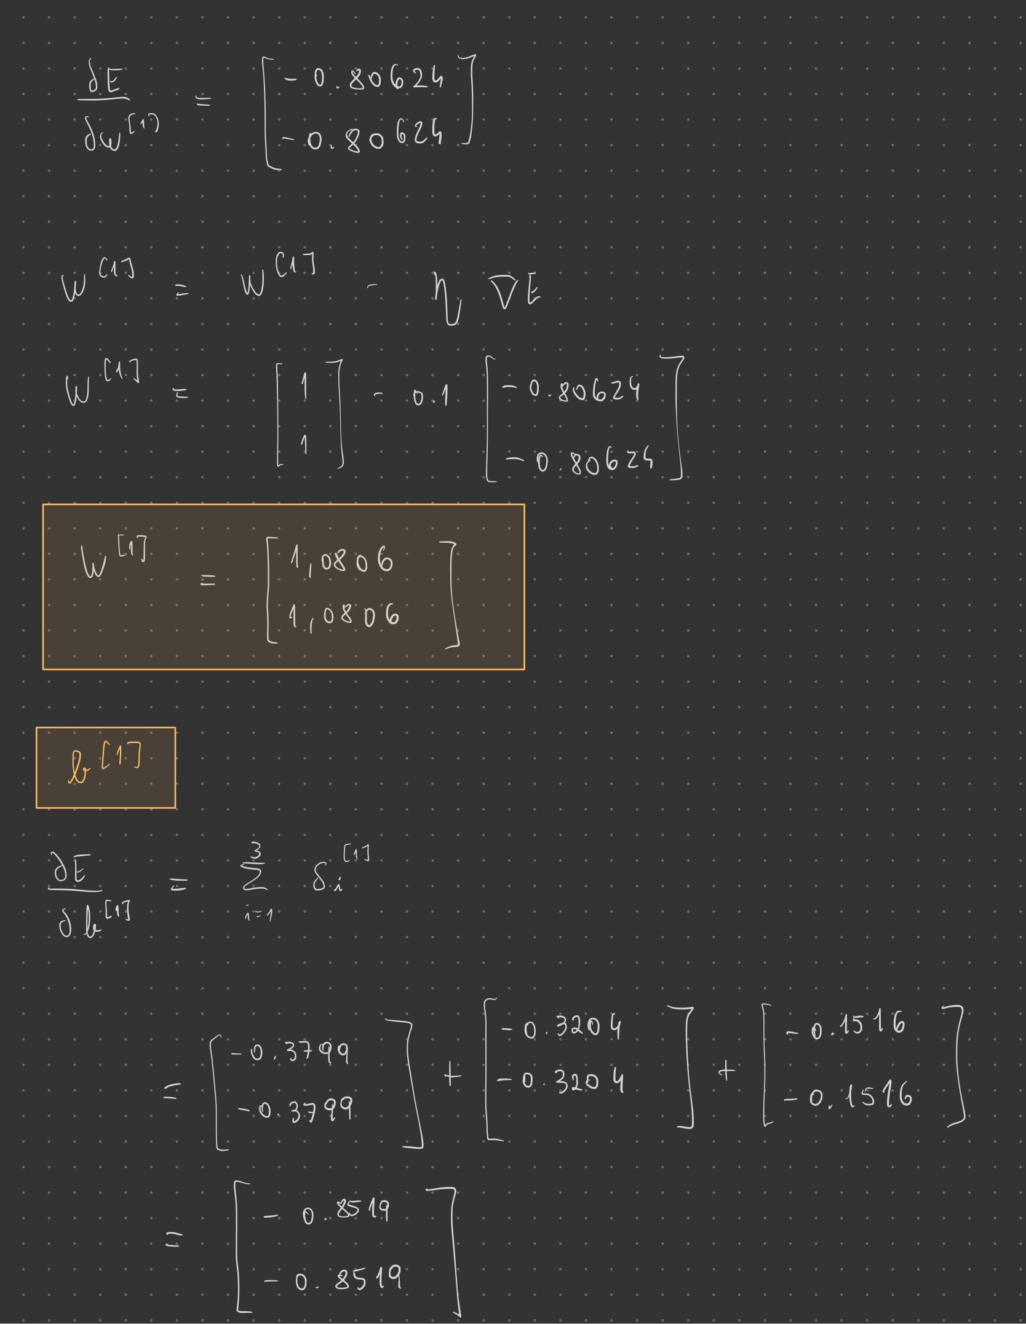

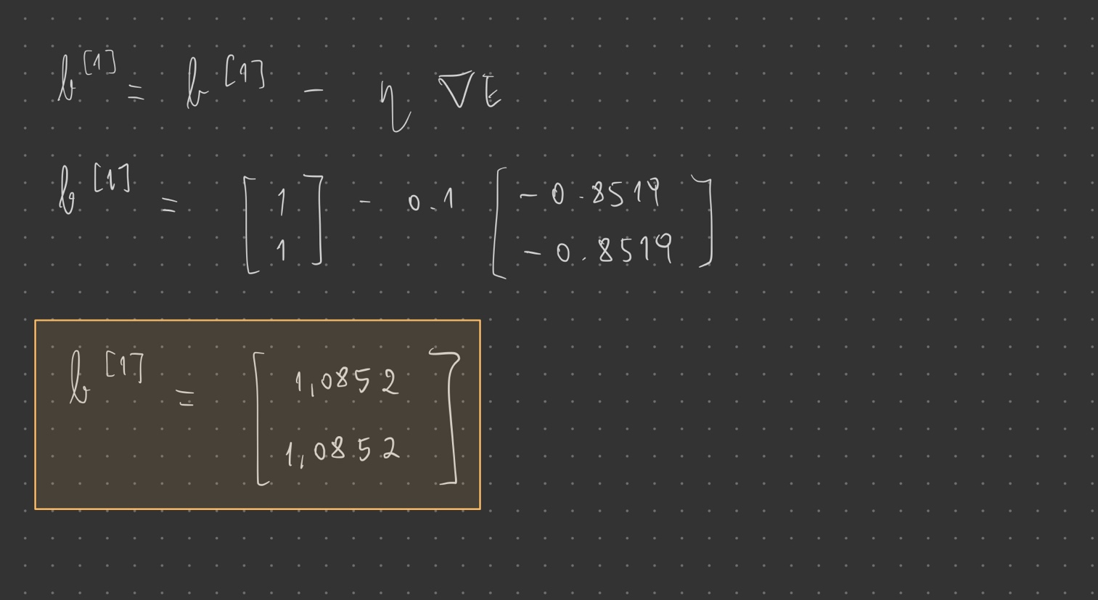

**II. Programming and critical analysis**

**4)** Answer 4

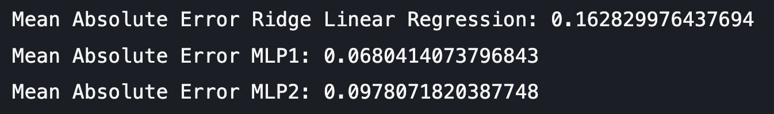

**5)** Answer 5

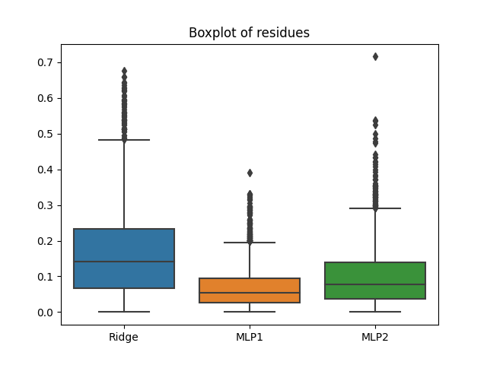

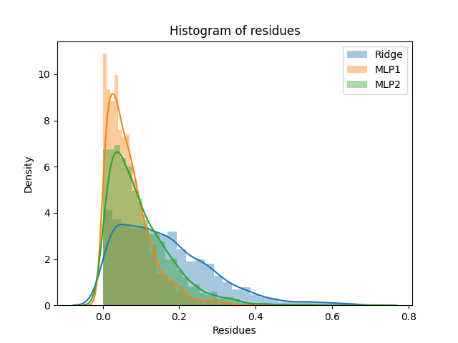

**6)** Answer 6

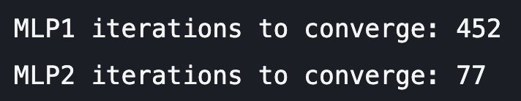

**7)** Answer 7

What is motivating the difference between the number of iterations of both MLPs is the early stopping. The fact that the first MLP is parameterized with early stopping helps fighting overfitting. When this parameter is set to true, it will automatically set aside 10% of training data as validation and terminate when validation score is not improving by at least a certain number of consecutive epochs. By doing this, we prevent the algorithm from getting too accustomed to the training data and, therefore, it needs more iterations to converge, whereas when this parameter is set to false, the training stops when the training loss does not improve by more than a certain number of consecutive passes over the training set. For these reasons, the second MLP converges much faster.

Regarding the observed performance differences between the MLPs, the one with early stopping demonstrates lower average residues and a lower Mean Absolute Error (MAE), which could be due to the fact that, as we fight overfitting, this trained neural network is better “prepared” when it comes to predicting the outcome of the testing data. On the other hand, the second MLP shows higher average residues and a higher MAE which could be a direct consequence of overfitting. By not parameterizing the second MLP with early stopping, this model fits to the training data to an extent that, compared to the first one, damages the generalization performance.

**III. APPENDIX**

**from** sklearn.linear_model **import** LinearRegression, Ridge, Lasso

**import** pandas **as** pd

**from** scipy.io.arff **import** loadarff

**from** sklearn.model_selection **import** train_test_split

**import** matplotlib.pyplot **as** plt

**import** seaborn **as** sns

**from** sklearn.neural_network **import** MLPRegressor

**from** sklearn **import** metrics, datasets

data **=** loadarff('kin8nm.arff')

df **=** pd.DataFrame(data[**0**])

X **=** df.drop('y', **axis=1**)

y **=** df['y']

X_train, X_test, y_train, y_test **=** train_test_split(X, y, **test_size** **=** **0.30**, **random_state** **=** **0**)

ridge **=** Ridge(**alpha** **=** **0.1**)

ridge.fit(X_train, y_train)

y_pred_Ridge **=** ridge.predict(X_test)

**print**("Mean Absolute Error Ridge Linear Regression:", metrics.mean_absolute_error(y_test, y_pred_Ridge))

mlp1 **=** MLPRegressor(**hidden_layer_sizes** **=** (**10**, **10**), **activation** **=** "tanh", **max_iter** **=** **500**, **random_state** **=** **0**, **early_stopping** **=** True)

mlp1.fit(X_train.values, y_train)

y_pred_mlp1 **=** mlp1.predict(X_test.values)

**print**("Mean Absolute Error MLP1:", metrics.mean_absolute_error(y_test, y_pred_mlp1))

mlp2 **=** MLPRegressor(**hidden_layer_sizes** **=** (**10**, **10**), **activation** **=** "tanh", **max_iter=500**, **random_state** **=** **0**, **early_stopping** **=** False, **verbose** **=** True)

mlp2.fit(X_train.values, y_train)

y_pred_mlp2 **=** mlp2.predict(X_test.values)

**print**("Mean Absolute Error MLP2:", metrics.mean_absolute_error(y_test, y_pred_mlp2))

ridgeResidues **=** **abs**(y_test **-** y_pred_Ridge)

MLP1Residues **=** **abs**(y_test **-** y_pred_mlp1)

MLP2Residues **=** **abs**(y_test **-** y_pred_mlp2)

residues **=** pd.DataFrame({"Ridge": ridgeResidues, "MLP1": MLP1Residues, "MLP2": MLP2Residues})

sns.boxplot(**data** **=** residues)

plt.title("Boxplot of residues")

plt.savefig("boxplots.png")

plt.show()

sns.distplot(residues["Ridge"], **hist** **=** True, **label** **=** "Ridge")

sns.distplot(residues["MLP1"], **hist** **=** True, **label** **=** "MLP1")

sns.distplot(residues["MLP2"], **hist** **=** True, **label** **=** "MLP2")

plt.title("Histogram of residues")

plt.legend()

plt.xlabel("Residues")

plt.savefig("histograms.png")

plt.show()

**print**("MLP1 iterations to converge:", mlp1.n_iter_)

**print**("MLP2 iterations to converge:", mlp2.n_iter_)

**if** mlp1.n_iter_ **<** mlp1.max_iter:

**print**("MLP1 converged")

**else**:

**print**("MLP1 did not converge")

**if** mlp2.n_iter_ **<** mlp2.max_iter:

**print**("MLP2 converged")

**else**:

**print**("MLP2 did not converge")

**END**