# Installations

Start with this tutorial. But not installing NodeRed

[https://kb.unipi.technology/en:sw:03-3rd-party:nodered:installation-neuron?s[]=sd&s[]=card](https://kb.unipi.technology/en:sw:03-3rd-party:nodered:installation-neuron?s%5b%5d=sd&s%5b%5d=card)

Password for user pi changed to: OEEtracker

### Then installing Node.js

<https://thisdavej.com/beginners-guide-to-installing-node-js-on-a-raspberry-pi/>

### Install Node.js Web Server

<https://thisdavej.com/create-a-web-server-in-node-without-any-code/>

### Install PIP

<https://www.raspberrypi.org/documentation/linux/software/python.md>

### Install Juypter

<https://schmidt-feldberg.de/jupyter-notebook-auf-dem-raspberry-pi-3-b-installieren/>

### UniPi Circuit Connection

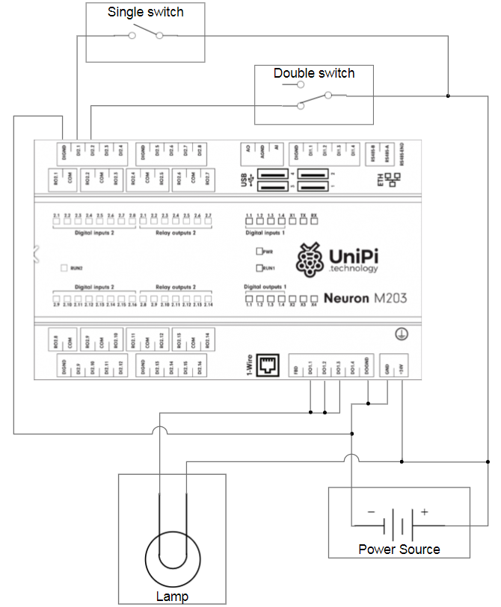

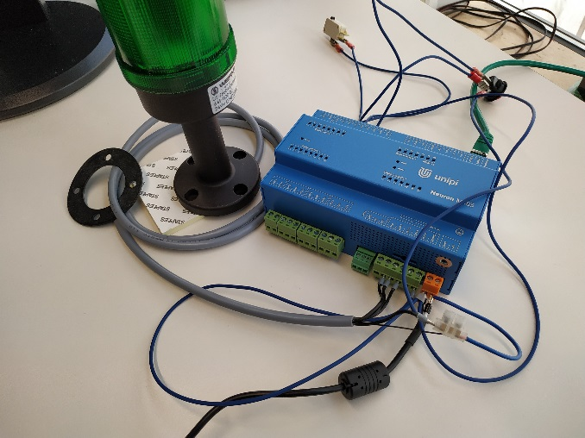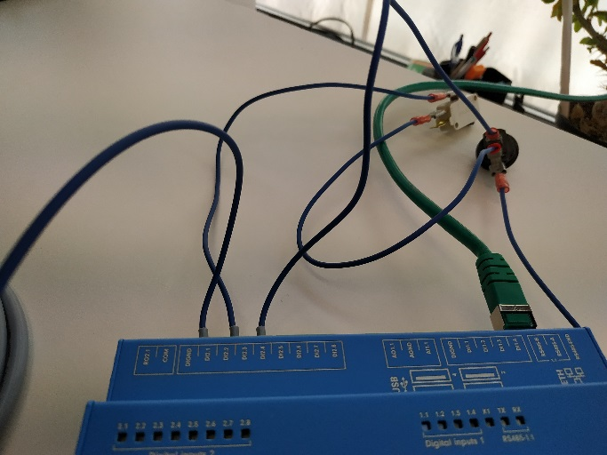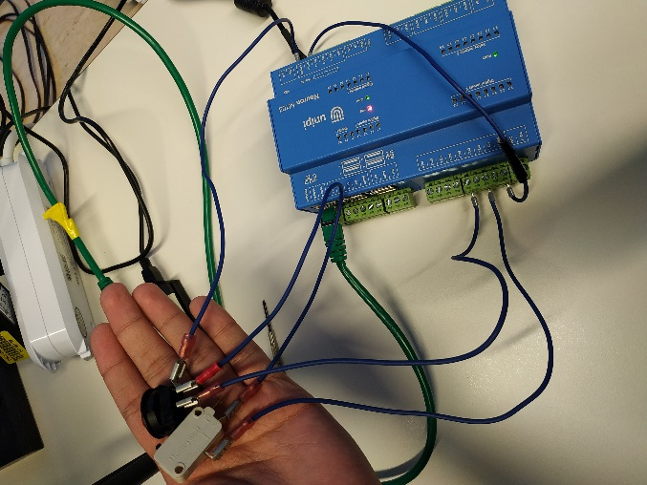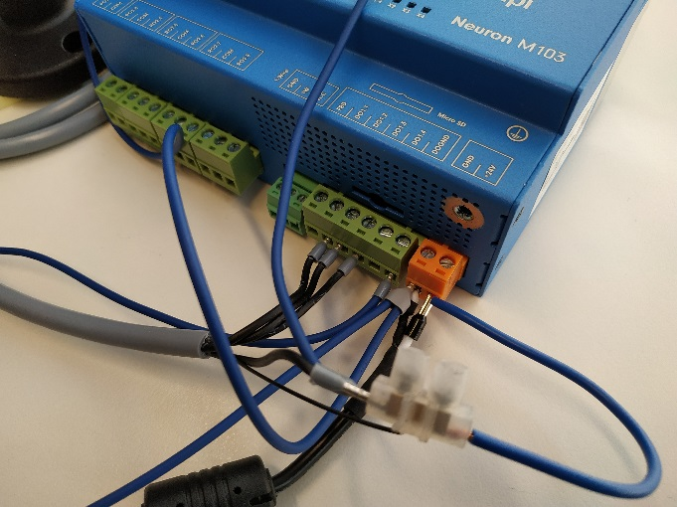

* After plugging the Power Source (White cable to +24v and black cable to GND), connect a cable from GND to DOGND(Digital Output Ground) and to DIGND (Digital Input Ground) to create a bridge between the different GNDs and close the circuits
* Connect a cable between the positive energy (+24v) to the entry points of the devices, in this case the lamp and the two switches
* The lamp has four labeled cables. The cable with the label 1 is the one that should be connected to the positive energy. The cables with the label 2, 3 and 4 should be connected to the digital inputs and they represent the colors green, yellow and red in that order.
* In this case, there are 2 switches that are connected to one another. The double switch with three cables has two cables stuck together, and one of those is connected to the other switch. The other one should be connected to the +24v. The remaining cable goes into a digital input.
* Finally, the button switch has two cables. One of them is what connects the switch with the double switch. The other cable should be connected to a digital input

## Check / To-Do

<https://forum.unipi.technology/topic/936/remote-controll-of-evok-api/3>

Is exposure of UniPi to Internet Safe?