Result Presentation

#1st Graph  
ggplot(ModelC) + stat_qq(aes(sample = ModelC$residuals), color = "black", alpha = 0.2) + geom_abline(intercept = mean(ModelC$residuals), slope = sd(ModelC$residuals), color = "red") + theme_calc()

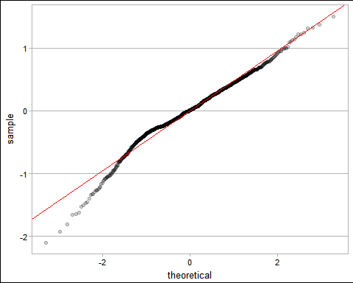

#2nd Graph  
ggplot(dataF, aes(x = dataF$kfavg, y = ..density..)) + geom_histogram(bins = 15, color = "white", fill = "black") + theme_calc()

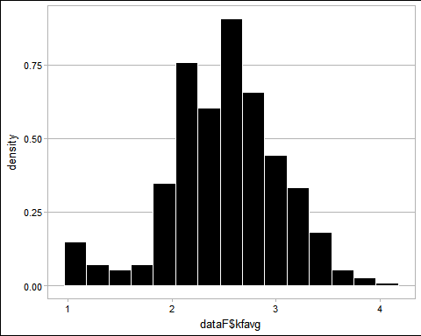

#3rd Graph  
ggplot(ModelN, aes(x = .fitted, y = .resid)) + geom_point(color = "black", alpha = 0.3) + stat_smooth(color = "red") + theme_calc()

## `geom_smooth()` using method = 'gam'

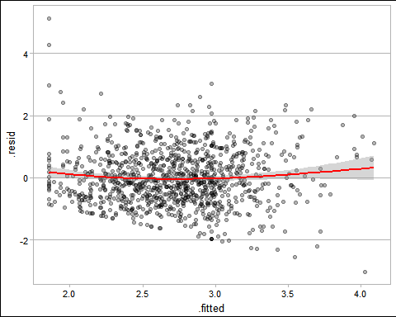

#4rd Graph  
ggplot(ModelN, aes(x = .fitted, y = .resid)) + geom_point(color = "black", alpha = 0.3) + stat_smooth(color = "red") + theme_calc()

## `geom_smooth()` using method = 'gam'



reg_table <- huxreg(ModelN, ModelC, statistics = c(N = "nobs", R2 = "r.squared", R2Adj = "adj.r.squared",   
 "AIC"))  
print_md(reg_table)

|  |  |  |
| --- | --- | --- |
|  | ( 1) | ( 2) |
| (Intercept) | 1.486 *** | 2.106 *** |
|  | (0.099) | (0.077) |
| oportunidade | 0.180 *** | 0.024 * |
|  | (0.022) | (0.012) |
| pressao | 0.070 *** | 0.064 *** |
|  | (0.020) | (0.011) |
| racionalizacao | 0.122 *** | 0.067 *** |
|  | (0.023) | (0.013) |
| kgavg 2 |  | -0.089 |
|  |  | (0.054) |
| kgavg 3 |  | -0.209 *** |
|  |  | (0.058) |
| kgavg 4 |  | -0.577 *** |
|  |  | (0.137) |
| N | 1044 | 1009 |
| R 2 | 0.173 | 0.164 |
| R 2Adj | 0.171 | 0.159 |
| AIC | 2753.942 | 1377.027 |
| *** p < 0.001; | ** p < 0.01; * | p < 0.05. |