User Guide

<?xml version="1.0"?><DocumentBlank xmlns:xsi="http://www.w3.org/2001/XMLSchema-instance" xmlns:xsd="http://www.w3.org/2001/XMLSchema"> <GraphicCharterDefinitionId>0</GraphicCharterDefinitionId> <TemplateBaseTypeId>0</TemplateBaseTypeId> <CompanyId>1</CompanyId> <ConfidentialId>3</ConfidentialId> <ConfidentialDescription>Internal Use Only</ConfidentialDescription> <CountryId>0</CountryId> <PageSizeId>1</PageSizeId> <PageOrientationId>1</PageOrientationId> <PrePrintedStationary>false</PrePrintedStationary> <Project>Pole MCS</Project> <Reference>20180327-160308-CE</Reference> <TemplateType>1</TemplateType> <CultureId>en-GB</CultureId> <LanguageId>1</LanguageId> <Customer>Sopra Steria</Customer> <DocumentDate>2018-04-27T18:49:23.802753+02:00</DocumentDate> <FirstPageHeader>Visual management</FirstPageHeader> <FirstPageSubHeader /> <FirstPageTitle_Blank>Visual Management</FirstPageTitle_Blank> <FirstPageSubtitle_Blank>User Guide</FirstPageSubtitle_Blank> <Saved>false</Saved> <IsValid>true</IsValid> <FirstPageCover>false</FirstPageCover> <IsNew>false</IsNew> <Title>User Guide</Title></DocumentBlank>

|  |  |  |  |  |
| --- | --- | --- | --- | --- |
|  |  |  |  | |
|  |  |  | Internal Use Only | |
|  |  | Visual Management | | |
|  |  |  | | |
|  |  | User Guide | | |
|  |  |  | |  |

1. INTRODUCTION

This is a quick user guide that will allow you to broadcast to your teams some content on the TV’s screen.

There is, for the moment 3 functionalities:

* One is a “Project view”, a simple Gantt chart generated automatically from the Database.
* The second one is a tool who let you broadcast your PowerPoint.
* The third one is an “Incident view” on two pages, one focuses on the backlog, the second on the tickets resolved and closed.

To have access at this two functionalities, you need to follow the few next steps:

1. INITIALISATION

First, on your Desktop, at the bottom left, click on the search button and search the “Remote Desktop connection” or “Connexion Bureau a distance” if you are on a French computer, adapt the search to the language of your computer.

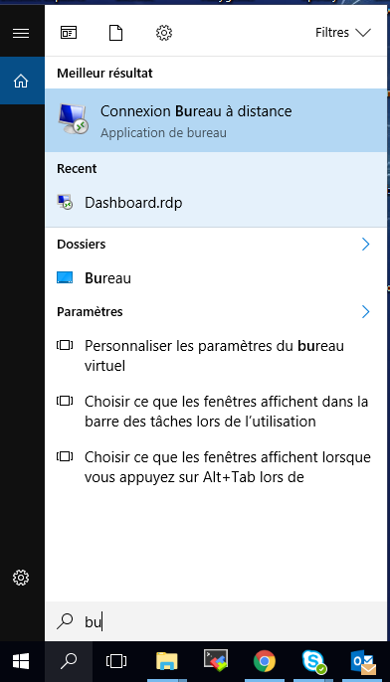

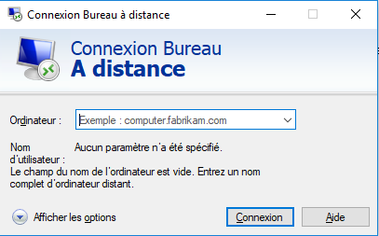When you click on it, you will access to a panel as follows:

Fill the Desktop line with

swinvmcbotse1.colo.fr.sopra

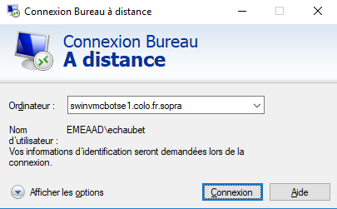

Click on Connexion

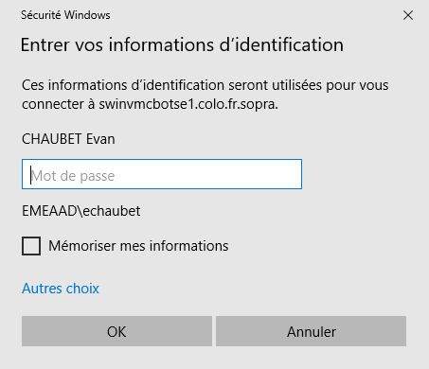

Fill the password line with your current password, then “OK”.

Wait few moments for the connection, once you are connected, you should come across the page as above.

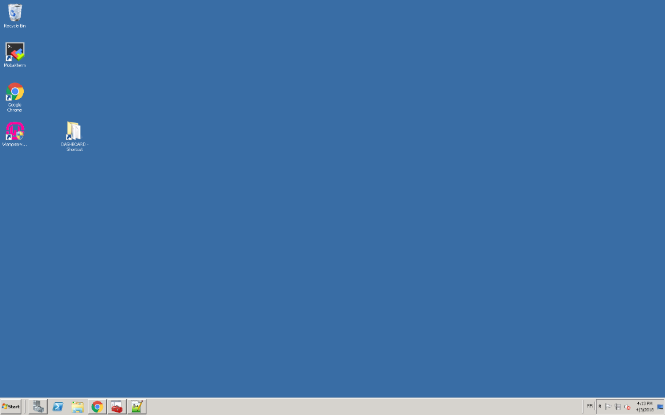

On the main bar at the bottom, click on the folder icon.

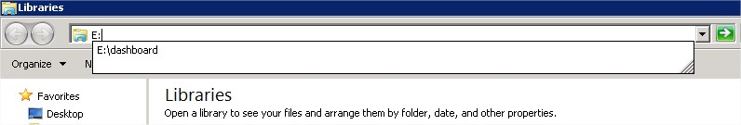Fill the following PATH: E:\dashboard

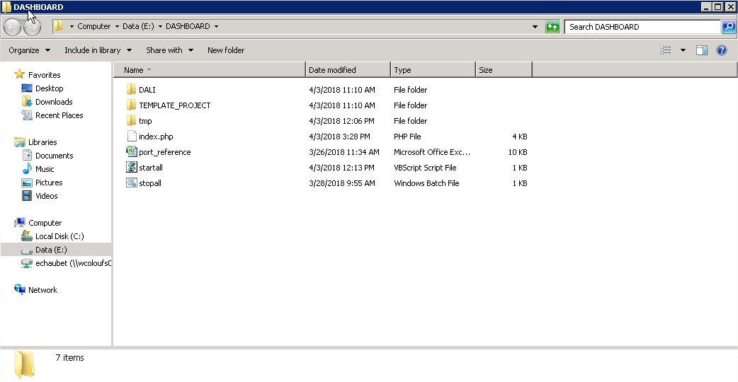You should access at this folder

Make a copy-paste of the TEMPLATE_PROJECT at the same PATH and rename it with the name of your Project. **Please use no special caracters, no space, no accent for the name of your folder.**

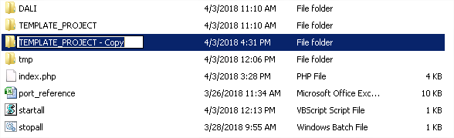

Double-click on the “port_reference” excel file

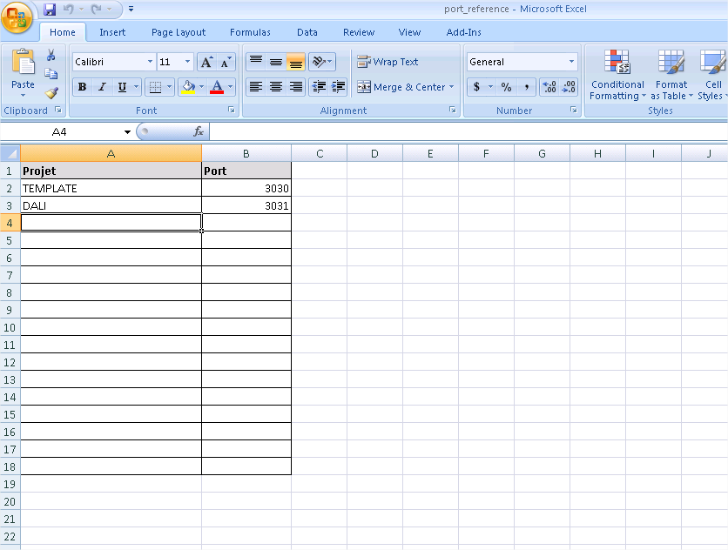

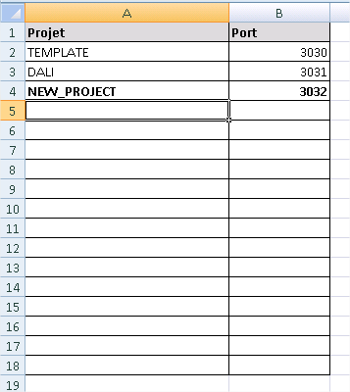

Fill the empty line with the name of your project, and take the “Port” with the next port, then save it and exit.

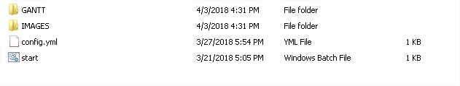Enter on the folder that you just rename, you should see this display

Right Click on the “start.vbs” file, then Edit with Notepad++

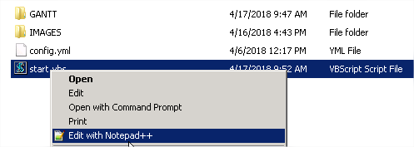

The file should be like that:

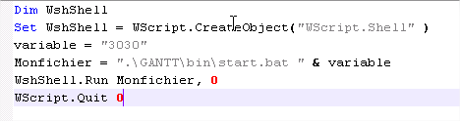

Just replace the value of the variable with the port that you chose on the excel file

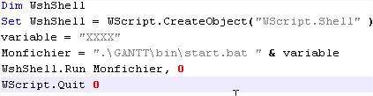

Save it and exit.

1. GANTT PART and AS PART

Now, for the Gantt part and the AS part, you need to fill the “config.yml” file.

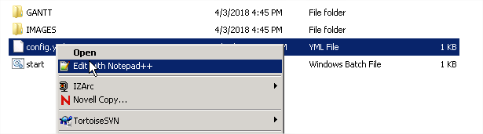Again, right click and Edit with Notepad++

WARNING: You need to fill the config file exactly like in the example, every space before a property will make fail the gantt dashboard.

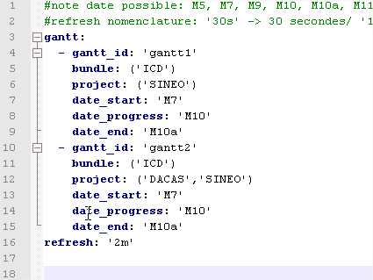Each Gantt id correspond to one tab.

You can put one Gantt for one Project or combine few projects into one Gantt as the example.

The date progress is just for you to see an intermediate date on the Gantt, as M10, for example.

The refresh is the interval for which the job will push the data to your Gantt.

The name of your bundle and your project, is present in the excel file “Project_Status” that you fill to save data in the data base, at the tab “Param”



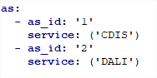

For the AS part, it is really simple, you just need to fill the name of your service

When you have finished to fill the config file as you want, save it, and click on the **start** file



There is no need to click on start each time you want to use the Dashboard. The start.vbs is just necessary once. The server will restart by himself. If you want to modify your Gantt, just change the config.yml file and wait the next refresh.

To access to your Gantt charts outside:

<http://swinvmcbotse1.colo.fr.sopra:3030/gantt1>

Just change the port with yours, and make one window for one Gantt, change the id of the Gantt to see each one.

You can access to youre AS charts outside by:

<http://swinvmcbotse1.colo.fr.sopra:3030/AS_backlog_1>

And

<http://swinvmcbotse1.colo.fr.sopra:3030/AS_resolved_1>

Again with your port, change the id to access to each as chart id

1. DIAPORAMA PART

This functionality allow you to display any images that you want to show to your teams.

Just before the “GANTT” Folder, you should see an “IMAGES” Folder, click on it.

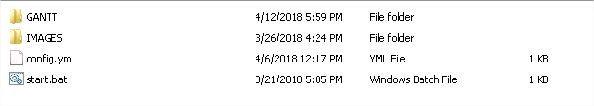

You can create as much as folder that you want and put as much as images that you want on it.

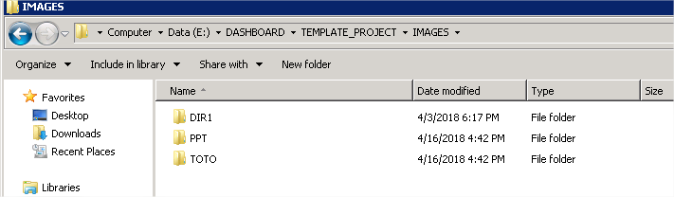

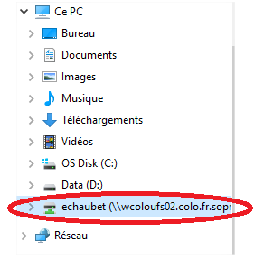

To transfer file or images of your local computer to the virtual machine, you can put your files on your public space.

And access to your public space on your virtual machine.

The Diaporama will start on the first folder, and on the first image, then the second image of the first folder and so on. You can rename your folders as you want, your pictures as you want, it’s just at you to make your own order.

TIPS: If you want to display a PowerPoint, transfer the ppt file via your public space as always, open it, and save it as “JPEG format” on the “IMAGE” Folder. It will automatically create you a folder and 1 image for each slide of your Powerpoint

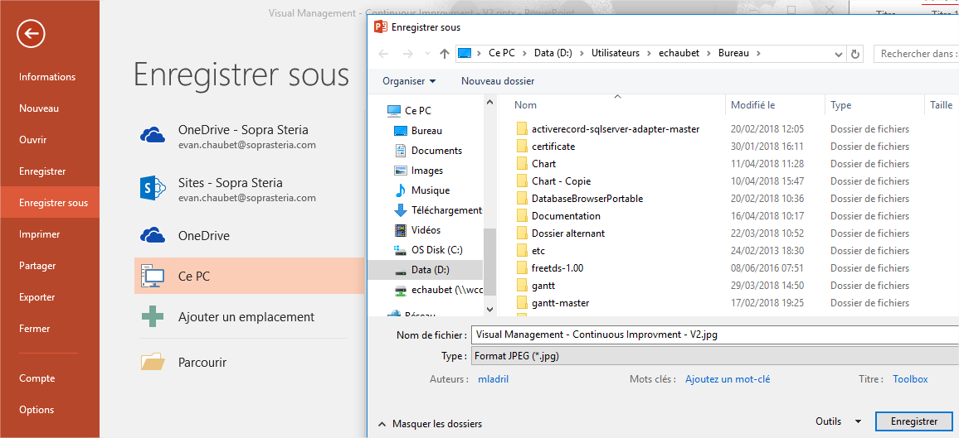

To access to your diaporama click on the link as follows:

<http://swinvmcbotse1.colo.fr.sopra:8088/dashboard/>

1. SWITCH TABS

When all your tabs are open, the Gantt tabs, the diaporama tab, and whatever tab you want to show.

You need something more to switch each tab from another.

This is a small chrome module, called Revolver-Tabs

Click on this link

<https://chrome.google.com/webstore/detail/revolver-tabs/dlknooajieciikpedpldejhhijacnbda>

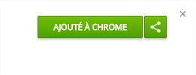

To add it, click on the button “add to Chrome” at the top right of the window.

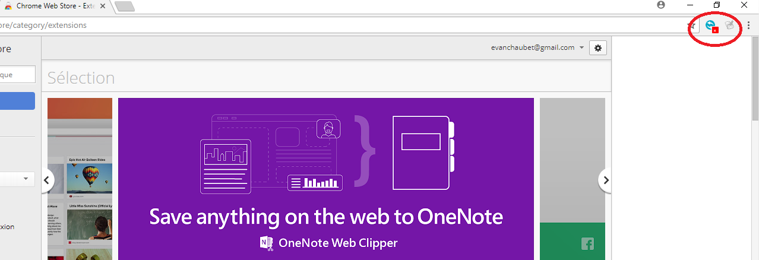Wait few moments, the module should appear just next to the URL bar

Right click then options.

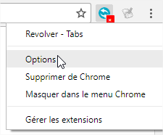

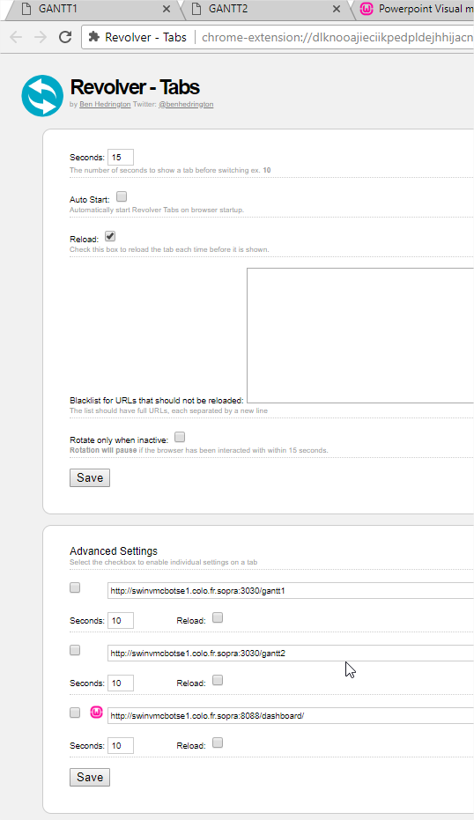

On this example, I have three tabs.

Go directly on the advanced settings part.

You have to choose for each tabs the number of seconds that you want to stay on it, and if you want to reload the page or not.

For the diaporama tab, if you have 5 images with 10s of interval, put 50 second for this tab.

Finally if you want to save the parameter for the next times for this URL, tick the case at the left of the URL bar.

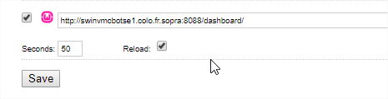

Click on the button save, close the option window, go on your first tab then click on the revolver-tabs icon to switch it on green.



Press “F11” of your keyboard to be on full screen.

Congratulations, the User Guide is finished.