CMS Documentation
Table of Contents
Access 2
CMS administration 3
Scope 3
Navigation 5
Home page 5
Top Navigation 5
Area selection navigation bar 7
General Site Sections Selector 7
Resource Center 8
Site Information 10
About Us 13
Home 16
Resource Center Main Page 18
Type of Templates. 22

Access
To access the CMS (Content Management System) of ER open your web browser and visit the following url:
URL: http://www.edresources.com/cms/cms_login.aspx

You will be in the login page of the CMS, which will look like this:

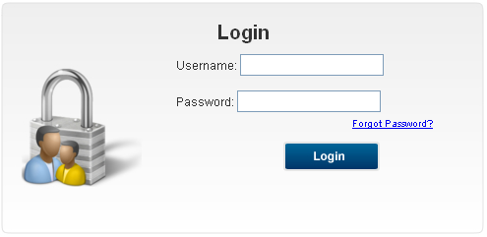

You will need to introduce the following data in the respective field in order to be able to login to the system:
- Username: adm
- Password: adm

Once you have entered your username and password, please click the “Login” button.

In case you enter the wrong information the following screen will be displayed:

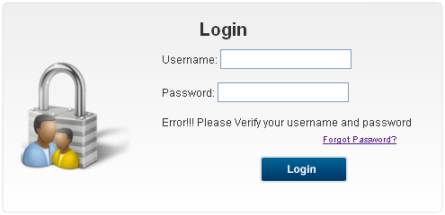

After you entered the correct data you will see a page where you can select the website you want to administrate. Please proceed to select “ER”.

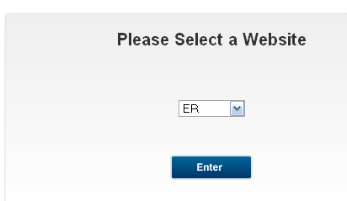

CMS administration

Scope
The ER CMS lets you manage the following content for the main sections of the site (educators, schools, parents, students, and general information):
- Administrator.
  - User name.
  - Full name.
- Resource Center.
  - Sections inside Resource Center.
- General Information.
  - Site information.
    - Site Information.
      - Name: Contains the name of the site.
      - Description: Contains a brief description of the content of the site.
      - URL: Contains the url that points to the site.
      - Phone: Contains the phone number of the site.
      - Tag line: Contains a small tag line for the site.
      - CopyRight: Contains the copy rights of the site.
      - Key Workds: Contains key words of the site.
    - Site Contact Information.
      - Contact Title.
      - Contact Image.
    - Additional Information.
      - Privacy Policy.
      - Terms of Use.
  - About.
    - Sections Inside About Us.
  - Home.
    - Adds.
    - Theater.
    - Highlights.
    - Featured Brands.
  - Resource Center Main Page.
    - Main image.
    - Left Side.
      - Title.
      - Content.
      - Email.
      - Contact.
      - More link.
      - Image.
      - Link.
      - Type of page.
    - Right Side.
      - Title.
      - Content.
      - Email.
      - Contact.
      - More link.
      - Image.
      - Link.
      - Type of page.

Navigation

Home page
The home page of the CMS is where you have access to the main areas you can modify as an administrator.

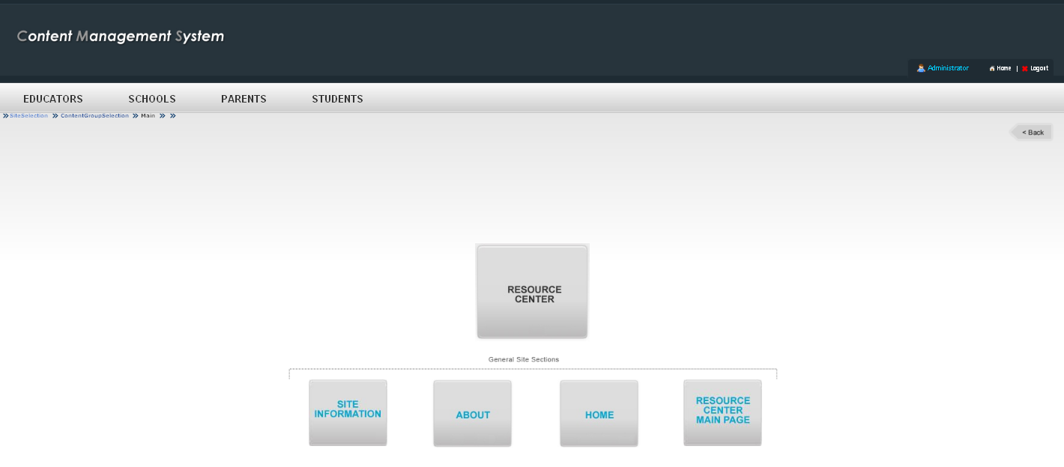

Top Navigation
Here you have access to the Administrator Profile, a link to the home page of the cms, and a logout option.
- Administrator: It allows you to edit the information related to an administrator: Username and full name.
- Home: Takes you to the home page of the cms.
- Logout: It close your user session.



Administrator
It allows you to edit the information related to an administrator: Username and full name.
- Username: Is the username that will be assigned to an user.
- Full name: Contains the full name of the administrator.

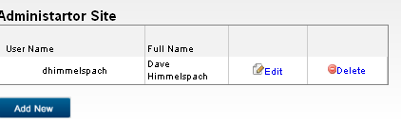

Operations
- Edit: It let you change the existing information of an administrator.
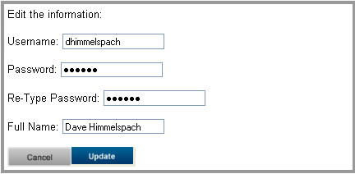
  - Username: You can change the username of the administrator.
  - Password: It let you change the password of an administrator. It must match the same password of the field Re- Type Password.
  - Re- Type Password: It must match the password entered in the “Password” field.
  - Full name: You can edit the name of the administrator here.
  - Cancel: It cancel the changes.
  - Update: It applies the changes made by the user.
- Delete: You can delete an existing administration with this option.
- Add New: It lets you add a new administrator for the site.
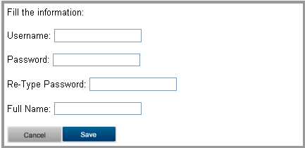
  - Username: You must add the username of the administrator.
  - Password: You must add the password of an administrator. It must match the same password of the field Re- Type Password.
  - Re- Type Password: It must match the password entered in the “Password” field.
  - Full name: You must add the name of the administrator here.
  - Cancel: It cancels the changes.
  - Update: It applies the changes made by the user.

Area selection navigation bar
You need to select any of the areas above in order to made any change in the other options (resource center, site information, about, home, resource center main page).
In order to select any of the above areas, just click over the name of the area once. You will see the page reload, and now you can navigate through the other sections.

General Site Sections Selector

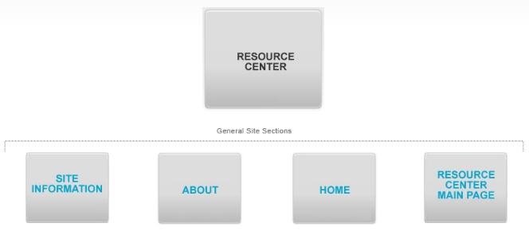
Here you can have access to the general site section selector.
In order to select any of the above areas, just click over the name of the area once. You will see the page reload, and now you can navigate through the other sections.

Resource Center
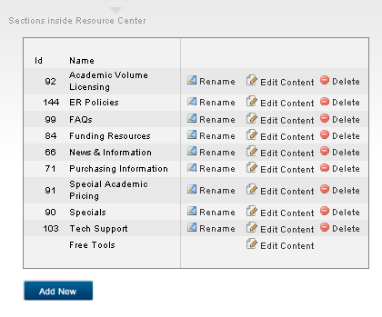
Here you can add new pages for the sections for the Resource Center.
These sections will appear in the footer of the website:

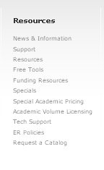

Operations
You have 4 basic operations:
- Rename: It lets you rename an existing section.
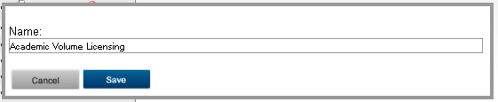
- Edit content: It lets you edit the content of a section.
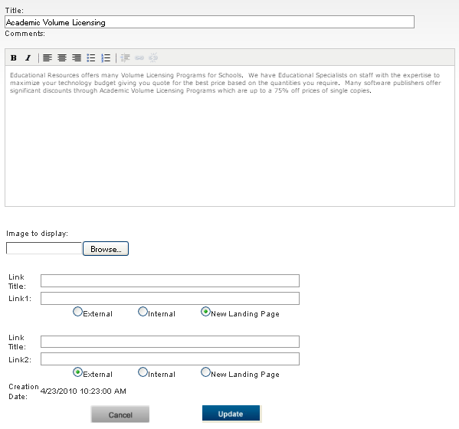
- Delete: It let you delete the content of a section.
- Add new: It lets you add a new section.
Once you introduce some content for the title, you will be able to choose what template you want to use for that page.
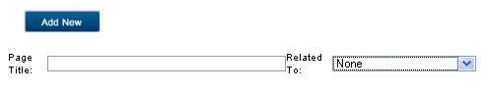
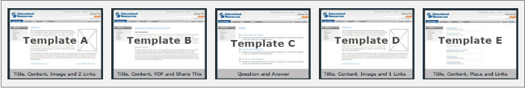

Site Information
Here you can modify the basic information of the website.

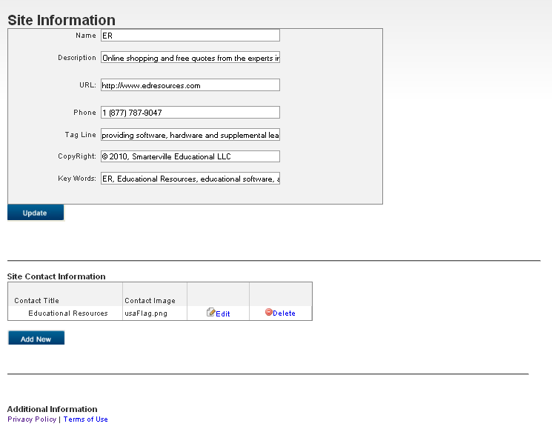

Site Information
- Name: Contains the name of the site.
- Description: Contains a brief description of the content of the site.
- URL: Contains the url that points to the site.
- Phone: Contains the phone number of the site.
- Tag line: Contains a small tag line for the site.
- CopyRight: Contains the copy rights of the site.
- Key Workds: Contains key words of the site.

Site Contact Information
You can add external contact information that will be displayed in the footer.

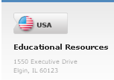

If you click the button “Add New” you will see the next modal window:

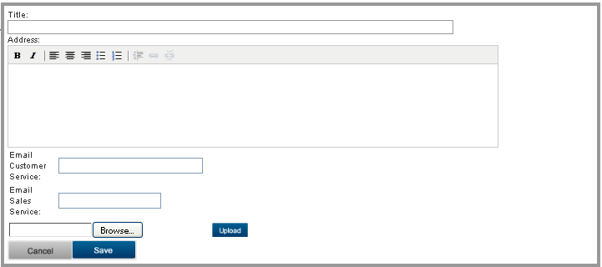

Additional Information
Here you can modify the information related to the privacy policy and the terms of use.

Privacy Policy
You can edit the information of the privacy policy here.
In order to have access to the editor click the link.
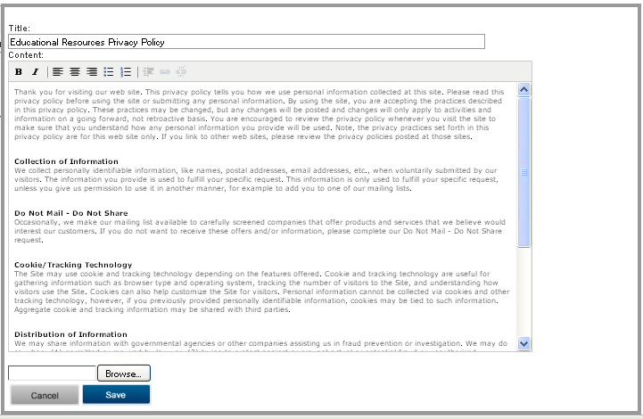

Terms of Use
You can edit the information of the privacy policy here.
In order to have access to the editor click the link.

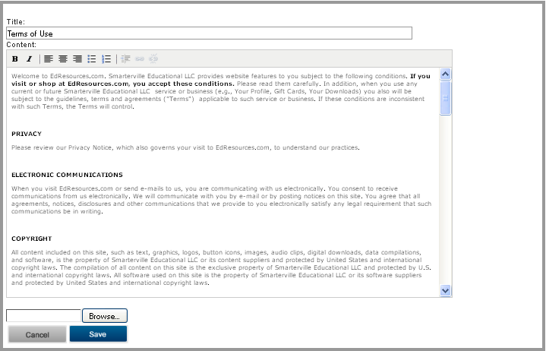

About Us
Here you can add, rename, edit and delete content for the about us section.

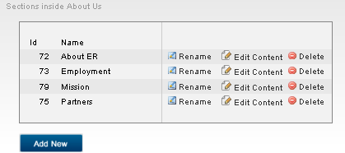

The changes you made will be reflected in the website in the footer.

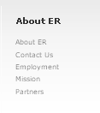

Operations
You have 4 basic operations:
- Rename: It lets you rename an existing section.
- Edit content: It lets you edit the content of a section.
- Delete: It let you delete the content of a section.
- Add new: It lets you add a new section.
Once you introduce some content for the title, you will be able to choose what template you want to use for that page.

Home
In this section you can edit the adds, theater, highlights and featured brands.

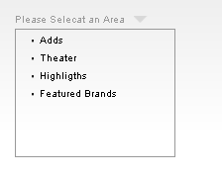

Adds
You can edit, delete or add new Adds. Please take in consideration that there is a limit of 2 adds.

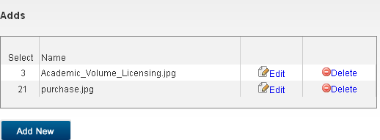

The adds will be displayed below the navigation bar of the website.

Theater
You can edit, delete or add new Theaters. Please take in consideration that there is a limit of 5 theater entries.

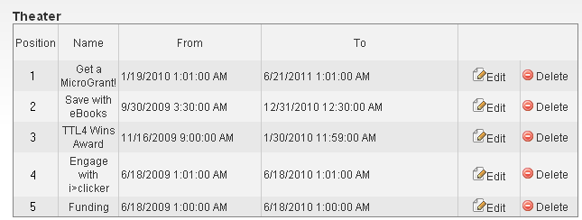

The theater will be displayed in the landing page of each section of the website.



Highlights
You can edit, delete or add new Highlights. Please take in consideration that there is a limit of 3 Highlights entries.

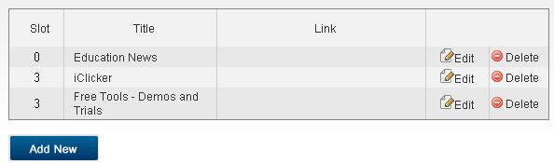
The Highlights will be displayed in the landing page of each section of the website.



Featured Brands
You can edit, delete or add new Featured Brands. These featured brands will appear in the carrousel of the landing page of each section.

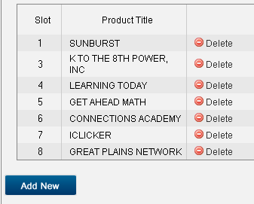



Resource Center Main Page
Here you can edit the information of the resources center landing page (http://www.edresources.com/resourcecenter.aspx?id=0&TypeGen=1&am=2&asm=3).

Main image
In this part of the page you upload the main image that will be displayed on the landing page.
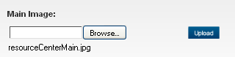

Left side
In this part of the page you add the information that will be displayed on the left side of the landing page.

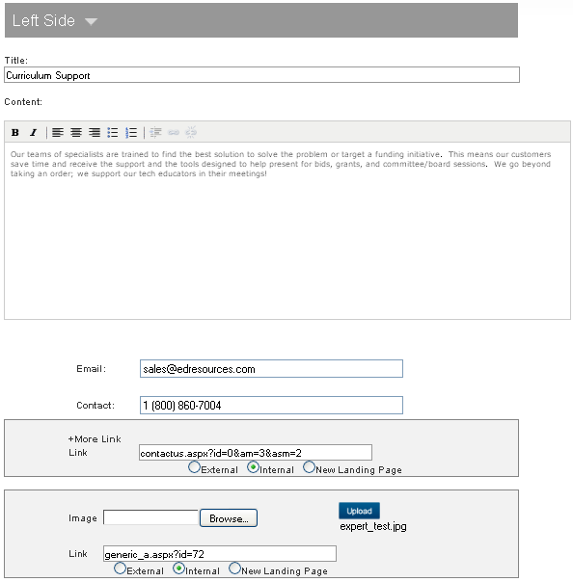

Right side
In this part of the page you add the information that will be displayed on the right side of the landing page.

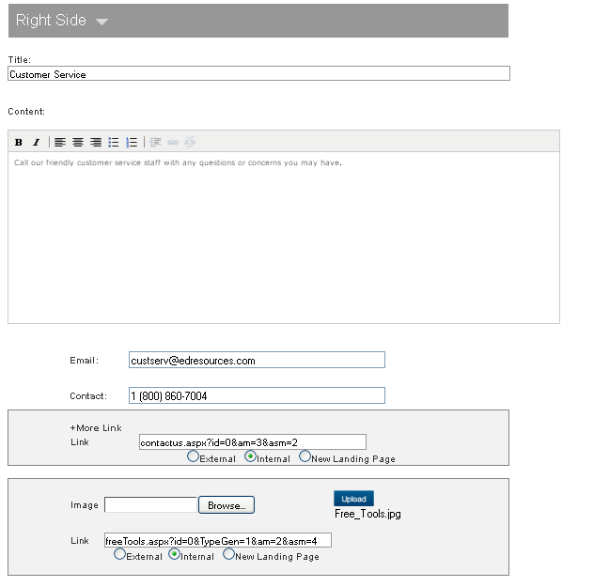
The layout of the final content will be described in the next image:
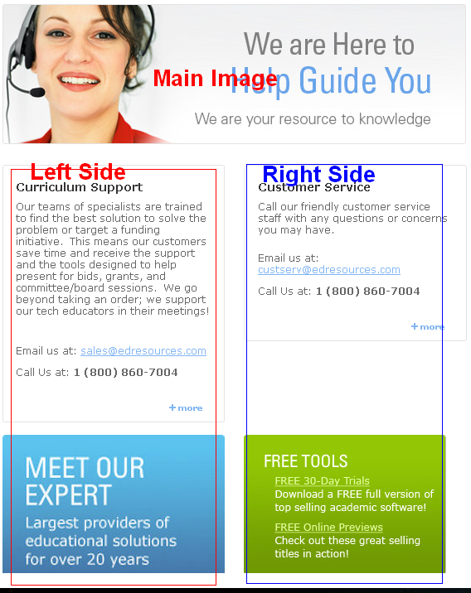

Type of Templates.

There will be opportunities where you can choose what template you want to use for a new page you want to publish.

Here is a description of each type of template you can choose:
- Template A: In this template you can add:
  - Title.
  - Content of page.
  - An image, this is displayed in the right side of the page.
  - Two links, these can be external, internal, or a new landing page.
- Template B: In this template you can add:
  - Title.
  - Content of page.
  - Upload one PDF file.
- Template C: In this template you can add:
  - Question.
  - Answer. After you insert the first Question the page will save a list in the main list of resources edition page. You can Edit this page and add, edit or delete questions.
- Template D: In this template you can add:
  - Title.
  - Content of page.
  - An image, this is displayed in the right side of the page.
  - One link, these can be external, internal, or a new landing page.
- Template E: In this template you can add:
  - Title.
  - Content of page.
  - One link, these can be external, internal, or a new landing page.
  - A Place. This text is displayed under the title.

