Cholera outbreak report

# Introduction to this template

This is a template which can be used to create an automated outbreak situation report for cholera.

* It is organised by time, place and person. For a more detailed explanation of this template, please visit <https://r4epis.netlify.com/outbreaks>
* Feedback and suggestions are welcome at the [GitHub issues page](https://github.com/R4EPI/sitrep/issues)
* Text within <! > will not show in your final document. These comments are used to explain the template. You can delete them if you want.

## Installing and loading required packages

### Person

From the start of the outbreak up until 2019-W25 there were a total of 300 cases. There were 90 (30.0%) females and 115 (38.3%) males.

The most affected age group was 45+ years.

#### Demographics

Cases by age group and definition

|  |  |  |  |  |  |  |  |
| --- | --- | --- | --- | --- | --- | --- | --- |
| Age group | Confirmed cases (n) | % | Probable cases (n) | % | Suspected cases (n) | % | Total |
| 0-2 | 5 | 2.2 | 1 | 2.9 | 1 | 2.7 | 7 |
| 3-14 | 18 | 7.9 | 6 | 17.1 | 2 | 5.4 | 26 |
| 15-29 | 32 | 14.0 | 4 | 11.4 | 5 | 13.5 | 41 |
| 30-44 | 38 | 16.7 | 5 | 14.3 | 4 | 10.8 | 47 |
| 45+ | 135 | 59.2 | 19 | 54.3 | 25 | 67.6 | 179 |
| Total | 228 | 100.0 | 35 | 100.0 | 37 | 100.0 | 300 |

There were 95 (31.7%) cases missing information on sex and 0 (0.0%) missing age group.

Cases by age group and sex

|  |  |  |  |  |  |  |  |
| --- | --- | --- | --- | --- | --- | --- | --- |
| Age group | Male cases (n) | % | Female cases (n) | % | Missing cases (n) | % | Total |
| 0-2 | 3 | 2.6 | 2 | 2.2 | 2 | 2.1 | 7 |
| 3-14 | 12 | 10.4 | 7 | 7.8 | 7 | 7.4 | 26 |
| 15-29 | 20 | 17.4 | 10 | 11.1 | 11 | 11.6 | 41 |
| 30-44 | 20 | 17.4 | 11 | 12.2 | 16 | 16.8 | 47 |
| 45+ | 60 | 52.2 | 60 | 66.7 | 59 | 62.1 | 179 |
| Total | 115 | 100.0 | 90 | 100.0 | 95 | 100.0 | 300 |

Cases by population proportion (age group and sex)

|  |  |  |  |  |  |  |  |
| --- | --- | --- | --- | --- | --- | --- | --- |
| Age group | Male cases (n) | % | Female cases (n) | % | Missing cases (n) | % | Total |
| 0-2 | 3 | 1.0 | 2 | 0.7 | 2 | 0.7 | 7 |
| 3-14 | 12 | 4.0 | 7 | 2.3 | 7 | 2.3 | 26 |
| 15-29 | 20 | 6.7 | 10 | 3.3 | 11 | 3.7 | 41 |
| 30-44 | 20 | 6.7 | 11 | 3.7 | 16 | 5.3 | 47 |
| 45+ | 60 | 20.0 | 60 | 20.0 | 59 | 19.7 | 179 |
| Total | 115 | 38.3 | 90 | 30.0 | 95 | 31.7 | 300 |

Age pyramid 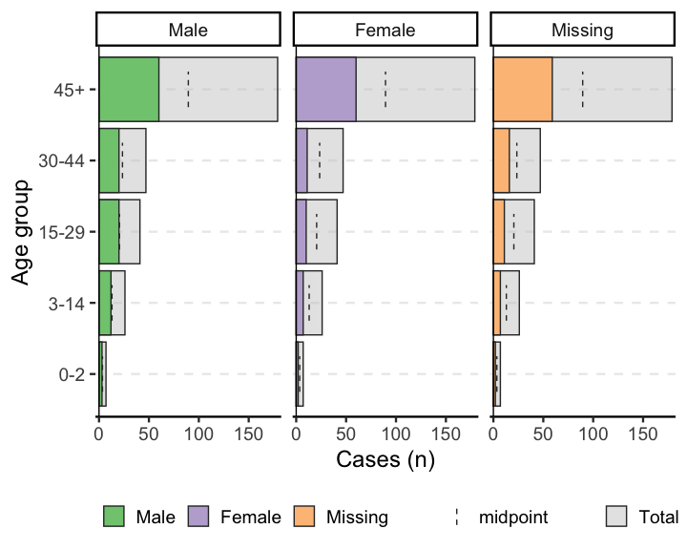

Of the patients, 92 (30.7%) were seen as outpatients and 208 (69.3%) were inpatients. Among inpatients, the median number of days admitted was 20, with a range between 1 and 113 days.

From the start of the outbreak, 63 (21.0%) patients recevied treatment plan A, 51 (17.0%) received treatment plan B, and 50 (16.7%) received treatment plan C.

Cases by treatment plan and case definition

|  |  |  |  |  |  |  |  |
| --- | --- | --- | --- | --- | --- | --- | --- |
| Fluid treatment plan | Confirmed cases (n) | % | Probable cases (n) | % | Suspected cases (n) | % | Total |
| None | 47 | 20.6 | 6 | 17.1 | 11 | 29.7 | 64 |
| Treatment plan A | 45 | 19.7 | 12 | 34.3 | 6 | 16.2 | 63 |
| Treatment plan B | 42 | 18.4 | 4 | 11.4 | 5 | 13.5 | 51 |
| Treatment plan C | 39 | 17.1 | 5 | 14.3 | 6 | 16.2 | 50 |
| Unknown | 55 | 24.1 | 8 | 22.9 | 9 | 24.3 | 72 |
| Total | 228 | 100.0 | 35 | 100.0 | 37 | 100.0 | 300 |

The median number of days admitted was 20, with a range between 1 and 113 days. A total of 102 (34.0%) patients were readmitted to the CTC.

Cases by dehydration severity at admission

|  |  |  |
| --- | --- | --- |
| Dehydration severity | Cases (n) | % |
| Severe | 70 | 23.3 |
| Some | 68 | 22.7 |
| None | 80 | 26.7 |
| Unknown | 82 | 27.3 |
| Total | 300 | 100.0 |

Cases by dehydration severity during stay

|  |  |  |
| --- | --- | --- |
| Dehydration severity | Cases (n) | % |
| Severe | 74 | 24.7 |
| Some | 75 | 25.0 |
| None | 85 | 28.3 |
| Unknown | 66 | 22.0 |
| Total | 300 | 100.0 |

Cases by lab results

## Note: Using an external vector in selections is ambiguous.  
## ℹ Use `all_of(LABS)` instead of `LABS` to silence this message.  
## ℹ See <https://tidyselect.r-lib.org/reference/faq-external-vector.html>.  
## This message is displayed once per session.

|  |  |  |  |  |  |  |
| --- | --- | --- | --- | --- | --- | --- |
| Results | Culture (n) | % | PCR (n) | % | RDT (n) | % |
| Not done | 50 | 16.7 | 38 | 12.7 | 52 | 17.3 |
| Negative | 55 | 18.3 | 50 | 16.7 | 43 | 14.3 |
| Positive O1 | 45 | 15.0 | 47 | 15.7 | 48 | 16.0 |
| Positive O139 | 42 | 14.0 | 57 | 19.0 | 59 | 19.7 |
| Positive O1 & O139 | 57 | 19.0 | 59 | 19.7 | 53 | 17.7 |
| Invalid/contaminated | 51 | 17.0 | 49 | 16.3 | 45 | 15.0 |
| Total | 300 | 100.0 | 300 | 100.0 | 300 | 100.0 |

Cases by vaccination status

|  |  |  |
| --- | --- | --- |
| Vaccination status | Cases (n) | % |
| Yes - vaccination card/ink | 62 | 20.7 |
| Yes - verbal | 92 | 30.7 |
| No | 73 | 24.3 |
| Unsure | 73 | 24.3 |
| Total | 300 | 100.0 |

#### Case fatality ratio

Of 208 (69.3%) inpatients, there have been 62 (20.7%) deaths, of which 42 (14.0%) were dead on arrival.

Among inpatients who died, the time to death is shown below.

|  |  |  |
| --- | --- | --- |
| Time (hours) | Deaths (n) | % |
| 0-4 hours | 16 | 25.8 |
| >4-24 hours | 15 | 24.2 |
| >24-48 hours | 17 | 27.4 |
| >48 hours | 14 | 22.6 |
| Total | 62 | 100.0 |

The case fatality ratio among inpatients with known outcomes is below.

|  |  |  |  |
| --- | --- | --- | --- |
| Deaths | Cases | CFR (%) | 95%CI |
| 62 | 208 | 29.8 | (24.00–36.34) |

The case fatality ratio by sex among inpatients with known outcomes is below.

|  |  |  |  |  |
| --- | --- | --- | --- | --- |
| Sex | Deaths | Cases | CFR (%) | 95%CI |
| Male | 25 | 85 | 29.4 | (20.79–39.82) |
| Female | 19 | 60 | 31.7 | (21.31–44.23) |
| - | 18 | 63 | 28.6 | (18.90–40.70) |
| Total | 62 | 208 | 29.8 | (24.00–36.34) |

CFR by age group among inpatients with known outcomes

|  |  |  |  |  |
| --- | --- | --- | --- | --- |
| Age group | Deaths | Cases | CFR (%) | 95%CI |
| 0-2 | 1 | 5 | 20.0 | (3.62–62.45) |
| 3-14 | 4 | 15 | 26.7 | (10.90–51.95) |
| 15-29 | 12 | 35 | 34.3 | (20.83–50.85) |
| 30-44 | 9 | 35 | 25.7 | (14.16–42.07) |
| 45+ | 36 | 118 | 30.5 | (22.92–39.32) |
| Total | 62 | 208 | 29.8 | (24.00–36.34) |

#### Attack rate

The attack rate per 10,000 population is below (based on available population data available for the catchment area/region of interest).

Below gives the attack rate per 10,000 population (N = 4,999.5)

|  |  |  |
| --- | --- | --- |
| Cases (n) | AR (per 10,000) | 95%CI |
| 300 | 600.1 | (537.54–669.33) |

Here, we can see that the attack rate for a population of 4,999.5 was 600.06 (CI 537.54–669.33).

To give attack rate by age group, with appropriate population denominators, use the following code.

|  |  |  |  |  |
| --- | --- | --- | --- | --- |
| Age group | Cases (n) | Population | AR (per 10,000) | 95%CI |
| 0-2 | 7 | 340.0 | 205.9 | (100.08–418.81) |
| 3-14 | 26 | 1,811.0 | 143.6 | (98.16–209.53) |
| 15-29 | 41 | 1,380.0 | 297.1 | (219.75–400.56) |
| 30-44 | 47 | 808.0 | 581.7 | (440.23–764.95) |
| 45+ | 179 | 660.5 | 2,710.1 | (2385.06–3061.56) |

#### Mortality attributable to cholera

Mortality rate attributable to cholera per 10,000 population

|  |  |  |  |
| --- | --- | --- | --- |
| Deaths | Population | Mortality (per 10,000) | 95%CI |
| 97 | 4999.5 | 194 | (159.31–236.11) |

Crude mortality rate attributable to cholera per 10,000 population per day

|  |  |  |  |
| --- | --- | --- | --- |
| Deaths | Person-days | Mortality (per 10,000/day) | 95%CI |
| 97 | 2619738 | 0.4 | (0.30–0.45) |

Mortality rate attributable to cholera per 10,000 patients per day

|  |  |  |  |
| --- | --- | --- | --- |
| Deaths | Population | Mortality (per 10,000/day) | 95%CI |
| 97 | 8742 | 111 | (91.05–135.16) |

### Time

There were 0 (0.0%) cases missing dates of onset.

## Warning: It is deprecated to specify `guide = FALSE` to remove a guide. Please  
## use `guide = "none"` instead.

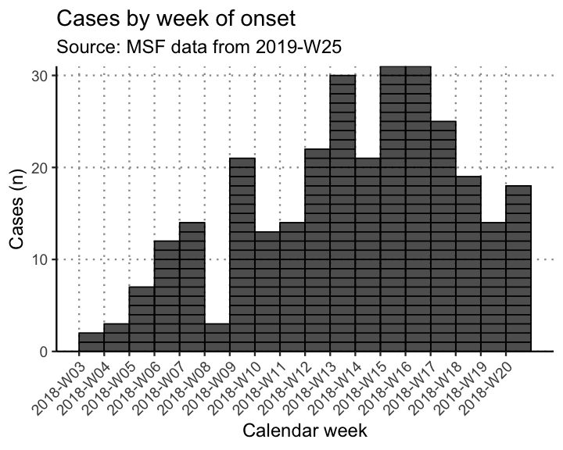

The peak of the outbreak was in 2018-W15.

## Warning: It is deprecated to specify `guide = FALSE` to remove a guide. Please  
## use `guide = "none"` instead.

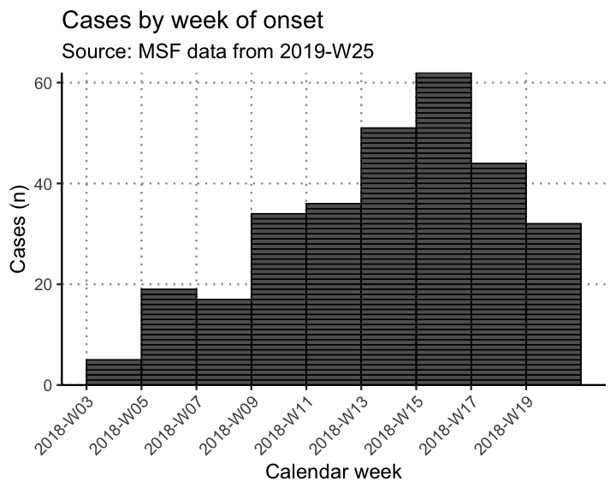

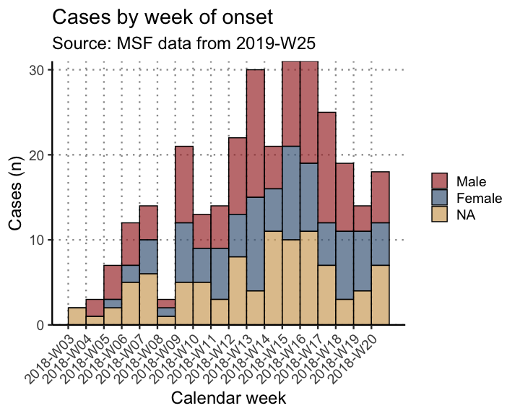

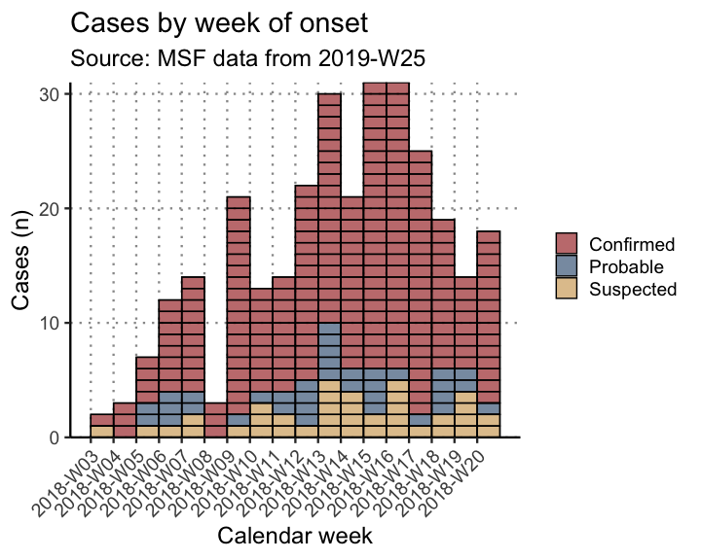

Cases by week of onset among inpatients by sex 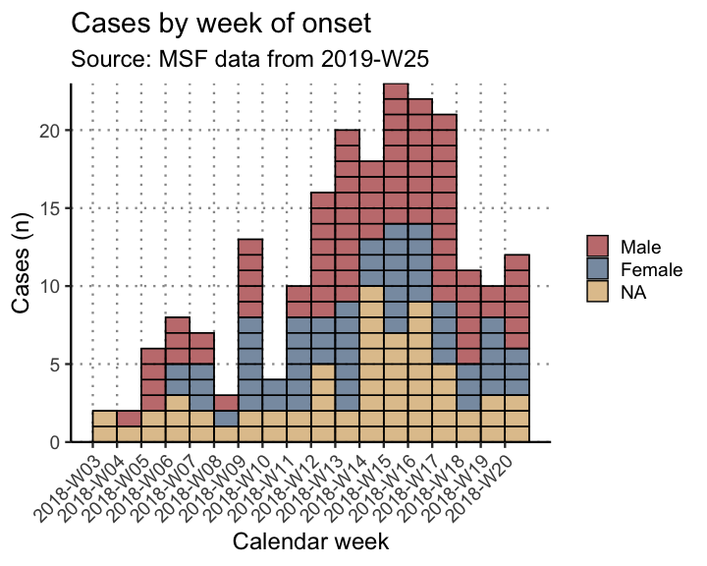

Attack rate per 10,000 population by week

|  |  |  |  |  |
| --- | --- | --- | --- | --- |
| Epiweek | Cases (n) | Population | AR (per 10,000) | 95%CI |
| 2018-W03 | 2 | 4999.5 | 4 | (1.10–14.58) |
| 2018-W04 | 3 | 4999.5 | 6 | (2.04–17.63) |
| 2018-W05 | 7 | 4999.5 | 14 | (6.78–28.88) |
| 2018-W06 | 12 | 4999.5 | 24 | (13.74–41.91) |
| 2018-W07 | 14 | 4999.5 | 28 | (16.69–46.95) |
| 2018-W08 | 3 | 4999.5 | 6 | (2.04–17.63) |
| 2018-W09 | 21 | 4999.5 | 42 | (27.49–64.13) |
| 2018-W10 | 13 | 4999.5 | 26 | (15.20–44.44) |
| 2018-W11 | 14 | 4999.5 | 28 | (16.69–46.95) |
| 2018-W12 | 22 | 4999.5 | 44 | (29.08–66.54) |
| 2018-W13 | 30 | 4999.5 | 60 | (42.07–85.53) |
| 2018-W14 | 21 | 4999.5 | 42 | (27.49–64.13) |
| 2018-W15 | 31 | 4999.5 | 62 | (43.72–87.88) |
| 2018-W16 | 31 | 4999.5 | 62 | (43.72–87.88) |
| 2018-W17 | 25 | 4999.5 | 50 | (33.89–73.72) |
| 2018-W18 | 19 | 4999.5 | 38 | (24.34–59.28) |
| 2018-W19 | 14 | 4999.5 | 28 | (16.69–46.95) |
| 2018-W20 | 18 | 4999.5 | 36 | (22.79–56.84) |

Cumulative attack rate per 10,000 population per week

|  |  |  |  |  |
| --- | --- | --- | --- | --- |
| Epiweek | Cases (n) | Population | AR (per 10,000) | 95%CI |
| 2018-W03 | 2 | 4999.5 | 4.0 | (1.10–14.58) |
| 2018-W04 | 5 | 4999.5 | 10.0 | (4.27–23.39) |
| 2018-W05 | 12 | 4999.5 | 24.0 | (13.74–41.91) |
| 2018-W06 | 24 | 4999.5 | 48.0 | (32.28–71.33) |
| 2018-W07 | 38 | 4999.5 | 76.0 | (55.43–104.15) |
| 2018-W08 | 41 | 4999.5 | 82.0 | (60.51–111.06) |
| 2018-W09 | 62 | 4999.5 | 124.0 | (96.86–158.65) |
| 2018-W10 | 75 | 4999.5 | 150.0 | (119.85–187.63) |
| 2018-W11 | 89 | 4999.5 | 178.0 | (144.89–218.55) |
| 2018-W12 | 111 | 4999.5 | 222.0 | (184.70–266.68) |
| 2018-W13 | 141 | 4999.5 | 282.0 | (239.64–331.67) |
| 2018-W14 | 162 | 4999.5 | 324.0 | (278.43–376.82) |
| 2018-W15 | 193 | 4999.5 | 386.0 | (336.08–443.08) |
| 2018-W16 | 224 | 4999.5 | 448.0 | (394.11–508.97) |
| 2018-W17 | 249 | 4999.5 | 498.0 | (441.13–561.88) |
| 2018-W18 | 268 | 4999.5 | 536.1 | (476.98–601.99) |
| 2018-W19 | 282 | 4999.5 | 564.1 | (503.45–631.48) |
| 2018-W20 | 300 | 4999.5 | 600.1 | (537.54–669.33) |

Case fatality ratio as a proportion among inpatients by week

|  |  |  |  |  |
| --- | --- | --- | --- | --- |
| Epiweek | Deaths | Cases | CFR (%) | 95%CI |
| 2018-W03 | 1 | 2 | 50.0 | (9.45–90.55) |
| 2018-W04 | 1 | 2 | 50.0 | (9.45–90.55) |
| 2018-W05 | 3 | 6 | 50.0 | (18.76–81.24) |
| 2018-W06 | 1 | 8 | 12.5 | (2.24–47.09) |
| 2018-W07 | 3 | 7 | 42.9 | (15.82–74.95) |
| 2018-W08 | 0 | 3 | 0.0 | (0.00–56.15) |
| 2018-W09 | 4 | 13 | 30.8 | (12.68–57.63) |
| 2018-W10 | 0 | 4 | 0.0 | (0.00–48.99) |
| 2018-W11 | 5 | 10 | 50.0 | (23.66–76.34) |
| 2018-W12 | 7 | 16 | 43.8 | (23.10–66.82) |
| 2018-W13 | 3 | 20 | 15.0 | (5.24–36.04) |
| 2018-W14 | 5 | 18 | 27.8 | (12.50–50.87) |
| 2018-W15 | 8 | 23 | 34.8 | (18.81–55.11) |
| 2018-W16 | 4 | 22 | 18.2 | (7.31–38.52) |
| 2018-W17 | 8 | 21 | 38.1 | (20.75–59.12) |
| 2018-W18 | 3 | 11 | 27.3 | (9.75–56.56) |
| 2018-W19 | 3 | 10 | 30.0 | (10.78–60.32) |
| 2018-W20 | 3 | 12 | 25.0 | (8.89–53.23) |

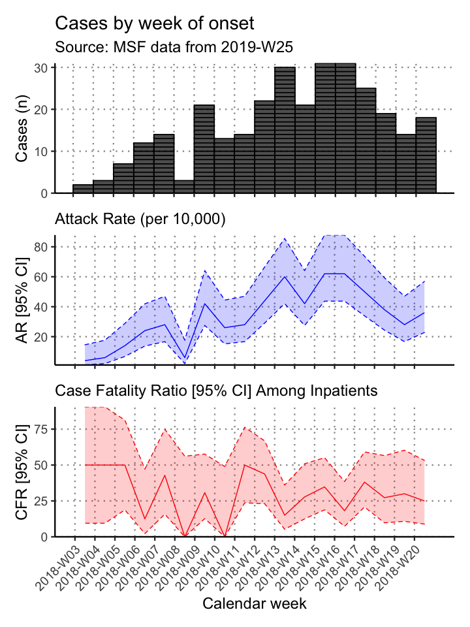

Inpatient admissions by case definition and week

|  |  |  |  |  |  |  |  |
| --- | --- | --- | --- | --- | --- | --- | --- |
| value | Confirmed (n) | % | Probable (n) | % | Suspected (n) | % | Total |
| 2018-W03 | 1 | 0.6 | 0 | 0 | 1 | 4.2 | 2 |
| 2018-W04 | 2 | 1.3 | 0 | 0 | 0 | 0.0 | 2 |
| 2018-W05 | 4 | 2.5 | 1 | 4 | 1 | 4.2 | 6 |
| 2018-W06 | 5 | 3.1 | 3 | 12 | 0 | 0.0 | 8 |
| 2018-W07 | 6 | 3.8 | 1 | 4 | 0 | 0.0 | 7 |
| 2018-W08 | 3 | 1.9 | 0 | 0 | 0 | 0.0 | 3 |
| 2018-W09 | 12 | 7.5 | 1 | 4 | 0 | 0.0 | 13 |
| 2018-W10 | 2 | 1.3 | 1 | 4 | 1 | 4.2 | 4 |
| 2018-W11 | 7 | 4.4 | 1 | 4 | 2 | 8.3 | 10 |
| 2018-W12 | 11 | 6.9 | 4 | 16 | 1 | 4.2 | 16 |
| 2018-W13 | 14 | 8.8 | 2 | 8 | 4 | 16.7 | 20 |
| 2018-W14 | 12 | 7.5 | 2 | 8 | 4 | 16.7 | 18 |
| 2018-W15 | 19 | 11.9 | 2 | 8 | 2 | 8.3 | 23 |
| 2018-W16 | 19 | 11.9 | 1 | 4 | 2 | 8.3 | 22 |
| 2018-W17 | 19 | 11.9 | 1 | 4 | 1 | 4.2 | 21 |
| 2018-W18 | 7 | 4.4 | 3 | 12 | 1 | 4.2 | 11 |
| 2018-W19 | 7 | 4.4 | 1 | 4 | 2 | 8.3 | 10 |
| 2018-W20 | 9 | 5.7 | 1 | 4 | 2 | 8.3 | 12 |
| Total | 159 | 100.0 | 25 | 100 | 24 | 100.0 | 208 |

Inpatient discharges by reason for exit and week

|  |  |  |  |  |  |  |  |  |  |
| --- | --- | --- | --- | --- | --- | --- | --- | --- | --- |
| Week | Died (n) | % | Discharged (n) | % | Left (n) | % | Transferred (n) | % | Total |
| 2018-W03 | 1 | 1.6 | 0 | 0.0 | 1 | 2.6 | 0 | 0.0 | 2 |
| 2018-W04 | 1 | 1.6 | 1 | 3.0 | 0 | 0.0 | 0 | 0.0 | 2 |
| 2018-W05 | 3 | 4.8 | 0 | 0.0 | 2 | 5.3 | 1 | 1.3 | 6 |
| 2018-W06 | 1 | 1.6 | 1 | 3.0 | 0 | 0.0 | 6 | 8.0 | 8 |
| 2018-W07 | 3 | 4.8 | 0 | 0.0 | 1 | 2.6 | 3 | 4.0 | 7 |
| 2018-W08 | 0 | 0.0 | 0 | 0.0 | 1 | 2.6 | 2 | 2.7 | 3 |
| 2018-W09 | 4 | 6.5 | 3 | 9.1 | 3 | 7.9 | 3 | 4.0 | 13 |
| 2018-W10 | 0 | 0.0 | 1 | 3.0 | 1 | 2.6 | 2 | 2.7 | 4 |
| 2018-W11 | 5 | 8.1 | 2 | 6.1 | 3 | 7.9 | 0 | 0.0 | 10 |
| 2018-W12 | 7 | 11.3 | 4 | 12.1 | 1 | 2.6 | 4 | 5.3 | 16 |
| 2018-W13 | 3 | 4.8 | 4 | 12.1 | 4 | 10.5 | 9 | 12.0 | 20 |
| 2018-W14 | 5 | 8.1 | 2 | 6.1 | 4 | 10.5 | 7 | 9.3 | 18 |
| 2018-W15 | 8 | 12.9 | 3 | 9.1 | 4 | 10.5 | 8 | 10.7 | 23 |
| 2018-W16 | 4 | 6.5 | 4 | 12.1 | 5 | 13.2 | 9 | 12.0 | 22 |
| 2018-W17 | 8 | 12.9 | 3 | 9.1 | 3 | 7.9 | 7 | 9.3 | 21 |
| 2018-W18 | 3 | 4.8 | 2 | 6.1 | 1 | 2.6 | 5 | 6.7 | 11 |
| 2018-W19 | 3 | 4.8 | 2 | 6.1 | 1 | 2.6 | 4 | 5.3 | 10 |
| 2018-W20 | 3 | 4.8 | 1 | 3.0 | 3 | 7.9 | 5 | 6.7 | 12 |
| Total | 62 | 100.0 | 33 | 100.0 | 38 | 100.0 | 75 | 100.0 | 208 |

### Place

#### Descriptive

Cases by region and facility type

|  |  |  |  |  |  |
| --- | --- | --- | --- | --- | --- |
| Region | Inpatient (n) | % | Outpatient (n) | % | Total |
| Village A | 60 | 28.8 | 19 | 20.7 | 79 |
| Village B | 52 | 25.0 | 29 | 31.5 | 81 |
| Village C | 42 | 20.2 | 20 | 21.7 | 62 |
| Village D | 54 | 26.0 | 24 | 26.1 | 78 |
| Total | 208 | 100.0 | 92 | 100.0 | 300 |

Inpatient discharges by reason for exit and region

|  |  |  |  |  |  |  |  |  |  |
| --- | --- | --- | --- | --- | --- | --- | --- | --- | --- |
| Region | Died (n) | % | Discharged (n) | % | Left (n) | % | Transferred (n) | % | Total |
| Village A | 18 | 29.0 | 11 | 33.3 | 11 | 28.9 | 20 | 26.7 | 60 |
| Village B | 15 | 24.2 | 8 | 24.2 | 8 | 21.1 | 21 | 28.0 | 52 |
| Village C | 11 | 17.7 | 5 | 15.2 | 11 | 28.9 | 15 | 20.0 | 42 |
| Village D | 18 | 29.0 | 9 | 27.3 | 8 | 21.1 | 19 | 25.3 | 54 |
| Total | 62 | 100.0 | 33 | 100.0 | 38 | 100.0 | 75 | 100.0 | 208 |

Attack rage per 10,000 population by region

|  |  |  |  |  |
| --- | --- | --- | --- | --- |
| Region | Cases (n) | Population | AR (per 10,000) | 95%CI |
| Village A | 79 | 1,105 | 714.9 | (577.40–882.15) |
| Village B | 81 | 870 | 931.0 | (755.43–1142.41) |
| Village C | 62 | 1,775 | 349.3 | (273.43–445.25) |
| Village D | 78 | 1,225 | 636.7 | (513.18–787.57) |

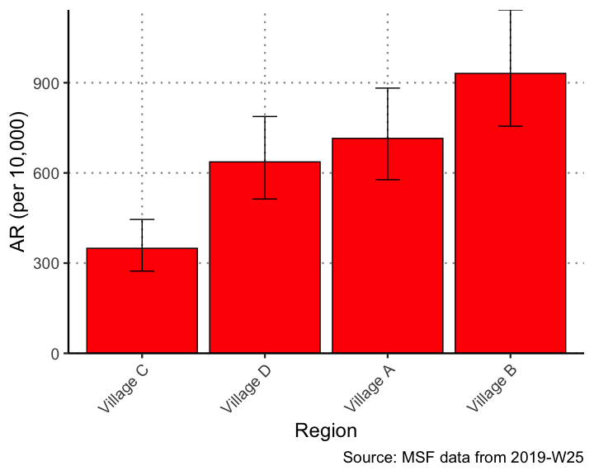

Mortality rate per 10,000 population by region

|  |  |  |  |  |
| --- | --- | --- | --- | --- |
| Region | Deaths | Population | Mortality (per 10,000) | 95%CI |
| Village A | 24 | 1105 | 217.2 | (146.38–321.15) |
| Village B | 27 | 870 | 310.3 | (214.15–447.77) |
| Village C | 21 | 1775 | 118.3 | (77.51–180.19) |
| Village D | 25 | 1225 | 204.1 | (138.61–299.54) |

#### Maps

