Task 1: Designing a Pokédex Interface
Objective: Design the graphical user interface (GUI) for a Pokédex application.
Tasks:
- Create a mock-up of the Pokédex interface, including layout, buttons, and data display areas.
- Use object descriptions to outline the functionality of each GUI component.
- Write pseudocode to describe the flow of the application, including how users will interact with the interface.
Key Knowledge Covered:
- Methods of representing designs (mock-ups, object descriptions, pseudocode)
- Characteristics of data types (GUI components)
- Processing features of a programming language (pseudocode)

Mock-up design:
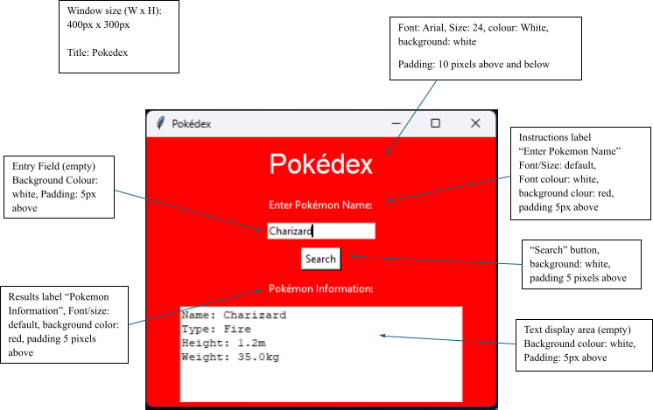



- Write Pseudocode for the Pokedex interface: (6 Marks)
if button pressed:
user input = get user input
print Name: user input
print Type: Fire
print Height: 1.2m
print Weight: 35.0kg

- Using PyCharm update the given code, so that it visually matches the mock-up design.
(this will be submitted via Google Classroom, and code does not need to be provided in this Word Document) (10 Marks)

- Complete the following Object Description Table: (4 marks)
GUI Component | Description  (describe what the component is) | Function  (What is the function of the GUI component)
Pokédex Title Label | displays the text “Pokedex” | a label that displays text
Entry Field | allows the user to input a Pokemon | an entry field that the user can enter text into
Search Button | a button that returns a set text with the text that the user inputted | a pressable button that the user can press
Text Display Area | returns the set text that includes the pokemon that the user input | an area that returns text

