Backup Settings Version 1.2.2.10
Description
- No more manual typing of user settings after a new reinstall of TV Server, Media Portal1 and MediaPortal2
- Allows to export / import all user settings of the TV server engine and all user setting folders
- This includes the settings of cards, LNB settings, TV channels, radio channels, tv groups, radio groups, schedules, recordings, EPG data, general settings, recording settings and plugin settings.
- It creates a backup / restore of the Media Portal configuration and program folders, settings, plugins, skins, input device mappings, thumbs and the database folders
- The Tv server plugin does backup / restore your MediaPortal1 and MediaPortal2 (Client and Server) Files
- An automated backup can be scheduled based on a time interval, where only the last exports will be preserved
- The plugin can be used as a TV server plugin or a Media Portal client plugin for users without TV server
Requirements
- MediaPortal/TV Server 1.0.1 or 1.0.2 or 1.1 or 1.2 or 1.3 or 2.0alfa
- Standard XP, Vista, Windows 7 or Windows 8 Installation (32 bit or 64 bit)
- Standard installation paths. A central media portal database defined in MediaPortalDirs.xml is supported.

Install and Enable the Plugin
- Start the MediaPortal Extension Installer (MPEI) which can be found in your MediaPortal program directory and search for BackupSettings. Load the online list, select BackupSettings and click “Install”.
- The MediaPortal Extension installer will then show the BackupSettings installer window. Click on “Next”, and the BackupSettings Installer window will show up after you have accepted the licesense.

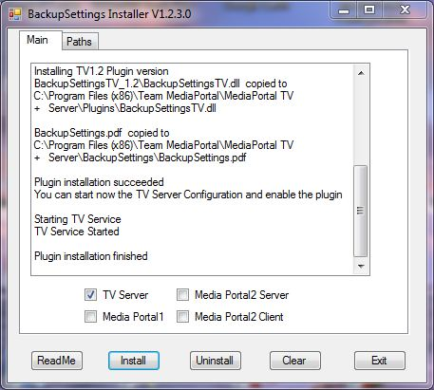

- The installer will detect if you need a TV server plugin (BackupSettingsTV) or a MediaPortal 1/2 plugin (BackupSettingsMP). The installer will also turn off TV server during the installation. The installer will also detect if you need the MP1.0.0, MP1.0.2, MP1.1RC1 or MP1.2 plugin. Using only the TV server plugin is the preferred way for client server installations on the same computer. Plugins can only be installed if the installer could detect the correct paths for Tvserver, MediaPortal1 or MediaPortal 2. On the tab „Paths“ you can verify the detected installation folders and manually correct any settings.
- Click the buttons “Readme”, “Install” and “Exit”. Enable the plugin in the TV server configuration if you have installed the Tv server plugin BackupSettingsTV or in the MediaPortal plugin configuration (“Other Plugins”) if you have installed the client only plugin BackupSettingsMP .
- During installation or during import you can get a security message for running programs downloaded from the internet twice. You need to confirm to run and uncheck the “ask always” checkbox.
- The button “Uninstall” will remove the plugin and all BackupSettings files.
- For Users with a TV Server only Installation: The MPI installer will unzip all files in the %PROGRAMDATA%\Team MediaPortal\MediaPortal\Installer\BackupSettings folder. If you have a computer with a TV server only installation you can copy this folder to the Tv server and install it there.
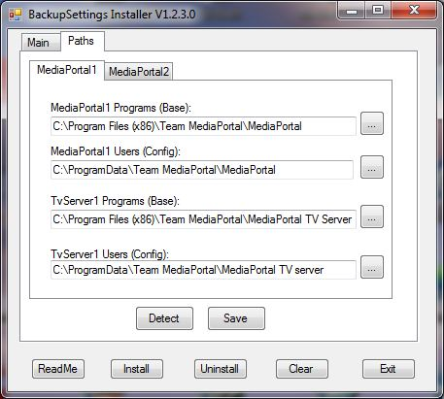
- Many version are not downward compatible. It is recommended to create a new backup once a new version is installed.
- You can delete all BackupSettings files by the Uninstall button.
- Before you upgrade to a new MediaPortal Version make sure you did an export with the latest BackupSettings plugin version as explained in the next section.
- MediaPortal2 data cannot be restored from MediaPortal1 data. You need to do a manual setup the first time. Afterwards your data will be backed up.
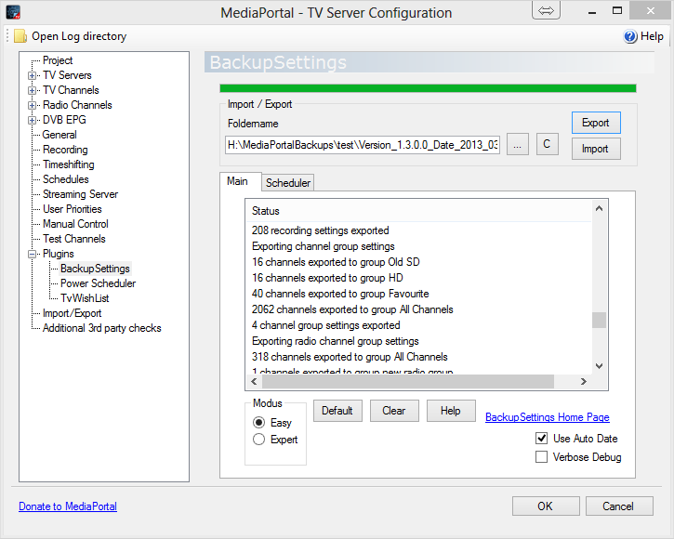
Quick Usage Guide (Easy Mode)
Standard users will only need the “Easy” mode of the Plugin. The other tabs are for MediaPortal expert only and will be visible if you switch to the “Expert” mode.

Main
- Select a folder name for the backup directory (must not contain any other user data)
- Check TV Server if you want to backup / restore the TV server settings
- Check Media Portal1 if you want to backup / restore Media Portal settings
- Check MediaPortal2 Server if you want to backup / restore Media Portal2 Server settings
- Check MediaPortal2 Client if you want to backup / restore Media Portal2 Client settings
- Go to the expert mode and the path tab if one of the above settings is missing and check the installation paths.
- Hit the "Export button" to backup your current settings. The data structure of the backup directory will be explained later.
- Hit the "Import" button to overwrite all your current settings from a previously saved backup folder. This will delete all your current settings including channels, recordings, program data, tv groups and radio groups. The data will be overwritten from the settings previously saved in the backup folder. This allows you now to import all your settings to a fresh Media Portal installation without manual typing.
- Clear will delete the text in the status window
- Default will restore the default filter settings to make sure you export or import a complete data set.
- Help will open this document

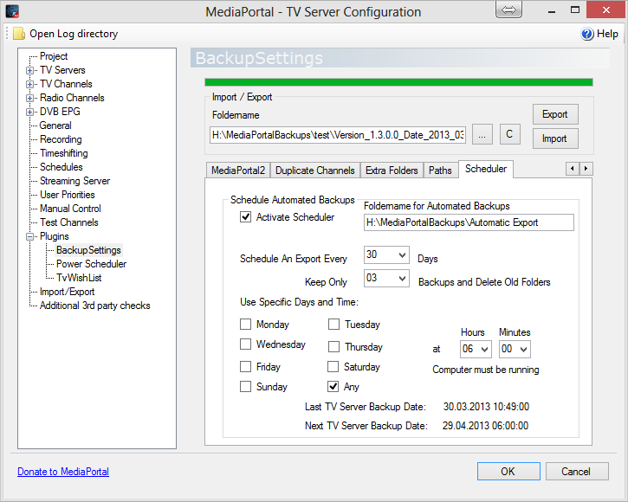
- After pushing the import button you will be guided through some message boxes. If you always click „Yes“ your current data will be overwritten by the imported data depending on the settings. During import the Tv server configuration will be temporarily closed for postprocessing of import data. Afterwards the Tv server configuration will be reopened again.
- If you check the "verbose debug" check box, the tv.log file and the main status listbox will contain more information.
- The option „Use Auto Date“ will always attach a new version and date to the export/import folder text box

With this you should be able to perform a backup and restore operation for upgrading to another MediaPortal version. If you click the button “C”, a folder name is created automatically with the MediaPortal version number and the actual date and time.

Scheduler
Here you can schedule automated backups once you enable „Activate Scheduler“. A separate foldername is used for automated backups, while all other settings are used from the other pages.The next field defines the base interval for an automated export. If you select 30 days a new backup will be done every 30 days to the folder specified under foldername. „Use Specific Days“ can be used to enable the backup only at certain days. If you specify 30 days for a new backup and „Monday“, then the plugin will do the backup on the first Monday after 30 days from the last backup. By default „Any“ day is selected. You can choose multiple days for allowing a backup.
Whenever you change some settings the last backup and the next backup will be displayed below. With „Hours“ and „Minutes“ you can specify a time after which the backup is been done. Please note that hours and minutes never can change the date for the next backup. The computer must be running at the time when the next backup is scheduled. Otherwise the backup will be performed after the computer is turned on again. To prevent standby during the backup the user should enable in the power scheduler plugin options „prevent standby during EPG grabbing“.
The „Keep Only“ option ensures that only a certain number of backup folders is stored. They will be stored in a folder BackupSettingsBackup001, BackupSettingsBackup002, ... . If the number exceeds the allowed backups, the oldest backup folder will be deleted. The option „All“ will not delete any folder. This ensures to manage your disk space and have a certain number of backups in case you detect a bad setting too late. The defaulkt values are to do a backup after 30 days and keep 3 backups.

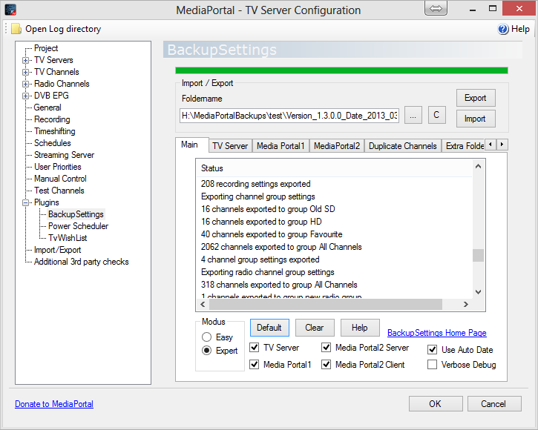

Detailed Usage Guide (Expert Mode)
1. First Time Use
- When you start the plugin the first time it tries to autodetect the installation paths and is searching for the file "MediaPortal.exe", which is for instance in %PROGRAMFILES%\Team MediaPortal\MediaPortal". This is usually the folder C:\Program Files\Team MediaPortal\MediaPortal for Vista or XP. If the plugin cannot find the path you will need to select it in the path tab.

- The same procedure will be done the first time for the Media Portal user setting folder. The plugin is searching for the folder Team MediaPortal\MediaPortal TV Server, which e.g. is under Vista in "C:\ProgramData\Team MediaPortal\MediaPortal". For XP it is the folder "C:\Documents and Settings\All Users\Application data\Team MediaPortal\MediaPortal"
- Next, the file TvService.exe is being searched to identify the TV server installation path and, last not least the file "tv.log" to determine the TV server user data directory. Those files can be found at "C:\Program Files\Team MediaPortal\MediaPortal TV Server\TvService.exe " and "C:\ProgramData\Team MediaPortal\Team MediaPortal\MediaPortal TV Server\log\tv.log" for Vista. For XP the log file should be in "C:\Documents and Settings\All Users\Application data\Team MediaPortal\MediaPortal TV Server\log\tv.log"
- For standard installation paths the folders should get automatically detected.
- It is recommended to check the first time the installation paths in the path tab.

2. TV Server Filter
All filter settings should be used by Media Portal experts only who understand the detailed data structure of the program. As a default user you can do a complete backup restore operation without touching anything on the filter section and all check boxes should be checked. The Filter tabs are only available if there has been the correct MediaPortal installation detected. So depending on your installation some tabs may be missing. Check the path tab on what installations have been detected.

- File Settings for Export and Import: This group defines the files being exported or imported. Check the files you want to be used for import or export. The setting is only used if the global TV server check mark is set on the status tab.
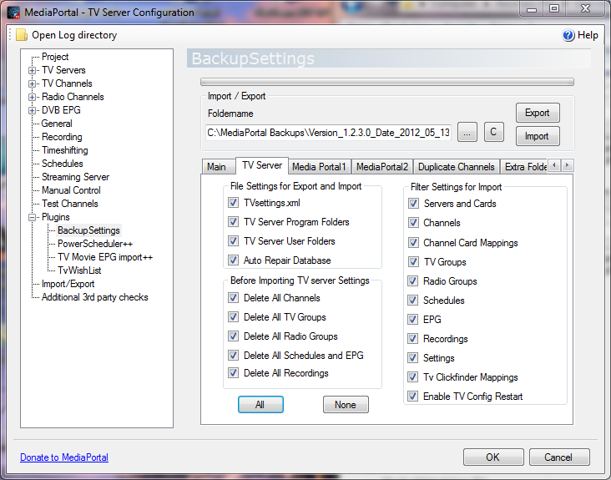
- TV Settings.xml: This check box defines if the Tv server settings are being exported to a .xml file or if the TV server settings are being restored during an import operation. During export the file is stored at <backup folder>\TV_User\TVsettings.xml. The file contains the settings for all servers, cards, channels, tvgroups, radiogroups, general settings, recording settings and the plugin settings for the supported plugins. If you uncheck this, all other filter settings are void as no export/import will be done.
- TV Server Program Folders: All folders from the directory <Program Files>\Team MediaPortal\MediaPortal TV Server\ are being copied during export to the location <backup folder>\TV_Program. In case of an import the files are only being copied back if the file does not exist at the original location. So newer versions from a program upgrade will not be overwritten. Subdirectories of the folders are also copied and restored. The only exception is the folder “BackupSettings”, which will not be exported.
- TV Server User Folders: All folders in <ProgramData>\Team MediaPortal\MediaPortal TV Server will be copied to the backup location at <backupfolder>\TV_User. The only exceptions are the log folder, the recordings folder and the timeshiftbuffer folder which will not be copied. In case of an import the original files are overwritten by the files in the backup folder. In the current default installation there is no additional folder, but this does allow the user to include personal installations into the backup. I have the tvserver monitor program installed here and it is automatically exported and restored.
- Auto Repair Database: If checked it will run the script C:\ProgramData\Team MediaPortal\MediaPortal TV Server\BackupSettingScripts\AutoRepair.bat. This script from Lehmden is being automatically installed by the installer for MySQl users and will be run before an export and before an import repairing your Tv database.
- Before Importing TV Server Settings: This group does only affect the import operation. It defines what data should be deleted of the current settings before the import. Combining this setting with the appropriate filter setting from the "Filter Settings for Import" group allows a partial import from a TVsettings.xml file.
- Delete All Channels: This check box will delete all channels before an import. If you do not check it before an import you may end up with duplicate channel names from the existing settings and the new settings. If you want to add only new channels you can uncheck it and your existing channels will be kept. Keep in mind that deleting channels before the import will also delete the schedules assigned to a channel and the EPG program assigned to a channel. If you import Servers and cards you must delete all channels.
- Delete All TV Groups: This setting will delete all existing TV groups before an import. Please note that delete all channels will also remove existing channels from existing groups. This setting allows to import only the group setting from a backup file together with the TV Groups filter setting. If you import Servers and Cards or you Delete All Channels, you must also delete all TV groups.
- Delete All Radio: This setting will do the same as above for the radio groups.
- Delete All TV Schedules and EPG: This setting will delete all schedules and all EPG data. Please note that also "delete all channels" will remove the schedules.
- Delete All Recordings: This setting will delete all recordings from the data base. The video files will not be touched. If you import Servers and Cards or you Delete All Channels, you must also delete all recordings.
- Filter Settings for Import: This group enables filter setting to do a partial import only. This can be used to define new groups, schedules or other sections selectively from the TVsettings.xml file. The filters are ignored for the export to avoid incomplete .xml files.
- Servers and Cards: This setting will import the server and card settings. For servers only the master flag is imported. For cards the recording and time shift folders, the recording format, the card enable flag, the grabepg flag, decrypting settings and the priority setting are being imported. Please note that hybrid card settings get also exported and imported. It also handles the LNB and scan settings for the different card types.
- Channels: All channel setting and tune setting are being imported. I have reused the code from the old import button, so the behavior is very similar. The channel type settings are imported also. For more details check the section in the TVsettings.xml file.
- Channel Card Mappings: This filter blocks the channel to card mapping. So it could be used to import the channel settings from a different card, where the mapping is done in the channel section. This setting must be used with special care.
- Schedules: Tv server recording schedules can be filtered with this setting for the import. Each schedule contains the detailed program, time and quality settings. The details can be seen in an exported .xml file.
- EPG: The program EPG data do contain all program information for a channel like title, start time, end time, description genre and so on. For more details check the Tvsettings.xml file. Because the program EPG data can become quite large this is the only setting which will unchecked by default. The import time is very slow and can be more than 11 minutes.
- Recordings: This setting will add the recorded tv shows, movies or episodes to the data base, but only if the physical file does exist for the imported file path.
- TV Groups: This setting will filter the import of TV groups, where you can place your favourite channels into different groups (Movie, Sport, HD, whatever)
- Radio Groups: After having read the TV groups I am sure you will figure out this by yourself.
- Clickfinder Mappings: This will filter the clickfinder EPG mappings to the programs in the database.
- Settings: This will filter the import of all settings for the Tv server and its plugins. Please note that this will also include settings defined in the future as a direct database SQL query is being done. However, you must have done an actual export first before upgrading MediaPortal.
- Enable TV Config Restart: This option will enable to restart the TV Server Configuration program and the TV Server during the import of TV server data. If this is unchecked the TV server and the Tv Server configuration will not be allowed to restart, but this will cause some settings of plugins, hybrid cards , LNB settings and scanning card settings not to be imported.
- All: This is the default setting and will check all check boxes.
- None: This will uncheck all check boxes.

3. Media Portal1 Filter
The plugin started originally only as a TV server .xml export/import, but it came out to be fairly easy also to backup/restore the Media Portal user settings. The plugin will just copy media portal folders, which contain user settings, to a backup directory. The plugin supports a centralized mediaPortal database, where the configuration paths are defined in the file MediaPortalDirs.xml in the program directory. If the Program XML File box is checked, the file MediaPortalDirs.xml will be copied back before the folders are being restored. This means that the configuration paths will be used from the backup copy and not from the MediaPortal program directory.
- File Settings for Export and Import: This group gives the user a choice what folders should be copied from the Media Portal Program File and Program Data Folder.
- Program .xml Files: Some older plugins still store data there. The plugin will copy all files matching the filter *.xml, *.config, *.ini or *.sav to the backup location <backup folder>\MP_Program. In case of an import the files will be copied back and will overwrite the files in the Program File folder.
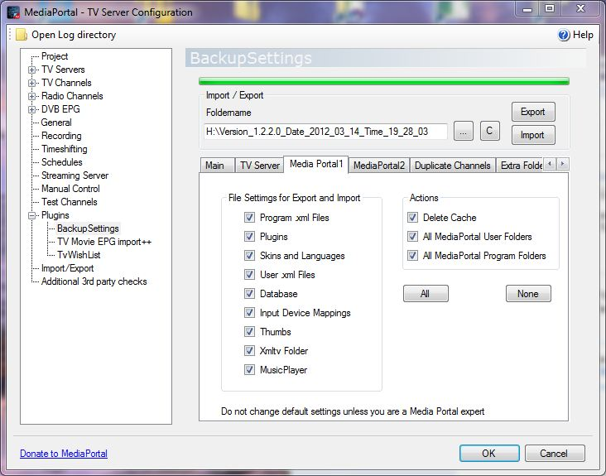
- Program .xml Files: Same as Program .xml files, but the source directory is the Program Data folder. This folder contains only .xml files with user settings. In case of an import the files will be copied back and will overwrite the files in the Program Data folder.
- Plugins: The Plugin folder from the Program File folder will be copied to a backup location <backup folder>\plugins. In case of an import the plugins are only being copied back if the file does not exist at the original location. So newer versions from a program upgrade will not be overwritten.
- Skins: This folder contains the skins in the program file directory and is copied to the backup location. Together with the skin folder also the language folder is copied to the backup location. During an import the language folder and the skin folder files are only copied if they do not exist.
- Database: This folder contains the Media Portal database and is copied to the backup location <backup folder>\MP_User\database. It contains the music, movie and other information.
- Input Device Mappings: This folder contains the user settings for remote controls and special keyboards.
- Thumbs: This folder contains the thumbnails for music albums, movies, tv/radio station logos and other information.
- XmlTv: This folder contains the XmlTV EPG program from WEBEPG. If you check the All Media Portal User Folders also the WEBEPG settings will be saved.
- Delete Cache: This will delete the media portal cache folder in the Media Portal Program Data directory. It is required after a new skin is imported.
- All Media Portal User Folders: This will backup/restore all folders in the <ProgramData>\Team MediaPortal\MediaPortal. The only exceptions are the cache and log folder. In case of an import the original files are overwritten by the files in the backup folder. This option enables that new future folders will be included into the backup procedure without the need of a new plugin version. Please note that this option refers only to folders which are not named explicitely in the “File Settings for Import and Export”.
- All Media Portal Program Folders: This will backup/restore all folders in the <Program Files>\Team MediaPortal\MediaPortal. In case of an import the original files are not overwritten by the files in the backup folder besides the language folder. This option enables that new future folders will be included into the backup procedure without the need of a new plugin version. Please note that this option refers only to folders which are not named explicitely in the “File Settings for Import and Export”.

- All: This is the default setting and will check all check boxes.
- None: This will uncheck all check boxes.

If the recording or time shift directory does not exist for an import you will get a message box as shown above. After the import you need to select a valid time shift or recording folder in the recording settings. Especially if you import the settings from a different computer all paths need to be manually checked.

4. Media Portal2 Filters
The MediaPortal 2 Client and Server folders can be selected for specific backup or restore operations. By default all options should be checked. The plugin will detect the path names from the Paths.xml file in the program folder of the client and the server.

- Defaults: This will backup/restore the default folder e.g. in <Program Files>\Team MediaPortal\MP2-Server\Defaults (or MP2-Client\Defaults). During restore this folder will be overwritten
- Plugins: This will backup/restore the Plugins folder e.g. in <Program Files>\Team MediaPortal\MP2-Server\Plugins (or MP2-Client\Plugins). During restore this folder will not be overwritten.
- Database: This will backup/restore the database file e.g.in <Program Data>\Team MediaPortal\MP2-Server\Datastore.sdf . During restore this file will not overwritten.
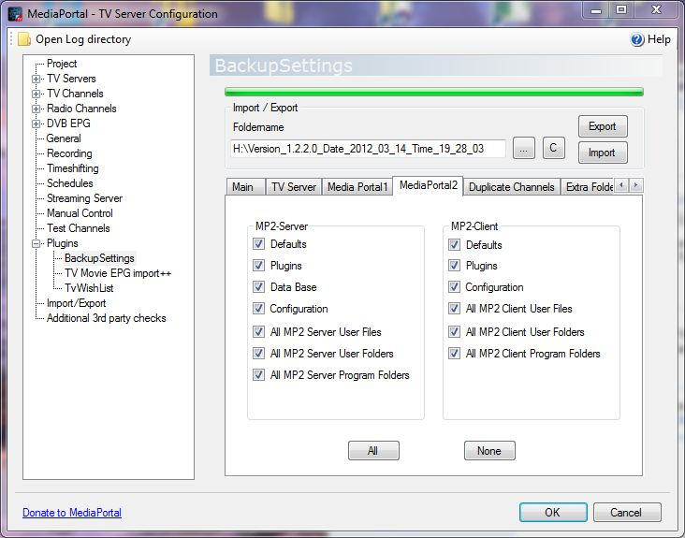
- Configuration: This will backup/restore the Config folder e.g. in <Program Data>\Team MediaPortal\MP2-Server\Config (or MP2-Client\Config). During restore this folder will be overwritten.
- All MP2 Server (Client) User Files: This will backup/restore all files in <ProgramData>\Team MediaPortal\MP2-Server (Mp2-Client). In case of an import the original files are being overwritten by the files in the backup folder. This option enables that future folders will be included into the backup procedure without the need of a new plugin version. Please note that this option refers only to folders which are not named explicitely in the File Settings for Import and Export.
- All Media Portal Server (Client) User Folders: This will backup/restore all folders in the <ProgramData>\Team MediaPortal\MP2-Server (MP2-Client). In case of an import the original files are being overwritten by the files in the backup folder. This option enables that future folders will be included into the backup procedure without the need of a new plugin version. Please note that this option refers only to folders which are not named explicitely in the File Settings for Import and Export.
- All Media Portal Server (Client) Program Folders: This will backup/restore all folders in the <ProgramFiles>\Team MediaPortal\MP2-Server (MP2-Client). In case of an import the original files are not being overwritten by the files in the backup folder. This option enables that future folders will be included into the backup procedure without the need of a new plugin version. Please note that this option refers only to folders which are not named explicitely in the File Settings for Import and Export.

5. Duplicate Channel Names
Checking and processing duplicate channel names addresses the problem that in Media Portal identical names can be used for channels with different tuning parameters and content. This can cause the issue that during import the group, program or recording assignments, which are being based on the channel name, are getting an incorrect channel. The plugin fixes this by renaming the Media Portal display channel name and applying an automatic renaming operation. If two channels have the same name, then the Media Portal display name is being changed into <name>_1 for the first duplicate channel, <name>_2 for the second one and so on. This ensures that during rescanning the TV card will not create another copy of the same channel. The default setting is tuned to apply an automatic renaming operation at each export if duplicate channel names do exist. If you do not want to do that you need to remove the check box “Automated Processing During Export”.

- Check: This will check for duplicate channel names and display the result in the status window at the first tab.
- Process: This will process the duplicate channel names according to the rules defined in the “Option” group. The processed actions can be viewed in the status window in the “main” tab.
- Undo Rename: This will undo the renaming operation. Please note that this operation will overwrite the Media Portal display name with the original channel names. If you have done some manual renaming of the channels outside of this plugin, this will be restored, too.
- Options: Here you define the rules for processing duplicate channel names. Please note that these options are also valid for the automated processing during each export if the check box is activated.
- Interactive User Confirmation: This will show a message box for each channel before deleting or renaming and ask the user if he agrees with the operation.
- Automated Processing During Export: This will automatically rename all duplicate channel names before an export operation. Otherwise the user only gets a warning that duplicate channels do exist.

6. Extra Folders
In the extra folder tab you can define additional directories outside the Media Portal folders, which you want to backup or restore. E.g the IR Server Suite (which will be automatically detected if you have it installed) has several directories outside the Media Portal paths which you may want to backup together with your Media Portal data. You can add any numbers of line just by editing the last empty row. During export, those folders will be stored together with your Media Portal data into your backup folder. During import they will be restored at the original location. The following columns allow the user to control the process:

Active
Only checked rows are being processed during export or import
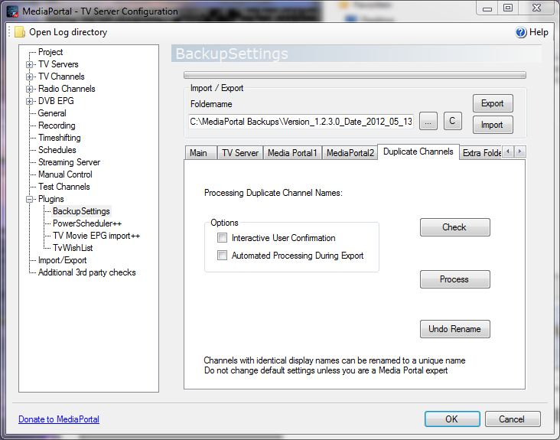
Name
The name is used as a subfolder in your Media Portal backup folder for export. During import this folder is being searched in your backup data for restoring it at the original location.

Folder
Location of the data folder you want to backup. During import the data are restored there

Overwrite
If checked the the data will be overweritten during import. Otherwise only existing files will not be overwritten at the folder location.

Kill Process
Here you can specify a process which must be terminated before the export operation or before the import operation. This can be used to terminate processes, which are accessing to files you want to restore during import. You can fins a list of all processes by opening the task manager. Do not specify the .exe in the name.

Restart
here you specify the complete path of a process you have terminated, so that it can be restarted after the export or import operation again.

The meaning of the buttons are:

All Active
This will enable all rows

All inactive
This will disable all rows

Delete
This will permanently delete the selected row. Please make sure you have the correct row selected before.

Select Dialog
This will open the select folder dialog if you have selected a cell in the folder column. If you have selected a cell in the "Restart Process" column, it will open the file dialog and ask you for opening the restarting process.

In order to activate the autoselect function, you must delete all rows. If you have good ideas of additional folders to backup together with your Media Portal data, please post them and I will add them to the automated selection process.
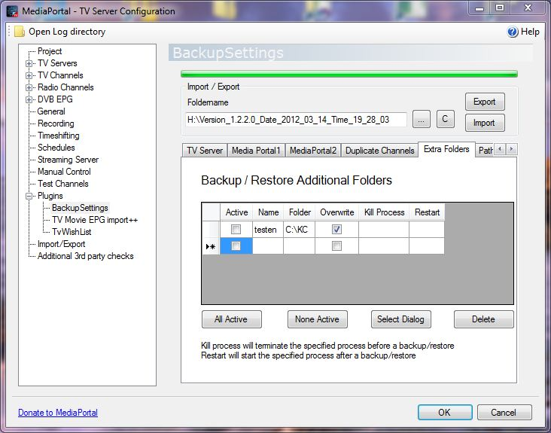
7. Paths
In the paths tab you can check and modify the installation paths. If you have used default installation paths they should be recognized automatically. For non default paths you can select for MediaPortal1 (Tv server and Mp1 Client) and for MediaPortal2 (Server and Client) the program and user folders. If the installation could not be detected it will show a „NOT_DEFINED“. Depending on your configurations settings for MP1 and/or MP2 will not be shown if the components have not been installed.
You need to save your configuration with the „Save“ button to have it stored in the database. „Cancel“ will reload the paths from the last saved settings. „Detect“ will try again an automated detection of all your installation paths.
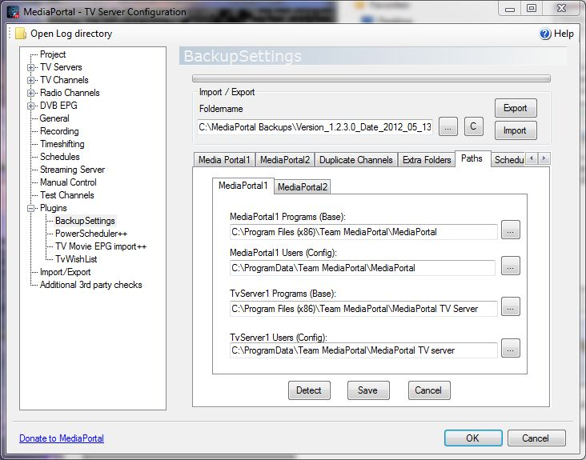
8. User Scriptfiles
If you are satisfied with the current backup restore process you do not need to continue to read the following section. However, if you would like to have some additional user specific copy functions for backup and restore operations, then this section will show you how to create customized user scripts from a provided template. BackupSettings will check after the import or export operation if a specific batch file exists in the directory BackupSettingScripts in the TV Server user folder. Please note that the names must be case sensitive and only the following scripts are supported:
<TV_USER>\BackupSettingScripts\TV_export.bat executed after Tv server export
<TV_USER>\BackupSettingScripts\TV_import.bat executed after Tv server import
<TV_USER>\BackupSettingScripts\MP_export.bat executed after MediaPortal backup
<TV_USER>\BackupSettingScripts\MP_import.bat executed after MediaPortal restore
Those batch files can contain any code or new program calls, but the following template is provided as an example for copying the TV server Program Tuning Parameters and restoring them. The plugin will provide the paths to the backup folder and all the Tv server and Mediaportal installation paths. Please do not change the marked 15 lines, as those are needed to remove the quotation marks from the path. During the xcopy operation the quotation marks need to be added back to the complete source or destination path to support spaces in the file names. The xcopy operation provides a lot of options for excluding or overwriting files. If you enter help xcopy in a command line window you will get a list of all options.
Copy the following lines into a batch file <TV_USER>\BackupSettingScripts\TV_export.bat and your tuning parameters will be copied to a folder <backupfolder>\mydirectory\TuningParameters

ECHO OFF
REM *********************************************************
REM Example User Script For TV Server BackupSettings Plugin
REM ********************************************************

echo TVEXPORT
REM do not change the following 15 lines
REM use the next 15 lines in all your scripts to remove the "
SET TMP1=%1
SET BACKUPFOLDER=%TMP1:"=%
SET TMP2=%2
SET TV_PROGRAM=%TMP2:"=%
SET TMP3=%3
SET TV_USER=%TMP3:"=%
SET TMP4=%4
SET MP_PROGRAM=%TMP4:"=%
SET TMP5=%5
SET MP_USER=%TMP5:"=%
echo BACKUPFOLDER=%BACKUPFOLDER%
echo TV_PROGRAM =%TV_PROGRAM%
echo TV_USER =%TV_USER%
echo MP_PROGRAM=%MP_PROGRAM%
echo MP_USER=%MP_USER%

REM _____________________________________________________________________
REM use XCOPY for your custom copy operation
REM enter "help xcopy" in a command window to get a list of all options
REM _____________________________________________________________________
SET MYSOURCE=%TV_PROGRAM%\TuningParameters
SET MYDESTINATION=%BACKUPFOLDER%\mydirectory\TuningParameters

ECHO XCOPY "%MYSOURCE%" "%MYDESTINATION%" /S /C /I
XCOPY "%MYSOURCE%" "%MYDESTINATION%" /S /C /I
IF ERRORLEVEL 1 SET EXITCODE=ERRORLEVEL

PAUSE
EXIT(%EXITCODE%)

The next script file gives you an example to restore the directory and overwrite the original data.
You can copy them into a batch file <TV_USER>\BackupSettingScripts\TV_import.bat
It is the same as the export script only with a source and destination exchanged

ECHO OFF
REM *********************************************************
REM Example User Script For TV Server BackupSettings Plugin
REM ********************************************************

echo TVIMPORT
REM do not change the following 15 lines
REM use the next 15 lines in all your scripts to remove the "
SET TMP1=%1
SET BACKUPFOLDER=%TMP1:"=%
SET TMP2=%2
SET TV_PROGRAM=%TMP2:"=%
SET TMP3=%3
SET TV_USER=%TMP3:"=%
SET TMP4=%4
SET MP_PROGRAM=%TMP4:"=%
SET TMP5=%5
SET MP_USER=%TMP5:"=%
echo BACKUPFOLDER=%BACKUPFOLDER%
echo TV_PROGRAM =%TV_PROGRAM%
echo TV_USER =%TV_USER%
echo MP_PROGRAM=%MP_PROGRAM%
echo MP_USER=%MP_USER%

REM _____________________________________________________________________
REM use XCOPY for your custom copy operation
REM enter "help xcopy" in a command window to get a list of all options
REM _____________________________________________________________________
SET MYSOURCE=%BACKUPFOLDER%\mydirectory\TuningParameters
SET MYDESTINATION=%TV_PROGRAM%\TuningParameters

ECHO XCOPY "%MYSOURCE%" "%MYDESTINATION%" /S /C /I
XCOPY "%MYSOURCE%" "%MYDESTINATION%" /S /C /I
IF ERRORLEVEL 1 SET EXITCODE=ERRORLEVEL

PAUSE
EXIT(%EXITCODE%)
Important:
Please notice that during a standard Tv server import operation all user settings will be overwritten. This means that also your script files in the BackupSettingScripts folder will get overwritten by the script files in the backup folder. So if you make changes to the script file in <TV_USER>\BackupSettingScripts your changes will be overwritten during the import operation. So if you make changes to your script files make sure you do a clean export first before you import any data. Alternatively you can disable the Tvserver User Folders during import.

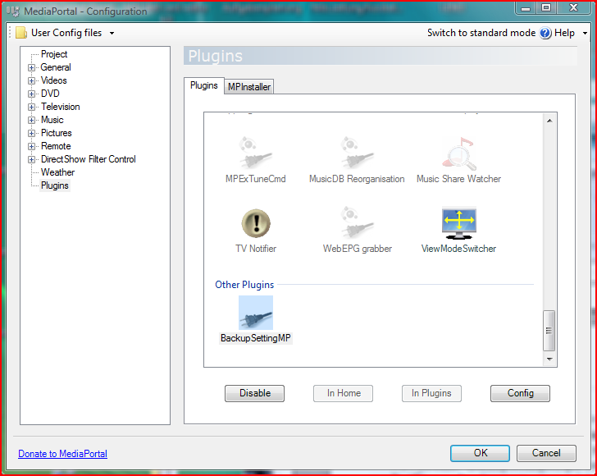

9. BackupSettingsMP Plugin:
The Media Portal BackupSettingsMP plugin can be used if you have no TV server installed or if you have a client only installation on a computer.The Media Portal BackupSettings plugin can be enabled from the Media Portal Configuration in the section “Other plugins”.
After activating the configuration the program calls BackupSettingsMP.exe, which works exactly like the Tv server plugin. You may need to confirm the windows security message for programs downloaded from the internet when you run the program the first time. Please read the Tv server manual for more information. During import the MediaPortal Configuration program is being closed to avoid problems with open files used by the configuration program. The user configuration data are stored in the User data config e.g.
C:\ProgramData\Team MediaPortal\MediaPortal\BackupSettingsMP.xml.
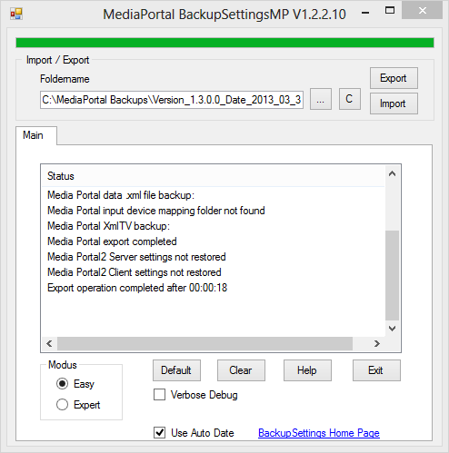

- Media Portal 2 Plugin
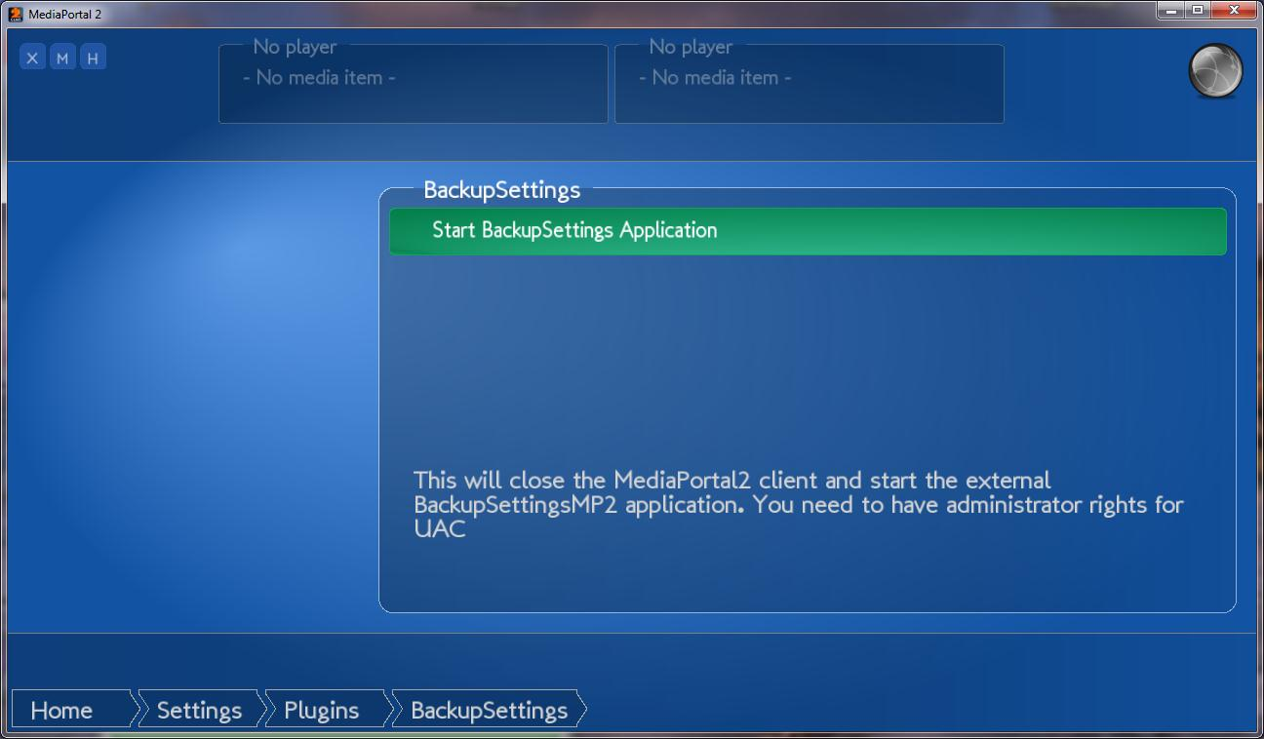
For a Mediaportal 2 client installation you can use the MP2 Backupsettings plugin. It will open the external client program and close your MP2 client during the export or import. The external client program will be started with administrator access rights. The settings of the client program are being stored e.g. in C:\ProgramData\Team MediaPortal\MP2-Client\Configuration\<User>\ BackupSettingsMP.xml.

A similar installation does exist for a MP2 server standalone installation. You need to start manually the external client program out of the server plugin directory.
In general the installer will find the best way for you to install the plugin, where using the Tv server is the preferred way to do the backups. Only for standalone clients or Mp2 server the external program is needed.

Please note that MP2 settings cannot be read from MP1 and need to be entered manually the first time.
In addition there is a database incompatibility between MP2-alfa and the MP2 easter built. This means you have to restore data without using the database option on the MP2 server and manually enter again the global shares.

11. How The Installer Works:
The install.exe program will try to detect automatically all installation paths. If it finds a Tv server installation it will install the file BackupSettingsTV.dll in the Tv server plugin directory e.g. C:\Program Files\Team MediaPortal\MediaPortal TV Server\Plugins. If tvservice is running, it will be stopped before the dll file is copied. It will also create a folder BackupSettings in C:\Program Files\Team MediaPortal\MediaPortal TV Server. This is the working directory of BackupSettingsTV. Do not modify any files here. The installer will also detect if the user has the latest SVN version of MediaPortal 1.0 Final as the latest SVN had major changes and requires a different plugin.
If you have a TV server installation on a host computer, you need to enter the path manually in the installer for both the program data (base) and the user data directory (configuration).
If the installer detects no Tv server it will install the Media Portal Client plugin BackupSettingsMP by default in C:\Program Files\Team MediaPortal\MediaPortal\plugins\process. The installer will copy the BackupSettingsMP.dll file and the BackupSettingsMP.exe file there. The plugin just calls the .exe file which is closing the MediaPortal Configuration program during import to ensure there are no data conflicts with open files. In case of a MP2-Client installation the installer will install the MP2 client plugin. Only for a MP2-Server installation the server client will be installed.

12. Known Problems / Troubleshooting
- none

13. FAQ
- Upgrading to 1.2
If you upgrade to 1.2 none of your backed up plugins or skins will work. That´s why BackupSettings will not copy any of your plugins or skins between a 1.1 and a 1.2 version
- If you downgrade from 1.2 to 1.1 you must do a complete uninstall of the MediaPortal Tvserver first before installing 1.1 or your system. You must choose during uninstalling the option “Full Media Portal Product Cleanup”. Other wise your BackupSettings import will cause an exception error.
- How to: Upgrading from version 1.00 or 1.02 to 1.1 or higher
- Step1:
- Download the latest BackupSettings plugin version with the MPI installer from
- http://www.team-mediaportal.com/files/Download/MediaPortalInstaller(MPI)/Automation/BackupSettings
- and make a complete backup of your data by using the default options.
Step 2:
- Install MediaPortal 1.1 by doing a clean install (no upgrade).
Step 3:
Open the new Media Portal Extension installer in your MediaPortal program directory and download the latest online list. Select BackupSettings and install it.
Step 4:
Now do an import of your previous backup folder.
Step 5:
- Reinstall your plugins and skins from the internet to make sure they are compatible with MP1.1. There were major program changes and many old plugins and skins will not work with MP 1.1. Also your music data base needs to be recreated again. In the Tv Server configuration go to “Recording Settings” -> “Database Import” and click “Import selected files”. In the Mediaportal configuration go to Music->Music Database and remove the checkbox “Only update new”. Then click “Update database”. Other databases may need to be regenerated as well.Other data bases may have changed, too. Old Tv server plugins will not be copied over by BackupSettings, because they will not work for sure. This is the tough part, but most developers have specified on their home page if the plugin is compatible with version 1.1 or 1.2.
- If you have used the client backup/restore on the Media Portal setting tab, please install the Media Portal Client plugin on your client computer. Just run the normal install process and the installer will pick the Media Portal client plugin if no TV server has been installed on the computer.
- Can the plugin be used to copy the settings between different MediaPortal versions?
- If the code changed the settings it can cause instability when copying the settings between different versions. You can try, but make a backup of the default settings first. Make sure you read the remarks in the Requirements section.

- Does the plugin support a TV Server installation without Media Portal
- Yes, you just need to uncheck Media Portal on the status tab

- Do I need to enable or disable the plugins for import/export?
- It does not matter

- Do I need to stop the Tv server before copying the dll file into the plugin directory
- the installer will do that for you. If you get a message “could not install” then do an uninstall first before you install the plugin
- How are the cards from the Tv server .xml file mapped to the actual cards of the computer?
- A new algorithm is been used in version 0.0.1.4 which allows also the import of card settings if a tv card has been removed or is being added. The algorithm tries to detect the id, the card name and the device path name and will look for the best match first. If that is not working out it will try to find a partial match. Cards on the computer which were not mapped to a card from the backupdata will not get any channels assigned. Cards in the .xml file, which could not be mapped to cards on the computer will be skipped together with their channel mappings and card data. The status window will report the actual mapping of the card ids from the backup data to the actual cards on the computer.
- Can I import older backup data with a newer version of BackupSettings?
- In general not. This will give you exception errors. That´s why you must do an export first with the latest BackupSettings version before you upgrade to a new version. You need to use the same version of BackupSettings for the import which you used for the export. The status window will give you a warning if the version of the backup data does not match the actual settings. Please remember that you actually stored with the default settings also your older backupsetting.dll file in the Tvserver plugin directory. This version you can now manually copy back and redo the import.
- Why do I get a huge amount of data (GB) for my backup data
- Most likely you have chosen your recording or timeshift folder within your Tvserver user directory and BackupSetting is now doing a backup of all your recorded movies. Open the TV server configuration and go to recording settings -> recording folders. Then ensure that the recording and timeshift folders for all cards are not within the \Team MediaPortal\MediaPortal TV Server or \Team MediaPortal\MediaPortal folder.
- After import I cannot watch any TV channels. A Message “No signal detected” occurs for every channel.
      - I got this issue sometimes for my hybrid Medion TV card (based on Creatix SAA7131 Tripple Capture Device) and believe it is an initialization hardware issue. I can fix it by shutting down the computer and switching off the power supply for about 10s. After reboot all channels can be watched.

14. Backup Directory Structure
The directory structure is shown for a default Vista installation:

- Backup Directory (selected by user)
- MP_User\database folder exported from
C:\ProgramData\Team MediaPortal\database
import: overwrite files

- MP_User\InputDeviceMappings folder exported from
C:\ProgramData\Team MediaPortal\MediaPortal\InputDeviceMappings
import: overwrite files

- MP_Program folder exported from
C:\Program Files\Team MediaPortal\MediaPortal\*.xml
C:\Program Files\Team MediaPortal\MediaPortal\*.config
C:\Program Files\Team MediaPortal\MediaPortal\*.sav
C:\Program Files\Team MediaPortal\MediaPortal\*.ini
import: do not overwrite files

- MP_User folder exported from
C:\ProgramData\Team MediaPortal\MediaPortal\*.xml
import: overwrite files

- MP_Program\plugins folder exported from
C:\Program Files\Team MediaPortal\MediaPortal\plugins
import: do not overwrite files

Before MediaPortal 1.1alpha
- MP_Program\skin folder exported from
C:\Program Files\Team MediaPortal\MediaPortal\skin
After MediaPortal 1.1alpha
- MP_User\skin folder exported from
C:\ProgramData\Team MediaPortal\MediaPortal\skin (for < 1.1alpha)
import: do not overwrite files

- MP_Program\MusicPlayer folder exported from
C:\ProgramData\Team MediaPortal\MediaPortal\MusicPlayer
import: do not overwrite files

- MP_User\thumbs folder exported from
C:\ProgramData\Team MediaPortal\MediaPortal\thumbs
import: overwrite files

- TV_Program\plugins folder exported from
C:\ProgramData\Team MediaPortal\MediaPortal TV Server \plugins
import: do not overwrite files

- TV_User\TVsettings.xml file exported from
Tvserver
import: .xml import of settings into Tv Server

- MP_User\xmltv folder exported from
C:\ProgramData\Team MediaPortal\MediaPortal\xmltv
import: overwrite files

- SV2_PROGRAM folder exported from
C:\ProgramFiles\Team MediaPortal\MP2-Server
import: do not overwrite files

- SV2_USER folder exported from
C:\ProgramData\Team MediaPortal\MP2-Server
import: overwrite files

- MP2_PROGRAM folder exported from
C:\ProgramFiles\Team MediaPortal\MP2-Client
import: do not overwrite files

- MP2_USER folder exported from
C:\ProgramData\Team MediaPortal\MP2-Client
import: overwrite files

- EXTRA_FOLDERS folder containing the content from the user defined
extra folders. The name is used as a subfolder.

15. Author(s) of Plugin
- huha

16. Acknowledgement
- I have reused part of the code of the TV server engine for xml import / export. So the credit goes to the programmers of this module.
- Thanks to all the folks working on this project resulting in the best Media Center I have seen.
- Thanks to all users who posted their comments and helped me to improve the plugin

17. Change Log

Version 1.2.2.10
- renamed automated backupfolders from <automated backupfolder>\Backup001 to <automated backupfolder>\BackupSettingsBackup001, ...
- automatic version/date creation as a default for the foldername (user can disable function) in the Tvserver and client plugins
- minor GUI bug fixes in client

Version 1.2.2.9
- modified folder structure for "Extra" folders, which are now stored in <backupfolder>\EXTRA_FOLDERS instead of <backupfolder>
- if the user specifies to delete old backup data the following plugin created subfolders/files are now deleted instead of the full backupfolder.
- <backupfolder>\EXTRA_FOLDERS,
- <backupfolder>\MP_Program,
- <backupfolder>\MP_User,
- <backupfolder>\TV_Program,
- <backupfolder>\TV_User,
- <backupfolder>\MP2_PROGRAM,
- <backupfolder>\MP2_USER,
- <backupfolder>\SV2_PROGRAM,
- <backupfolder>\SV2_USER,
- <backupfolder>\Version.xml

Version 1.2.2.8
- added separate foldername for Automated Export
- bug fix on automated export option after an import
- added channelnumber for MP1.3 (export/import)
- separate version for MP1.3
- updated MP2 language file

Version 1.2.2.6
- updated TVserver version to 1.2.100.0 (MP1.3)
- bug fix with default settings for export/import in TV server plugin
- bug fix with selected path in client
- bug fix if path did not exist
- backup of .dll files in TV server program folder

Version 1.2.2.4
- bug fix when moving from a 32bit system to a 64 bit system or reverse
- bug fix for recording counter for automatic export at specified times

Version 1.2.2.2
- severe bug when moving from a 32bit system to a 64 bit system or reverse
- bug fix for blocking automated export at specific times
- bug fix for not using default settings (wrong warning)

Version 1.2.2.1
- updated for upcoming 1.3alfa – no code changes

Version 1.2.2.0
- new: standalone client program for MP1, MP2-client and MP2-server
- new: automated scheduling of exports
- new: auto repair script of Lehmden for MySQL users
- installer updated and improved
- bug fix for export
- duplicate channels restructured and bug fixes
Version 1.2.0.12
- bug fix for installer when using non default paths
- bug fix for exporting settings and deleting the backupfolder before the export
- initial support for MediaPortal2 in the Tv Server plugin
Version 1.2.0.11
- bug fix for exporting and importing episode names in recordings
Version 1.2.0.10
- bug fix in SQL query of settings during export
- bug fix with verbose debug setting
Version 1.2.0.9
- severe bug fix for importing settings of plugins
- added easy/expert mode switch
Version 1.2.0.8
- “C” button will remember last drive letter
- fixes for stretching GUI
- fixed invalid + like “PowerScheduler++”for import/export
Version 1.2.0.6
- installer bug fixed. If you could installed 1.2.0.5 there is no reason to upgrade.
Version 1.2.0.5
- added general database query for all settings. So the plugin will now export/import all settings. By that future setting changes and plugin settings will be automatically covered
- between up/down grading from MediaPortal 1.1 to 1.2 the mpei installation directory will no more be restored as it can introduce incompatible plugins.
Version 1.2.0.4
- fixed bug installer to be compatible with 1.2
- fixed bug for verbose debug
- plugins and skins will not be copied over between 1.1 and 1.2
Version 1.2.0.3
- fixed bug for importing TV Movie plugin channel mappings with channel name for 1.2
- fixed bug in installer.exe on path priorities
Version 1.2.0.2
- fixed installer bug for "license file not found"
Version 1.2.0.1
- fixed version number in .mpe1 file
Version 1.2.0.0
- added plugin compatibility check for TV server and MediaPortal plugin
- updated .dlls and structures for MP1.2
Version 1.1.0.2
- fixed bug for non default installation paths
- added license text during install
- search manual in installation directory
Version 1.1.0.1
- added support for iPiMP plugin
- removed 4k limitation for added folder import/export
- updated 4k import/export limitation for TvWishlist
- removing old version of online videos (onlinevideo.dll) after restore
- This version is not compatible to the backupdata of older versions! Please create a new backup first!
Version 1.1.0.0
- bug fix in assembly properties
- autocreation of exportfolder if "C" is being clicked
- removed MediaPortal Client mode (use BackupSettingsMP instead)
- added network provider for CAM settings
- added plugin support for For The Record Recorder/Tuner
- Version 1.0.6.0
- supporting MP1.1RC2
- supporting new MPEV2 installer
- bug fixes on progress bar
- supporting WebEPG Tvserver plugin
- updated settings (checked with MP 1.1RC1)
- added extra folder for bexport/import
- changed skins and languages to "not overwrite" for MP_USER_FOLDER
- bug fixes on restoring data for downgrading version
- added all changes to media Portal plugin BackupSettingsMP
Version 1.0.4.4
- fixed bug in progress bar causing exception and avoided restart of TV server configuration
- added support for TvWishList plugin
- changed directory from TV_PROGRAM to TV_USER for EmailScheduler plugin
- added IPTV channels for import from mvedrina patch
Version 1.0.4.3
- fixed bug in Installer for unistalling the TV server plugin
- added Win7 64 bit support for autodetection of Program Files (x86)
- colored text in status window for warnings and errors
- MediaPortal Plugin directory search for the MediaPortal plugin
- supported new dll files from SVN1.0.4.24281 for recording and program structure
Version 1.0.4.2
- fixed issue in card detection algorithm if TV card position did change
- added adaptive progress bar for import/export
- code cleanup in import and export section
- fixed issue with latest SVN version for importing data
Version 1.0.4.0
- mpi installer is unzipping all files into the Media Portal config directory (%PROGRAMDATA%) and not into the MediaPortal program directory
- old MediaPortal program directories are being deleted
- fixed autodetection in installer for non English/German XP version in MP1.1beta
- added CultureInfo.InvariantCulture for DateTime Conversion in export function
- improved robustness of import function for dateTime conversion
- default path C:\MediaPortal Backups used for backup directory
Version 1.0.3.1
- supporting installation via MedfiaPortal Extension Installer (MPEI)
- fixed bug on schedule import from last version
- supports TV server import of settings if a card has been removed
- additional version warnings
- added support for latest SVN Revision 23407 (new .dll files of MP)
Version 1.0.3.0
- fixed import issue which could crash the TV service when using 1.1alpha
- languages are no more overwritten during import
- directory changes for 1.1 alpha of skins,languages and Tuning details
- updated new .dll files when compiling for MP1.1alpha
- installer differs now 3 different versions: MP1.0.0, MP1.0.1, MP1.1
- added additional card/channel program features for 1.1alpha (CAM,episode,...)
- installer is checking current directory before installation
- updated BackupSettingsMP for 1.1 alpha
- includede version checking and warnings for plugins, skins and databases if major changes did occur in Media Portal
- Tv server is now stopped during complete import and restarted after the import is completed

- / Version History BackupSettingsTV.dll
Version 1.0.0.4
- changed error message for plugin check for better user understanding
Version 1.003
- added support for EmailScheduler plugin
- do not show attribute values in the log file
- added checkbox for not allowing to restart the tvserver during importthis will not import all settings!
- added link to homepage
- bugfix on POSTIMPORT initialization

Version 1.0.0.2
- MP import/export settings are no more overwritten by all program folders or all user folders
- new bass.dll handling
- removed setting for "CAM"
Version 1.0.0.0
- support for MediaPortalsDirs.xml in User\Documents\TeammediaPortal folder for support of user defined MP settings
- improved autodetection of installation paths by installpath class
- threading added for all processing
- error handling of threading if user aborts backupSettings during a running operation
- added CAM setting for new SVN only
- - changed messagebox with export recommendation before import
- changed default settings for duplicate channels – no more automated processing

Version 0.0.1.8
- - added support for latest SVN build with changed Tv server .dll files
- - updated all Ilist definitions for latest SVN and included conditional compiling based on the variables MP10 or SVN to support two dll versions with only one source code. The .dll files were copied to two different directories and are linked together with the same source code controlled by the variable SVN and MP10 for compiling.
- Improved autodetection. Helpreferences.xml is no more searched as it is not available before the program is started

Version 0.0.1.6
- included import postprocessing and added process communication structure
- -all import post processing instructions are written into POSTPROCESSING_FILE
- -SetupTv is closed after standard import and calls the application RestartSetupTv
- TV server is triggered by systemfilewatcher after a file POSTPROCESSING_FILE is created and
- is starting the postprocessing after SetupTv is being closed
- TV server is deleting the file POSTPROCESSING_FILE after the import post processing is completed
- RestartSetupTv is restarting SetupTv after the file POSTPROCESSING_FILE is deleted (does no more exist)
- This enables now importing data which were overwritten before when exiting SetupTv
- added export/import support for plugin enable/disable
- added support for LNB settings and scan settings (2nd try)
- added support for hybrid mappings
- added support mediaPortalsDirs.xml for distributed mediaPortal installation with centralized data base (thanks to rekenaar)
- added support for TV movie mappings if plugin is enabled during import
- added support for backup/restore all Tv server program folders (no BackupSettings)
- added support for backup/restore all MediaPortal program folders
- added missing channel number,audiopid and videopid for DVB-C import (thanks to mbb)
- added logical channel number to analog channels for import

Version 0.0.1.5
- bugfix on MediaPortal Client export
- bugfix with removing duplicate group members although checkbox was unchecked
Version 0.0.1.4
- improved card detection algorithm to enable partial card import if a TV card is plugged or displugged
- fixed bug with date conversion (did systematic search for all date conversions)
Version 0.0.1.3
- fixed bug with schedule types not getting imported for weekely, ...
- force user to delete schedules, groups,recordings if delete all channels or import new card settings
- added support for import/export scanning settings for analog,dvb-c,dvb-s,dvb-t ant atsc
- added support for encrypted Cams in card settings (CamType and DecryptLimit)
- added support for Media Portal MusicPlayer folder backup/restore
Version 0.0.1.2
- bugfix on date format for checkfilepath
- added card name detection mechanism
- remove duplicate channel mappings from groups (radio and tv)
Version 0.0.1.1
- bugfix when importing schedules: all schedules are now imported as a series can be reported in the past is is still on
Version 0.0.1.0
- added support for duplicate channel names
- added new tab duplicate channels
- automated processing of duplicate channel names for the MP display name
- undo renaming for different channel names and display channel names
- automated renaming procedure attaching -1, _2 , ... to the duplicate channel display name
- automated deleting if all properties are identical (channel, mapping and tuning detail)
Version 0.0.0.9
- host computer only import/export for Client Computer
- MP_PROGRAM and MP_USER on the same host computer
- added displayname for export/import of schedules, programs, recordings, groups, radiogroups and tvmovie mappings
- exception handling for quality settings in export function
- exception handling for unidentified drive letter for disk space checking in export function
- added support of MP Client backup/restore on host computer
Version 0.0.0.8
- added recordings for export and import operation
- added programs for export and import
- added user script support after import and export of TV server and MP
- new format string for all date´/time imports and exports defined by "yyyy-MM-dd HH:mm:ss" This makes the version incompatible to older ones
- fixed bugs in exception handling
- no abort of import when error occurs for single entry
Version 0.0.0.7
- removed warning popup message in case of incorrect maping export for Tv groups radio groups or hybrid groups as they
- should come from garbage data of changed settings, where the old mappings got not deleted
Version 0.0.0.6
- improved exception handling for export
- suspect that old tv group mappings or radio group mappings which are not getting deleted caused an exception
- now a warning will be issued like for hybrid card settings, but export will continue
Version 0.0.0.4 (release 11.10.2008)
- fixed severe bug with not exporting/importing plugin settings for first time use in xp
- improved autodetection
- suspect that folderboxdialog of manual detection did change the system io directory path which is used to detect the plugins in plugin loader
Version 0.0.0.3 (release 4.10.08)
- full xmltv support including bool EpgHasGaps and string ExternalId for export/import in channels
- let user choose to abort import if server name does not match
- added checkbox Use All MP User Folder
- backup restore all mediaPortal user Setting Folders
- removed copy of sql config filecan cause trouble with password from new installation
- fixed bug in autodetect from version 0.0.0.2 with aborted path selection
- fixed bug with checkboxes not correctly restored after import
- added more checking of plugin folder and file paths for existence
- removed copy TVsettings.xml into TV server userfolder (TV_USER_FOLDER) after export or import
- bugfix added TV Movie install path
- using plugin name for plugin detection and not dll file
- changed backup data structure with TV_Program TV_User MP_Program and MP_User
- added default button for checking all boxes
- added vesion control warning if restore data were created by a different plugin version

Version 0.0.0.2
- bugfix: program tried to find MediaPortal.exe for TV server only installation in detectfolder path
- detectfolderpath was moved fromm load/save settings to restorebackup and createbackup
- copy TVsettings.xml into TV server userfolder (TV_USER_FOLDER) after export or import

Version 0.0.0.1 (release)
- initial release

- Version History RestartSetupTV.exe
- 0.0.0.1 initial release for BackupSettingsTV.dll V0.0.1.0
- Version History BackupSettingsMP.dll

- 0.0.0.2
- plugin calls BackupSettingsMP.exe and closes Configuration. This avoids data conflicts with open files during import
- 0.0.0.1 (release)
- initial release

- / Version History BackupSettingsMP.exe
- 1.0.0.2
- MP import/export settings are no more overwritten by all program folders or all user folders
- new bass.dll handling
- removed setting for "CAM"
- 0.0.0.3
- Improved autodetection. Helpreferences.xml is no more searched as it is not available before the program is started
- 0.0.0.2 initial release for BackupSettingsMP.dll V0.0.0.2
- same functionality as the TV Server plugin for export/import of MediaPortal data only

- Version History Install.exe
- 0.0.0.3
- - support for detecting if SVN version or MediaPortal 1.0 final is installed. This is detected by the version number of the Gentle.Common.dll file
- requesting admin rights for Vista to be able to start /stop tvservice
- 0.0.0.1 initial release

18. License
/*
* Copyright (C) 2005-2010 Team MediaPortal
* http://www.team-mediaportal.com
*
* This Program is free software; you can redistribute it and/or modify
* it under the terms of the GNU General Public License as published by
* the Free Software Foundation; either version 3, or (at your option)
* any later version.
*
* This Program is distributed in the hope that it will be useful,
* but WITHOUT ANY WARRANTY; without even the implied warranty of
* MERCHANTABILITY or FITNESS FOR A PARTICULAR PURPOSE. See the
* GNU General Public License for more details.
*
* You should have received a copy of the GNU General Public License
* along with GNU Make; see the file COPYING. If not, write to
* the Free Software Foundation, 675 Mass Ave, Cambridge, MA 02139, USA.
* http://www.gnu.org/copyleft/gpl.html
*
*/

