‘CREDITS SYSTEM’

PLUGIN

FOR DOKEOS

USER MANUAL

Hernández Hernández, Ana
Nuñez Salinas, Borja
Hueso Vázquez, Jose Carlos

Introduction 3
Installation 3
Setting-up the plug-in 3
Activating the plug-in 3
Setting-up the plug-in 4
Uninstalling the plug-in 4
Using the plug-in 4
User Options 4
Buy Credits 4
History 6
See the subscription data 6
See the payment data 7
Teacher Options 7
Manage Course Credits 7
Change the status of a course 8
Change Credit Courses´ Payment Options 9
Add 10
Edit 11
Delete 11
My Courses History 11
Admin Options 12
Settings 12
Payment Methods 13
Payment Options 13
Add 14
Edit 14
Delete 14
General Options 15
Manage User Credits 16
Add 17
Edit 17
Substract 18
Manage Course Credits 18
Change the status of a course 19
Change Credit Courses´ Payment Options 20
Add 21
Edit 21
Delete 21
Platform History 23
See the Credits spent per course 23
See the Users payment 24
See the Credits spent per user 24
Statistics 25
See the credits bought per month 26
See the credits bought per year 27

Introduction

The plug-in is a tool for DOKEOS platform Users, which adds a new functionality to the platform.
This functionality is mainly the possibility to assign credits to courses so that Users must spend ‘credits’ to get a valid subscription.
Subscriptions to ‘Credit Courses’ are made selecting ‘Payment Options’, that represent the period of time within the subscription is valid, and so, the access to this ‘Credit Course’ by the User.
By default, the plug-in includes one ‘Payment Method’ (‘Paypal’). This is the way a User can ‘buy’ credits to spend in the platform.
The plug-in also includes a complete list of payments and subscriptions records, with the possibility to export them into CSV files.

Installation

Setting-up the plug-in

To Install the credits system plug-in in your Dokeos platform, perform the following:

- Unzip Credits.System.Plugin.v1.0.zip file into yor Dokeos fólder.

.

Activating the plug-in

Once installed, you have to activate it in your Dokeos platform:

- Log in as an Administrator.
- Click on the Platform Administration link (Last tab).
- Click on the Dokeos configuration settings link in the platform menu. This displays the categories to set the configuration.
- Click on the Plugins link. This displays the plugins that have been found on your system and the location to activate each one.
- Select the header checkbox in the credits system plugin.
- Click on the Submit button to save your changes.

To deactivate, perform the same steps but unselecting the header checkbox.

Setting-up the plug-in

The plug-in can only be set-up by a platform admin.To set-up the plug-in, perform the following:

- Click on the My Credits link in the upper left corner. This displays the credits system menu.
- Click on the Settings link in the admin menu displayed in the right side.
- Specify the General Options, the Payment Methods and the Payment Options. For details on these settings, see “Configuration Settings” on page 5.

Uninstalling the plug-in
To uninstall the plug-in delete the ‘credits_system’ folder from your ‘c:/…/Dokeos/plugin’ fólder.

Using the plug-in

User Options

Buy Credits

- Click on the My Credits link in the upper left corner. This displays the credits system menu.

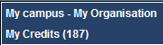

- Click on the Buy Credits link in the user panel displayed at the right side of the screen.

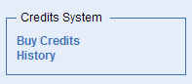

This is the Buy Credits menu, where every User can buy credits to spend them in the different credit courses existing in the platform.
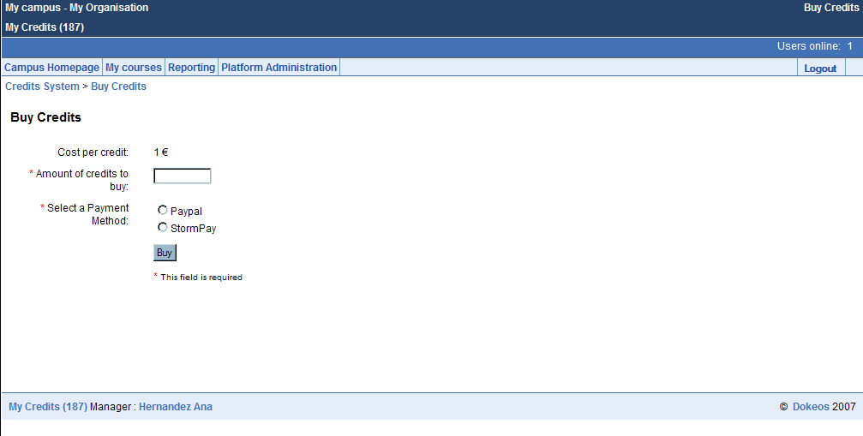

To buy some credits:

- Insert a valid amount of credits in the box.
- Select between the different payment methods available in the platform.
- Click on the Buy button.
- You will be redirected to the payment method platform to complete your purchase.

History

- Click on the My Credits link in the upper left corner. This displays the credits system menu.

- Click on the History link in the user panel displayed at the right side of the screen.

Here there are two data records of the user who has logged-in, one shows the subscription data and the other the payment data.

See the subscription data

The table with the user’s subscription data appears by default when the user has clicked on the “History” link.

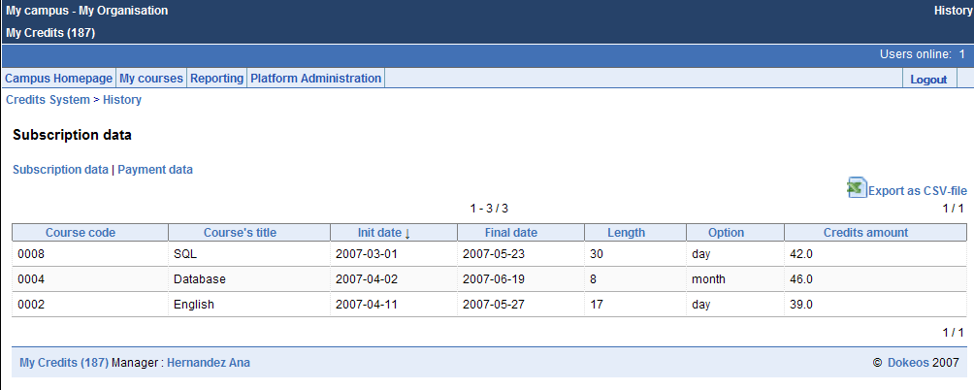

Click on the “Subscription data” link, if you are in Payment data website to go to Subscription data website.
Click on the “EXPORT as CSV-file” link to export the subscription data to a CSV file.

See the payment data

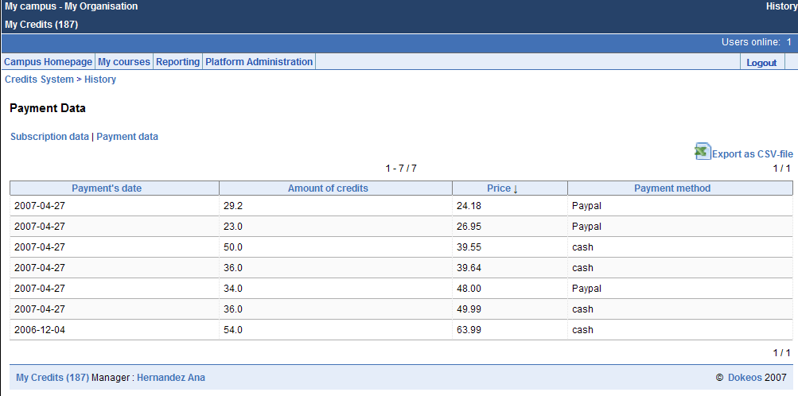

- Click on the “Payment data” link.
- Click on the “EXPORT as CSV-file” link to export the payment data to a CSV file.

Teacher Options

Manage Course Credits

- Click on the My Credits link in the upper left corner. This displays the credits system menu.

- Click on the Manage Course Credits link in the teacher panel displayed at the right side of the screen.

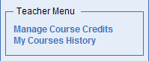

This is the Manage Course Credits menu, where a teacher can change the status, and also modify the current payment options, of every course he/she is the course administrator of.

Change the status of a course
From Credit to Free Course:

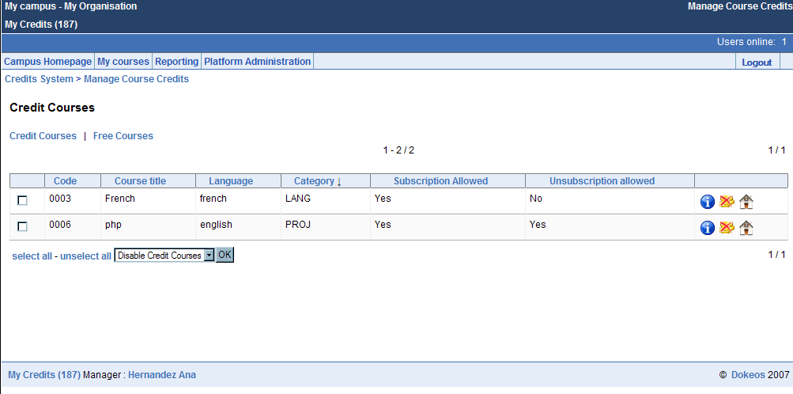

One Course:
- Select the course you want to make free, clicking the ‘no-coins’ icon () in the last column of the current credit courses table.
- Confirm your choice.

Several Courses:
- Select the course or courses which you want to make free, clicking on checkboxes in the first column of the current credit courses table.
- Choose the ‘Disable Credit Courses’ option in the select box below the current credit courses table.
- Confirm our choice.

From Free to Credit Course:

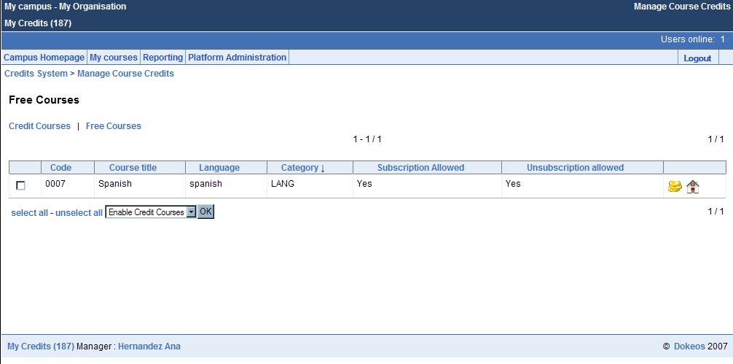

- Click on the Free Courses link to show all the Free Courses avaliable in the platform.

One Course:
  - Select the course you want to change to Credit course, clicking on ‘coins’ icon () in the last column of the current free courses table.
  - Confirm your choice.

Several Courses:
- Select the course/s which you want to change to Credit Course/s, clicking the checkboxes in the first column of the current free courses table.
- Choose the ‘Enable Credit Courses’ option in the select box below the current free courses table.

Change Credit Courses´ Payment Options

To select a credit course to edit:

- Click on the Current Payment Options link , represented by an ‘info’ icon () in last column of the current credit courses table.

Once you clicked on the Current Payment Options link, yo will see the Current Payment Options Menu. There you will be able to add, edit or delete any available payment option of the course selected.

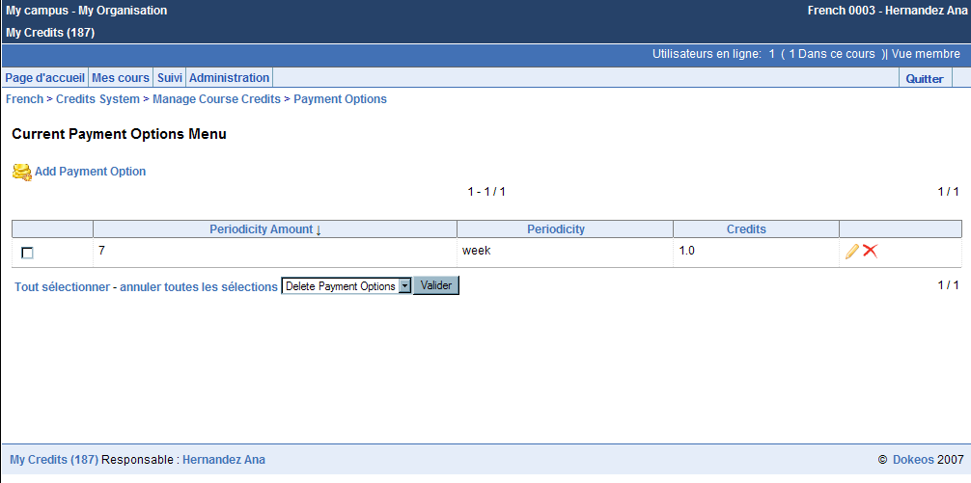

Add
- Click on the Add Payment Option link
- Insert the new payment options
- Click on the OK button

Edit
One Course:

- Select the payment option you want to edit clicking on pencil icon () in the last column of the table.
- Change the number of credits.
- Click on the OK button

Several Courses:

- Select the payment options you want to edit clicking the checkboxes in the first column of the table.
- Choose the ‘Edit Payment Options’ in the select box below the current payment options table.
- Confirm your choice.
- Change the number of credits.
- Click the ‘OK’ button

Delete
One Course:

- Select the payment option you want to delete clicking the cross icon () in the last column of the table.
- Confirm your choice

Several Courses:

- Select the payment options you want to delete clicking the checkbox in the first column of the table.
- Choose the ‘Delete Payment Options’ in the select box below the current payment options table.
- Confirm your choice

My Courses History

- Click on the My Credits link in the upper left corner. This displays the credits system menu.

- Click on the My Courses History link in the teacher panel displayed at the right side of the screen.

Here, the teacher can see first a table with the total number of credit courses he has, and the total number of credits spent on these payment courses, and then, a table with all his credit courses.

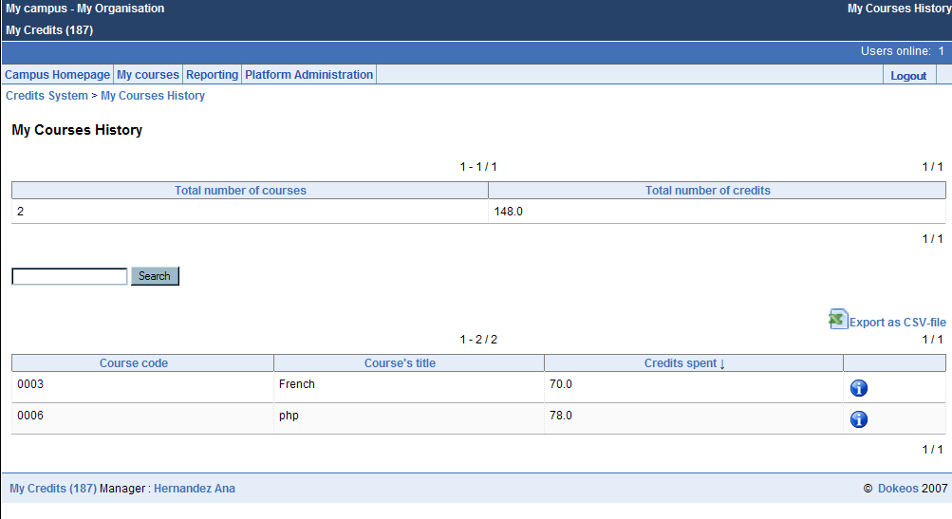

Click on the “Info” icon () to see the subscription data of one course.
Click on the “EXPORT as CSV-file” link to export the data to a CSV file

Admin Options

Settings
- Click on the My Credits link in the upper left corner. This displays the credits system menu.

- Click on the Settings link in the admin panel displayed at the right side.

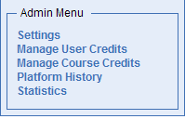

This is the credits system settings menu. There are three submenus:

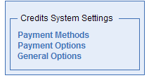

- Payment Methods. Where you can set the payment methods’ options.
- Payment Options. Where you can set the payment options for the entire platform.
- General Options. Where you can set general options for the entire platform.

General options are displayed by default.

Payment Methods

Every payment method has its own section with all its possible configurable options.

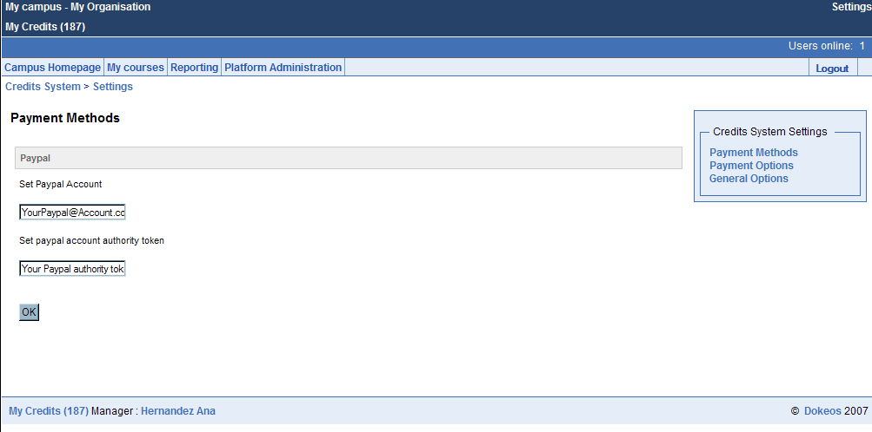

- Click on the Payment Methods link in the ‘Credits System Settings’ panel displayed at the right side.
- Fill the options.
- Confirm to save the changes.

Payment Options

The payment options are the different periods of time available for a course which an User can choose to subscribe spending his/her credits.
Here you can set up the payment options available for the entire platform, adding, deleting and editting them.

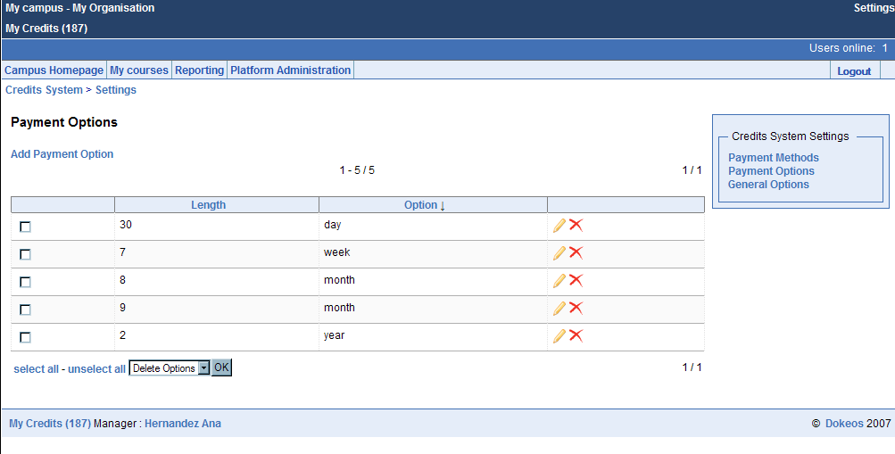

- Click on the Payment Options link in the ‘Credits System Settings’ panel displayed at the right side.

Add

- Click on the Add Payment Option Link.
- Insert the new payment option.
- Click on the OK button.

Edit

- Select the payment option you want to edit clicking the pencil icon () in the last column of the table.
- Perform the changes.
- Click on the OK button.

Delete
One payment option:

- Select the payment option you want to delete clicking the cross icon () in the last column of the table.
- Confirm your choice.

Several payment options:

- Select the payment options you want to delete clicking the checkboxes in the first column of the table.
- Choose ‘Delete Options’ in the select box below the table.
- Confirm your choice.

General Options

Here you will be able to set up the credits system settings. These settings are:

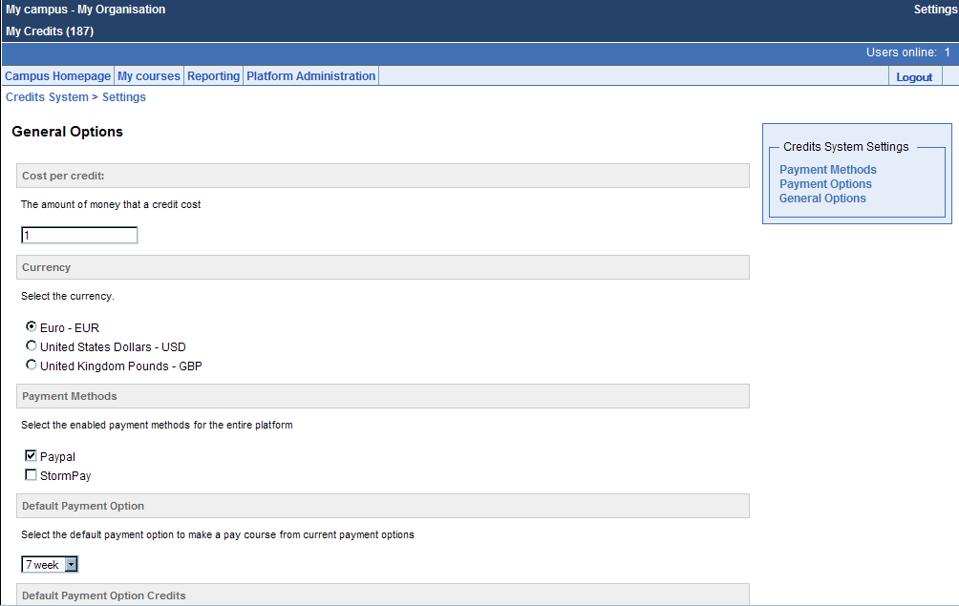
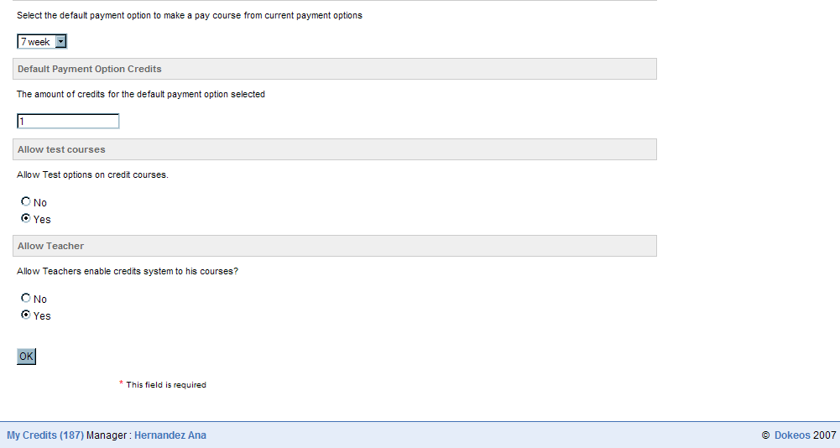

- Cost per Credit. The amount of money that a credit cost.
- Currency. The currency for the entire platform.
- Payment Methods. The payment methods that will be available.
- Default Payment Option. The payment option that will be added to a course when it changes from free to credit course. You will be able to select any from the current payment options.
- Default Payment Option Credits. The credits that will cost the default payment option.
- Allow test courses. To allow test options on credits courses.
- Allow Teacher. To allow the teacher manage his/her credits courses.

Manage User Credits

- Click on the My Credits link in the upper left corner. This displays the credits system menu.

- Click on the Manage User Credits link in the admin panel displayed at the right side.

An Admin is able to manage the user`s credits. Here you will be able to add, substract and edit one or several user`s credits.

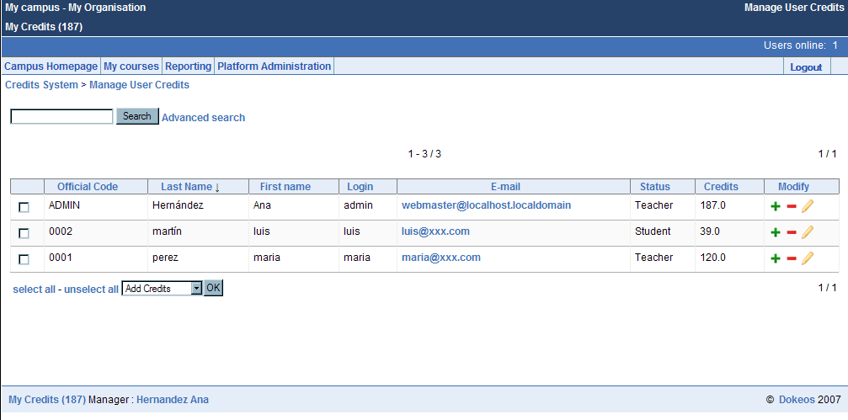

Add
One User:

- Select the user you want to add credits to, clicking the plus icon () in the last column of the table.
- Insert the amount of credits to add.
- Clic on the Continue link.

Several Users:

- Select the users you want to add credits clicking the checkboxes in the first column of the table.
- Choose ‘Add credits’ in the select box below the table.
- Confirm your choice.
- Insert the amount of credits to add.
- Click on the Continue link.

Edit
One User:

- Select the user you want to edit clicking the pencil icon () in the last column of the table.
- Change the number of credits.
- Click on the Save button.

Several Courses:

- Select the users you want to edit clicking the checkboxes in the first column of the table.
- Choose ‘Edit Credits’ in the select box below the table.
- Confirm your choice.
- Change the number of credits.
- Click on the Save button.

Substract
One User:

- Select the user you want to substract credits clicking the minus icon () in the last column of the table.
- Insert the amount of credits to substract.
- Click on the Continue link.

Several Users:

- Select the users you want to substract clicking the checkboxes in the first column of the table.
- Choose ‘Substract Credits’ in the select box below the table.
- Insert the amount of credits to substract.
- Click on the Continue link.

Manage Course Credits

- Click on the My Credits link in the upper left corner. This displays the credits system menu.

- Click on the Manage Course Credits link in the admin panel displayed at the right side of the screen.

This is the Manage Course Credits menu, where the platform administrator can change the status, and also modify the current payment options, of every course created in the platform.

Change the status of a course
From Credit to Free Course:

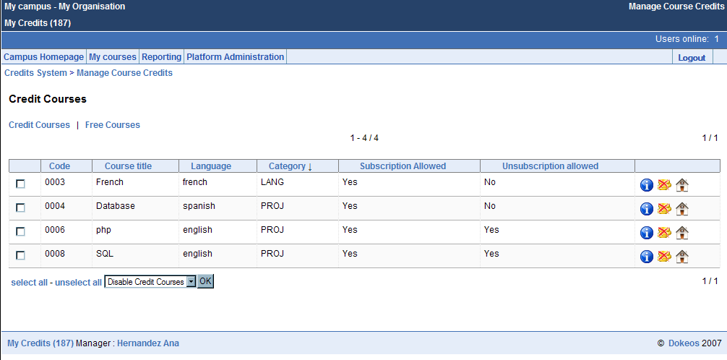

One Course:
- Select the course you want to make free, clicking the ‘no-coins’ icon () in the last column of the current credit courses table.
- Confirm your choice.

Several Courses:
- Select the course or courses which you want to make free, clicking the checkboxes in the first column of the current credit courses table.
- Choose the ‘Disable Credit Courses’ option in the select box below the current credit courses table.
- Confirm your choice.

From Free to Credit Course:

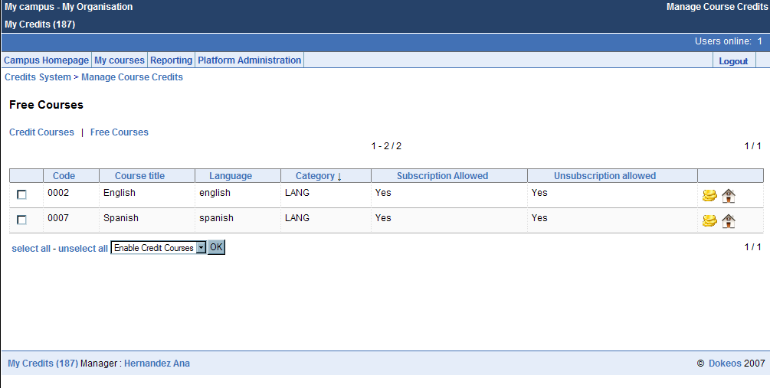

- Click on the Free Courses link to show all the Free Courses avaliable in the platform.

One Course:
- Select the course you want to change to Credit course, clicking the ‘coins’ icon () in the last column of the current free courses table.
- Confirm your choice.

Several Courses:
- Select the course/s which you want to change to Credit Course/s, clicking the checkboxes in the first column of the current free courses table.
- Choose the ‘Enable Credit Courses’ option in the select box below the current free courses table.

Change Credit Courses´ Payment Options

To select a credit course to edit:
- Click on the Current Payment Options link , represented by an ‘info’ icon () in last column of the current credit courses table.

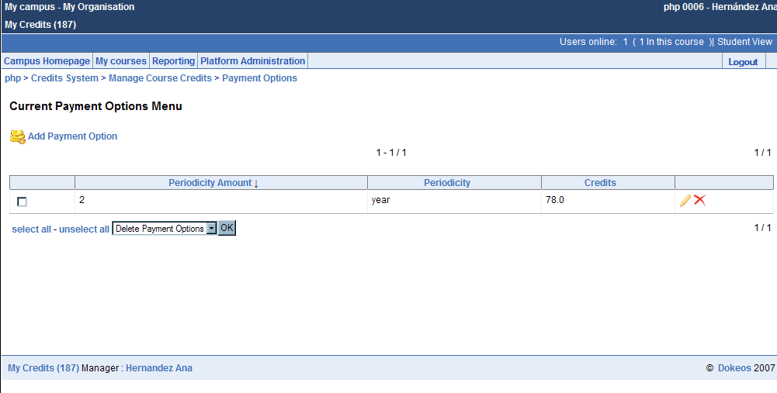

Once you clicked on the Current Payment Options link, yo will see the Current Payment Options Menu. There you will be able to add, edit or delete any available payment option of the course selected.

Add
- Click on the Add Payment Option link
- Insert the new payment options
- Click on the OK button

Edit
One Course:

- Select the payment option you want to edit clicking on the pencil icon () in the last column of the table.
- Change the number of credits.
- Click on the OK button

Several Courses:

- Select the payment options you want to edit clicking on the checkboxes in the first column of the table.
- Choose ‘Edit Payment Options’ in the select box below the current payment options table.
- Confirm your choice.
- Change the number of credits.
- Clic on the OK button

Delete
One Course:

- Select the payment option you want to delete clicking the cross icon () in the last column of the table.
- Confirm your choice

Several Courses:

- Select the payment options you want to delete clicking the checkbox in the first column of the table.
- Choose ‘Delete Payment Options’ in the select box below the current payment options table.
- Confirm your choice

Platform History

- Click on the My Credits link in the upper left corner. This displays the credits system menu.

- Click on the Platform History link in the admin panel displayed at the right side of the screen.

Here there are three data records for the admin. The first shows the credits spent per each course, the second one the users payment and the other one the credits spent per user.

See the Credits spent per course

A table with the credits spent per course appears by default when the admin has clicked on the “Platform History” link.

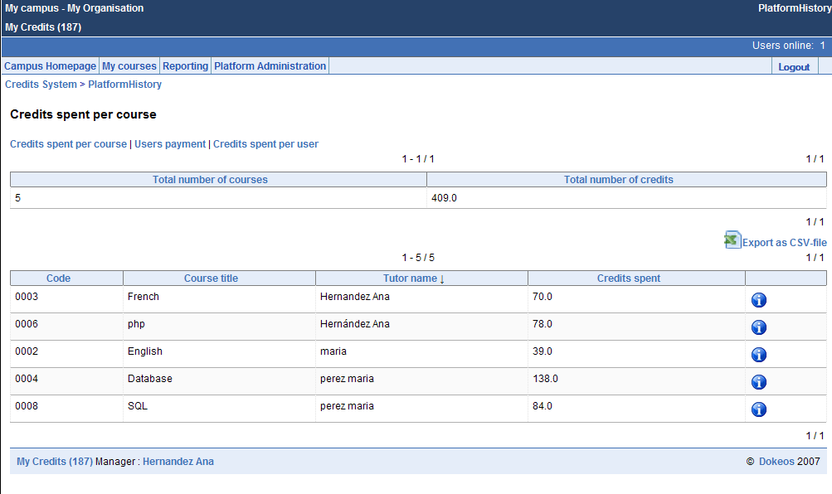

Click on the “Credits spent per course” link if you are in Users payment website or Credits spent per user website, and you want to go to Credits spent per course website.
Click on the “Info” icon () to see the course’s subscription data.
Click on the “EXPORT as CSV-file” link to export the data to a CSV file.

See the Users payment

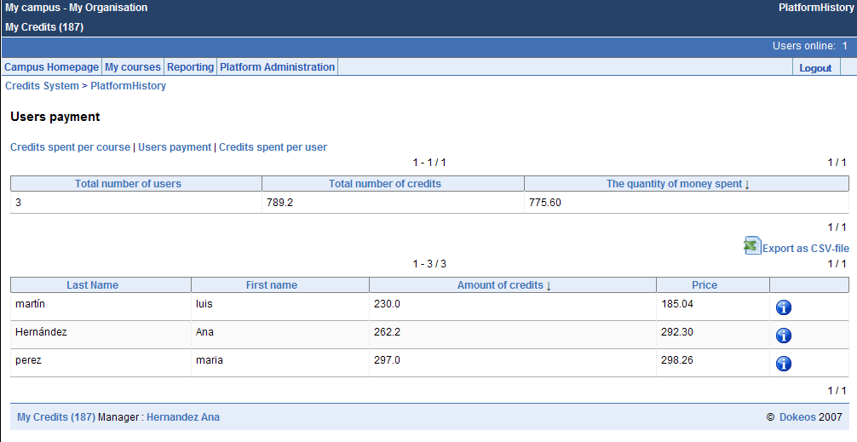

Click on the “Users payment” link. It is at the left side of the screen, over the two tables.
Click on the “Info” icon () to see the users’ payment data.
Click on the “EXPORT as CSV-file” link to export the data to a CSV file.

See the Credits spent per user

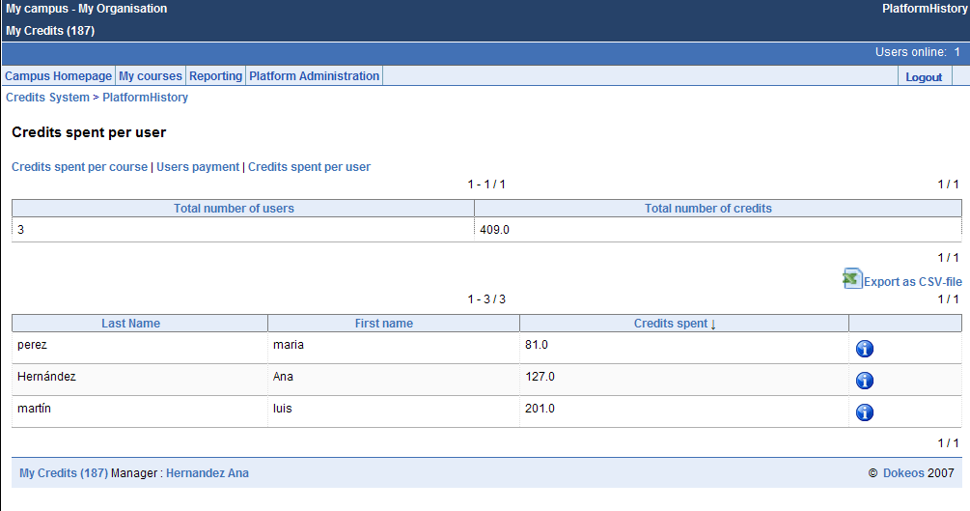

Click on the “Credits spent per user” link. It is at the left side of the screen, over the two tables.
Click on the “Info” icon () to see the credits spent of one user.
Click on the “EXPORT as CSV-file” link to export the data to a CSV file.

Statistics

- Click on the My Credits link in the upper left corner. This displays the credits system menu.

- Click on the Statistics link in the admin panel displayed at the right side of the screen.

There are two statistics for the credits that an user has bought. One is the credits bought per month and the other is the credits bought per year.

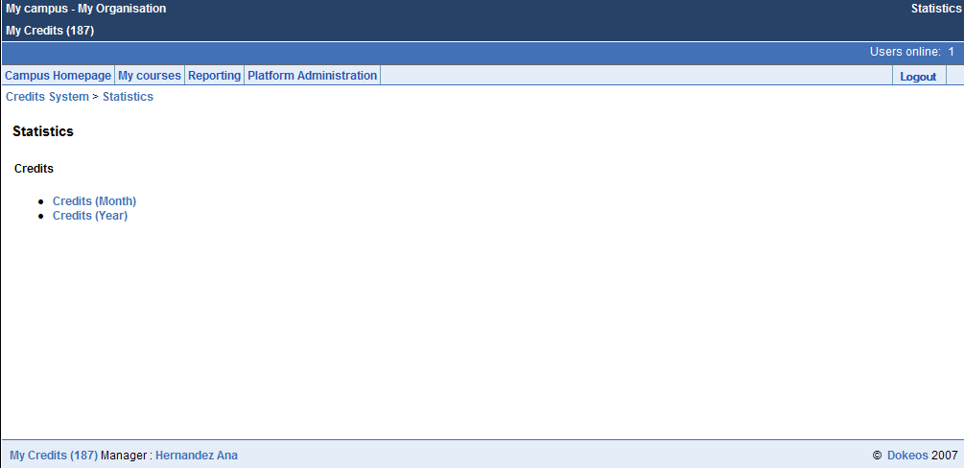

See the credits bought per month

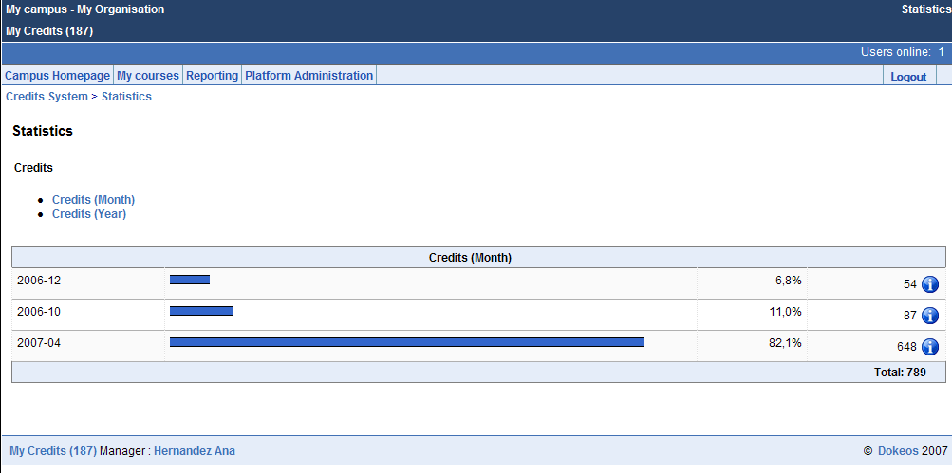

Click on the “Credits (Month)” link.
Click on the “Info” icon () to see the credits bought in one month.

See the credits bought per year

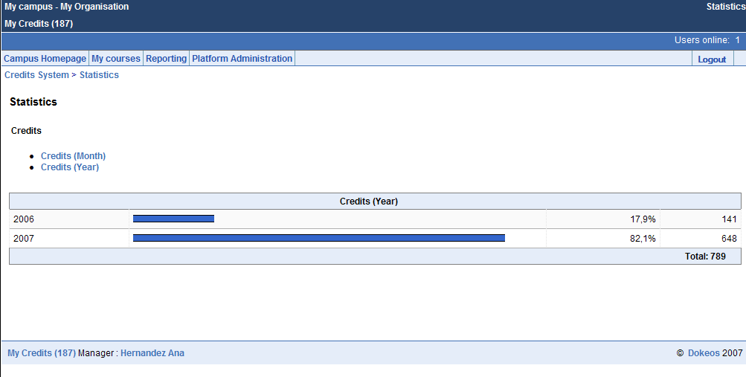

Click on the “Credits (Year)” link.

