Dokeos
Partnership contract

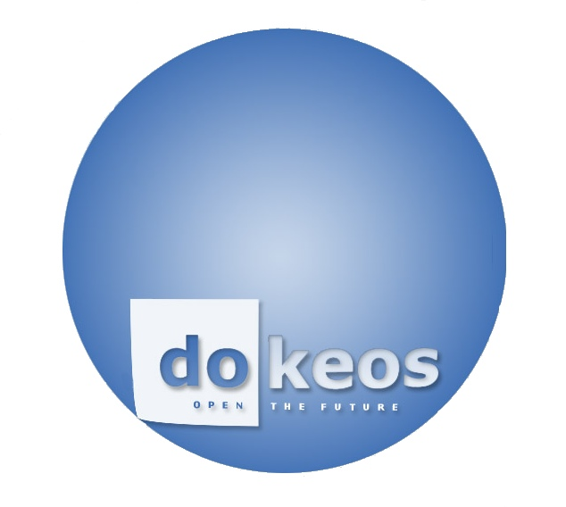

GATHERED
On the one hand, Dokeos (CIF place here your company ID), a corporation organised and existing under the laws of Belgium, having its principal place of business at 44 rue des Palais b.3, B-1030 Brussels (hereinafter called the “company”),
AND

On the other Partner name, commercial brand of Partner company (NIF Number), a corporation organised and existing under the laws of Country, having its principal place of business at Partner address (hereinafter called the “agent”),

On the DD/MM/YYYY, in Brussels and having both parties full rights to lawfully develop their economical activity and recognize each other, therefore they execute this agency agreement in which they

STATE
- The agent commit himself, on the company´s name and account to promote and conclude commercial acts and operations in a continued way as an idependent mediator in exchange of a remuneration.
- The company is interested on the promotional works of its products and in the conclusion of acts and operations that will facilitate the release of the product into the market through the mediation work that the agent will do.

Being both parties interested on holding the present agency agreement they agree as stated in the following.

CLAUSES

First 1.- The agent is authorized to sell the company value-added services related to Dokeos LMS (support, assistance, hosting, maintenance, videoconferencing, content integration and training) in order to proceed to commercialize and sell them in a continued way through the acts and operations required for this aim.

The company hereby appoints the agent as the exclusive distributor for all the Dokeos services pointed out above in partner country while the agreement lasts.

The agent is authorized by the company to translate Dokeos web site into country language.The agent is also authorized to maintain the news that will be posted on the web site. “Maintenance” shall mean the translation of news that Dokeos esteem convenient to be published on the country localized Dokeos web site, and also the ones that the partner chooses for this purpose.

The agent commits himself to provide in country language the added-value services retained by the Dokeos country language-speaking customers.

Second 2.- The agent will be helped by the company in all the tasks related to sales, promotion and delivery of all the services aforementioned on first clause.

Third 3.- The agent should proceed acording to law regulations and good faith, taking diligent charge of the promotion and conclusion of the acts and operations requiered for the company product sale.

The agent has to inform the company about any kind of complaints made by third parties on faults or bugs on the quality of sold products as a result of promoted operations, even if those operations were not concluded.

Fourth 4.- The agent will receive a remuneration that consists of :

 | Activity | Partner | Dokeos
1 | Sales | 20% | 80%
2 | First line support (bugs) | 10% | 90%
3 | Second line support (bugs) | 0% | 100%
3 | Technical Assistance (non bugs) | 30% | 70%
4 | Hosting 24/7 | 0% | 100%
5 | Videoconferencing | 0% | 100%
6 | Maintenance (including upgrades) | 0% | 100%
7 | Training | 100% | 0%
8 | Content integration | 100% | 0%
9 | Consulting | 100% | 0%

Fifth 5.- After the end of the agreement, the agent will have the right to receive the same remuneration indicated on clause fourth on top of each sold product, when one of the following circumstances concurs:
- The acts or operations are directly related to the activity developed by the agent during the period while the agreement was still relevant, provided that all those operations had conclude among the three months following the end of the agreement.
- If the agent starts a commercial operation or act before the end of the agreement and this operation or act is concluded after the end of this agreement, the agent will still have the right to get the commission he would have get if the agreement was still valid.

Sixth 6.- This agreement shall remain in force and effect for 24 months. It can be cancelled after an unilateral formal complaint, after sending a two months in advance written notice.
If there is no formal complaint by any of the parts, it´s understood that the agreement will be tacit renovated by periods of twelve months.

Seventh 7.- The agent should inform the company every three months about the management, the concluded operations and the ones still in course.

Eighth 8.- The company should provide in advance and in an appropriate cuantity: demos, offer templates, contract templates, marketing material, price lists and any other document relevant for the correct development of the agent professional activity.

Ninth 9.- The company gives the agent the right to present himself as “Dokeos Country name”. The company should have a link to www.partnername.com, or any other internet address that replaces it, on both the country web site and the english one.
The company commits itself to set info.countrycode@dokeos.com as the oficial contact address on the country Dokeos web site. This address should be the agent´s address.

Tenth 10.- The agent won´t be able to develop activities related to the promotion and sale of added-value services of Dokeos in partner country during a year after the end of this agreement.

Eleventh 11.- All claims wich cannot be amicably settled between the parties shall be submitted to the exclusive jurisdiction of Brussels District Court.

In witness whereof, the parties have executed this agreement on the date first written above in two original counterparts each party retaining one.

Thomas De Praetere  Dokeos e-Learning sprl  44 rue des Palais  B-1030 Brussels  Tel. +32 2 211 34 56 | Partner

