Training remotely with
Dokeos Live Conferencing®
An example scenario and some remarks

I. Introduction

This document aims at helping you structure a videoconference training.

We train our clients on how to use our main software : Dokeos Learning Management System®. The seminar takes place either as a 2 days hands on workshop in a room (face-to-face training) or remotely (3 hours Live Conferencing + 2 weeks practice under forum supervision by one of our coaches + 3 hours Live Conferencing at the end). The reason, for the client, to go online is either distance (like for the European Universities Continued Education Network http://www.eucen.org whose members are spread over Europe) or human ressources management : avoid a 2 days paralysis of one's workforce like for the Progressio company (http://www.progressio.com), based in Paris, not far from our Brussels headquarters but having no time to waste in a 2 days classical training.

We describe below a typical remote training scenario and end with 10 lessons we retain from this experience.

II. The tool

Dokeos Live Conferencing® is a standardised videoconferencing tool offering classical features: remote slideshow with a whiteboard layer on top to draw over the slides in realtime, duplex audio and video communication, possibility for the participants to ask for the microphone like in a classical classroom, chat discussion and the list of who is connected. It runs inside your favourite browser on any type of computer (Win, Linux or Mac) and offers 3 modes: one2one, one2many and many2many.
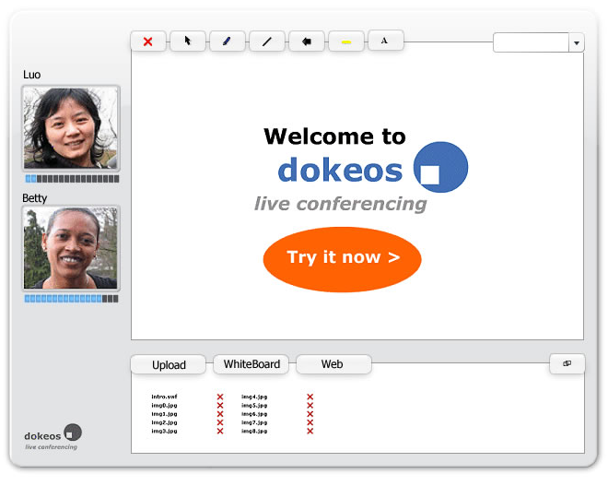

III. A typical distance training scenario

The seminar contains 5 steps.

Step 1 : the trainer shows screenshots of Dokeos LMS software interface and highlights in realtime the relevant spots in the image along his audio/video explanation. Mode: one2many.

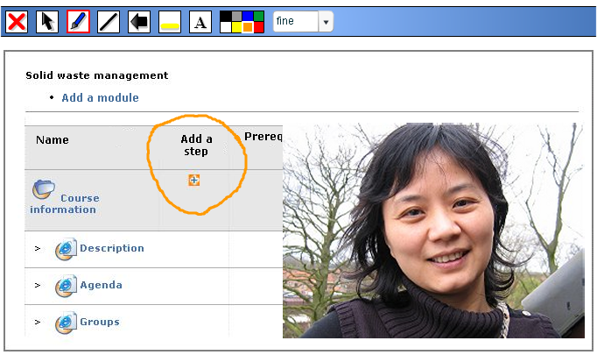

Step 2 : the trainer guides the participants through the interface of the real software. All participants open 2 browser windows : one for the conference and another in Dokeos Open Campus : http://campus.dokeos.com where he/she registers, creates a course, learns to handle the various Dokeos LMS features. Mode: one2many.

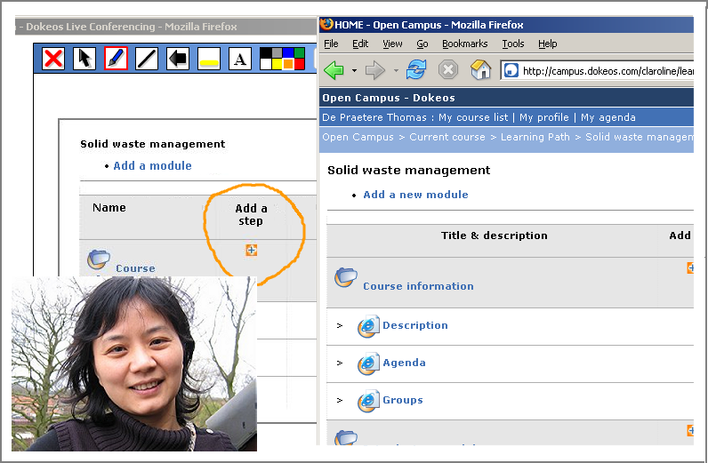

Step 3 : Questions & Answers. Option 1 : the participants ask their questions through the chat and the trainer answers by audio/video. Mode: Many2many.

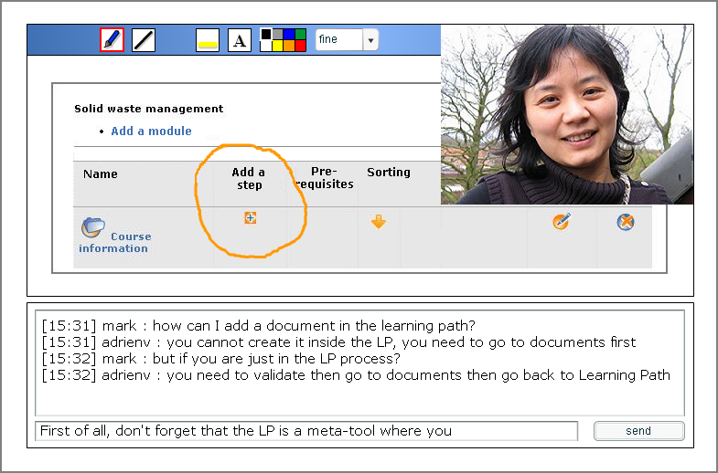

Step 3b : Questions and answers. Option 2 : the participants ask, one by one, for the microphone and utter their question by audio. The trainer answers using the audio/video. Looks better but prooves worse as it assumes a lot of audio and microphone finetuning on the participant computer ending in technical troubleshooting during the conference.

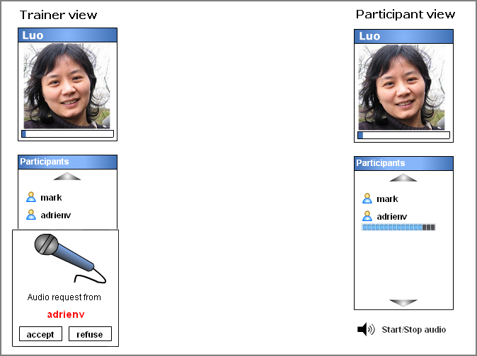
Step 4 : two weeks of practice on Dokeos Open Campus : http://campus.dokeos.com under the trainer supervision in Dokeos forum http://www.dokeos.com/forum/ (dedicated area for the seminar participants). Mode: asynchronous many2many.

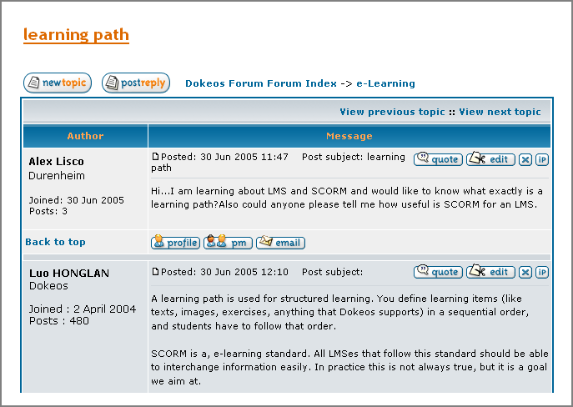

Step 5 : After two weeks of practice, a second 3 hours videoconference. Synthesis of the work done, comments by the trainer on the participants productions, conclusions. Mode: many2many pre-cooked by the trainer with screenshots of the productions.

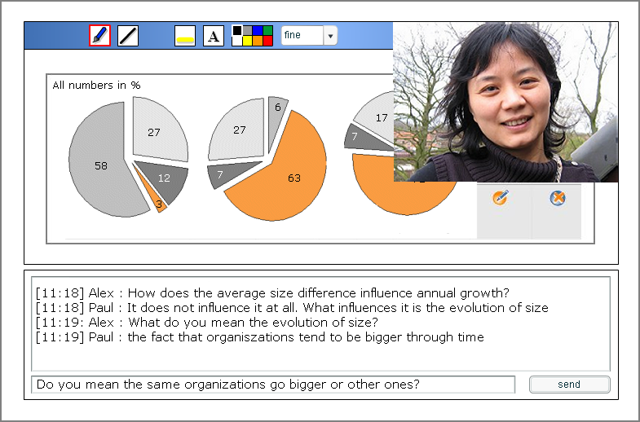

IV. Conclusions

Our experience as trainers with Dokeos Live Conferencing® and other systems teached us 10 lessons:

- Going remote can be motivated either by distance or by human ressources management : less time stuck all together in a room with no access to day-to-day workflow;
- Technical hassle is very critical. If participants need to download and install Java® or any complex plugin, more than 30% of them run into problems. Flash® is pre- installed on 95% of computers and preferable for this reason. In the same philosophy, questions by chat work better than a sophisticated but problematic remote microphone management. To participate, no need of a microphone or a webcam, you just need Flash® + loudspeakers + a reasonable internet connection (ADSL or more);
- Two modes can peacefully co-exist : a chat discussion among some of the participants when some others attend to the audio/video speech of the trainer;
- Dokeos Live Conferencing® fits better practical training (modus operandi) than complex brainstorming on soft skills where free and quick interaction is required;
- It is necessary that the trainer prepares the conference accurately : sequencing, scheduling, scenario, clean screenshots and pre-define what to draw on top of them;
- Lack of feedback is the main weakness of live conferencing : loosing contact with a participant experiencing technical trouble or misunderstanding your explanations is hard to recover. Forcing interaction by breaks every 15 minutes and providing participants with our telephone number (+32 2 211 34 56) beforehand often prooved relevant;
- Maximum time : 3 hours. After that, the participants are exhansted because videoconferencing requires a lot of concentration;
- The clients look very satisfied. Saving time, productivity and travel costs, better human ressources management, initiating a way of collaboration that might be integrated into the organization processes are some of the most obvious advantages;
- The trainers tend to compensate the lack of interaction by a very expressive way of behaving and speaking : highlighting questions through emphatic sentences, thanking people and naming them so as others know where the question comes from, repeating important information twice (trainers seem inspired by radio speakers tips & tricks). More generally, the trainers need to master both the technical device, the content provided and the complex game of a remote interaction. This requires a lot of qualifications and concentration. Being two (one who types in the chat, taking care of individual questions when the other speaks for the rest of the audience) is a plus when possible;
- The videoconference proces as such does not help grasping any practical qualification, it is mainly informative. Real learning happens during the 2 weeks practice under the e-coach supervision. This scenario is a blended learning one. It mixes two remote situations : synchronous (videoconference) and asynchronous (practice under supervision).

© Dokeos, September 2005

