Read Me

System Environment: Windows 10

Software Requirement: PyCharm Community Edition 2017.2.4

Microsoft Excel 365

1. **Multi-label Classification**

The source code file is Q3.py

The steps are as following:

1. Open PyCharm software

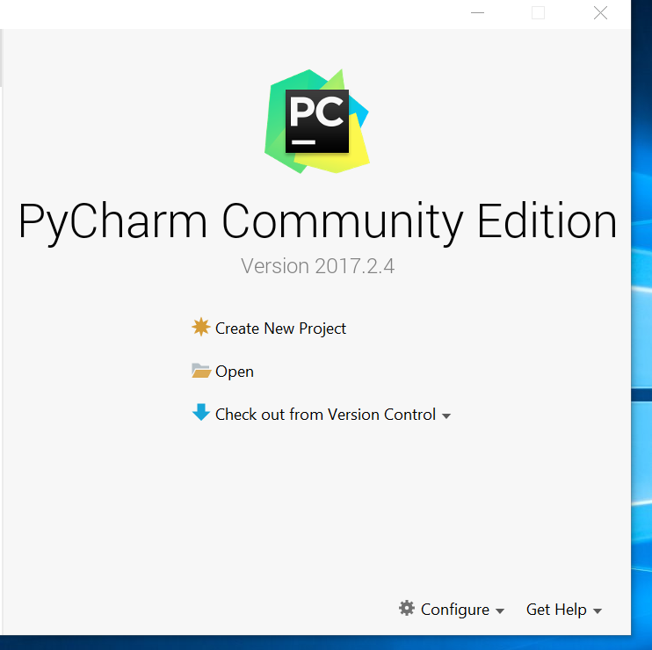

1. Click ‘File’, Open Q3.py file

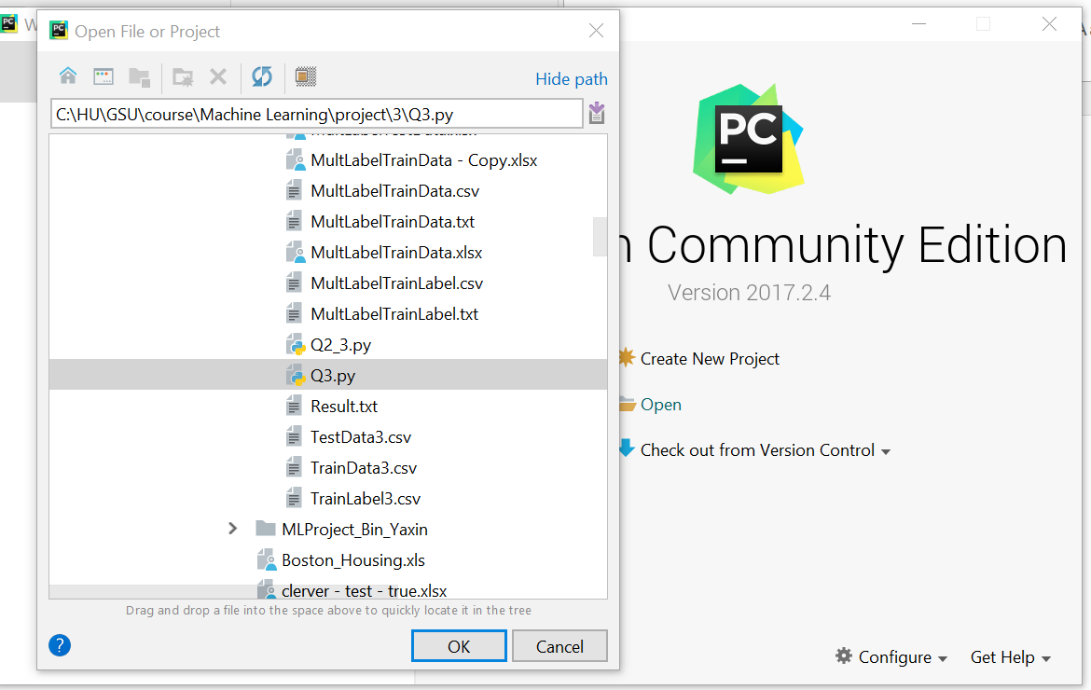

1. In the main menu, click ‘Run’, select ‘Run…’

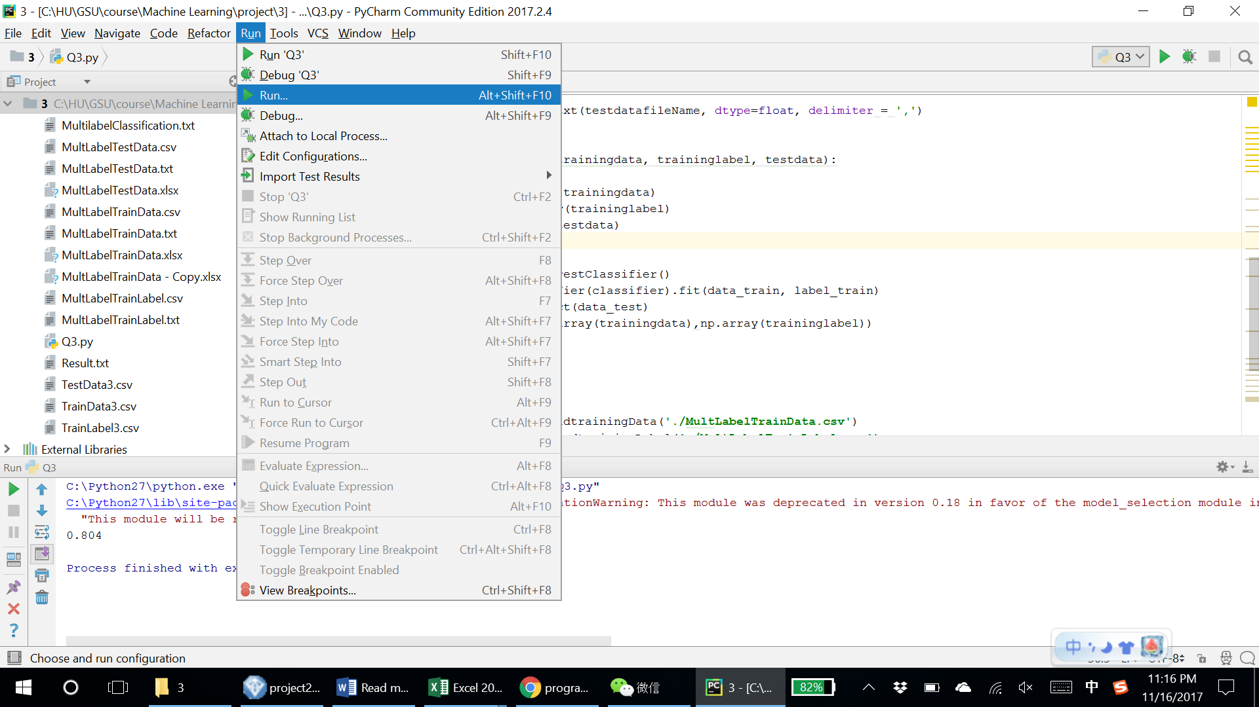

1. Select ‘Q3’

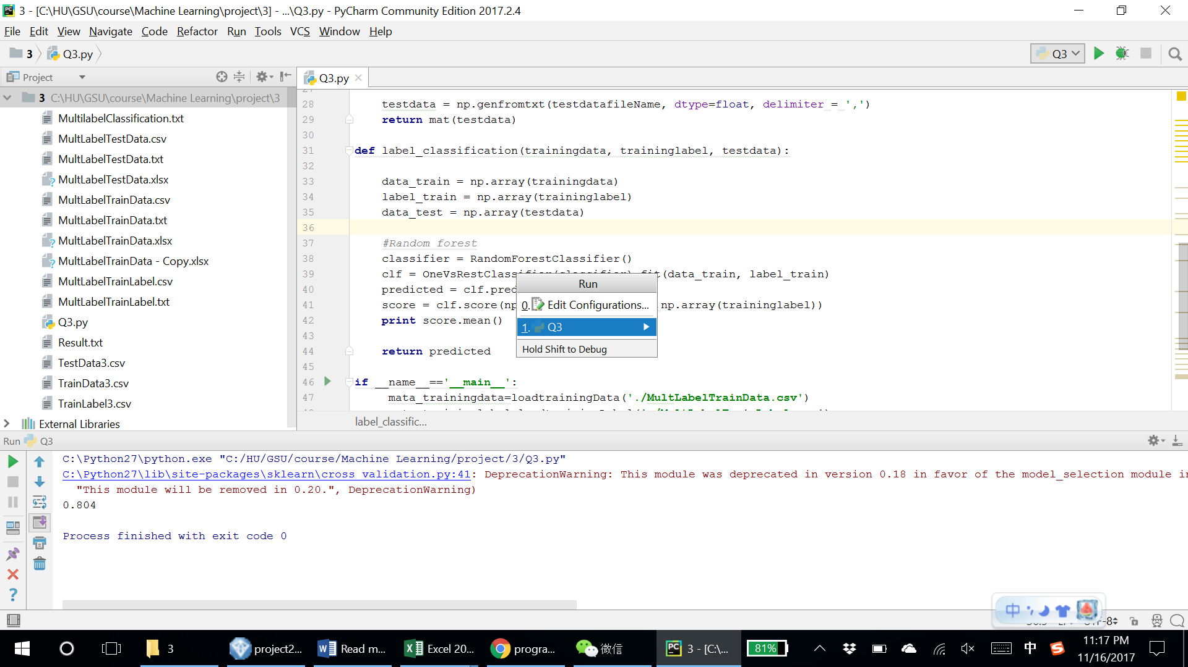

1. Get result and save in ‘MultilabelClassification.txt’