CSC8820 Advanced Graphics Algorithms
Spring 2018

Project #1
Due date: 11:59 pm, February 12, 2018 (Monday)
In this project, you will learn the basics of drawing and transforming 3D geometry objects in OpenGL or WebGL. You will also learn how to specify a camera and its projection.
Requirements (100 points total):
- (50 points) Write a C or C++ program that draws the 3D object in the attached OBJ file. The output of the program should be like the picture below.
  - This means that you either transform the 3D object or the camera to match the view in this picture.
  - The 3D object should be displayed in wired frame mode with the same color as in the picture. (Lighting will be added in the next project.)
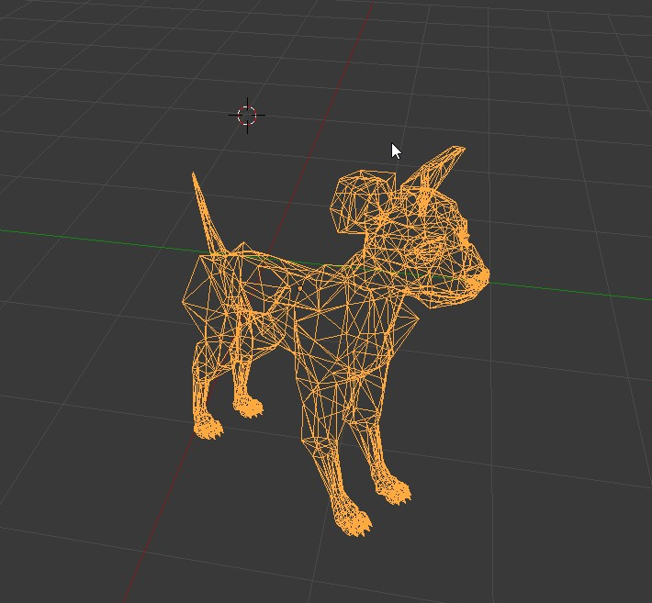

- (10 points) You can either write your own 3D loader program to read an OBJ file, or you can use ASSIMP to load the OBJ file. Your program should be able load any OBJ file.
  - Embedding the data directly in your code is allowed, but you will lose this part of the credit (10 points).
- (5 points) You must explicitly specify a camera in your program.
- (10 points) You must write a vertex shader and a fragment shader.
- (10 points) When user press the up and down arrow key, the object should be rotated around its center along the X axis. When user press the up and down arrow key, the object should be rotated around its center along the Y axis.
- (5 points) Highlight the lines of code related to drawing in yellow background color. Highlight the lines of code related to 3D transformations (including view and projection) in gray color.
- (10 points) Draw a data flow diagram that shows how the vertex data and transformation data are transferred from the host program (on CPU) and the shader programs (on GPU). You can find examples of such diagrams on the course web site.
  - It’s better to draw everything on one diagram. But if your space is limited, you can draw two diagrams.
  - Use free online diagramming tools such as Google Drawing.
- On Windows, you may use freeglut, glew, and glm libraries. On other platforms, you may use WebGL. There are detailed discussions on how to set up OpenGL and WebGL on the course web site.
- Name your source file (lastname)_proj1.cc. In the source code, write your name and any special instructions for building and running your program. Either embed your shaders in your program or save them in separate files. Name your shaders (lastname)_vshader.glsl and (lastname)_fshader.glsl.
- Submit your source code as well as a report. The report should contain your highlighted source code (see requirement 6) and the diagram (requirement 7).
- Upload your source code and report in a ZIP file to iCollege under the folder Project 1. Do not submit via email.

