CSC8820 Advanced Graphics Algorithms
Spring 2018

Project #1 Report
Due date: 11:59 pm, February 19, 2018 (Monday)
Requirements (100 points total):
- (50 points) Write a C or C++ program that draws the 3D object in the attached OBJ file. The output of the program should be like the picture below.
  - This means that you either transform the 3D object or the camera to match the view in this picture.
  - The 3D object should be displayed in wired frame mode with the same color as in the picture. (Lighting will be added in the next project.)
// displayed in wired frame mode
glPolygonMode(GL_FRONT_AND_BACK, GL_LINE);
// with the same color as in the picture
color = vec4(0.98, 0.68, 0.25, 1.0);
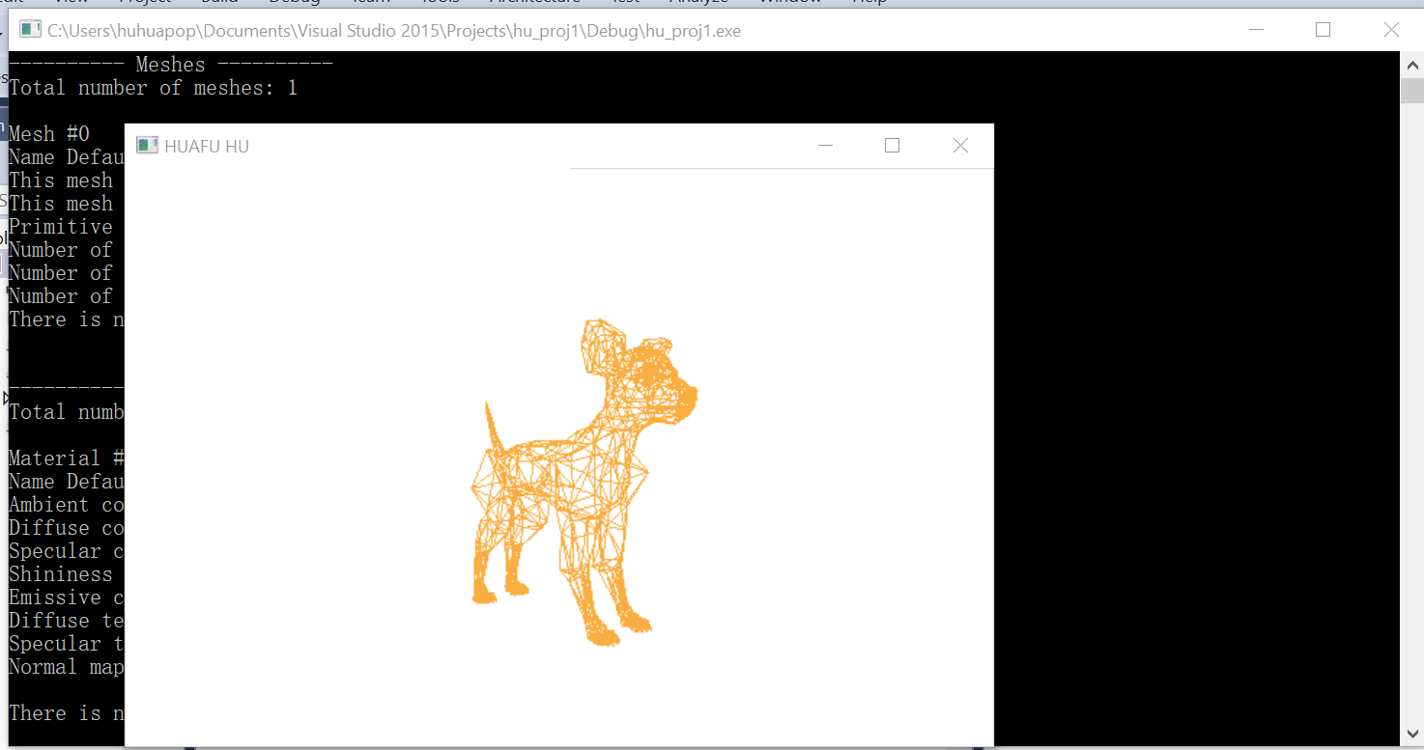
- (10 points) You can either write your own 3D loader program to read an OBJ file, or you can use ASSIMP to load the OBJ file. Your program should be able load any OBJ file.
  - Embedding the data directly in your code is allowed, but you will lose this part of the credit (10 points).
// 3D object file name
const char * objectFileName = "object.obj";
// use ASSIMP to load the OBJ file
scene = load3DFile(
(string(defaultModelFolder) + string(getFileName(objectFileName))).c_str());
- (5 points) You must explicitly specify a camera in your program.
//specify a camera
vec3 defaultCameraPosition = vec3(2.0f, 0.0f, 2.0f);
vec3 defaultCameraLookAt = vec3(0.5f, 0.0f, 0.5f);
vec3 defaultCameraUp = vec3(0.0f, 1.0f, 0.0f);
- (10 points) You must write a vertex shader and a fragment shader.
// **************************
// Load and build the shaders.

GLuint vShaderID, fShaderID;

// Create empty shader objects
vShaderID = glCreateShader(GL_VERTEX_SHADER);
checkGlCreateXError(vShaderID, "vShaderID");
if (vShaderID == 0) {
return false;
}

fShaderID = glCreateShader(GL_FRAGMENT_SHADER);
checkGlCreateXError(fShaderID, "fShaderID");
if (fShaderID == 0) {
return false;
}
//read vertex shader
const char* vShader = readShaderFile(
(string(defaultShaderFolder) + getFileName(string(vShaderFilename))).c_str());
if (!vShader) {
return false;
}
//read fragment shader
// OpenGL fragment shader source code
const char* fShader = readShaderFile(
(string(defaultShaderFolder) + getFileName(string(fShaderFilename))).c_str());
if (!fShader) {
return false;
}

// Attach shader source code the shader objects
glShaderSource(vShaderID, 1, &vShader, NULL);
glShaderSource(fShaderID, 1, &fShader, NULL);

// Compile the vertex shader object
glCompileShader(vShaderID);
printShaderInfoLog(vShaderID); // Print error messages, if any.
glCompileShader(fShaderID);
printShaderInfoLog(fShaderID); // Print error messages, if any.
- (10 points) When user press the up and down arrow key, the object should be rotated around its center along the X axis. When user press the up and down arrow key, the object should be rotated around its center along the Y axis.
// Use up and down keys to move the object along the Y axis.
// Use left and right keys to move the object along the x axis.
void specialKeys(int key, int x, int y) {

//When user press the left and right arrow key, the object should be rotated around its center along the X axis.
//When user press the up and down arrow key, the object should be rotated around its center along the Y axis.
switch (key) {
case GLUT_KEY_UP:
yTranslation += transformationStep;
break;
case GLUT_KEY_DOWN:
yTranslation -= transformationStep;
break;
case GLUT_KEY_LEFT:
xTranslation -= transformationStep;
break;
case GLUT_KEY_RIGHT:
xTranslation += transformationStep;
break;
default:
break;
}

// Generate a dislay event to force refreshing the window.
glutPostRedisplay();
}
- (5 points) Highlight the lines of code related to drawing in yellow background color. Highlight the lines of code related to 3D transformations (including view and projection) in gray color.
Drawing:
color = vec4(0.98, 0.68, 0.25, 1.0);
color += ambientColor + emission + attenuation * (diffuseColor + specularColor);
color = mix(color, textureColor, 0.5f);

// Bind (transfer) the vertex position array (stored in aiMesh's member variable mVertices)
// to the VBO.
// Note that the vertex positions are stored in a continuous 1D array (i.e. mVertices) in the aiScene object.
glBufferData(GL_ARRAY_BUFFER, sizeof(float) * 3 * currentMesh->mNumVertices,
currentMesh->mVertices, GL_STATIC_DRAW);

// This VBO is an GL_ELEMENT_ARRAY_BUFFER, not a GL_ARRAY_BUFFER.
// GL_ELEMENT_ARRAY_BUFFER stores the face indices (elements), while
// GL_ARRAY_BUFFER stores vertex positions.
glBindBuffer(GL_ELEMENT_ARRAY_BUFFER, buffer);
glBufferData(GL_ELEMENT_ARRAY_BUFFER,sizeof(unsigned int) * currentMesh->mNumFaces * currentMesh->mFaces[0].mNumIndices,faceArray, GL_STATIC_DRAW);

// Bind (transfer) the vertex normal array (stored in aiMesh's member variable mNormals)
// to the VBO.
// Note that the vertex normals are stored in a 1D array (i.e. mVertices)
// in the aiScene object.
glBufferData(GL_ARRAY_BUFFER, sizeof(float) * 3 * currentMesh->mNumVertices,
currentMesh->mNormals, GL_STATIC_DRAW);

// Bind (transfer) the texture coordinate array to the VBO.
glBufferData(GL_ARRAY_BUFFER, sizeof(float) * 2 * currentMesh->mNumVertices,
textureCoordArray, GL_STATIC_DRAW);
// The second parameter is crucial. This is the number of face indices, not the number of faces.
// (numFaces * numIndicesPerFace) is the total number of elements(face indices) of this mesh.
// Now draw all the faces. We know these faces are triangle because in
// importer.ReadFile(filename, aiProcessPreset_TargetRealtime_Quality);
// "aiProcessPreset_TargetRealtime_Quality" indicates that the 3D object will be triangulated.
glDrawElements(GL_TRIANGLES, (numFaces * numIndicesPerFace), GL_UNSIGNED_INT, 0);

3D transformations (including view and projection):
// Calculate this (camera) node's transformation matrix.
aiMatrix4x4 currentTransformMatrix = matrix * node->mTransformation;

// Transform the camera position, lookAt, and up vector
cameraPosition = currentTransformMatrix * cameraPosition;
cameraLookAtPosition = currentTransformMatrix * cameraLookAtPosition;
cameraUpVector = currentTransformMatrix * cameraUpVector;
cameraUpVector.Normalize(); // Remember to normalize the UP vector.

// First create the transformation matrix that will transform the 3D objects.
// Note that this transformation only applies to the meshes, not the lights and camera.
// Because the transformation matrix is pass down the scene graph through the root, all the meshes are
// transformed. If you want to transform a specific mesh, then you need to attach the transformation matrix to
// that mesh's node on the scene graph.
// These rotation, translation, and scaling parameters are controlled by the mouse and keyboard.
aiMatrix4x4 rotationXMatrix = aiMatrix4x4::RotationX(radians(rotateX), rotationXMatrix);
aiMatrix4x4 rotationYMatrix = aiMatrix4x4::RotationY(radians(rotateY), rotationYMatrix);
aiMatrix4x4 scaleMatrix = aiMatrix4x4::Scaling(aiVector3D(scaleFactor, scaleFactor, scaleFactor), scaleMatrix);
aiMatrix4x4 translationXMatrix = aiMatrix4x4::Translation(aiVector3D(xTranslation, 0.0f, 0.0f),
translationXMatrix);
aiMatrix4x4 translationYMatrix = aiMatrix4x4::Translation(aiVector3D(0.0f, yTranslation, 0.0f),
translationYMatrix);
aiMatrix4x4 translationZMatrix = aiMatrix4x4::Translation(aiVector3D(0.0f, 0.0f, zTranslation),
translationZMatrix);
aiMatrix4x4 overallTransformationMatrix =
translationZMatrix * translationXMatrix * translationYMatrix * rotationXMatrix * rotationYMatrix * scaleMatrix;
- (10 points) Draw a data flow diagram that shows how the vertex data and transformation data are transferred from the host program (on CPU) and the shader programs (on GPU). You can find examples of such diagrams on the course web site.
  - It’s better to draw everything on one diagram. But if your space is limited, you can draw two diagrams.
  - Use free online diagramming tools such as Google Drawing.
