CSC8820 Advanced Graphics Algorithms
Spring 2018

Project #2 Report
Due date: 11:59 pm, March 19, 2018 (Monday)
In this project, you will learn the basics of lighting and texture mapping 3D geometry objects in OpenGL or WebGL.
Requirements (100 points total):
- Write a C or C++ program that draws the 3D object in the attached OBJ file. The output of the program should be like the picture below.
  - You can build your project 2 code on your project 1 code.
  - The 3D object file sphere.obj is attached. The texture image cedarstone.jpg is also attached. The surface material properties can be found in the attached sphere.mtl file.
const char * defaultModelFolder = "..\\Models\\";
const char * defaultImageFolder = "..\\Images\\";
const char * objectFileName = "sphere.obj";
filename = "cedarstone.jpg";

  - (40 points) The object shall be lighted. You must write a vertex shader and a fragment shader. The lighting must be implemented in the fragment shader. There should be two directional lights that generate two specular highlights, as shown in the picture below.
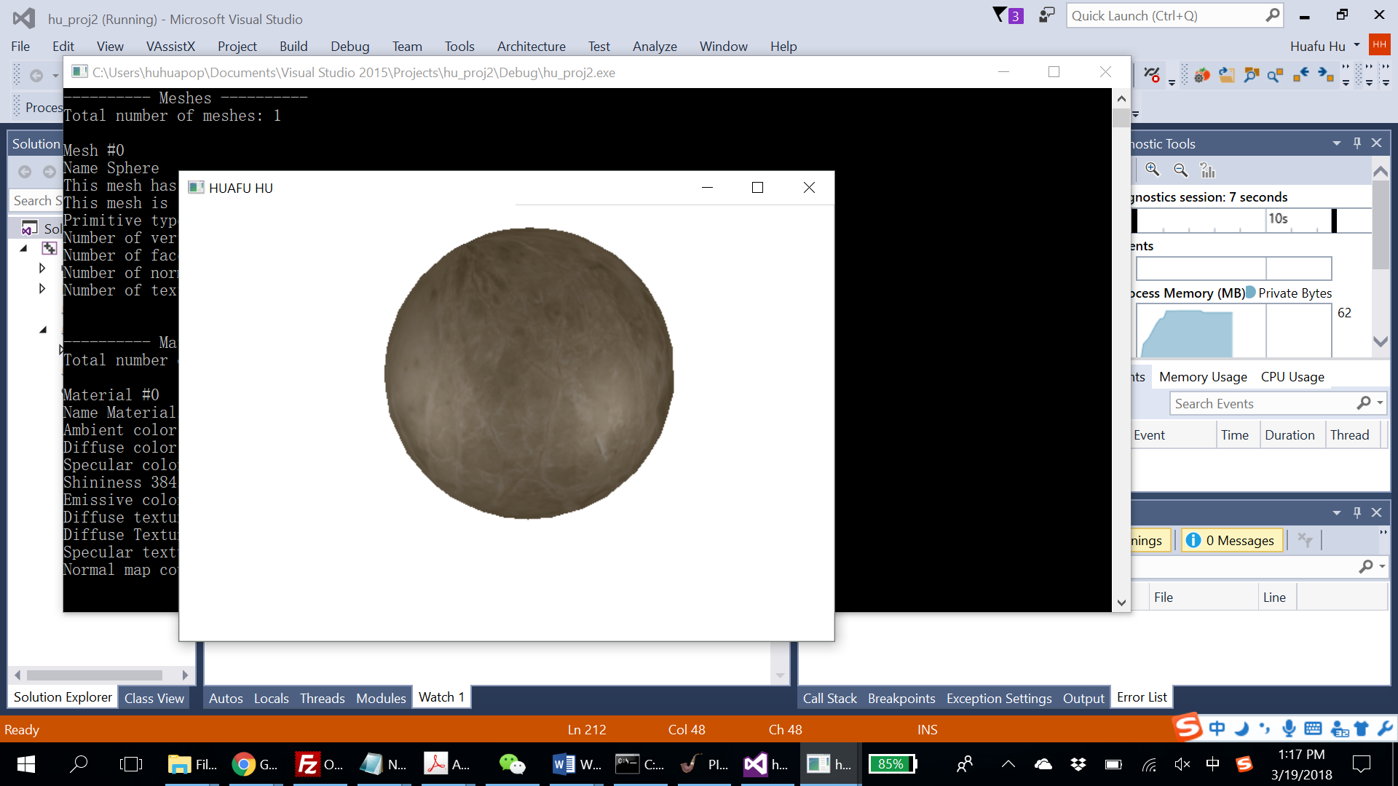
  - (40 points) The sphere must be texture mapped using the attached picture cedarstone.jpg.
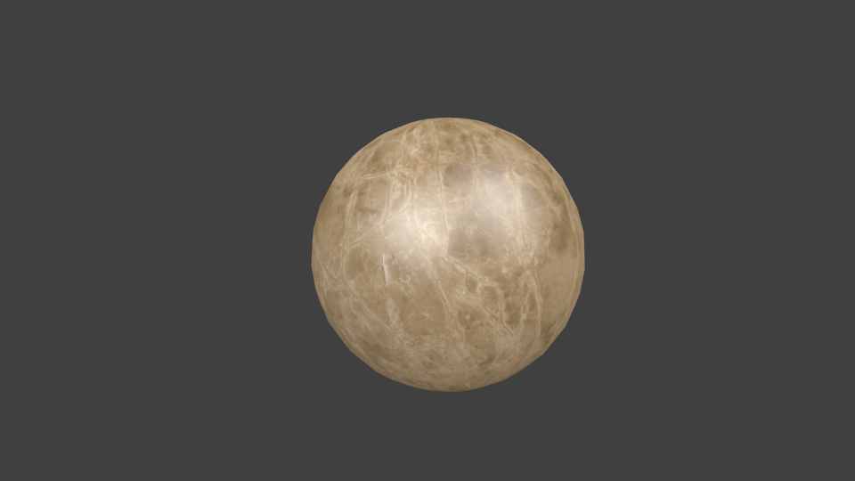

- (5 points) Highlight the lines of code related to lighting in yellow background color. Highlight the lines of code related to texture mapping in gray color.

Lighting:
float lightPosition[maxNumLightSources][4] = { { 1.0f, 1.0f, 1.0f, 1.0f } ,{ -1.0f, 1.0f, 1.0f, 1.0f } };
float lightDirection[maxNumLightSources][4] = { { 0.0f, 0.0f, 0.0f, 1.0 } ,{ 0.0f, 0.0f, 0.0f, 1.0 } };
float lightDiffuse[maxNumLightSources][4] = { { 1.0f, 1.0f, 1.0f, 1.0f },{ 1.0f, 1.0f, 1.0f, 1.0f } };
float lightSpecular[maxNumLightSources][4] = { { 1.0f, 1.0f, 1.0f, 1.0f },{ 1.0f, 1.0f, 1.0f, 1.0f } };
float lightAmbient[maxNumLightSources][4] = { { 0.0f, 0.0, 0.0f, 1.0f } ,{ 0.0f, 0.0, 0.0f, 1.0f } };
float lightConstantAttenuation[maxNumLightSources] = { 1.0f , 1.0f };
float lightLinearAttenuation[maxNumLightSources] = { 1.0f,1.0f };
float lightQuadraticAttenuation[maxNumLightSources] = { 0.1f ,0.1f };
float spotlightInnerCone[maxNumLightSources] = { 0.3f,0.3f }; // inner cone cutoff angle (in radians)
float spotlightOuterCone[maxNumLightSources] = { 2.0f ,2.0f}; // spotlight cutoff angle (in radians)
int lightType[maxNumLightSources] = { 1,1 }; // default point light source

// The actual number of lights in the scene.
unsigned int numLights = 2;

texture mapping:
textureObjectIDArray[i] = SOIL_load_OGL_texture((string(defaultImageFolder) + filename).c_str(),SOIL_LOAD_AUTO, SOIL_CREATE_NEW_ID, SOIL_FLAG_MIPMAPS);

- (15 points) Draw two data flow diagrams. One diagram shows how the lighting parameters are transferred from the host program to the shader program. The other diagram shows how the texture image and texture coordinates are transferred to the shader program. You can find examples of such diagrams on the course web site.
  - Use free online diagramming tools such as Google Drawing.
how the lighting parameters are transferred from the host program to the shader program:
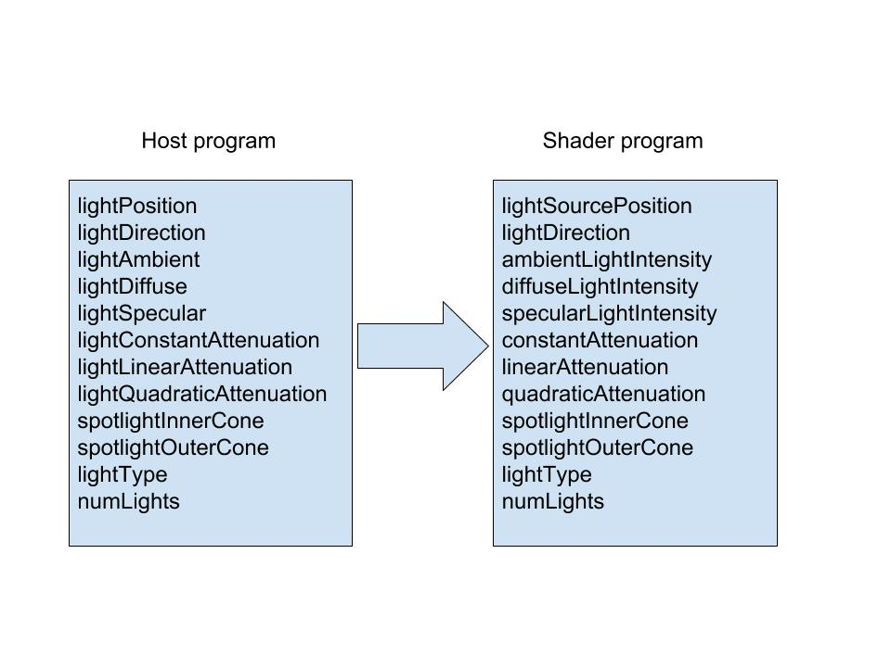
how the texture image and texture coordinates are transferred to the shader program
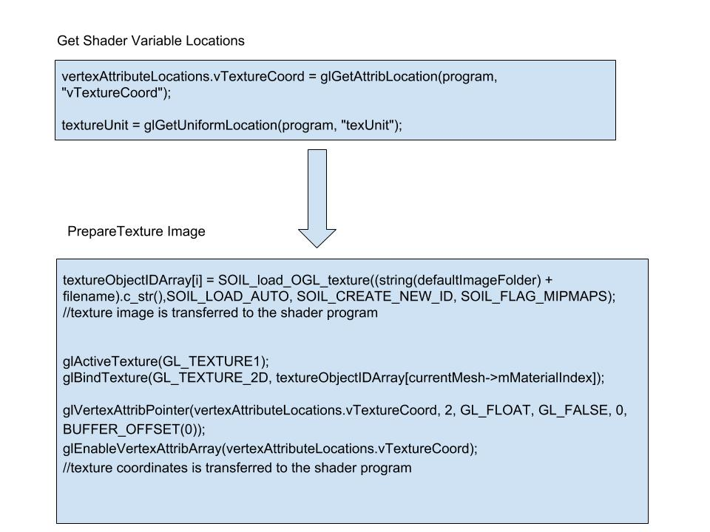
- On Windows, you may use freeglut, glew, glm, and SOIL libraries. On other platforms, you may use WebGL. There are detailed discussions on how to set up OpenGL and WebGL on the course web site.
- Name your source file (lastname)_proj2.cc. In the source code, write your name and any special instructions for building and running your program. Either embed your shaders in your program or save them in separate files. Name your shaders (lastname)_vshader.glsl and (lastname)_fshader.glsl.
- Submit your source code as well as a report. The report should contain your highlighted source code (see requirement 2) and the diagram (requirement 3).
- Upload your source code and report in a ZIP file to iCollege under the folder Project 2. Do not submit via email.

