CSC8820 Advanced Graphics Algorithms
Spring 2018

Project #3
Due date: 11:59 pm, April 9, 2018 (Monday)
In this project, you will learn the basics of drawing and lighting using Vulkan API.
Requirements (100 points total):
- Write a C or C++ program that draws the 3D object in the attached OBJ file. The output of the program should be like the picture below.
  - The 3D object file pyramid.obj is attached.
  - Use Vulkan to develop your program. You can download Vulkan SDK from https://vulkan.lunarg.com. Detailed instructions on how to install and compile Vulkan SDK is included with the package or can be found online. Additional instructions can be found at https://sites.google.com/site/csc8820/educational/vulkan-basics.
  - (60 points) The object shall be lighted. You must write a vertex shader and a fragment shader. The lighting must be implemented in the fragment shader. There should be at least one light source.


Result:

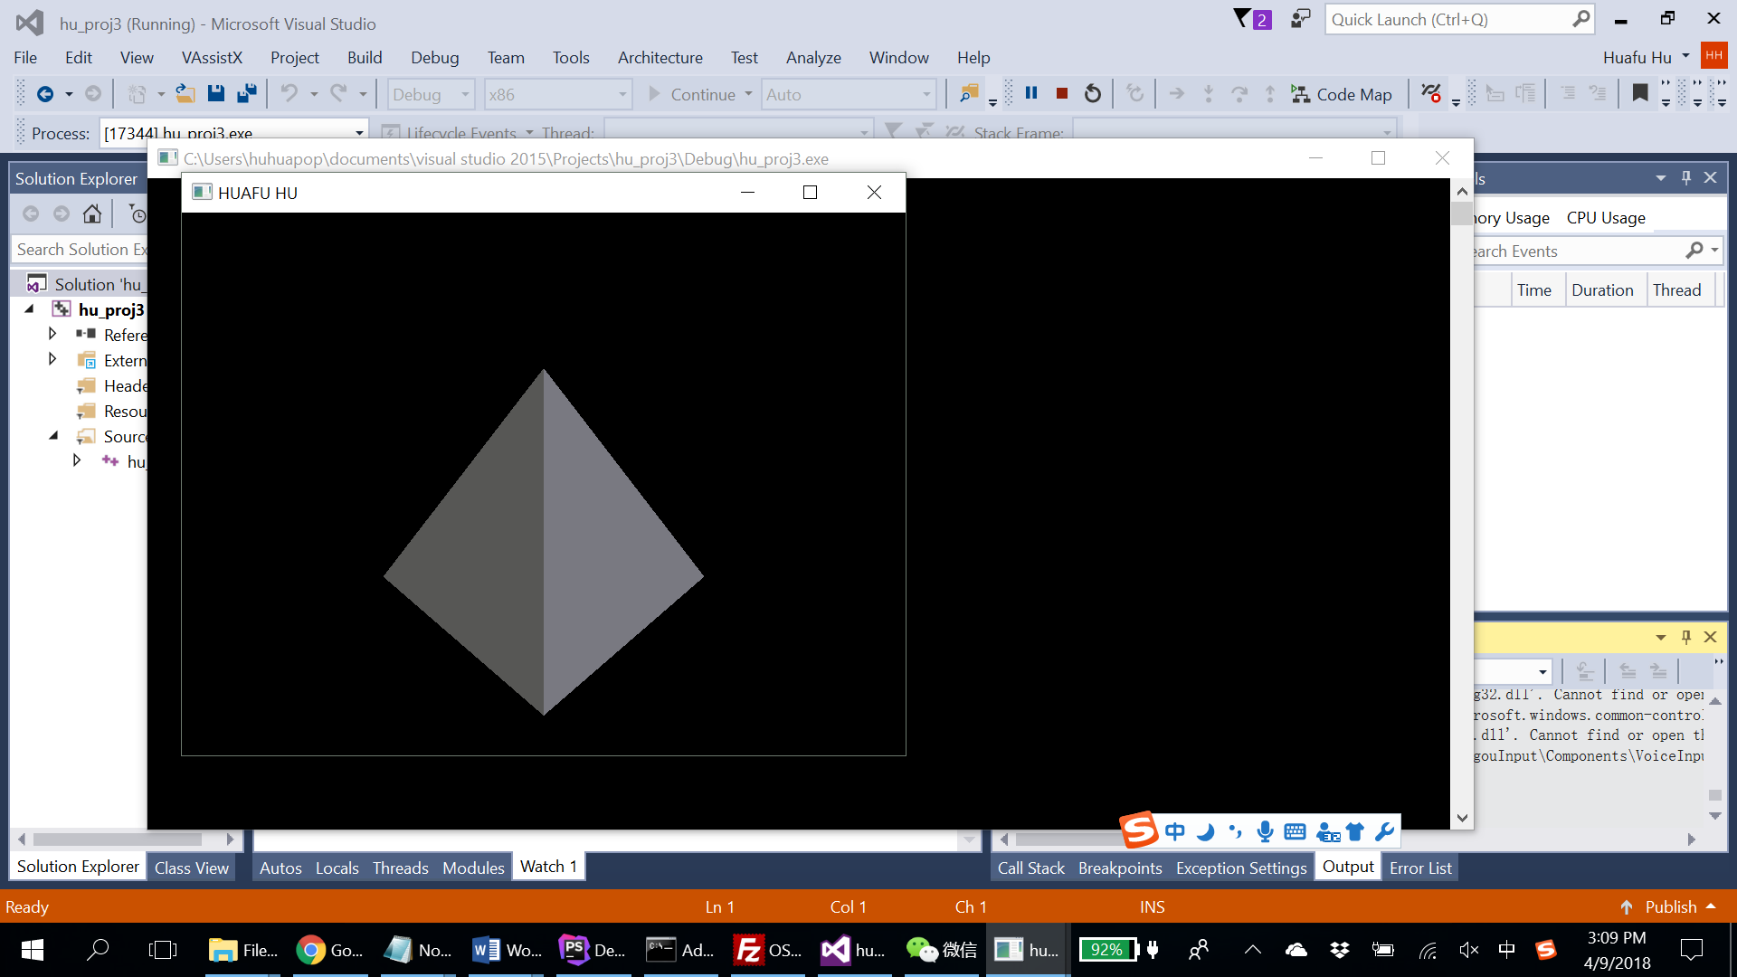

write a vertex shader and a fragment shader
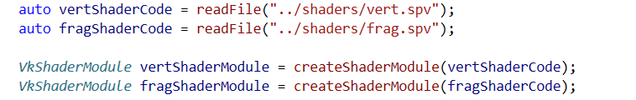

Light Source:
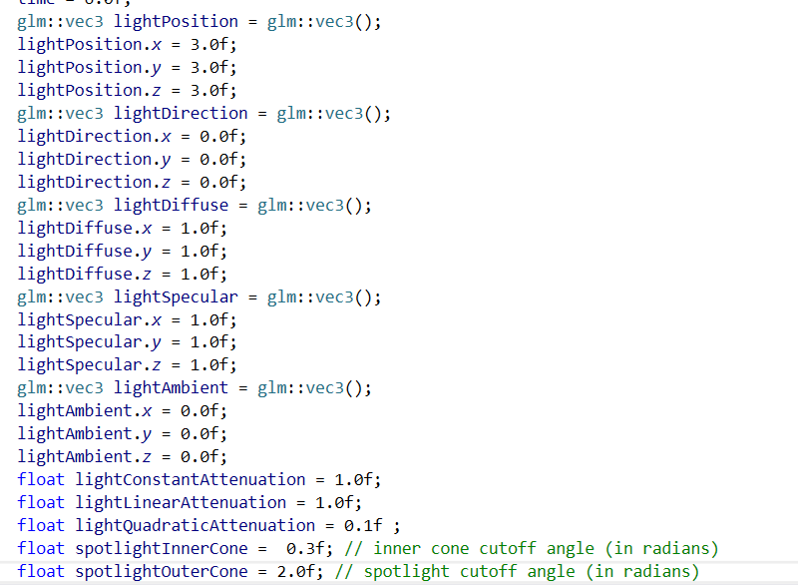
- (20 points) Draw two data flow diagrams. One diagram shows how the lighting parameters are transferred from the host program to the shader program. The other diagram shows how the vertex data is transferred from the host program to the shader program.
  - Use free online diagramming tools such as Google Drawing.
how the lighting parameters are transferred from the host program to the shader program
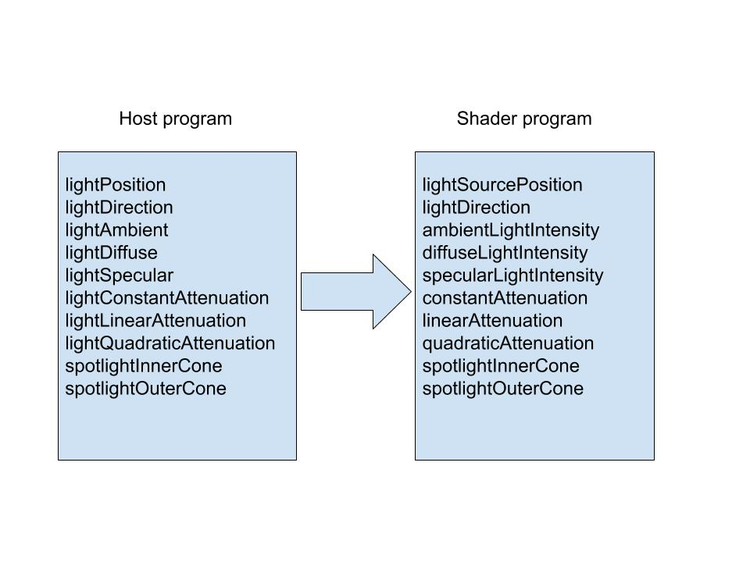
how the vertex data is transferred from the host program to the shader program.
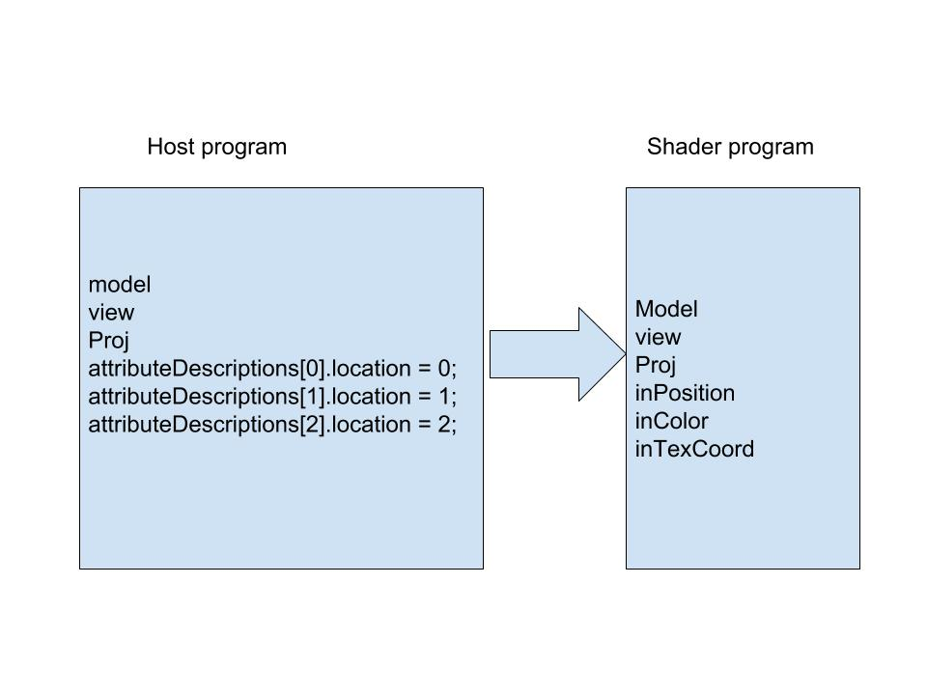
- (20 points) Answer the following questions:
  - Compare Vulkan and OpenGL in three areas: pipeline set, data transfer, and data processing. In which part is Vulkan more complicated than OpenGL?
Vulkan is more complicated than OpenGL at pipeline set. Because it encompasses all the parameters like vertex, fragment, geometry, compute and tessellation where applicable, plus things like vertex attributes, primitive topology, backface culling, and blending mode, to name just a few. All those parameters that used to be separate settings in much older graphics APIs (DirectX 9, OpenGL), were later grouped into a smaller number of state objects as the APIs progressed (DirectX 10 and 11) and must now be baked into a single big, immutable object with today’s modern APIs like Vulkan.
  - What design decisions make Vulkan more efficient than OpenGL?
Because Vulkan is closer to hardware than OpenGL, OpenGL does a lot of stuff under the hood which in Vulkan you do manually, like execute command queue.
  - What is SPIR-V? Why use SPIR-V? What is the relationship between SPIR-V and GLSL?
SPIR-V is the first open standard, cross-API intermediate language for natively representing parallel compute and graphics and is part of the core specifications of OpenCL 2.1, OpenCL 2.2, and the Vulkan GPU API.
SPIR-V is also supported in an OpenGL 4.6 extension. SPIR–V does not use LLVM, and so is isolated from LLVM roadmap changes. Khronos has open sourced SPIR-V/LLVM conversion tools to enable construction of flexible toolchains that use both intermediate languages. SPIR-V exposes the machine model for OpenCL 1.2, 2.0, 2.1, 2.2 and Vulkan - including full flow control, and graphics and parallel constructs not supported in LLVM.
SPIR-V also supports OpenCL C and OpenCL C++ kernel languages as well as the GLSL shader language for Vulkan and OpenGL.

