Read Me

System Environment: Windows 10

Software Requirement: IBM SPSS Statistics 24,

IBM SPSS Modeler 18,

PyCharm Community Edition 2017.2.4

Microsoft Excel 365

Because all the source file is txt format, the IBM SPSS Statistics 24 and IBM SPSS Modeler 18 only use excel format file.

1. **Classification**

The source code files are project2_1, project2_2, project2_3, project2_4, project2_5.

The steps are as following:

1. Open IBM SPSS Modeler software.

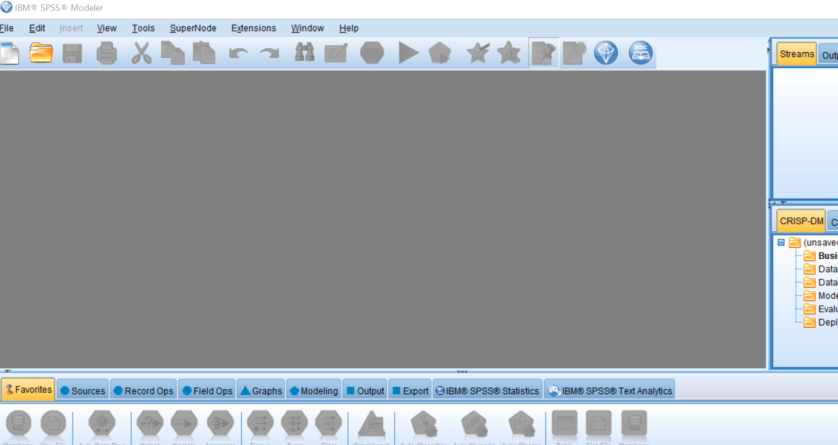

1. Open source file

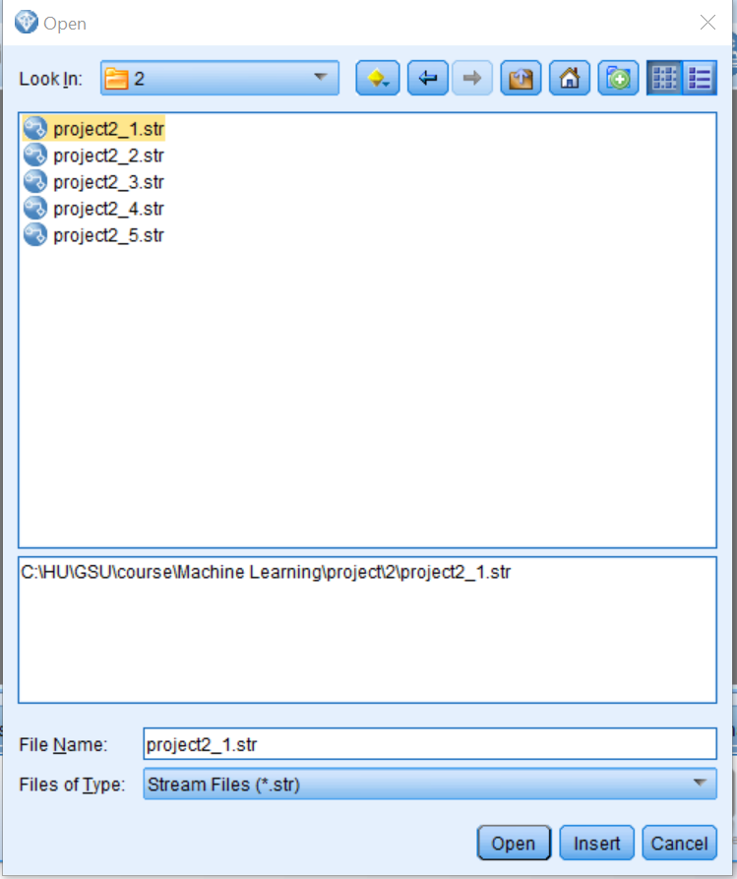

1. Execute the program

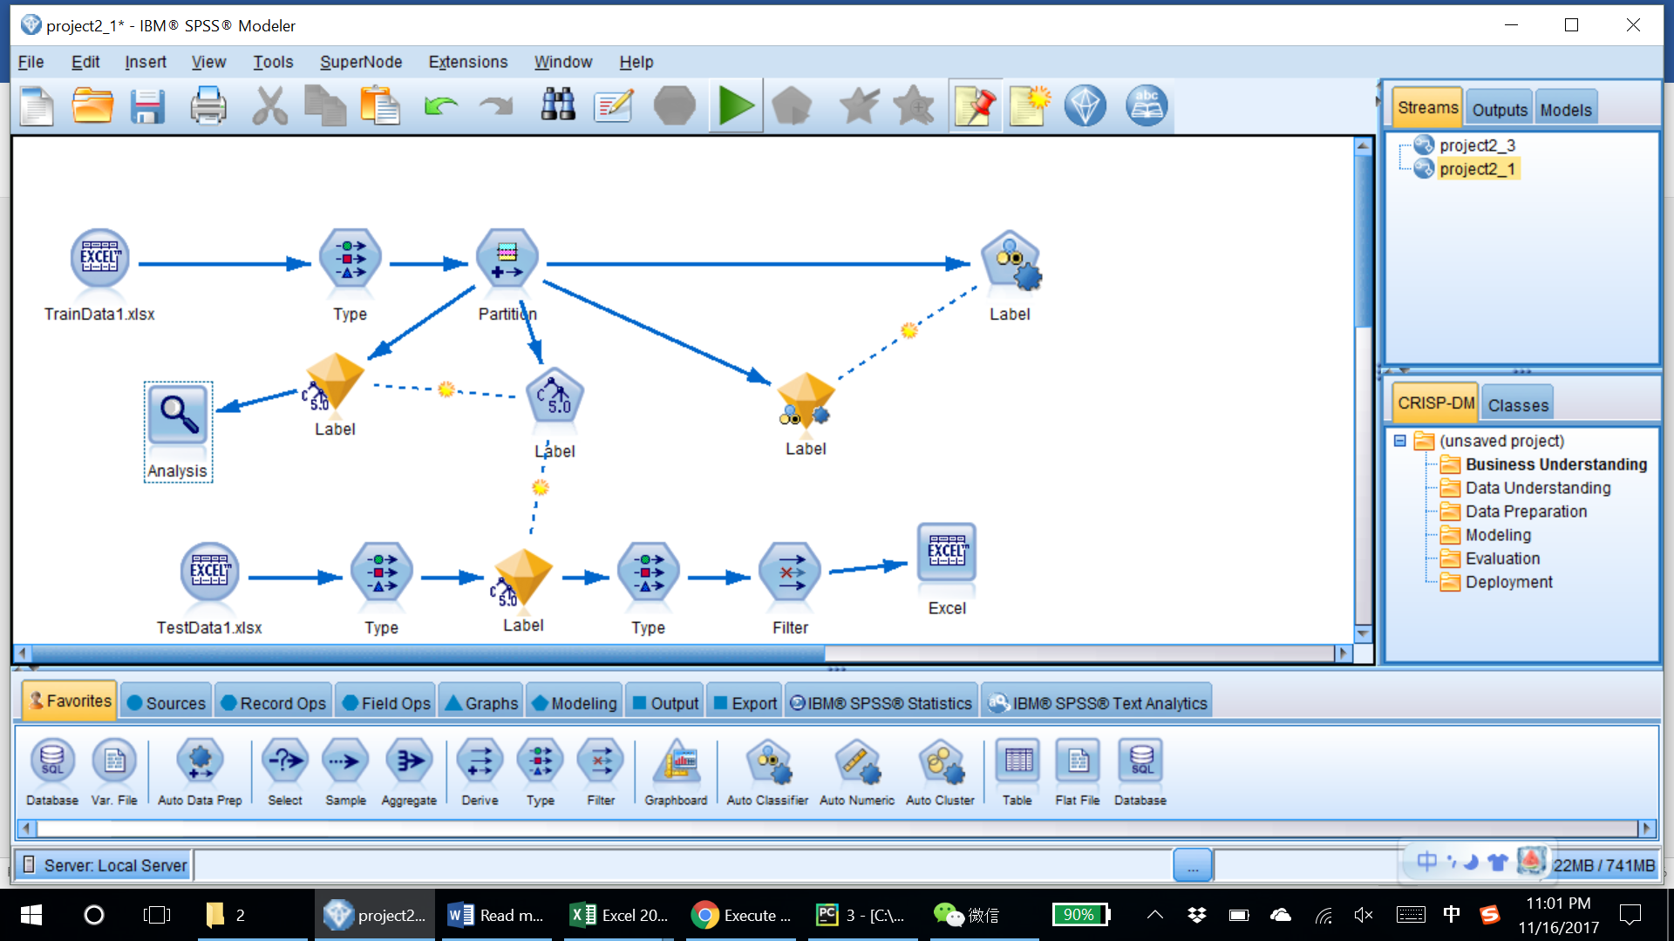

1. Get model accuracy for training

For Dataset1

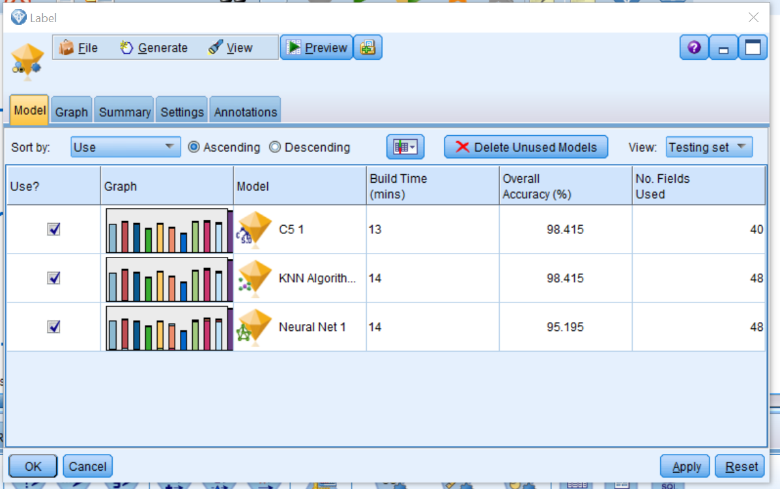

For Dataset2

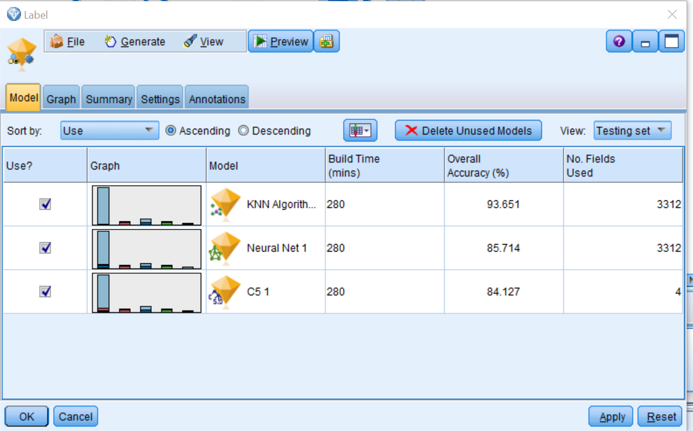

For Dataset3, using C5

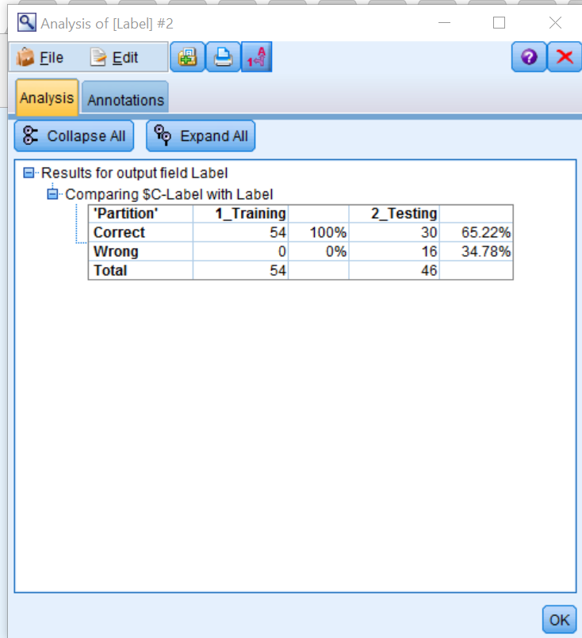

For Dataset4

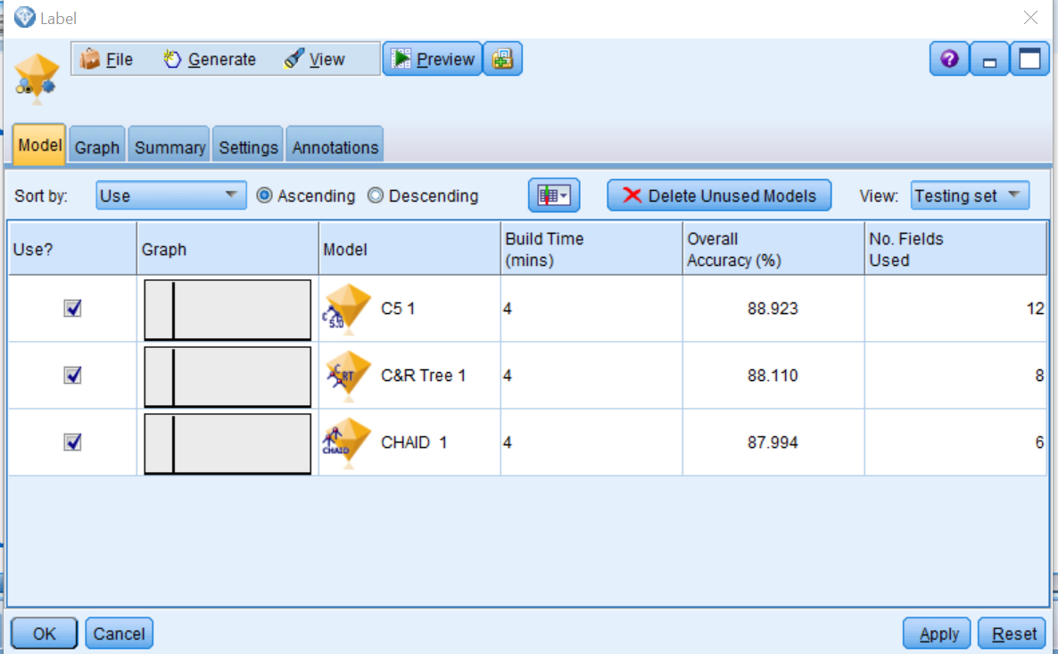

For Dataset5

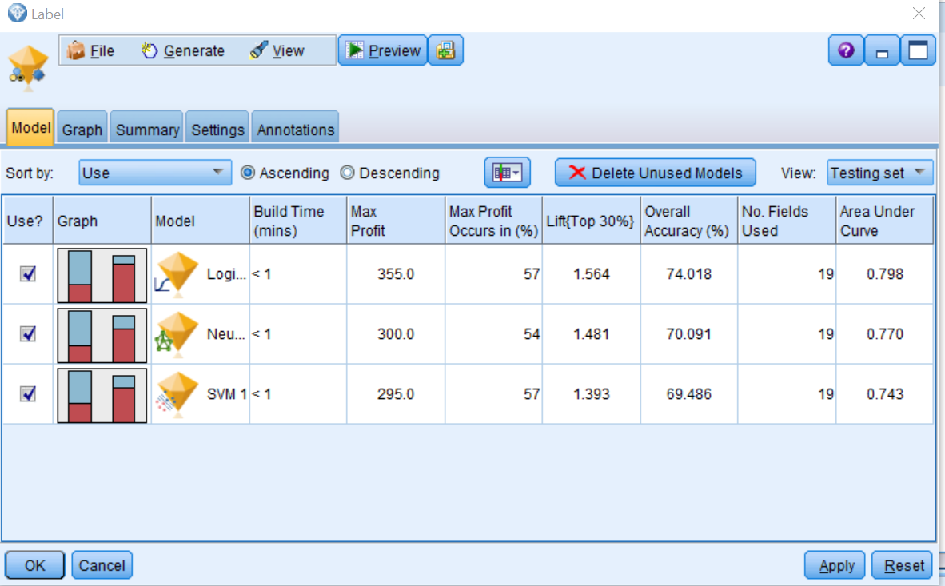

1. Choose which model is the best for this data
2. Get output result.