第一个核心技能点是**「BPF Hooks」**，即BPF钩子，也就是在内核中，哪些地方可以加载BPF程序，在目前的Linux内核中已经有了近10种的钩子，如下所示：

* kernel functions (kprobes)
* userspace functions (uprobes)
* system calls
* fentry/fexit
* Tracepoints
* network devices (tc/xdp)
* network routes
* TCP congestion algorithms
* sockets (data level)

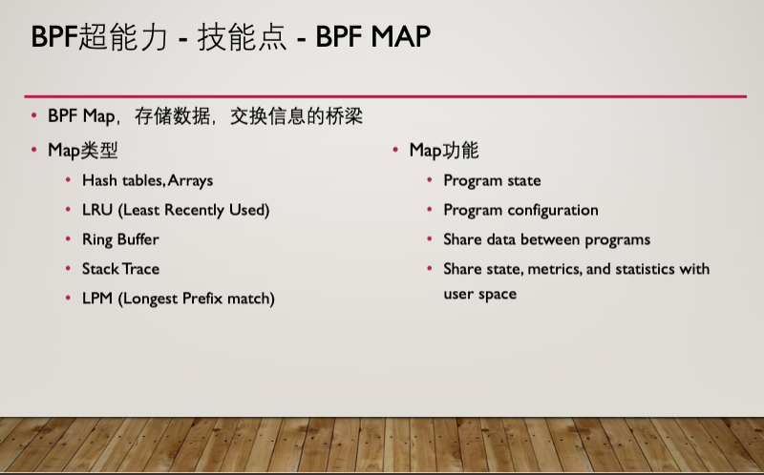

// SPDX-License-Identifier: GPL-2.0 OR BSD-3-Clause

/* Copyright (c) 2020 Facebook */

#include "vmlinux.h"

#include <bpf/bpf_helpers.h>

#include <bpf/bpf_tracing.h>

#include <bpf/bpf_core_read.h>

#include "bootstrap.h"

char LICENSE[] SEC("license") = "Dual BSD/GPL";

struct {

__uint(type, BPF_MAP_TYPE_HASH);

__uint(max_entries, 8192);

__type(key, pid_t);

__type(value, u64);

} exec_start SEC(".maps");

struct {

__uint(type, BPF_MAP_TYPE_RINGBUF);

__uint(max_entries, 256 * 1024);

} rb SEC(".maps");

const volatile unsigned long long min_duration_ns = 0;

SEC("tp/sched/sched_process_exec")

int handle_exec(struct trace_event_raw_sched_process_exec *ctx)

{

struct task_struct *task;

unsigned fname_off;

struct event *e;

pid_t pid;

u64 ts;

/* remember time exec() was executed for this PID */

pid = bpf_get_current_pid_tgid() >> 32;

ts = bpf_ktime_get_ns();

bpf_map_update_elem(&exec_start, &pid, &ts, BPF_ANY);

/* don't emit exec events when minimum duration is specified */

if (min_duration_ns)

return 0;

/* reserve sample from BPF ringbuf */

e = bpf_ringbuf_reserve(&rb, sizeof(*e), 0);

if (!e)

return 0;

/* fill out the sample with data */

task = (struct task_struct *)bpf_get_current_task();

e->exit_event = false;

e->pid = pid;

e->ppid = BPF_CORE_READ(task, real_parent, tgid);

bpf_get_current_comm(&e->comm, sizeof(e->comm));

fname_off = ctx->__data_loc_filename & 0xFFFF;

bpf_probe_read_str(&e->filename, sizeof(e->filename), (void *)ctx + fname_off);

/* successfully submit it to user-space for post-processing */

bpf_ringbuf_submit(e, 0);

return 0;

}

SEC("tp/sched/sched_process_exit")

int handle_exit(struct trace_event_raw_sched_process_template* ctx)

{

struct task_struct *task;

struct event *e;

pid_t pid, tid;

u64 id, ts, *start_ts, duration_ns = 0;

/* get PID and TID of exiting thread/process */

id = bpf_get_current_pid_tgid();

pid = id >> 32;

tid = (u32)id;

/* ignore thread exits */

if (pid != tid)

return 0;

/* if we recorded start of the process, calculate lifetime duration */

start_ts = bpf_map_lookup_elem(&exec_start, &pid);

if (start_ts)

duration_ns = bpf_ktime_get_ns() - *start_ts;

else if (min_duration_ns)

return 0;

bpf_map_delete_elem(&exec_start, &pid);

/* if process didn't live long enough, return early */

if (min_duration_ns && duration_ns < min_duration_ns)

return 0;

/* reserve sample from BPF ringbuf */

e = bpf_ringbuf_reserve(&rb, sizeof(*e), 0);

if (!e)

return 0;

/* fill out the sample with data */

task = (struct task_struct *)bpf_get_current_task();

e->exit_event = true;

e->duration_ns = duration_ns;

e->pid = pid;

e->ppid = BPF_CORE_READ(task, real_parent, tgid);

e->exit_code = (BPF_CORE_READ(task, exit_code) >> 8) & 0xff;

bpf_get_current_comm(&e->comm, sizeof(e->comm));

/* send data to user-space for post-processing */

bpf_ringbuf_submit(e, 0);

return 0;

}