**学习网站**

IView库：

http://v1.iviewui.com/docs/guide/install

Element库：

http://element-cn.eleme.io/#/zh-CN/component/installation

**安装ElementUI：**

1-安装npm

npm i element-ui -S

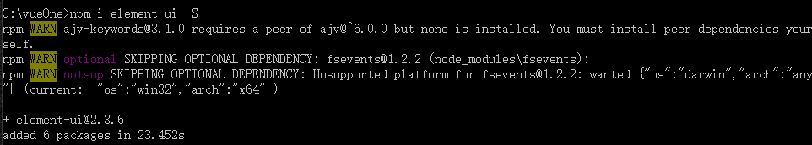

2-完整引入(在 main.js 中写入以下内容)

import ElementUI from 'element-ui';

import 'element-ui/lib/theme-chalk/index.css';

Vue.use(ElementUI);

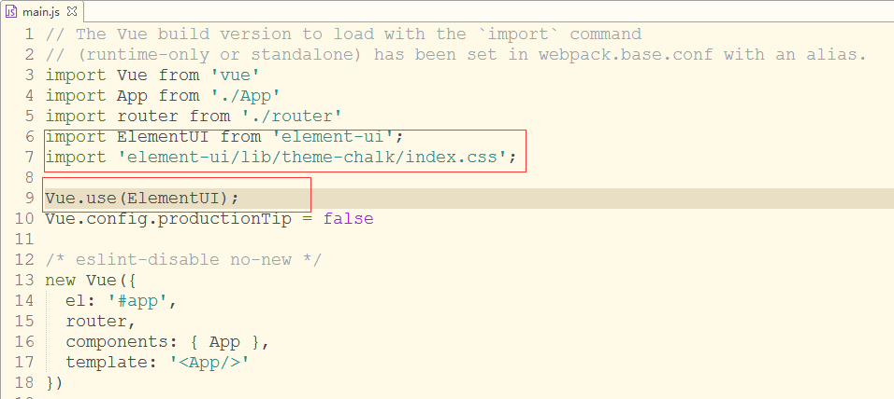

3-示例验证是否安装成功

<!--ElementUI-->

<el-row>

<el-button icon="el-icon-search" circle></el-button>

<el-button type="primary" icon="el-icon-edit" circle></el-button>

<el-button type="success" icon="el-icon-check" circle></el-button>

<el-button type="info" icon="el-icon-message" circle></el-button>

<el-button type="warning" icon="el-icon-star-off" circle></el-button>

<el-button type="danger" icon="el-icon-delete" circle></el-button>

</el-row>

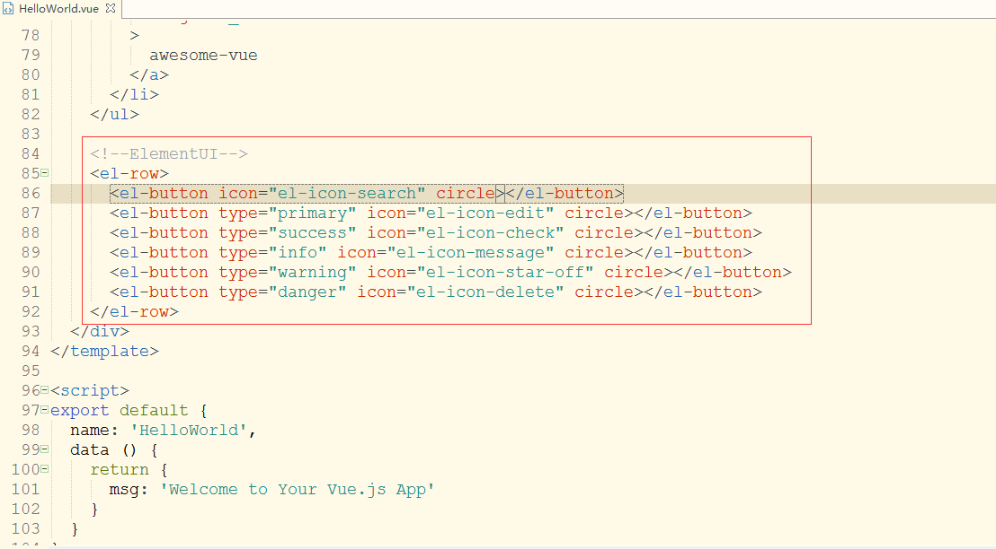

iView 是一套基于 Vue.js 的开源 UI 组件库，主要服务于 PC 界面的中后台产品。

**安装IView：**

1-安装npm

Npm install --save iview

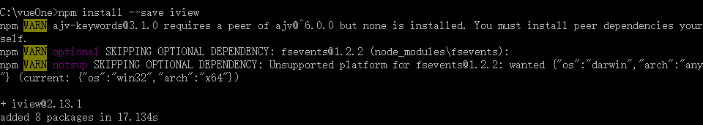

2-完整引入(在 main.js 中写入以下内容)

import iView from 'iview'

import 'iview/dist/styles/iview.css'

Vue.use(iView)

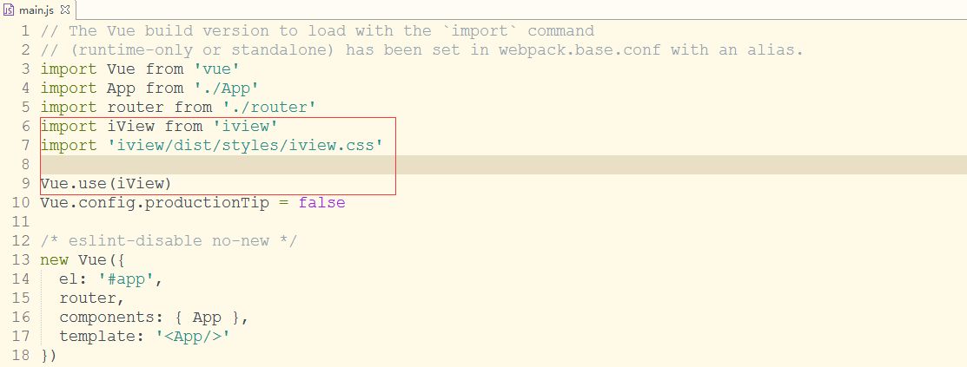

3-示例验证是否安装成功

<!--IViewUI-->

<i-button type="info">信息按钮</i-button>

<i-button type="success">成功按钮</i-button>

<i-button type="warning">警告按钮</i-button>

<i-button type="error">错误按钮</i-button>

