Huibo Zhao

hz2480

COMS4111 SEC003

EC1

Nov.18th.2017

The ddl and test sql codes are appended at the end of this document.

Employee table after Initial load & Test 1:

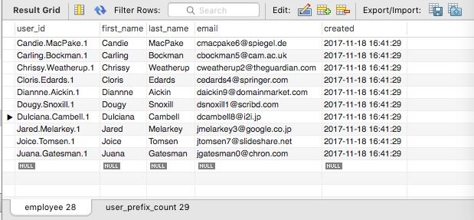

Employee table after Test 2:

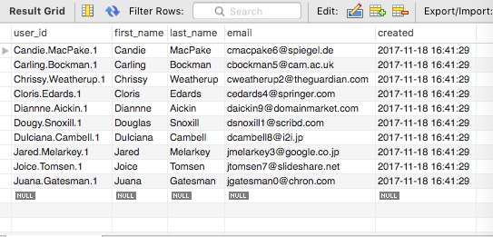

Result after Test 3:

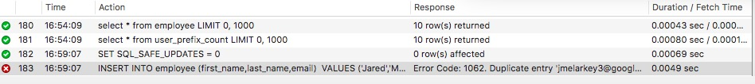

Full text: 16:59:07 INSERT INTO employee (first_name,last_name,email) VALUES ('Jared','Melarkey','jmelarkey3@google.co.jp') Error Code: 1062. Duplicate entry 'jmelarkey3@google.co.jp' for key 'email' 0.0049 sec

Result after Test 4:

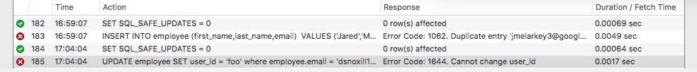

Full text: 17:04:04 UPDATE employee SET user_id = 'foo' where employee.email = 'dsnoxill1@scribd.com' Error Code: 1644. Cannot change user_id 0.0017 sec

Test 5:

Employee table after first insert (5 John Smith):

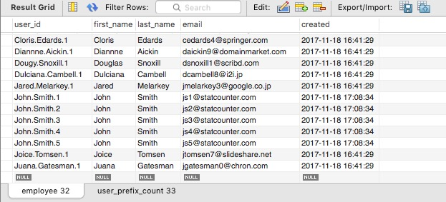

Employee table after delete:

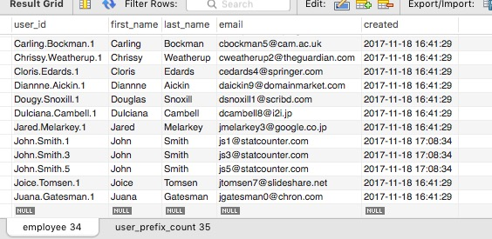

Result for select statement after second insert (Single John Smith):

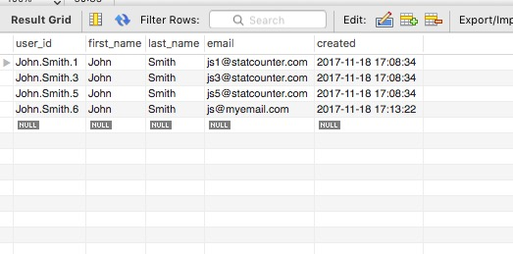

Appendix:

DDL:

--

-- Table structure for table `Employee`

--

DROP TABLE IF EXISTS `Employee`;

CREATE TABLE `Employee` (

`user_id` varchar(32) NOT NULL,

`first_name` varchar(32) NOT NULL,

`last_name` varchar(32) NOT NULL,

`email` varchar(32) NOT NULL,

`created` datetime,

PRIMARY KEY (`user_id`),

UNIQUE (`email`)

) ENGINE=InnoDB DEFAULT CHARSET=utf8;

--

-- Table structure for table `user_prefix_count`

--

DROP TABLE IF EXISTS `user_prefix_count`;

CREATE TABLE `user_prefix_count` (

`prefix` varchar(32) NOT NULL,

`max_value` int(12) NOT NULL,

PRIMARY KEY (`prefix`)

) ENGINE=InnoDB DEFAULT CHARSET=utf8;

# trigger before insert into `employee`

DROP TRIGGER IF EXISTS `trigger_insert_employee`;

DELIMITER $$

CREATE TRIGGER `trigger_insert_employee`

BEFORE INSERT ON `employee` FOR EACH ROW

BEGIN

DECLARE `prefix_name` VARCHAR(32);

DECLARE `existed` int(1);

DECLARE `count` int(12);

SET `prefix_name` = CONCAT(New.`first_name`, '.', New.`last_name`);

# check if `prefix_name` existed or not

SET `existed` = (select exists (select * from `user_prefix_count` where `prefix` = `prefix_name`));

# if existed, we increment its max_value field

# if not existed, we insert a new tuple to the `user_prefix_count` table

IF `existed` = 1 THEN

SET `count` = (select `max_value` from `user_prefix_count` where `prefix` = `prefix_name`) + 1;

UPDATE `user_prefix_count` SET `max_value` = `count` where `user_prefix_count`.`prefix` = `prefix_name`;

ELSE

SET `count` = 1;

INSERT INTO `user_prefix_count` (prefix,max_value) VALUES (`prefix_name`,1);

END IF;

SET New.`user_id` = CONCAT(New.`first_name`, '.', New.`last_name`,'.',`count`);

SET New.`created` = CURRENT_TIMESTAMP;

END $$

DELIMITER ;

# trigger before update on 'employee'

DROP TRIGGER IF EXISTS `trigger_update_employee`;

DELIMITER $$

CREATE TRIGGER `trigger_update_employee`

BEFORE UPDATE ON `employee` FOR EACH ROW

BEGIN

SET NEW.`created` = Old.`created`;

IF NOT NEW.`user_id` = Old.`user_id` THEN

SIGNAL SQLSTATE '45001'

SET MESSAGE_TEXT = 'Cannot change user_id';

end if;

END $$

DELIMITER ;

Test Codes:

SET SQL_SAFE_UPDATES = 0;

### test 1 ####################################################

/*

INSERT INTO employee (first_name,last_name,email)

VALUES ('Candie','MacPake','cmacpake6@spiegel.de');

INSERT INTO employee (first_name,last_name,email)

VALUES ('Carling','Bockman','cbockman5@cam.ac.uk');

INSERT INTO employee (first_name,last_name,email)

VALUES ('Chrissy','Weatherup','cweatherup2@theguardian.com');

INSERT INTO employee (first_name,last_name,email)

VALUES ('Cloris','Edards','cedards4@springer.com');

INSERT INTO employee (first_name,last_name,email)

VALUES ('Diannne','Aickin','daickin9@domainmarket.com');

INSERT INTO employee (first_name,last_name,email)

VALUES ('Dougy','Snoxill','dsnoxill1@scribd.com');

INSERT INTO employee (first_name,last_name,email)

VALUES ('Dulciana','Cambell','dcambell8@i2i.jp');

INSERT INTO employee (first_name,last_name,email)

VALUES ('Jared','Melarkey','jmelarkey3@google.co.jp');

INSERT INTO employee (first_name,last_name,email)

VALUES ('Joice','Tomsen','jtomsen7@slideshare.net');

INSERT INTO employee (first_name,last_name,email)

VALUES ('Juana','Gatesman','jgatesman0@chron.com');

*/

#####################################################################

### test 2 ####################################################

/*

UPDATE employee SET first_name = 'Douglas', `created` = CURRENT_TIMESTAMP

where employee.first_name = 'Dougy' and employee.last_name = 'Snoxill';

*/

#####################################################################

### test 3 ####################################################

/*

INSERT INTO employee (first_name,last_name,email)

VALUES ('Jared','Melarkey','jmelarkey3@google.co.jp');

*/

#####################################################################

### test 4 ####################################################

# UPDATE employee SET user_id = 'foo' where employee.email = 'dsnoxill1@scribd.com';

#####################################################################

### test 5 ####################################################

/*

INSERT INTO employee (first_name,last_name,email)

VALUES ('John','Smith','js1@statcounter.com');

INSERT INTO employee (first_name,last_name,email)

VALUES ('John','Smith','js2@statcounter.com');

INSERT INTO employee (first_name,last_name,email)

VALUES ('John','Smith','js3@statcounter.com');

INSERT INTO employee (first_name,last_name,email)

VALUES ('John','Smith','js4@statcounter.com');

INSERT INTO employee (first_name,last_name,email)

VALUES ('John','Smith','js5@statcounter.com');

*/

/*

DELETE FROM employee WHERE `email`='js2@statcounter.com';

DELETE FROM employee WHERE `email`='js4@statcounter.com';

*/

/*

INSERT INTO employee (first_name,last_name,email)

VALUES ('John','Smith','js@myemail.com');

select * from employee where last_name = 'Smith';

*/

#####################################################################

select * from employee;

select * from user_prefix_count;