Huibo Zhao

hz2480

COMS4111 SEC003

EC2

Nov.25th.2017

Here is the base table:

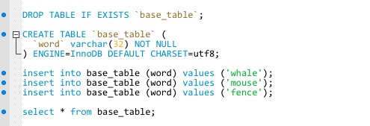

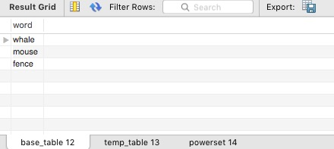

Here is the DDL and final result for powerset table:

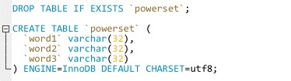

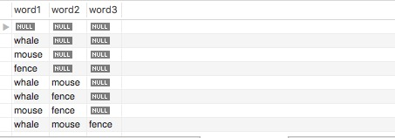

Here is the set of procedures:

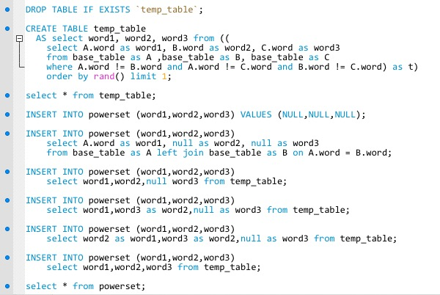

First, we create a temp table. The queries will generate six rows of combination of those 3 words. By adding the condition order by rand() limit 1, we randomly select a row as temp_table. Note that each row is a unique combination of three words, they are just different in orders.

Here is what we have after creating temp_table:

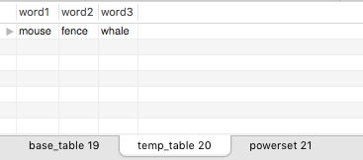

Then, we add each types of data into the powerset table: all null, one unique word with two null, two unique words combination with one null and three unique word combination.

The all codes for this extra credit assignment is attached below

Appendix:

DROP TABLE IF EXISTS `base_table`;

CREATE TABLE `base_table` (

`word` varchar(32) NOT NULL

) ENGINE=InnoDB DEFAULT CHARSET=utf8;

insert into base_table (word) values ('whale');

insert into base_table (word) values ('mouse');

insert into base_table (word) values ('fence');

select * from base_table;

DROP TABLE IF EXISTS `powerset`;

CREATE TABLE `powerset` (

`word1` varchar(32),

`word2` varchar(32),

`word3` varchar(32)

) ENGINE=InnoDB DEFAULT CHARSET=utf8;

DROP TABLE IF EXISTS `temp_table`;

CREATE TABLE temp_table

AS select word1, word2, word3 from ((

select A.word as word1, B.word as word2, C.word as word3

from base_table as A ,base_table as B, base_table as C

where A.word != B.word and A.word != C.word and B.word != C.word) as t)

order by rand() limit 1;

select * from temp_table;

INSERT INTO powerset (word1,word2,word3) VALUES (NULL,NULL,NULL);

INSERT INTO powerset (word1,word2,word3)

select A.word as word1, null as word2, null as word3

from base_table as A left join base_table as B on A.word = B.word;

INSERT INTO powerset (word1,word2,word3)

select word1,word2,null word3 from temp_table;

INSERT INTO powerset (word1,word2,word3)

select word1,word3 as word2,null as word3 from temp_table;

INSERT INTO powerset (word1,word2,word3)

select word2 as word1,word3 as word2,null as word3 from temp_table;

INSERT INTO powerset (word1,word2,word3)

select word1,word2,word3 from temp_table;

select * from powerset;