Huibo Zhao

hz2480

COMS4111 SEC003

EC3

Dec.12th.2017

The code is in the appendix, which is at the end of this document.

Here is the initial checking and saving table:

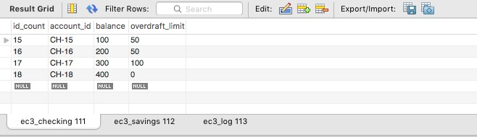

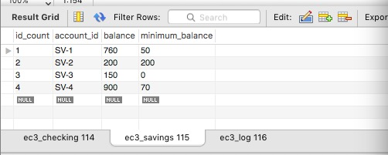

After Test 1:

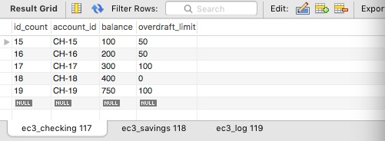

After Test 2:

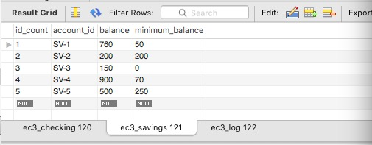

After Test 3:

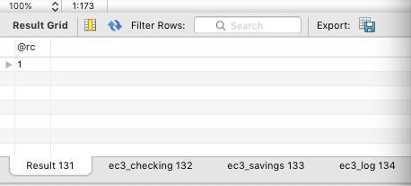

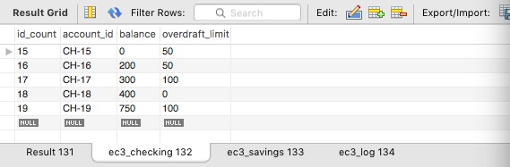

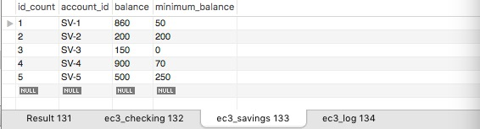

After test 4:

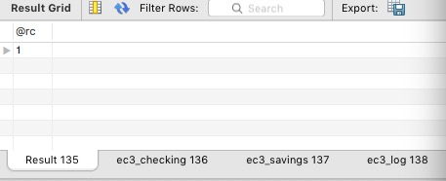

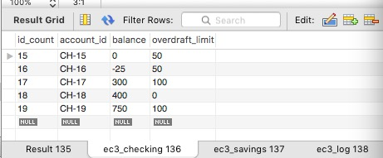

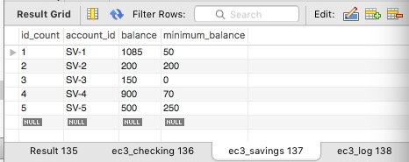

After test 5:

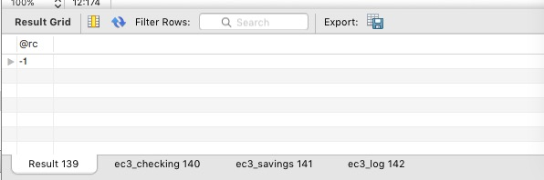

Tables have no change.

Final result:

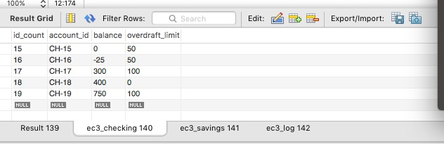

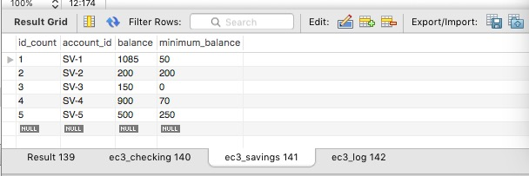

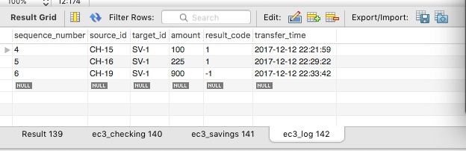

Appendix:

/*

DROP TABLE IF EXISTS `ec3_checking`;

CREATE TABLE `ec3_checking` (

`id_count` int(11) NOT NULL AUTO_INCREMENT,

`account_id` varchar(12) DEFAULT NULL,

`balance` float NOT NULL,

`overdraft_limit` float NOT NULL,

PRIMARY KEY (`id_count`),

UNIQUE KEY `id_count_UNIQUE` (`id_count`)

) ENGINE=InnoDB AUTO_INCREMENT=14 DEFAULT CHARSET=utf8;

DROP TABLE IF EXISTS `ec3_savings`;

CREATE TABLE `ec3_savings` (

`id_count` int(11) NOT NULL AUTO_INCREMENT,

`account_id` varchar(12) DEFAULT NULL,

`balance` float NOT NULL,

`minimum_balance` float NOT NULL,

PRIMARY KEY (`id_count`),

UNIQUE KEY `id_count_UNIQUE` (`id_count`)

) ENGINE=InnoDB AUTO_INCREMENT=1 DEFAULT CHARSET=utf8;

DROP TABLE IF EXISTS `ec3_log`;

CREATE TABLE `ec3_log` (

`sequence_number` int(11) NOT NULL AUTO_INCREMENT,

`source_id` varchar(12) DEFAULT NULL,

`target_id` varchar(12) DEFAULT NULL,

`amount` float DEFAULT NULL,

`result_code` int DEFAULT NULL,

`transfer_time` timestamp,

PRIMARY KEY (`sequence_number`)

) ENGINE=InnoDB AUTO_INCREMENT=4 DEFAULT CHARSET=utf8;

DROP TRIGGER IF EXISTS `trigger_insert_checking`;

DELIMITER $$

CREATE TRIGGER `trigger_insert_checking`

BEFORE INSERT ON `ec3_checking` FOR EACH ROW

BEGIN

IF NOT EXISTS (select * from `ec3_checking`) THEN

SET New.account_id = "CH-14";

ELSE

SET New.account_id = CONCAT("CH-",(select max(id_count) from `ec3_checking`)+1);

end if;

END $$

DELIMITER ;

DROP TRIGGER IF EXISTS `trigger_insert_saving`;

DELIMITER $$

CREATE TRIGGER `trigger_insert_saving`

BEFORE INSERT ON `ec3_savings` FOR EACH ROW

BEGIN

IF NOT EXISTS (select * from `ec3_savings`) THEN

SET New.account_id = "SV-1";

ELSE

SET New.account_id = CONCAT("SV-",(select max(id_count) from `ec3_savings`)+1);

end if;

END $$

DELIMITER ;

DROP PROCEDURE IF EXISTS `transfer_commit`;

DELIMITER $$

CREATE PROCEDURE `transfer_commit` (source_id VARCHAR(12),target_id VARCHAR(12),

amount float,OUT rc int)

BEGIN

DECLARE temp_balance float;

IF source_id LIKE "CH-%" THEN

IF ((select balance from `ec3_checking` where `account_id` = source_id) - amount) >

(-1.0 * (select overdraft_limit from `ec3_checking` where `account_id` = source_id)) THEN

# Debit the balance in the source account

SET temp_balance = (select balance from `ec3_checking` where `account_id` = source_id);

update `ec3_checking` set balance = temp_balance - amount where account_id = source_id;

# Increase the balance in the target account

IF target_id LIKE "CH-%" THEN

SET temp_balance = (select balance from `ec3_checking` where `account_id` = target_id);

update `ec3_checking` set balance = temp_balance + amount where account_id = target_id;

END IF;

IF target_id LIKE "SV-%" THEN

SET temp_balance = (select balance from `ec3_savings` where `account_id` = target_id);

update `ec3_savings` set balance = temp_balance + amount where account_id = target_id;

END IF;

# Write a log record containing the source account id,

# target account id, amount and an rc=1 to the log table

INSERT INTO `ec3_log` (`source_id`, `target_id`, `amount`, `result_code`)

VALUES (source_id,target_id,amount,1);

SET rc = 1;

ELSE

INSERT INTO `ec3_log` (`source_id`, `target_id`, `amount`, `result_code`)

VALUES (source_id,target_id,amount,-1);

SET rc = -1;

END IF;

ELSEIF source_id LIKE "SV-%" THEN

IF ((select balance from `ec3_savings` where `account_id` = source_id) - amount) >

(1.0 * (select minimum_balance from `ec3_savings` where `account_id` = source_id)) THEN

# Debit the balance in the source account

SET temp_balance = (select balance from `ec3_savings` where `account_id` = source_id);

update `ec3_savings` set balance = temp_balance - amount where account_id = source_id;

# Increase the balance in the target account

IF target_id LIKE "CH-%" THEN

SET temp_balance = (select balance from `ec3_checking` where `account_id` = target_id);

update `ec3_checking` set balance = temp_balance + amount where account_id = target_id;

END IF;

IF target_id LIKE "SV-%" THEN

SET temp_balance = (select balance from `ec3_savings` where `account_id` = target_id);

update `ec3_savings` set balance = temp_balance + amount where account_id = target_id;

END IF;

# Write a log record containing the source account id,

# target account id, amount and an rc=1 to the log table

INSERT INTO `ec3_log` (`source_id`, `target_id`, `amount`, `result_code`)

VALUES (source_id,target_id,amount,1);

SET rc = 1;

ELSE

INSERT INTO `ec3_log` (`source_id`, `target_id`, `amount`, `result_code`)

VALUES (source_id,target_id,amount,-1);

SET rc = -1;

END IF;

END IF;

END $$

DELIMITER ;

# load initial data

INSERT INTO `ec3_checking` (balance,overdraft_limit) VALUES (0,0);

INSERT INTO `ec3_checking` (balance,overdraft_limit) VALUES (100,50);

INSERT INTO `ec3_checking` (balance,overdraft_limit) VALUES (200,50);

INSERT INTO `ec3_checking` (balance,overdraft_limit) VALUES (300,100);

INSERT INTO `ec3_checking` (balance,overdraft_limit) VALUES (400,0);

DELETE FROM `ec3_checking` where id_count = 14;

INSERT INTO `ec3_savings` (balance,minimum_balance) VALUES (760,50);

INSERT INTO `ec3_savings` (balance,minimum_balance) VALUES (200,200);

INSERT INTO `ec3_savings` (balance,minimum_balance) VALUES (150,0);

INSERT INTO `ec3_savings` (balance,minimum_balance) VALUES (900,70);

# test 1

INSERT INTO `ec3_checking` (balance,overdraft_limit) VALUES (750,100);

# test 2

INSERT INTO `ec3_savings` (balance, minimum_balance) values(500, 250);

# test 3

call transfer_commit("CH-15", "SV-1",100,@rc);

select @rc;

# test 4

call transfer_commit("CH-16", "SV-1",225,@rc);

select @rc;

*/

# test 5:

call transfer_commit("CH-19", "SV-1",900,@rc);

select @rc;

#call transfer_commit("V-15", "SV-1",100,@rc);

#select @rc;

select * from `ec3_checking`;

select * from `ec3_savings`;

select * from `ec3_log`;