Huibo Zhao

hz2480

COMS4111 SEC003

HW5

Dec.14th.2017

Part1:

Sql:

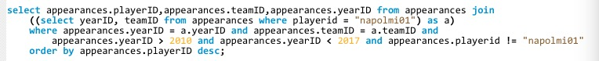

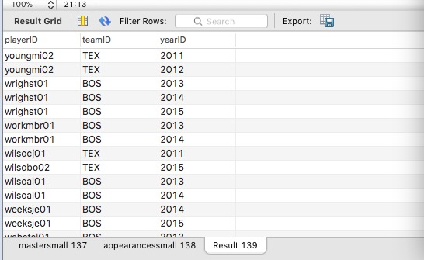

Neo4j:

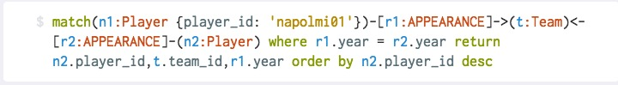

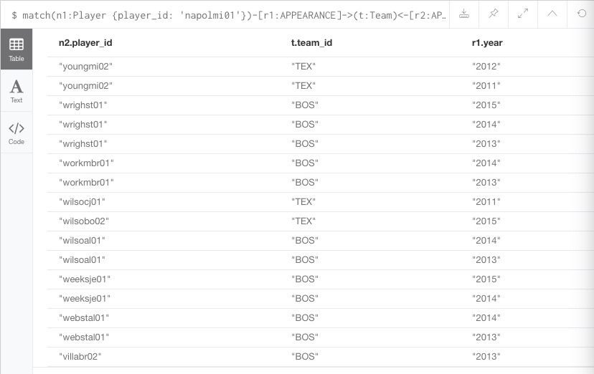

Part 2:

Initially, we have nothing stored in Redis.

Macintosh HD:Users:apple:Library:Containers:com.tencent.xinWeChat:Data:Library:Application Support:com.tencent.xinWeChat:2.0b4.0.9:347d71f6a64c6354b86d9300e21cf8b9:Message:MessageTemp:347d71f6a64c6354b86d9300e21cf8b9:Image:1951513434755_.pic.jpg

Then, we call find\_by\_id(“napolmi01”)

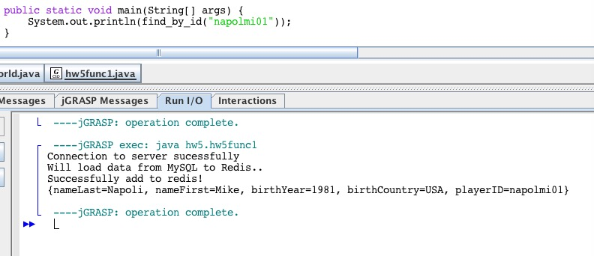

Checking Redis again, we could see that the data is loaded into Redis

Macintosh HD:Users:apple:Library:Containers:com.tencent.xinWeChat:Data:Library:Application Support:com.tencent.xinWeChat:2.0b4.0.9:347d71f6a64c6354b86d9300e21cf8b9:Message:MessageTemp:347d71f6a64c6354b86d9300e21cf8b9:Image:1971513435397_.pic.jpg

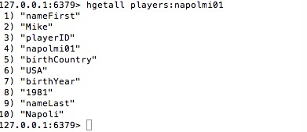

Calling find\_by\_id function again, it would find data from redis directly.

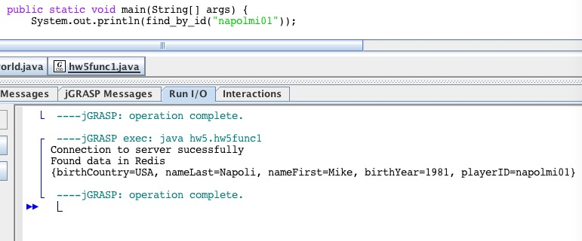

The above test examines all four functions. The codes are attached below. Please examine. I use a map format instead of JSON, which I got approved by our professor on Piazza.