1.

(a)

The number of support vectors for C=1 is 12, for C=100 is 10.

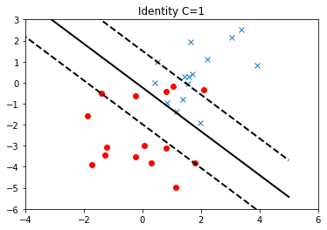

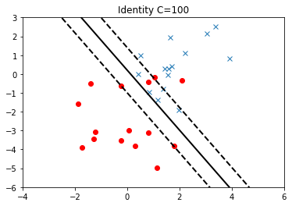

(b)

The number of support vectors for C=1 is 24, for C=3 is 21.

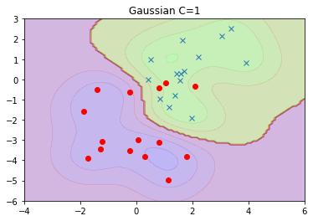

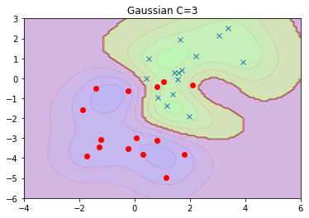

2.

(a) The accuracy of a classifier is 0.1. Sine you guess the class label uniformly, and there’s ten labels total, then the probability that you are right is 0.1.

(b) The accuracy of the train model on the test set is 16.18%.

(c) A classifier with high $γ$ has low bias and high variance. Consider when $γ$ is quite small, then all k will almost equal to 1, that’s the case of underfitting. So, similarly, when $γ$ is large, it will cause overfitting. Overfitting means low bias and high variance.

(d)

By performing 5-fold cv, the best values of C is 3, $γ$ is 0.05. The corresponding test accuracy is 96.57%.