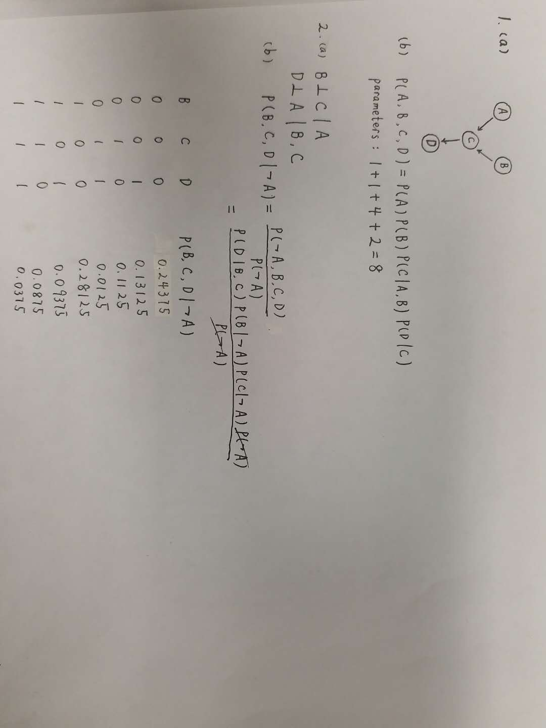

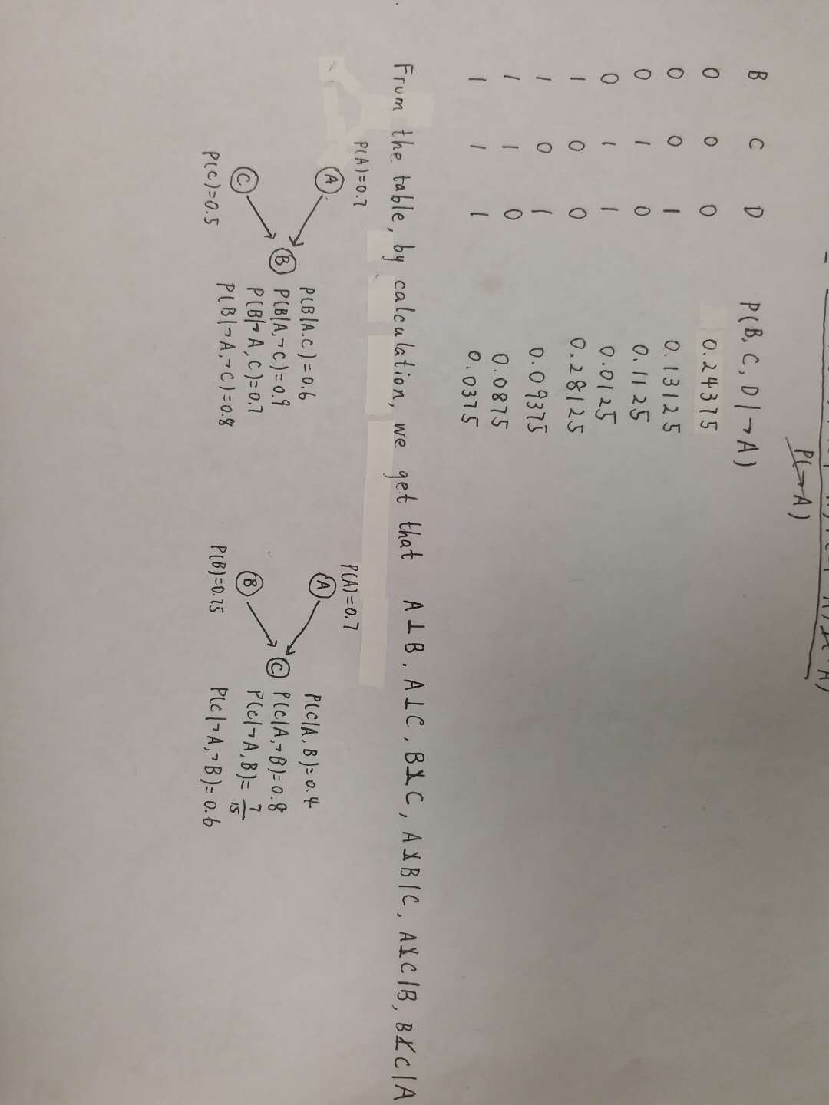

4.

(a)

K=2

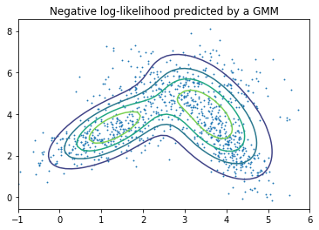

K=3

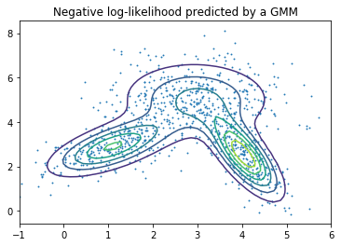

K=5

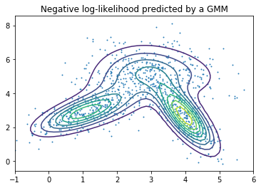

K=10

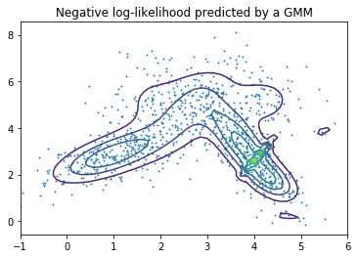

(b)

1 step:

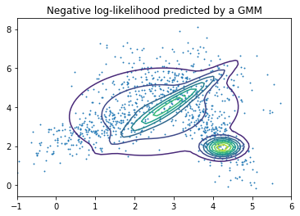

5 steps:

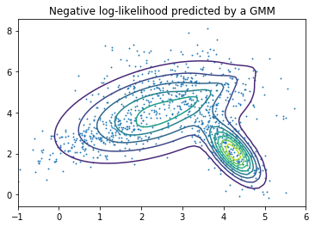

10 steps:

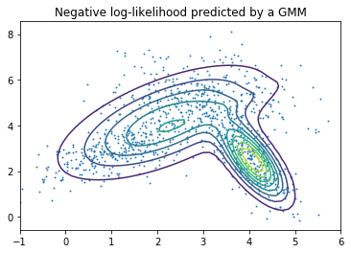

20 steps:

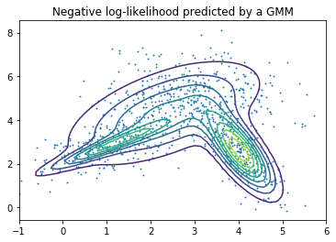

50 steps:

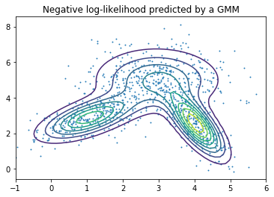

Model parameters:

$π$:

[0.29085370724411608, 0.41871863656465769, 0.29042765619122624]

$μ$:

[[1.0552311330913857, 2.8599948528529326],

[2.9603051263510638, 5.0069983235458944],

[4.0518992929984305, 2.4815516213917506]]

$Σ$:

[array([[ 0.62283072, 0.36501207],

[ 0.36501207, 0.53719646]]),

array([[ 1.01032542, -0.01279441],

[-0.01279441, 1.05066972]]),

array([[ 0.21541969, -0.36190934],

[-0.36190934, 1.12336943]])]