Hui Cai

This handwriting is for problem 1 and 3.

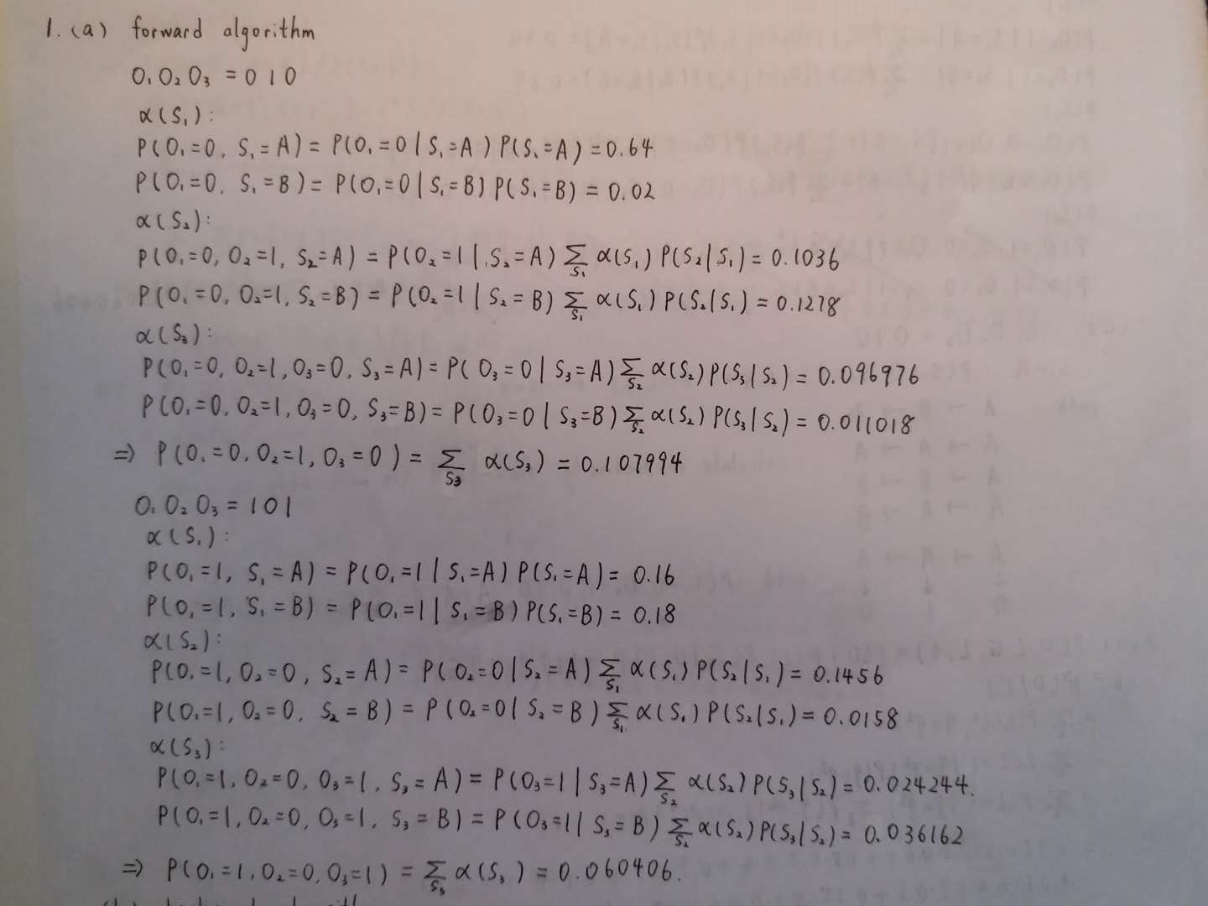

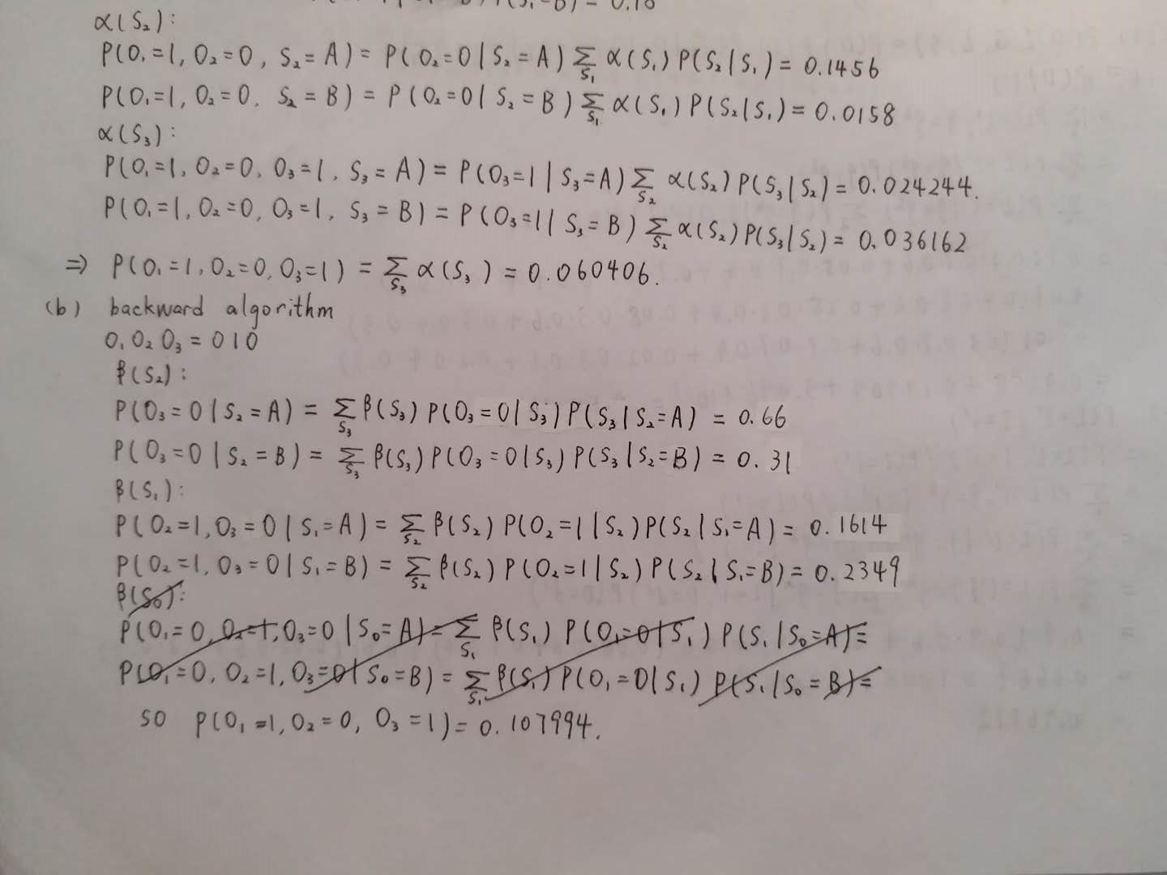

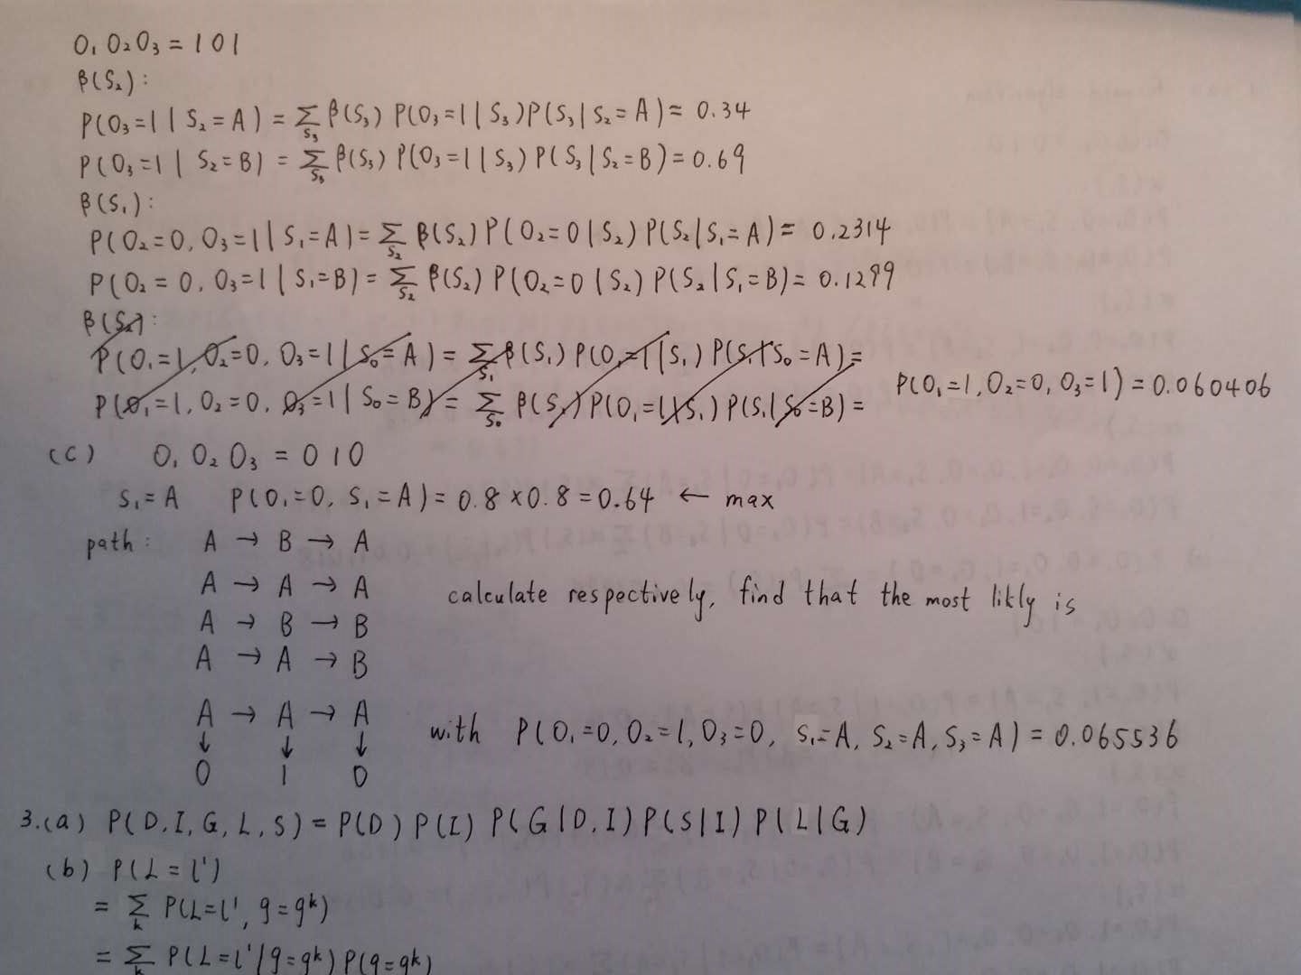

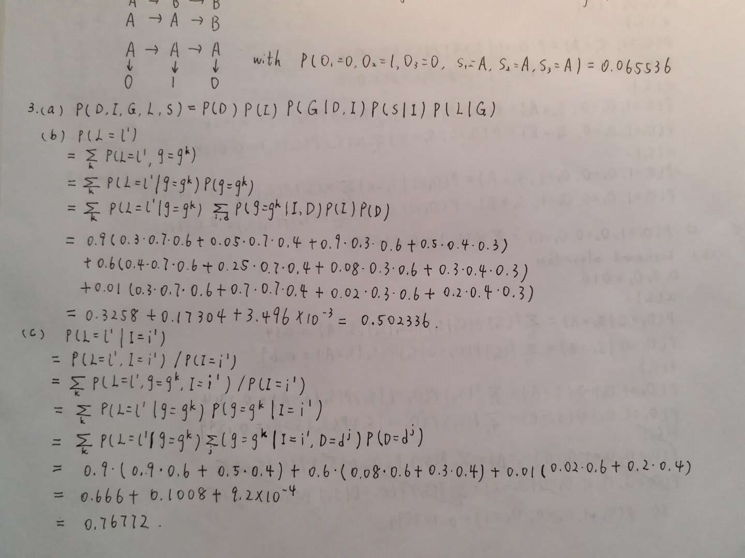

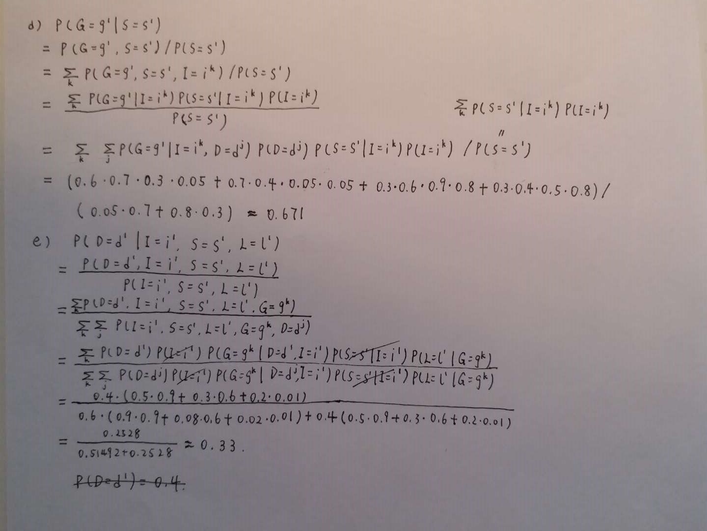

2.

Iterate 10 times.

K=2

Transition Probability

array([[ 0.12044337, 0.87955663],

[ 0.9910059 , 0.0089941 ]])

Emission Probability

array([[ 5.99817846e-01, 2.00209763e-01, 1.99940581e-01,

3.18095450e-05],

[ 4.33452066e-06, 6.66587595e-01, 2.07313187e-16,

3.33408071e-01]])

K=4

Transition Probability

array([[ 5.14751585e-05, 7.19341565e-01, 2.69370553e-05,

2.80580022e-01],

[ 4.40058933e-02, 3.45646392e-04, 4.52532364e-01,

5.03116096e-01],

[ 2.09043317e-04, 9.99703756e-01, 2.79228264e-10,

8.72000617e-05],

[ 9.82158118e-01, 1.57920606e-02, 5.65622201e-04,

1.48419879e-03]])

Emission Probability

array([[ 8.69938202e-01, 1.30014169e-01, 2.32347424e-08,

4.76056216e-05],

[ 2.49142908e-05, 9.89941678e-01, 3.16054222e-18,

1.00334079e-02],

[ 3.05193658e-01, 1.55962763e-01, 5.38843579e-01,

2.29273184e-10],

[ 3.49642565e-01, 2.32387775e-03, 3.64553001e-06,

6.48029911e-01]])

The most likely sequence of states of length 4 when 1st observation is A:

1. 0101
2. 0130

4.

First:

array([ 0.24959319, -0.25652131, 0.3468611 , 0.005099 , 0.34297566,

-0.18943673, 0.31385097, -0.32173451, 0.31981745, 0.33853899,

0.20502118, -0.20273245, 0.30984085])

Second:

array([-0.31318631, -0.32130825, 0.11181554, 0.45672596, 0.21985693,

0.15387677, 0.31174761, -0.34918069, -0.2703984 , -0.23885931,

-0.30870354, 0.23495727, -0.07598235])

