Technical Test

Candidate: Ho Hui Chung

Job - Web Developer - Tyrell Systems Sdn. Bhd.

# (A) Programming Test

Card Game

Hosted on <https://github.com/huichungho/cakephp-4.x-mysql-docker-card-game>

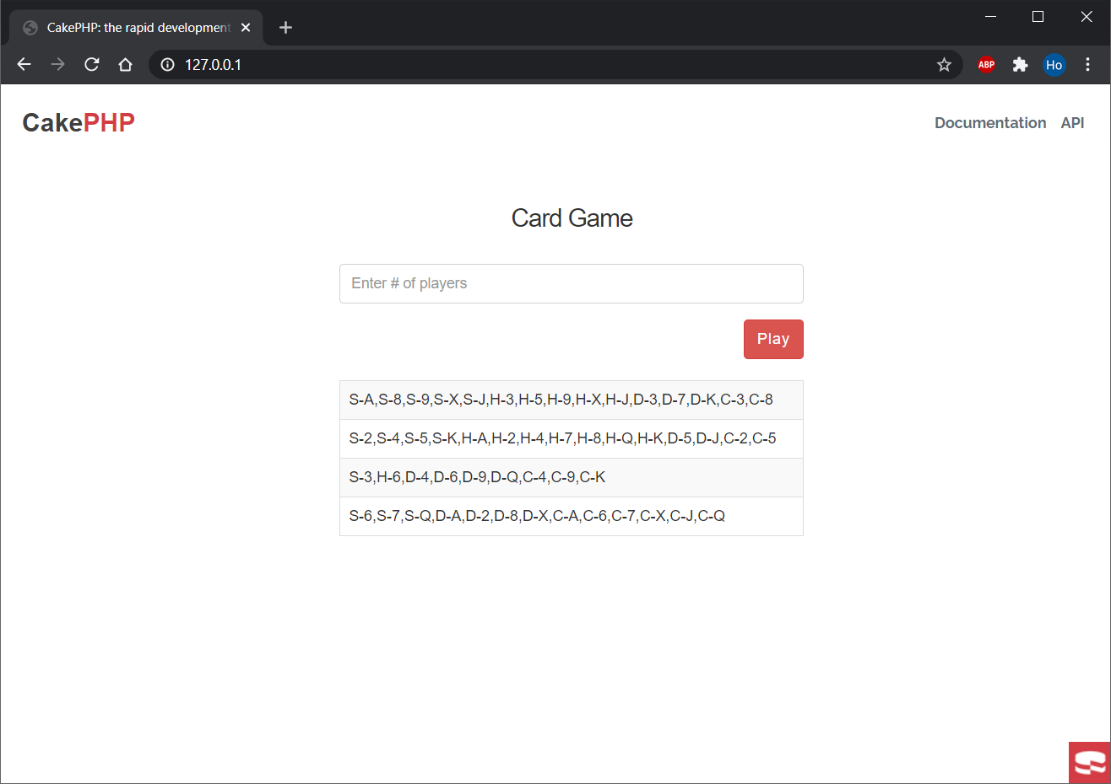

# (B) SQL Improvement Logic Test

Purpose: These are a SQL query that produces a search result. The query produces results in

approximately 8 seconds.

To do: Suggest what improvements should be done to the query in order to improve its

performance.

1. **Indexing** order by columns

**ALTER** Table `Jobs` ADD INDEX (`sort_order`)

1. Use **subquery** to group Jobs table by id and serve the resulting table as an alias joining other tables. This can reduce the group size to number of rows in `Jobs` table rather than (`jobs`, `jobs_personalities`, `personalities`, `jobs_practical_skills`, `practical_skills`, `jobs_basic_abilities`, `basic_abilities`, `jobs_tools`)

**SELECT**

Jobs.id AS `Jobs__id`,

Jobs.name AS `Jobs__name`,

…

**FROM**

( SELECT * FROM `jobs` WHERE publish_status = 1 and deleted IS NULL GROUP BY id ORDER BY id) Jobs

**LEFT JOIN** jobs_personalities JobsPersonalities

ON Jobs.id = (JobsPersonalities.job_id)

**LEFT JOIN** personalities Personalities

ON (Personalities.id = (JobsPersonalities.personality_id)

…

**ORDER BY** Jobs.sort_order

**LIMIT** 50

**OFFSET** 0

1. Remove unnecessary string checking conditions and indexing the search column

Jobs.name **=** 'キャビンアテンダント'

**ALTER** Table `Jobs` ADD INDEX (`name `)

1. Putting **inner join** before **left join** to reduce unnecessary check computations *(only if the intention is to exclude records that has already removed from `*JobCategories*` or `* JobTypes*`)*

**…**

**INNER JOIN** job_categories JobCategories

ON (JobCategories.id = (Jobs.job_category_id)

AND (JobCategories.deleted) IS NULL)

**INNER JOIN** job_types JobTypes

ON (JobTypes.id = (Jobs.job_type_id)

AND (JobTypes.deleted) IS NULL)

**LEFT JOIN** jobs_personalities JobsPersonalities

ON Jobs.id = (JobsPersonalities.job_id)

…

Optimized Query

**ALTER** Table `Jobs` ADD INDEX (`sort_order`);

**ALTER** Table `Jobs` ADD INDEX (`name `);

**SELECT**

Jobs.id AS `Jobs__id`,

Jobs.name AS `Jobs__name`,

Jobs.media_id AS `Jobs__media_id`,

Jobs.job_category_id AS `Jobs__job_category_id`,

Jobs.job_type_id AS `Jobs__job_type_id`,

Jobs.description AS `Jobs__description`,

Jobs.detail AS `Jobs__detail`,

Jobs.business_skill AS `Jobs__business_skill`,

Jobs.knowledge AS `Jobs__knowledge`,

Jobs.location AS `Jobs__location`,

Jobs.activity AS `Jobs__activity`,

Jobs.academic_degree_doctor AS `Jobs__academic_degree_doctor`,

Jobs.academic_degree_master AS `Jobs__academic_degree_master`,

Jobs.academic_degree_professional AS `Jobs__academic_degree_professional`,

Jobs.academic_degree_bachelor AS `Jobs__academic_degree_bachelor`,

Jobs.salary_statistic_group AS `Jobs__salary_statistic_group`,

Jobs.salary_range_first_year AS `Jobs__salary_range_first_year`,

Jobs.salary_range_average AS `Jobs__salary_range_average`,

Jobs.salary_range_remarks AS `Jobs__salary_range_remarks`,

Jobs.restriction AS `Jobs__restriction`,

Jobs.estimated_total_workers AS `Jobs__estimated_total_workers`,

Jobs.remarks AS `Jobs__remarks`,

Jobs.url AS `Jobs__url`,

Jobs.seo_description AS `Jobs__seo_description`,

Jobs.seo_keywords AS `Jobs__seo_keywords`,

Jobs.sort_order AS `Jobs__sort_order`,

Jobs.publish_status AS `Jobs__publish_status`,

Jobs.version AS `Jobs__version`,

Jobs.created_by AS `Jobs__created_by`,

Jobs.created AS `Jobs__created`,

Jobs.modified AS `Jobs__modified`,

Jobs.deleted AS `Jobs__deleted`,

JobCategories.id AS `JobCategories__id`,

JobCategories.name AS `JobCategories__name`,

JobCategories.sort_order AS `JobCategories__sort_order`,

JobCategories.created_by AS `JobCategories__created_by`,

JobCategories.created AS `JobCategories__created`,

JobCategories.modified AS `JobCategories__modified`,

JobCategories.deleted AS `JobCategories__deleted`,

JobTypes.id AS `JobTypes__id`,

JobTypes.name AS `JobTypes__name`,

JobTypes.job_category_id AS `JobTypes__job_category_id`,

JobTypes.sort_order AS `JobTypes__sort_order`,

JobTypes.created_by AS `JobTypes__created_by`,

JobTypes.created AS `JobTypes__created`,

JobTypes.modified AS `JobTypes__modified`,

JobTypes.deleted AS `JobTypes__deleted`

**FROM**

( SELECT * FROM `jobs` WHERE publish_status = 1 and deleted IS NULL GROUP BY id ORDER BY id ) Jobs

**LEFT JOIN**

jobs_personalities JobsPersonalities

ON Jobs.id = (JobsPersonalities.job_id)

**LEFT JOIN**

personalities Personalities

ON (Personalities.id = (JobsPersonalities.personality_id)

AND (Personalities.deleted) IS NULL)

**LEFT JOIN**

jobs_practical_skills JobsPracticalSkills

ON Jobs.id = (JobsPracticalSkills.job_id)

**LEFT JOIN**

practical_skills PracticalSkills

ON (PracticalSkills.id = (JobsPracticalSkills.practical_skill_id)

AND (PracticalSkills.deleted) IS NULL)

**LEFT JOIN**

jobs_basic_abilities JobsBasicAbilities

ON Jobs.id = (JobsBasicAbilities.job_id)

**LEFT JOIN**

basic_abilities BasicAbilities

ON (BasicAbilities.id = (JobsBasicAbilities.basic_ability_id)

AND (BasicAbilities.deleted) IS NULL)

**LEFT JOIN**

jobs_tools JobsTools

ON Jobs.id = (JobsTools.job_id)

**LEFT JOIN**

affiliates Tools

ON (Tools.type = 1

AND Tools.id = (JobsTools.affiliate_id)

AND (Tools.deleted) IS NULL)

**LEFT JOIN**

jobs_career_paths JobsCareerPaths

ON Jobs.id = (JobsCareerPaths.job_id)

**LEFT JOIN**

affiliates CareerPaths

ON (CareerPaths.type = 3

AND CareerPaths.id = (JobsCareerPaths.affiliate_id)

AND (CareerPaths.deleted) IS NULL)

**LEFT JOIN**

jobs_rec_qualifications JobsRecQualifications

ON Jobs.id = (JobsRecQualifications.job_id)

**LEFT JOIN**

affiliates RecQualifications

ON (RecQualifications.type = 2

AND RecQualifications.id = (JobsRecQualifications.affiliate_id)

AND (RecQualifications.deleted) IS NULL)

**LEFT JOIN**

jobs_req_qualifications JobsReqQualifications

ON Jobs.id = (JobsReqQualifications.job_id)

**LEFT JOIN**

affiliates ReqQualifications

ON (ReqQualifications.type = 2

AND ReqQualifications.id = (JobsReqQualifications.affiliate_id)

AND (ReqQualifications.deleted) IS NULL)

**INNER JOIN**

job_categories JobCategories

ON (JobCategories.id = (Jobs.job_category_id)

AND (JobCategories.deleted) IS NULL)

**INNER JOIN**

job_types JobTypes

ON (JobTypes.id = (Jobs.job_type_id)

AND (JobTypes.deleted) IS NULL)

**WHERE**

Jobs.name = 'キャビンアテンダント'

**ORDER BY** Jobs.sort_order

**LIMIT** 50

**OFFSET** 0