姓名：饶华城 学号：19072302008 专业：应用统计

# 习题3.4

16.1915-2004年澳大利亚每年与枪支有关的凶杀案死亡率（每10万人）如表3-5所示。

（1）绘制序列时序图，直观考察该序列的平稳性

Python代码：

import numpy as np

import pandas as pd

import pylab as plt

from statsmodels.stats.diagnostic import unitroot_adf

# 写入数据，x为死亡率，y为年份

x = np.array([0.5215052,0.4248284,0.4250311,0.4771938,

0.8280212,0.6156186,0.366627,0.4308883,

0.2810287,0.4646245,0.2693951,0.5779049,

0.5661151,0.5077584,0.7507175,0.6808395,

0.7661091,0.4561473,0.4977496,0.4193273,

0.6095514,0.457337,0.5705478,0.3478996,

0.3874993,0.5824285,0.2391033,0.2367445,

0.2626158,0.4240934,0.365275,0.3750758,

0.4090056,0.3891676,0.240261,0.1589496,

0.4393373,0.5094681,0.3743465,0.4339828,

0.4130557,0.3288928,0.5186648,0.5486504,

0.5469111,0.4963494,0.5308929,0.5957761,

0.5570584,0.5731325,0.5005416,0.5431269,

0.5593657,0.6911693,0.4403485,0.5676662,

0.5969114,0.4735537,0.5923935,0.5975556,

0.6334127,0.6057115,0.7046107,0.4805263,

0.702686,0.709017,0.6030854,0.6980919,

0.597656,0.8023421,0.6017109,0.5993127,

0.6025625,0.7016625,0.4995714,0.4980918,

0.497569,0.600183,0.3339542,0.274437,

0.3209428,0.5406671,0.4050209,0.2885961,

0.3275942,0.3132606,0.2575562,0.2138386,

0.1861856,0.1592713])

y = np.array(np.arange(len(x))+1915)

#合并数据

data = pd.Series(x,index=y)

# 画时间序列线图

data.plot(figsize=[15,4])

plt.show()

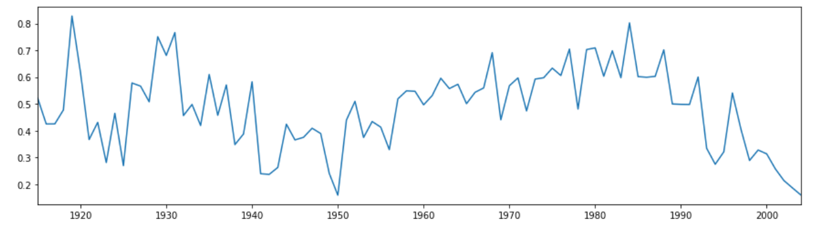

程序运行结果如图所示，从图分析可以看出波动较大，认为该时间序列不平稳。

（2）使用单位根检验的方法，判断该序列的平稳性。

Python代码：

# ADF检验

p_value = unitroot_adf(data)[1]

print("adf检验的p-value:",p_value)



根据程序运行结果，p值远大于0.05，因此我们暂时不能拒绝原假设，暂时认为该时间序列是非平稳的。

17.1860-1955年密歇根河每月平均水位的最高值序列如表2-1所示。

（1）绘制时间序列线图，用直观的方法考察序列的平稳特征。

Python代码：

import numpy as np

import pandas as pd

import pylab as plt

from statsmodels.stats.diagnostic import unitroot_adf

# 写入数据，x为死亡率，y为年份

x = np.array([83.3,83.5,83.2,82.6,82.2,82.1,81.7,

82.2,81.6,82.1,82.7,82.8,81.5,82.2,

82.3,82.1,83.6,82.7,82.5,81.5,82.1,

82.2,82.6,83.3,83.1,83.3,83.7,82.9,

82.3,81.8,81.6,80.9,81,81.3,81.4,80.2,

80,80.85,80.83,81.1,80.7,81.1,80.83,

80.82,81.5,81.6,81.5,81.6,81.8,81.1,

80.5,80,80.7,81.3,80.7,80,81.1,81.87,

81.91,81.3,81,80.5,80.6,79.8,79.6,78.49,

78.49,79.6,80.6,82.3,81.2,79.1,78.6,78.7,

78,78.6,78.7,78.6,79.7,80,79.3,79,80.2,

81.5,80.8,81,80.96,81.1,80.8,79.7,80,

81.6,82.7,82.1,81.7,81.5])

y = np.array(np.arange(len(x))+1860)

data = pd.Series(x,index=y)

# 画时间序列线图

data.plot(figsize=[15,4])

plt.show()

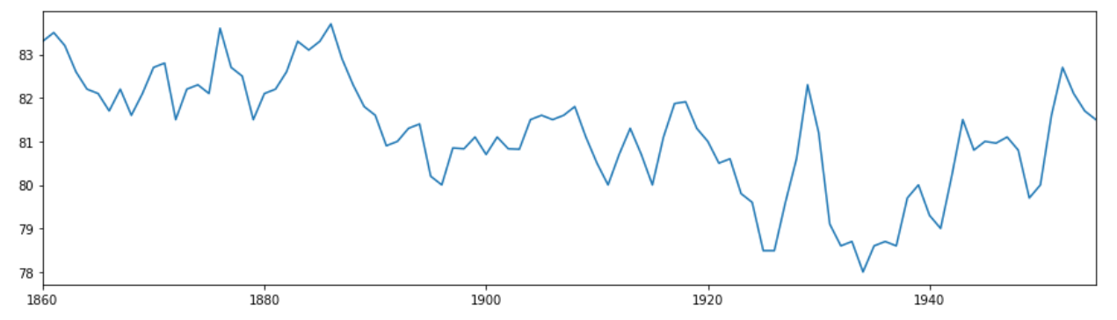

程序运行结果如图所示，从图分析可以看出存在一定的波动，认为该时间序列不平稳。

（2）使用单位根检验的方法，判断该序列的平稳性。

Python代码：

# ADF检验

p_value = unitroot_adf(data)[1]

print("adf检验的p-value:",p_value)



根据程序运行结果，p值大于0.05，因此我们暂时不能拒绝原假设，暂时认为该时间序列是非平稳的。