Predicting Customer Churn in Telecommunications: A Comparative Analysis of Classification Models
MAST6100 Individual Project Report
1. Introduction
Customer churn, also known as customer or subscriber churn, represents a challenge for telecommunication businesses. As telecommunication businesses operate within an increasingly competitive market, it is more expensive for businesses to gain customers as compared to maintaining them. It is evident that customer acquisition incurs five times as much cost as customer retention, and a ratio of 20:1 for some market share sections. Therefore, customer churn prediction plays a critical role within telecommunication businesses.
The telecom sector, with a considerably large customer turnover rate and an annual churn rate as high as 30% in some regions, represents a big challenge for the business organization regarding the formulation and implementation of customer retention strategies that will succeed in identifying high-risk customers as early as possible. The conventional response manner associated with customer turnover, whereby the organization acts after realizing that the customer intends to leave, may be expensive and ineffective. Also, customer dissatisfaction builds up with time at various contact points. Moreover, at the stage at which customers make an open statement regarding their dissatisfaction, they might have already changed their mind and joined a competing organization. Conversely, proactive efforts made by business organizations toward identifying possible customer loss can be an affordable act that will help save precious customer relationships.
The objective of this project will be to build and compare various models based on machine learning for prediction on customer churn based on Telco customer churn data set. Analysis of customers who are at risk of attrition will enable telecom service providers to optimize resource utilization and develop personalized customer retention plans.
The research question being posed within this analysis is: Which classification algorithm can make the most reliable prediction regarding customer churn within the telecomm sector? To address our research question, we selected and compared the performance of four different classification algorithms: General Linear Model/Logistic Regression (GLM), RF, XGBoost, and Deep Learning. All these classification algorithms correspond with different generations within the classification paradigm of modern ML.
2. Literature Review
Lately, customer churn prediction with different machine learning models and techniques has received significant research interests because it plays an increasingly important role within business operation. A high turnover rate and highly competitive market make telecom a very active sector on customer churn prediction research.
Vafeiadis et al. (2015) performed an extensive comparative analysis on widely used machine learning techniques for loss prediction. The researchers employed cross-validation on public datasets to analyze several algorithms, ranging from support vector machines and random forest classification to gradient lifting. Their contribution highlights that an integrated technique, and more so with the adoption of gradient lifting, will normally perform better compared to solely using a classification model. It becomes clear that the accuracy level for polynomial SVM with a lift technique is almost 97%, serving as a reference for comparative classification techniques applicable within a churn prediction scenario.
Brandusoiu et al. (2016) targeted telecom loss prediction using an artificial neural network in the prepaid mobile service domain. Their research work involved a list of calls data set with more than 3,000 subscribers and 21 features. The current research works on various architectures for a neural network and compares them with support vector machines and Bayesian networks. From the research done by Brandusoiu et al. (2016), it is clear that deep learning architectures are capable of learning nonlinear relationships between customer attributes and churn rates. The researcher highlights that there are interpretability issues associated with the neural network model.
A comprehensive research on customer churn prediction has been done by Ahmad et al. (2019), wherein they have applied machine learning on the big data platform. Their research addresses the scalability issue and develops the model on Apache Spark. Their research focuses on comparing decision tree, random forest, gradient elevator tree, and XGBoost algorithm. Their research concludes that XGBoost gives the best result with an AUC value of 93.3%. It is very important because they have included features from social network analysis.
A research on customer churn prediction with a focus on feature selection was conducted by Lalwani et al. (2022). The research uses a combination of a gravity search algorithm for feature selection and classification. It shows that intelligent feature selection can result in higher classification accuracy and lower complexity. From these research papers, it can be deduced that customer churn prediction research area is mature with perfect research methodology, and there is still an ongoing debate on model complexity and interpretability.

3. Data Description
To analyze this problem, I have relied on Telco customer churn data set. It holds detailed information about customers. It is quite a popular benchmark data set among researchers working on brain drain prediction and can be downloaded from Kaggle platform. The data set consists of 7,043 entries with 21 variables covering various aspects about customer demographics and accounts.
From our exploration of preliminary data, we have been able to identify that there are 11 missing values for TotalCharges, which make up 0.16% of our total data set. Based on our observation, it appears that these missing values belong to customers who have short-term service, meaning they might have been new customers with not yet full service records. In view of the small proportion of missing data, we choose to delete these observations. The final cleaned data set contains 7,032 customers.
The target variable is Churn, which is a binary indicator that shows whether the customer left the company last month. The data set shows unbalanced categories, with 5,163 customers (73.4%) retained and 1,869 customers (26.6%) lost. This ratio of about three to one is typical in the telecommunications industry and must be carefully considered in the process of model training and evaluation.
Table 1: Summary of Dataset Characteristics
Characteristic | Value
Total observations | 7,032
Training set size | 5,626 (80%)
Test set size | 1,406 (20%)
Number of features | 19 (after removing customerID and Churn)
Churn rate | 26.6%
Missing values | 11 (0.16%)
Predictive variables can be organized into four conceptually different categories. Demographic information includes gender, senior citizenship and whether the customer has a partner or dependent. Service-related features capture the types of telecommunication services subscribed by each customer, including telephone service, Internet type and various additional services, such as online security, backup, equipment protection, technical support and streaming media services. Account information variables capture financial and contractual aspects, including tenure (number of months as a customer), contract type, payment method, paperless billing preference, monthly fee and total fee.
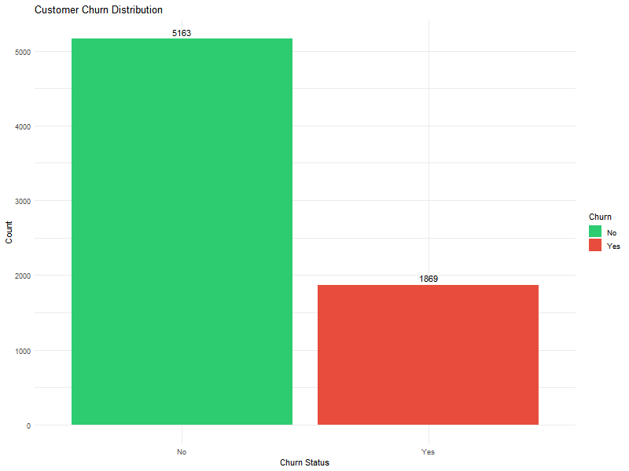
Figure 1: Distribution of customer churn showing 73.4% retention and 26.6% churn rate
4. Exploratory Data Analysis
There is a strong relationship between contract types and turnover. Figure 2 shows that the monthly payment contract has the highest customer turnover rate of 42.7%, while the one-year and two-year contracts have significantly lower turnover rates of 11.3% and 2.8% respectively. This shows that contractual commitment is a powerful predictor of customer loyalty.
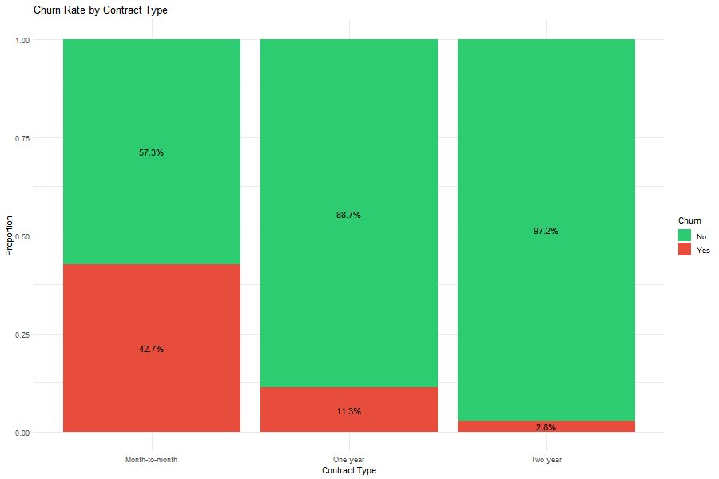
Figure 2: Proportion of churned customers by contract type
The pattern shown in the tenure indicates that customers with shorter tenure have a higher chance of being lost. It can be seen from Figure 3 that customers who are lost are mainly within 0-10 months, thus reflecting that the initial months are extremely critical from a retention perspective. It is evident that customer on-the-job experience and service rendered within the initial months are critical factors defining customer loyalty. Retained customers show a more decentralized pattern in all tenure lengths, and many customers maintain relationships for more than five years, indicating that once customers pass the initial critical period, they tend to remain loyal for a long time.
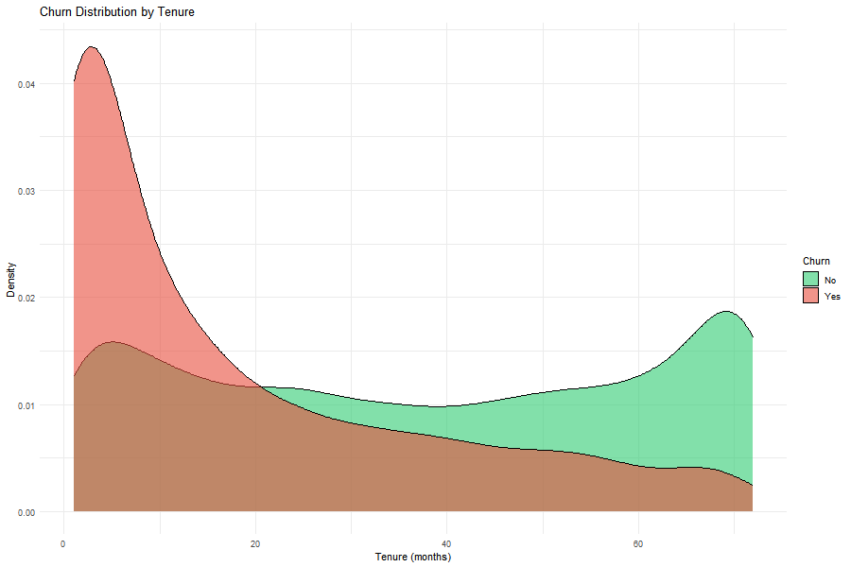
Figure 3: Density distribution showing higher churn risk for newer customers
The monthly fee also shows the relationship with the loss. Figure 4 shows that customers who leave often have a higher monthly fee (the median is about $80), while those who stay have a lower monthly fee (the median is about $65), which indicates that price sensitivity may be a factor in the turnover decision.
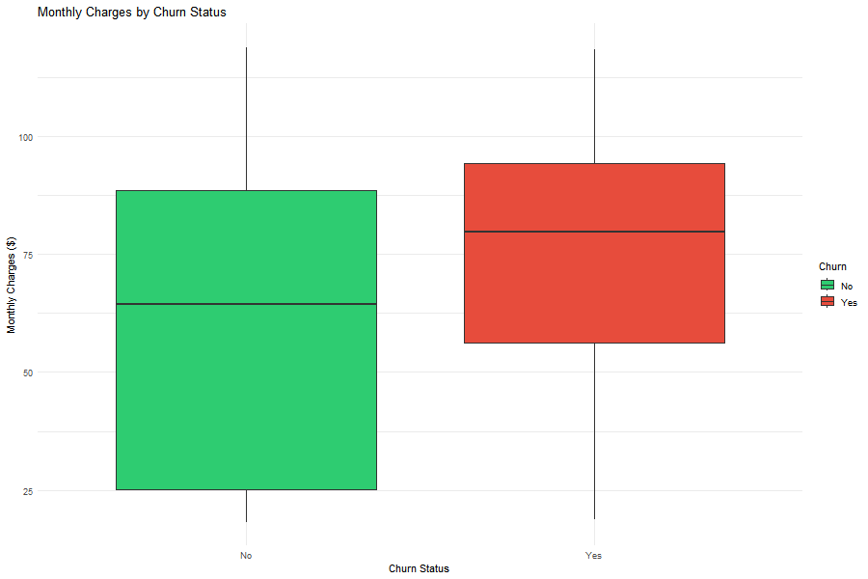
Figure 4: Distribution of monthly charges for churned and retained customers
The type of Internet service is another important factor. Figure 5 shows that the churn rate of customers who use optical fiber service is significantly higher than that of customers who use DSL or have no Internet service. This unexpected discovery may indicate that there is a quality of service problem or pricing problem at the fiber level.

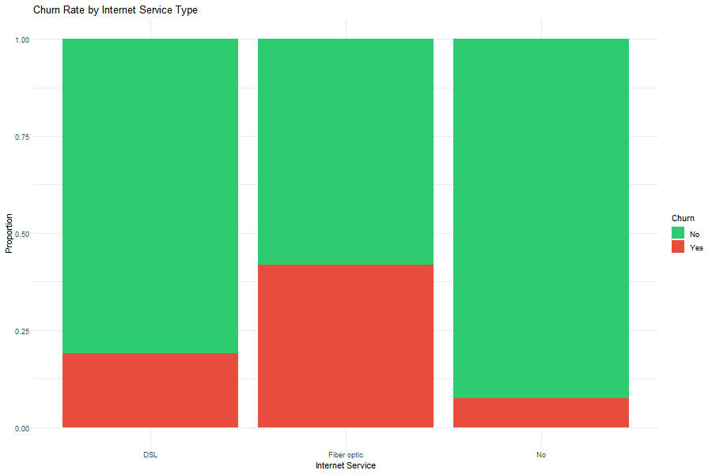
Figure 5: Churn rates across different internet service types
Correlation analysis (Figure 6) depicts some vital correlations. First, there is a strong and positive correlation between tenure and total expenses at 0.83, as expected. It implies that as customer longevity increases, the total expenses will be higher. More significantly, there is a negative correlation at -0.35. It verifies again that as customer longevity increases, so will customer retention and vice versa. Next, there is a positive correlation between monthly fee and turnover at 0.19. It confirms that as costs rise, so will turnover.
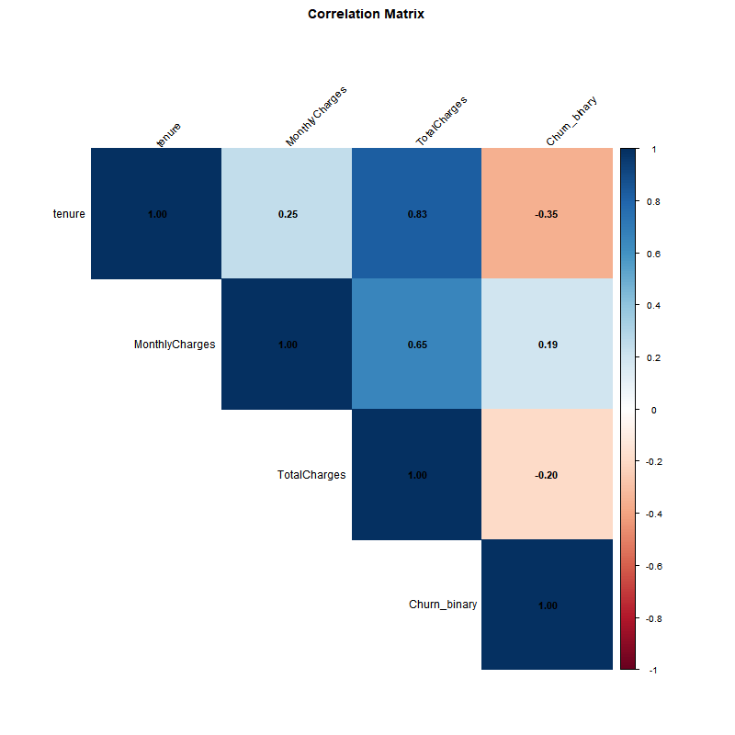
Figure 6: Correlation matrix of numerical variables
5. Methodology
5.1 Logistic Regression (GLM)
As our benchmark model, logistic regression corresponds to the traditional statistical approach for binary classification. It employs a logical function for computing the probability of churn, which links a weighted combination of input variables and a probability value ranging from 0 to 1. We select all available prediction variables and apply logistic regression with a binomial distribution family and a logit link function. Its main advantage focuses on the interpretation of estimation coefficients because it highlights the direction and magnitude of association.
5.2 Random Forest
A random forest considers an integrated learning technique. Multiple decision trees are incorporated using self-sample and random feature subset at each node. We set up our configuration model with 500 trees. This will let there be diversity while still being resource efficient. Each tree within the forest learns on a self-help sample, and a random feature subset alone will be considered at splits. The random component removes correlation among trees and average prediction will be more reliable compared to a single tree. The averaging technique itself handles nonlinear associations and feature interactions with less preprocessing and ranks feature importance based on average reduction in impurity. Compared with a single tree, it reduces overfitting and retains excellent prediction skills.
5.3 XGBoost
XGBoost can be seen as an embodiment of the latest concept of gradient boosting, which adds trees sequentially. Adding a new tree aims to make up for the error committed by the previous tree. When we develop XGBoost, we set the maximum tree depth as 6, learning rate as 0.3, and sub-sample ratio as 0.8. XGBoosting performs very well on structured data and avoids overfitting problems.
5.4 Deep Learning Neural Network
The technique employs a fully connected feedforward neural network as implemented using the Keras library. The structure consists of an input layer with 31 features obtained with single-heat coding, three hidden layers with ReLU activation functions housing 64, 32, and 16 neurons respectively, and a dropout layer with 0.3 and 0.2 rates. The output layer employs a sigmoid activation function for probability prediction. A 50-epoch model with a 32-size batch size and Adam optimizer with binary cross-entropy as loss functions is employed. All features undergo standardization before training.
5.5 Model Evaluation Strategy
We use stratified sampling to divide the data into 80% training set and 20% test set to keep the category distribution. All models are trained on the same training set and evaluated on the same test set to ensure fair comparison. The evaluation indexes include accuracy (overall correctness), sensitivity (proportion of correctly identified leakers), specificity (proportion of correctly identified non-leakers) and AUC-ROC (area under receiver's operating characteristic curve). AUC-ROC is particularly important because it provides a threshold-independent evaluation of discriminant ability.
6. Results
Table 2 presents the comparative performance of all four models on the test set.
Table 2: Model Performance Comparison
Model | Accuracy | Sensitivity | Specificity | AUC
Logistic Regression | 0.827 | 0.573 | 0.916 | 0.861
Random Forest | 0.814 | 0.501 | 0.923 | 0.848
XGBoost | 0.795 | 0.512 | 0.894 | 0.825
Deep Learning | 0.812 | 0.543 | 0.905 | 0.846
Logistic regression achieved the highest performance in most indicators, with an accuracy of 82.7% and an AUC of 0.861. The model shows the best balance between sensitivity and specificity, and correctly identifies 57.3% of the actual leakers, while maintaining a high specificity of 91.6%. The strong performance of this traditional statistical model shows that the relationship between features and churn may be mainly captured by the linear combination of features.
The accuracy of random forest is 81.4% and AUC is 0.848. However, its sensitivity is the lowest, which is 50.1%, and only half of the leakers are correctly identified. The model compensates by the highest specificity of 92.3%, which means that it rarely classifies retained customers as churns. This conservative prediction model makes random forest unsuitable when the cost of missing the lost people is high.
XGBoost shows the lowest performance with an accuracy of 79.5% and an AUC of 0.825. Although it is a powerful gradient lifting algorithm, its performance is not as good as that of a simpler model. This unexpected result may be due to the relatively small size of the data set or the need for more extensive superparameter adjustment.
Deep learning has achieved competitive performance, with an accuracy of 81.2% and an AUC of 0.846. Its sensitivity of 54.3% is between logistic regression and tree-based model, while its specificity of 90.5% is considerable. Neural network successfully learns patterns from data, although it is not significantly superior to simpler models.
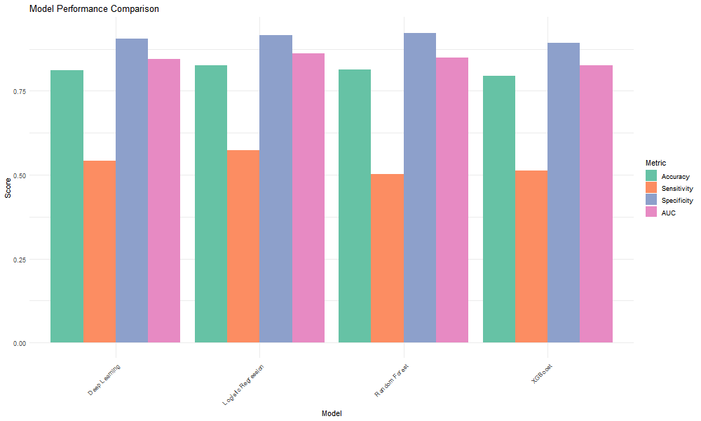
Figure 7: Comparison of accuracy, sensitivity, specificity, and AUC across all models
The ROC curve in Figure 8 provides additional insight into the performance of the model under different classification thresholds. The curve of logistic regression achieved the highest AUC of 0.861, showing superior discrimination ability. Random forest and deep learning show similar curves, and AUC is about 0.846-0.848. XGBoost shows the worst ROC performance, although it is still significantly better than random guess.
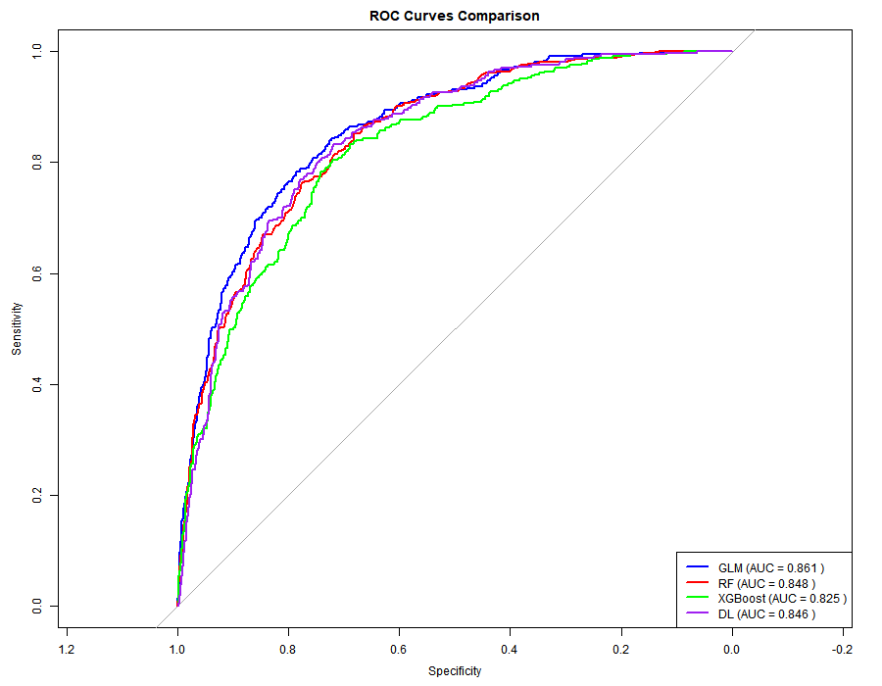
Figure 8: ROC curves showing the tradeoff between sensitivity and specificity
The analysis of logistic regression coefficient provides business insight. The type of contract becomes the strongest predictor, and compared with the monthly contract, the two-year contract will reduce the loss probability by about 78%. Tenure shows a significant negative correlation with turnover, which confirms that longer relationships reduce risks. Internet service types are also very important, and optical fiber customers show a higher tendency to lose.
The importance analysis of random forest variables highlights the term of office, total cost, monthly fee and contract type as the most influential characteristics, which is consistent with the findings of logistic regression and provides cross-validation of key drain drivers.
7. Discussion
The excellent performance of logistic regression provides important insights for the characteristics of the problem. It shows that the relationship between customer characteristics and churn behavior, although multivariable, can be well captured by additive linear combination. This discovery has practical significance, indicating that a simpler model may be enough to deal with many real-world brain drain prediction problems.
The interpretable advantage of logistic regression provides substantial business value in addition to the accuracy of prediction. Marketing teams can check the coefficients to understand what factors drive churn and design targeted interventions. For example, the strong negative coefficient of a two-year contract directly translates into operational strategies, such as providing incentives for contract upgrading.
XGBoost's poor performance compared with expectations is worth considering. The data set size of 7,000 observations may not be enough for gradient lifting to show its full potential, because XGBoost usually performs well on larger data sets. Furthermore, the default superparameter may not be optimal. Extensive tuning using grid search or Bayesian optimization may significantly improve performance.
The competitive but non-superior performance of deep learning is consistent with the understanding that neural networks need large data sets. With only 5,626 training observations, the network may lack enough data to learn complex hierarchical representations. Deep networks usually perform well on high-dimensional raw data (such as images), and this tabular data set has provided well-planned features.
Category imbalance (26.6% wastage rate) affects all models in different ways. The relatively low sensitivity value indicates that it is difficult to identify minority classes. In business applications, the cost of false negatives (failure to identify churns) usually exceeds that of false positives (unnecessarily targeting loyal customers). This shows that the model should be recalibrated according to the specific business cost to improve sensitivity, at the cost of reducing some specificity.
Several limitations should be acknowledged. The dataset represents a snapshot of time, and the time pattern may not be captured. The model does not consider customer segmentation, although the churn dynamics may vary according to demographics. This study uses single training-test segmentation instead of cross-validation, which may introduce sampling variability.
8. Conclusion
Four classification algorithms have been successfully created and compared within this project with a task of customer churn prediction. Despite its simplicity, logistic regression shows the best result with an accuracy of 82.7% and an AUC of 0.861. All these findings illustrate that it is not necessary for an algorithm to be more complex and have more features and better performance on a task, particularly with a medium-sized dataset and properly structured variables.
The business implication here is that it is primarily contract type, duration, and service factors that impact turnover. Telcos can employ these research findings to develop a retention strategy, wherein they focus on promoting long-term contracts, customer satisfaction with services in the initial months of association, and rectification of complaints regarding services, with special emphasis on Fiber Internet subscribers.
To make it more deployable, we propose using a logistic regression model due to its superior performance and ease of implementation. The model will be incorporated into the customer relationship management platform to calculate the daily risk of customer churn on a daily basis. At-risk customers will then be targeted with proactive customer retention efforts, including special promotions and service enhancements, as well as personalized contact with customer service representatives.
The next research directions include modeling with temporal dynamics using survival analysis and time series analysis, customer segmentation research for modeling respective segmentation models, cost-sensitive learning methods for explicit handling of category imbalance problems, and causality analysis instead of forecasting correlations. Moreover, the method that jointly forecasts based on stacking forecasts or equal combination of various models might perform better than single models.

References
Ahmad, A. K., Jafar, A., & Aljoumaa, K. (2019). Customer churn prediction in telecom using machine learning in big data platform. Journal of Big Data, 6(1), 1-24.
Brandusoiu, I. B., Toderean, G., & Beleiu, H. (2016). Methods for churn prediction in the pre-paid mobile telecommunications industry. In 2016 International Conference on Communications (COMM) (pp. 97-100). IEEE.
Lalwani, P., Mishra, M. K., Chadha, J. S., & Sethi, P. (2022). Customer churn prediction system: A machine learning approach. Computing, 104(2), 271-294.
Vafeiadis, T., Diamantaras, K. I., Sarigiannidis, G., & Chatzisavvas, K. C. (2015). A comparison of machine learning techniques for customer churn prediction. Simulation Modelling Practice and Theory, 55, 1-9.

