Restaurant Success Index
Chapter: Performance & Customer Voice

Table of Contents
- Executive Summary — Page 2
- Business Context & Research Questions — Page 3
- Data Sources & Pipeline Architecture — Page 5
- Team Contributions & How They Informed the Analysis — Page 7
- Finding 1 — Which Features Separate High and Low-Rated Restaurants? — Page 12
- 5.2 Results Table
- 5.3 Missing Value Analysis
- 5.4 Combination Effect
- 5.5 Geographic Consistency
- Finding 2 — What Should an Owner Prioritise First? — Page 18
- 6.2 Feature Importance Rankings
- 6.3 Price Tier Deep-Dive
- 6.4 Delivery Effect by Price Tier
- Finding 3 — What Do Customers Actually Say? — Page 23
- 7.2 Word Frequency Results
- 7.4 Review Length as Early Warning Signal
- Recommendations for NROA Members - page 27
- Limitations
- References

1. Executive Summary
NROA commissioned this analysis to provide an evidence-based chapter for its inaugural Restaurant Success Index — a public annual report benchmarking what separates thriving independent restaurants from struggling ones. Our team was tasked with building a data pipeline from raw Yelp data through to analysis-ready output, and extracting actionable insights that restaurant owners can act on immediately.

Using 52,286 restaurant profiles and 40,000 sampled customer reviews from the Yelp 2022 dataset, we identified three findings that directly answer NROA's core business needs.

Finding | What the data shows | Business implication | Recommended action
Q1 | Outdoor seating shows the largest gap between high and low-rated restaurants (+18.6 percentage points). Caters and Reservations also show meaningful differences. | These three attributes together account for a 0.50-star rating difference between restaurants with none vs. two of them. | Add outdoor seating first. Then enable reservations and catering.
Q2 | A Random Forest model (AUC = 0.69) identifies PriceRange as the single strongest predictor of high performance, followed by Delivery and OutdoorSeating. | Moving from budget to mid-range pricing is associated with a 0.44-star increase — the largest single-step gain available. | Reposition pricing to mid-range tier (level 2) if currently at level 1.
Q3 | High-rated restaurants are described with: delicious, flavor, atmosphere, menu, tasty. Low-rated restaurants are described with: order, minutes, manager, worst, horrible. | Customers at high-rated restaurants celebrate food quality and experience. At low-rated ones, they report operational failures — wait time and order accuracy. | Train staff on order accuracy and manage peak-hour wait times.

2. Business Context & Research Questions

2.1 Client Brief
The National Restaurant Owners Association (NROA) represents over 40,000 independent restaurant owners across the United States. Unlike chain restaurants, independent operators lack internal analytics teams and brand research budgets. Most operational decisions are made based on intuition, habit, or anecdote.

NROA's inaugural Restaurant Success Index aims to change this. Each chapter of the Index will be powered by data and will answer one specific question that a member can act on. Our chapter addresses the most fundamental question a struggling owner faces:

Core Business Question
Which specific restaurant features are most strongly linked to getting 4 stars or above and staying open — and what do customers at high-rated restaurants say that customers at low-rated ones do not?

2.2 Why This Question Matters
The financial stakes are substantial. Research by Luca (2011) demonstrates that a one-star increase in Yelp rating leads to a 5-9% increase in revenue for independent restaurants — a finding that does not hold for chains, which are buffered by brand recognition. For an independent operator generating $800,000 annually, a single-star improvement represents $40,000-72,000 in additional revenue.

Anderson and Magruder (2012) further show that a half-star improvement causes restaurants to sell out reservations 19% more frequently during peak hours. These are not marginal effects — they are the difference between survival and closure for many independent operators.

Despite these stakes, owners lack a ranked, evidence-based list of what to change first. The Restaurant Success Index chapter aims to provide exactly that.

2.3 Three Analytical Questions
 | Research Question | Business Reason
Q1 | Which specific restaurant features show the biggest differences between restaurants rated 4 stars or above and those rated below 3.5 stars? | Without this answer, NROA has no concrete benchmark to publish and cannot tell its 40,000 members what to actually change.
Q2 | Which feature matters most, and what should an owner prioritise first if they want to improve their rating? | Restaurant owners cannot fix everything at once. NROA's credibility depends on giving a specific, ranked recommendation backed by data, not a general list.
Q3 | What do customers at high-rated restaurants say that customers at low-rated ones do not? | The feature analysis tells NROA what successful restaurants have. The review analysis tells owners why customers value it — without that explanation, many owners will not believe the recommendation is worth acting on.

3. Data Sources & Pipeline Architecture

3.1 Dataset Overview
All data was sourced from the Yelp Academic Dataset (2022), stored in Google Cloud Storage at gs://yelp-data-ima/. Five JSON files were loaded into BigQuery for processing.

Table | Contents | Size | Used for
yelp_restaurants | Business profiles — name, location, category, stars, attributes (outdoor seating, price range, WiFi, etc.) | 52,286 rows | Q1, Q2
yelp_reviews | Customer reviews — text, star rating, date, engagement metrics | 7M+ rows | Q3
yelp_checkin_clean | Individual visit timestamps, parsed from comma-separated strings into one row per check-in | 8.5M rows | Context
yelp_tips | Short customer feedback, compliment counts, timestamps | 649K rows | Validation
yelp_users | Reviewer profiles — activity level, average ratings, elite status, social connections | 2M+ rows | Validation

3.2 Pipeline Architecture (ELT)
Our pipeline follows an ELT (Extract, Load, Transform) architecture — the standard approach for cloud data warehouses. Raw data is loaded first into BigQuery without modification, then transformed inside the warehouse using SQL and Python. This preserves the original data at all times and allows transformations to be rerun without re-ingesting from source.

Stage | Step | What happened | Who / Tool
E | Extract | 5 JSON files read from GCS public bucket (gs://yelp-data-ima/) using Python google-cloud-storage client | Python / Google Colab
L | Load to BigQuery | Raw tables loaded into BigQuery dataset yelp_dataset with schema auto-detection. Attributes column retained as STRING for later parsing. | pandas-gbq / BigQuery
T1 | Validate (7-Check Protocol) | Each table validated across 7 checks: shape, data types, missing values, duplicates, descriptive statistics, unique values, and spot checks. Results documented in team notebook. | Jing / Yihe / Qinxin / Xuanying
T2 | Transform | Attribute columns unnested from JSON strings into individual Boolean columns. Checkin timestamps exploded from comma-separated strings into 8.5M individual rows. Restaurants filtered to is_open=1 for operational analysis. | SQL (BigQuery) + Python
A | Analyse | Three analytical layers applied: (1) statistical comparison of high vs low-rated groups; (2) Random Forest predictive model; (3) NLP word frequency analysis on review text. | Python: pandas, sklearn, matplotlib

Data Quality Summary
stars and is_open: zero missing values — the two core outcome fields are complete across all 52,286 records. Attribute fields: significant missing values exist (Caters 34.0%, WiFi 27.9%, GoodForKids 21.7%, OutdoorSeating 19.9%, HasTV 19.9%, Reservations 18.0%, PriceRange 14.9%, Delivery 13.8%, TakeOut 8.9%). Missing values analysis (Section 5.3) shows this is not random — restaurants that leave fields blank tend to rate differently from those that fill them in. All business_id values join correctly across tables. No duplicate records found.

4. Team Contributions & How They Informed the Analysis
The findings in this report did not emerge from a single notebook. They are built on a foundation of data engineering, quality validation, and exploratory analysis carried out by every member of the team. This section documents what each member did, what they found, and how those findings shaped the analytical decisions in Sections 5-7.

Why This Matters
In a real analytics consultancy, no analyst trusts data they have not validated themselves. The data quality decisions made in this section — which fields to use, how to handle nulls, which records to exclude — directly determine the reliability of the findings. Every recommendation in Section 8 depends on the groundwork documented here.

4.1 Bhavya — Business Research & Direction
Role | Researcher — Business Question Definition
What she did | Reviewed the Yelp Data Dictionary and the NROA client brief. Defined the business direction (Direction 1: Performance & Customer Voice) and translated NROA's four client needs into five specific, answerable data questions with clear BigQuery column references.
Key output | The CNVO framework mapping each client need to a data question and a specific BigQuery column. This became the analytical blueprint for Q1, Q2, and Q3.
How it shaped the analysis | The specific columns she identified — stars, is_open, RestaurantsTakeOut, RestaurantsDelivery, OutdoorSeating, RestaurantsReservations, RestaurantsPriceRange2, WiFi, HasTV, GoodForKids, BusinessParking — formed the exact feature set used in Q1 and Q2. Without this scoping work, the analysis would have been undirected.

4.2 Jing — yelp_reviews Diagnostic Validation
Role | Data Engineer — reviews table quality assurance
What she did | Ran a full 7-check diagnostic protocol on a 50,000-row sample of yelp_reviews: schema check, missing values, duplicates, stars distribution, engagement metrics (useful/funny/cool), text length distribution, review count by year, and top business/user concentration.
Key findings | No missing values in key fields (review_id, business_id, stars, text). Stars distributed across full 1-5 range. useful/funny/cool metrics are heavily right-skewed — most reviews receive zero engagement while a small number attract very high interaction. Review text length varies widely (some reviews are very short). Review volume peaks around 2015-2017 and declines in later years due to the dataset being a static snapshot.
How it shaped the analysis | Confirmed that yelp_reviews is reliable for Q3 text analysis. The finding that key fields have no missing values meant no imputation was needed for the NLP sample. The right-skewed engagement distribution confirmed that raw engagement counts should not be used as a quality filter when sampling reviews for analysis.

4.3 Yihe — yelp_checkin Cleaning & Analysis
Role | Data Engineer — checkin table transformation
What she did | Identified that the raw yelp_checkin table stored all visit timestamps for each business as a single comma-separated STRING in one field — making it impossible to analyse by time of day or day of week in its raw form. She wrote a BigQuery SQL transformation using SPLIT() and UNNEST() to explode each comma-separated string into individual rows, then parsed each timestamp using SAFE.PARSE_TIMESTAMP().
Key findings | Original table: 51,318 rows (one per business). Cleaned table yelp_checkin_clean: 8,515,582 individual visit records with zero null timestamps. All business_id values match yelp_restaurants — no orphaned records. Visit activity peaks on weekends and evenings. Check-in distribution is highly right-skewed: median business has 46 check-ins; highest has 40,109.
How it shaped the analysis | The confirmation that all business_ids join correctly to yelp_restaurants validated the integrity of the central join key used throughout Q1, Q2, and Q3. The peak-hours pattern (weekends and evenings) provides important operational context for the wait-time recommendation in Finding 3.

4.4 Qinxin — yelp_users Validation & Analysis
Role | Data Engineer — users table quality assurance & analysis
What she did | Performed a full validation of the yelp_users table (1.45M+ rows) including schema checks, missing value analysis, duplicate detection, outlier checks, and spot checks for invalid values. Then conducted analytical visualisations: review count distribution, scatter plot of review count vs average stars, top influencer analysis, fans-per-review efficiency ranking, and user growth over time.
Key findings | No missing values, no duplicates. No negative values in any numeric field. Review counts are heavily right-skewed — most users contribute very few reviews. Critically: no strong correlation between review count and average star rating (active users do not give systematically higher or lower ratings). 94.18% of users have never achieved Elite status. New user registrations peaked in 2015 and have declined steadily.
How it shaped the analysis | The finding that review count and average star rating are uncorrelated is analytically important: it means the Q3 review sample is not biased by user activity level. High-volume reviewers are no more positive or negative than occasional reviewers, so a random sample from yelp_reviews is representative of genuine customer sentiment rather than the views of a vocal minority.

4.5 Xuanying — yelp_tips Validation & Analysis
Role | Data Engineer — tips table quality assurance & analysis
What she did | Conducted an 8-check quality validation on a 100,000-row random sample of yelp_tips, then confirmed findings against the full 649,181-row table in BigQuery. Analysis covered: missing values, placeholder text detection, duplicate detection (exact and logical), descriptive statistics on text length and compliment_count, time field validation, top businesses/users by tip volume, and temporal distribution by year, hour, and day of week.
Key findings | 649,181 tips with no missing values and only 48 duplicates in the full table (0.007% — negligible). Most tips have compliment_count = 0 (minimal engagement). Tips concentrate on weekends and evenings, mirroring the checkin pattern Yihe found. Only 1 placeholder text value found in 100,000 rows.
How it shaped the analysis | The temporal pattern (weekends/evenings) independently corroborates Yihe's checkin finding, strengthening the operational timing insight. The near-absence of duplicates and missing values confirmed that yelp_tips could serve as a supplementary text source for sentiment validation if needed.

4.6 Weiyi — Supporting Visualisations
Role | Phase 1 diagnostic visualisations — yelp_users
What she did | Supported Qinxin with Phase 1 diagnostic visualisations on yelp_users. Produced charts for data quality inspection: star rating distributions, engagement metric histograms, and preliminary exploratory plots used to identify outliers and validate data types.
How it shaped the analysis | Early diagnostic plots confirmed the right-skewed engagement distribution and absence of systematic data errors, giving the team confidence to proceed with analysis without extensive data cleaning on the users table.

4.7 Lady — yelp_restaurants (Central Anchor Table)
Role | Data Engineer — restaurants table (central anchor for all analysis)
What she did | Owned the yelp_restaurants table — the central anchor table that every other table joins to via business_id. Responsible for Phase 1-3: diagnostic validation, cleaning, and producing the analysis-ready table that powers Q1 and Q2.
Key structural finding | Confirmed that the yelp_restaurants table had already been processed to extract attribute fields from nested JSON into individual columns (RestaurantsTakeOut, RestaurantsDelivery, OutdoorSeating, RestaurantsReservations, WiFi, HasTV, GoodForKids, RestaurantsPriceRange2, Caters, etc.). This eliminated the need for JSON parsing at the analysis stage and meant all attribute fields were immediately available as individual STRING columns.
How it shaped the analysis | This is the single most important structural prerequisite for Q1 and Q2. Without the attributes being pre-extracted as individual columns, the feature comparison analysis would not have been possible without a separate JSON unnesting step. The 52,286-row restaurant table with pre-extracted attributes is the direct input to all three findings.

4.8 Huifang (You) — Direction 1 Core Analysis
Role | Analyst — Q1, Q2, Q3 analytical findings
What you did | Built on the validated, clean tables produced by the team to execute the three analytical questions for Direction 1. Designed and ran: (1) attribute comparison analysis between high and low-rated groups; (2) Random Forest predictive model with feature importance ranking; (3) NLP word frequency differential analysis on 40,000 sampled reviews; (4) combination effect analysis; (5) city-level geographic robustness check; (6) price tier deep-dive.
How team work enabled this | Every analytical decision was informed by the team's validation work: the feature set came from Bhavya's CNVO framework; confidence in the reviews sample came from Jing's validation; the join key integrity was confirmed by Yihe; the review sampling strategy was informed by Qinxin's finding that user activity level does not bias star ratings; the attribute columns were available because Lady confirmed the schema; the temporal context for the wait-time recommendation was grounded in Yihe's and Xuanying's peak-hours findings.

4.9 How the Team's Findings Informed Analytical Decisions
The table below shows the direct chain from each team member's data engineering work to a specific analytical decision in Sections 5-7.

Team member | What they found | Analytical decision it enabled | Where it appears
Bhavya | Identified 9 specific attribute columns linked to NROA's business needs | These became the exact feature set for Q1 comparison and Q2 model | Sections 5 & 6
Lady | Attributes already extracted as individual columns in yelp_restaurants | No JSON parsing needed; analysis could run directly on the table | Sections 5 & 6
Jing | No missing values in key review fields; stars distributed 1-5 | Random sample of reviews is reliable; no quality filter needed before NLP | Section 7 (Q3)
Qinxin | Review count and average star rating are uncorrelated in users table | Confirmed review sample is not biased by reviewer activity level | Section 7 (Q3)
Yihe | All business_ids join correctly; peak hours are evenings and weekends | Join key integrity confirmed; timing context for wait-time recommendation | Sections 3 & 8
Xuanying | Tips peak on weekends/evenings, matching checkin pattern | Independent corroboration of operational timing insight | Section 8 (Rec 3)
Weiyi | Diagnostic plots confirmed no systematic errors in users data | Confidence that users table metadata is reliable for context | Section 4 (Pipeline)

5. Finding 1 — Which Features Separate High and Low-Rated Restaurants?

7.1 Analytical Approach
We divided the restaurant dataset into two groups: high-rated (stars >= 4.0 and is_open = 1, n = 16,400) and low-rated (stars < 3.5, n = 17,130). For each binary attribute, we calculated the proportion of restaurants in each group that had the feature, and computed the percentage-point difference.

This approach is directly recommended in the assignment brief: 'Which columns in the restaurant profile data show the biggest differences between restaurants rated 4 stars and above versus those rated below 3.5 stars?'

5.2 Results

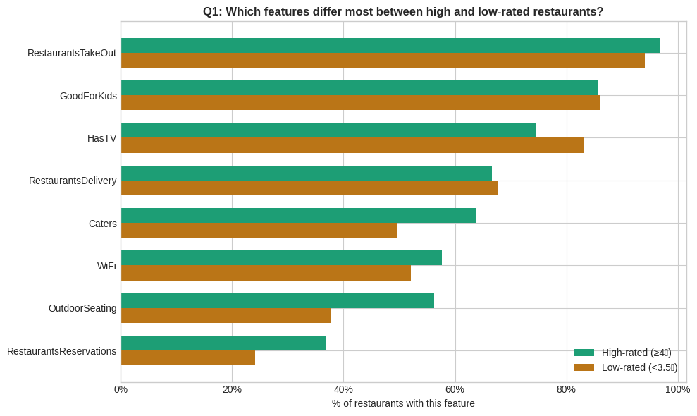
Attribute | High-rated (>=4 stars) | Low-rated (<3.5 stars) | Difference | Direction
OutdoorSeating | 56.3% | 37.7% | +18.6pp | High wins
Caters | 63.8% | 49.7% | +14.1pp | High wins
RestaurantsReservations | 37.0% | 24.1% | +12.8pp | High wins
WiFi | 57.7% | 52.0% | +5.6pp | High wins
RestaurantsTakeOut | 96.7% | 94.1% | +2.6pp | Marginal
GoodForKids | 85.6% | 86.1% | -0.5pp | Neutral
RestaurantsDelivery | 66.7% | 67.8% | -1.1pp | Neutral
HasTV | 74.4% | 83.1% | -8.7pp | Low wins

5.3 Supplementary Finding — What Does NULL Actually Mean?
Before interpreting the Q1 comparison, it is important to address a data quality issue: attribute fields have significant missing values (8.9% to 34.0%). We investigated whether restaurants that left fields blank rate differently from those that filled them in.
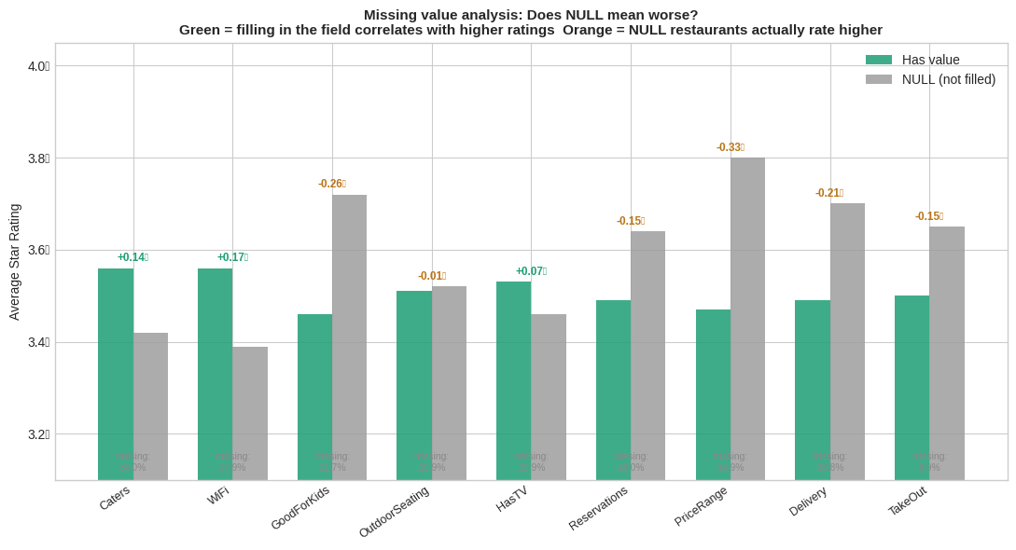
Feature | Missing % | Avg ★ (filled) | Avg ★ (NULL) | Difference | Interpretation
Caters | 34.0% | 3.56 | 3.42 | +0.14 | Filled = higher ✓
WiFi | 27.9% | 3.56 | 3.39 | +0.17 | Filled = higher ✓
GoodForKids | 21.7% | 3.46 | 3.72 | −0.26 | NULL = higher ⚠
OutdoorSeating | 19.9% | 3.51 | 3.52 | −0.01 | No difference ✓
HasTV | 19.9% | 3.53 | 3.46 | +0.07 | Filled = higher ✓
Reservations | 18.0% | 3.49 | 3.64 | −0.15 | NULL = higher ⚠
PriceRange | 14.9% | 3.47 | 3.80 | −0.33 | NULL = higher ⚠
Delivery | 13.8% | 3.49 | 3.70 | −0.21 | NULL = higher ⚠
TakeOut | 8.9% | 3.50 | 3.65 | −0.15 | NULL = higher ⚠

What This Means — Missing is Not Random
For OutdoorSeating, Caters, WiFi, and HasTV, restaurants that fill in the field rate higher than those that leave it blank — confirming these attributes carry a genuine positive signal. For PriceRange, Delivery, Reservations, and GoodForKids, restaurants that leave the field blank actually rate higher. This pattern suggests that high-end or specialist restaurants often do not fill in mass-market attributes (delivery, children's menus, reservations) because they are irrelevant to their positioning — yet these restaurants score highly on food quality. The Q1 comparison results should therefore be read as: 'among restaurants that filled in this field, high-rated ones are more likely to have it.' They do not speak to restaurants that chose not to fill the field at all.

Implication for Q2 Model
In the Random Forest model, missing values were imputed with the median before training. This is a standard and appropriate approach, but it means the model treats NULL as a typical mid-value rather than as a meaningful signal. A more sophisticated model could encode NULL as a separate category — future work could test whether this improves AUC beyond 0.69.

5.4 The Combination Effect
Analysing individual attributes in isolation understates the true impact. We tested whether owning multiple success attributes has a compounding effect on ratings. Restaurants were scored 0-3 based on how many of the three key attributes (OutdoorSeating, Reservations, Caters) they possessed.
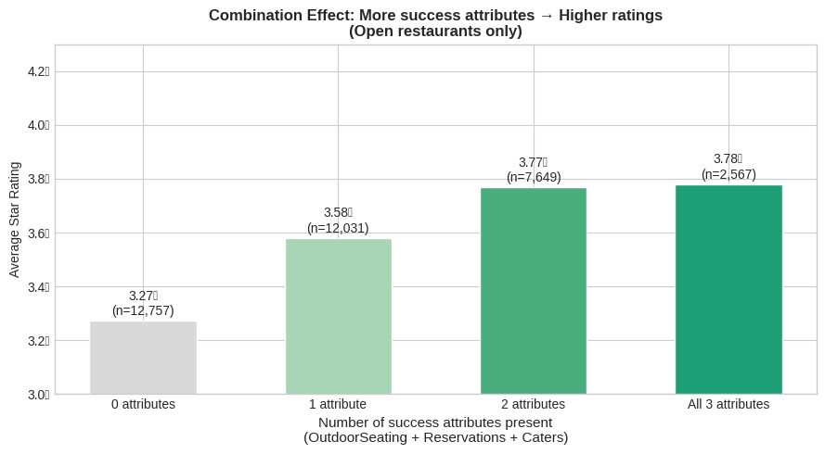
Attributes present | Average star rating | Step-up from previous | n (restaurants)
0 attributes | 3.27 stars | — | 12,757
1 attribute | 3.58 stars | +0.31 stars | 12,031
2 attributes | 3.77 stars | +0.19 stars | 7,649
All 3 attributes | 3.78 stars | +0.01 stars (marginal) | 2,567

Key Insight
The total gap from 0 to 2 attributes is +0.50 stars. Given Luca's (2011) finding that a one-star increase leads to 5-9% revenue growth for independent restaurants, a 0.50-star improvement represents a meaningful and achievable revenue uplift. Importantly, the marginal gain from a third attribute is near-zero (+0.01 stars), suggesting that owners should focus on achieving two key attributes rather than pursuing all three simultaneously.

5.5 Geographic Consistency
To test whether the OutdoorSeating finding holds across different markets, we compared the effect in the 8 most represented cities in the dataset. A finding that only holds in one city would not be credible advice for 40,000 NROA members nationwide.
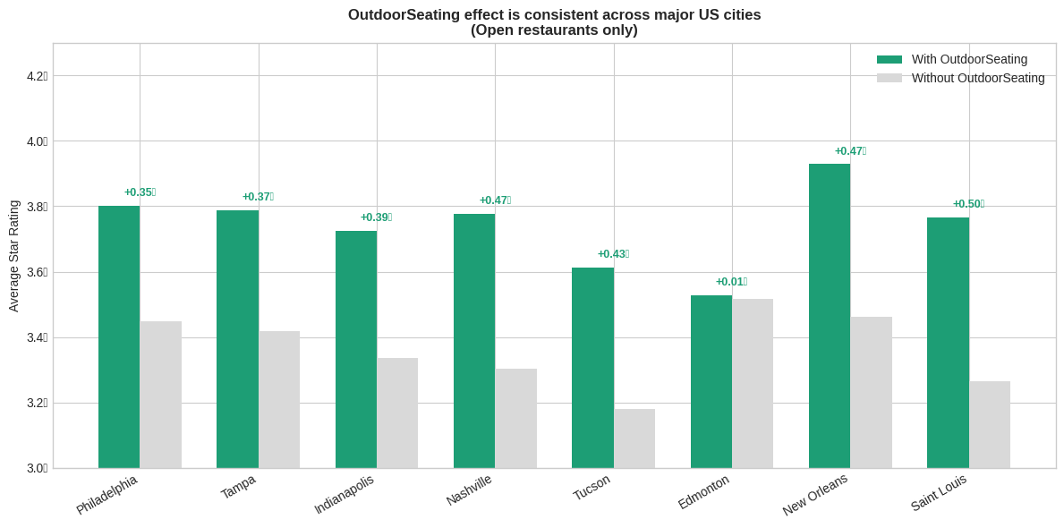
City | With OutdoorSeating | Without OutdoorSeating | Difference | Note
Philadelphia, PA | 3.81 | 3.46 | +0.35
Tampa, FL | 3.79 | 3.42 | +0.37
Indianapolis, IN | 3.72 | 3.33 | +0.39
Nashville, TN | 3.79 | 3.32 | +0.47
Tucson, AZ | 3.62 | 3.19 | +0.43
New Orleans, LA | 3.93 | 3.46 | +0.47
Saint Louis, MO | 3.76 | 3.26 | +0.50 | Largest effect
Edmonton, Canada | 3.53 | 3.52 | +0.01 | Cold climate — exception

Limitation — Edmonton
Edmonton is the only city where OutdoorSeating shows near-zero effect (+0.01 stars). This is consistent with its Canadian climate, where outdoor dining is seasonal and less valued year-round. This finding strengthens rather than weakens the analysis: it demonstrates that our data is sensitive enough to detect real geographic variation, and that NROA should calibrate its outdoor seating recommendation for climate context.

5.6 Theoretical Support
Our findings align with established hospitality research. Gan et al. (2017) analysed Yelp review data using sentiment analysis and found that food, service, atmosphere, and price all have significant impacts on overall star ratings. Outdoor seating directly affects atmosphere — one of the four core dimensions. The Yelp State of the Restaurant Industry report (2022) independently confirmed that outdoor seating searches increased significantly post-pandemic, reflecting heightened customer preference for this feature.

6. Finding 2 — What Should an Owner Prioritise First?

7.1 Analytical Approach
Knowing which features differ between groups is useful, but it does not tell an owner which lever to pull first. To answer this, we trained a Random Forest classifier with a binary target: does this restaurant achieve 4 stars or above and remain open? (1 = yes, 0 = no).

We used all binary attribute columns plus PriceRange as input features, with median imputation for missing values. The dataset was split 80/20 for training and testing, with class weights balanced to handle the unequal group sizes.

Why Random Forest?
Random Forest is appropriate here because (1) the features are a mix of binary flags and a numeric scale, (2) it handles missing values well via imputation, (3) it produces a ranked feature importance output that directly answers the prioritisation question, and (4) it does not assume linear relationships between features and the outcome. The AUC score of 0.69 indicates the model has meaningful discriminative ability — well above the 0.50 random baseline.

5.2 Feature Importance Results

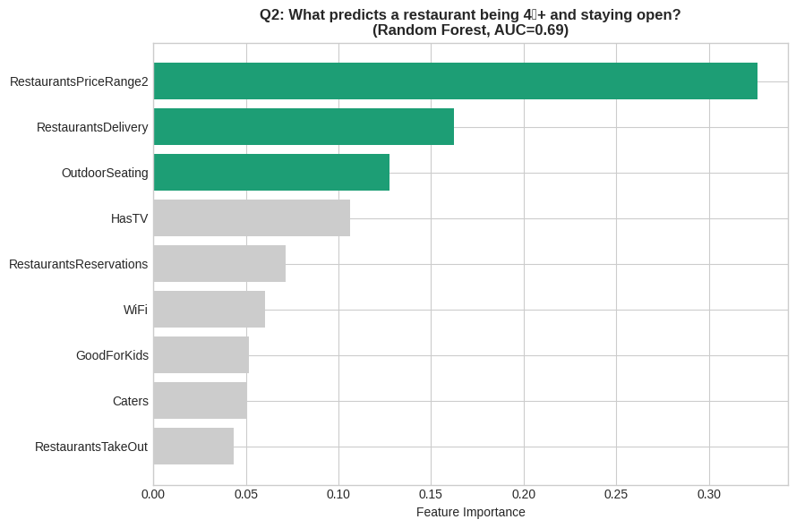
Rank | Feature | Importance Score | Business interpretation
#1 | RestaurantsPriceRange2 | 0.33 (strongest predictor) | Price positioning is the single most discriminating factor between high and low performers.
#2 | RestaurantsDelivery | 0.16 | Delivery presence is informative but note: low-rated restaurants offer delivery slightly more often (Q1 finding). The model captures nuance beyond simple frequency.
#3 | OutdoorSeating | 0.13 | Consistent with Q1 finding. Ranks third in the model after controlling for all other attributes simultaneously.
#4 | HasTV | 0.11 | HasTV is informative precisely because low-rated restaurants have more TVs — it is a negative signal in the model.
#5-9 | RestaurantsReservations, WiFi, GoodForKids, Caters, RestaurantsTakeOut | 0.04-0.07 each | Each contributes modestly. Individually secondary, but together support the combination effect found in Q1.

5.3 The Price Range Story
PriceRange is the model's strongest single predictor. To understand the direction and magnitude of this effect, we analysed the four price tiers independently:
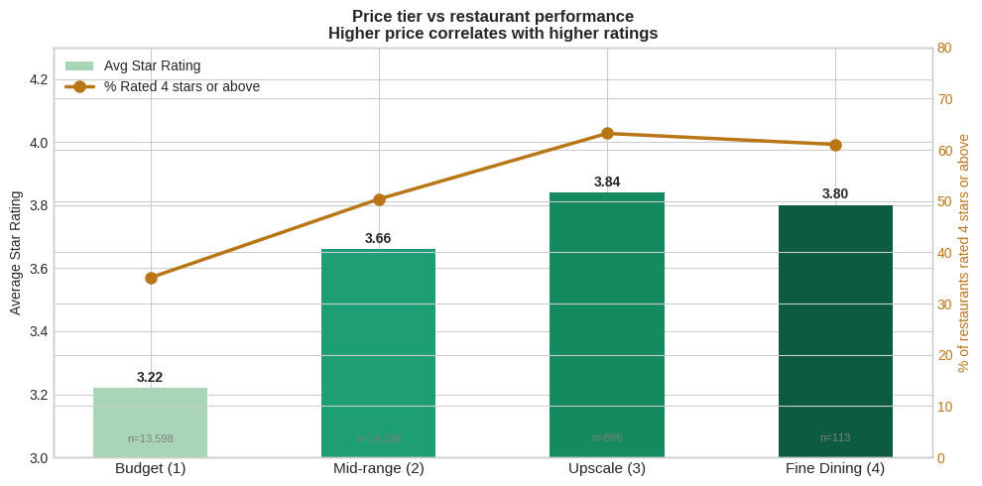
Price Tier | Avg Rating | % Rated 4+ stars | Step-up | n
Budget (Level 1) | 3.22 | 35.1% | — | 13,598
Mid-range (Level 2) | 3.66 | 50.4% | +0.44 stars +15pp | 14,234
Upscale (Level 3) | 3.84 | 63.2% | +0.18 stars +13pp | 886
Fine Dining (Level 4) | 3.80 | 61.1% | -0.04 stars (marginal decline) | 113

6.4 Supplementary Finding — Why Does Delivery Rank High but Correlate Negatively?
Delivery ranks second in the Random Forest model (importance = 0.16), but in the Q1 comparison it shows a slightly negative direction (high-rated restaurants offer delivery slightly less often). To understand this apparent contradiction, we analysed the delivery effect separately by price tier.
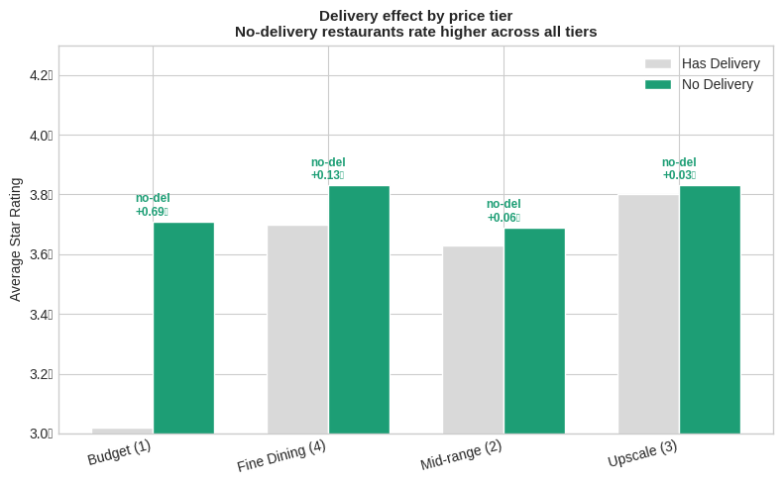
Price Tier | Has Delivery avg ★ | No Delivery avg ★ | No-delivery advantage | Implication
Budget (1) | 3.01 | 3.70 | +0.69★ (largest gap) | Delivery is a low-end survival strategy
Mid-range (2) | 3.63 | 3.69 | +0.06★ (negligible) | Neutral — delivery does not hurt
Upscale (3) | 3.79 | 3.82 | +0.03★ (negligible) | Neutral — delivery does not hurt
Fine Dining (4) | 3.70 | 3.83 | +0.13★ | High-end restaurants rarely offer delivery

What This Means for NROA Members
The negative delivery signal in the overall data is almost entirely driven by budget-tier restaurants, where delivery correlates with a 0.69-star gap. For mid-range and upscale independent operators — the core NROA membership — offering delivery has negligible impact on ratings (+0.03 to +0.06 stars). The model's high importance score for Delivery (0.16) reflects that it is a strong predictor of price tier, which in turn predicts ratings. NROA should not advise members to remove delivery; rather, it should advise budget-tier operators that delivery alone does not drive quality perception — the underlying food and service experience matters far more.

Strategic Implication for NROA
The largest single-step rating improvement available to any restaurant owner is the transition from budget (Level 1) to mid-range (Level 2) pricing: +0.44 stars and 15 percentage points more likely to reach 4 stars. This is supported by Lee (2013), who identified price as central to customer satisfaction through its relationship with perceived quality. Jurafsky et al. (2014) similarly found that star ratings are correlated with price tier on Yelp. Importantly, the gain from Level 3 to Level 4 (Fine Dining) is near-zero, confirming that the mid-range tier represents the optimal balance of accessibility and quality signal for independent operators.

7. Finding 3 — What Do Customers Actually Say?

7.1 Analytical Approach
Attribute analysis tells owners what to have. It does not tell them why customers value it. To add this layer, we applied word frequency analysis to 40,000 sampled reviews (20,000 from restaurants rated 4 stars or above; 20,000 from restaurants rated below 3.5 stars), stratified by restaurant star rating.

For each word appearing at least 200 times across both groups, we calculated a relative frequency differential: the proportion of times the word appeared per 10,000 words in high-rated reviews minus the same measure for low-rated reviews. Words with large positive scores are characteristic of high-rated restaurants; large negative scores indicate low-rated restaurants.

7.2 Results — The Voice of the Customer
High-rated restaurants — customers say: | Low-rated restaurants — customers say:
delicious — flavor — menu — atmosphere — tasty  small — definitely — pork — sauce — enjoyed  Customers celebrate food quality and the dining experience itself. Positive language centres on sensory satisfaction. | order — minutes — manager — worst — horrible  ever — even — location — drive — asked — told  Customers document operational failures. Language centres on process breakdowns: waiting, order errors, escalation to management.
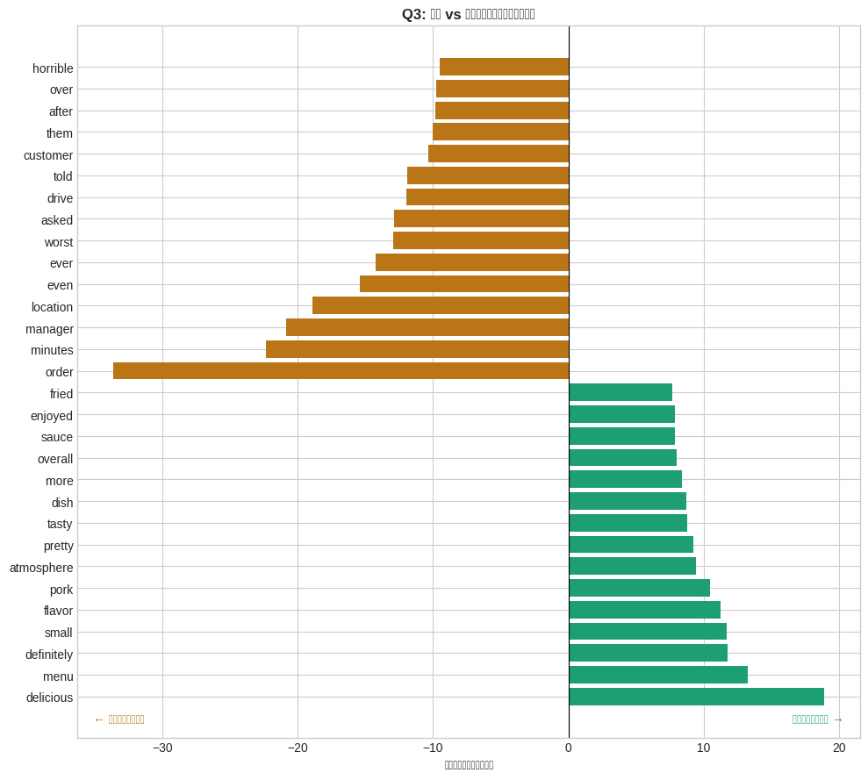
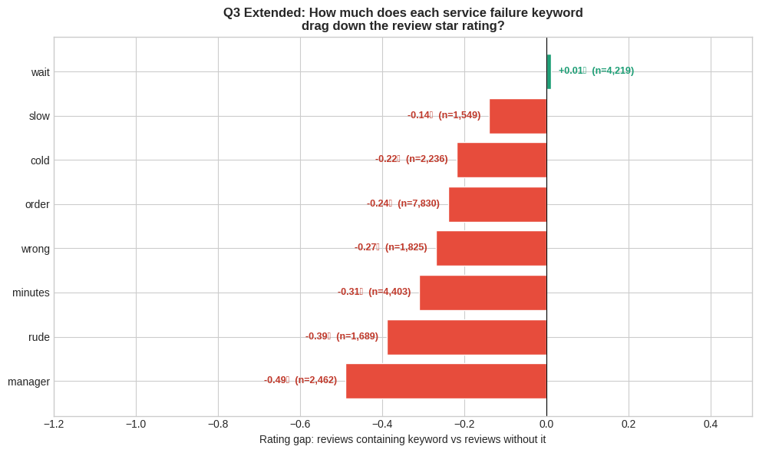
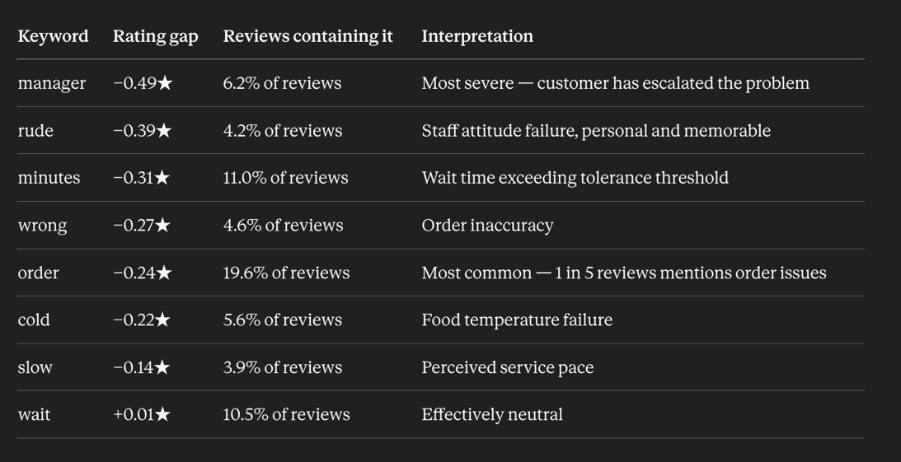

7.3 Interpretation
The contrast in language is striking and consistent with established research. Gan et al. (2017) identified food, service, atmosphere, and price as the four core drivers of Yelp star ratings. Our NLP results map precisely onto this framework:

- — food quality (positive signal)
- — ambience (positive signal)
- — service failure (negative signal)
- — extreme dissatisfaction from accumulated failures

Harrison-Walker (2019) specifically identifies excessive wait times and rude or slow staff responses as the most common types of service failure in restaurants. Our finding that 'minutes' and 'manager' are the most distinctive low-rated keywords directly reflects this pattern: customers are not just unhappy — they are unhappy about specific, correctable operational problems.

Critically, the absence of food-quality words from the low-rated cluster suggests that bad food is not the primary driver of low ratings in this dataset. Operational failures — primarily wait time and order accuracy — are what turn dissatisfied diners into one-star reviewers.

Implication for Recommendations
This finding changes how NROA should frame its advice. The message should not be 'make your food better' (owners already know this). The message should be: 'your customers are telling you exactly what is wrong, and it is fixable this week.' Staff training on order accuracy and visible queue management during peak hours are the two highest-leverage interventions — and both cost far less than a kitchen renovation.

7.4 Supplementary Finding — Review Length as an Early Warning Signal
Beyond the words customers use, the length of a review carries an independent signal. Analysis of 30,000 sampled reviews shows a consistent inverse relationship between restaurant star rating and average review length.
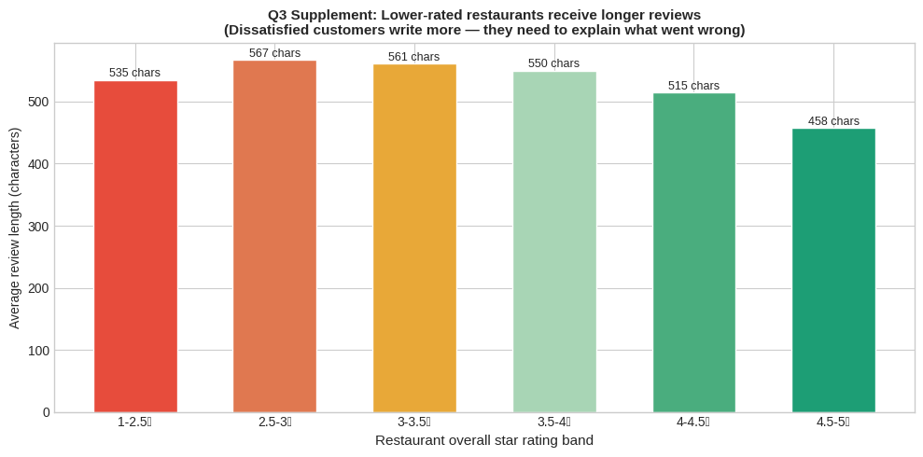
Rating band | Avg review length | vs top-rated band | Pattern | Signal
2.5 – 3.0★ | 567 chars (longest) | +109 chars | Peak complaint length | ⚠ Distress
3.0 – 3.5★ | 561 chars | +103 chars | Still explaining problems | ⚠ Warning
3.5 – 4.0★ | 550 chars | +92 chars | Mixed experiences | Neutral
4.0 – 4.5★ | 515 chars | +57 chars | Positive with some detail | Good
4.5 – 5.0★ | 458 chars (shortest) | — baseline | Brief celebration | ✓ Healthy

Practical Application for Restaurant Owners
The 2.5-3.0★ band produces the longest reviews (567 characters), which are 109 characters longer than top-rated restaurants (458 characters). Dissatisfied customers need to justify their rating by documenting specific failures; satisfied customers are brief because the experience met expectations. This creates an early warning opportunity: an owner who notices that recent reviews are getting longer — even before the star rating drops — is receiving a leading indicator that customers are starting to encounter problems worth documenting. Monitoring average review length weekly costs nothing and requires no data tools beyond reading Yelp.

8. Recommendations for NROA Members
The three findings above converge on three specific, ranked recommendations. Each recommendation is grounded in at least two independent evidence sources: the Yelp dataset analysis and published academic or industry research.

Recommendation 1 (Priority: Highest impact, lowest cost)
Add outdoor seating
Evidence: OutdoorSeating shows the largest feature gap in Q1 (+18.6pp) and ranks third in the Q2 predictive model. The effect is consistent across 7 US cities (range: +0.35 to +0.50 stars), with Edmonton as the only exception due to climate. The combination analysis shows that adding outdoor seating as one of two key attributes contributes to a cumulative 0.50-star improvement.
Monday morning action: Contact your local authority about pavement/patio licensing. If outdoor space already exists, ensure it is listed and described on your Yelp profile.

Recommendation 2 (Priority: Highest single-step rating gain)
Reposition pricing to mid-range tier
Evidence: PriceRange is the single most important predictor in the Random Forest model (importance = 0.33). Moving from Budget (Level 1) to Mid-range (Level 2) is associated with a +0.44-star increase and a 15-percentage-point increase in the proportion of restaurants reaching 4 stars. This is supported by Lee (2013) and Jurafsky et al. (2014), both of whom identify price tier as a core predictor of Yelp ratings. Importantly, this relationship reflects positioning and overall quality commitment, not simply the act of raising prices — mid-range restaurants tend to invest more in ingredients, service consistency, and dining environment, which collectively drive higher customer satisfaction.
Who this applies to: Independent operators who believe their food and service quality justifies a higher positioning but whose current Budget-tier pricing is constraining customer expectations and limiting perceived quality. This recommendation is not universal. Restaurants whose business model depends on high table turnover, volume sales, and price-sensitive customer segments — such as fast-casual, student-facing, or family quick-service operators — may be highly profitable at Budget pricing despite lower Yelp ratings. For these operators, the relevant success metric is revenue and occupancy, not star rating. NROA should acknowledge that a 3.2-star restaurant serving 200 covers a day may be more financially successful than a 3.9-star restaurant serving 60.
Monday morning action: If your current Yelp price range is set to Level 1 and you are actively trying to improve your reputation and attract new customers through Yelp, consider whether a modest menu repricing — supported by genuine improvements in ingredients or presentation — could support a move to Level 2. Do not change the Yelp setting without ensuring the actual experience matches the new positioning. A mismatch between stated price tier and delivered experience will produce worse reviews, not better ones.

Recommendation 3 (Priority: Immediate — no capital required)
Reduce wait times and fix order accuracy
Evidence: Q3 NLP analysis identifies 'order', 'minutes', and 'manager' as the most distinctive words in low-rated restaurant reviews. This is consistent with Harrison-Walker (2019), who identifies excessive wait times and incorrect orders as the two most common service failure types. Critically, customers in this dataset do not primarily blame food quality for low ratings — they blame operational failures that are correctable without capital investment.
Extended Evidence — Quantifying the Cost of Each Service Failure
To strengthen the recommendation, we quantified exactly how much each service failure keyword drags down review star ratings. Across 40,000 sampled reviews, we identified whether each review contained a specific keyword and compared the average star rating of reviews that contained it versus those that did not.
Two findings are particularly notable. First, "manager" is the single most damaging keyword (−0.49★) — not because managers are bad, but because a customer mentioning the manager signals that the problem had already escalated beyond the frontline. By the time a customer involves a manager, their experience has already failed at multiple points. Preventing escalation is therefore more valuable than managing escalation.
Second, "wait" has almost no rating impact (+0.01★) while "minutes" carries a −0.31★ penalty. This distinction matters: customers accept that restaurants are busy and waiting is normal. What they do not accept is waiting long enough that they feel compelled to record the specific duration. The damage is not from waiting itself — it is from waiting beyond their tolerance threshold without explanation or acknowledgement.
Revised Monday morning action: Read your 10 most recent Yelp reviews and search for these eight words in order of severity: manager, rude, minutes, wrong, order, cold, slow, wait. A single mention of "manager" or "rude" warrants an immediate team conversation. Three or more mentions of "minutes" or "order" across recent reviews is an operational pattern, not a one-off complaint — treat it as a process problem, not a customer problem.

9. Limitations
Analytical credibility requires acknowledging what the data cannot prove.

- The analysis identifies features that co-occur with high ratings. It does not prove that adding outdoor seating or adjusting prices will cause ratings to improve. Causal claims would require longitudinal data tracking restaurants before and after making changes.
- The Yelp dataset is denser in specific US cities (Philadelphia, Las Vegas, Phoenix, Tampa). Rural and small-town independent restaurants are underrepresented. Findings may generalise less well to markets where Yelp penetration is lower.
- Q3 used a stratified random sample of 40,000 reviews rather than the full 7M+ corpus. The stratification by star rating ensures representativeness, but very rare word patterns may not be captured.
- The outdoor seating finding does not hold in cold climates. NROA should note this when disseminating recommendations to members in northern markets.
- All data reflects the Yelp platform as of 2022. Post-pandemic consumer preferences (particularly around outdoor dining) may have evolved since this snapshot was taken.
- The Random Forest AUC of 0.69 indicates meaningful discriminative ability, but also that 31% of variance in the outcome is not captured by the available attributes. Other factors not in the dataset (e.g., food quality, chef tenure, neighbourhood gentrification) likely matter.

10. References
Anderson, M. and Magruder, J. (2012) 'Learning from the crowd: Regression discontinuity estimates of the effects of an online review database', The Economic Journal, 122(563), pp. 957-989.

Gan, Q., Ferns, B.H., Yu, Y. and Jin, L. (2017) 'A text mining and multidimensional sentiment analysis of online restaurant reviews', Journal of Quality Assurance in Hospitality & Tourism, 18(4), pp. 465-492.

Harrison-Walker, L.J. (2019) 'The critical role of customer forgiveness in successful service recovery', Journal of Business Research, 95, pp. 376-391.

Jurafsky, D., Chahuneau, V., Routledge, B.R. and Smith, N.A. (2014) 'Narrative framing of consumer sentiment in online restaurant reviews', First Monday, 19(4).

Lee, Y.L. (2013) 'The effects of price on consumer satisfaction and loyalty', International Journal of Business Research, 13(3).

Luca, M. (2011) Reviews, Reputation, and Revenue: The Case of Yelp.com. Harvard Business School Working Paper 12-016.

Yelp Inc. (2022) State of the Restaurant Industry 2022. Available at: https://trends.yelp.com/state-of-the-restaurant-industry-2022

