III. SYSTEM OVERVIEW AND PROBLEM FORMULATION
To reduce the physical risks of rigid rehabilitation robots and provide an engaging therapeutic environment, we introduce a magnetically-actuated non-contact rehabilitation system. This section describes the hardware architecture, states the control problem, and formulates it as a reinforcement learning task.
A. Hardware Platform
The platform achieves safety by physically separating the robotic actuator from the patient. As shown in Fig. X, the system has three layers. The actuation layer places a UR10 robotic arm beneath the workspace, with a permanent magnet on its end-effector that drives the microrobot above. The interaction layer is a 5 mm acrylic sheet that supports the unpowered magnetic microrobot while acting as a barrier between the arm and the patient. The perception layer uses an overhead RGB camera connected via USB to a host computer, which also communicates with the UR10 over Ethernet. At each control cycle the computer acquires a camera frame, estimates the positions of the microrobot and the patient's hand, and sends target pose commands to the arm.
By separating the robotic actuator from the patient's limb, the acrylic interface substantially reduces the risk of blunt impact, excessive traction, and crushing injuries that may arise in direct-contact rehabilitation devices. In addition to improving safety, the system has a simple and reproducible structure: it requires only a collaborative robot, a camera, and a permanent magnet, without wearable components, force sensors, or custom actuation modules. The microrobot itself is unpowered and is driven passively by the magnetic field, eliminating the need for onboard electronics or batteries. This hardware simplicity facilitates setup, maintenance, and potential deployment across clinical environments. Moreover, the non-contact actuation mechanism provides an additional safety margin for deploying and refining learning-based controllers on the physical platform.
B. Problem Formulation
We formulate the rehabilitation task as a pursuit-evasion game played on a flat workspace. The patient sits in front of the acrylic surface and uses one hand to chase the magnetic microrobot, which moves under the control of the robot arm below. The goal is to catch the microrobot by bringing the hand within a small contact radius. This is not a static reaching exercise: the microrobot actively evades, so the patient must continuously track, predict, and intercept a moving target, which demands sustained attention and real-time motor planning. Clinical evidence shows that this kind of continuous, goal-directed visuomotor tracking engages the central nervous system and promotes neuroplasticity for motor recovery [X]. To maximize therapeutic benefit, task difficulty must adapt to the patient's current ability. This principle is formalized by the Zone of Proximal Development (ZPD), a concept from educational psychology introduced by Vygotsky [X] that describes the range of tasks a learner can perform with guidance but not alone. In our setting, the ZPD translates to a target distance range between the hand and the microrobot: the robot should neither escape completely nor yield passively, but keep the distance within this range so the patient stays challenged without becoming fatigued or frustrated.
Maintaining this therapeutic difficulty range is challenging for conventional control methods. Many classical approaches, such as artificial potential fields or rule-based impedance controllers, rely primarily on hand-crafted rules and instantaneous state feedback. As a result, they may struggle to anticipate higher-level patient strategies, such as trajectory interception, or to adapt to heterogeneous movement patterns across patients. Their performance may further degrade in the presence of neurological motor impairments, including tremor, delayed response, and bradykinesia, because these methods typically lack an explicit mechanism for distinguishing purposeful movement from involuntary perturbations. Reinforcement learning provides a suitable framework for addressing these challenges. In our formulation, the robot learns an evasion policy through repeated interaction with the patient or patient models. The policy is rewarded for maintaining the hand-microrobot distance within the therapeutic range and penalized for unsafe or uninformative behaviors, such as escaping too far or being caught too easily. By conditioning the policy on temporal observations of hand and microrobot motion, the controller can infer patient intent from movement history rather than responding only to instantaneous position error. Through this process, the robot can progressively adapt its behavior to different patient capabilities and maintain an appropriate level of challenge. The following sections describe how the policy is trained to generalize across diverse movement patterns observed in neurological rehabilitation.
IV. METHODOLOGY
The previous section formulated the rehabilitation task and motivated the use of reinforcement learning. This section describes the complete training framework. We first introduce a domain randomization scheme that accounts for both patient movement strategies and motor limitations (Section IV-A). We then present a dual-stream encoder with an auxiliary forward dynamics head to extract motion information from noisy temporal observations (Section IV-B). Finally, we describe a league training procedure that improves the robustness of the robot policy against a growing pool of hand behaviors (Section IV-C).
A. Cognitive-Motor Decoupled Domain Randomization
The pursuit-evasion task is implemented as a Gymnasium environment with two interacting entities. The robot policy controls the magnetic microrobot, while the hand represents the patient and is controlled by a separate policy or scripted controller. A key challenge for real-world deployment is that neurological patients may move in very different ways. If the simulated hand follows only one fixed strategy, the learned robot policy may overfit to that behavior and perform poorly when facing real patients. To address this issue, we use a two-layer domain randomization scheme. The first layer randomizes the hand's movement strategy. At the beginning of each episode, a hand controller is sampled from an opponent pool. This pool includes simple scripted controllers based on fixed pursuit rules as well as trained RL controllers that can intercept and anticipate the microrobot. The selected controller produces a desired hand displacement at each timestep. The second layer modifies this desired displacement according to motor and sensing constraints. The raw displacement is first passed through a first-order low-pass filter to model muscle inertia:
x_t = alpha x_{t-1} + (1 - alpha) u_t, alpha in (0, 1),
where u_t denotes the raw desired displacement and x_t denotes the filtered displacement. Acceleration clipping is then applied to limit abrupt changes in motion:
Delta x_t = clip(x_t - x_{t-1}, -a_max, a_max).
Gaussian observation noise is further added to simulate position estimation errors from the vision system. To model delayed motor response, a temporal delay is introduced so that the displacement executed at time t corresponds to the intended displacement generated several frames earlier. The delay is sampled at the beginning of each episode. This design separates what the hand attempts to do from how the movement is actually executed. As a result, the robot policy is exposed to a wide range of patient-like behaviors and is encouraged to learn motion patterns that are not tied to a single simulated hand model.
Parameter | Symbol | Range
Muscle inertia | alpha | 0.7
Maximum acceleration | a_max | 0.15
Gaussian observation noise | sigma | U(0.01, 0.08)
Neural delay | delta | 0-3 frames (0-375 ms)
B. Dual-Stream Encoder with Future Dynamics Head
The patient's intended movement cannot be directly inferred from a single frame. In addition, the observed hand motion may be affected by sensing noise, motor delay, tremor-like perturbations, and slow response. Therefore, using only instantaneous position inputs may not be sufficient for the policy to distinguish purposeful movement from short-term disturbances. To address this problem, we design a dual-stream encoder with an auxiliary prediction task, as shown in Fig. X.
At each timestep, the 44-dimensional observation vector is divided into a 12-dimensional scalar vector and a 32-dimensional temporal buffer:
o_t = [s_t ; h_{t-T:t}].
The scalar vector is defined as:
s_t = [p_R; p_H; d(R,H); b_N, b_S, b_E, b_W; stride; a_{t-1}],
where p_R and p_H denote the two-dimensional positions of the microrobot and the hand, respectively; d(R,H) is their Euclidean distance; b_N, b_S, b_E, and b_W are the signed distances to the workspace boundaries; stride is the current movement step size; and a_{t-1} is the previous robot action. These variables describe the current geometric state of the interaction, including relative position, boundary distance, and recent action information.
The temporal buffer h_{t-T:t} contains the T = 16 most recent relative hand displacement vectors, forming a 32-dimensional sequence. This buffer captures recent velocity, acceleration, and repeated movement patterns that cannot be obtained from the current position alone. The scalar vector is processed by an MLP to extract the current geometric information. In parallel, the temporal buffer is processed by a GRU sequence encoder. Because the GRU uses relative displacements rather than absolute positions, it focuses on movement direction, speed, acceleration, and oscillation. The outputs of the two streams are then concatenated and passed through a fusion MLP to produce a shared representation for policy and value prediction.
Although the ZPD-based reward provides a continuous training signal, it does not directly teach the encoder how to represent patient motion. Learning this representation only through policy reward can be slow and unstable. To provide a more direct signal, we attach a future-dynamics head to the fused representation. This head predicts the patient's future relative displacement over an eight-step horizon and also estimates near-catch risk. Since future displacements are already contained in the rollout, these targets can be obtained without extra data collection or manual annotation. The auxiliary trajectory loss is defined as:
L_traj = E[||D_hat_{t+1:t+H} - D_{t+1:t+H}||_2^2], H = 8,
where D_hat_{t+1:t+H} is the predicted future displacement sequence and D_{t+1:t+H} is the observed future displacement sequence. The full training objective combines the PPO loss with the auxiliary trajectory and risk-prediction losses:
L_total = L_PPO + lambda_traj L_traj + lambda_risk L_risk,
where lambda_traj and lambda_risk control the auxiliary loss weights. Because the future-dynamics head shares the encoder with the policy, its gradients also update the spatial and temporal streams. This encourages the encoder to capture patient inertia, delay, and interaction dynamics, helping the robot policy anticipate near-future hand motion instead of reacting only to the current hand-microrobot distance.
C. League Training
A natural baseline is to train the robot and hand policies at the same time. However, simultaneous training in a two-agent game creates a non-stationary learning problem. The return of each agent depends on the policy of the other agent. When both policies are updated together, each update changes the environment faced by the other policy, which conflicts with the stationarity assumption of PPO. In practice, this can lead to cyclic adaptation: the robot learns to exploit the current hand policy, the hand then adapts to the robot, and the robot may forget strategies that were useful against earlier hand behaviors. To avoid this issue, we freeze one side of the interaction while training the other. During robot training, the hand policies are fixed and treated as part of the environment. During hand training, the robot policy is fixed. This alternating procedure provides a more stable learning objective than updating both policies simultaneously.
Our goal is different from purely competitive games. In rehabilitation, the robot should not simply learn to defeat the hand. Instead, it should maintain an appropriate level of challenge for patients with different movement abilities. A single hand policy cannot represent this range of behavior. We therefore maintain an opponent pool P that stores hand policies from different training stages. These hand policies provide a diverse set of pursuit behaviors for training the robot.
As summarized in Algorithm 1, each iteration has two phases. In the robot phase, the opponent pool P is fixed, and the robot policy is trained with PPO against hand policies sampled from the pool. In the hand phase, a new hand policy is initialized from the previous hand policy and further trained against the current fixed robot policy. The trained hand policy is then added to P, increasing the diversity of hand behaviors used in the next robot training phase.
Algorithm 1: Iterative League Training
Initialize: opponent pool P <- {pi_H^script}, robot policy pi_R^(0)
for n = 1, 2, ..., N do
// Robot phase (pool frozen)
Train pi_R^(n) via PPO against opponents sampled
from P using prioritized distribution P(i)
// Hand phase (robot frozen)
Warm-start pi_H^(n) from pi_H^(n-1), fine-tune
against frozen pi_R^(n)
P <- P union {pi_H^(n)}
end for
Uniformly sampling from the opponent pool is inefficient. Weak hand policies provide little learning signal because the robot can maintain the desired distance too easily. Very strong hand policies may lead to mostly failed episodes, which also provide limited useful feedback. The most useful hand policies are those that are challenging but not impossible for the current robot policy. To focus training on these useful opponents, we track the robot's average normalized episode length against each hand policy and sample opponents using a length-prioritized distribution:
P(i) propto f(w_i), f(w) = 1 / (1 + exp(-k * (eta - |w - 0.5|)))
where w_i denotes the normalized episode length against opponent i, k controls the sharpness of the distribution, and eta defines the tolerance band around the target value of 0.5. This sampling rule gives higher probability to hand policies that produce intermediate episode lengths. In this way, the robot is trained more often against opponents that match its current ability, without manually specifying a difficulty schedule.
One possible risk of league training is that the robot may learn to exploit artificial patterns in the simulated hand policies. Such behavior would reduce the relevance of the learned policy for real rehabilitation. To reduce this risk, a fixed probability p_s is always assigned to the heuristic scripted hand policy. This ensures that the robot remains exposed to simple, noisy pursuit behavior, which is closer to the behavior expected from real patients.
VI. EXPERIMENTS AND RESULTS
We evaluate the simulation component through three complementary studies. First, a ten-generation league experiment examines whether iterative opponent-pool training improves robustness against heterogeneous learned hand behaviors. Second, a GRU-based network ablation isolates the contribution of temporal interaction-history encoding and auxiliary future-dynamics supervision. Third, a held-out policy comparison evaluates the resulting robot policies against both a scripted pursuit controller and a learned hand agent.
A. League Training Robustness
The league experiment uses a ZPD band of 3.5-5.5 workspace units and trains ten robot generations without providing an explicit opponent identity. Each robot generation is evaluated against the first ten learned hand policies and a scripted pursuit controller. Time-in-zone (TIS), defined as the fraction of interaction time spent inside the ZPD band, is used as the main robustness metric. We report both mean TIS across learned hands and worst-case TIS to measure the lower tail of performance.
Fig. 1 summarizes the final ten-generation league result. The final robot R10 achieves the strongest learned-hand robustness among the evaluated generations. Mean TIS against learned hands increases from 0.188 for R1 to 0.282 for R10, an absolute gain of 0.094. Worst-case learned-hand TIS increases from 0.138 to 0.204, an absolute gain of 0.065. These gains indicate that iterative opponent accumulation improves not only average performance but also robustness against harder learned hand policies.
The sorted empirical matrix further supports this interpretation. When robots are ordered from weak to strong and hands from easy to hard, later robot generations occupy higher-TIS regions across a broader set of opponents. The scripted-hand curve remains useful as a sanity check, but the learned-hand pool exposes robustness differences that a single scripted hand would not reveal. This result motivates league-trained virtual patients as a stress-test distribution for adaptive rehabilitation policies.
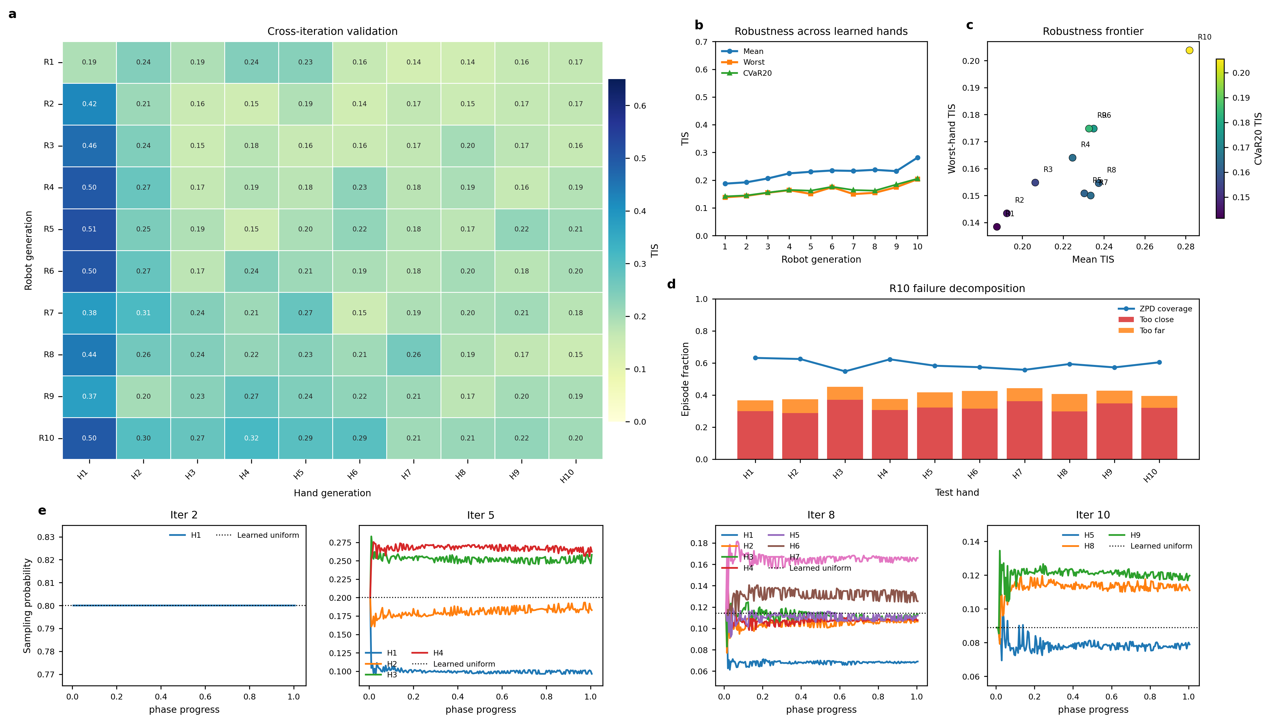
Fig. 1. League-training overview for the no-opponent-ID ZPD 3.5-5.5 simulation. The final robot generation improves mean and worst-case time-in-zone against the learned-hand pool, while the sorted empirical matrix visualizes robustness across increasingly difficult virtual patients.
B. GRU Network Ablation
The architecture ablation compares three robot policy encoders trained for one generation under the same mixed-opponent protocol. The MLP baseline uses only the scalar spatial state and does not process the interaction-history buffer. The GRU variant adds a temporal sequence encoder over the 16-frame relative-displacement history. The GRU+Aux variant further augments the recurrent encoder with the auxiliary future-prediction objective described in Section IV-B. All variants are trained for 8 million environment steps against a pool composed of the first ten learned hand policies and the scripted pursuit controller.
Fig. 2 summarizes the GRU ablation. The top row reports smoothed training trajectories for episode return and episode length, using a 200k-timestep smoothing window to emphasize the long-term learning trend. The MLP baseline converges to lower return and shorter episodes than both recurrent variants, indicating that instantaneous geometric state alone is insufficient for stable closed-loop adaptation. Over the final 10% of training episodes, the MLP obtains a mean reward of -42.94 and a mean episode length of 27.58, whereas the GRU reaches -35.56 reward and 36.12 steps. This corresponds to an improvement of 7.39 reward points and 8.54 steps per episode. The GRU+Aux policy reaches a comparable final-stage reward (-35.39) and episode length (35.92), suggesting that temporal sequence modeling is the primary source of aggregate control improvement in this experiment.
Although the auxiliary model does not substantially exceed the GRU-only policy in final aggregate control metrics, it provides a direct and interpretable representation-learning signal. The bottom row of Fig. 2 visualizes representative future-motion predictions and the trajectory error over the eight-step horizon. The error increases with prediction horizon, as expected for multi-step forecasting, while short-horizon predictions remain close to the observed hand trajectory. These results indicate that the auxiliary task encourages the encoder to represent latent hand dynamics, even when the resulting control-performance gain is modest under the current loss weighting.
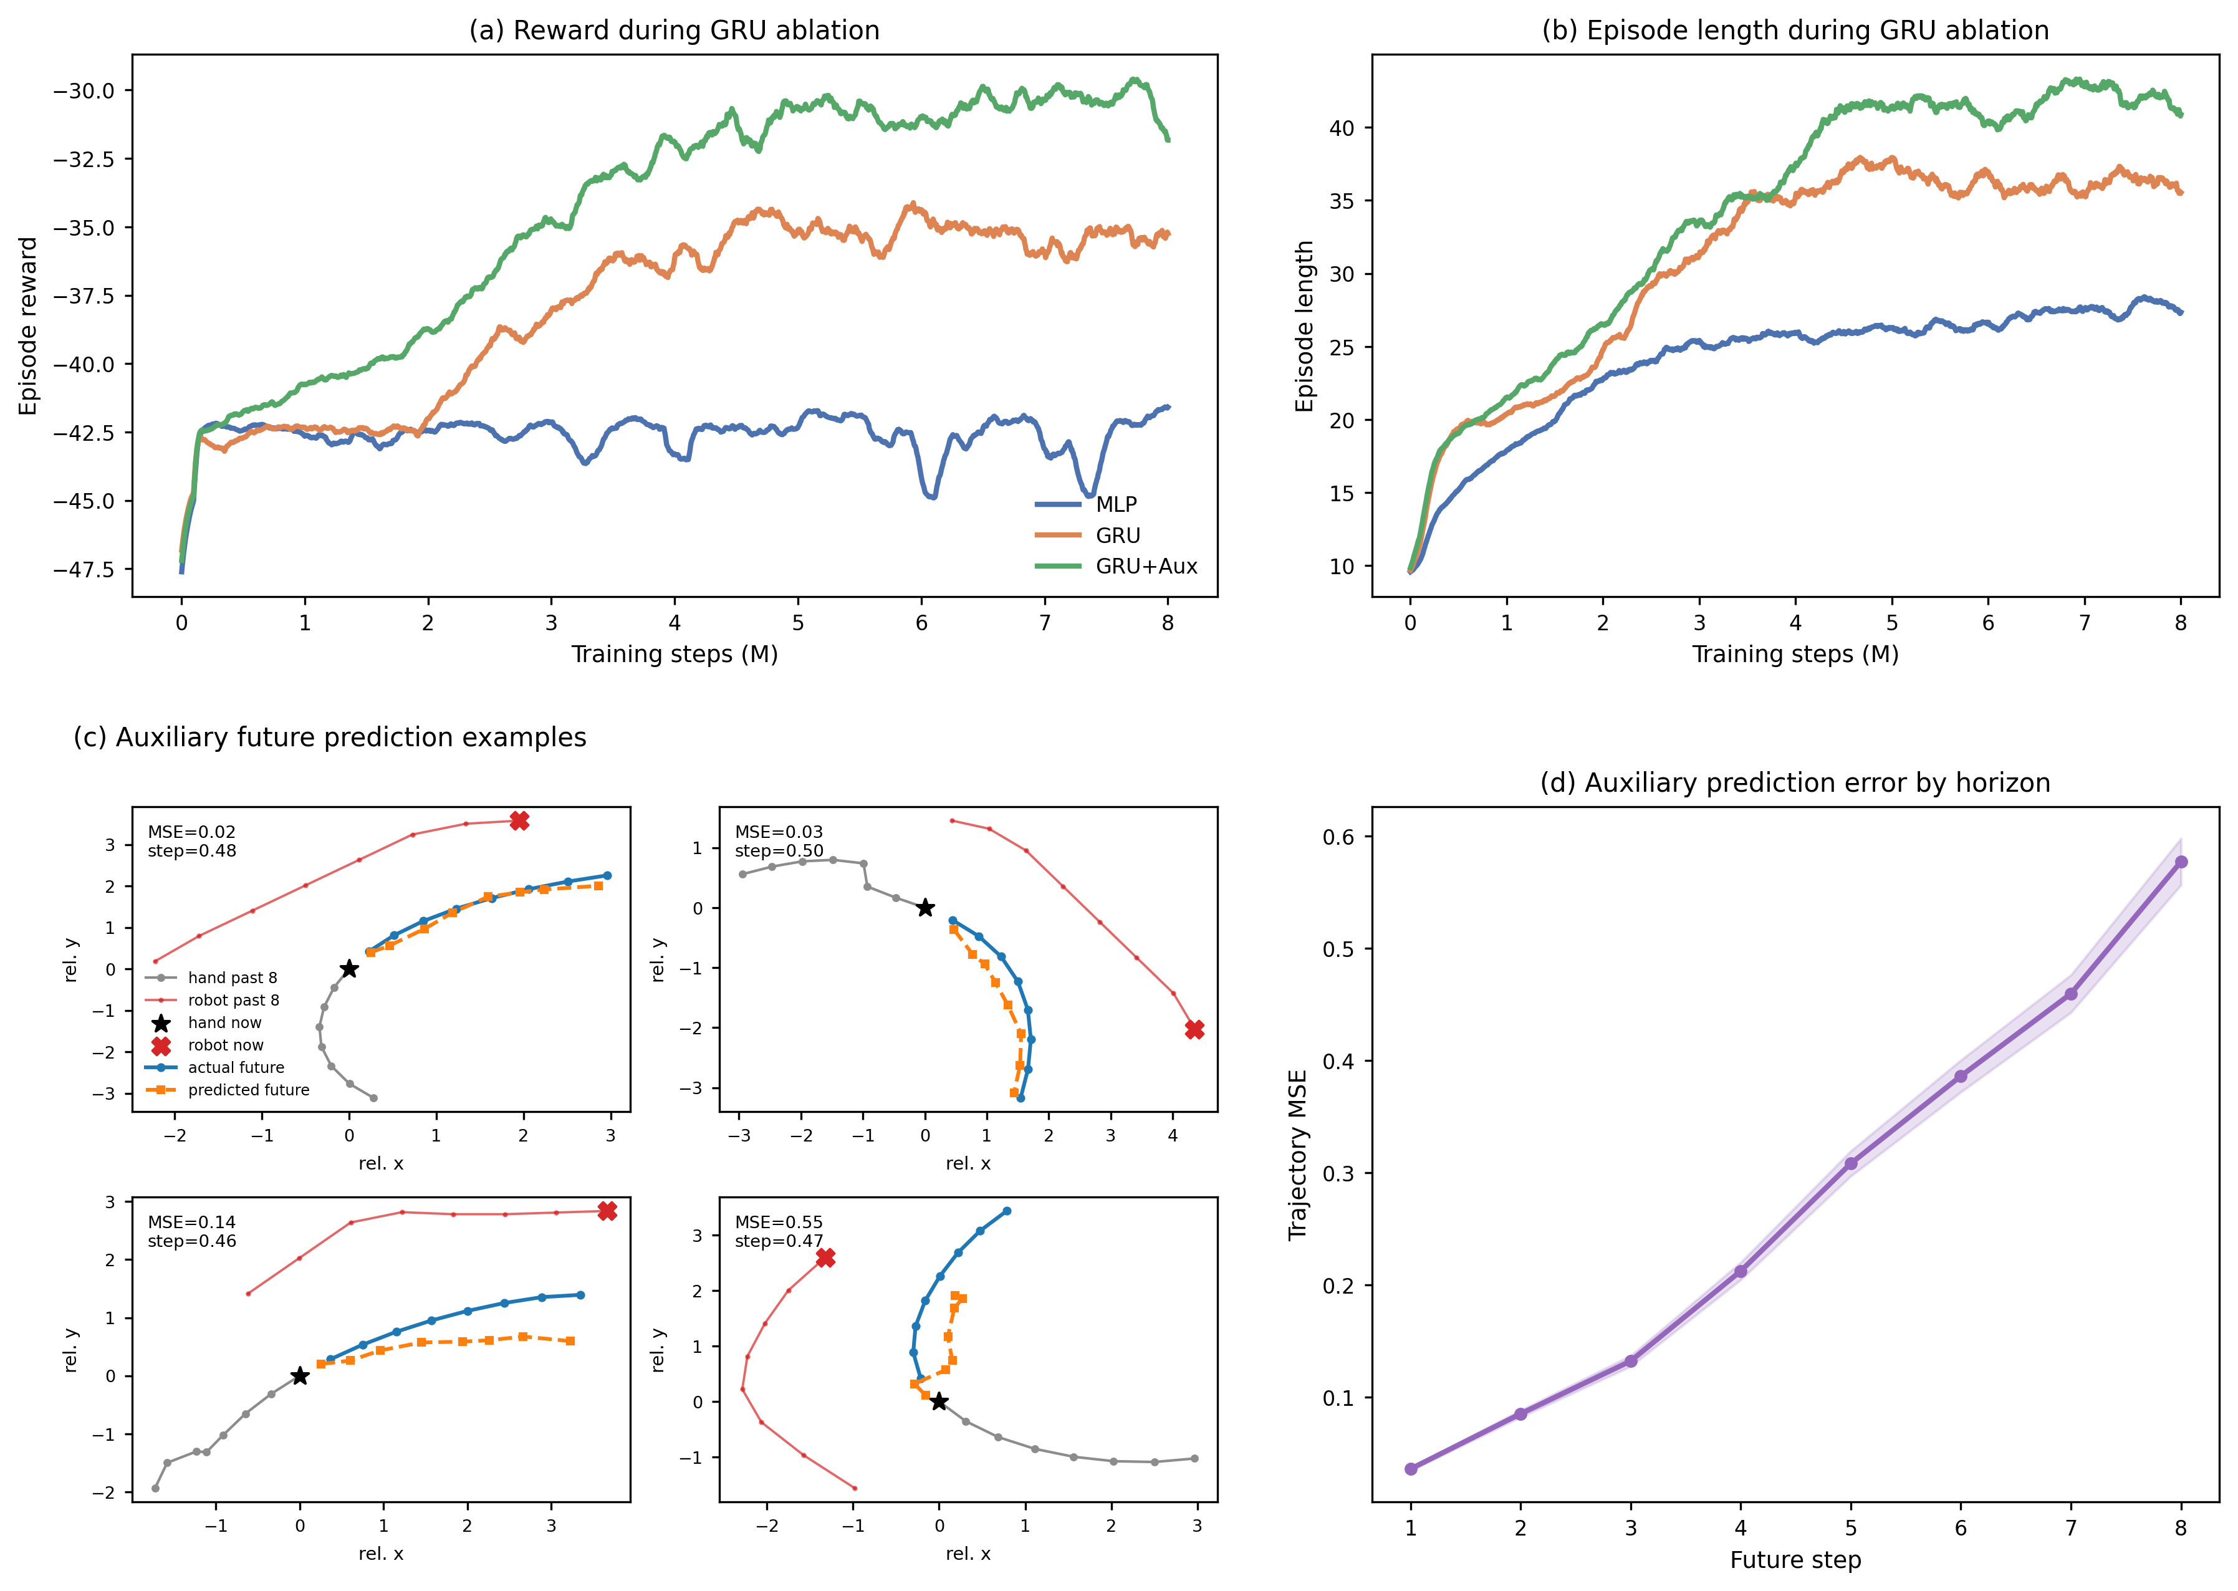
Fig. 2. GRU ablation and auxiliary future-motion prediction. Panels (a) and (b) show smoothed training reward and episode length for MLP, GRU, and GRU+Aux policies trained against the mixed learned-hand and scripted-hand pool. Panels (c) and (d) visualize representative auxiliary future-prediction examples and horizon-dependent trajectory error.
C. Policy Comparison on Scripted and Learned-Agent Hands
To complement the training curves, we evaluate the final robot policies against two representative non-interactive test conditions: a stochastic scripted pursuit controller and a learned hand agent. This comparison probes whether each training protocol produces behavior that is specific to its training opponent or remains effective across different hand-control mechanisms.
TABLE II: POLICY COMPARISON ON SCRIPTED AND LEARNED-AGENT HANDS
Robot policy | Scripted hand | Agent hand
Scripted-only | 0.31 / 0.54 / 52 / 60% | 0.19 / 0.54 / 31 / 90%
Single-agent | 0.11 / 0.41 / 25 / 95% | 0.49 / 0.60 / 70 / 38%
League | 0.38 / 0.55 / 67 / 43% | 0.48 / 0.65 / 64 / 48%
The table reports TIS / ZPD coverage / episode length / catch rate. The scripted-only baseline attains a TIS of 0.31 against the scripted hand but drops to 0.19 TIS with a 90% catch rate against the learned hand, indicating weak robustness outside its training distribution. The single-agent baseline performs well against the learned hand (TIS = 0.49) but degrades substantially on the scripted hand (TIS = 0.11), suggesting over-specialization to one learned opponent. The league-trained robot achieves competitive TIS on the learned hand (0.48) while also retaining the strongest scripted-hand TIS (0.38), yielding the most balanced performance across the two automated test conditions. Mouse-controlled human-in-the-loop evaluation will be reported after collection.
D. Sim-to-Real Transfer
The physical UR10 deployment is not directly comparable to simulation through a pointwise sim-real gap table, because real human behavior, camera latency, magnetic actuation, and safety constraints are not distribution-matched to virtual hands. We therefore treat sim-to-real validation as a real-world closed-loop feasibility study rather than as a paired simulation benchmark. The implementation uses the same 44-dimensional observation structure as simulation: robot position from RTDE, hand and microrobot positions from the overhead camera, boundary features, previous action, and the displacement-history buffer.
The implementation uses temporal decoupling between perception and control. The camera runs at 10-15 Hz, but the robot needs deterministic commands at a fixed control rate. Running both in one thread would cause jitter: a slow YOLO inference would stall the control loop and freeze the robot. We therefore use two threads connected by a single-element message queue. The vision thread captures frames, runs undistortion and detection, and pushes results to the queue. If the queue is full, the stale result is replaced. The control thread runs at 20 Hz and attempts a non-blocking read each cycle. If a new frame is available, the hand position is updated; otherwise the system falls back to dead reckoning using a low-pass filtered velocity estimate from recent vision updates.
The 44-dimensional observation is assembled from the estimated hand position, the robot position via RTDE, and the displacement-history buffer, then fed to the PPO policy. The 2D action is accumulated as a virtual target in pixel space, rate-limited to prevent large per-step motion, and mapped to world coordinates via the inverse homography. The final pose is sent to the UR10 through the servoL interface with a 0.1 s lookahead time and proportional gain of 400, yielding smooth end-effector tracking.

