III. SYSTEM OVERVIEW AND PROBLEM FORMULATION
We introduce a magnetically actuated, non-contact rehabilitation system designed to reduce the physical risks associated with rigid robotic interaction while preserving an engaging motor-training task. This section first describes the hardware architecture and then formulates the control problem as a reinforcement learning (RL) task.
A. Hardware Platform
The platform improves safety by physically separating the robotic actuator from the patient. As shown in Fig. X, the system consists of three layers. The actuation layer places a UR10 robotic arm beneath the workspace, with a permanent magnet mounted on the end-effector to drive the microrobot above. The interaction layer is a 5-mm acrylic sheet that supports the unpowered magnetic microrobot and serves as a barrier between the arm and the patient. The perception layer uses an overhead RGB camera connected to a host computer, which also communicates with the UR10 over Ethernet. At each control cycle, the computer acquires a camera frame, estimates the positions of the microrobot and the patient's hand, and sends target pose commands to the arm.
This physical separation is central to the safety design. The acrylic interface reduces the risk of blunt impact, excessive traction, and crushing injuries that may occur in direct-contact rehabilitation devices. The hardware is also simple and reproducible: it requires a collaborative robot, a camera, and a permanent magnet, without wearable components, force sensors, or custom actuation modules. Because the microrobot is unpowered and driven passively by the magnetic field, it does not require onboard electronics or batteries. This simplicity facilitates setup and maintenance, and it provides an additional safety margin during the iterative development of data-driven controllers.
B. Problem Formulation
We formulate the rehabilitation task as a pursuit-evasion game on a flat workspace. The patient sits in front of the acrylic surface and uses one hand to chase the magnetic microrobot, which is controlled by the robot arm below. The goal is to bring the hand within a small contact radius of the microrobot. Unlike static reaching exercises, the microrobot actively evades the patient's hand, requiring continuous visuomotor tracking, trajectory prediction, and real-time motor planning. Such goal-directed tracking can impose sustained cognitive and physical demands beyond point-to-point reaching and is relevant to motor recovery [X]. To maximize therapeutic benefit, task difficulty must adapt to the patient's current ability. We formalize this requirement using the Zone of Proximal Development (ZPD), which describes tasks that remain challenging but achievable with support [X]. In our setting, the ZPD corresponds to a target distance range between the hand and the microrobot. The robot should neither escape completely nor yield passively; instead, it should keep the interaction within this range so that the patient remains engaged without becoming fatigued or frustrated. This objective is challenging because patient movement speed, strategy, delay, and motor noise can vary over time.
Conventional controllers are not well suited to this setting. Methods based on artificial potential fields or rule-based impedance control usually rely on hand-crafted responses to instantaneous state feedback. They therefore have limited ability to anticipate higher-level patient strategies, such as interception, or to adapt to heterogeneous movement patterns. Their performance may degrade further under tremor, delayed response, or bradykinesia because they do not explicitly distinguish purposeful movement from involuntary perturbations. RL provides a natural framework for learning such adaptive behavior through repeated interaction. In our formulation, the robot learns an evasion policy that is rewarded for keeping the hand-microrobot distance within the therapeutic range and penalized for unsafe or uninformative behavior, such as escaping too far or being caught too easily. By conditioning the policy on temporal observations, the controller can infer patient intent from movement history rather than reacting only to instantaneous position error. The design choices in Section IV--domain randomization, temporal encoding, and league training--address these sources of patient variability.
IV. METHODOLOGY
This section describes the training framework. We first introduce Cognitive-Motor Decoupled Domain Randomization (CMD-DR), which separates patient movement strategy from motor execution limitations. We then present a dual-stream encoder with an auxiliary future-dynamics head for extracting motion information from noisy temporal observations. Finally, we describe a league-training procedure designed to improve robustness against a growing pool of hand behaviors.
A. Cognitive-Motor Decoupled Domain Randomization
A generalizable robot policy must account for variation in both patient strategy and motor execution. CMD-DR addresses these two factors separately. The first layer randomizes the hand strategy by sampling a controller from an opponent pool at the beginning of each episode. The pool contains scripted pursuit controllers and trained RL controllers that can intercept or anticipate the microrobot. The selected controller produces a desired hand displacement at each timestep. The second layer transforms this desired displacement through motor and sensing constraints. Specifically, the raw displacement is passed through a first-order low-pass filter to model muscle inertia:
x_t = alpha x_{t-1} + (1 - alpha) u_t, alpha in (0, 1). (1)
where u_t denotes the raw desired displacement and x_t denotes the filtered displacement. Acceleration clipping is then applied to limit abrupt changes in motion:
Delta x_t = clip(x_t - x_{t-1}, -a_max, a_max). (2)
Gaussian observation noise simulates position-estimation errors from the vision system. A sampled temporal delay models delayed motor response by executing a displacement generated several frames earlier. Table I lists the parameter values and sampled ranges for these constraints. By separating intended movement from motor execution, CMD-DR exposes the robot policy to diverse patient-like behaviors and reduces dependence on any single simulated hand model.
Parameter | Symbol | Range
Muscle inertia | alpha | 0.7
Maximum acceleration | a_max | 0.15
Gaussian observation noise | sigma | U(0.01, 0.08)
Neural delay | delta | 0-3 frames (0-375 ms)
B. Dual-Stream Encoder with Future Dynamics Head
A single frame is often insufficient for inferring patient intent. Observed hand motion may reflect sensing noise, motor delay, tremor-like perturbations, or slow response, rather than deliberate pursuit. We therefore use a dual-stream encoder with an auxiliary prediction task, as shown in Fig. X.
The encoder separates geometric context from motion history. At each timestep, the 44-dimensional observation vector is divided into a 12-dimensional scalar vector and a 32-dimensional temporal buffer:
o_t = [s_t ; h_{t-T:t}]. (3)
The scalar vector is defined as:
s_t = [p_R; p_H; d(R,H); b_N, b_S, b_E, b_W; stride; a_{t-1}]. (4)
where p_R and p_H denote the two-dimensional positions of the microrobot and the hand, respectively; d(R,H) is their Euclidean distance; b_N, b_S, b_E, and b_W are the signed distances to the workspace boundaries; stride is the current movement step size; and a_{t-1} is the previous robot action. These variables describe the current geometric state of the interaction, including relative position, boundary distance, and recent action information.
The temporal buffer h_{t-T:t} contains the T = 16 most recent relative hand displacement vectors, forming a 32-dimensional sequence. This buffer captures velocity, acceleration, and repeated movement patterns that are unavailable from the current position alone. The scalar vector is processed by a Multi-Layer Perceptron (MLP) to extract geometric information. In parallel, the temporal buffer is processed by a Gated Recurrent Unit (GRU) sequence encoder. Because the GRU operates on relative displacements rather than absolute positions, it emphasizes movement direction, speed, acceleration, and oscillation. The two stream outputs are concatenated and passed through a fusion MLP to produce a shared representation for policy and value prediction.
The ZPD-based reward provides a control signal, but it does not directly supervise how the encoder should represent patient motion. Learning this representation only through policy reward can therefore be slow and unstable. To provide a denser signal, we attach a future-dynamics head to the fused representation. This head predicts the patient's relative displacement over an eight-step horizon and estimates near-catch risk. Because future displacements are already available from the rollout, the auxiliary targets require no additional annotation. The trajectory loss is defined as:
L_traj = E[||D_hat_{t+1:t+H} - D_{t+1:t+H}||_2^2], H = 8. (5)
where D_hat_{t+1:t+H} is the predicted future displacement sequence and D_{t+1:t+H} is the observed future displacement sequence. The full training objective combines the PPO loss with the auxiliary trajectory and risk-prediction losses:
L_total = L_PPO + lambda_traj L_traj + lambda_risk L_risk. (6)
where lambda_traj and lambda_risk control the auxiliary loss weights. Because the future-dynamics head shares the encoder with the policy, its gradients also update the spatial and temporal streams. This encourages the encoder to capture patient inertia, delay, and interaction dynamics, enabling the policy to anticipate near-future hand motion rather than reacting only to the current hand-microrobot distance.
C. League Training
Training both policies simultaneously is a straightforward baseline, but it creates a non-stationary learning problem. The return of each agent depends on the policy of the other agent. When both policies are updated together, each update changes the environment faced by the other policy, violating the stationarity assumption of Proximal Policy Optimization (PPO). In practice, this can lead to cyclic adaptation and forgetting: the robot exploits the current hand policy, the hand adapts, and the robot loses strategies that were useful against earlier hands. We avoid this issue by freezing one side of the interaction while training the other. During robot training, the hand policies are fixed and treated as part of the environment. During hand training, the robot policy is fixed.
The objective also differs from purely competitive games. In rehabilitation, the robot should not simply learn to defeat the hand. It should maintain an appropriate level of challenge for patients with different movement abilities. A single hand policy cannot represent this range of behavior, so we maintain an opponent pool P containing hand policies from different training stages. This pool provides a diverse set of pursuit behaviors for robot training.
The full procedure is formalized in Algorithm 1. Each iteration has two phases. In the robot phase, the opponent pool P is fixed, and the robot policy is trained with PPO against hand policies sampled from the pool. In the hand phase, a new hand policy is initialized from the previous hand policy and further trained against the current fixed robot policy. The trained hand policy is then added to P, increasing the diversity of hand behaviors used in the next robot training phase.
Algorithm 1: Iterative League Training
Initialize: opponent pool P <- {pi_H^script}, robot policy pi_R^(0)
for n = 1, 2, ..., N do
// Robot phase (pool frozen)
Train pi_R^(n) via PPO against opponents sampled
from P using prioritized distribution P(i)
// Hand phase (robot frozen)
Warm-start pi_H^(n) from pi_H^(n-1), fine-tune
against frozen pi_R^(n)
P <- P union {pi_H^(n)}
end for
Uniform sampling from the opponent pool is inefficient. Weak hand policies provide little learning signal because the robot can maintain the desired distance too easily, whereas very strong hand policies can terminate episodes before useful feedback is obtained. The most informative opponents are challenging but not impossible for the current robot. We therefore track the robot's average normalized episode length against each hand policy and sample opponents using a length-prioritized distribution:
P(i) propto f(w_i), f(w) = 1 / (1 + exp(-k * (eta - |w - 0.5|))). (7)
where w_i denotes the normalized episode length against opponent i, k controls the sharpness of the distribution, and eta defines the tolerance band around the target value of 0.5. This sampling rule gives higher probability to hand policies that produce intermediate episode lengths. In this way, training effort is automatically concentrated on the most informative opponents without requiring a manually specified curriculum.
One possible risk of league training is that the robot may learn to exploit artificial patterns in the simulated hand policies. Such behavior would reduce the relevance of the learned policy for real rehabilitation. To reduce this risk, a fixed probability p_s is always assigned to the heuristic scripted hand policy. This ensures that the robot remains exposed to simple, noisy pursuit behavior, which is closer to the behavior expected from real patients.
VI. EXPERIMENTS AND RESULTS
The experiments are organized to evaluate the main claims of the proposed framework rather than to mirror the order of the methodology section. We first define the common simulation setup, training protocols, and evaluation metrics. We then examine whether league training improves robustness across learned hand behaviors, whether temporal interaction history is necessary for adaptive control, and whether the auxiliary prediction head captures meaningful patient-motion dynamics. Finally, we evaluate policy generalization across scripted and learned-agent hand controllers and describe the real-world deployment pipeline that connects the simulation policy to the UR10 platform.
A. Experimental Setup
All simulation experiments use the pursuit-evasion rehabilitation environment described in Section III. The robot controls the magnetic microrobot, and the hand is controlled either by a scripted pursuit controller or by a learned hand policy. The therapeutic objective is defined by a ZPD distance band of 3.5-5.5 workspace units. A step is counted as in-zone when the hand-microrobot distance lies inside this band.
The primary evaluation metric is Time-In-Zone (TIS), the fraction of the episode horizon during which the interaction remains inside the ZPD band. We also report ZPD coverage, episode length, catch rate, and, where relevant, empirical robustness across the learned hand pool. These metrics are complementary: TIS measures sustained therapeutic interaction over the full horizon, ZPD coverage measures the quality of the realized portion of an episode, episode length captures survival, and catch rate reflects overly easy interactions in which the microrobot is caught too quickly.
We compare three representative robot training protocols. The scripted-only baseline is trained against the stochastic scripted pursuit controller. The single-agent baseline is trained against one learned hand policy. The league policy is trained through iterative opponent-pool expansion, where robot generations are trained against a mixture of scripted and learned hand behaviors. For the network ablation, we compare an MLP policy, a GRU policy with temporal interaction history, and a GRU+Aux policy with the auxiliary future-dynamics head.
B. League Training and Robustness Evaluation
The first experiment asks whether league training improves robustness to diverse learned hand behaviors. The league is trained for ten generations without providing an explicit opponent identity to the robot. This setting is closer to rehabilitation deployment, where patient capability must be inferred from motion history rather than read from a label. Each robot generation is evaluated against the learned hand pool and a scripted pursuit controller.
Fig. 1 shows that robustness improves as the opponent pool becomes more diverse. Later robot generations achieve higher mean TIS against learned hands and also improve the worst-case trend. This lower-tail improvement is important: a controller that performs well only on average may still fail for patients with difficult or atypical movement patterns. The sorted empirical matrix gives a complementary view, showing that later generations maintain useful ZPD interaction across a broader range of opponent difficulty.
The scripted-hand curve serves as a consistency check, but the learned-hand matrix is more diagnostic because it exposes strategy-dependent failures. The result supports the central role of league-trained virtual patients as a stress-test distribution for adaptive rehabilitation policies.
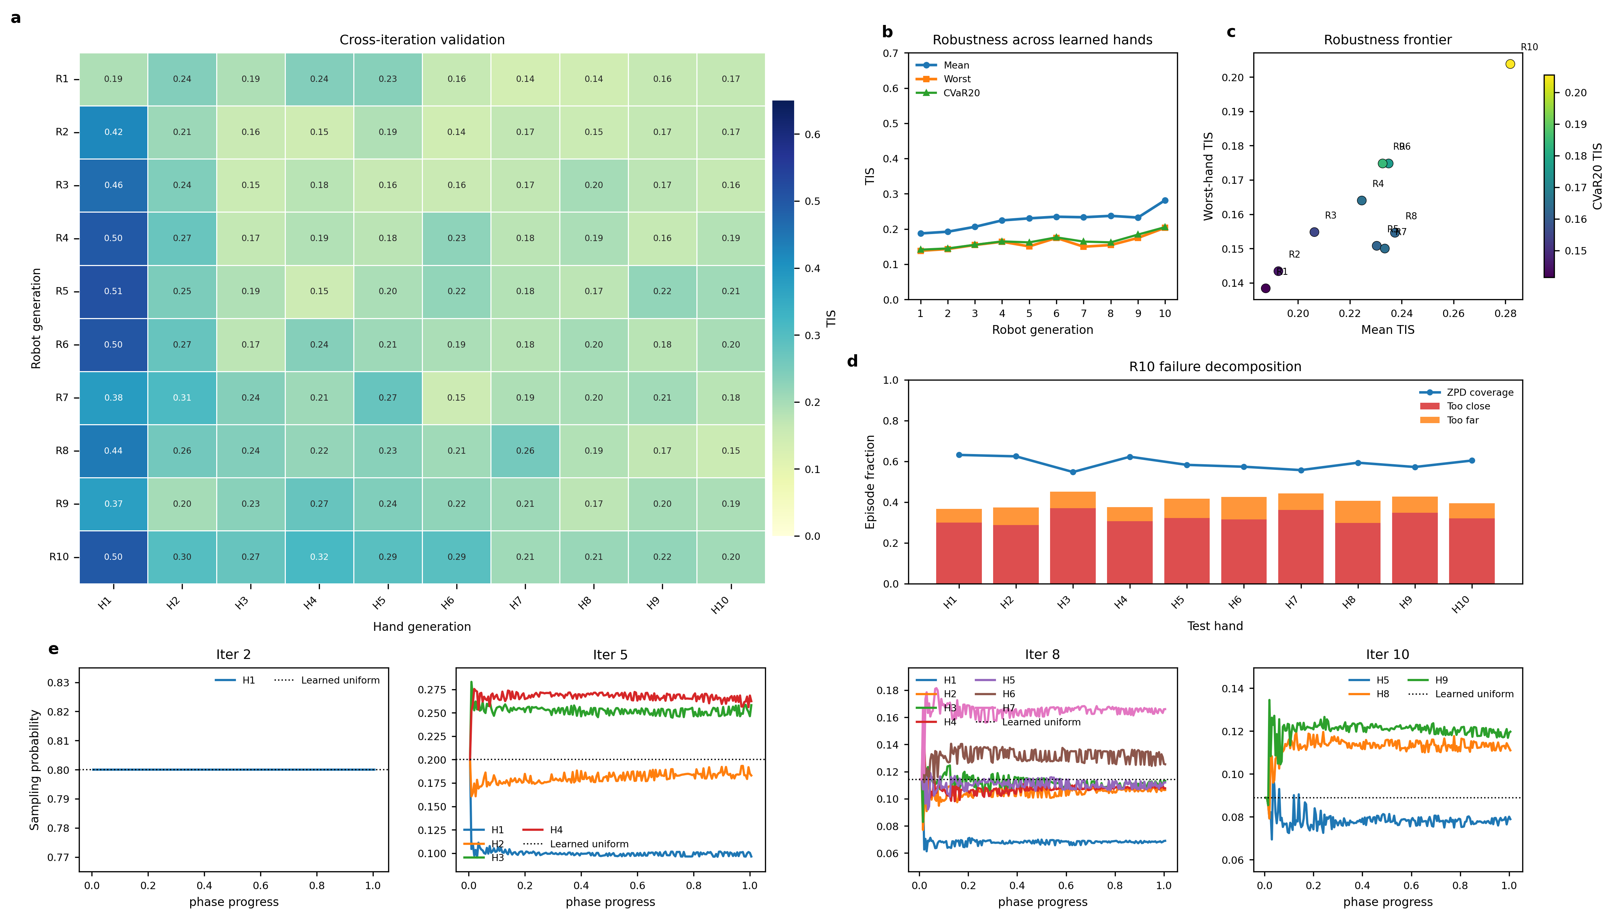
Fig. 1. League-training overview for the no-opponent-ID ZPD 3.5-5.5 simulation. The final robot generation improves mean and worst-case Time-In-Zone against the learned-hand pool, while the sorted empirical matrix visualizes robustness across increasingly difficult virtual patients.
C. Network Ablation and Auxiliary Dynamics Analysis
The second experiment asks whether temporal patient history is necessary for adaptive control. The MLP baseline observes the current geometric state but does not explicitly encode recent interaction history. The GRU policy processes the 16-frame relative-displacement buffer, allowing it to infer hand velocity, response delay, and pursuit tendency. The GRU+Aux policy further adds the future-dynamics prediction head described in Section IV-B.
The upper panels of Fig. 2 show that the main performance gain appears when temporal interaction history is introduced. Both recurrent policies learn longer and more rewarding interactions than the MLP baseline. This suggests that the robot benefits from observing how the hand has been moving, not only where it is at the current instant. In this setting, the GRU-only and GRU+Aux policies follow similar aggregate learning trends, indicating that temporal sequence modeling is the dominant contributor to control performance.
The lower panels of Fig. 2 address a different question: what does the auxiliary task learn? The predicted trajectories capture short-horizon movement direction and diverge gradually at longer horizons, consistent with the uncertainty of multi-step prediction in an interactive task. Thus, the auxiliary head should not be interpreted primarily as a separate performance booster in this run. Its role is to encourage and expose a temporal representation of patient dynamics, which can be inspected through future-motion prediction.
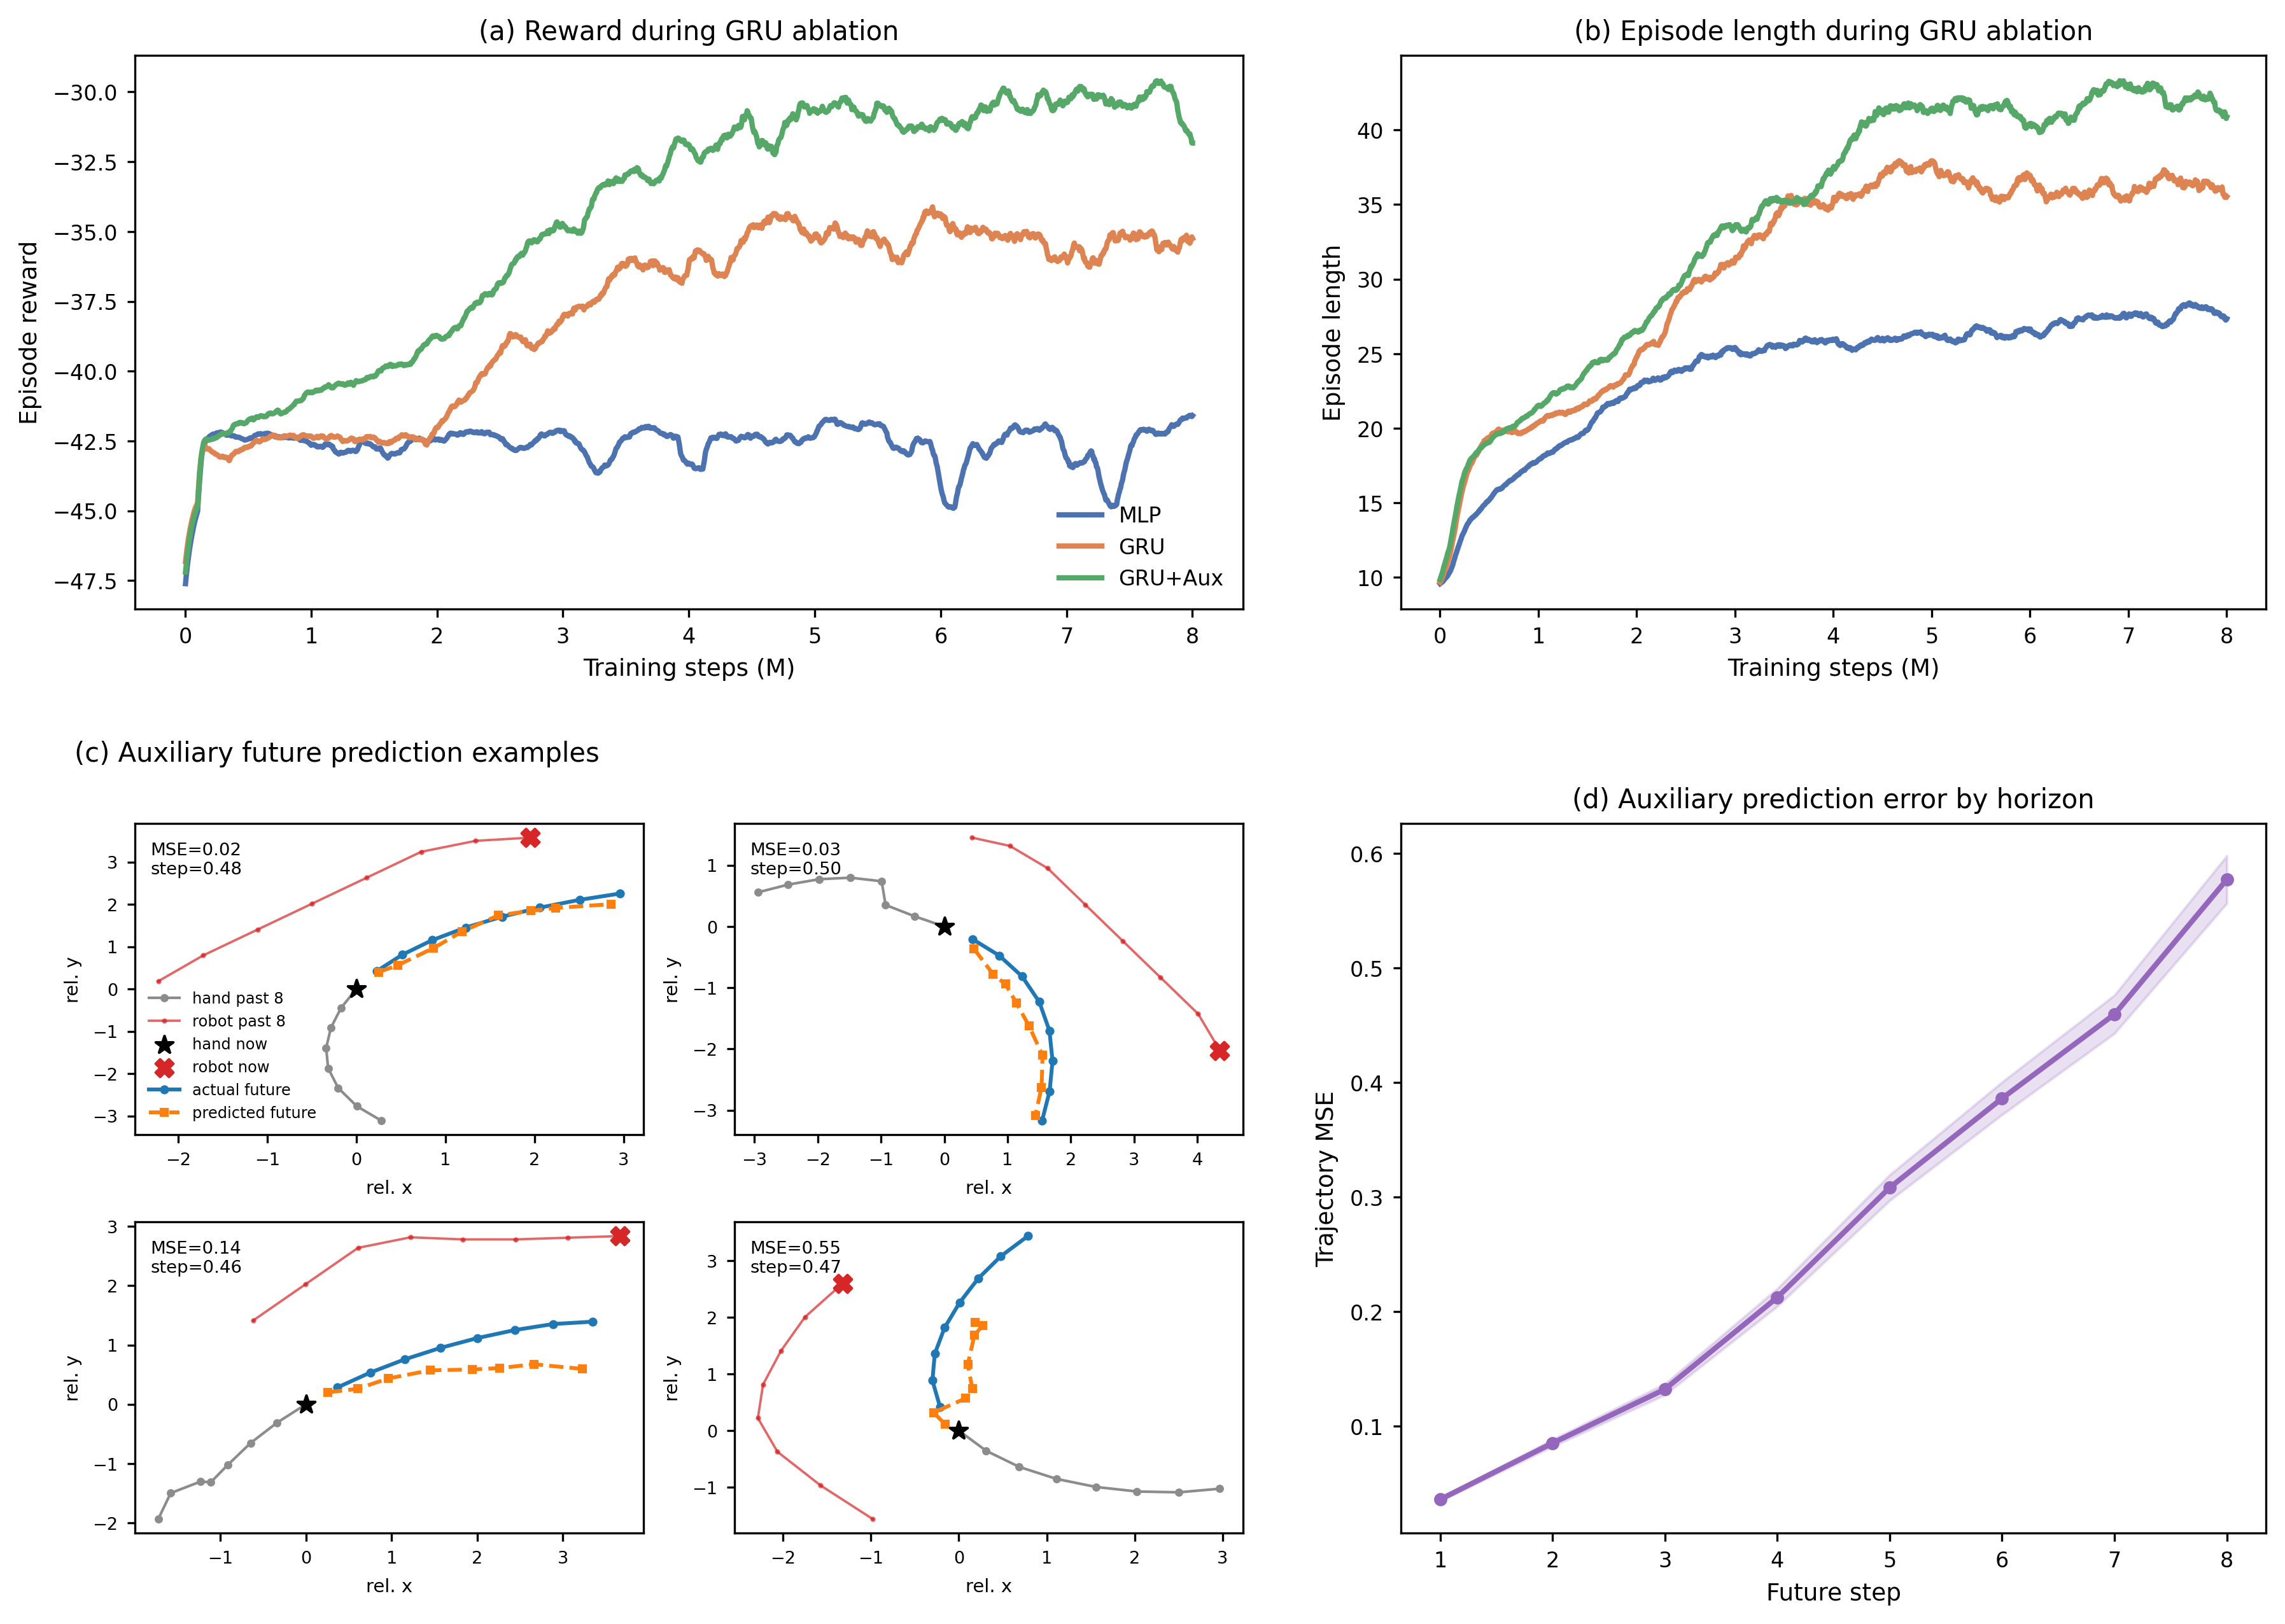
Fig. 2. GRU ablation and auxiliary future-motion prediction. Panels (a) and (b) show smoothed training reward and episode length for MLP, GRU, and GRU+Aux policies trained against the mixed learned-hand and scripted-hand pool. Panels (c) and (d) visualize representative auxiliary future-prediction examples and horizon-dependent trajectory error.
D. Generalization Across Scripted and Learned-Agent Hands
The third experiment evaluates whether the final robot policies generalize across hand-control mechanisms. The scripted controller represents noisy rule-based pursuit, whereas the learned hand agent can exploit interaction patterns acquired through RL training. A robust rehabilitation controller should not be tuned exclusively to either case; it should maintain useful interaction as hand behavior shifts between rule-based and learned pursuit.
TABLE II: POLICY COMPARISON ON SCRIPTED AND LEARNED-AGENT HANDS
Robot policy | Scripted hand | Agent hand
Scripted-only | 0.31 / 0.54 / 52 / 60% | 0.19 / 0.54 / 31 / 90%
Single-agent | 0.11 / 0.41 / 25 / 95% | 0.49 / 0.60 / 70 / 38%
League | 0.38 / 0.55 / 67 / 43% | 0.48 / 0.65 / 64 / 48%
Table II reports TIS, ZPD coverage, episode length, and catch rate. The scripted-only baseline remains relatively effective on the scripted hand but is frequently caught by the learned agent. The single-agent baseline shows the opposite pattern, performing well against the learned hand while degrading on the scripted controller. These complementary failures indicate that training against a single opponent type can produce brittle specialization. The league-trained robot avoids the strongest form of either failure mode and provides the most balanced behavior across the two automated test conditions. Mouse-controlled human-in-the-loop evaluation is treated as a separate validation stage.
E. Real-World Deployment Pipeline
The final part of the experiment section describes how the simulation policy is connected to the physical UR10 platform. This pipeline is presented as an implementation bridge rather than as a paired sim-to-real benchmark, because real hand kinematics, camera latency, magnetic actuation, and safety constraints are not fully represented in the virtual training environment.
The physical implementation uses the same 44-dimensional observation structure as simulation: robot position from Real-Time Data Exchange (RTDE), hand and microrobot positions from the overhead camera, boundary features, previous action, and the displacement-history buffer. Perception and control run in separate threads to avoid jitter. The camera runs at 10-15 Hz, whereas the robot requires deterministic commands at a fixed control rate. If both processes ran in one thread, a slow You Only Look Once (YOLO) inference step could stall the control loop.
The system therefore uses two threads connected by a single-element message queue. The vision thread captures frames, runs undistortion and detection, and pushes results to the queue. If the queue is full, stale results are replaced. The control thread runs at 20 Hz and attempts a non-blocking read each cycle. If a new frame is available, the hand position is updated; otherwise, the system uses dead reckoning based on a low-pass filtered velocity estimate from recent vision updates. The resulting observation is passed to the PPO policy, and the two-dimensional action is mapped through the inverse homography before being sent to the UR10 through the servoL interface.

