Stage Manuscript Draft: Methods, Experiments, and Physical Deployment
Abstract, Introduction, Discussion, Conclusion, and References remain to be finalized.
Stage manuscript draft revised from `methodology_ieee_v2.41_league_section_rewrite.md`. This version rewrites the network-ablation results section and standardizes the Fig. 4 caption to match the actual four-panel figure.

II. SYSTEM OVERVIEW AND PROBLEM FORMULATION
We introduce a magnetically actuated, non-contact rehabilitation system for active upper-limb motor training. The user interacts with an unpowered magnetic microrobot on a tabletop workspace, while a robotic arm drives the microrobot indirectly through a permanent magnet placed below the surface. This layout preserves an active pursuit task for the user while avoiding rigid physical coupling between the robot and the human body. It places the user in a pursuit role rather than a passive following role, aligning the task with the need for active engagement in motor rehabilitation. We formulate the control problem as a reinforcement learning (RL) task in which the robot regulates interaction difficulty through the motion of the microrobot.

A. Hardware Platform
The platform separates actuation, interaction, and perception into three physical layers. In the actuation layer, a UR10 robotic arm is placed beneath the workspace, and a permanent magnet is mounted on its end-effector to drive the microrobot above. In the interaction layer, a 5-mm acrylic sheet supports the unpowered microrobot and forms a physical barrier between the robotic arm and the user. In the perception layer, an overhead red-green-blue (RGB) camera sends images to a host computer, which estimates the positions of the microrobot and the hand and transmits target pose commands to the UR10 over Ethernet.
This layout supports both safety and reproducibility. Fig. 1 summarizes the complete simulation-to-real workflow, from policy training in the pursuit-evasion simulator to camera-based observation construction and physical magnetic actuation. The acrylic sheet creates a fixed separation between the actuator and the user-side workspace, so the participant interacts only with the passive microrobot rather than with the robot arm. The microrobot is lightweight and unpowered, and commanded motion can be limited in software while the UR10 remains below the surface with its standard emergency stop available. The hardware also requires only a collaborative robot, a camera, a calibrated planar workspace, and a permanent magnet. It does not rely on wearable components, force sensors, onboard batteries, or custom actuators, which makes the setup easier to reproduce across sessions.
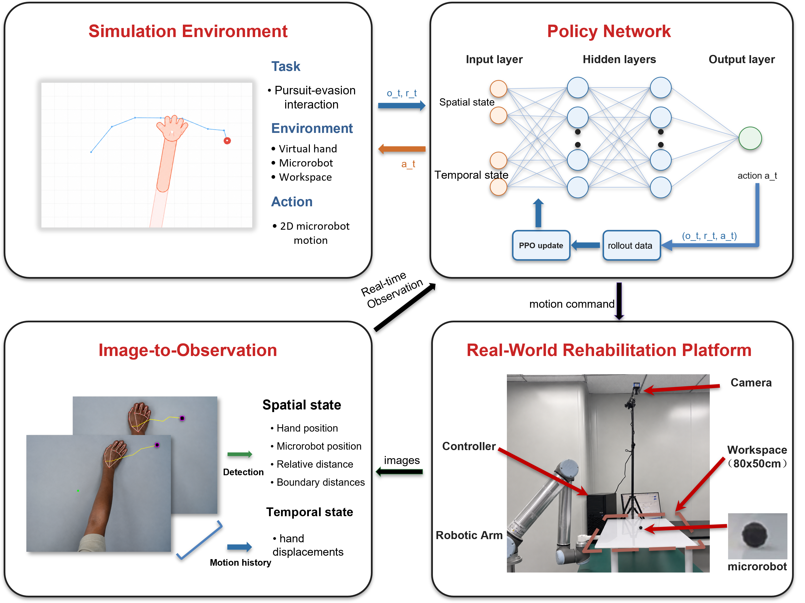
Fig. 1. System framework for simulation-to-real non-contact rehabilitation. The simulation environment defines the pursuit-evasion interaction, the policy network maps spatial and temporal observations to microrobot actions, the image-to-observation module converts camera measurements into policy inputs, and the physical platform executes the learned policy through magnetic actuation.

B. Problem Formulation
We cast the task as a closed-loop pursuit-evasion interaction on a flat workspace. The participant's hand acts as the pursuer, and the microrobot acts as a moving target driven by the robot arm beneath the acrylic surface. The participant attempts to approach and catch the microrobot, while the robot controls the microrobot motion to keep the task challenging but still reachable. This differs from static reaching because the target does not remain fixed after a movement is planned. The participant must continuously track, anticipate, and correct hand motion, making the task a sustained visuomotor exercise rather than an isolated point-to-point reach [1].
To keep the task challenging but achievable, we define a Zone of Proximal Development (ZPD) as a target distance range between the hand and the microrobot [2]. The robot should neither escape completely nor yield passively. Instead, it should keep the interaction inside this range so that the user remains engaged without the task becoming trivial or unreachable. Hand speed, pursuit strategy, response delay, and motion noise can all change during interaction, making fixed difficulty settings inadequate.
Conventional controllers are limited in this setting because methods such as artificial potential fields or rule-based impedance control usually rely on hand-crafted responses to instantaneous state feedback. These methods struggle to anticipate strategic pursuit behaviors such as interception or to adapt to heterogeneous movement patterns. Their performance can also degrade under delayed response or noisy motion, since purposeful movement and perturbation are not explicitly separated. These limitations motivate an RL formulation in which the controller optimizes a long-horizon ZPD objective under variable hand behavior rather than reacting only to the current hand-microrobot distance.
For robot training, the reward is written as the sum of four intuitive terms: distance regulation, action smoothness, workspace-boundary safety, and catch avoidance. Let d_t be the hand-microrobot distance, a_t be the robot action, and p_R,t be the microrobot position. The robot reward optimized by PPO is summarized as
$$r_{t} = r_{dist}(d_{t}) + r_{smooth}(a_{t}) + r_{bound}(p_{R,t}) + r_{catch}(d_{t}) (1)$$
Equation (1) groups the robot reward into four components. The distance component r_dist(d_t) encourages the hand-microrobot separation to remain inside the ZPD band and penalizes deviations on either side. The smoothness component r_smooth(a_t) discourages abrupt commanded motion. The boundary component r_bound(p_R,t) penalizes microrobot positions outside the valid workspace. The catch component r_catch(d_t) penalizes hand-microrobot contact. Episodes terminate after catch, workspace exit, or the maximum horizon.

III. METHODOLOGY
The robot must therefore regulate difficulty while hand behavior changes in both strategy and motor execution. Our approach treats this variability as a simulation problem, an observation problem, and a training-distribution problem. Cognitive-motor decoupled domain randomization broadens the simulated hand-behavior distribution by separating movement intent from motor-execution constraints. A dual-stream encoder makes hand-motion history available to the policy, while an auxiliary future-dynamics head adds a direct learning signal for short-horizon motion prediction. Iterative league training exposes the robot to a growing pool of hand policies so that the learned controller does not depend on one fixed virtual user.

A. Cognitive-Motor Decoupled Domain Randomization
Hand behavior varies in both intended pursuit strategy and execution accuracy. The proposed domain-randomization strategy models these sources of variability separately by generating intended hand motion first and then applying motor-execution constraints, observation noise, and temporal delay. At the strategy level, a hand policy sampled from the hand-policy pool determines the intended displacement at each timestep. The pool contains a stochastic scripted pursuit controller (SPC) and trained RL hand policies. The SPC provides a transparent pursuit model, while learned hand policies can produce more anticipatory strategies such as interception.
For the stochastic scripted pursuit controller, let ρ_ep denote the episode-level stride length and q_t denote a planar unit direction. The intended displacement is
$$u_{t}^{SPC} = ρ_{ep}q_{t} (2)$$
The stride ρ_ep is sampled once at episode reset and then held fixed. The direction q_t follows an ε-greedy pursuit rule. With probability 1 - ε, q_t points from the current hand position toward the microrobot; with probability ε, q_t is sampled uniformly from all planar unit directions. In the experiments, ρ_ep is sampled uniformly between 0.45 and 0.70, and ε is fixed at 0.05. Learned hand policies output the intended displacement directly, and this displacement is passed through the same motor-execution model.
The raw desired displacement is first passed through a first-order low-pass filter to model motion inertia, as shown in (3).
$$x_{t} = αx_{t−1} + (1−α)u_{t} (3)$$
where u_t denotes the raw desired displacement, x_t denotes the filtered displacement, and alpha in (0,1) is the inertia coefficient. Acceleration clipping is then applied componentwise to limit abrupt changes in motion, as shown in (4).
$$Δx_{t} = clip(x_{t}−x_{t−1}, −a_{max}, a_{max}) (4)$$
The delayed displacement is then applied to update the simulated hand position,
$$p_{H,t+1} = p_{H,t} + Δx_{t−δ} + η_{t} (5)$$
where delta is sampled from the delay range and eta_t is zero-mean Gaussian position noise with covariance sigma^2 I. The delay buffer advances at 8 Hz in the motor-execution layer, so the 0--3 frame range in Table I corresponds to 0--375 ms. Table I lists the values and sampled ranges used for these constraints. Through this decoupled design, the robot policy is exposed to plausible hand-motion variations without tying training to a single simulated hand model.
TABLE I: MOTOR RANDOMIZATION PARAMETERS
Parameter | Symbol | Range
Motion inertia | alpha | 0.7
Maximum acceleration | a_max | 0.15
Gaussian observation noise | sigma | Uniform distribution over 0.01-0.08
Neural delay | delta | 0-3 frames (0-375 ms)
Uniform distribution denotes sampling uniformly over the stated interval.

B. Dual-Stream Encoder with Future Dynamics Head
The proposed domain randomization scheme exposes the robot to diverse interaction behaviors during training. However, the robot does not observe the underlying behavior model directly. It must infer behavior patterns from the current interaction state and recent hand motion. The current hand position alone cannot distinguish deliberate pursuit from sensing noise, motor delay, or slow response. We therefore encode the observation with two streams, one for instantaneous geometric context and one for recent hand-motion history.
At each timestep, the 44-dimensional observation vector is divided into a 12-dimensional scalar vector and a 32-dimensional temporal buffer, as shown in (6).
$$o_{t} = [s_{t}; h_{t−T:t}] (6)$$
The scalar component represents the instantaneous geometry of the interaction and is defined in (7).
$$s_{t} = [p_{R}; p_{H}; d(R,H); b_{N}, b_{S}, b_{E}, b_{W}; stride; a_{t−1}] (7)$$
Here, p_R and p_H denote the two-dimensional positions of the microrobot and the hand. d(R,H) is their Euclidean distance. b_N, b_S, b_E, and b_W denote signed distances to the workspace boundaries. The variables stride and a_{t-1} represent the current movement step size and the previous robot action, respectively.
The temporal buffer h_{t-T:t} contains the T = 16 most recent relative hand displacement vectors, forming a 32-dimensional sequence. This history allows the encoder to estimate motion direction, response delay, and oscillatory behavior that are unavailable from the current position alone. Relative displacements make the history representation translation-invariant, so the recurrent stream focuses on how the hand is moving rather than where the interaction occurs in the workspace.
The scalar vector and temporal buffer are encoded in separate streams, as shown in Fig. 2. A multi-layer perceptron (MLP) extracts geometric information from the scalar state, while a gated recurrent unit (GRU) processes the displacement sequence. The two stream outputs are concatenated and passed through a fusion MLP to produce the shared representation used by the policy and value heads.
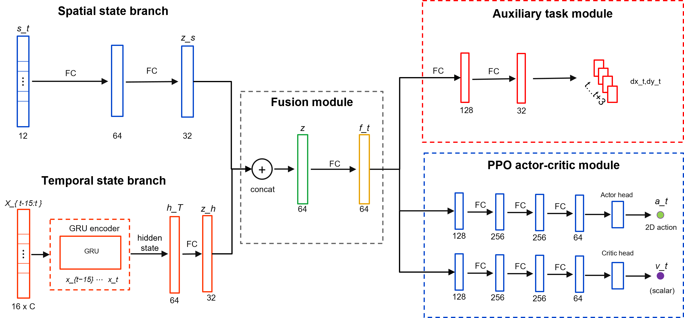
Fig. 2. Dual-stream policy architecture with auxiliary future dynamics. The spatial branch encodes the geometric state, the temporal branch encodes recent interaction history with a recurrent module, and the fused representation supports both the policy-value heads and the auxiliary future-motion prediction head.
The ZPD-based reward provides the main control signal, but it only supervises the encoder indirectly through policy optimization. To provide a denser learning signal for motion representation, we attach a future-dynamics head to the fused representation. The head predicts the relative hand displacement over an eight-step horizon. Because future displacements are available from the rollout, this auxiliary task is self-supervised and requires no additional annotation.
The trajectory prediction loss is given in (8).
$$L_{traj} = E[{‖{D̂}_{t+1:t+H}−D_{t+1:t+H}‖₂}^{2}], H=8 (8)$$
where D_hat_{t+1:t+H} is the predicted future displacement sequence and D_{t+1:t+H} is the observed future displacement sequence. The full training objective combines the PPO loss with the auxiliary trajectory-prediction loss in (9).
$$L_{total} = L_{PPO} + λ_{traj}L_{traj} (9)$$
where lambda_traj controls the auxiliary loss weight. Because the future-dynamics head shares the encoder with the policy, its gradients also update the spatial and temporal streams. These auxiliary gradients encourage the encoder to capture motion inertia, delay, and interaction dynamics, helping the policy anticipate near-future hand motion from recent history.

C. League Training
Even with a well-designed motion representation, achieving stable and adaptive difficulty regulation remains challenging when the training distribution lacks diversity in hand behaviors. A robot trained against a single hand policy may over-specialize to that policy and fail when the pursuit strategy changes. At the same time, training the robot and hand policies simultaneously creates a non-stationary learning problem. The actions of both agents jointly determine the next environment state, so each agent’s transition dynamics and resulting returns are directly influenced by the current policy of the other agent. When both policies are updated together, each update changes the environment faced by the other policy, violating the stationarity assumption of PPO. In practice, the interaction can enter a cycle in which the robot exploits the current hand policy, the hand adapts, and the robot loses strategies that were useful against earlier hands.
We address these two issues separately. To reduce non-stationarity, one side of the interaction is frozen while the other is trained. During robot training, the hand policies are fixed and treated as part of the environment. During hand training, the robot policy is fixed. To reduce over-specialization, the robot is trained against a hand-policy pool P that retains the SPC and learned hand policies from different training stages. Each hand policy is a scripted or learned controller that generates hand motion in simulation. A pool with the SPC and multiple learned hand policies exposes the robot to direct pursuit behavior as well as more strategic interception patterns.
The training objective also differs from that of a purely competitive game. The robot should not simply learn to defeat the hand. It should maintain an appropriate level of challenge for users with different movement patterns. For this reason, the hand-policy pool is used not to maximize adversarial difficulty, but to broaden the range of hand behaviors under which the robot must maintain the ZPD interaction.
The iterative procedure is formalized in Algorithm 1. Each iteration has two phases. In the robot phase, the hand-policy pool P is fixed, and the robot policy is trained with PPO against hand policies sampled from the pool. In the hand phase, a new learned hand policy is initialized from the previous learned hand policy and further trained against the current fixed robot policy. The trained hand policy is then added to P, increasing the diversity of hand behaviors used in the next robot training phase.
Algorithm 1: Iterative League Training
Input: initial robot policy $\pi_R^{(0)}$, scripted pursuit controller $\pi_H^{\mathrm{SPC}}$, number of league iterations $N$.
Initialize: hand-policy pool $\mathcal{P} \leftarrow \{\pi_H^{\mathrm{SPC}}\}$.
1. for $n=1,2,\ldots,N$ do
2. Train robot policy $\pi_R^{(n)}$ with PPO against hand policies sampled from $\mathcal{P}$.
3. Initialize hand policy $\pi_H^{(n)}$ from $\pi_H^{(n-1)}$ when available.
4. Train $\pi_H^{(n)}$ against the frozen robot policy $\pi_R^{(n)}$.
5. Update hand-policy pool $\mathcal{P} \leftarrow \mathcal{P} \cup \{\pi_H^{(n)}\}$.
6. end for
Uniform sampling from the learned-hand pool is inefficient because different learned hand policies provide different levels of challenge to the current robot. The implemented Prioritized Fictitious Self-Play (PFSP) rule uses recent episode length as the competitiveness signal. A shorter episode usually means that the hand quickly catches the microrobot or forces early termination, indicating that the current robot policy has difficulty handling that pursuit pattern. This episode-length priority acts as a dynamic curriculum, directing robot training toward the hand policies that are currently most challenging. For learned hand i, let l_bar_i denote its mean episode length in a rolling window. If fewer than 20 recent episodes are available for a learned hand, its length estimate is replaced by the median of the available estimates. If no estimates are available, the learned-hand distribution is uniform. The priority score and learned-hand sampling distribution are defined in (10).
$${ℓ̄}_{ref} = max_j {ℓ̄}_{j}, γ = \frac{α_{PFSP}}{τ}$$
$$s_{i} = {(\frac{{ℓ̄}_{ref}}{max({ℓ̄}_{i},1)})}^{γ}, r_{i} = \frac{s_{i}}{∑s_{j}}$$
$${p̃}_{i} = (1−μ)r_{i} + \frac{μ}{m} (10)$$
$$Pr(SPC) = p_{SPC}, Pr(H_{i}) = (1−p_{SPC}){p̃}_{i} (11)$$

Here, m is the number of learned hand policies, alpha_PFSP controls the strength of prioritization, tau is the temperature, and mu is the uniform exploration mass. The PFSP coefficient alpha_PFSP is a sampling-priority exponent and is unrelated to the motor-inertia coefficient alpha in Table I. A shorter recent episode length yields a larger priority score, so learned hand policies that still challenge the current robot are sampled more often. The uniform mixture keeps every learned hand policy available.
The SPC is sampled outside the learned-hand PFSP distribution with a fixed probability p_SPC. The final hand-policy sampling rule is given in (11).

In implementation, the PFSP estimate uses a finite rolling window, a small uniform exploration mass, and a fixed SPC sampling probability. Keeping the SPC in the pool reduces the risk that the robot overfits to artifacts of learned hand policies, while PFSP concentrates learned-policy sampling on hand policies that remain challenging for the current robot generation.

IV. EXPERIMENTS AND RESULTS
The evaluation combines simulation experiments with a physical deployment test. The simulation experiments measure robustness across hand behaviors and isolate the contribution of temporal hand-history encoding. The physical deployment test evaluates whether the learned policy can run inside the real-time perception-control stack on the UR10 platform and whether the realized motion responds coherently to measured hand movement.

A. Simulation Protocol and Metrics
Simulation experiments were conducted in the pursuit-evasion environment described in Section II and instantiated with the hand-behavior models introduced in Section III. The robot controlled the microrobot, while the hand trajectory was generated by one of three evaluation interfaces. The first was the stochastic scripted pursuit controller, the second was a trained hand policy, and the third was a manual mouse pursuit interface used for human-in-the-loop stress testing. The ZPD interval was fixed to 3.5-5.5 workspace units, and an interaction step was classified as in-zone when the Euclidean distance between the hand and the microrobot fell within this interval. The simulator and physical deployment use the same 15 x 10 planar coordinate frame, so one workspace unit corresponds to 1 cm in the calibrated physical workspace. Thus, the 3.5-5.5 workspace-unit ZPD maps to 3.5-5.5 cm in the physical rollout analysis.
Time-In-Zone (TIZ) was used as the primary outcome measure and was computed as the fraction of the full episode horizon spent inside the ZPD interval. Additional metrics were included to separate distinct failure modes of adaptive difficulty regulation. ZPD coverage measures the in-zone fraction over the realized portion of an episode, episode length measures how long the interaction remains active, and catch rate is the fraction of evaluation episodes terminated by catch before the horizon. For league evaluation, robustness across learned hand policies was summarized using mean TIZ, worst-hand TIZ, and Conditional Value-at-Risk over the worst 20% of hand policies (CVaR20) of TIZ.
Two simulation comparisons were performed. The training-protocol comparison evaluated a robot trained only with the stochastic scripted pursuit controller, a robot trained against a single learned hand policy, and a robot trained through iterative league expansion. The representation comparison evaluated a feed-forward MLP policy, a GRU policy that encodes recent hand displacement, and a GRU policy trained with the auxiliary future-dynamics objective. The physical UR10 experiment used the same observation definition but was analyzed separately because camera latency, robot communication, and fixed-rate control introduce constraints that are absent from the simulation protocol.

B. League Training and Cross-Hand Robustness
The league evaluation asks whether an expanding hand-policy pool improves robustness across pursuit behaviors, rather than only improving performance against the most recent hand policy. After each robot generation is trained, it is evaluated against all learned hand generations in the pool. This cross-generation test separates generalization across hand behaviors from progress against a single training opponent.
The cross-generation matrix in Fig. 3(a) fixes one robot generation per row and one learned hand generation per column. Early robot generations perform well only for limited parts of the hand pool, indicating sensitivity to the particular pursuit behavior used for training. Later generations maintain stronger TIZ over a broader set of learned hands, which suggests that league training reduces narrow specialization.
The mean and worst-hand curves in Fig. 3(b) summarize average and difficult-case robustness across the learned-hand pool. The mean curve reflects typical performance, while the worst-hand curve tracks the most difficult learned hand for each robot generation. Both curves improve from early to final generations despite local fluctuations, showing that the final policy improves the typical interaction while also reducing the weakest-case failure.
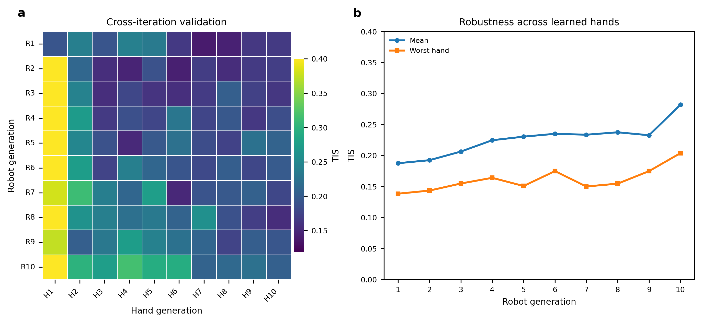
Fig. 3. Cross-hand validation of league-trained robot policies under the ZPD 3.5-5.5 simulation setting. (a) TIZ matrix obtained by evaluating each robot generation against each learned hand generation. Rows correspond to robot generations, and columns correspond to learned hand generations. (b) Mean and worst-hand TIZ across learned hand test policies for each robot generation.
Table II evaluates whether this robustness extends beyond the learned-hand pool used in Fig. 3. The final SPC-only, single-hand, and league-trained robot policies are tested against the stochastic scripted pursuit controller, a learned hand policy, and manual mouse pursuit. Manual mouse pursuit introduces human reaction time and voluntary pursuit strategy, so it is treated as a human-in-the-loop stress test rather than another automated hand policy. Higher TIZ and longer episode length indicate more sustained difficulty regulation.
TABLE II: POLICY COMPARISON ACROSS THREE HAND TEST SETS
Robot policy | Test set | TIZ | Length
SPC-only | SPC | 0.31 | 52
SPC-only | Learned hand | 0.19 | 31
SPC-only | Manual mouse | 0.14 | 33
Single-hand | SPC | 0.11 | 25
Single-hand | Learned hand | 0.49 | 70
Single-hand | Manual mouse | 0.19 | 40
League | SPC | 0.38 | 67
League | Learned hand | 0.48 | 64
League | Manual mouse | 0.49 | 74
Each value is reported as a mean over 50 evaluation episodes for each test condition. TIZ denotes the mean fraction of the full episode horizon spent in the ZPD, and Length denotes mean episode length in simulation steps. Standard deviations are omitted to keep the policy comparison compact.
The two non-league baselines show complementary forms of specialization. The SPC-only robot remains most suitable for the scripted pursuit controller but degrades under learned and manual pursuit. The single-hand robot performs well against the learned hand policy but loses robustness when the pursuit behavior changes to scripted or manual control. The league-trained robot gives the most balanced profile across all three test sets, preserving learned-hand performance while improving the scripted and manual-pursuit cases. This balance is the desired behavior for adaptive difficulty regulation, because hand behavior can change across controllers, sessions, and voluntary strategies.

C. Network Ablation and Auxiliary Dynamics Analysis
The league results evaluate the diversity of hand behaviors used during training. The network ablation then tests whether the robot policy can use temporal hand-motion information once that diversity is present. The MLP baseline uses the instantaneous geometric state only. The GRU policy adds the 16-frame relative-displacement history, and the auxiliary GRU further adds the future-dynamics prediction head described in Section III.B.
The training curves in Fig. 4(a) and Fig. 4(b) show that temporal history improves optimization and interaction persistence. The GRU policies reach higher episode reward and longer episode length than the MLP baseline, indicating that current geometry alone is insufficient for stable difficulty regulation when hand motion changes over time. The auxiliary GRU gives the strongest training curve, suggesting that the prediction loss helps the recurrent stream form a more useful motion representation.
The auxiliary prediction examples in Fig. 4(c) provide a qualitative check on this representation. The predicted short-horizon displacement generally follows the direction and curvature of the observed future hand motion, showing that the auxiliary head learns local motion dynamics rather than only reconstructing the current position.
The final normalized metrics in Fig. 4(d) summarize the control effect of these representation changes. Recurrent history improves in-zone behavior and workspace coverage relative to the MLP baseline. Adding the auxiliary prediction objective further improves these task-quality metrics while reducing mean jerk. Together, the ablation indicates that both temporal hand history and auxiliary dynamics prediction contribute to smoother and more reliable difficulty regulation.
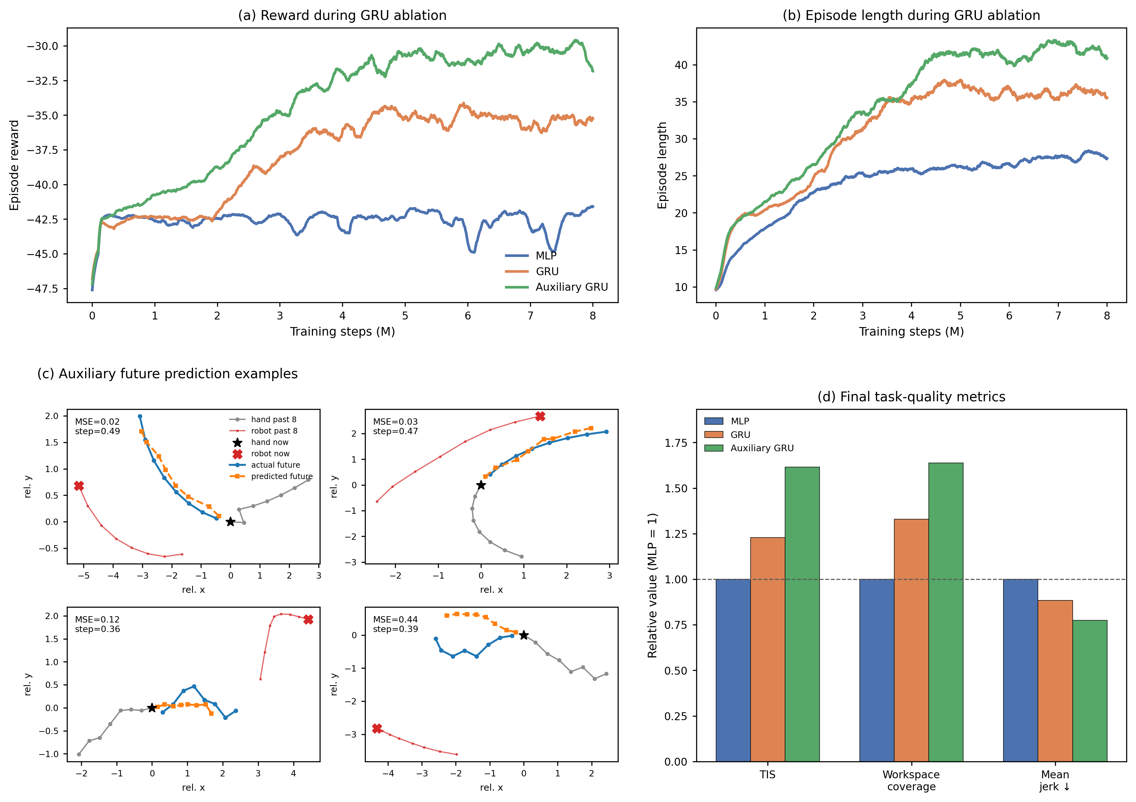
Fig. 4. Network ablation for temporal encoding and auxiliary dynamics prediction. (a) Smoothed episode reward during training for the MLP, GRU, and auxiliary GRU policies. (b) Smoothed episode length during training for the same policies. (c) Representative auxiliary-head predictions of short-horizon hand displacement compared with observed future motion. (d) Final task-quality metrics normalized to the MLP baseline; higher values are better for in-zone time and workspace coverage, whereas lower values are better for mean jerk.

D. Real-Time Physical Deployment
The simulation-trained policy was deployed on the UR10 microrobot platform to evaluate zero-shot physical execution under real hand input. A healthy pilot pursued the microrobot on the acrylic workspace while the UR10 drove the magnetic actuator below the surface. The policy was transferred without physical fine-tuning. The physical data comprise nine zero-shot rollouts from the same pilot session. Across these rollouts, the camera and UR10 command loops operated near their target real-time rates, PPO inference required only a few milliseconds, and the image-to-control age remained within the range needed for online interaction.
The implementation preserves the simulation observation layout without adding UR10 telemetry or end-effector pose to the learned-policy input. At each control step, the observation was constructed from calibrated camera measurements of the hand and microrobot, workspace-boundary features, the previous executed robot command, and recent relative hand-displacement history, matching the categories in (6) and (7). The deployment controller used RTDE pose readback only to execute and monitor Cartesian target commands over Ethernet, not as an additional policy observation.
Tracking and calibration were handled by the camera-based perception stack. The microrobot was detected with the trained YOLO model, the hand was detected with MediaPipe-based hand tracking, and a homography calibration mapped image coordinates into the 15 x 10 cm workspace. When a new hand detection was not available, the controller used low-pass dead-reckoning from the last measured hand velocity until the next camera update. Safety constraints included workspace clipping of commanded targets, a maximum commanded target step of 0.6 cm, automatic stop-on-catch at a 1.5 cm distance threshold, UR10 servoStop on shutdown or interruption, and the standard hardware emergency stop available during testing.
Fig. 5 presents one representative zero-shot physical rollout among the nine physical trials. The image sequence in Fig. 5(a) shows the hand and microrobot at selected moments of the same trial. These frames are not independent snapshots; they are time-aligned with the dynamic traces in Fig. 5(b). The selected events cover the beginning of the interaction, a steady pursuit phase, a faster hand movement phase, a slower movement phase, and the end of the rollout. Together, the frames provide direct visual evidence that the policy was executed on the physical platform and that the hand, microrobot, camera perception, and UR10 actuation were coupled in a closed loop.
The quantitative traces in Fig. 5(b) summarize how the interaction evolved during the same physical rollout. The smoothed hand-microrobot distance remains near the target ZPD band for a substantial portion of the trial and repeatedly returns toward this range after deviations. This pattern matches the intended difficulty-regulation objective: the microrobot does not simply move away from the hand indefinitely, nor does it remain static until being caught. Instead, the physical interaction alternates between periods in which the hand closes the distance and periods in which the robot response increases the separation.
The speed profiles provide additional evidence that the measured distance changes are tied to real pursuit dynamics. The hand-speed trace identifies periods of steady motion, acceleration, and deceleration by the pilot, while the robot-speed trace reports the realized motion of the magnetic actuation system. The relative timing of these curves demonstrates that changes in human pursuit speed are reflected in the physical interaction and in the robot response during the same rollout. Thus, the deployment result verifies more than offline policy inference: it demonstrates that the simulation-trained controller can sustain an online hand-microrobot interaction on the UR10 platform using real camera feedback.
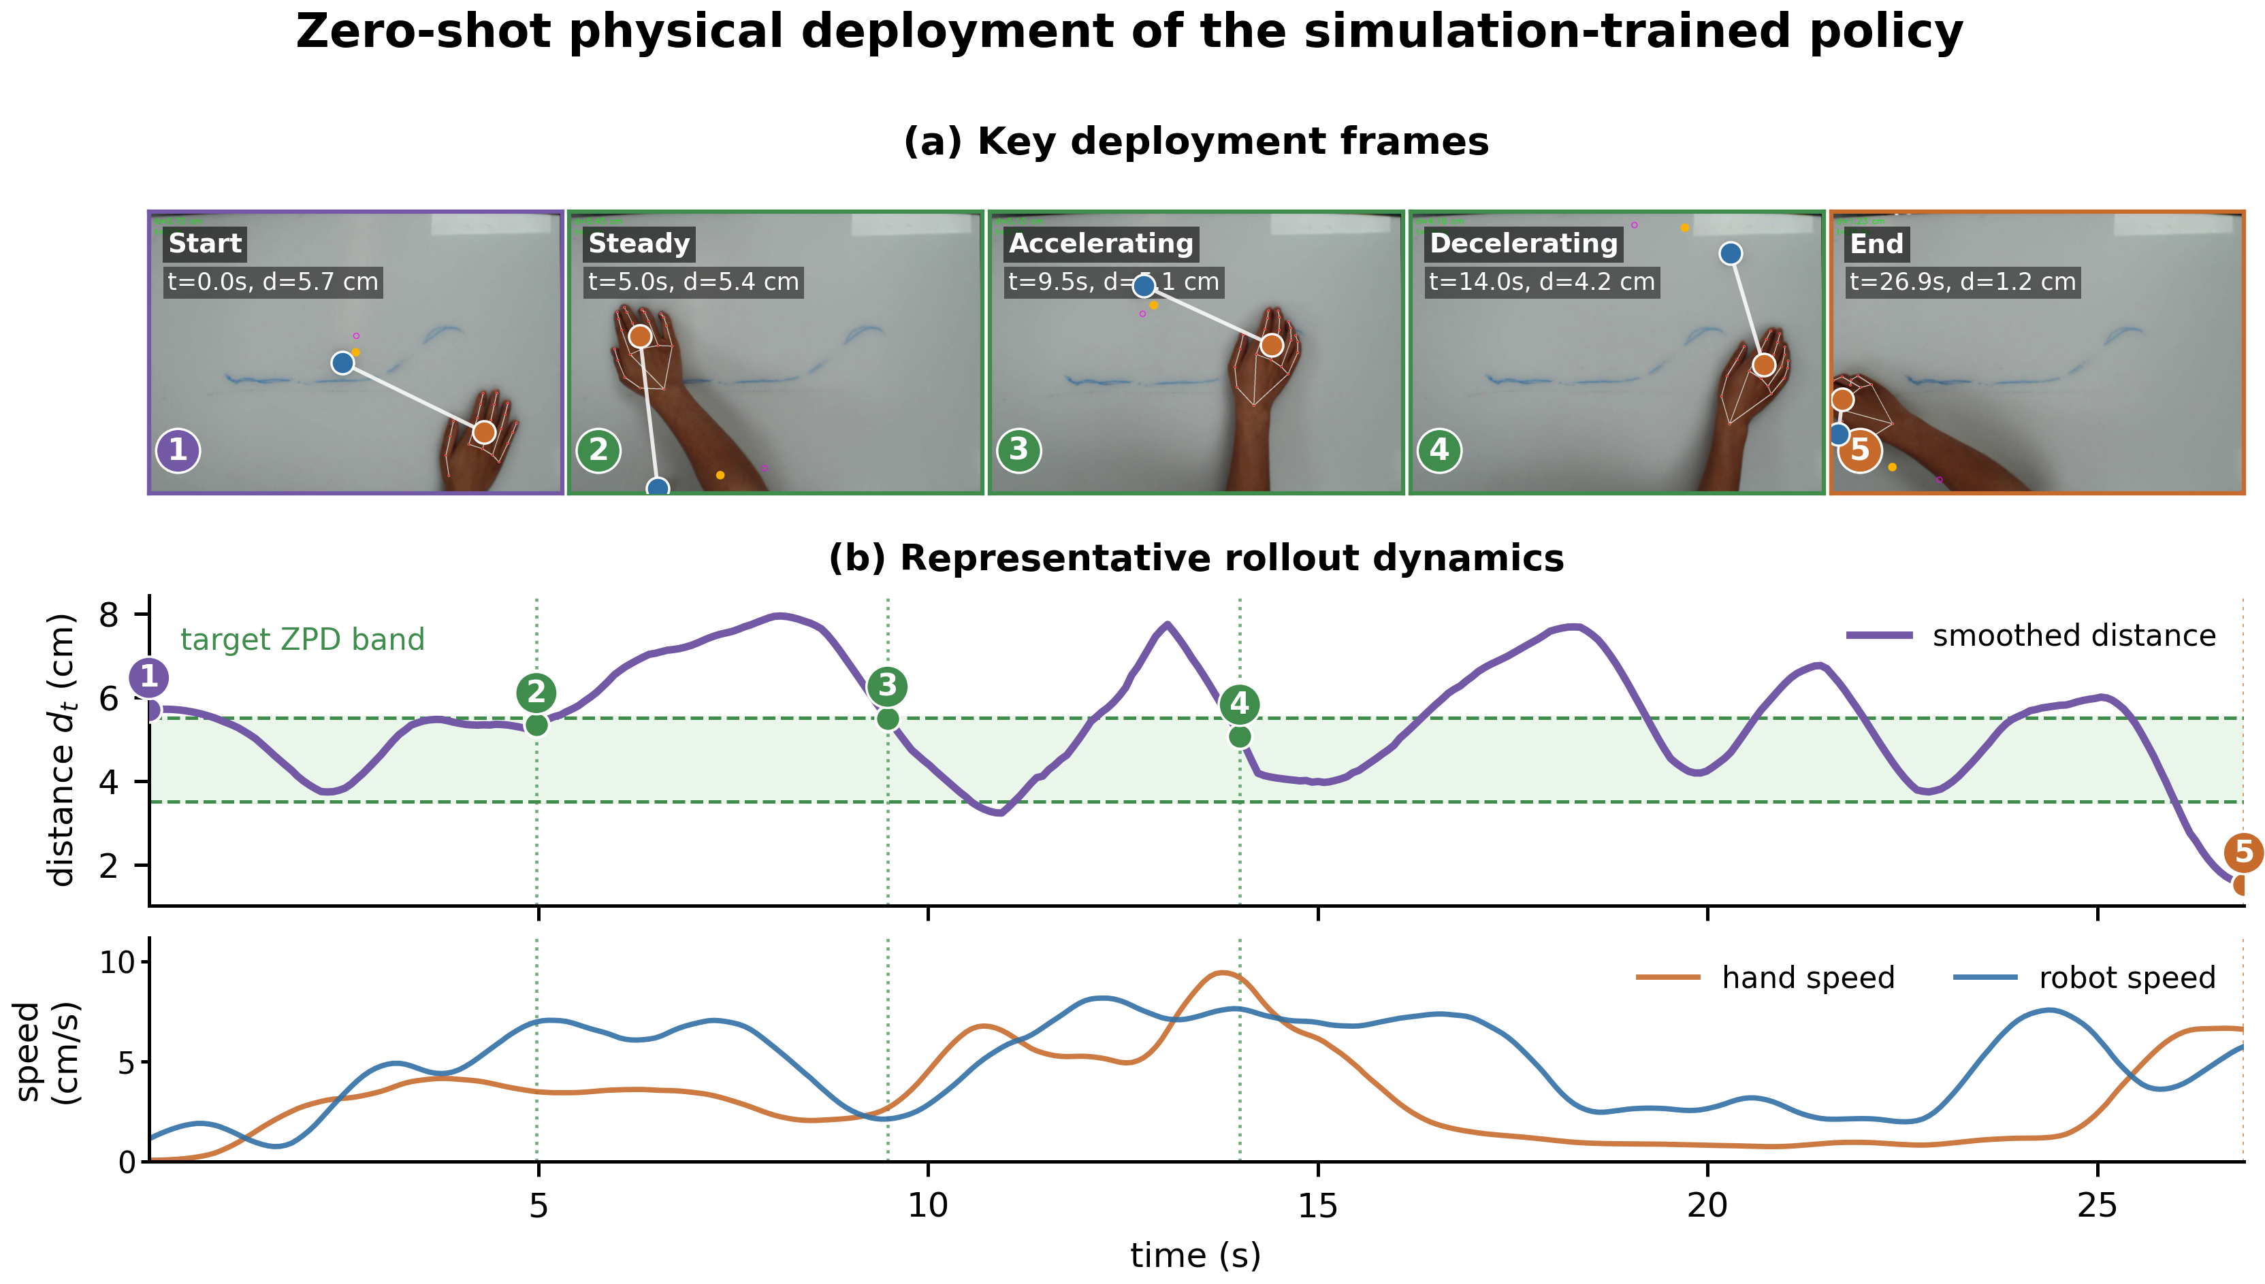
Fig. 5. Zero-shot physical deployment on the UR10 microrobot platform. (a) Key deployment frames from a representative rollout among nine physical trials. (b) Smoothed hand-microrobot distance, target ZPD band, and measured hand and robot speeds from the same rollout.

